Arrival
Point to the first and last picture in the cell strip. What changed?
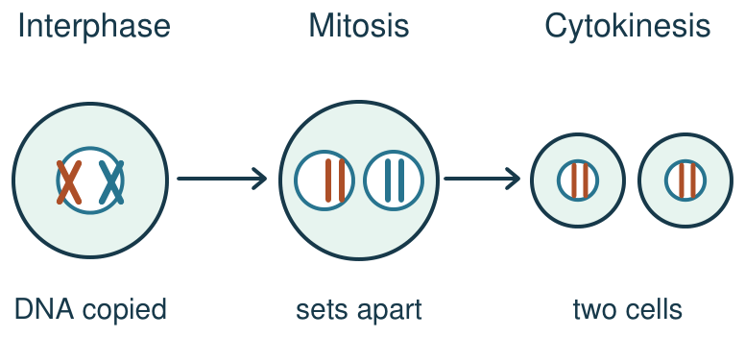
My response

Starter
Recall three things from earlier lessons. Show one answer at a time.
1. Which process uses energy to move a substance from low to high concentration?

2. In osmosis, which substance moves through a partially permeable membrane?

3. In a eukaryotic animal cell, which structure holds the chromosomes?

Talk-then-sort
Complete the missing step in the part-done model. Then place the paper strips in both new cells.
Interphase: copy DNA. Mitosis: prophase (condense), metaphase (line up), ________, telophase (two nuclei). Cytokinesis: split the cell.
Choices: Interphase · Mitosis · Cytokinesis
Card or step | My group or match
First
Then
Last

Use the model to explain how cell division helps replace damaged body cells.
Independent F
Order the three cards and show the same chromosome colours in each new cell.
First …; then …; last …
My response

Independent M
Explain why each new cell has a matching chromosome set.
Each new cell matches because …
My response

Independent H
Predict what would happen to the sets if copied chromosomes did not separate evenly.
If the copies did not separate evenly, then … because …
My response

Go deeper
How do copy, separate and split work together when new cells are needed for repair?
My response

Fault finder: compare two faulty models. One skips DNA copying; the other puts both copies of one chromosome in one nucleus. Find each first error and propose a repair.
My response

Exit
Show how you know: order the three stages and explain why the new cells match.
My exit response

My feedback was … Name the feedback you heard at Review.
Next I need to … Check both matching chromosome sets and the final cell split.

Word help
Word | Meaning | Example | My language
cell cycle | the series of steps in which a cell grows and divides | The cell cycle includes interphase, mitosis and cytokinesis.
interphase | the stage in which the cell grows and copies its DNA | The cell copies its DNA in interphase.
mitosis | the stage in which copied chromosomes separate into two nuclei | Mitosis separates the chromosome sets.
chromosome | a structure of DNA that carries genes | Each new nucleus receives a matching set of chromosomes.
cytokinesis | the division of the cell after the nuclei form | Cytokinesis splits one cell into two.
prophase | the mitosis phase when chromosomes condense | In prophase, chromosomes become easier to see.
metaphase | the mitosis phase when chromosomes line up in the middle | In metaphase, chromosomes form a line.
anaphase | the mitosis phase when the two copies of each chromosome are pulled to opposite ends | In anaphase, the two copies of each chromosome are pulled to opposite ends.
telophase | the mitosis phase when two new nuclei form | In telophase, each set gains a nucleus.

