Arrival
Look at this week’s letter tiles A and a. Point to one detail you notice.
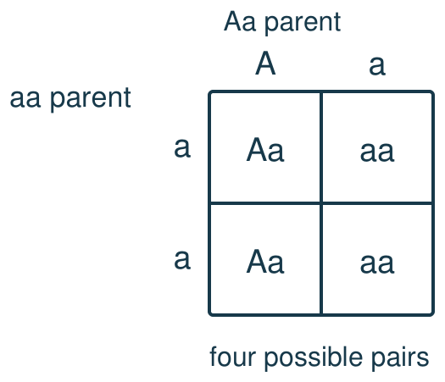
My response

Starter
Recall three ideas from earlier lessons. Show one answer at a time.
1. What is a gene?

2. What do stem cells do in growth?

3. Where are chromosomes found in an animal cell?

Talk-then-sort
Complete the missing step in the part-done model. Speak, then match the cards.
Aa × aa: top A, a; side a, a. First row Aa, aa; second row ___, ___. Chance of aa: ___ out of 4.
Choices: Aa · aa
Card or step | My group or match
Top A with side a
Top a with first side a
Top A with second side a
Top a with second side a

Calculate the aa probability for Aa × aa. Evaluate an exact-count claim about real offspring.
Independent F
Complete Aa × aa with allele tiles.
Top ___ and side ___ make ___.
My response

Independent M
Calculate and justify the aa probability from the grid.
I count ___ aa squares out of four, so …
My response

Independent H
Evaluate an exact-count claim about four real offspring.
The grid shows a chance, not a promise, because …
My response

Go deeper
Compare aa chances for Aa × Aa and Aa × aa with a second grid.
My response

Correct a faulty grid that gives an Aa parent two A headings; explain its wrong probability.
My response

Exit
Show what you know with a model and explain one reason.
My exit response

My feedback was … Name what you heard at Review.
Next I need to … Check the top and side alleles before giving a chance.
Word help
Word | Meaning | Example | My language
allele | a version of a gene | A and a represent two alleles in our invented model.
genotype | the pair of alleles shown by letters | Aa is one possible genotype in this model.
dominant | an allele shown by one copy in this simple model | A is dominant in our invented flower model.
recessive | an allele shown when two copies are present in this model | aa shows the recessive version in our model.
Punnett square | a grid that shows possible allele pairs | The Punnett square for Aa × aa has four cells.

