Arrival
Look at this week’s NHS source card. Point to one detail you notice.
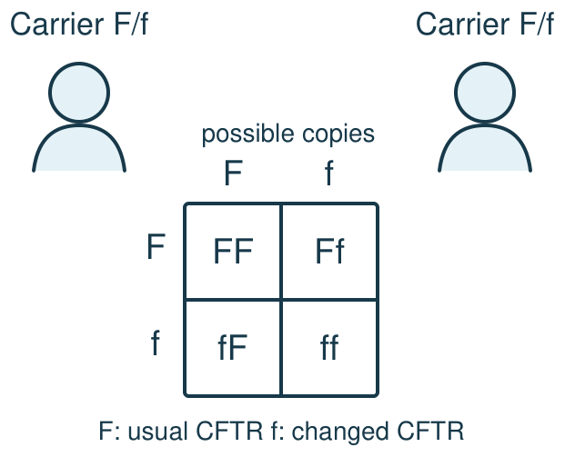
My response

Starter
Recall three ideas from earlier lessons. Show one answer at a time.
1. What does a Punnett square show?

2. What is a gene?

3. Where are chromosomes found in an animal cell?

Talk-then-sort
Complete the missing step in the part-done model. Speak, then match the cards.
The NHS card says cystic fibrosis is ___. It involves the ___ gene. One changed copy usually means a ___. Source: ___.
NHS card: Cystic fibrosis is inherited. It can affect breathing and digestion. Changed CFTR copies are inherited from both parents; one changed copy usually makes a carrier. Treatments can ease symptoms. The genetic cause is inherited; infection precautions are separate. This card predicts nothing about a person. NHS, Cystic fibrosis; NHS Genomics Education Programme, Cystic fibrosis. Checked 24 September 2026.
Choices: What it is · Inheritance · Care · Source
Card or step | My group or match
Can affect breathing and digestion
Usually two changed CFTR copies
Treatments help manage symptoms
NHS page named and dated

Present three sourced facts from the offline NHS card, then correct an unsupported claim.
Independent F
State the condition and one fact with the NHS source named.
The card says …; the source is …
My response

Independent M
Explain CFTR inheritance and separate it from infection.
The CFTR change is inherited because …; infection advice is separate because …
My response

Independent H
Revise an unsupported claim with the NHS card.
The claim is not supported by …; I would revise it to …
My response

Go deeper
Why does one changed copy in this example not justify saying a carrier has the condition?
My response

Repair a draft saying a CFTR change spreads by touch and outcomes are fixed; source both repairs.
My response

Exit
Show what you know with a model and explain one reason.
My exit response

My feedback was … Name what you heard at Review.
Next I need to … Put the NHS source next to each scientific claim.
Word help
Word | Meaning | Example | My language
inherited | passed to a child through genes | The card says cystic fibrosis is inherited.
variant | a changed version of a gene | The card describes a changed CFTR variant.
carrier | a person with one changed copy in this recessive example | A carrier usually does not have cystic fibrosis.
source | where a claim comes from | The NHS page is the source for this card.

