Arrival
Look at this week’s familiar cell and allele models. Point to one detail you notice.
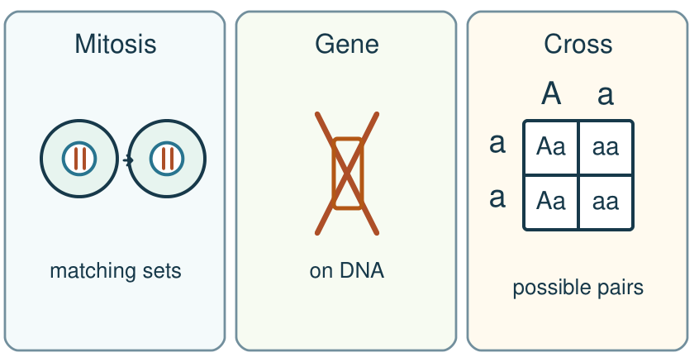
My response

Starter
Recall three ideas from earlier lessons. Show one answer at a time.
1. Which named source supports our cystic fibrosis card?

2. How does a gene relate to DNA?

3. Which part of an animal cell holds chromosomes?

Talk-then-sort
Complete the missing step in the part-done model. Speak, then match the cards.
Parallel example: the chromosome sets are copied. Mitosis moves the sets to ___ nuclei; the evidence detail is ___.
Choices: Cell model · DNA model · Cross model
Card or step | My group or match
Two matching chromosome sets
Short marked part of a DNA string
Four possible allele pairs

Complete a short three-part check: order copy/separate/split, mark a gene on DNA, and use Aa × aa to state a possible pair and chance.
Independent F
In the independent check, order the three stages and mark one gene on the model.
First …; then …; last …
My response

Independent M
Explain matching body cells and why a gene is only part of DNA.
The model shows … because …
My response

Independent H
Use Aa × aa to reject the claim that a probability promises an exact family count.
The model chance is …; the real count may differ because …
My response

Go deeper
Which model feature supports an explanation that transfers to a fresh example, and which detail is only the model?
My response

After submitting the check, compare two wrong cross explanations. Name each misconception and a precise repair without altering the checked answer.
My response

Exit
Show what you know with a model and explain one reason.
My exit response

My feedback was … Name what you heard at Review.
Next I need to … Choose one model error you found; repair it and explain that change in the next lesson.
Word help
Word | Meaning | Example | My language
mitosis | division of the nucleus to separate matching chromosome sets | Mitosis helps make matching body cells.
gene | a section of DNA that codes for a protein | A gene is a part of the DNA string.
allele | a version of a gene | A and a stand for two alleles in our invented model.
evidence | a fact or model detail that supports a claim | The labelled chromosome sets are evidence for my answer.

