Choice cards
White Standard sheet
Make a choice and say why.

Which job
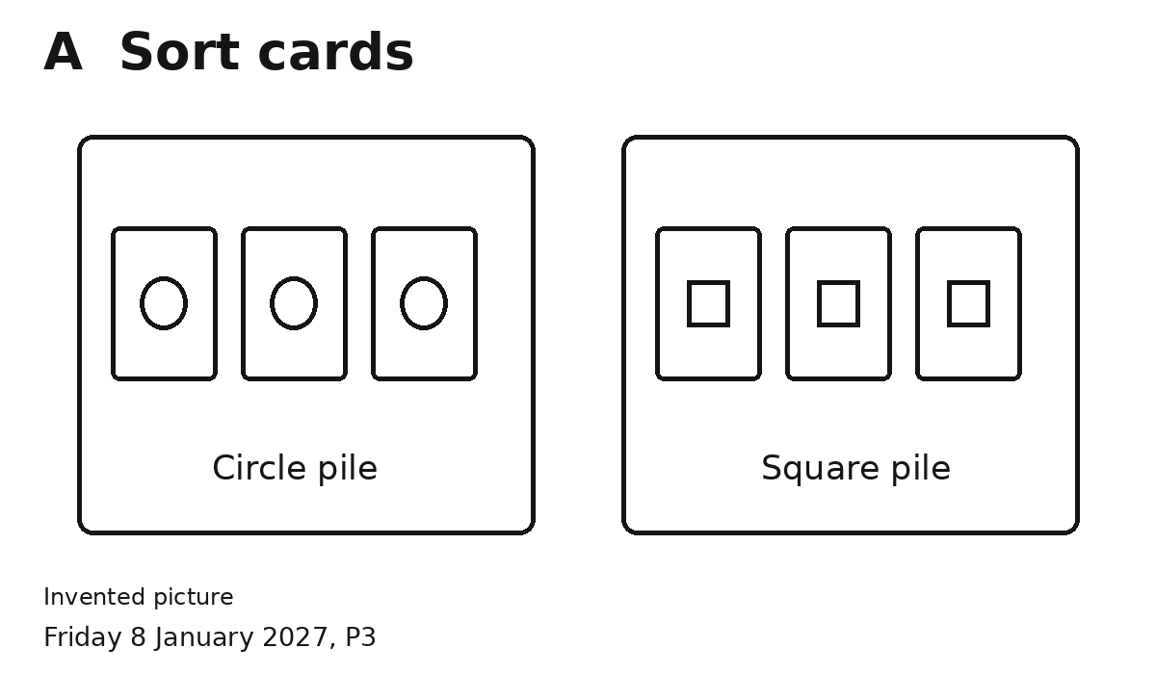
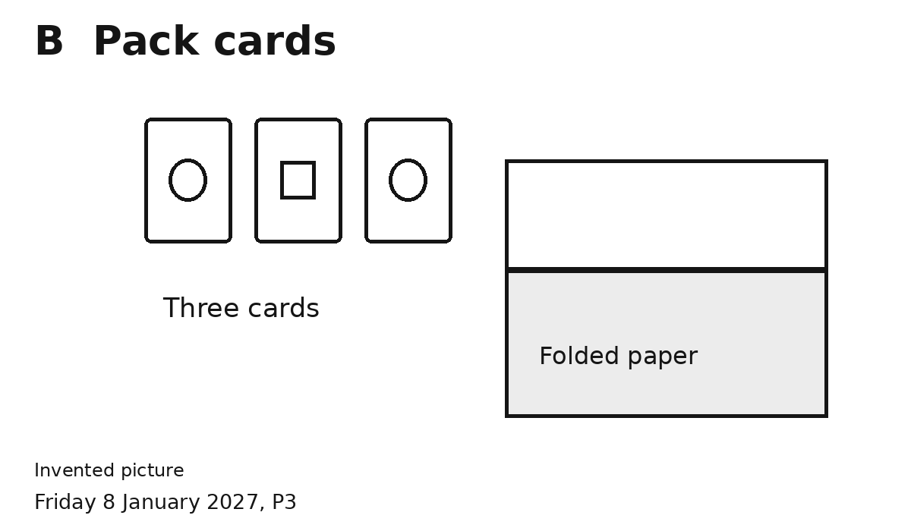
Pick A or B.
I chose ... because ...
You can give your own reason.

Which tool
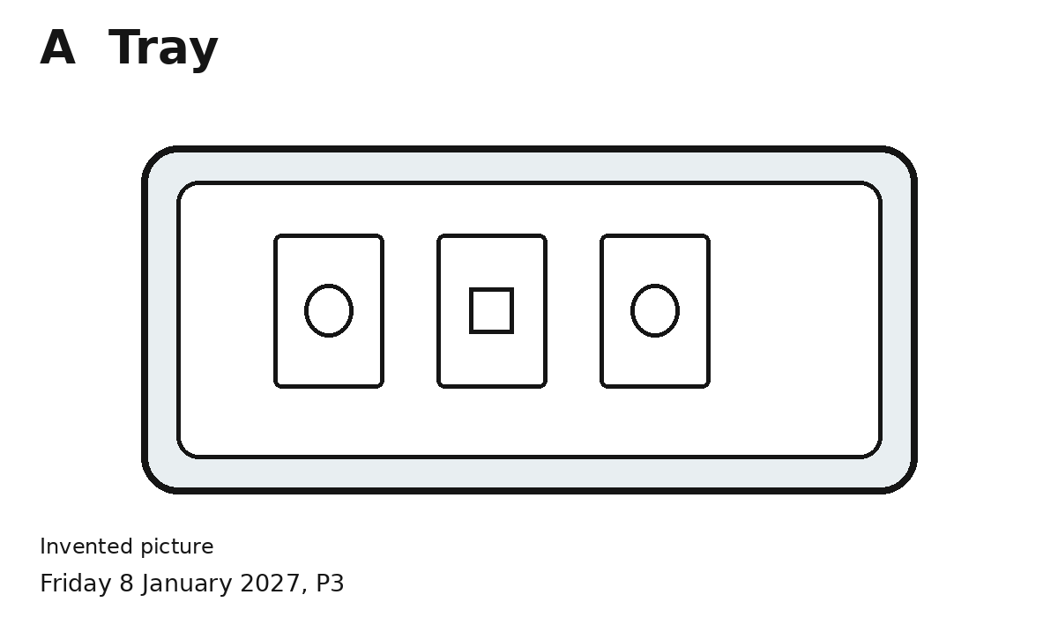
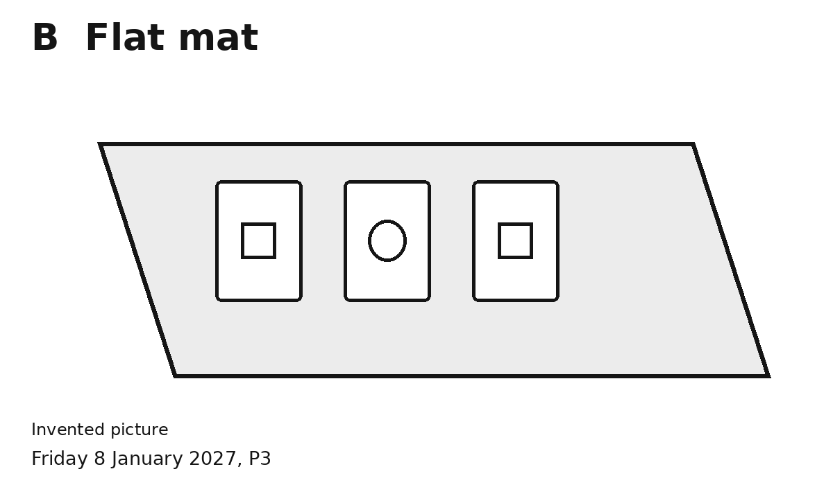
Pick A or B.
I chose ... because ...
You can give your own reason.

What comes first
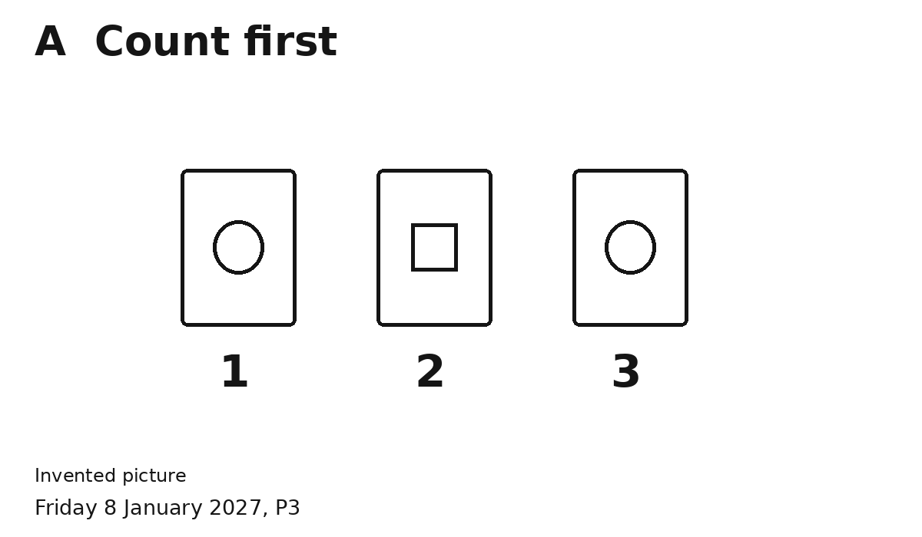
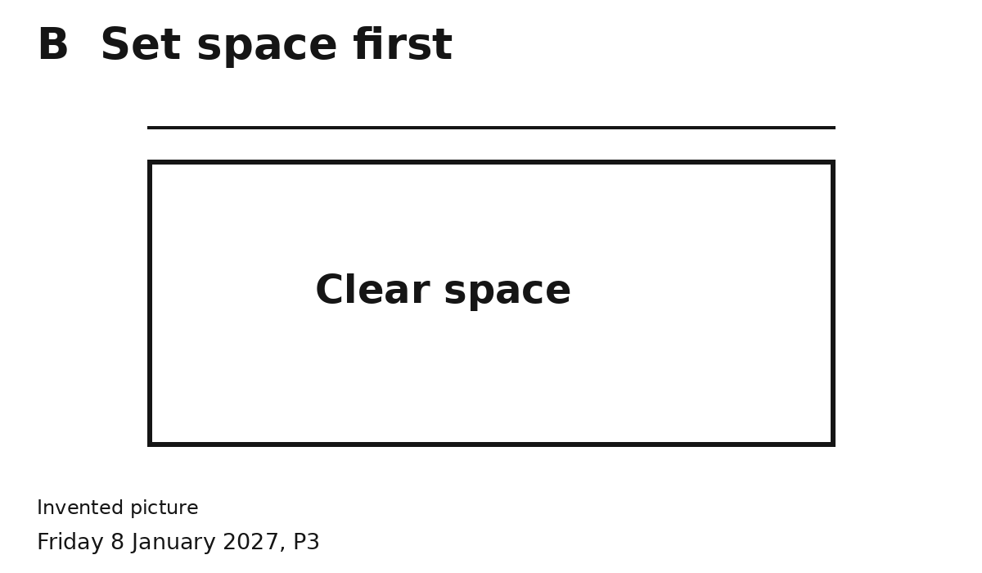
Pick A or B.
I chose ... because ...
You can give your own reason.

