My work choice
Pink Supported sheet
Make a choice and say why.
We help in a small packing room. It is made up.
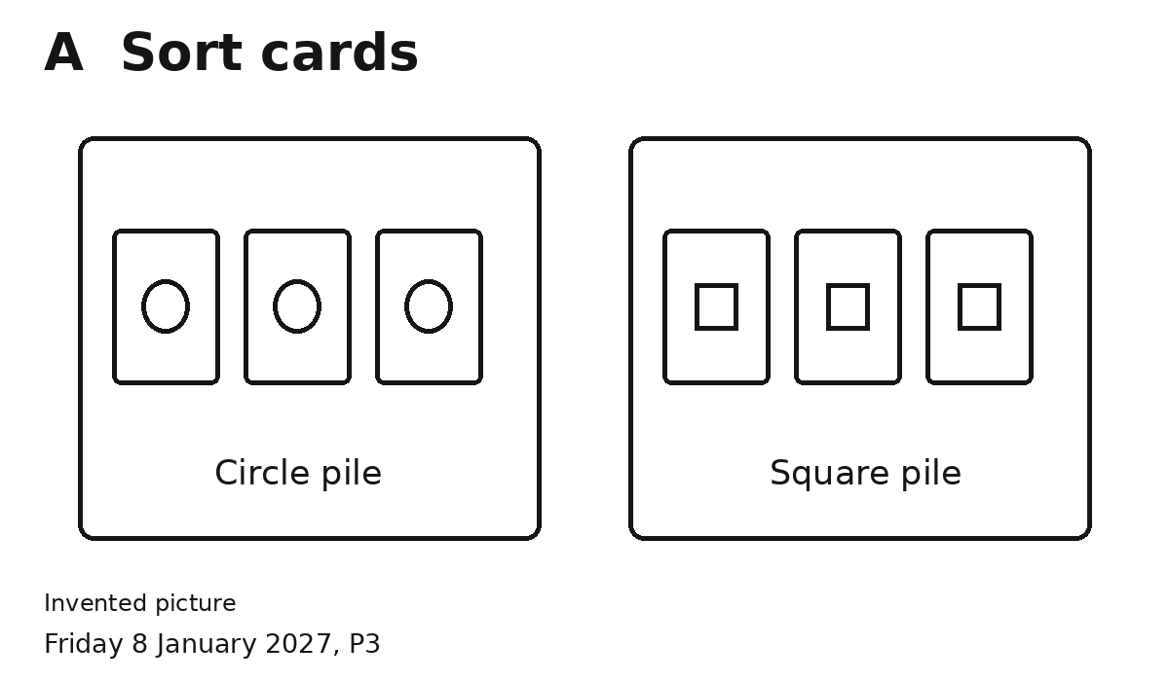
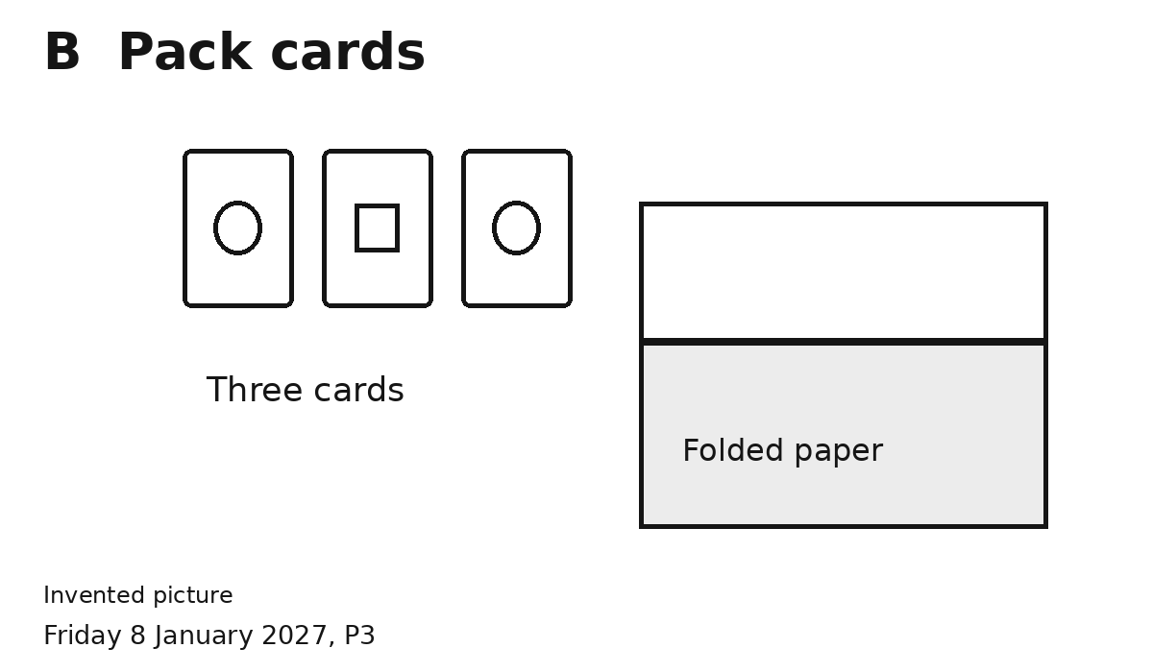
1 Pick one.
2 Tell or show why.
Try your job with an adult.
I chose ... because ...
You can point or speak. You can ask for help.

