My work choice
White Standard sheet
Make a choice and say why.
We help in a small packing room. It is made up.
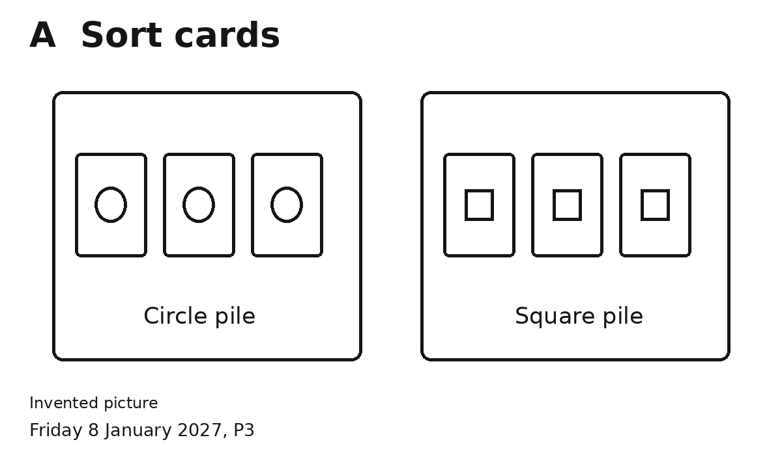
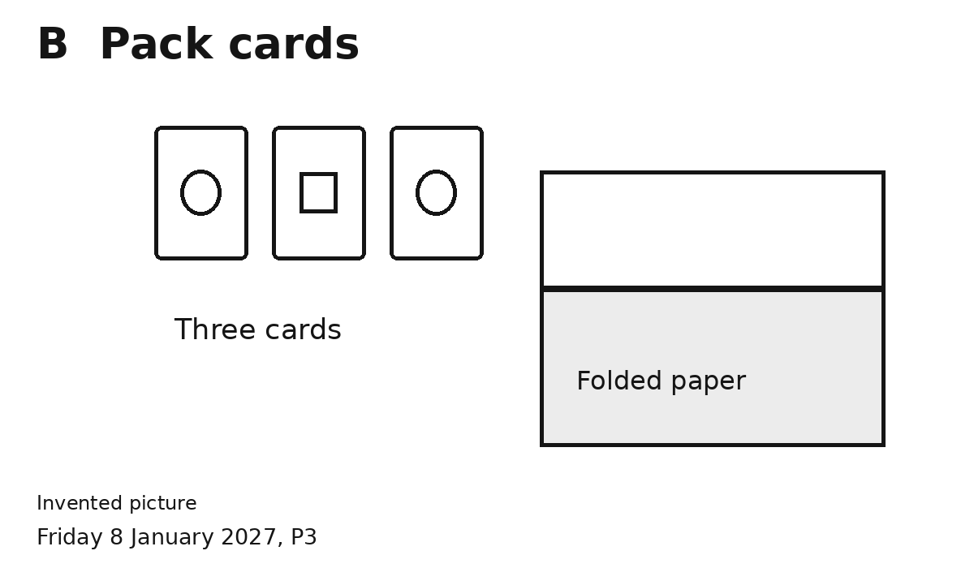
1 Pick a job.
2 Pick a tool. Pick what to do first.
3 Try the job. Use the job card.
4 Say or show why you chose it.
I chose ... because ...
You can point or speak. You can ask for help.

