Who does what
White Standard sheet
Work with a partner to complete a task.
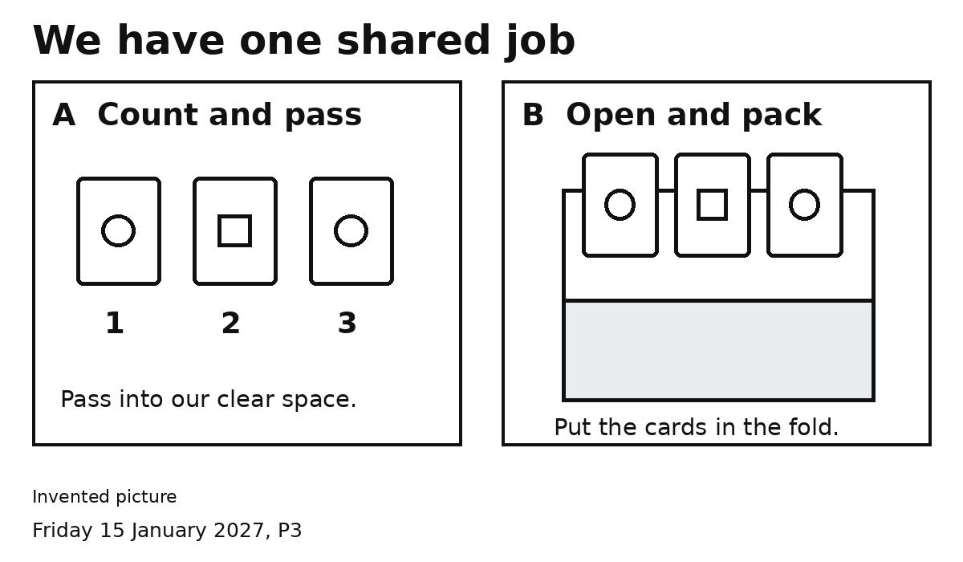

A Count and pass
Count three cards. Put them where B can reach.

B Open and pack
Open the fold. Put the three cards in.

Both Check together
Open it. Count three. Close it.
Agree who will do A and who will do B.

