Our shared packing task
Pink Supported sheet
Work with a partner to complete a task.
We help in a small packing room. It is made up.
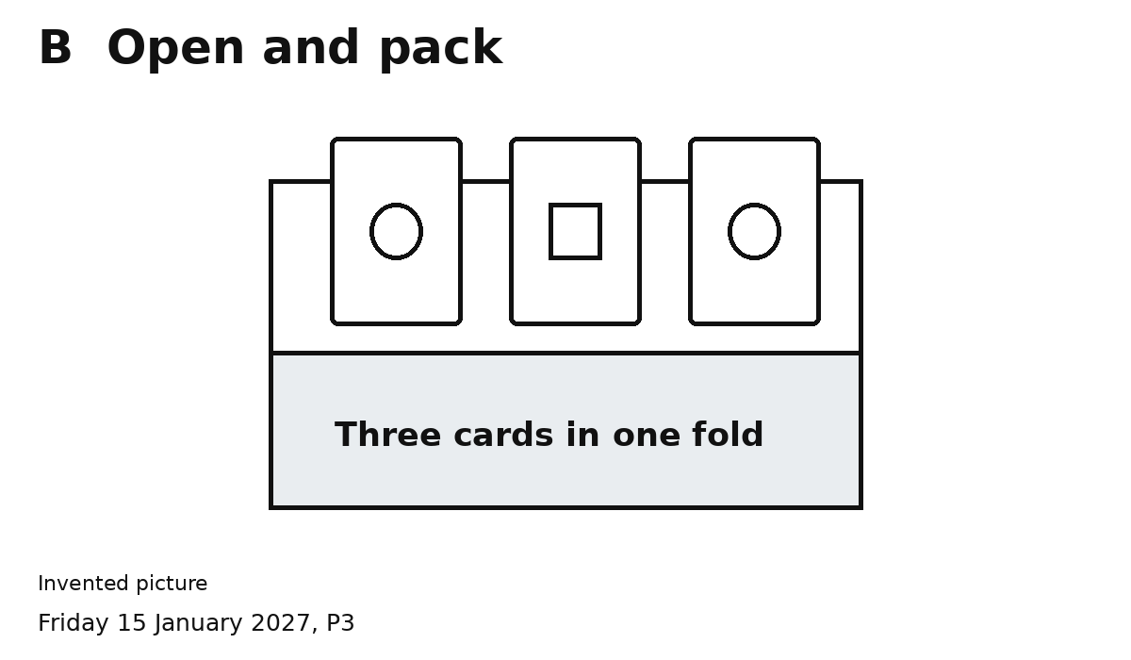
Our job is one pack with three cards.
1 Do your part with your partner.
2 Check three cards together.
We did it together when ...
You can point or speak. Ask for help if you need it.

