Our shared packer job
White Standard sheet
Take turns and share a role.
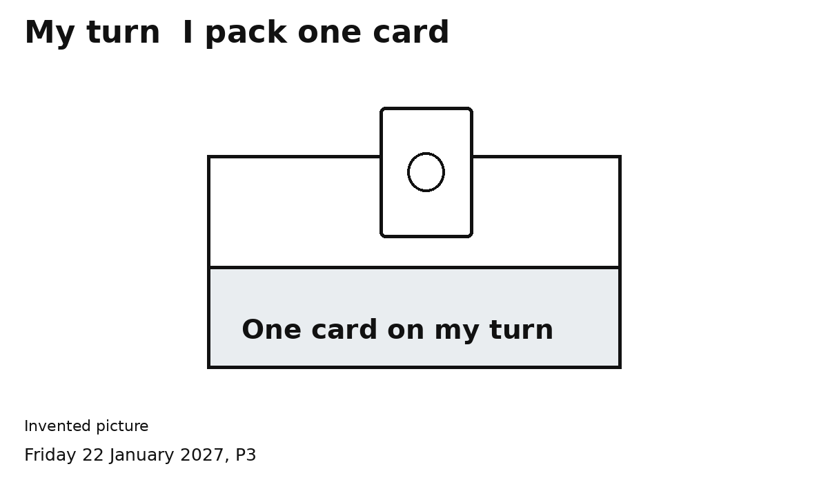
One role. Two turns. Two cards.
1 Show who has the first turn.
2 That person packs one card.
3 Show SWAP. The other person packs one.
4 Open the pack. Check two cards. Close it.
Keep hands clear for the swap.

