Our visible turn cards
Pink Supported sheet
Take turns and share a role.
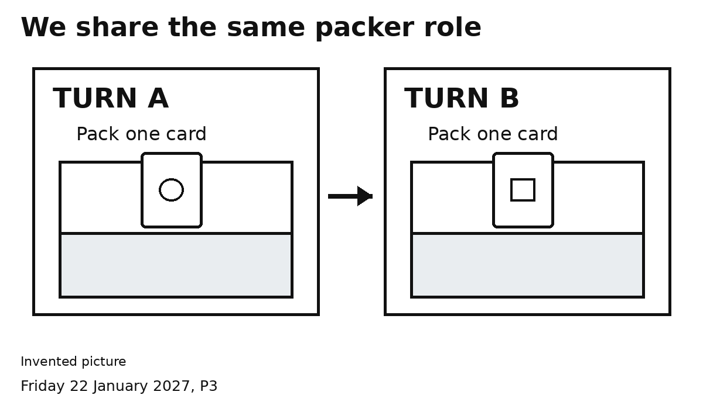

A TURN
A packs one card. B waits.

B TURN
B packs one card. A waits.
Point to A or B to show the turn.
We share the same packer job.

Our swap signal

SWAP
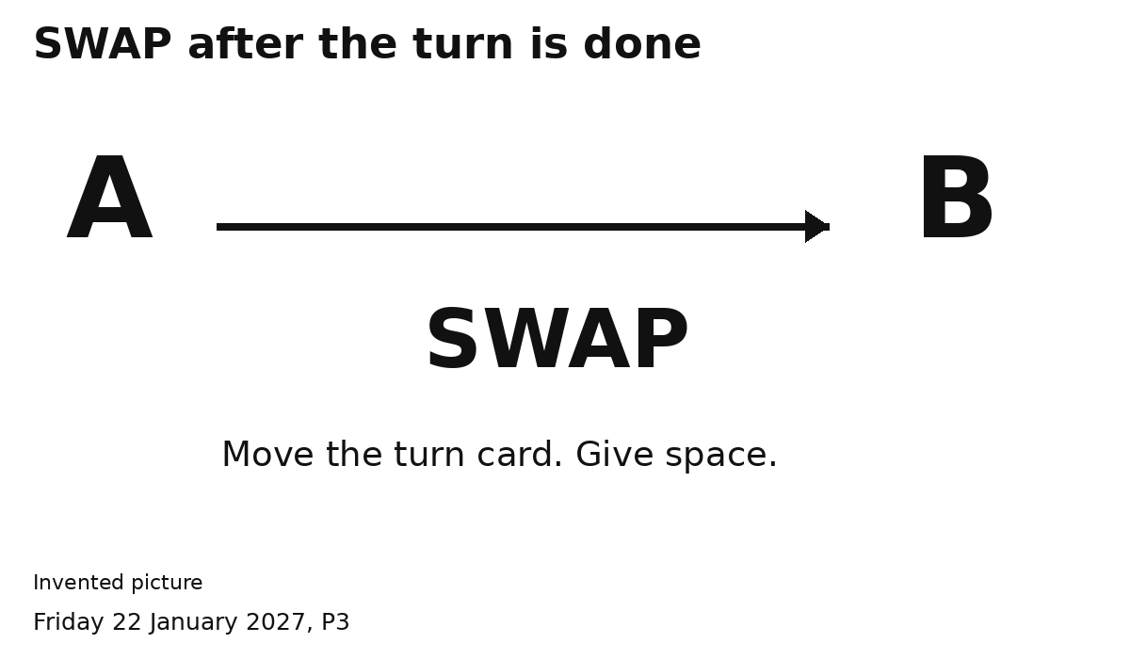
1 Finish one card. Hands clear.
2 Show SWAP. Point to the next turn.
My turn. Your turn.

