Our turn taking task
White Standard sheet
Take turns and share a role.
We help in a small packing room. It is made up.
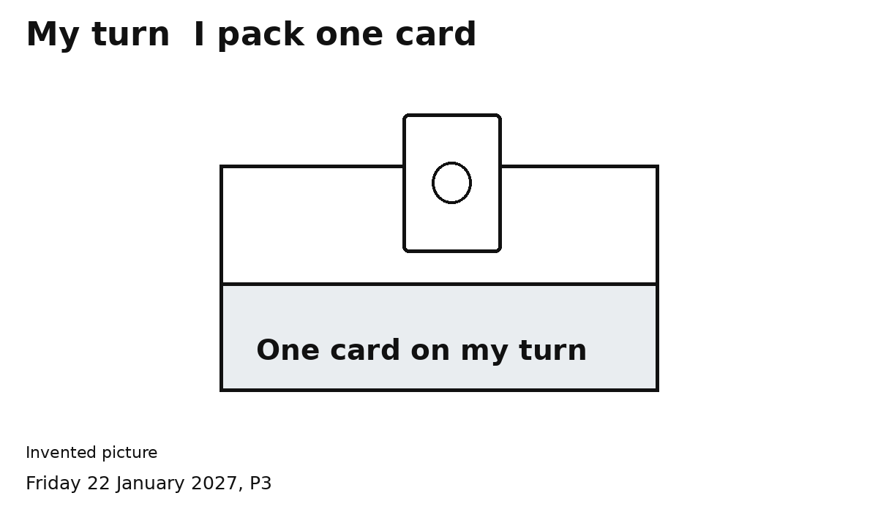
We both do the packer job.
1 Agree who goes first. Show the turn card.
2 Pack one card on your turn.
3 Show SWAP. Let your partner pack one.
4 Check two cards in the pack together.
My turn. Your turn.
You can point or speak. Ask for help.

