Choose and try a safe step
Pink Supported sheet
Solve a simple everyday problem.
My problem: Missing card / Spill / Waiting
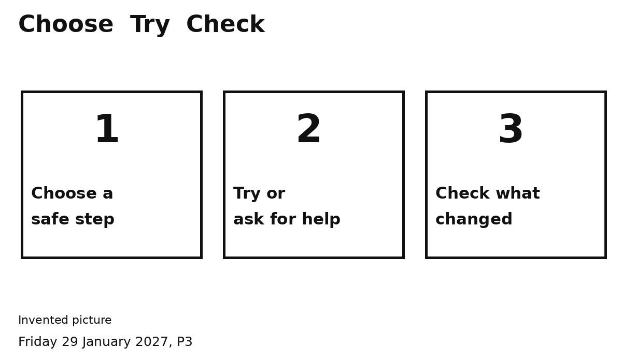
My safe step ...
________________________________
I can ask an adult for help.
What I did ...
________________________________
Did it work ... Yes / Not yet
Point, say it or ask an adult to write.

