Choose and try a safe step
White Standard sheet
Solve a simple everyday problem.
My problem: Missing card / Spill / Waiting
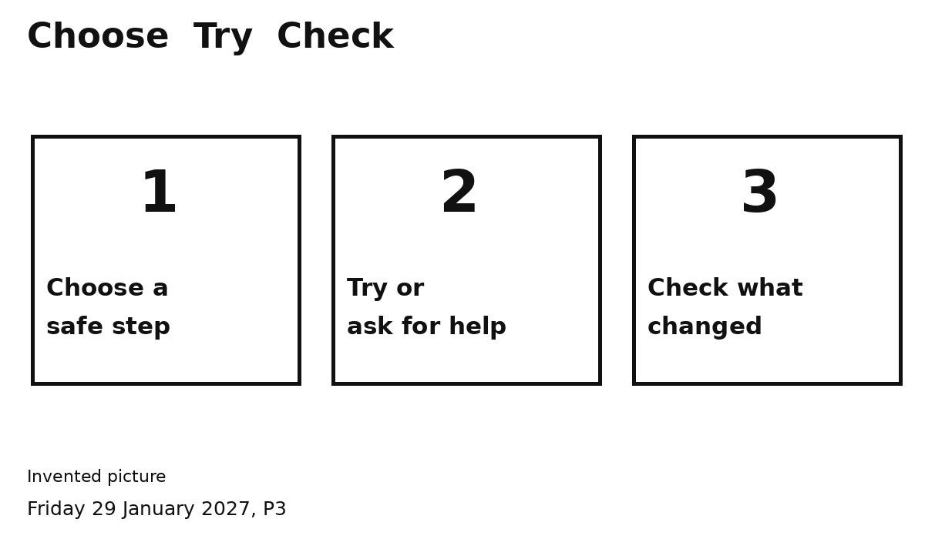
My safe step ...
________________________________
I can check the tray, tell an adult or ask for help.
What I did ...
________________________________
Did it work ... Yes / Not yet
Point, say it or ask an adult to write.

