Our problem solving job card
Pink Supported sheet
Solve a simple everyday problem.
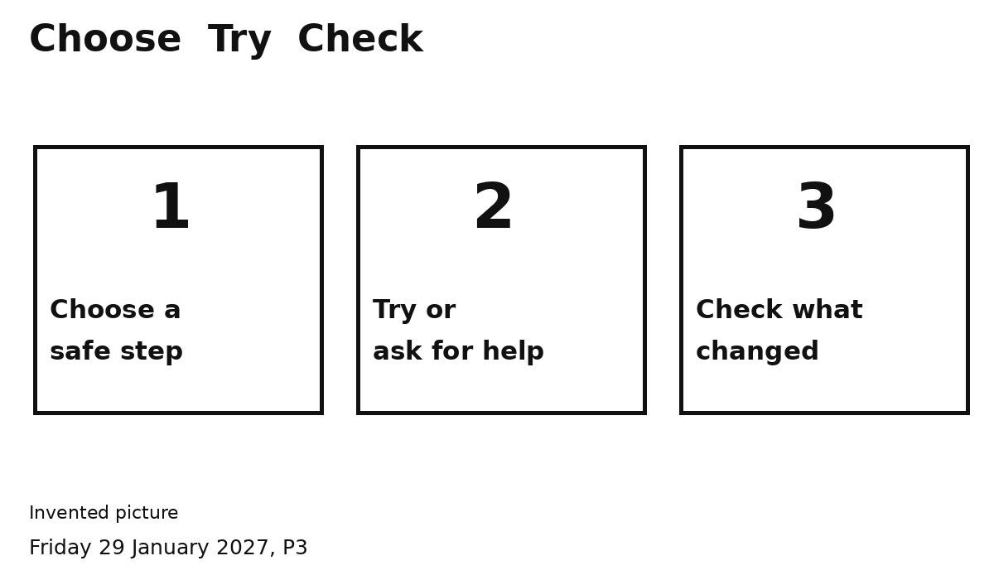
1 Pick a safe step.
2 Try it and check.
For a spill: STOP. Stay back. Tell an adult.
The adult deals with the spill.

