Our everyday problem task
Pink Supported sheet
Solve a simple everyday problem.
We help in a small packing room. It is made up.
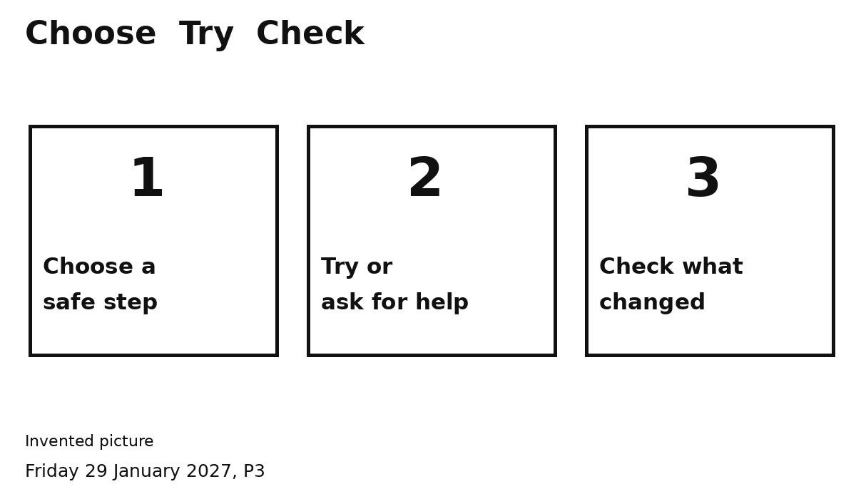
Pick one problem to try.
1 Pick a safe step.
2 Try it and check.
Asking an adult can help solve it.
You can point or speak. Ask for help.

