My partner checker card
Pink Supported sheet
Follow instructions in a practical task.
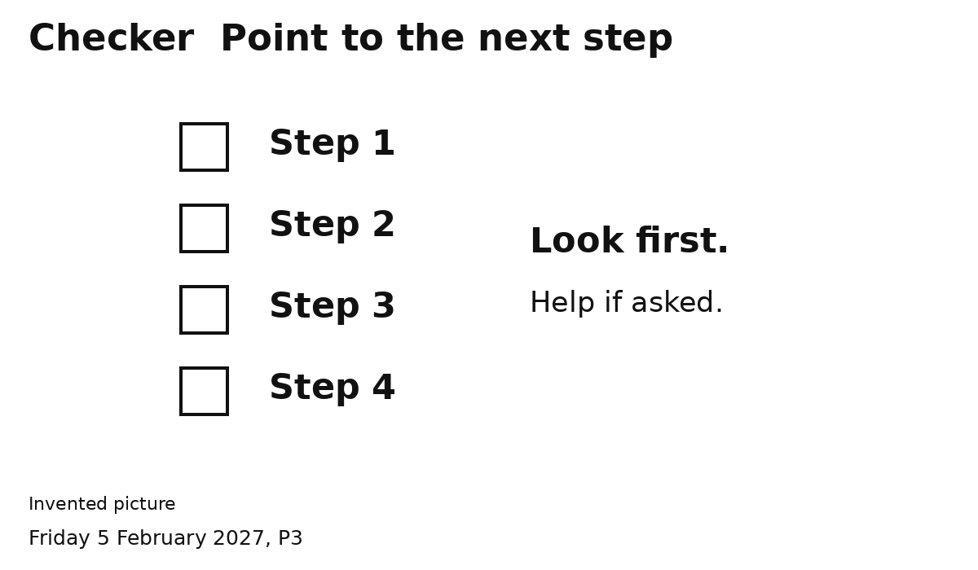
1 Point to this step. Wait.
2 Help if asked. Show the next step.
Let your partner do the job.
Ask an adult if you need help.

