My partner checker card
White Standard sheet
Follow instructions in a practical task.
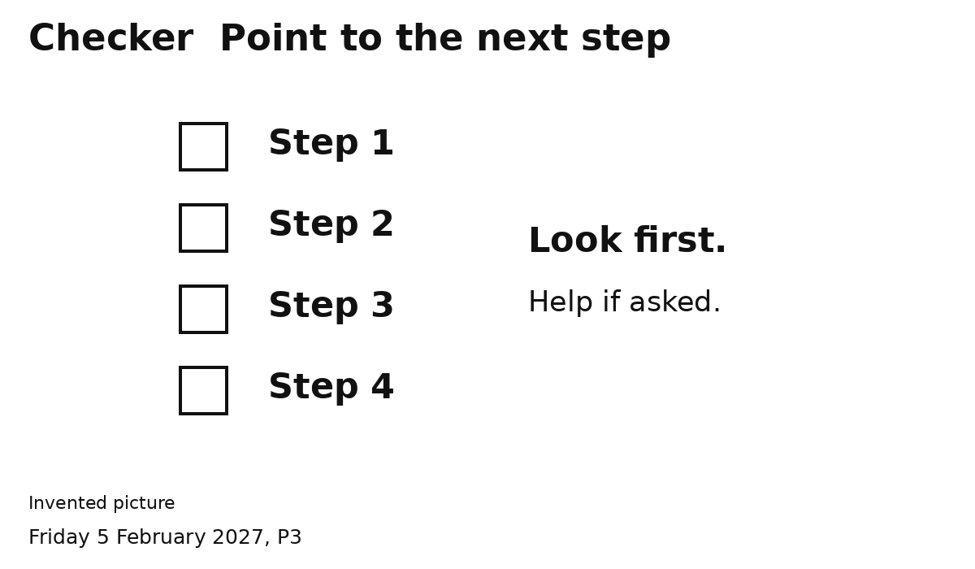
1 Point to the step your partner is on.
2 Wait while your partner does it.
3 Help if your partner asks.
4 Point to the next step when ready.
Let your partner do the job.
Ask an adult if you need help.

