My self check
Pink Supported sheet
Follow instructions in a practical task.
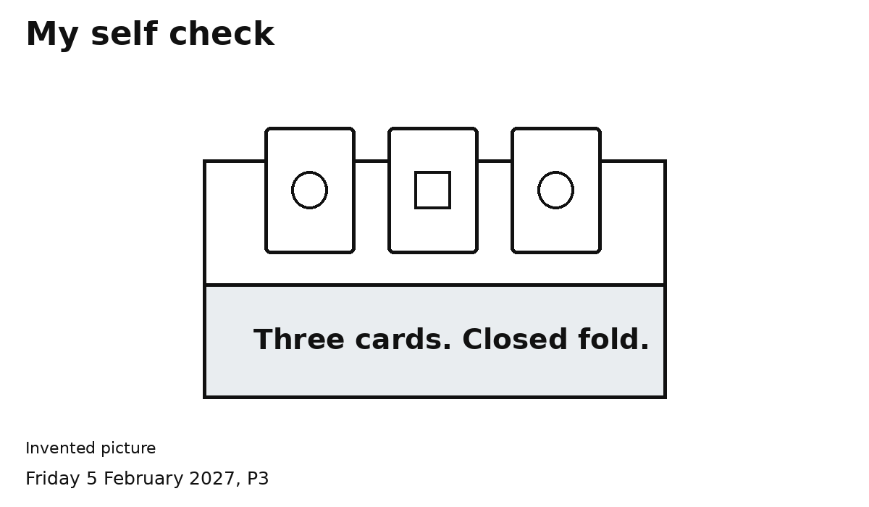
Three cards inside.
Point or tick: Yes / Not yet
Fold closed.
Point or tick: Yes / Not yet
I checked my work.
Point or tick: Yes / Not yet
Ask for help with a step if needed.

