My four step packing task
Pink Supported sheet
Follow instructions in a practical task.
We help in a small packing room. It is made up.
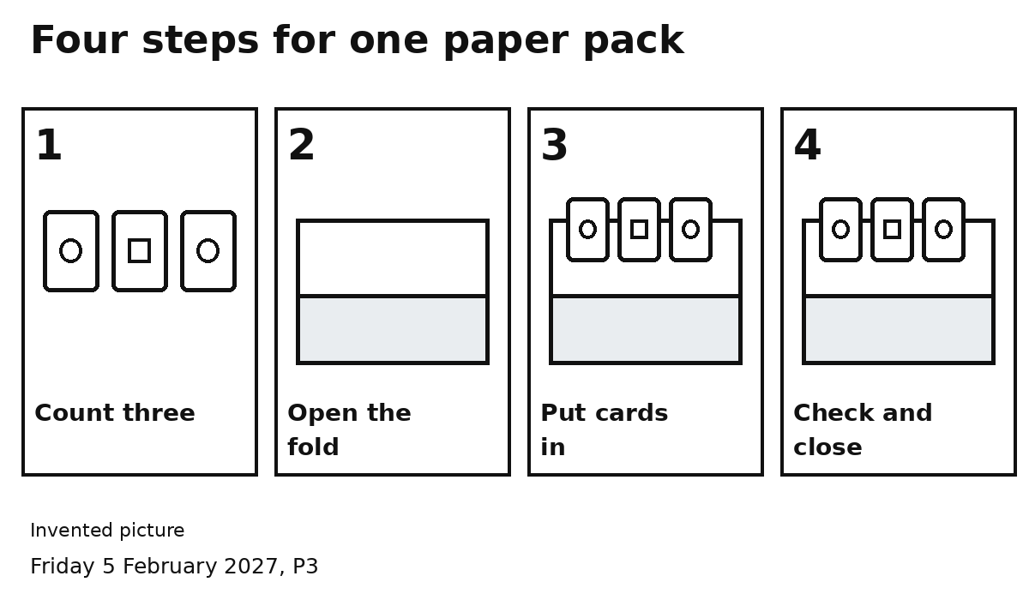

Steps 1 and 2
Count three cards. Open the fold.

Steps 3 and 4
Put three cards in. Check three. Close the fold.
Do one step at a time, in order.
You can point or ask for help.

