Our reflection job card
Pink Supported sheet
Reflect on how our team worked.
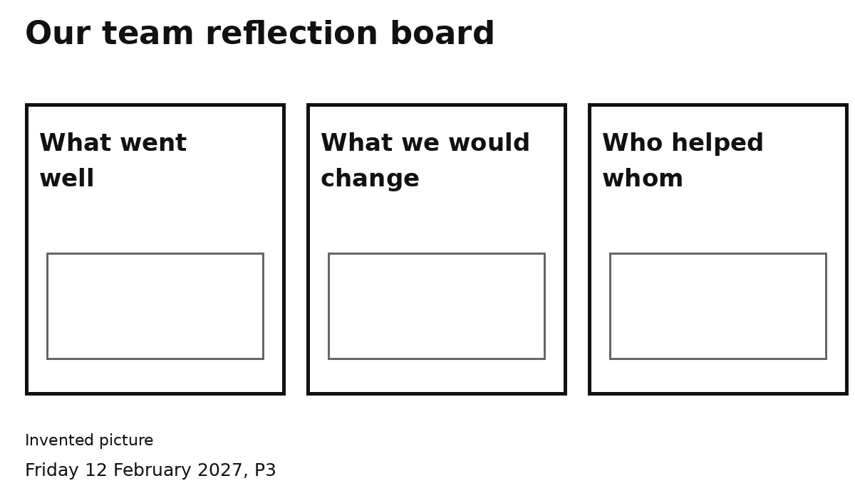
1 Pick a heading.
2 Show or tell one idea.
We can look at a paper pack to help us think.
One idea is enough. Ask for help if needed.

