Our reflection job card
White Standard sheet
Reflect on how our team worked.
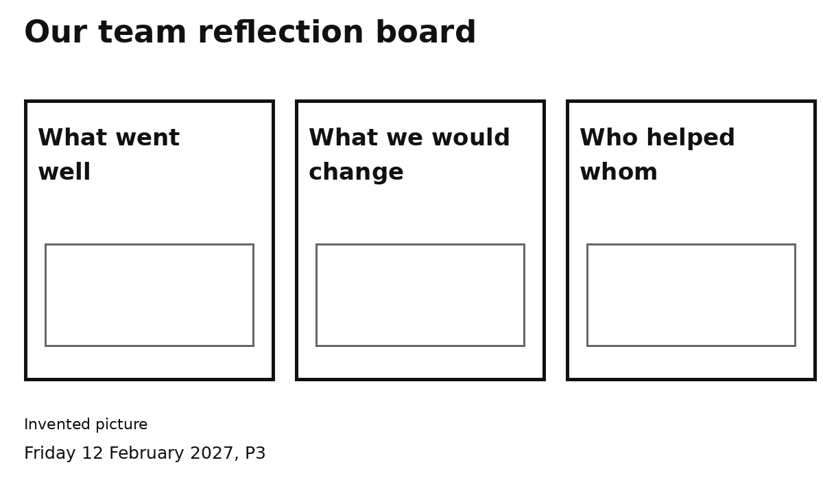
1 Think about our shared job.
2 Pick one board heading.
3 Show an idea that fits our team.
4 Say or show one reflection.
We can look at a paper pack to help us think.
One idea is enough. Ask for help if needed.

