Reflection idea cards
Pink Supported sheet
Reflect on how our team worked.

Example of what went well
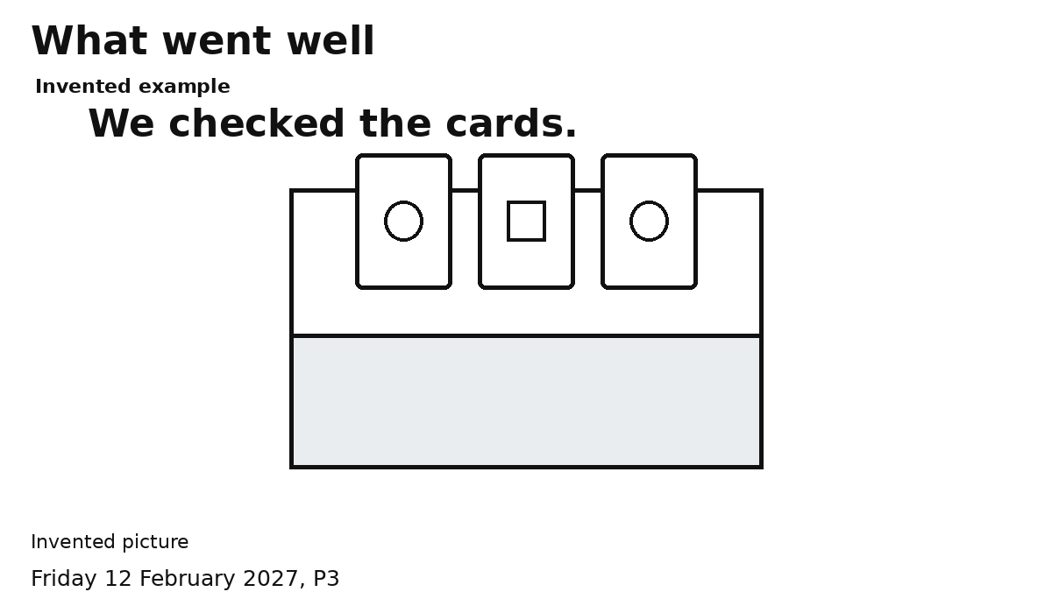
Invented example
We checked the cards.
Use this idea only if it fits our team.
My own idea is fine too.
Our team ...
________________________________
Point, say it or ask an adult to write.

Example of what we would change
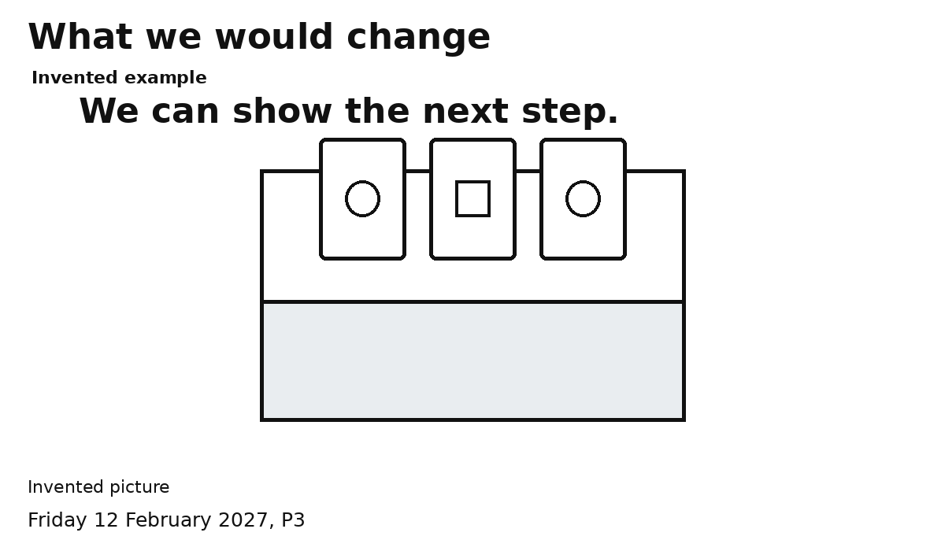
Invented example
Next time I can show the next step.
Use this idea only if it fits our team.
My own idea is fine too.
Next time ...
________________________________
Point, say it or ask an adult to write.

Example of who helped whom
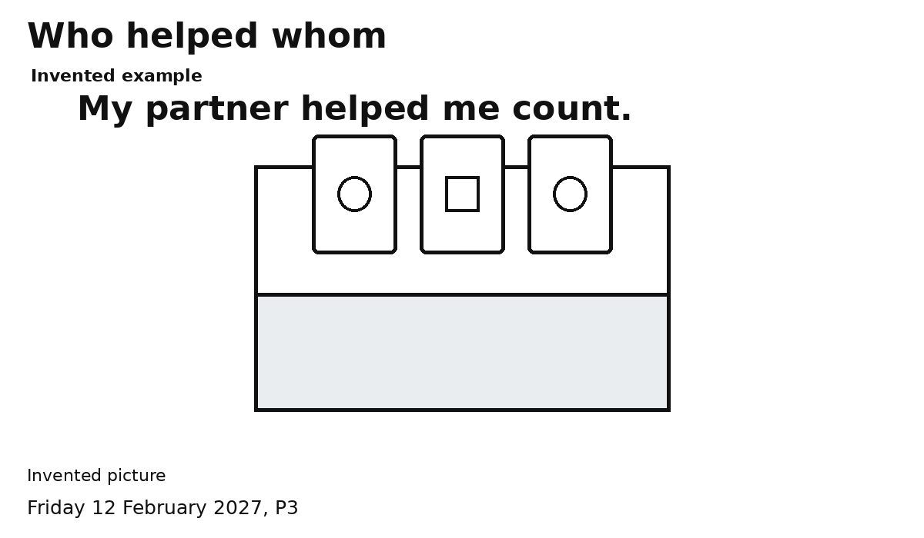
Invented example
My partner helped me count.
Use this idea only if it fits our team.
My own idea is fine too.
Our team ...
________________________________
Point, say it or ask an adult to write.

