1. Install Anaconda3
2. Open Anaconda navigator and create new environment for python 3.6

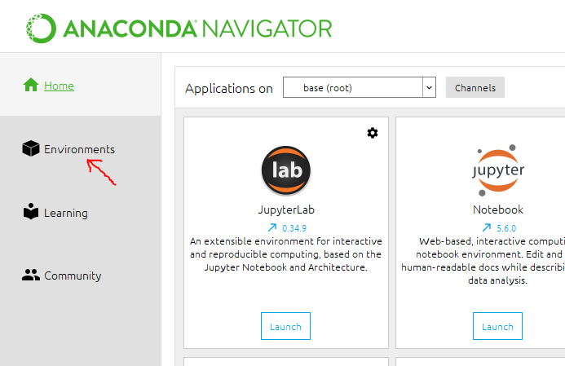

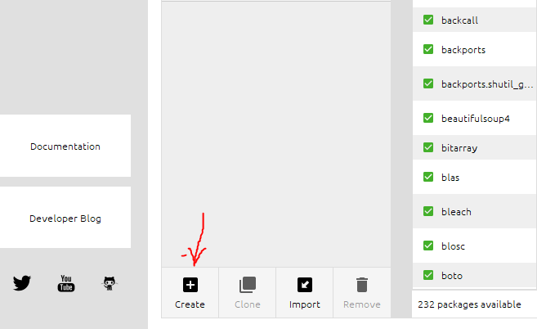

1. Provide the name for new environment and select Python version 3.6. Also note the location of the environment as marked in yellow, we will need this location for pycharm project interpreter settings.

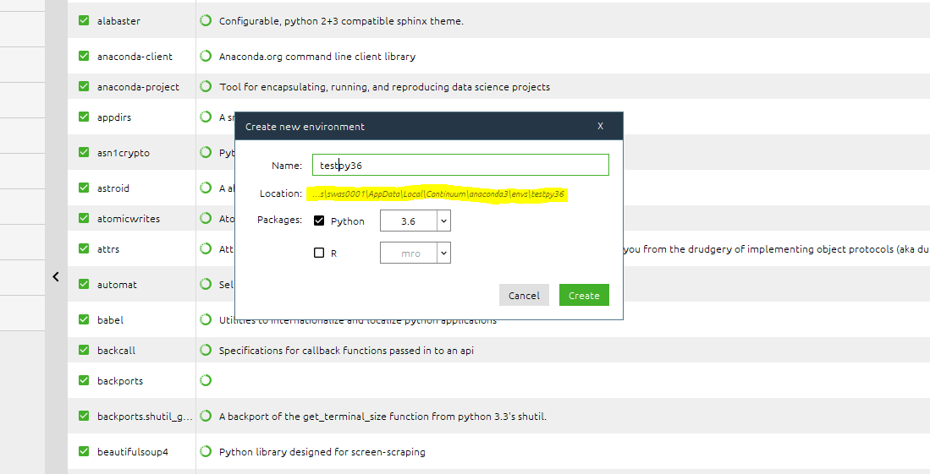

1. In Pycharm create a new project after fetching the code from github. Edit the Project interpreter location ( from the previous step) for the existing environment tab.

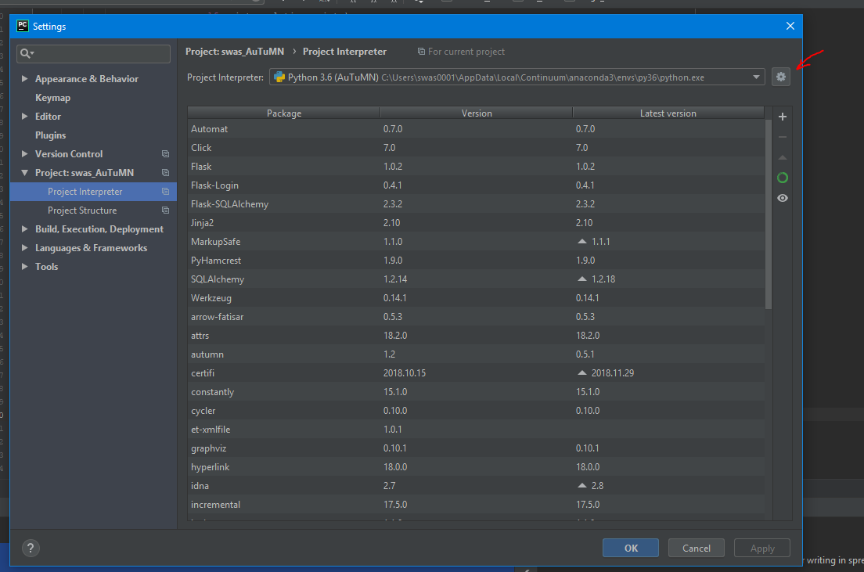

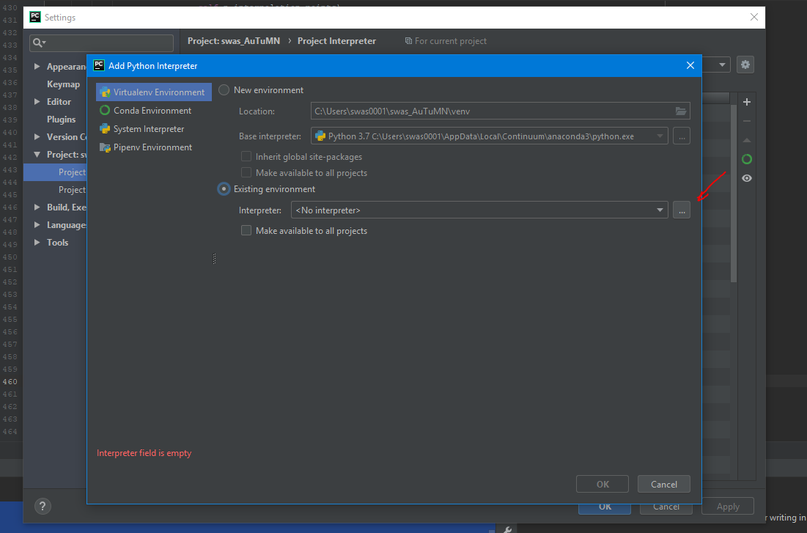

1. Select setup.py and then from Tools tab ‘Run Setup.py task’

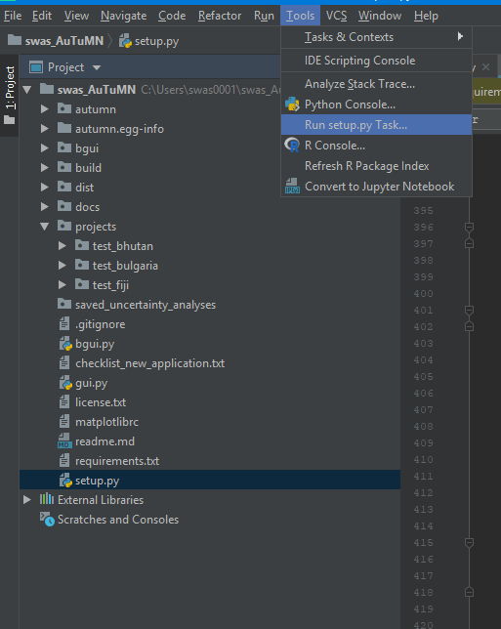

1. A new window with options for setup.py will open. Select the install option

