Internet
- The Internet is a global network of interconnected computer networks that use the Internet Protocol Suite (TCP/IP) to communicate.
- It enables the exchange of data, information, and services across the world, connecting billions of devices and users.
- The Internet has revolutionized communication, commerce, education, and entertainment, becoming an integral part of modern society.
- It supports various applications and services, from web browsing and instant messaging to streaming media and online gaming.
- While offering unprecedented access to information and connectivity, the Internet also raises concerns about privacy, security, and digital divide issues.

How does the internet work?
- The Internet works through a global network of interconnected computers and servers, communicating via standardized protocols
- Data is broken into packets and routed through various network nodes using the Internet Protocol (IP)
- These packets travel across different physical infrastructures including:
  - Fiber optic cables
  - Satellites
  - Wireless networks
- The Transmission Control Protocol (TCP) ensures reliable delivery and reassembly of packets at their destination.
- Domain Name System (DNS) servers translate human-readable website names into IP addresses.
- When you access a website, your device sends a request to the appropriate server, which responds with the requested data.
- This process, facilitated by routers, switches, and other networking equipment, enables the seamless exchange of information across vast distances, forming the backbone of our digital communications.
https://roadmap.sh/guides/what-is-internet
- Through this article and the accompanying videos, you’ll learn the basics of the Internet and how it works

Learning Objectives
- Answer the following questions:
  - What is the Internet?
  - How does the information move on the internet?
  - How do the networks talk to each other and the protocols involved?
  - What’s the relationship between packets, routers, and reliability?
  - HTTP and the HTML – How are you viewing this webpage in your browser?
  - How is the information transfer on the internet made secure?
  - What is cybersecurity and what are some common internet crimes?

What is the Internet?
- The Internet is a global network of computers connected to each other which communicate through a standardized set of protocols
- In the early 1970s Vint Cerf and Bob Kahn began working on the design of what we now call the internet.
  - It was the result of another experiment of what we now call the ARPANET (Advanced Research Projects Agency Network)
  - DoD research project
  - Paul Baran
    - Computer network pioneer
    - Was trying to figure out how to build a communications system that might survive a nuclear attack
    - So, he had the idea of breaking messages up into blocks and sending them as fast as possible in every possible direction through a mesh network
    - 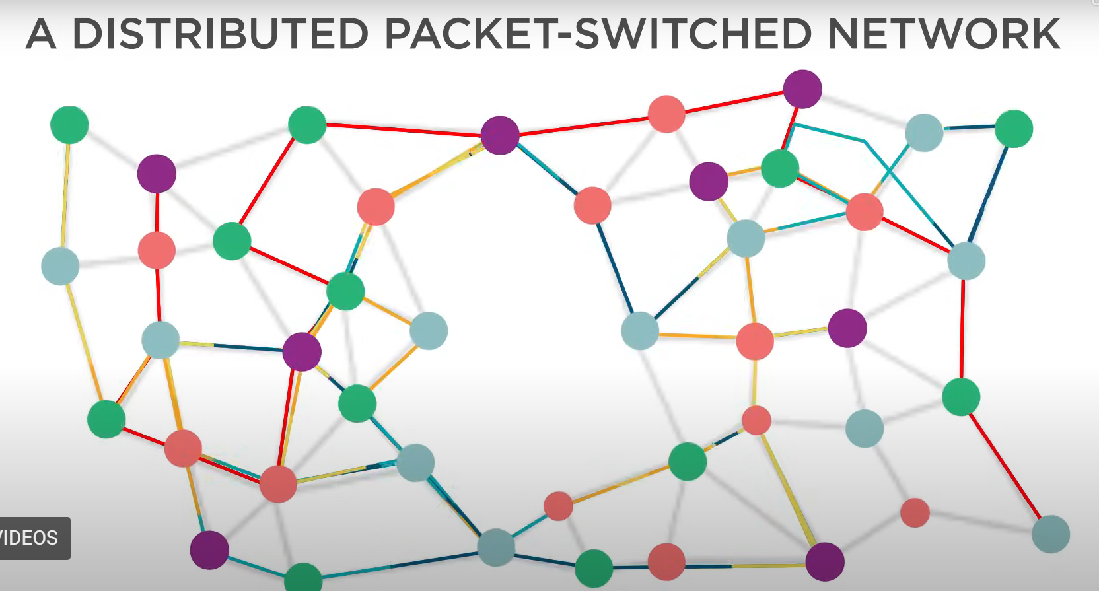
    - This eventually became a nation-wide experimental packet network
- Who controls the internet?
  - Made up a large number of independently operated networks
  - The system is fully distributed
    - There’s no central control that’s deciding how packets are routed
  - Decisions are made independently by the operators..
    - They are all motivated to assure that there is end to end connectivity of every part in the network.
    - 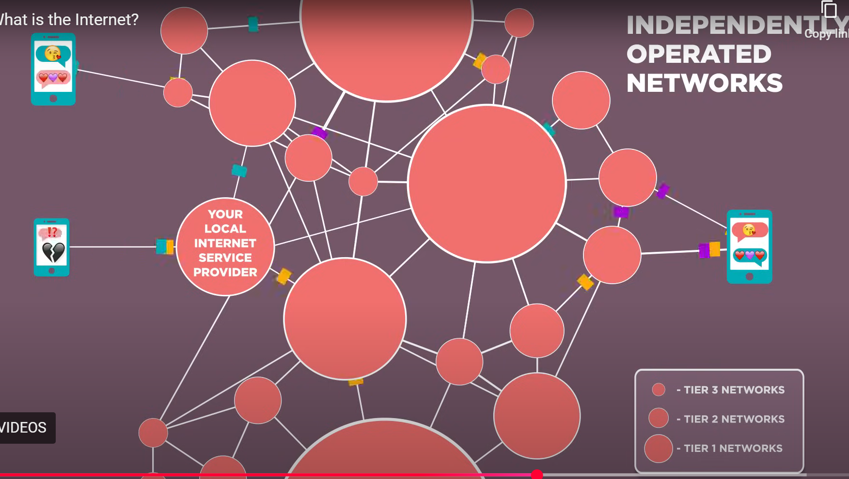
      - Any device can communicate with any other device in the network, just like you want to be able to make phone calls to any other telephone in the world.
  - The idea that you know something that might be useful to somebody else or vice versa, is a very powerful motivator for sharing information.
- Opportunity to
  - Think of new applications
    - Maybe program them as apps on a mobile phone
  - Maybe become part of the continued growth of the infrastructure of the network to bring it to people that don’t have access to it!
  - Or just make use of it on a day to day basis..
- You can’t escape from contact with the internet, so why not get to know it, and use it!

Wires, Cables, and Wi-Fi
- Information on the Internet moves from one computer to another in the form of bits over various mediums, including:
  - Ethernet cables, fiber optic cables, and wireless signals (i.e., radio waves)
- https://www.youtube.com/watch?v=ZhEf7e4kopM
  - Tess Winlock
    - SWE @ Google
  - How does a picture, text message or email get sent from one place to another?
    - The internet
      - A tangible physical system that was made to move information
  - The internet is a lot like the postal service except the internet ships binary information
    - 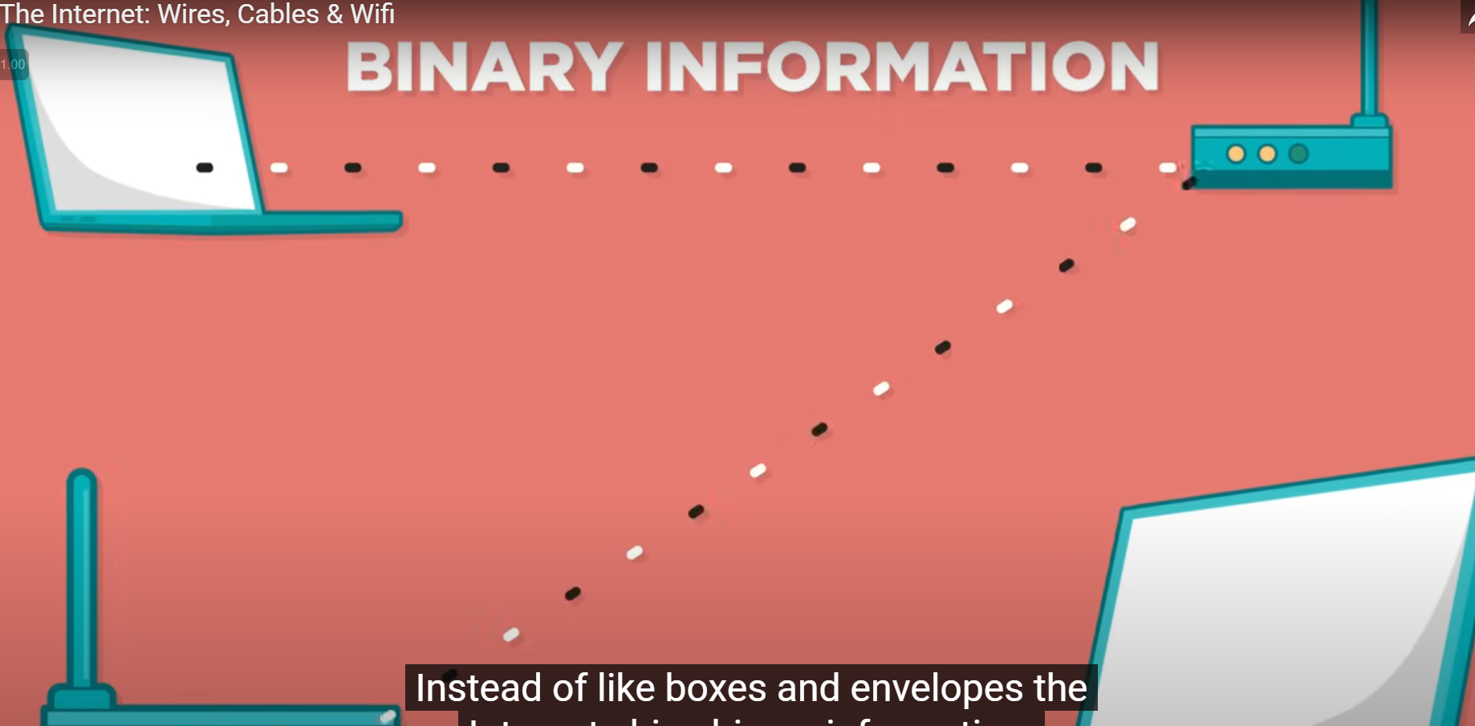
  - Information is made of bits
    - Bit
      - Any pair of opposites
        - “On” or “Off”
        - “Yes” or “No”
      - We typically use a 1 meaning “on” or a zero meaning “off”
    - Because a bit has two possible states, we call it binary code.
    - 8 Bits == 1 Byte
    - 1024 Bytes == 1 Kilobyte
    - 1024 Kilobytes == 1 Megabyte
    - A song is typically encoded using about 3-4 megabytes
    - It doesn’t matter if it’s a picture, a video or a song.. everything on the Internet is represented and sent around as bits.
    - These are the Atoms of Information
  - What is the physical stuff that actually gets sent over the wires and the airwaves?
    - Let’s look at a small example of how humans can physically communicate to send a single bit of information from one place to another.
      - So say we could turn on a light for a 1 or off for 0.
      - Or use beeps or similar sort of things suchas Morse code..
      - These methods work but they’re really slow, error-prone and totally dependent upon humans.
        - What we really need is a machine!
    - So throughout history we’ve build many systems that can actually send this binary information through different types of physical mediums.
      - 
    - Today we physically send bits by electricity, light, and radio waves
    - To send a bit via electricity
      - Imagine that you have two light bulbs connected by a copper wire
      - If one device operator turns on the electricity then the light bulb lights up.
        - No electricity, no light
      - If the operators on both ends agree that light on means one and light off means zero, then we have a system for sending bits of information from one person to another using electricity.
        - 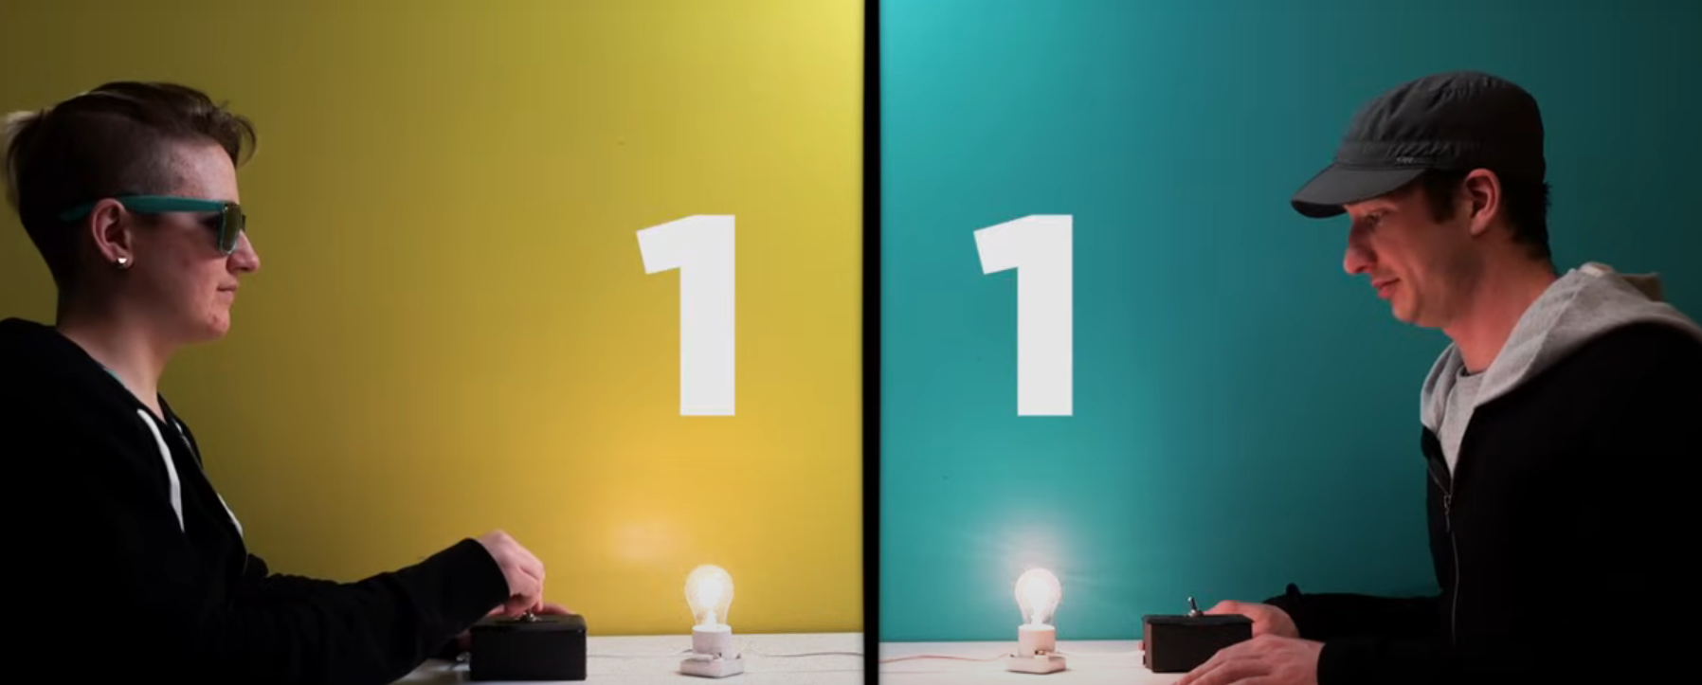
      - But we have a problem, let’s say that we want to send five zeros in a row.
        - Well how can you do that in such a way that either person can actually count the number of zeros?
          - The solution is to introduce a clock or a timer.
            - The operators can agree that the sender will send one bit per second
            - The receiver will sit down and record every single second and see what’s on the line.
            - To send five zeros in a row, you just turn off the light, wait five seconds, the person on the other end of the line will write down all five seconds (0 0 0 0 0)
            - And for ones, do the opposite – turn on the light
          - Obviously we’d like to send things a little bit faster than one bit per second!
            - So we need to increase our bandwidth
    - Bandwidth
      - is the maximum transmission capacity of a device
      - Measured by Bit Rate:
        - The number of bits that we can send over a given period of time, usually measured in seconds.
    - Latency
      - The amount of time it takes for one bit to travel from one place to another
  - In our human analogy one bit per second was pretty fast, but kind of hard for a human to keep up with..
    - So let’s say that you want to download a 3 megabyte song in 3 seconds:
      - At 8 million bits per megabyte, 3 MB == 24 million Bits
      - Bitrate ~= 8 million Bits / second
      - Obviously humans can’t send or receive 8 million bits per second, but a machine can do that just fine.
  - But now there’s also the question of what sort of cable to send these messages over, and how far the signals can go?
    - With an Ethernet wire, the kind that you find in your home or office or school
      - You see really measurable signal loss over just a few hundred feet
    - So if we really want this Internet thing to work over the entire world, we need a different way of sending this information really long distances (like across an ocean)
    - So what else can we use?
      - What do we know that is faster than electricity through a wire?
        - Light
    - We can send bits as light beams from one place to another using a fiber optic cable
      - 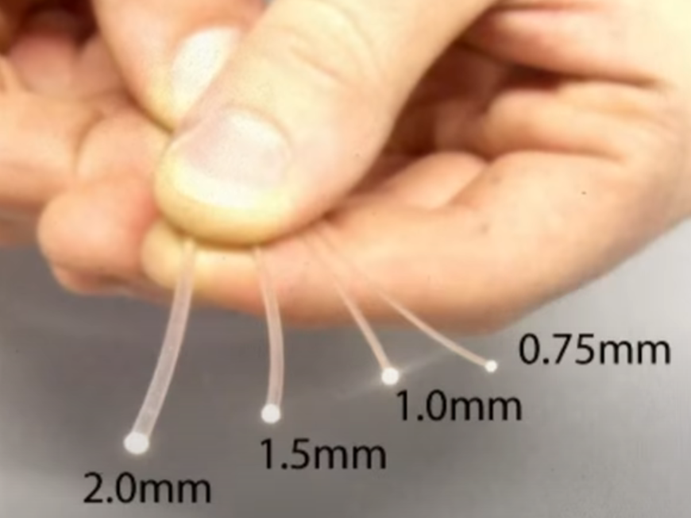
      - 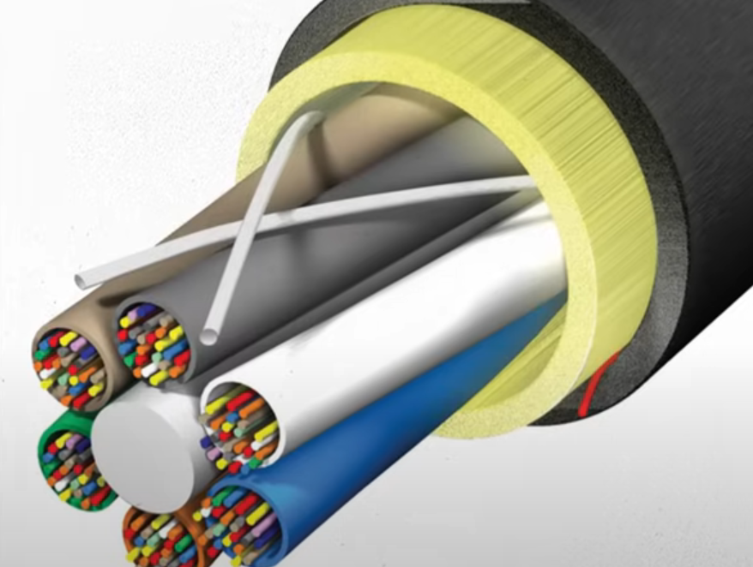
  - Fiber Optic Cable
    - A thread of glass engineered to reflect light
    - 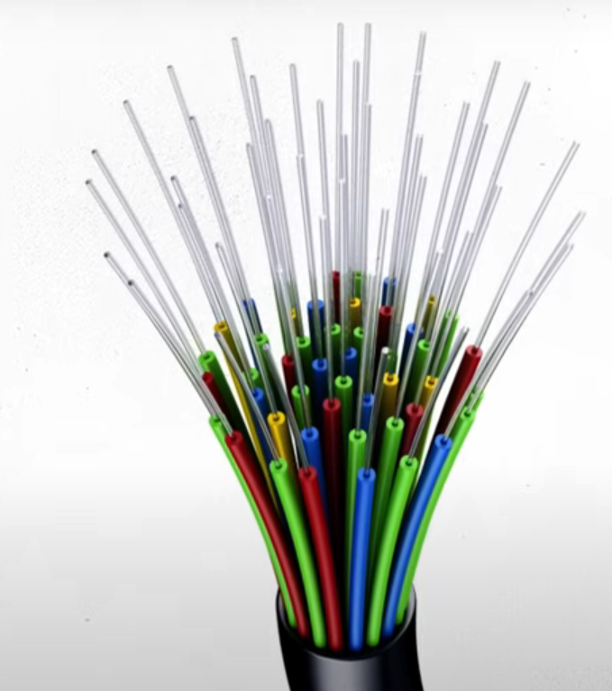
    - When you send a beam of light down the cable
      - Light bounces up and down the length of the cable until it is received on the other end.
    - Depending on the bounce angle, we can send multiple bits simultaneously
      - 
    - So Fiber is really fast!
    - But more importantly, the signal doesn’t really degrade over long distances!
      - This is why we use fiber optic cables across the ocean floors to connect one continent to another
        - 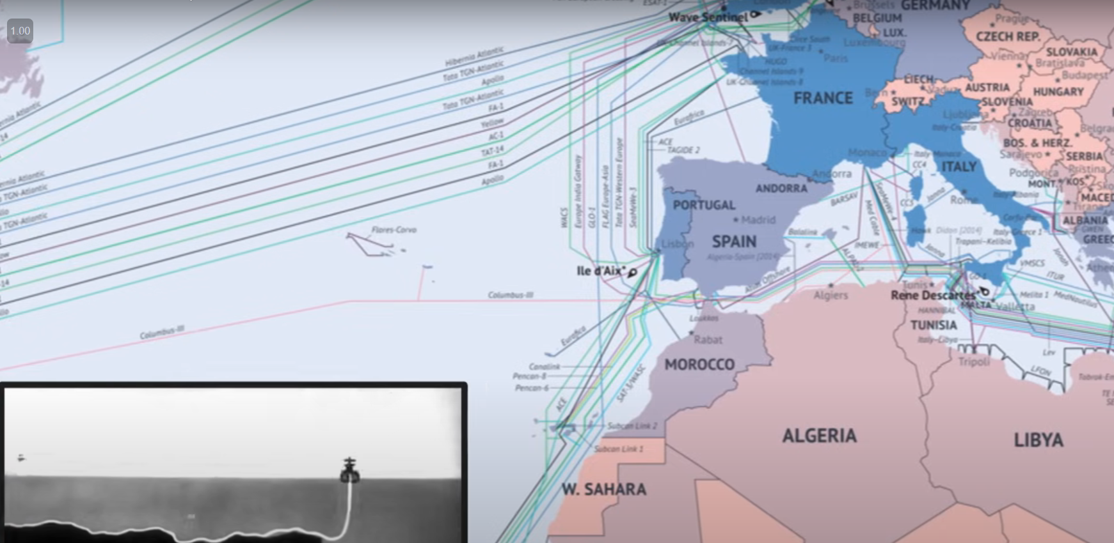
    - In 2008 there was a cable cut near Alexandria, Egypt
      - Really interrupted the Internet for most of the Middle East and India.
      - 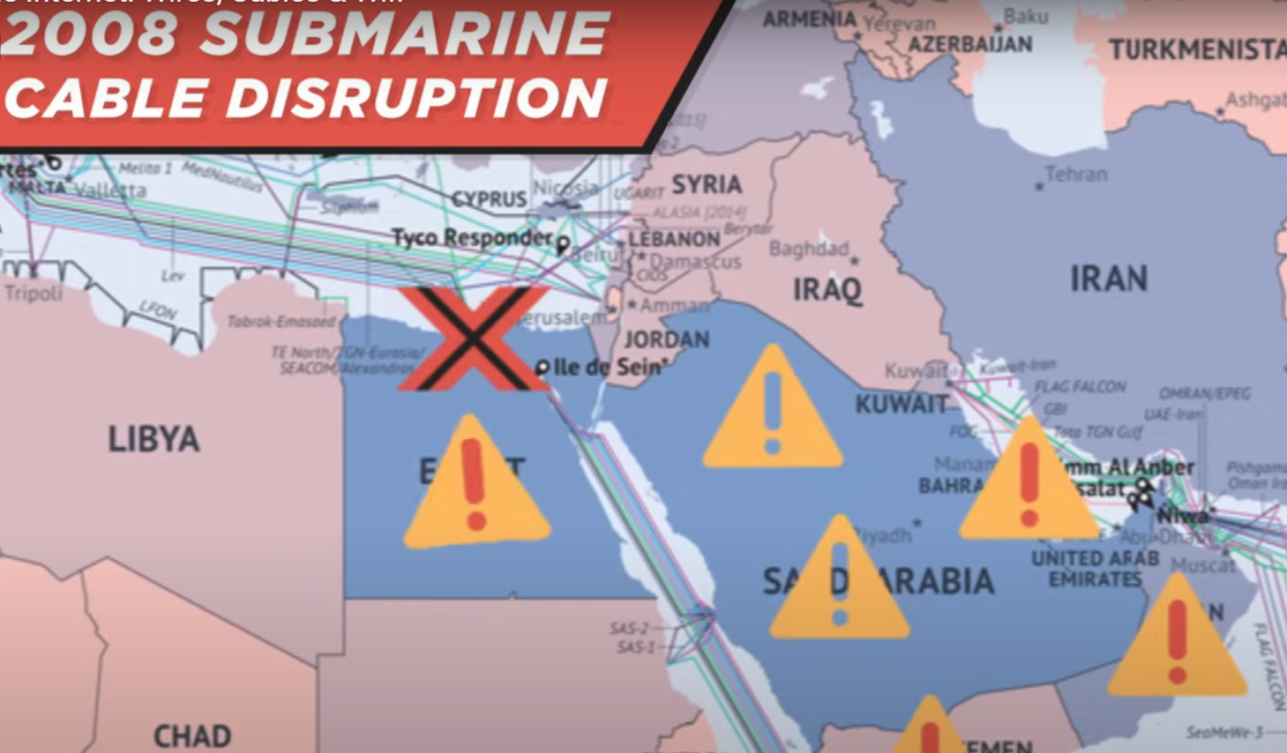
    - So, we take this Internet thing for granted but it’s really a pretty fragile physical system.
    - Fiber is awesome but it’s also really expensive and hard to work with.
      - For most purposes you’re gonna find copper cable
        - 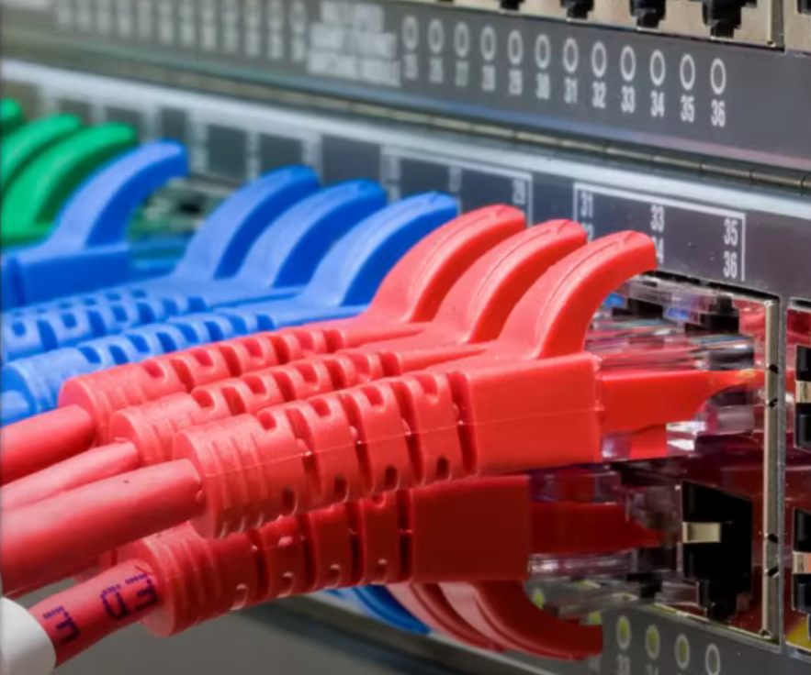
  - But how do we move things without wires?
    - How do we send things wirelessly?
  - Radio
    - Wireless bit sending machines typically use a radio signal to send bits from one place to another
    - The machines must translate the ones and zeros into radio waves of different frequencies
      - 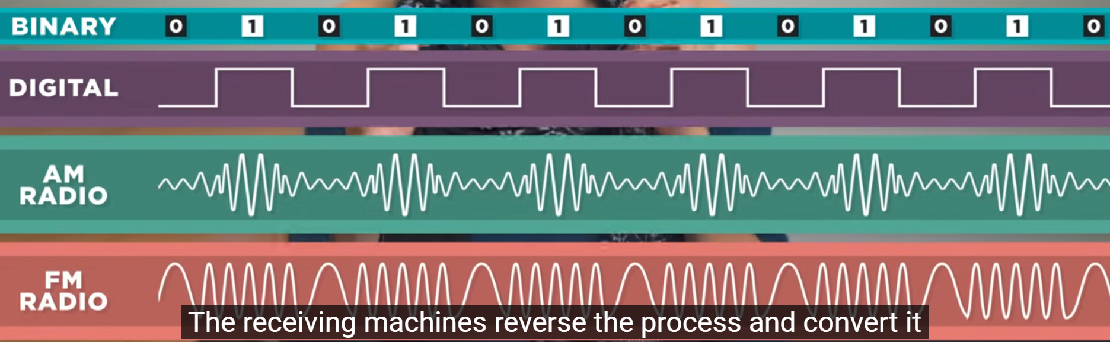
    - The receiving machines reverse the process and convert it back into binary on your computer
    - So wireless has made our Internet mobile but a radio signal doesn’t travel all that far before it completely get garbled..
    - This is why you can’t really pick up a LA radio station in Chicago.
    - As great as wireless is today, it still relies on the wired internet.
  - 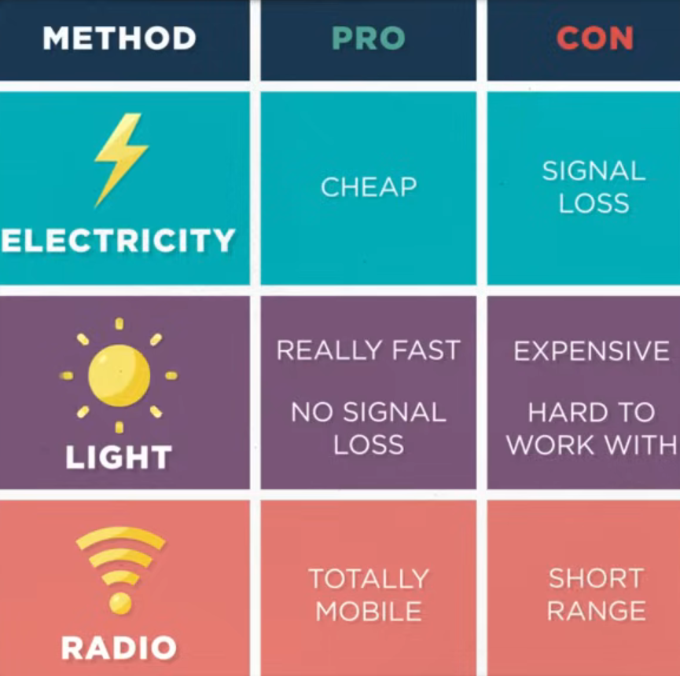
  - If you’re in a coffee shop using Wi-Fi then the bits get sent through a wireless router and then are transferred to the physical wire to travel the really long distances of the Internet.
  - The physical method for sending bits may change in the future.
    - Whether it’s lasers send between satellites or radio waves from balloons or drones.
  - But the underlying binary representation of information and the protocols for sending that information and receiving that information have pretty much stayed the same.
  - Everything on the internet whether it’s words, emails, images, cat videos, puppy videos …
    - All come down to these ones and zeros being delivered by:
      - Electronic pulses
      - Light beams
      - Radio waves

IP Addresses and DNS
- Now that you know about the physical medium for the data transfer over the internet, it’s time to learn about the protocols involved.
- How does the information traverse from one computer to another in this massive global network of computers?
- https://www.youtube.com/watch?v=5o8CwafCxnU
  - Paola
    - SWE @ Microsoft
- Back in the 1970s There was no standard method for networks to communicate
- It took the work of Vint Cerf and Bob Kahn to invent the internetworking protocol to make communication possible.
- This invention laid the groundwork for what we now call the internet.
- Vint:
  - The internet is a network of networks.
  - It links billions of devices together all around the globe.
  - So maybe you’re connected with a laptop or a phone through wifi,
    - but then that wifi connection connects to an internet service provider (or ISP),
      - and that ISP connects you to billions and billions of devices around the world through hundreds of thousands of networks that are all interconnected.
  - One thing that most people do not appreciate is that the internet is really a design philosophy, and an architecture expressed in a set of protocols.
  - A protocol
    - Is a well known set of rules and standards used to communicate between machines
    - If all parties agree to use it, then a protocol allows them to communicate without trouble
  - How the internet actually physically works is less important than the fact that this design philosophy has allowed the internet to adapt and absorb new communication technologies.
    - This is because in order for a new technology to use the internet in some fashion, it just needs to know which protocols to work with.
  - All the different devices on the internet have unique addresses
    - An address on the internet is just a number, similar to a phone number or a sort of street address, that’s unique to each computer or device at the edge of the network.
      - This is similar to how most homes and businesses have a mailing address.
        - You don’t need to know a person to send them a letter in the mail, but you do need to know their address and how to write the address properly so the letter can be carried by the mail system to its destination.
    - The addressing system for computers on the internet is similar, and it forms part of one of the most important protocols used in internet communication, simply called the internet protocol (or IP)
  - A computer’s address is called its IP address
  - Visiting a website is really just your computer asking another computer for information.
    - Your computer sends a message to the other computer’s IP address, and it also sends along its origin address, so the other computer knows where to send its response.
- Paola:
  - You may have seen an IP address. It’s just a bunch of numbers!
  - These numbers are organized in a hierarchy.
    - Just like a home address has a country, a city, a street, and a house number, an IP address has many parts.
    - Just like all digital data, each of these numbers is represented in bits.
    - Traditional IP addresses are 32 bits long with 8 bits for each part of the address
      - 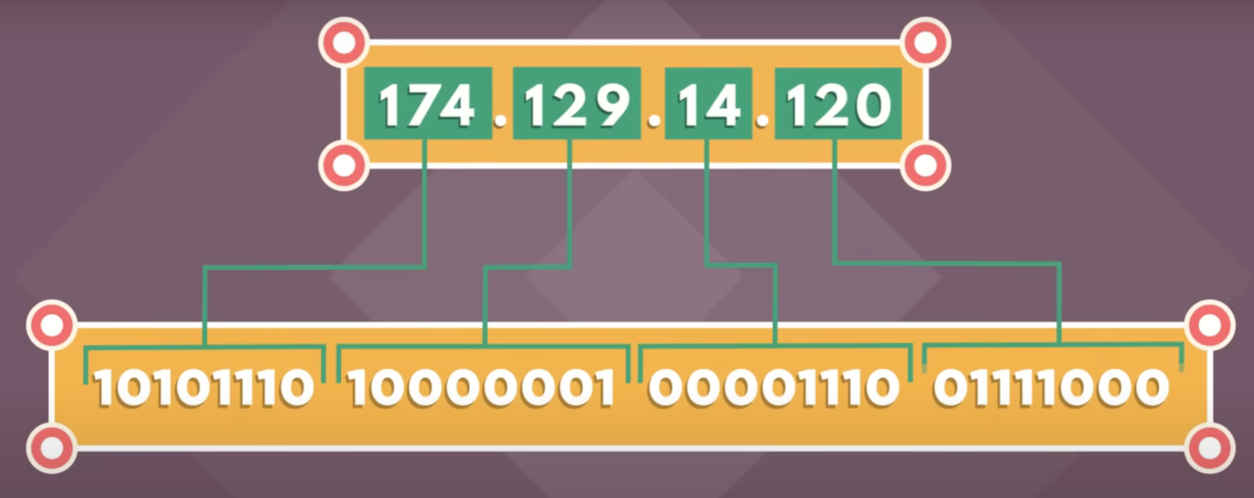
    - The earlier numbers usually identify the country and regional network of the device.
    - Then come the subnetworks, and then finally the address of the specific device.
      - This version of IP addressing is called IPv4.
        - It was designed in 1973 and widely adopted in the early 80s
        - Provides for more than 4 billion unique addresses for devices connecting to the internet.
  - But the internet has turned out to be much more popular than even Vint Cerf imagined, and 4 Billion unique addresses won’t be enough.
    - We’re now in the middle of a multi-year transition to a longer IP address format called IPv6:
      - which uses 128 bits per address
      - and provides over 340 undecillion unique addresses
        - That’s more than enough for every grain of sand on earth to have its own IP address.
- Vint:
  - Most users never see or care about internet addresses
  - A system called the “Domain Name System” (or DNS)
    - Associates names like www.example.com with the corresponding addresses.
    - Your computer uses the DNS to look up domain names and get the associated IP address,
      - The IP address is then used to connect your computer to the destination on the internet
- Paola:
  - So how do we design a system for billions of devices to find any one of billions of different websites?
    - There’s no way one DNS server can handle all the requests from all devices.
    - The answer is that:
      - DNA servers are connected in a distributed hierarchy and are divided into zones, splitting up responsibility for the major domains such as .org, .com, .net, etc…
  - DNS was originally created to be an open and public communication protocol for government and educational institutions.
    - Because of its openness, DNS is susceptible to cyberattacks.
      - An example attack is DNS spoofing.
        - That’s when a hacker taps into a DNS server and changes it to match a domain name with the wrong IP address.
        - This lets the attackers send people to an imposter website.
          - If this happens to you, you are vulnerable for more problems because you are using that fake website as if it is real!
  - The internet is huge and getting bigger every day, but the domain name system and internet protocol are designed to scale, no matter how much the internet grows.

Packets, Routing, and Reliability
- Information transfer on the Internet from one computer to another does not need to follow a fixed path
  - In fact, it may change paths during the transfer.
- This information transfer is done in the form of packets and these packets may follow different routes depending on certain factors.
- In this video, you will learn about how the packets of information are routed from one computer to another to reach the destination.
https://www.youtube.com/watch?v=AYdF7b3nMto
- Lynn Root
  - SWE @ Spotify
- Lynn:
  - The sheer amount of information zooming around the internet is astonishing.
  - But how is it possible for every piece of data to be delivered to you reliably?
  - Say you want to play a song on spotify..
    - It seems like your computer connects directly to spotify servers and spotify sends you a song on a direct dedicated line.
      - But actually, that’s not how the internet works!
      - If the internet were made of direct, dedicated connections it would be impossible to keep things working as millions of users join, especially since there is no guarantee that every wire and computer is working all the time.
  - Instead data travels on the internet in a much less direct fashion.
- Vint:
  - Many, many years ago in the early 1970s, my partner Bob Khan and I began working on the design of what we now call the internet.
  - Bob and I had the responsibility and the opportunity to design the internet’s protocols and its architecture.
    - So, we persisted in participating in the internet’s growth and evolution for all of this time, up to and including the present.
  - The way information gets transferred from one computer to another is pretty interesting.
    - It need not follow a fixed path. In fact, your path may change in the midst of a computer-to-computer conversation.
    - Information on the internet goes from one computer to another in what we call a packet of information
    - And a packet travels from one place to another on the intenet a lot like how you might get from one place to another in a car.
      - Depending on traffic congestion or road conditions you might choose to be forced to take a different route to get to the sample place each time you travel.
      - And just as you can transport all sorts of stuff inside a car, many kinds of digital information can be sent with IP packets, but there are some limits.
  - What if, for example, you need to move a space shuttle from where it was build to where it will be launched.
    - The shuttle won’t fit in one truck so it needs to be broken down into pieces and transported using a fleet of trucks.
      - They could all take different routes and might get to the destination at different times,
      - But once all the pieces are there you can reassemble the pieces into the complete shuttle, and it’ll be ready for launch.
  - On the internet, the details work similarly.
  - If you have a very large image that you want to send to a friend or upload to a website
    - That image might be made up of tens of millions of bits (or ones and zeros)
      - Too many to send along in one packet.
    - Since it’s data on a computer, the computer sending the image can quickly break it into hundreds or even thousands of smaller parts, called packets.
  - Unlike cars or trucks, these packets don’t have drivers and they don’t choose their route.
    - Each packet has the internet address of where it came from and where it’s going.
  - Special computers on the internet, called routers act like traffic managers to keep the packets moving through the networks smoothly.
    - If one route is congested, individual packets may travel different routes through the internet and they may arrive at the destination at slightly different times, or even out of order.
- Lynn:
  - So let’s talk about how this works.
    - As part of the Internet Protocol,
      - every router keeps track of multiple paths for sending packets,
      - and it chooses the cheapest available path for each piece of data based on destination IP address for the packet.
        - Cheapest in this case doesn’t mean cost but time and nontechnical factors such as politics and relationships between companies.
        - Often the best route for data to travel isn’t necessarily the most direct.
    - Having options for paths makes the network fault tolerant,
      - Which means the network can keep sending packets even if something goes horribly, horribly wrong.
        - This is the bases for a key principle of the internet:
          - Reliability
  - What if you want to request some data and not everything is delivered?
    - Say you want to listen to a song, how can you be 100% sure all the data will be delivered so the song plays perfectly?
      - TCP (Transmission Control Protocol)
        - TCP manages the sending and receiving of all your data as packets.
        - Think of it like a guaranteed mail service
          - When you request a song on your device, Spotify sends a song broken up into many packets.
          - When you packets arrive, TCP does a full inventory and sends back acknowledgements of each packet received.
          - If all packets are there, TCP signs for your delivery and you’re done.
          - If TCP finds some packets are missing, it won’t sign.
            - Otherwise your song wouldn’t sound as good, or portions of the song could be missing.
          - For each missing or incomplete packet, Spotify will resend them.
          - Once TCP verifies the delivery of many packets for that one song request, your song will start to play.
  - What’s great about the TCP and router systems is they’re scalable.
    - They can work with eight devices or eight billion devices.
    - In fact, because of these principle of fault tolerance and redundancy,
      - the more routers we add, the more reliable the internet becomes.
  - What’s also great is we can grow and scale the internet without interrupting service for anybody using it.
- Vint:
  - The internet is made of hundreds of thousands of networks and billions of computers and devices connected physically.
  - These different systems that make up the internet connect to each other, communicate with each other, and work together because of agreed-upon standards for how data is sent around on the internet.
  - Computing devices or routers along the internet help all the packets make their way to the destination, where they’re reassembled, if necessary, in order.
    - This happens billions of times a day, whether you and others are
      - sending an email,
      - visiting a web page,
      - doing a video chat,
      - using a mobile app,
      - Or when sensors or devices on the internet talk to each other.

HTTP and HTML
- HTTP is the standard protocol by which webpages are transferred over the Internet.
- This video is a brief introduction to HTTP and how web browsers load websites for you:

