Reid-Hillview Airport Lead Analysis: TWFE with Weather Controls
Sample window: 2016-01-01 to 2025-01-01; main exposure band: 0-4 km

1. Executive Summary
• The analysis successfully restricts the sample to 2016-01-01 <= date < 2025-01-01. The lead panel covers 112,983 daily observations from 270 monitors, ending on 2024-12-31.
• Weather merge worked well: temperature, wind speed, humidity, and pressure are all 0% missing in the final airport-monitor-date panel.
• The final TWFE regression sample for the 0-4 km band contains 14 airports: Reid-Hillview plus 13 control airports, with 1,386 airport-month observations.
• The estimated RHV x Post-2022 coefficient remains large and negative after adding weather controls. The implied decline is about 67% relative to control airports.
• The event-study plot shows a sharp and persistent decline beginning in 2022, but several pre-treatment years are not exactly zero. This means the evidence is strong and suggestive, but the causal interpretation should be cautious.

2.Data procession method

2.1 Why require at least 12 pre-months and 3 post-months?
Reason: TWFE needs each control airport to contribute meaningful information before and after the policy date. Airports with only pre-period data cannot directly help estimate post-2022 counterfactual changes. The 12-pre-month and 3-post-month rule is a minimum coverage screen; it removes airport panels that are too short to be useful while keeping enough controls for estimation.

2.2 Why exclude other Santa Clara County control airports?
Reason: Reid-Hillview is in Santa Clara County. Other Santa Clara County airports may have been exposed to the same local fuel policy environment or related county-level changes. If they are included as controls, the control group could be partially treated, which would contaminate the comparison. The code keeps Reid-Hillview but removes Santa Clara County non-treated airports from the control pool.

3. Data and Sample Construction
Item | Value
Lead daily observations | 112,983
Unique lead monitors | 270
Counties | 138
Lead date range | 2016-01-01 to 2024-12-31
Santa Clara County daily observations | 869
Santa Clara County monitors | 2
Weather missing rate | 0% for temperature, wind, humidity, pressure
Distance-band daily sample:
Distance band | Airports | Monitors | Daily observations | Date range
0-1 km | 9 | 9 | 2,883 | 2016-01-01 to 2024-12-26
1-3 km | 14 | 14 | 3,595 | 2016-01-01 to 2024-12-26
3-5 km | 38 | 43 | 14,287 | 2016-01-01 to 2024-12-29
0-4 km | 35 | 38 | 11,291 | 2016-01-01 to 2024-12-26
Plotting sample after 24-month airport-band screen:
Distance band | Airports kept for plots
0-1 km | 4
1-3 km | 10
3-5 km | 27
0-4 km | 21

4. TWFE Regression Results
Model specification: The dependent variable is log(mean monthly lead + 0.001). The model includes airport fixed effects and month fixed effects, with standard errors clustered by airport.
Model | RHV x Post-2022 beta | Approximate percent change | Weather controls
Baseline | -1.143 | -68.1% | No
Weather controls | -1.111 | -67.1% | Temperature, wind speed, humidity, pressure
Weather + wind direction | -1.113 | -67.2% | Adds wind direction sine/cosine
Interpretation: The coefficient stays close to -1.11 after adding weather controls, so the estimated decline near Reid-Hillview is not explained away by local weather conditions. The implied decline is about 67% relative to the control airports.

5. Event Study Results
Relative year | Calendar year | Estimate | Interpretation
-6 | 2016 | 0.101 | Not statistically significant
-5 | 2017 | 0.141* | Positive pre-period difference
-4 | 2018 | 0.257** | Positive pre-period difference
-2 | 2020 | -0.278. | Marginally negative
-1 | 2021 | -0.111 | Not statistically significant
0 | 2022 | -0.889*** | Large post-policy decline
1 | 2023 | -1.089*** | Decline persists
2 | 2024 | -1.282*** | Decline grows further
Interpretation: The event study supports a sharp drop beginning in 2022. However, 2017 and 2018 are statistically different from the 2019 reference year, so pre-trends are not perfectly flat. The results are strong suggestive evidence, not definitive causal proof.

6. Figures
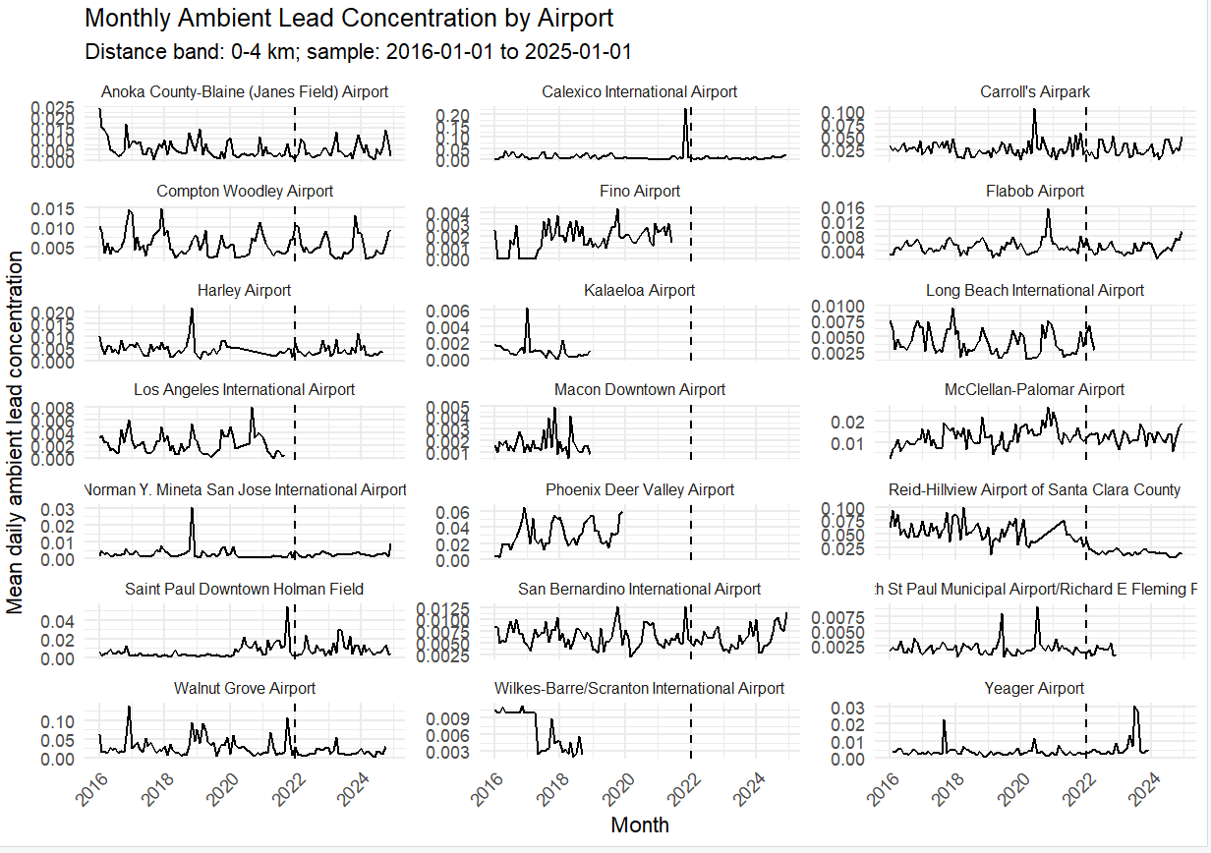
Figure 1. Airport-level monthly lead concentration panels, 0-4 km band.
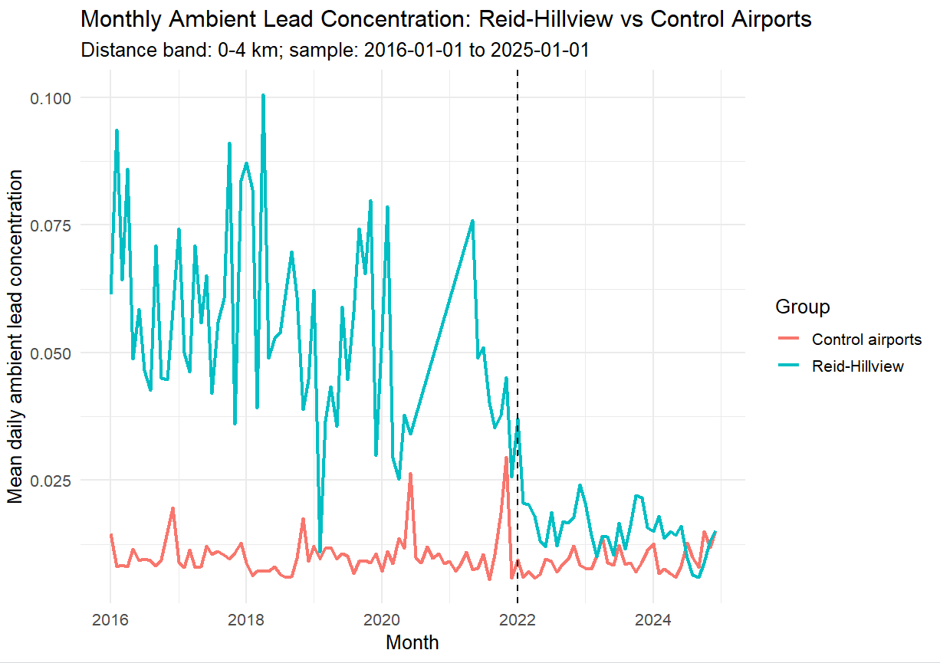
Figure 2. Reid-Hillview versus control airports, monthly mean lead concentration.
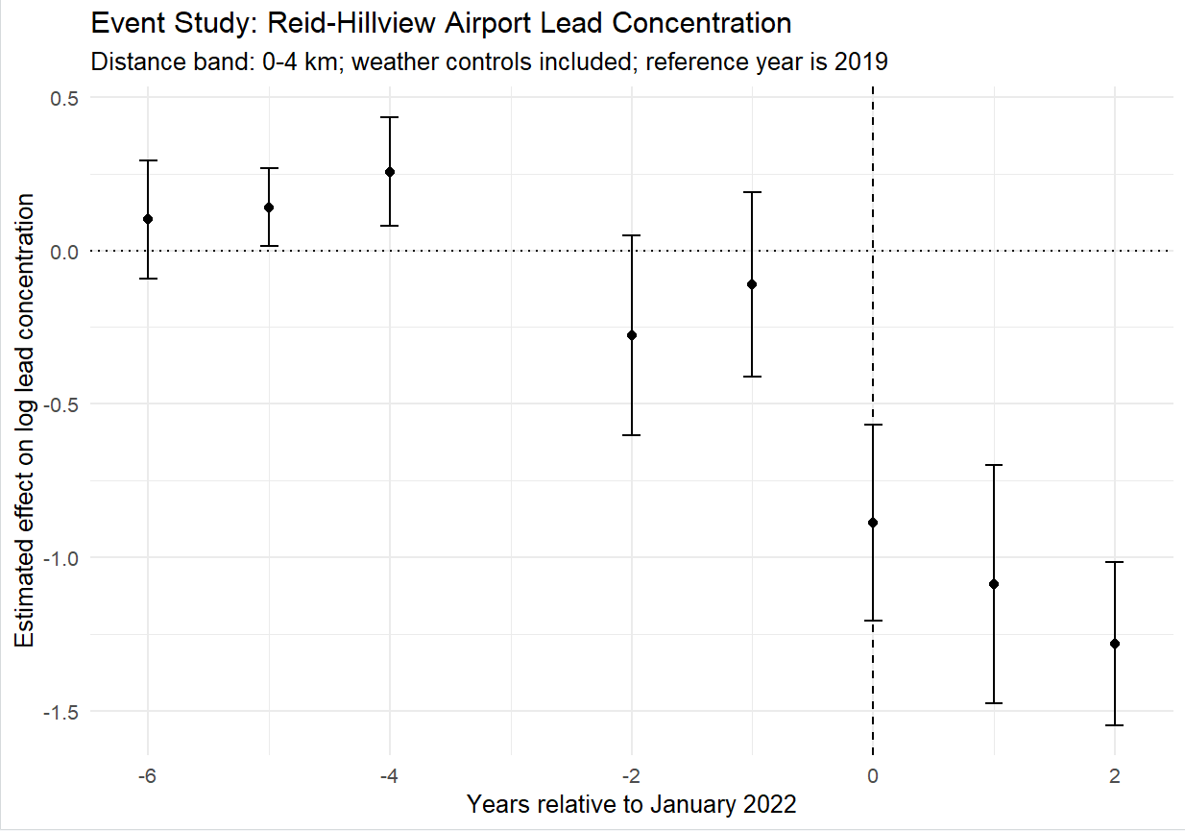
Figure 3. Event study with weather controls; reference year is 2019.

7. Suggested Report
Suggested conclusion: Using an airport-month panel from 2016 through 2024, the TWFE estimates show a large post-2022 decline in ambient lead concentrations within 0-4 km of Reid-Hillview relative to control airports. The estimate remains about 67% after adding weather controls, and the event study shows the decline begins in 2022 and persists through 2024. Because some pre-treatment coefficients differ from zero and there are only 14 airport clusters, interpret the results as strong suggestive evidence rather than definitive causal proof.

