0324 ZIPCITY ZIPNAME ZIPSTATE

Function Name: ZIPCITY

Author: Matt Triano

Input Parameters: 5-digit US zip code (leading zeros can be omitted)

Return Values: Returns city name and 2-character postal code (state abbreviation) that corresponds to the input zip code.

Function Description: This function takes a zip code and returns a string representation of the city name and abbreviation for the corresponding state (or US territory).

Sample Code: **data** zip;

input origin destination @@;

city_orig=zipcity(origin);

city_dest=zipcity(destination);

distance = zipcitydistance(origin, destination);

datalines;

60622 53713

60614 48201

60126 30135

;

**run**;

**proc** **print**;

**run**;

Output:

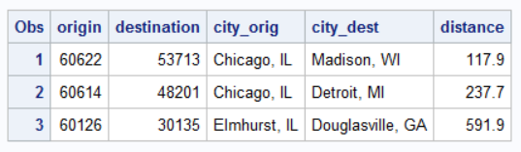

Function Name: ZIPNAME

Author: Matt Triano

Input Parameters: 5-digit US zip code (leading zeros can be omitted)

Return Values: Returns the upper-case name of the state that corresponds to the input zip code.

Function Description: This function takes a US zip code and returns a string representation of the full state (or US territory) name.

Sample Code: **data** zip;

input origin destination @@;

name_orig=zipname(origin);

name_dest=zipname(destination);

distance = zipcitydistance(origin, destination);

datalines;

60622 53713

60614 48201

60126 30135

;

**run**;

**proc** **print**;

**run**;

Output:

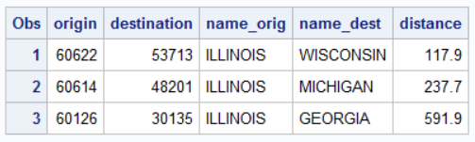

Differences:

Rather than return a string representation of the state (or US territory) postal code or of the city name and state (or US territory) postal code, this returns a string representation of just the state (or US territory) postal code.

Function Name: ZIPSTATE

Author: Matt Triano

Input Parameters: 5-digit US zip code (leading zeros can be omitted)

Return Values: Returns a string containing the uppercase, two-character state postal code (or GSA code for US territories) that corresponds to the input zip code.

Function Description: This function takes a US zip code and returns a string representation of the abbreviation for the corresponding state (or US territory).

Sample Code: **data** zip;

input origin destination @@;

state_orig=zipstate(origin);

state_dest=zipstate(destination);

distance = zipcitydistance(origin, destination);

datalines;

60622 53713

60614 48201

60126 30135

;

**run**;

**proc** **print**;

**run**;

Output

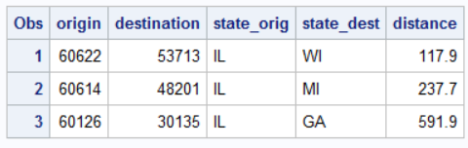

Differences: Rather than return a string representation of the full name of the state, or of the city name and state (or US territory) postal code, this returns a string representation of just the state (or US territory) postal code.