Contact us (solar VIC): 1300 376 393

**VIC State rebates**

Source: <https://www.solar.vic.gov.au/solar-panel-rebate>

Ammended as per: <https://www.solarquotes.com.au/victorian-solar-rebate.html?gad_source=1&gclid=CjwKCAiAg9urBhB_EiwAgw88mbqI9vVnYz5dzFuYfetH3sHD5yzQQ1rI4QmFHAcgvYV8rqVfJIgkUBoCswsQAvD_BwE>

Rebate: $1400 or 50% (whichever is lower)

Eligibility

* You are the owner-occupier of an existing property or the owner of a home under construction where the system is to be installed
* the combined household taxable income of all owners is less than $210,000 per year
* the property is valued at under $3 million, or a home under construction that will be valued at under $3 million at the time of completion
* the property address has not previously received a solar panel (PV) rebate under the Solar Homes Program
* the property has not had a solar panel (PV) system installed in the last ten years (owners with systems installed more than 10 years ago are eligible to expand their system with the rebate)

Other concurrent offer:

* You can apply for an interest-free loan equal to the rebate amount. Must be repaid in 4 years.

Other information:

* Eligible rental providers can claim a discount of up to $1,400 on the cost of installing solar panels (PV) on up to two rental properties per financial year. Interest-free loans are also offered for approved applicants.
* Eligible households can apply for a $1,000 solar hot water or heat pump rebate
* Eligible households can claim up to a $8,800 interest-free loan on solar battery installations

**Federal subsidy**

Source: <https://www.solarquotes.com.au/panels/rebate/>

* The federal subsidy reduces by one fifteenth every year from 2017 to 0 in 2031
* Subsidy is based on STC (Small scale Technology Certificate) price, which can range from $0 to $40.
* You get 1 STC for every year before 2031 (2031 – current year)
* 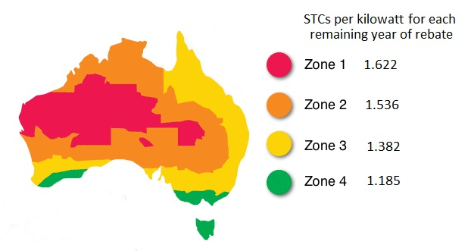

Source: <https://www.solarquotes.com.au/blog/solar-panel-rebate-phased-1st-january-2017/>

* Diagram above shows how many STCs are available per installed kW
* To calculate STCs: kW installed * years before 2031 * zone scalar
* STC graph: <https://www.demandmanager.com.au/certificate-prices/> shows that the price has been $40 for the last 12 months.
* [Important to stress that people claim credits sooner rather than later before the rebate reduces every year. Also say that because STC is at the max level, it can only go down, and reduce their rebate.]
* Most homes can only accept a maximum 6.6kW of solar

Eligibility:

* PV system is less than 100kW
* The system is installed by a Clean Energy Council accredited professional
* Use panels and inverters that are accredited by the Clean Energy Council