Liste requêtes Face Key Groupe 6

Liste les comptes d'un user
SELECT id_account, domain, login
FROM Account
INNER JOIN Sites
ON account.id_site = sites.id_site
WHERE account.id_user = 2
;
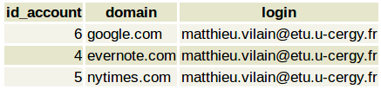

Infos générales d'un accound selectionné
SELECT account.id_account, account.id_site, domain, login, password, name_tag
FROM Account
INNER JOIN Sites
ON account.id_site = sites.id_site
INNER JOIN Tags
ON account.id_tag = tags.id_tag
WHERE account.id_user = 2 AND account.id_account = 4
;

Liste sharedAccount d'un user
SELECT id_sharedAccount, domain, name, first_name
FROM SharedAccount
INNER JOIN Account
ON sharedAccount.id_account = account.id_account
INNER JOIN Sites
ON account.id_site = sites.id_site
INNER JOIN Users
ON account.id_user = users.id_user
WHERE sharedAccount.id_receiver = 3
;
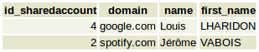

Infos générales d'un sharedAccount sélectionné
SELECT id_sharedAccount, id_receiver, sharedAccount.id_account, expiration_date, domain, users.name, users.first_name, users.id_user
FROM SharedAccount
INNER JOIN account
ON sharedAccount.id_account = account.id_account
INNER JOIN Sites
ON account.id_site = sites.id_site
INNER JOIN Tags
ON account.id_tag = tags.id_tag
INNER JOIN Users
ON account.id_user = Users.id_user
WHERE sharedAccount.id_receiver = 2 AND sharedAccount.id_sharedaccount = 4
;

Nombre utilisateur par site
SELECT COUNT(id_account)
FROM Account
INNER JOIN Sites
ON Account.id_site = Sites.id_site
WHERE domain = 'google.com'
;
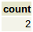

Somme du temps d'utilisation + nb utilisateurs d'un site pour calcul moyenne
SELECT SUM(average_conn_time) AS summe, COUNT(average_conn_time) AS count
FROM Account
INNER JOIN Sites
ON Account.id_site = Sites.id_site
INNER JOIN DataAccount
ON Account.id_account = DataAccount.id_account
WHERE domain = 'facebook.com'
;
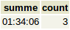

Liste des positions GPS des utilisateurs d'un site
SELECT last_loc
FROM DataAccount
INNER JOIN Account
ON DataAccount.id_account = Account.id_account
INNER JOIN Sites
ON Account.id_site = Sites.id_site
WHERE domain = 'twitter.com'
;
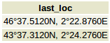

Liste account et PaymentAccount d’un user
SELECT account.id_account, account.login, domain, account.password, account.id_user, account.id_tag, bank, rib, card_num, cryptogram
FROM Account
LEFT JOIN PaymentAccount
ON account.id_account = paymentaccount.id_account
INNER JOIN Sites
ON account.id_site = sites.id_site
WHERE account.id_user = 3
;
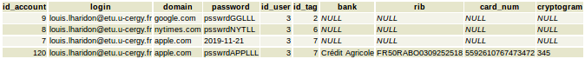

Liste des tags d'un site
SELECT DISTINCT name_tag
FROM Account
INNER JOIN Tags
ON account.id_tag = tags.id_tag
INNER JOIN sites
ON account.id_site = Sites.id_site
WHERE account.id_site = 3
;
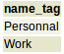

Dernier compte utilisé par un user
SELECT MAX(last_conn)
FROM(
SELECT Account.id_account, domain, last_conn
FROM Account
INNER JOIN sites
ON account.id_site = sites.id_site
INNER JOIN DataAccount
ON account.id_account = DataAccount.id_account
WHERE account.id_user = 2
)AS account_user;
