MathcadPy Interface Test Worksheet
Inputs
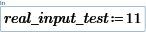
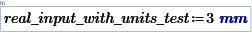
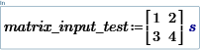
Outputs
