**Project Title**:

Transfer Learning-Based Classification of Poultry Diseases for Enhanced Health Management

**1. Introduction**

**Team Members**:

* **Team Leader**: Matta Kanakasri
* **Team Member**: Vinukonda Vikram
* **Team Member**: Thota Thanusree

This project aims to provide an AI-powered solution for classifying poultry diseases using image-based analysis of poultry droppings. The model uses transfer learning techniques integrated into a user-friendly web interface to help farmers detect and act on disease symptoms early.

**2. Project Overview**

**Purpose**:

* Developed as a deep learning-powered web application built using Flask and integrated with Visual Studio Code.
* Classifies poultry droppings to detect potential infections and help farmers take prompt action.
* Aims to improve poultry health outcomes and minimize economic loss through early detection.

**Features**:

* Image-based disease classification
* User-friendly image upload interface
* Real-time prediction with feedback
* Model pre-connected with web app

**Supported Classes**:

* Coccidiosis
* Newcastle Disease
* Salmonella
* Healthy

**3. Architecture**

* Frontend: HTML, CSS, Bootstrap
* Backend: Python Flask
* Model: CNN using Transfer Learning
* Deployment: Localhost (or deployable on cloud platforms like Heroku)

**4. Workflow**

* User uploads an image of poultry droppings.
* Flask backend preprocesses and sends the image to the trained model.
* Model returns predicted class.
* Result is displayed in a readable format.

**5. Folder Structure**

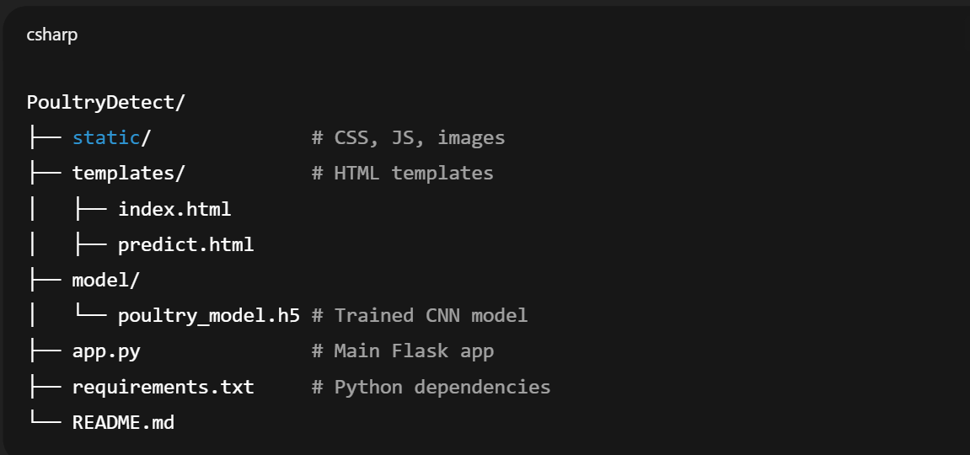

**6. Setup Instructions**

**Prerequisites**:

* Python 3.8+
* Flask
* TensorFlow / Keras
* NumPy / OpenCV (if used)
* Visual Studio Code

**7. Web Interface Details**

**Main Pages**:

Home Page:

Welcome message – Overview images of poultry

Navigation Menu:

Home | Prediction Page | About

Prediction Page:

Upload input

Model response displayed with:

* + - Predicted infection class
    - Selected image preview

About Page:

Description of the AI model, dataset, and benefits for farmers

**Model Info**

* Model Type: Convolutional Neural Network
* Technique: Transfer Learning
* Dataset: Poultry droppings images (classified manually)
* Output Classes: 4
* Input Format: .jpg or .png images

**Testing & Evaluation**

* Manual testing via GUI
* Model accuracy validated on test dataset
* Various infection types tested through UI

**Sample Predictions**

| **Image Type** | **Result** |
| --- | --- |
| Yellow Droppings | Coccidiosis |
| Greenish Droppings | Newcastle Disease |
| White Watery Patch | Salmonella |
| Clean/Normal Droppings | Healthy |

**Screenshots:**

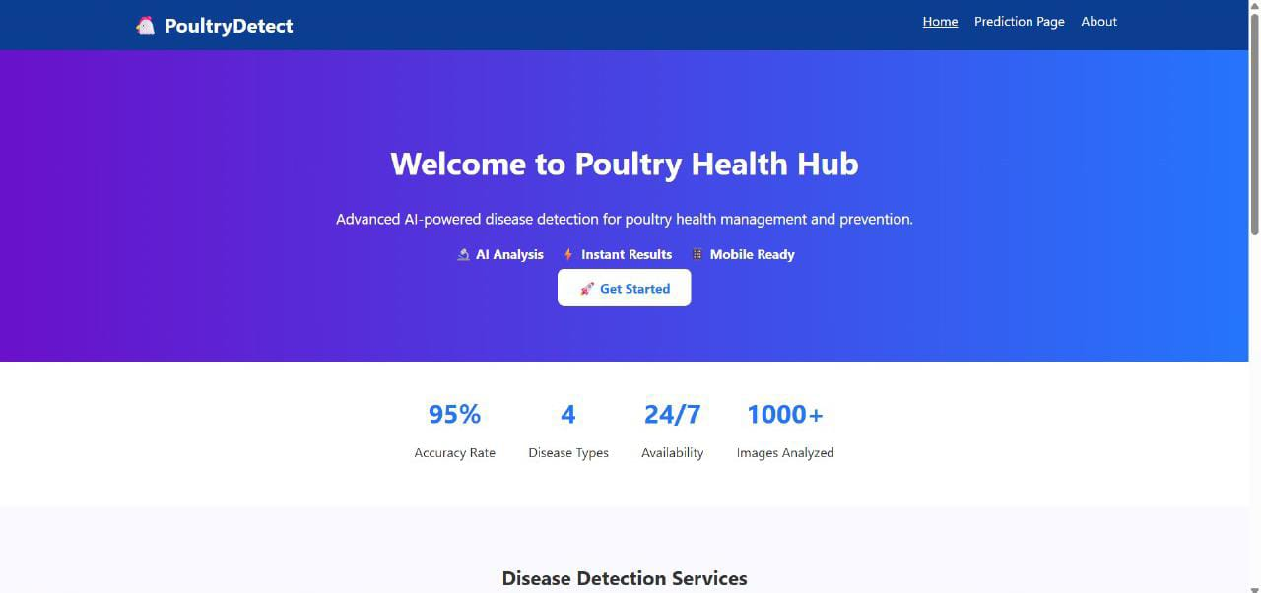

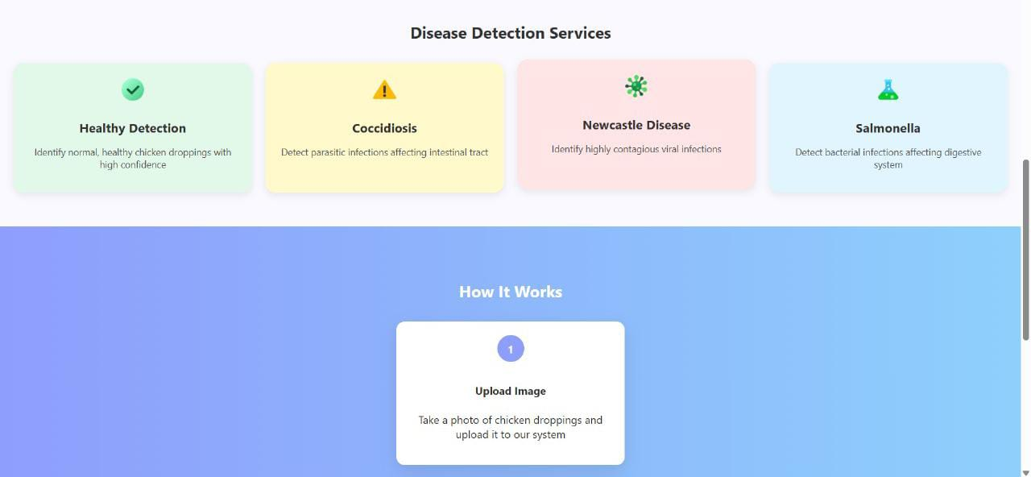

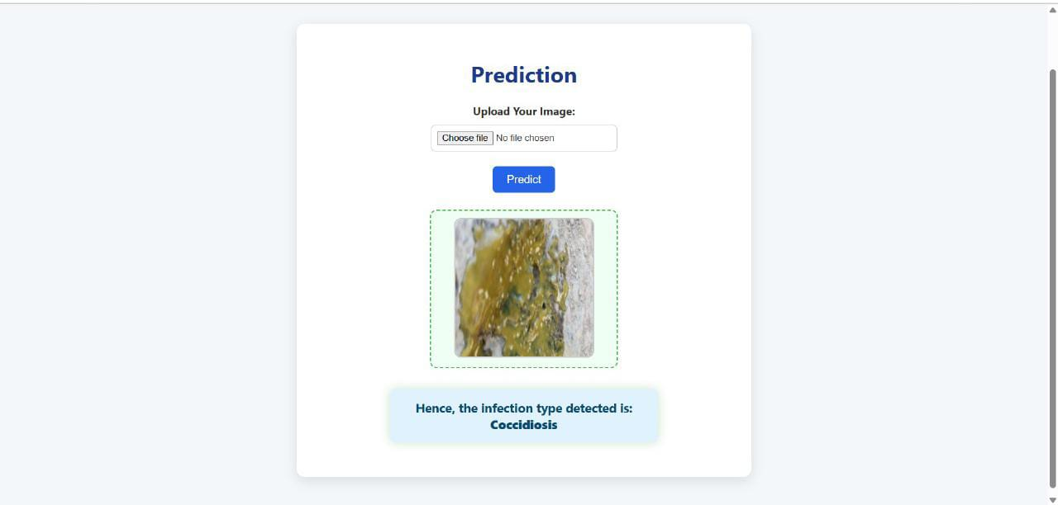

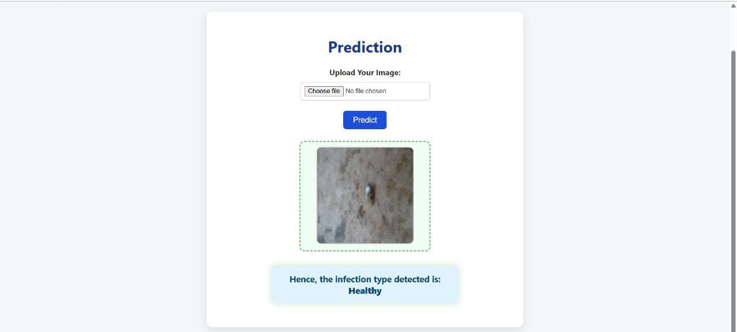

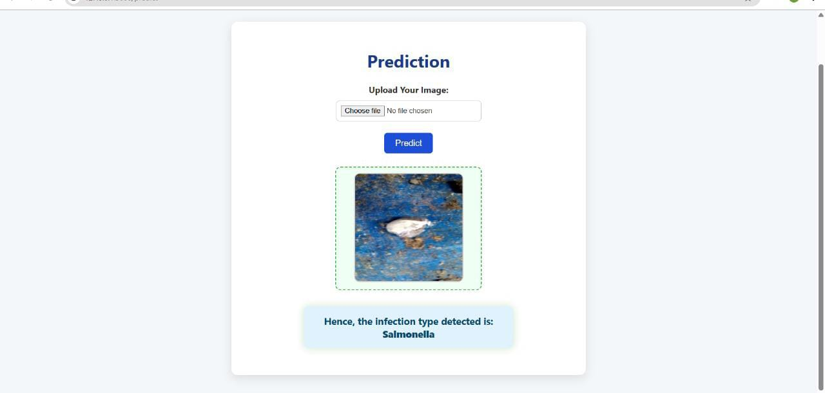

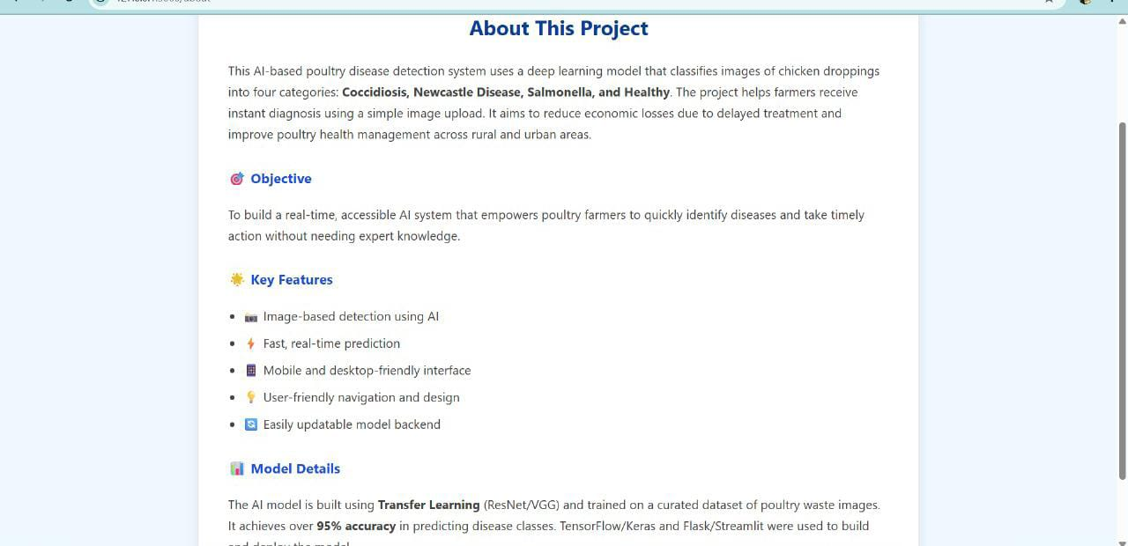

**Known Issues**

* Model accuracy may vary in poor lighting
* Dataset limited to visually labeled classes
* No user authentication
* Limited mobile responsiveness (minor layout shifts)

**Future Enhancements**

* Add user login and history tracking
* Confidence score with predictions
* Suggest preventive measures based on result
* Expand dataset with more varied images
* Add multi-language support
* Improve mobile UX and camera integration