Project Design Phase-II
Technology Stack (Architecture & Stack)
Date | 12-10-2026
Team ID | Individual participant - 323103312124@gvpce.ac.in
Project Name | Software Installation Request - ServiceNow
Maximum Marks | 4 Marks

Technical Architecture:
The solution is organized around the ServiceNow hosted platform. Employees use the Service Catalog; Flow Designer coordinates approval and fulfillment; standard platform records retain request, approval, and task data; portal/status views and configured outbound email support communication.
Architecture diagram — conceptual deployment and data flow
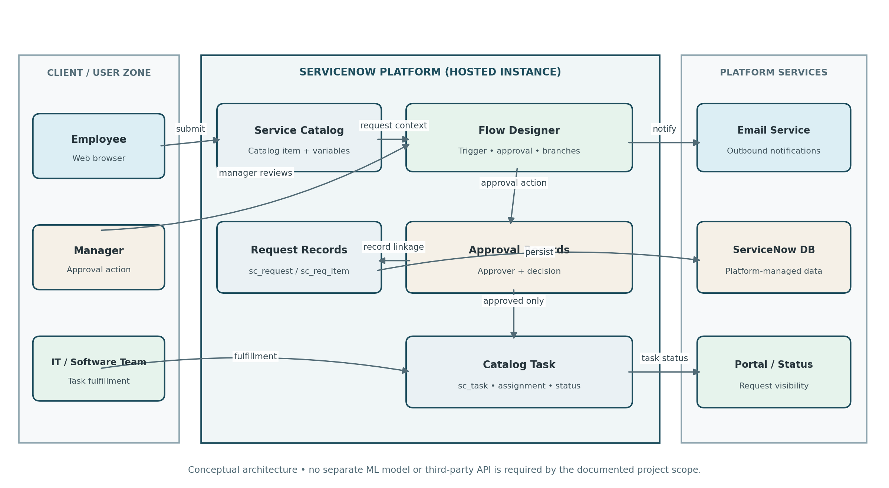
Infrastructure demarcation: users access a hosted ServiceNow instance through a web browser. Request data is stored in ServiceNow-managed tables. Email is represented as a platform notification service. No separate local server, external API, or machine-learning model is required by the documented project scope.

Table-1: Components & Technologies
S.No | Component | Description | Technology
1 | User Interface | Employee-facing catalog form and request/status views; manager approval UI; fulfillment task UI. | ServiceNow Service Catalog / Service Portal; web browser
2 | Application Logic-1 | Collects catalog inputs and creates the request / Requested Item. | ServiceNow Catalog Item and catalog variables
3 | Application Logic-2 | Starts workflow and routes the Requested Item for manager approval. | ServiceNow Flow Designer
4 | Application Logic-3 | Handles decision outcomes and creates a fulfillment task only after approval. | Flow Designer approval/conditional actions; Catalog Task
5 | Database | Stores parent request, Requested Item, and Catalog Task records. | ServiceNow platform tables: sc_request, sc_req_item, sc_task
6 | Cloud Database | Persistent storage managed by the hosted ServiceNow platform; database engine is abstracted from the project. | ServiceNow-managed data store (underlying engine not specified)
7 | File Storage | No separate file-storage component is identified as required by the documented workflow. | Not applicable / not specified
8 | External API-1 | No third-party API is identified in the project scope. | None specified
9 | External API-2 | No second external API is identified in the project scope. | None specified
10 | Machine Learning Model | No ML model is required for catalog intake, manager approval, or task routing. | Not applicable
11 | Infrastructure (Server / Cloud) | Accessed by users over a browser; application logic and record storage are hosted in the ServiceNow instance. | Hosted ServiceNow instance; local server configuration not applicable

Table-2: Application Characteristics
The characteristics below describe the architectural approach and design expectations. Instance-specific security settings, availability commitments, and performance limits must be confirmed in the target ServiceNow environment.
S.No | Characteristics | Description | Technology
1 | Open-Source Frameworks | No separate open-source application framework is identified. The solution primarily uses native ServiceNow platform configuration rather than a custom React/Angular application. | ServiceNow Service Catalog and Flow Designer
2 | Security Implementations | Use platform authentication, roles, and access controls configured in the ServiceNow instance. Limit access to request, approval, and fulfillment records according to user responsibilities. Exact ACLs/roles must be verified in the target instance. | ServiceNow roles / ACLs (configuration-dependent)
3 | Scalable Architecture | Catalog items, flow configuration, and standard platform tables provide a platform-managed pattern for handling additional software request types, subject to instance capacity and governance. | Hosted ServiceNow platform
4 | Availability | Availability depends on the ServiceNow service and the target instance's service commitments and configuration. No project-specific uptime SLA or redundant deployment is specified in the supplied artifacts. | ServiceNow hosting; provider SLA to be confirmed
5 | Performance | Keep the form focused, avoid unnecessary flow actions, and limit notifications to relevant events. No measured throughput, response-time target, or cache/CDN layer is specified. | Native ServiceNow form and Flow Designer; validate in testing

Architecture notes
- The diagram is a conceptual representation of the intended request lifecycle, not a claim that every connector has been verified in a live instance.
- The platform-managed database is shown logically; the project does not specify the underlying database engine.
- No third-party API or machine-learning model is identified as necessary for the documented core workflow.

References
- C4 model: https://c4model.com/
- AWS Architecture: https://aws.amazon.com/architecture
- IBM Cloud Architecture: https://www.ibm.com/cloud/architecture

