Project Development Phase
Workflow Validation Metrics
Date | 12-10-2026
Team ID | Individual participant - 323103312124@gvpce.ac.in
Project Name | Software Installation Request - ServiceNow
Maximum Marks | As specified by template

Applicability
The source template asks for machine-learning metrics. The project materials do not describe an ML model, so MAE, MSE, RMSE, R², confusion matrices, classifier accuracy, and hyperparameter tuning do not apply. The equivalent quality evidence is functional correctness and workflow integrity.
Validation dimension | Acceptance check | Evidence / measurement
Input validation | Required fields are enforced and submitted values persist. | Catalog form and resulting RITM.
Approval correctness | The configured manager receives the request and decision is recorded. | Approval record.
Branch correctness | Approved requests proceed to fulfillment; rejected requests do not. | Approved/rejected path results.
Record integrity | Request, Requested Item, approval, and task are linked correctly. | Record IDs and relationship checks.
Assignment correctness | Fulfillment task is assigned to the intended Software group. | Catalog Task assignment details.
Notification correctness | Configured emails are generated for intended recipients. | Outbound email log.

Metrics to populate after testing
Metric | Calculation | Result
Functional pass rate | Passed test cases ÷ executed test cases × 100 | Not yet measured
Branch correctness rate | Correct branch outcomes ÷ branch tests executed × 100 | Not yet measured
Notification success rate | Expected notifications generated ÷ expected notifications triggered × 100 | Not yet measured
Record-linkage success rate | Requests with correct record links ÷ requests tested × 100 | Not yet measured
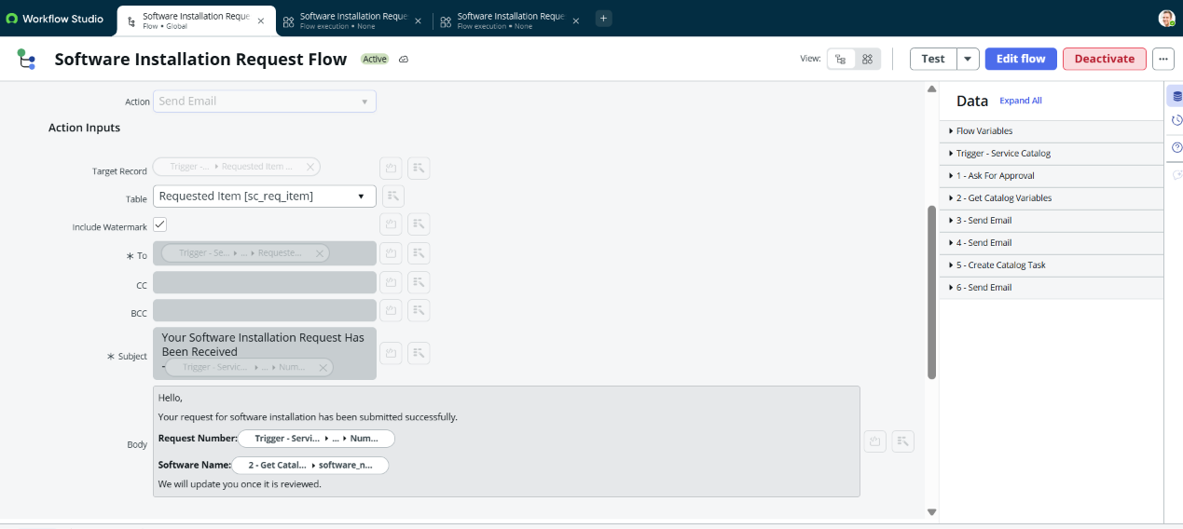
Repository evidence: task mapping is workflow evidence, not an ML evaluation.

