Project Development Phase
Request Data & Reporting Review
Date | 12-10-2026
Team ID | Individual participant - 323103312124@gvpce.ac.in
Project Name | Software Installation Request - ServiceNow
Maximum Marks | As specified by template

Reporting / Data Review
No Power BI report or dashboard is evidenced in the supplied project materials. This document maps the original template's data-rendering and reporting fields to the existing ServiceNow request interface and record data without claiming a separate BI implementation.
Template parameter | Project-specific assessment | Evidence
Data rendered | Request summary/status displays request information within ServiceNow. | ServiceNow request summary screenshot.
Data preprocessing | No Power Query pipeline is documented. Form validation and workflow record creation are application behavior. | Catalog item form and RITM.
Filters | No Power BI slicers are documented. Any ServiceNow catalog/search filters should be described as platform UI features. | Portal navigation screenshot if available.
DAX queries | Not applicable — no Power BI semantic model or DAX measures identified. | None supplied.
Dashboard design | No Power BI dashboard is evidenced. | Do not invent visuals.
Report design | No Power BI report is evidenced. Current reporting is limited to available request/status views. | Portal/status UI only.

Possible future reporting (not current scope)
If authorized reporting is added later, useful measures could include request volume, approval outcomes, fulfillment status, and request age. These are recommendations only and must not be presented as implemented dashboards.
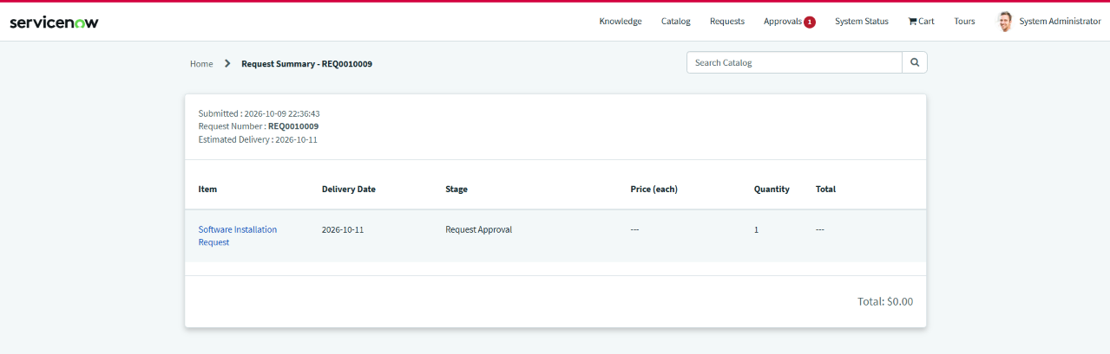
Repository evidence: ServiceNow request summary, not a Power BI report.

