Project Development Phase
Platform Configuration & Integration Verification
Date | 12-10-2026
Team ID | Individual participant - 323103312124@gvpce.ac.in
Project Name | Software Installation Request - ServiceNow
Maximum Marks | As specified by template

Platform Summary
The implementation platform is ServiceNow. Salesforce is not identified as part of the project. The relevant integration points are the Service Catalog, Flow Designer, standard request records, approval records, Catalog Tasks, portal/status views, and outbound email service.
Verification area | Expected result | Evidence to retain
Catalog variables | Software name, version, business justification, and urgency map to request fields. | Catalog item configuration and submitted record.
Flow trigger | Flow runs for the intended Requested Item event/state. | Flow Designer configuration and execution details.
Approval | Manager decision is linked to the Requested Item. | Approval record.
Task creation | Approved request creates linked Catalog Task assigned to Software group. | SCTASK and assignment fields.
Email | Configured notifications are generated after relevant events. | Outbound email logs.
Update Set | Configuration package can be reviewed and moved according to deployment procedure. | Update Set status and import/preview/commit evidence, if performed.

Accuracy / confidence fields from the source template
Training accuracy, validation accuracy, and YOLO confidence scores are not applicable. Workflow correctness should be reported using executed functional test results, not an invented model-accuracy percentage.
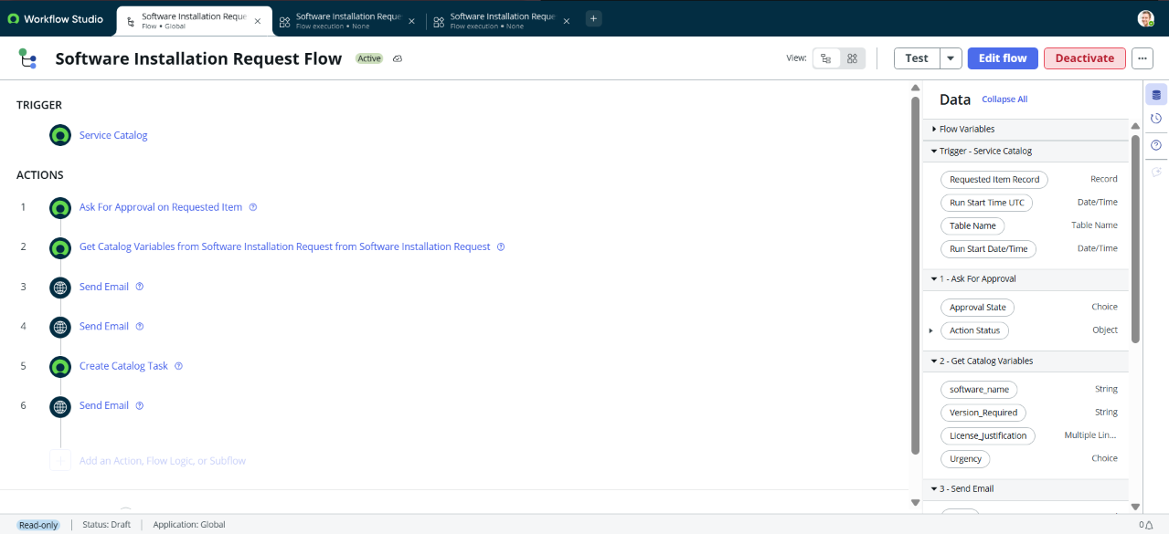
Repository evidence: ServiceNow Flow Designer.

