Project Development Phase
Request Status & Usability Review
Date | 12-10-2026
Team ID | Individual participant - 323103312124@gvpce.ac.in
Project Name | Software Installation Request - ServiceNow
Maximum Marks | As specified by template

UI / Status Review
No Tableau workbook, dashboard, calculated fields, or story is identified in the project materials. The equivalent review concerns the ServiceNow catalog form, request summary, status visibility, and clarity of user-facing workflow states.
Review area | Expected behavior | Review evidence
Data displayed | Request summary shows the request reference and relevant status information. | ServiceNow request summary.
Input preparation | Catalog form labels and validation help users provide complete request data. | Catalog item form.
Search / filters | Users can locate the catalog item through the available portal navigation/search. | Portal navigation evidence.
Calculated fields | No Tableau calculated fields are documented. | Not applicable.
Dashboard / story | No Tableau dashboard or story is documented. | Not applicable.
Usability | Requester can understand what to submit and how to track progress. | UAT observations and user feedback, once collected.

Review checklist
- Labels are understandable and consistent.
- Required fields are clear before submission.
- Confirmation exposes a usable request reference.
- Approval and rejection outcomes are communicated clearly.
- Status wording helps the requester understand the next step.
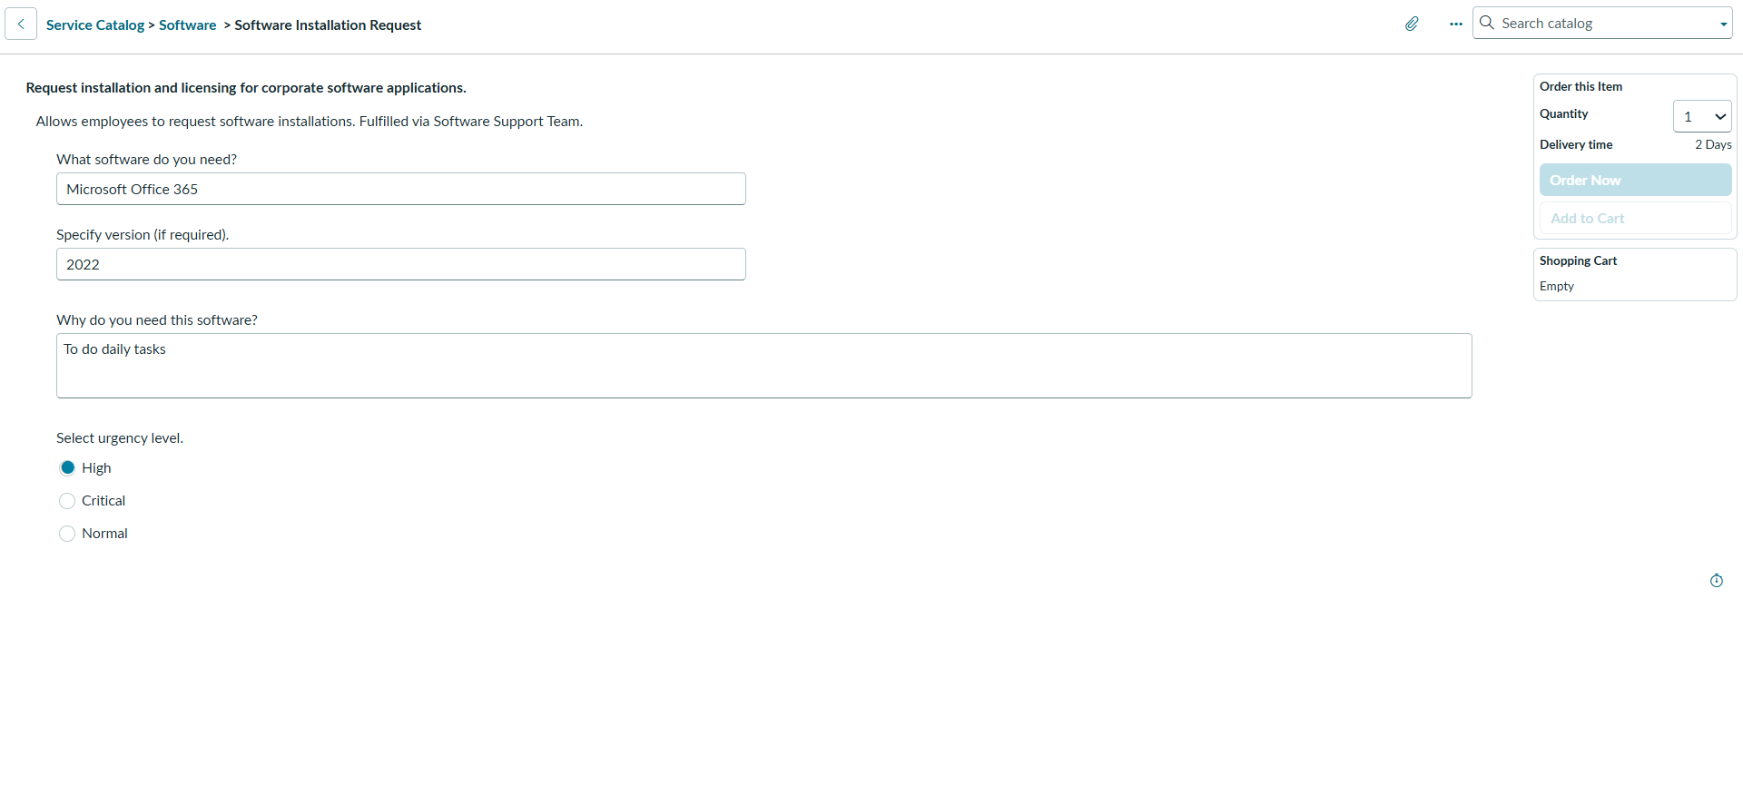
Repository evidence: ServiceNow catalog form, not a Tableau artifact.

