Project Planning Phase
Project Planning Template — Product Backlog & Schedule
Date | 12-10-2026
Team ID | Individual participant - 323103312124@gvpce.ac.in
Project Name | Software Installation Request - ServiceNow
Maximum Marks | 5 Marks

Planning basis
This plan follows the repository's documented implementation sequence rather than imposing arbitrary Scrum dates. The repository describes requirement analysis and update-set preparation, backend data/workflow configuration, catalog UI/UX, testing and migration, then deployment documentation. Sprint labels and story points below are planning estimates for organizing the work; the supplied ZIP does not include a verifiable Git commit history or actual sprint records.

Product Backlog, Sprint Schedule, and Estimation
Sprint | Functional Requirement (Epic) | Story No. | User Story / Task | Story Points | Priority | Team Members
Phase 1 | Requirements & data model | USN-1 | As an administrator, I want the request scope and core table relationships defined so the build has a clear baseline. | 2 | High | Individual
Phase 1 | Update Set baseline | USN-2 | As an administrator, I want the initial configuration packaged in an Update Set so it can be tracked and moved. | 2 | High | Individual
Phase 2 | Catalog data architecture | USN-3 | As the workflow, I need Requested Item and Catalog Task fields/relationships configured to retain request context and assignment. | 3 | High | Individual
Phase 2 | Business Rules | USN-4 | As the system, I need the configured Requested Item rule to run on the relevant Pending-state transition. | 2 | Medium | Individual
Phase 2 | Approval automation | USN-5 | As a manager, I need the catalog request routed to me for approval so the business need is reviewed before fulfillment. | 5 | High | Individual
Phase 2 | Approved fulfillment | USN-6 | As the fulfillment team, I need a linked Catalog Task assigned to Software after approval so approved work has clear ownership. | 3 | High | Individual
Phase 3 | Catalog item & variables | USN-7 | As an employee, I want a Software Installation Request catalog item with software name, version, justification, and urgency fields. | 3 | High | Individual
Phase 3 | Usability & portal | USN-8 | As an employee, I want required-field validation, help text, and portal search/status access so I can submit and track a request. | 3 | High | Individual
Phase 4 | End-to-end validation | USN-9 | As a tester, I want to verify REQ/RITM/SCTASK linkage, approval routing, task assignment, and configured email generation. | 5 | High | Individual
Phase 4 | Update Set migration | USN-10 | As an administrator, I want the update set completed, exported, previewed, and committed in a target instance to check migration readiness. | 3 | Medium | Individual
Phase 5 | Setup manual & handover | USN-11 | As a reviewer, I want setup instructions and implementation screenshots so the solution can be recreated and demonstrated. | 2 | Medium | Individual

Phase-level schedule (sequence-based; not historical sprint dates)
Phase | Repository-backed work package | Dependency / exit condition | Planned story points
Phase 1 | Requirements, scope, stakeholder roles, table mapping, baseline update set. | Scope and core records identified before configuration. | 4
Phase 2 | Data architecture, Business Rules, Flow Designer approval and task creation. | Approval and task path ready for catalog integration. | 10
Phase 3 | Catalog item, variables, mandatory validation, tooltips, portal search and status. | Employee can submit and track a request. | 6
Phase 4 | End-to-end checks, record linkage, email logs, update-set export/import. | Core request path and migration package checked. | 8
Phase 5 | Setup manual, screenshots, deployment documentation and presentation. | Recreation and handover materials prepared. | 2
Total | Sequence reflects the repository's five implementation phases. | Estimates only; actual velocity is not available. | 30

Project Tracker, Velocity & Progress Review
The template asks for actual sprint start/end dates, completed story points, release dates, velocity, and a burndown chart. The supplied repository ZIP documents implementation phases and screenshots but does not provide dated sprint records or a daily task log. Therefore, actuals are marked “Not recorded in supplied evidence”; no historical dates or completion metrics are fabricated.

Project tracker
Work package | Planned points | Duration | Start date | End date | Points completed | Release date
Phase 1 | 4 | Not recorded | Not recorded | Not recorded | Not recorded | Not recorded
Phase 2 | 10 | Not recorded | Not recorded | Not recorded | Not recorded | Not recorded
Phase 3 | 6 | Not recorded | Not recorded | Not recorded | Not recorded | Not recorded
Phase 4 | 8 | Not recorded | Not recorded | Not recorded | Not recorded | Not recorded
Phase 5 | 2 | Not recorded | Not recorded | Not recorded | Not recorded | Not recorded
Total | 30 | — | — | — | Not recorded | Not recorded

Velocity calculation
Velocity is the number of story points completed in a sprint. Since actual completed points and sprint durations are not present in the supplied repository, actual velocity and average velocity cannot be calculated responsibly. For future tracking, use:
Velocity = story points completed in the sprint
Average velocity = total completed story points ÷ number of completed sprints

Progress / burndown handling
No burndown chart is included because a truthful chart requires daily remaining-work data or sprint-level actuals, neither of which is present in the repository ZIP. This follows the instruction to avoid generic bar graphs and prevents presenting invented progress as project evidence.

Repository evidence used
Repository artifact | Planning evidence derived
Phase 1 README | Requirements, stakeholders, scope, table mapping, and update-set baseline.
Phase 2 README | Data architecture, Requested Item business rule, Flow Designer approval and task creation.
Phase 3 README | Catalog item, software_name/version_required/license_justification/urgency variables, portal navigation, validation and status.
Phase 4 README | Flow-to-catalog binding, sc_request/sc_req_item/sc_task linkage, update-set export/import, end-to-end verification.
Phase 5 README + SETUP_MANUAL | Deployment/recreation steps and screenshots for catalog setup, Flow Designer, portal submission, task assignment, and email logs.

Implementation evidence (repository screenshots)
Selected screenshots from the repository illustrate the real configuration artifacts behind the plan:
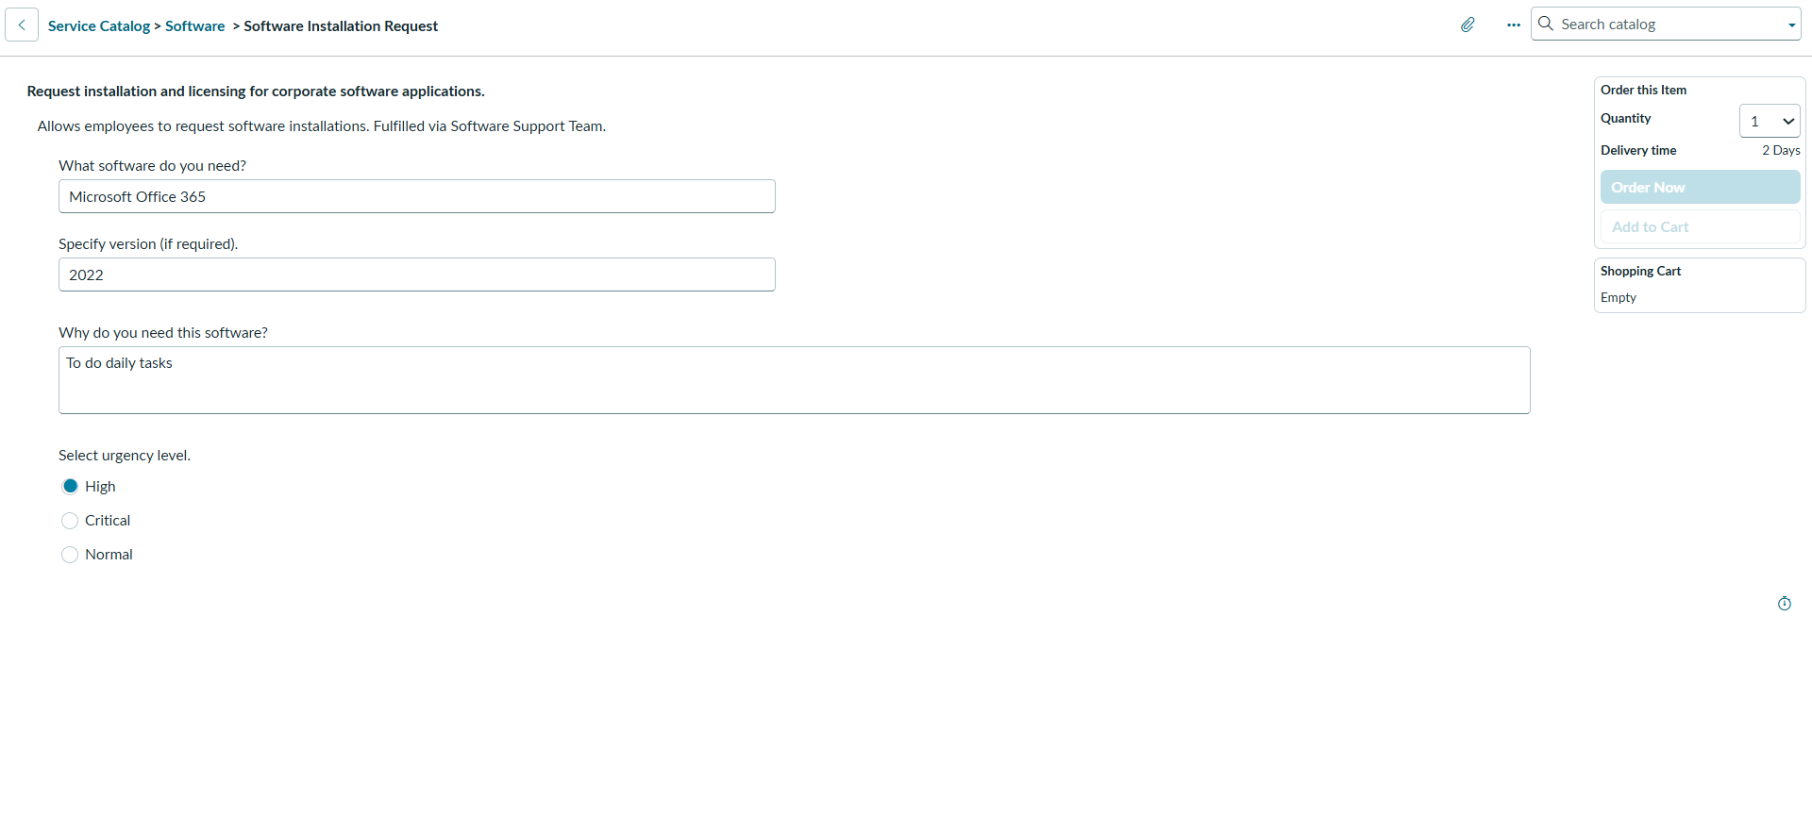
Catalog item form — UI/UX configuration
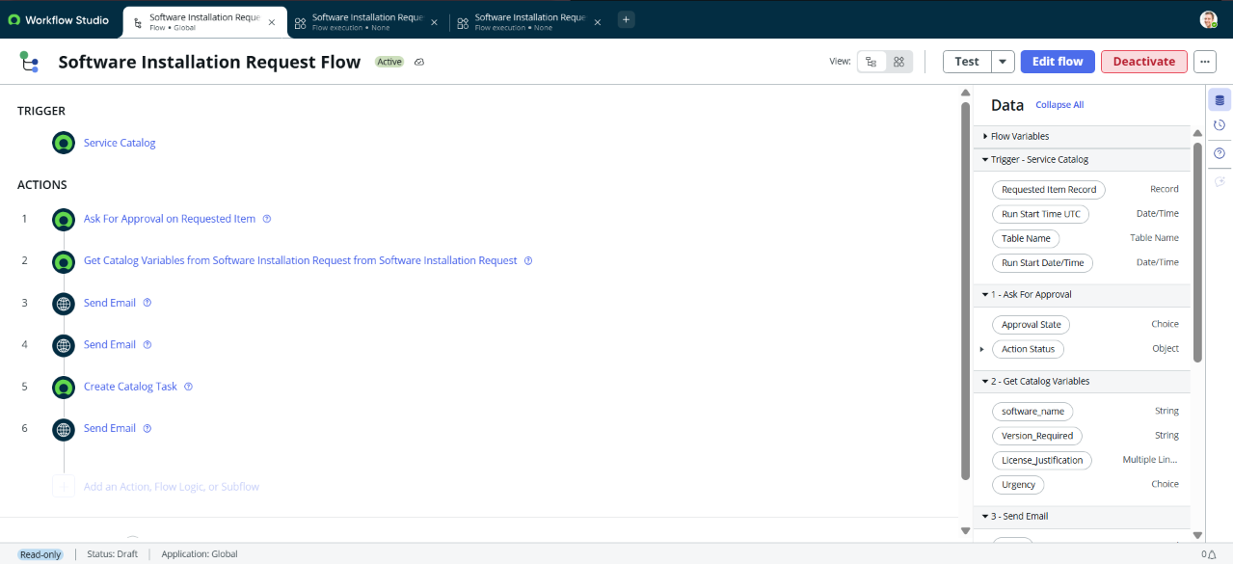
Flow Designer canvas — approval and automation

Planning note
Story points are relative estimates for organizing the documented work, not values from a recorded planning meeting. The phase ordering is based on the repository's implementation documentation. To convert this into a historical tracker, add actual Git commit dates, sprint boundaries, and verified completed work.

