  SNIR 2 SNIR2 | LAN PARTY |     ESLA

Your mission:

You are entrusted with the organization of a LAN party in a sports hall. 300 guests will be present.
The place needs to be equipped with an ADSL box, 188 desktops (connected with RJ45 plugs), and 100 Wi-Fi connected laptops.

- TASK 1: Observe the diagram of an ADSL box and fill in the caption.

- TASK 2; Look at the map of the sports hall and choose the CISCO equipment you will need on https://www.amazon.com

- FINAL TASK ; Project the map of the sports hall on the white board and use it to explain the solution you have envisaged.

EXTRA HELP:
You may find some help from the following video:
https://www.youtube.com/watch?v=8J00rfZE17Y
The speech delivery being quick, you are exceptionally allowed to use subtitles.

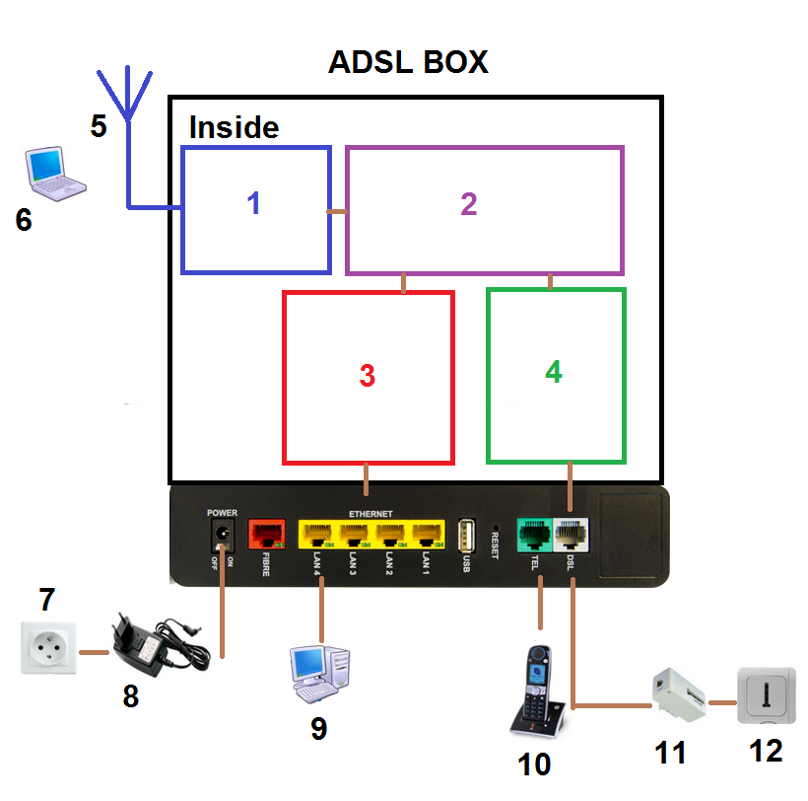
1 Router
2
3 Ethernet switch
4 Modem
5 Wifi antenna
6 Laptop
7 Plug
8 Power supply
9 Computer
10 Fixed line phone
11 ADSL filter
12 Phone plug
