Doc1
What is Joomla !

Joomla also spelled Joomla! (with an exclamation mark) and sometimes abbreviated as J!, is a free and open-source content management system (CMS) for publishing web content on websites. Web content applications include discussion forums, photo galleries, e-Commerce and user communities and numerous other web-based applications.


10 advantages of using Joomla

- Joomla is developed in open source so that everyone can download it for free. It uses PHP as the primary language and supports MySQL alongside. | - PHP and MySQL in Joomla make it possible for many volunteers to continue their contributions in optimizing the code and creating new extensions.
- It costs money to hire people to configure it. However, if you download Joomla now, you can instantly have a website and easily configure it all at free cost. | - Joomla is well suited for setting up an online store. Joomla has number of shopping cart extensions which lets you create e-commerce website easily and smoothly . Shopping carts need to be secure and need to avoid the spams.
- On the login form, you can add CAPTCHA and secure your store from spammers. Here is the official documentation to add ReCAPTCHA on your Joomla website. | - The backup extension allows you to backup your e-commerce store. It has everything you need to keep your website steady, including tracking your website analytics, social marketing, affiliate marketing, and SEO optimization.
- Joomla offers a straightforward menu creation tool that benefits people without any experience. | - Joomla supports PHP, so you don't have to write lengthy code when you want to add features to your website.
- Joomla offers multilingual support, enabling you to build the leading site in English and create the same website in other languages . Supporting multiple languages on your website is essential if you have many visitors from foreign countries. | - Because of PHP, you can connect to the database more efficiently. PHP has a memory of its own, which reduces the server load and increases the processing speed.

Doc2

Sites using joomla

It currently powers over 6.1% of all websites. While Joomla is slowly fading in popularity, it will still remain one of the best CMSs out there, see: Is Joomla! It sits in between WordPress – at the first position – and Drupal – at the third position – in terms of popularity. There are many popular sites that are built on Joomla.


Harvard University
Harvard is one of the most prestigious universities in the world and also one of the oldest in the US. It was built in 1986.
It is a testament to Joomla’s capabilities to have hosted Harvard University website for quite a long time.


IKEA
IKEA is a prominent ready-to-sell furniture store using Joomla websites. Based out of Sweden, it has branches all over the world and its furniture is regarded of highest quality. As one of the best furniture makers, it requires the power of the best CMS platform.

LINUX

Linux.com is the hub of information related to Linux documentation, software, technical questions, and how-to’s relevant to desktop, laptop, mobile and netbook platforms. It has a customized template built with Joomla . It uses several extensions for Joomla websites such as the Frontpage Slideshow and Community.


Lipton Ice Tea
Lipton Ice Tea website is a portfolio dedicated to Lipton products that uses Joomla websites . It showcases various different flavours, and highlights some popular recipes made with it.

Doc3
Breakdown of joomla market share and CMS 2020 usage

When we talk about CMS (Content Management System), these famous software that allow you to easily create websites and update their content, the name of WordPress comes up very quickly as a reference. But it is not alone in this competitive market, even if its many strengths have made it an essential reference. WordPress is the CMS which knew the fastest development in 2017, for the eighth consecutive year! In the last 12 months, it is ahead of Shopify and Squarespace.
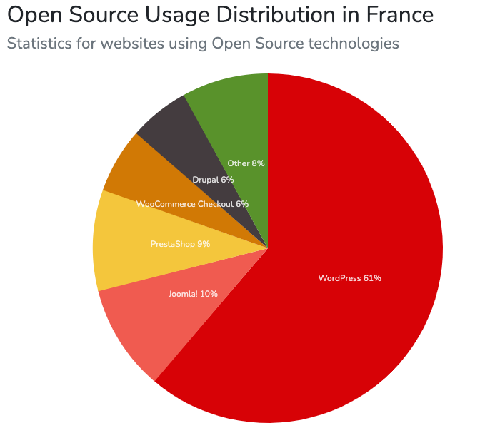
TOP 3 CMS

#1 WordPress
#2 Joomla
#3 PrestaShop
CMS market share over time (without WordPress)
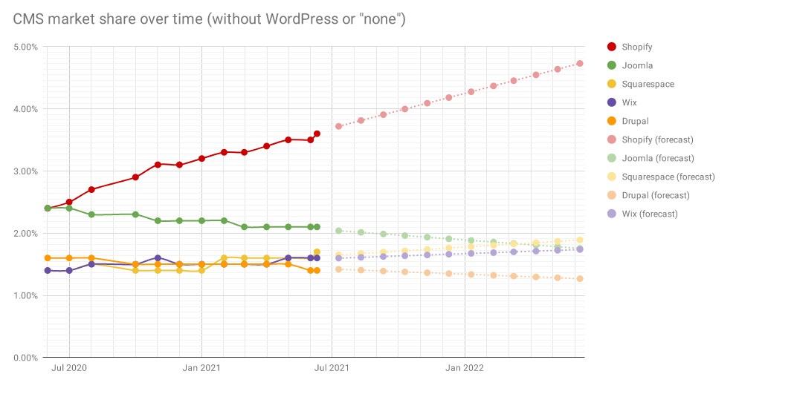
WordPress has seen tremendous growth in these numbers, adding 0.3% to 0.4% market share month over month for many months in a row now.
A large part of the growth of WordPress is driven by WooCommerce, which has grown incredibly as well. Drupal and Joomla decline.
Unlike WordPress, the other “formerly big open source CMSes” continue to decline. So much so that if they continue their current trends, Joomla and Drupal will be the #4 and #5 CMSes in the world by this time next year.

