“The Sharn Inquisitor Archive” Site Plan

[Matthew Hilton]

WDD 130

Overview

Purpose
I’m part of my campus D&D club’s Newspaper Guild, which publishes short articles about events happening each week across the different games (which are all in the same setting). Each week about 10–25 games take place, and the newspaper—The Sharn Inquisitor—reports on the major events and stories that come out of them, since no one can attend every game every week. Right now, all the articles are buried in a Discord thread, which makes them hard to find or revisit. This will be a simple website that acts as a central archive for the newspaper, which also doubles as a [somewhat] recorded history of the club.

Audience
Other members of the D&D club -- especially the ones who actually care about keeping up with the lore, as well as club leaders who want to have an archive of the club’s (and the campaign’s) history.

Branding

Website Logo

If you need a logo here’s an AI-generated one, but honestly I don’t feel the need for a logo in the first place. My first choice would be to just not bother with one.

Style Guide

Color Palette
Primary | Secondary | Accent 1 | Accent 2
#687351 | #9BA17F | #E8E4DB | #C9C1AE

(plus white & black, of course)

Typography

Heading Font: Manufacturing Consent

Subheading Font: Quintessential

Paragraph Font: EB Garamond

Navigation
Home Article 1 Article 2 About the Inquisitor

Content

[put all content for the pages here, including written text and images]

Home
[See wireframe for layout details. Note that not every article in the “timeline” section has a corresponding image.]

Welcome to the Archive!

Welcome to The Sharn Inquisitor Archive, the online repository for The Hold’s one and only newspaper. This site is meant to act as an online hub for all the articles that have been written by the newspaper guild; ideally, it could also function as an archive for the lore of The Hold itself, since there’s no place that currently keeps records of all that information.

Below is a timeline of [hopefully] all currently published articles, from newest to oldest. Clicking on an entry should take you to that article’s page.

If you have anything you’d like us to report on, you can get ahold of us here. [<- link to the ‘About’ page]

Articles - Authors - Dates
Gugalanna Games Show Early Signs of Guild Conflicts – Sam Sabula - 2/26/26
The Smart Vote is the Fool? – Truman Gottem – 2/28/26
Skrix: Outcast Turned Protector – Truman Gottem – 2/28/26
Discrimination in the Gugalanna Games? – Sam Sabula - 3/1/26
Justice for Orlando – Truman Gottem – 3/7/26
Lycanthrope Cult bombs the Hold! – The Fool Called V – 3/8/26

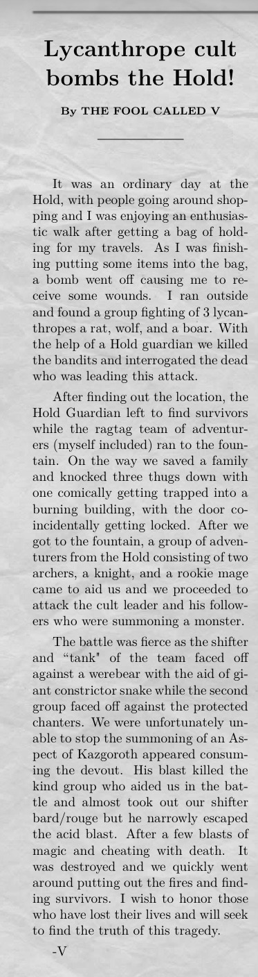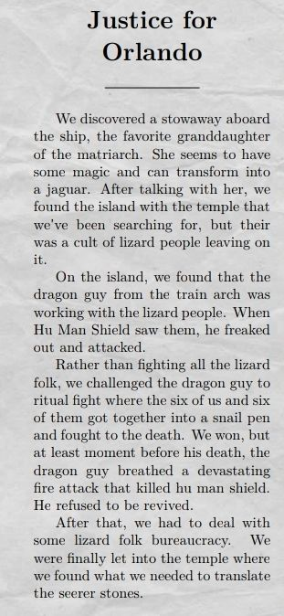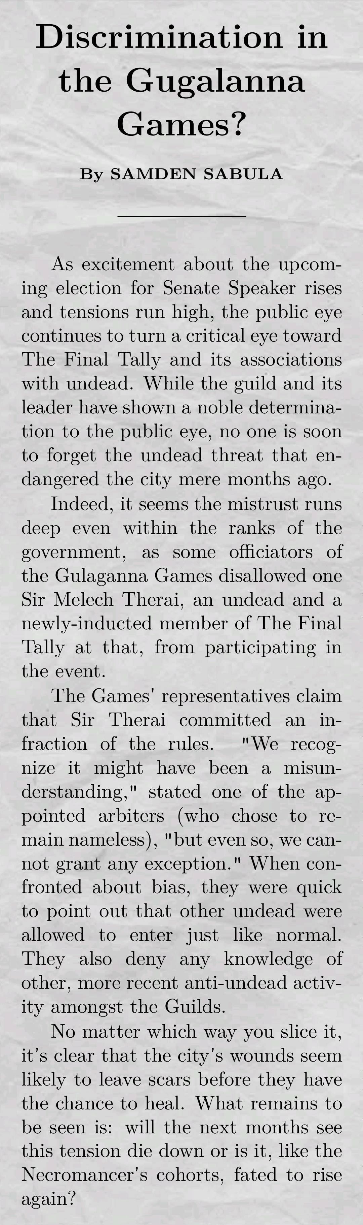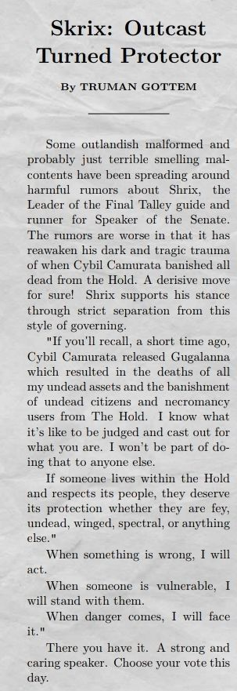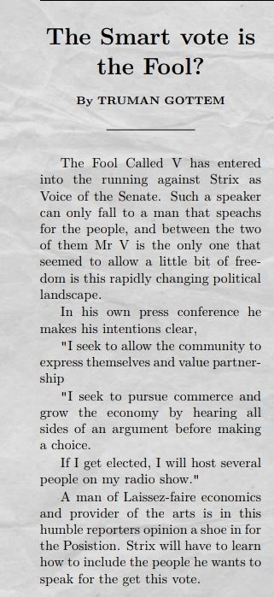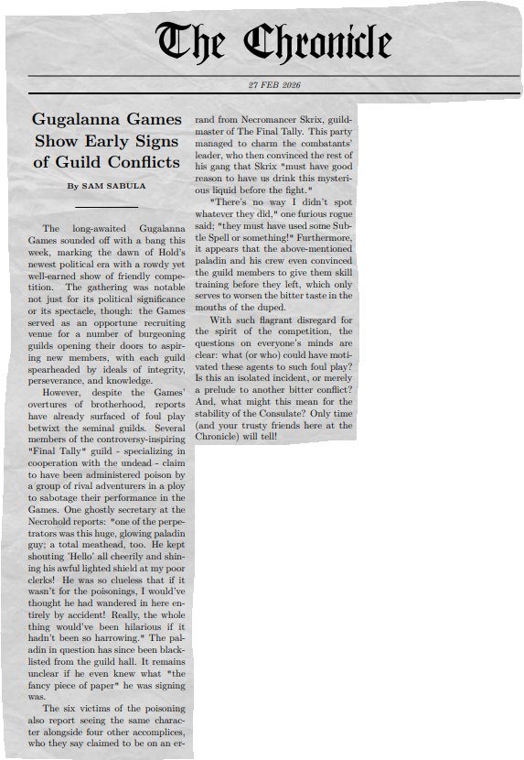

Article 1
[This and the page below (“Article 2”) will have the same layout (see wireframe(s)). I didn’t want to ask you to make a page for every article (unless you know how to do that do that easily, then by all means please do!) – but either way, I don’t have access to the raw text of every article (and I don’t want to type them out by hand…) so I chose one with the raw text and one without. These should both be linked in their corresponding timeline entries on the homepage, and the latter should be linked to a “Most Recent Article” button on the homepage.]

Discrimination in the Gugalanna Games?

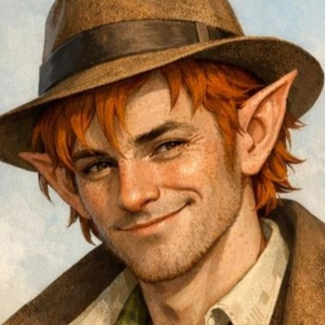 by Sam Sabula 03-01-26

As excitement about the upcoming election for Senate Speaker rises and tensions run high, the public eye continues to turn a critical eye toward The Final Tally and its associations with undead. While the guild and its leader have shown a noble determination to the public eye, no one is soon to forget the undead threat that endangered the city mere months ago.

Indeed, it seems the mistrust runs deep even within the ranks of the government, as some officiators of the Gulaganna Games disallowed one Sir Melech Therai, an undead and a newly-inducted member of The Final Tally at that, from participating in the event.

The Games' representatives claim that Sir Therai committed an infraction of the rules. "We recognize it might have been a misunderstanding," stated one of the appointed arbiters (who chose to remain nameless), "but even so, we cannot grant any exception." When confronted about bias, they were quick to point out that other undead were allowed to enter just like normal. They also deny any knowledge of other, more recent anti-undead activity amongst the Guilds.

No matter which way you slice it, it's clear that the city's wounds seem likely to leave scars before they have the chance to heal. What remains to be seen is: will the next months see this tension die down… or is it, like the Necromancer's cohorts, fated to rise again?



Article 2
[no source text available – see notes on above page]

Lycanthrope Cult bombs the Hold!

[no author image available]
by The Fool Called V 03-08-26



About the Inquisitor
[Note that I only have pictures for two of them, so you’ll need to find some kind of default/blank/placeholder image for the third one]

About The Sharn Inquisitor

The Hold’s premier (and only) newspaper is run by the city’s Newspaper Guild! It’s still just growing, but here are the important people who make all of this possible!
(Note: This page doesn’t get updated very often, so it’s quite possibly incorrect! Check the Discord server for the most up-to-date information on the Guild & its members.)

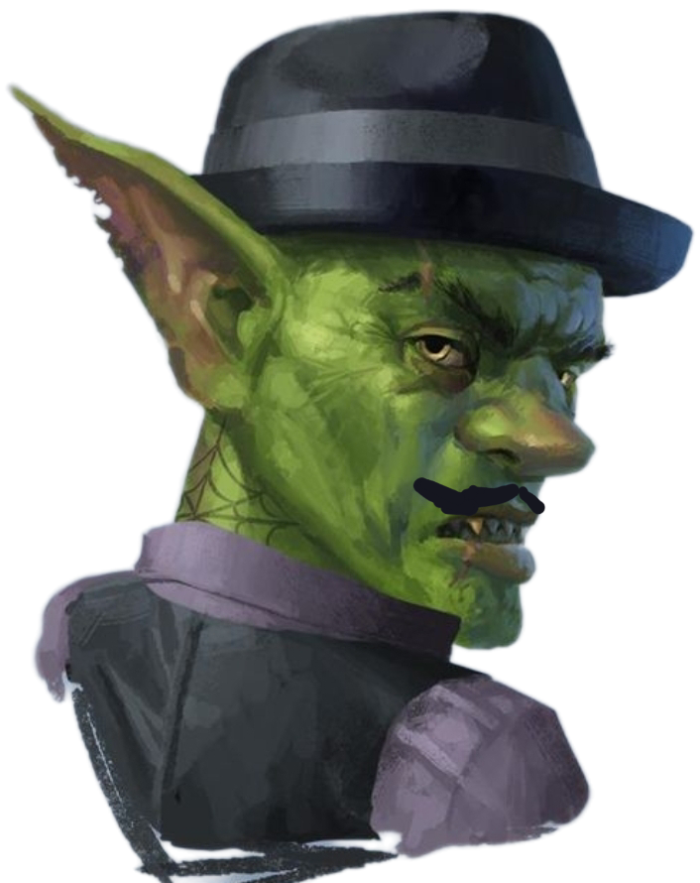
Truman Gottem
Half gnome, half goblin (class unknown)
Guildmaster & Editor-In-Chief
Created by Joseph (@jasonssecondalt on Discord)

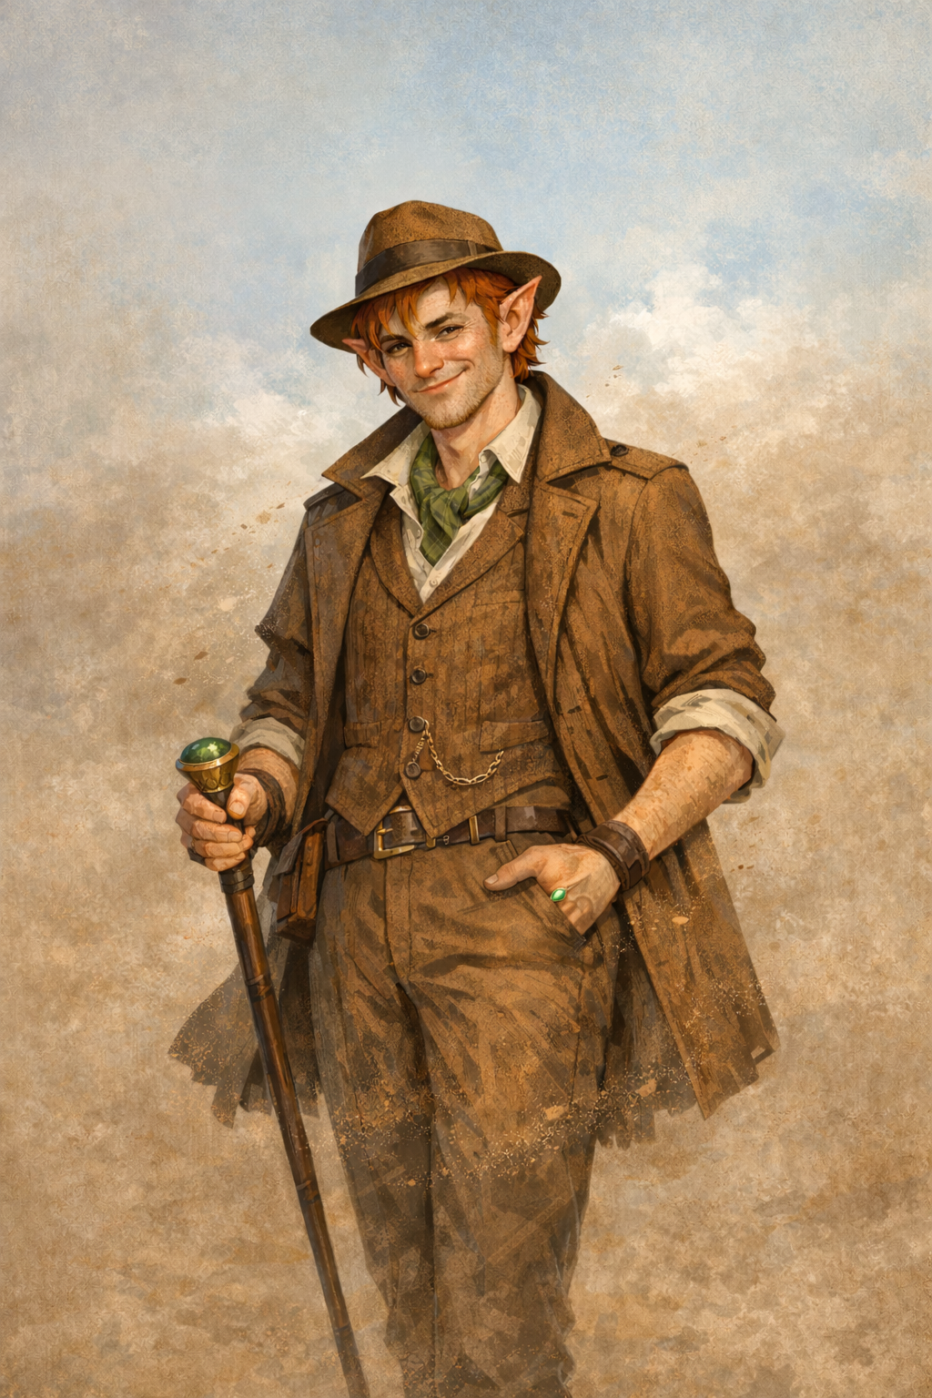
Sam Sabula
Half-elf Warlock
Reporter
Created by Matthew (@mattcraft900 on Discord)

[no image available]
The Fool Called V
Human Bard
Reporter
Created by (@thetimelessfool on Discord)

Wireframes

Home Page Wireframe

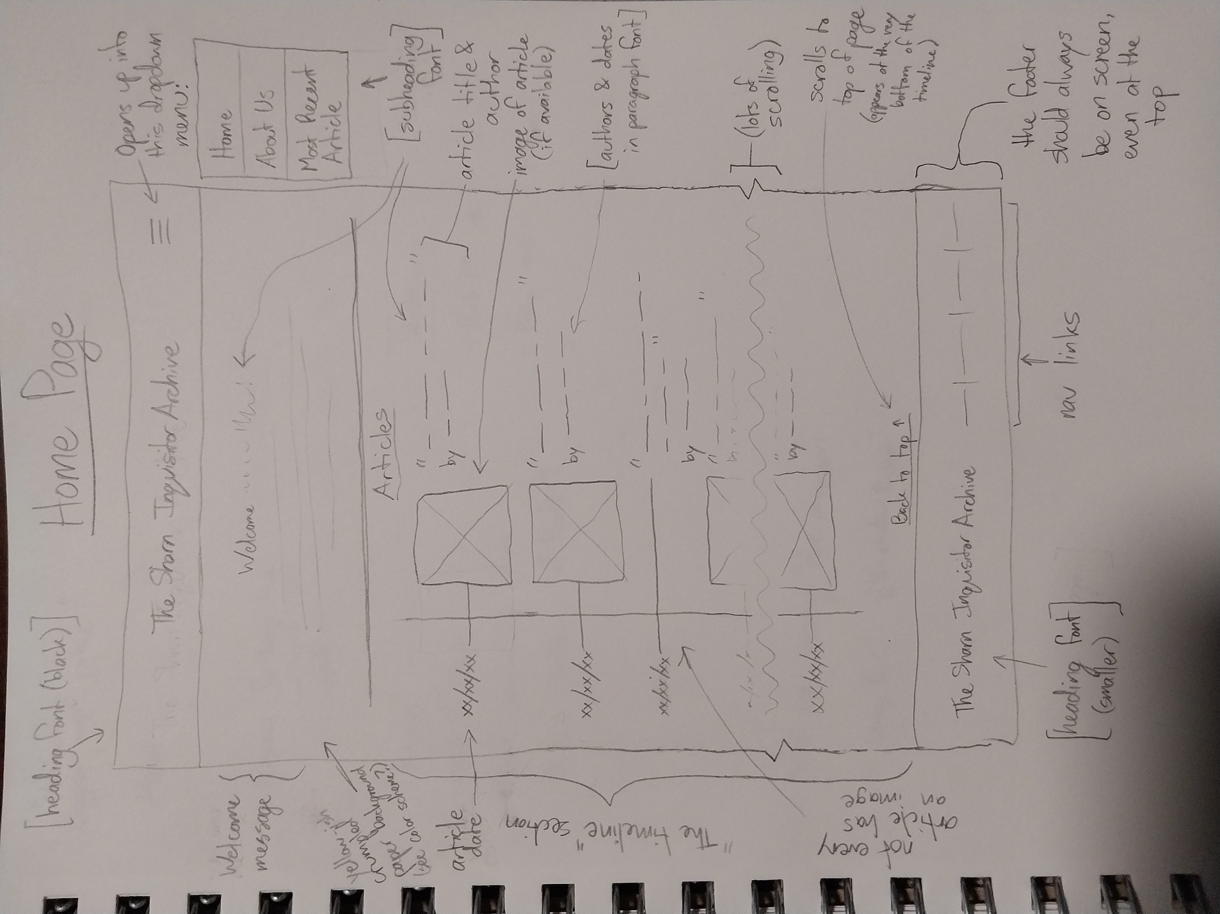

Articles 1&2 Wireframe (same design for both)

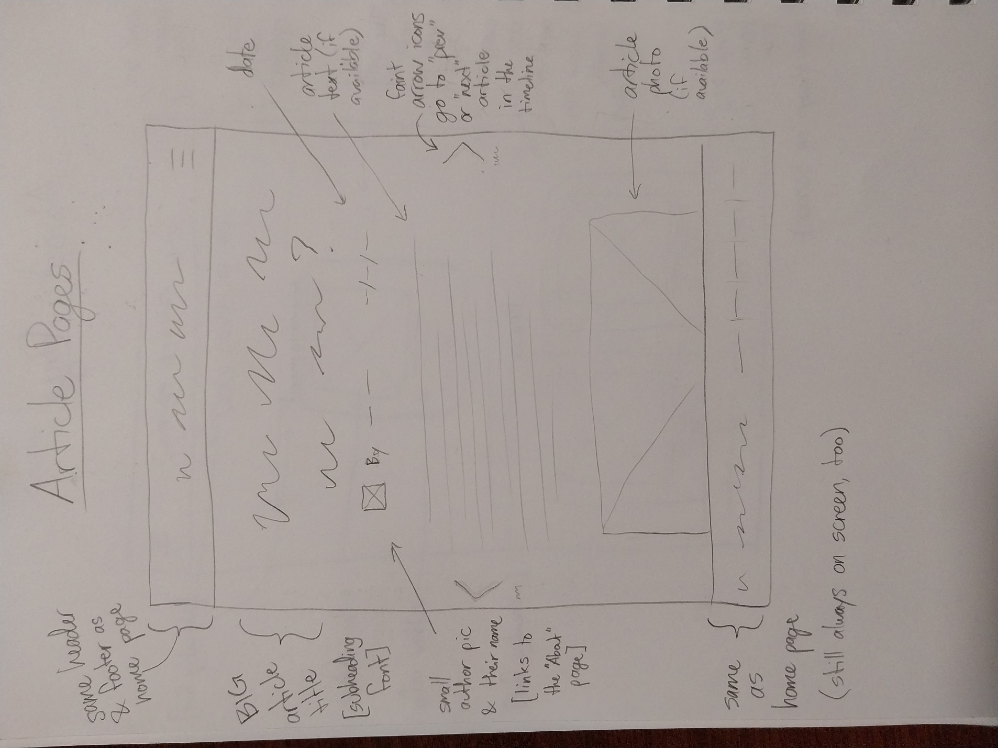

“About” page Wireframe
