5. Discussion

5.1 What the thesis set out to do and what it delivered
The main contribution of this thesis is a quality framework that the investigational site runs for itself during conduct, derived from ICH E6(R3), ISO 14155:2026, and MDR Annex XV _{[8, 10]} and fitted to the site with the least support. Conducting an investigation well and showing that the site controlled its conduct are separate achievements. Under the older arrangement the sponsor assured quality through monitoring visits and source data verification, together with audit, and held the evidence that the conduct had been controlled, so the site needed no account of its own processes. ICH E6(R3) now asks the investigator to put processes in place and to make sure that qualified staff and adequate resources support quality at the site _{[6]}, without saying what the site should produce to show it. A party that shares responsibility for quality has to be able to show how it carries its share, and the framework gives the site the means to do so. The thesis delivered this framework as a design, with each component traced to the analysis that produced it, and whether it improves conduct in a real site is a question the thesis prepared and did not answer.
The framework asks the site to act as a quality agent in its own right. The sponsor still designs the investigation and decides what is measured, and the site still executes the protocol. In a multicenter investigation, however, the sponsor cannot assess the specific risks of each site and build controls for each of them. Some of the most consequential risks are local, such as the way a team captures implant identifiers or positions a shoulder for imaging, together with each surgeon's progress through the first cases. The site is the only party that sees these risks as they arise. Every quality activity above it, from the sponsor's planning to central monitoring, rests on the conduct the site performs, and neither planning nor monitoring can recover data that were badly produced at the base. A site without a quality structure depends on what the sponsor asks and corrects its errors after someone else detects them, while a site with one can anticipate part of its failures and prevent them. Responsibility in this sense is a proactive role, in which the site understands the weight of its actions and keeps improving them, while final responsibility for the investigation stays where the regulations place it. We found no published framework that gives the site this role in device investigations, although the successive revisions of ICH guidance point toward sites being asked to show it.
The plan described a comparison of texts and the requirements drawn from it, followed by a framework that answered them, but the design needed more than that. Placing the controls against the course of an investigation showed that the moment of a control matters as much as its content, because an error made while an implant is fixed cannot be corrected afterward, and this led to the lifecycle. The registry analysis then showed that nonhospital organizations hosted almost a third of the site records, so the framework had to work first where it could assume the least support, which produced the scalability model and its minimum level. Finally, a set of records turned out to be insufficient on its own, since a problem can sit unnoticed in several records that nobody reads together. The instruments were therefore built to pass information from the record of one event to a decision about how the site works. None of these elements was among the objectives, and they are what turns a list of instruments into something a site can run.
The observation of the surgeon during conduct delivered less than we hoped, because it is the most original part of the framework and also the part with the weakest derivation, since no clause asks for it. The indicators have rules and thresholds that are provisional, because we found no published values for site-level indicators of this kind. In hindsight, the order of the work also left a mark on the result. We derived the requirements and designed the full set of instruments before the scalability model was settled, and the minimum level was then obtained by removing instruments and naming proxies for them. A design that started from the minimum level and added instruments as capacity grew would probably have produced a smaller and more economical set.
Gregor and Hevner classify a design contribution by how mature its problem and its solution are, and they call the transfer of a known solution to a new problem an exaptation [ref: Gregor and Hevner 2013]. Most of the framework is a contribution of this kind. A documented quality system is an established solution, run by the manufacturer under ISO 13485:2016 and ISO 14971:2019 and by the medical laboratory under ISO 15189:2022 _{[52, 53, 54]}. The problem is recent, since the revised guidelines give the site a larger share of the responsibility for quality without a structure to carry it. For four of the five gaps, the framework takes a principle that the texts state for the sponsor, such as the risk management cycle or continuous improvement, and builds the site-level instrument that the texts leave out. A regulator could derive each of these four duties from duties the site already holds, so in these areas the framework adds organization to obligations that already exist.
Observation of the surgeon during conduct, which answers the third gap, is a contribution of another kind. ISO 14155:2026 allows the sponsor to justify a roll-in phase in the CIP, and the surgical trials literature controls the operator at entry, but none of the texts we compared gives the site a role once the investigation has started. In Gregor and Hevner's terms this part is an improvement, a new solution to a problem the field already knows, and its justification rests on an argument. When the CtQ logic required by the texts is applied to an intervention delivered by a person whose execution changes over time, operator learning becomes a threat to data validity. A qualification at entry cannot control it, because it records a state at one moment while learning unfolds as a trajectory.

5.2 Position in the literature
The works we reviewed address four themes that bear on the framework (Table 5.1), and the text below discusses those that shaped the design.
Table 5.1. Works on quality in clinical investigations grouped by theme, with what each establishes and the response of the framework to each theme.
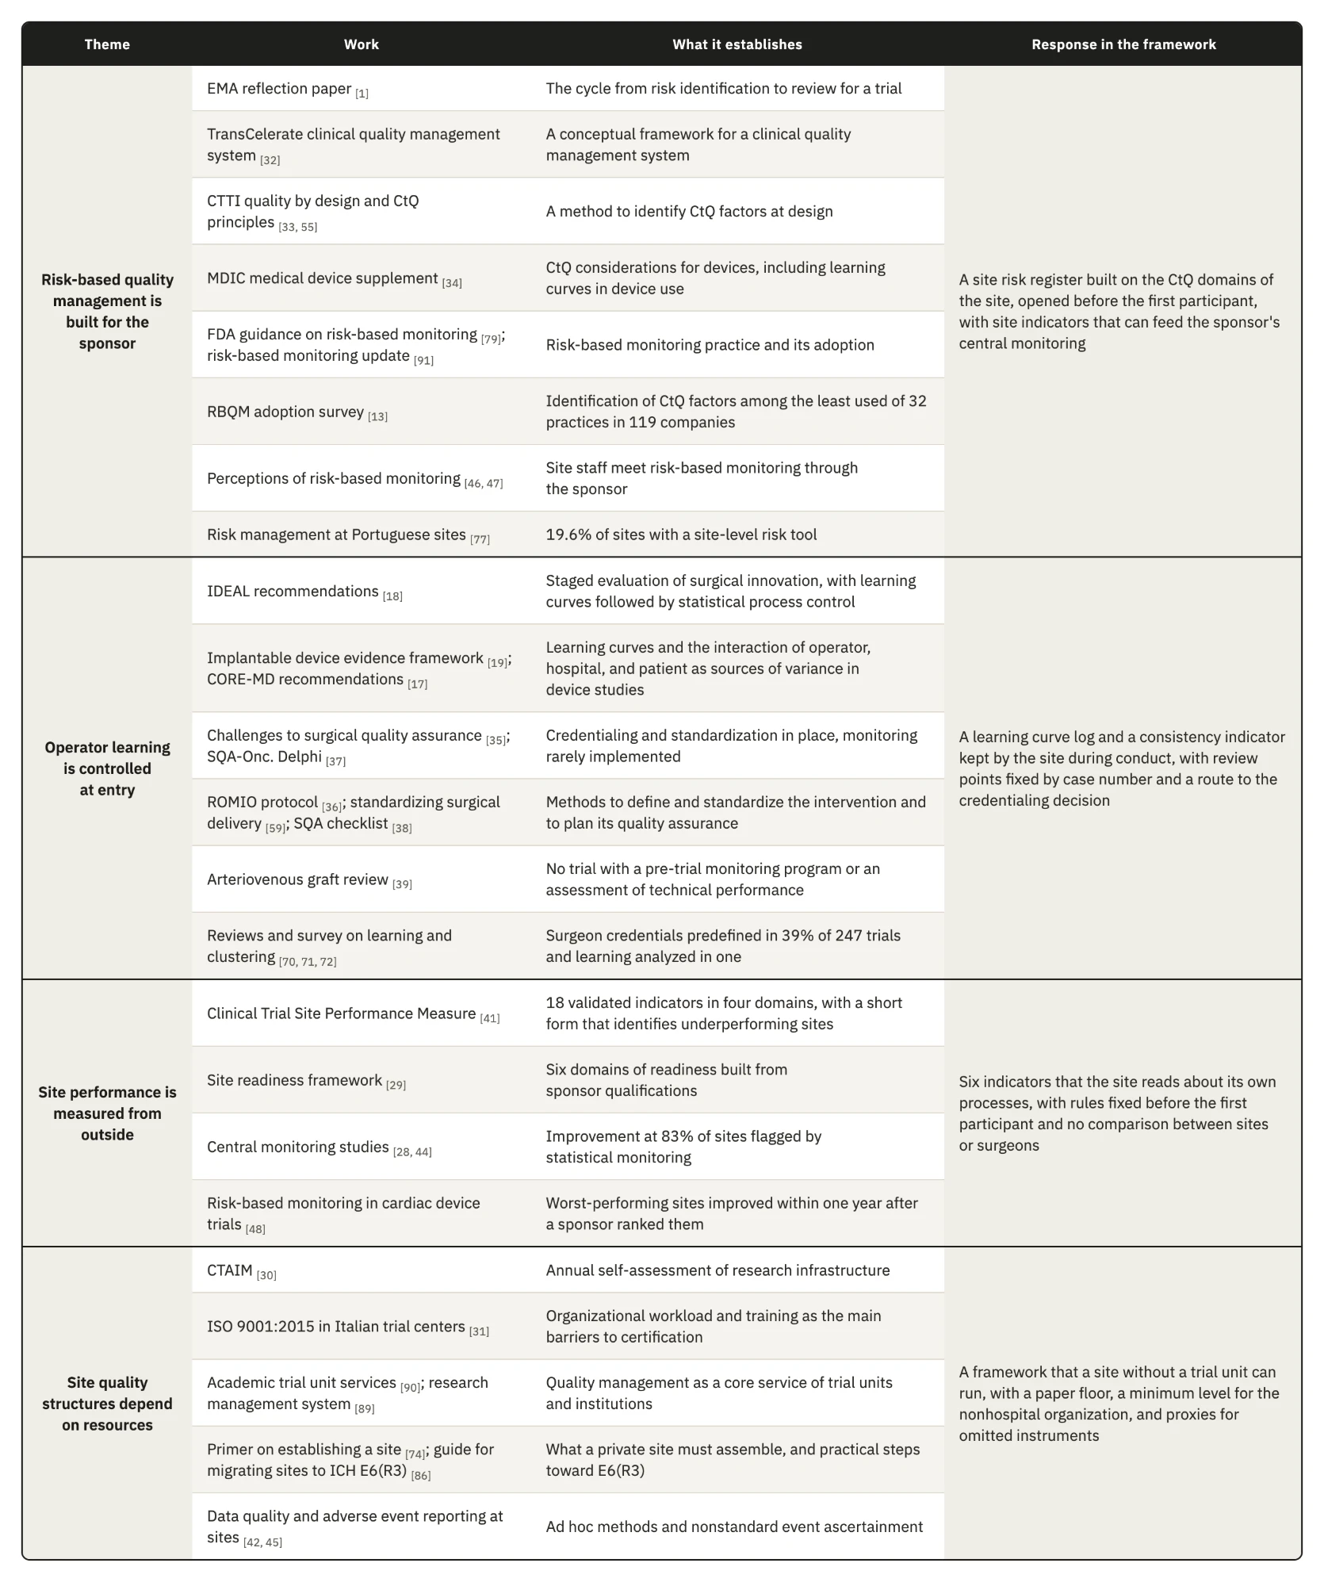
Risk-based quality management was developed for the party that designs and oversees a trial. The EMA reflection paper and the CTTI principles describe how a sponsor identifies critical factors and directs its oversight toward them _{[1, 55]}, and the MDIC supplement carries the same reasoning to devices _{[34]}. Sites meet this work through the sponsor, as a monitoring plan that arrives with the protocol _{[46]}. Only 19.6% of the Portuguese sites in one survey described a tool that captured risk analysis at site level _{[77]}, and in the RBQM adoption survey identification of CtQ factors was among the least used practices even among sponsors _{[13]}. These findings shaped the SRR, which applies the sponsor's risk cycle to the risks created by the site's own execution and starts from the CIP so that it can be built even where the sponsor never formalized its critical factors. In those investigations the site register may be the first place where anyone applies CtQ reasoning to local processes.
Surgical methodology knows operator learning well and controls it before the trial starts. The challenges reported for surgical quality assurance fall under credentialing and standardization, while monitoring during the trial is rarely implemented _{[35]}, and the review of arteriovenous graft trials found no trial that assessed technical performance _{[39]}. Among 247 randomized surgical trials, 39% predefined surgeon credentials and only one analyzed learning _{[72]}. The IDEAL recommendations already proposed statistical process control to follow learning curves _{[18]}, but they addressed the evaluation of an innovation by researchers, so the method never reached the site as a quality control. Our response is the SLCT, which keeps each surgeon's case sequence during conduct, compares each case with the same surgeon's earlier cases of the same complexity, and leads to the credentialing decision when a pattern appears. It uses a structured clinical review in place of formal process control, because a single site rarely has enough cases to set control limits.
Site performance is mostly measured by others. The Clinical Trial Site Performance Measure reduced 126 candidate indicators to 18 in six academic hospitals _{[41]}, and its four domains match four of our six indicators although the two sets were built independently, which gives modest support to our domain analysis. The validated measure includes consent, which our framework covers only through the eligibility record, so a site whose register rates consent as a high risk should add a measure for it. The validated measure also identifies underperforming sites for another party, while our indicators tell one site that one of its processes has started to drift, without comparing sites or surgeons. Central monitoring shows why a signal at the site is worth having. Data quality improved at 83% of 1,111 sites flagged by statistical monitoring, against 56% in two historical studies without it _{[44]}, and in implantable cardiac device trials the worst-performing sites improved once a sponsor ranked them _{[48]}. In both cases the improvement followed a signal that reached the site from outside, and the framework places the origin of that signal inside the site, earlier in the conduct.
The few quality structures that sites hold today depend on resources. The CTAIM supports an annual self-assessment of a research program's infrastructure _{[30]}, and Italian trial centers that considered ISO 9001 certification reported organizational workload and insufficient training as the main barriers _{[31]}. Academic institutions add research management systems and trial units whose senior staff rank quality management among their essential services _{[89, 90]}. A nonhospital organization has none of this, and none of these structures carries the CtQ content of a device investigation. The framework therefore sets its minimum level in the nonhospital organization and asks for no software or dedicated staff, so that the instruments carry the quality function that an academic hospital receives from its trial unit.

5.3 Putting the framework to work
A site starts the instruments in an order set by the lifecycle and by the dependencies between them, which differs from the order by pillar that Chapter 4 used to describe them. The route below assumes the full set of instruments and notes where the minimum level differs.

5.3.1 A route through the lifecycle
1. During feasibility the site decides whether it can take the investigation. It reads the CIP together with whatever the sponsor provides on critical factors and risks, and checks each CtQ domain against its own capacity. The check covers whether radiology can produce the required views within each window and whether the surgeons have experience with comparable procedures. It also covers follow-up, which needs a coordinator for several years. The organizational category of the site gives a first estimate of its implementation level, which the site then checks against its actual staff and services. A device or technique that is new to the surgeons will lead the risk register to add the learning curve log. When the investigation requires controls beyond what the site can run, the site asks the sponsor for support, such as proctoring, or declines. Its answer informs the sponsor's judgment of the site under Clause 6.8 of ISO 14155:2026, and the decision is recorded in the MRL at the academic level and in the POT at the other levels.
2. Start-up opens with the RACI, since no task can be assigned until each of the six functions has a holder and a backup, with a limit of authority for each. When the PI also operates in the investigation, the site names at this point the person who will decide on the PI's own authorization.
3. The site then prepares and releases people in a fixed order. It sets the training each role requires, through the DTRM or the sponsor's requirements, and records each person's release in the TRE once that training is complete. Each surgeon then receives a credentialing decision in the SCR, which takes the release on device training as one of its inputs and places the surgeon in one of the four categories. Only after this do the delegation grades of the CCDM, or the limits recorded in the RACI at the lower levels, become active, so nobody is delegated a task before being released for it.
4. The SRR opens before the first participant. For each CtQ domain the site identifies the factors that its own conduct can affect and links each local risk to the factor it threatens, with a rating and a named owner. Each entry also records its control and the trigger for reassessment. In a shoulder investigation the first entries usually concern implant identifiers that may not be captured in the operating room and intraoperative changes documented too late, followed by imaging positions that are hard to reproduce and visit windows spread over a long follow-up. Because the register decides which optional instruments the site adds to its minimum set, the implementation level is confirmed only after this step.

5. Every rule is fixed before any data exist. The site defines the basis of comparison of the learning curve log, with its complexity levels and expected operative durations, and the support a surgeon receives early on. It sets the thresholds of the complication review and the rule and control values of each indicator, and it writes the scope of internal verification by choosing among the ten checks and setting their sample, together with the reviewer. The source of each critical datum is mapped at the same time, including whether the ICDL serves as the source for the intraoperative data the CIP requires. Finally, the site sets the review frequency of each instrument and the triggers that call for an earlier review. Each rule carries a date, and a later change applies only to future periods.
6. At the review that closes start-up, the PI confirms that these steps are complete and records the implementation level, together with the instruments added because of risk. By this point fifteen of the twenty-four instruments have acted, although no participant data exist yet.
7. Participant records are kept as the data arise. Each person considered enters the screening log, and each eligibility decision is documented in the PSEAR before enrollment, with a second review where a criterion depends on imaging. Image sets enter the IQL at acquisition. In the operating room the ICDL is completed during the procedure, and the learning curve log takes its case entry from it. From the operating room onward, any event opens a case in the SART and an entry in the SCML, and each follow-up visit is documented in the PFVR. Only these five records have to be completed at the clinical moment, and every other instrument reads them.
8. Internal verification runs its first review after the first inclusions, earlier than its routine schedule, and the learning curve review follows each surgeon's first cases, while the first safety review takes place soon after the first procedures. Problems of a new workflow are then found while few participants have been exposed to them.
9. An event that meets an escalation trigger in the CCDM goes to the PI without waiting for the next review, and the POT records the PI's decision.
10. At close-out the site reconciles device accountability and safety cases, and it checks the screening log against the eligibility records before a final internal review. Each corrective action closes with an effectiveness review or with a documented limitation. The PIDLR records the lessons and the standing procedures are revised, after which the instruments that outlive the investigation pass to the next one.

5.3.2 The review cycle
The instruments need a review cycle, but a single rhythm for all of them would not match the work they record. A small site that tried to review twenty-four instruments every month would barely finish one round before the next began. The framework therefore fixes a rhythm only where the risk depends on timing, and leaves the rest to the site, which knows its volume of cases and the people available. The learning curve log is reviewed at set points in each surgeon's sequence, for example after the fifth and the tenth case, because learning shows in the early cases whatever the calendar says. Safety cases are followed within the intervals the CIP sets for reporting. For the other instruments the site chooses at start-up whether a review is monthly or quarterly, or only yearly, according to how much each instrument records and how fast its content changes, and records that choice with the other rules. Periodic review also needs a complement, since a serious adverse device effect or a cluster of complications should start a review at once, and so should a protocol amendment or the departure of a key person.
When a review takes place, the oversight meeting connects the instruments, starting with safety. Open cases in the SART come first, and the CSST counts events by category and component, and by surgeon, against the number of procedures. A signal tied to a surgeon goes to the learning curve review and a signal pointing to the device goes to the sponsor through the deficiency route, while patterns in a local process enter the risk register or corrective action. The surgeons are reviewed next, because operative time can only be read once the meeting knows which cases had complications. This review may confirm stable execution or lead to closer observation and retraining, and in some cases to proctoring. A restriction returns to the SCR and passes to the delegation records, where the ICDL checks it at the surgeon's next case. The indicators and the findings of internal verification follow, and the risk register closes the agenda with the new risks and the triggers met since the last review. The PI records each decision in the POT. Corrective action opens when a first response has failed and closes when the indicator that prompted it returns under control.
The minimum level omits the SLCT and, with it, the instruments that review complication signals and indicators, so the meeting itself does their work. It reads the substitutions recorded in the ICDL and reviews the SART cases together, and it checks follow-up through the FUCR. The minimum level therefore depends on this recurring meeting more than on any single instrument. When meetings are missed, the synthesis that the higher levels spread across several instruments disappears, and no record shows that it is missing.

5.3.3 Where implementation is likely to fail
We applied to the framework the reasoning it asks a site to apply to its own conduct, and looked for the points where a site could operate the instruments and still lose their function. Table 5.2 lists the failures we consider most likely, in the order of the lifecycle, with what each one costs and the guard the design provides. This is our own assessment, made without data from a site, and the list is not complete.
Table 5.2. Our assessment of the most likely failures in operating the framework, ordered by lifecycle phase, with what each failure costs and the guard in the design.
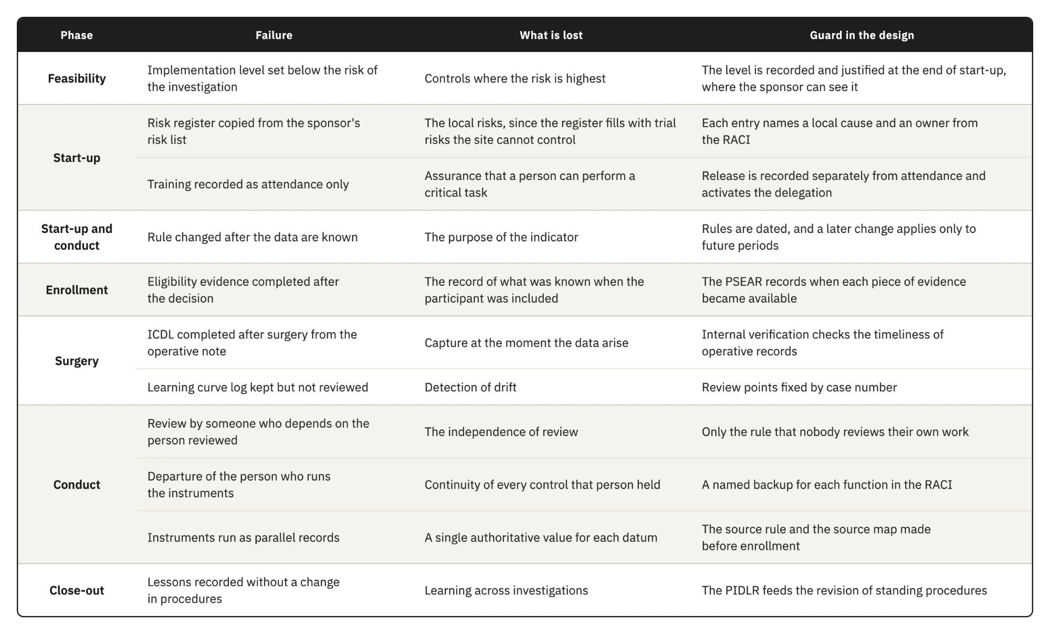
The weakest guard concerns the independence of review in a team of two. The framework only requires that the reviewer is not the person who did the work, and in a surgeon-owned practice the coordinator who reviews the surgeon's operative documentation may be the surgeon's employee. A peer from another site would give that review some distance, as would an arrangement in which two small sites review each other's records, and a sponsor's monitor could examine the internal reviews at each visit. None of these options is part of the current design.

5.3.4 What the framework is expected to change
Each instrument takes part in a chain that starts with a record made at the clinical moment and read together with other records. The synthesis supports a decision, which then becomes the condition against which the next record is checked. The value of the framework depends on that chain closing in time, which depends on the people who run it as much as on the design. Its expected effects are therefore propositions, ordered in Table 5.3 by the phase in which each effect should first appear. The conditions for refuting them are left open on purpose, because a site needs time to learn the instruments before their signals mean much, so each site should decide how many review periods or visits it will observe before judging a proposition.
Table 5.3. The propositions on the effects of the framework, ordered by the phase in which each effect should first appear, with the mechanism, the observation that would refute it, and the measure that would test it.
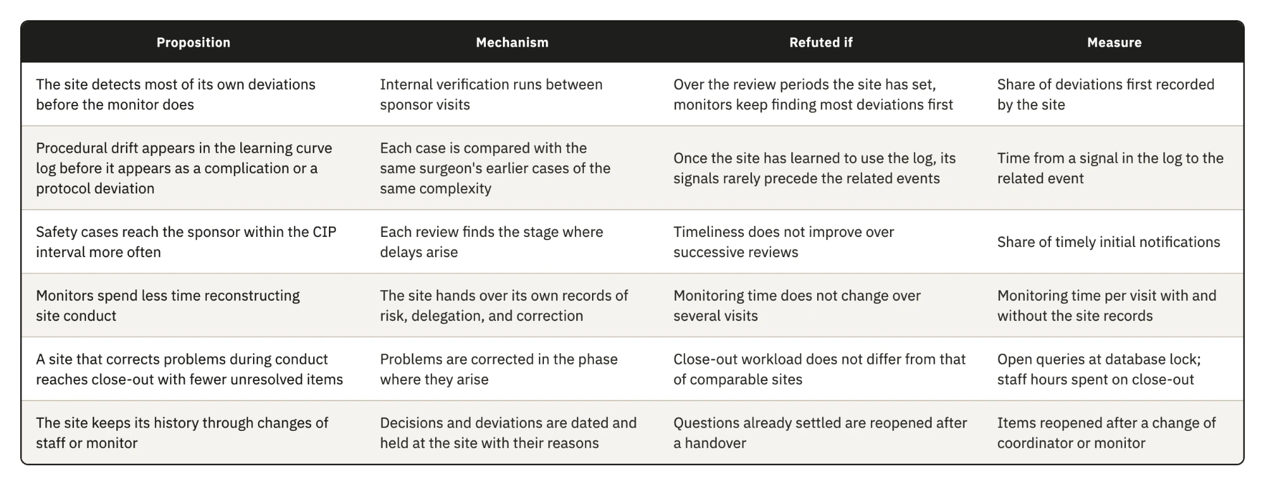
The indicators of enrollment quality and critical data completeness read a process while it runs, and so does surgeon procedural consistency. The other three indicators count events that have already happened, although each can still signal a deterioration before it reaches a participant or an endpoint. With few cases in each review period, one event is often enough to move an indicator from control to closer review or action. In the target center the indicators therefore work mainly as a scheduled review of events against rules fixed in advance, and their value comes from that schedule and those rules more than from any statistical property.

5.3.5 Does documentation improve conduct?
A site can record its conduct impeccably and still conduct itself badly, and nothing in this thesis settles whether documenting a practice improves it. The claim we can defend is narrower, since controls written for a specific activity leave fewer gaps open, so the framework acts on the probability that a failure goes undetected and says nothing directly about the quality of the conduct itself. This rests on a premise we state as such, namely that many failures in clinical investigations come from lapses and competing demands on the same person, or from the lack of a tool that makes an error visible in time. Deliberate misconduct is outside the reach of the framework, since a person who intends to misrepresent conduct can misrepresent the record as well. For the other failures, diligence cannot act on what nobody sees, and an instrument that brings a failure into view turns it into something a person can respond to.
If the framework changed nothing in conduct and its only effect were a complete and traceable record of what the site did, that outcome would still be better than the same conduct leaving no record. The record allows a case to be reconstructed years later and supports the manufacturer whose post-market obligations depend on it, although it protects a participant only when someone reviews it and acts in time.
Observation may also change behavior, since a surgeon or a nurse who knows that the work is reviewed may attend to it more closely and learn from the review which elements matter. The same pressure can lead people to satisfy the fields while the practice stays as it was. The design limits that risk, because its instruments record decisions and identifiers with their dates, so a device identifier is captured or missing whatever attention is paid to the form, and because most records are read by someone other than their author.
Documentation also has a cost, paid in the scarcest resource of the target center. Every hour a coordinator spends on a record is taken from a visit or a follow-up call, so a framework that changed nothing in conduct would have consumed what the site can least spare. For this reason the set has a minimum level, and the effort per instrument is among the first things an implementation study should measure, together with conduct itself, since records alone cannot show that a documented site conducts an investigation better than an undocumented one.

5.4 Scaling and transfer
Many of the organizations the framework was designed for have no structure dedicated to research. A private site is expected to assemble standard operating procedures and trained staff, together with the infrastructure research requires, before it enters the field _{[74]}. We assume, without data from these organizations, that few of them employ people whose only work is clinical trials, so the same people hold several functions. The surgeon is often the PI, and a nurse may also carry out the physical assessments that a physiotherapist would perform in a hospital. Some activities, such as imaging or specialized assessments, may be contracted outside the practice, so the site has to oversee work that it does not perform itself. A framework that assumed a trial unit and dedicated staff would not fit this setting, and ICH E6(R3) itself asks for quality management proportionate to risk, without unnecessary complexity. The scalability model tries to keep the essential controls in place with fewer people and fewer instruments, and to let a site add instruments as its capacity or the risk of its investigation grows.

5.4.1 The minimum level and its trade-offs
At the minimum level a site runs twelve instruments, and these cover the core of the framework. Every gap has at least one response, every record that ISO 14155:2026 and the MDR require is kept, and four of the five records made at the clinical moment remain as instruments, with the CRF serving as the visit record. Each function has a named holder and a backup, and the oversight meeting brings the records together. The level rests on a premise we could not source, namely that inspection assesses compliance through the completeness and consistency of the records, so a site with fewer instruments but a complete record carries no additional regulatory exposure. A reader who rejects the premise should also reject the scalability argument.
In exchange, the meeting at the minimum level reviews less often than dedicated instruments would, so a signal may be noticed later, and one person may hold several functions, which weakens the separation between execution and oversight required by DR10. The proxies carry a less visible cost, since the CRF and the sponsor's screening log sit in systems the sponsor controls and the site's access to them may end after close-out, leaving part of the site's history in records it will not keep. A site at the minimum level should therefore keep a copy of these records under its own control at close-out, or use the PFVR from the start when follow-up lasts several years.
In practice the minimum also depends on the stage of the investigation. The risk register adds the learning curve log for a new implant design or technique, and in a premarket investigation the device is new to every surgeon, so the rule will almost always apply and the effective minimum becomes thirteen instruments. The minimum of twelve applies mainly to investigations of devices already in the surgeon's use, such as post-market clinical follow-up. The PI who records the implementation level also carries part of the work each level adds, so a site has a reason to choose the lowest level its category allows, and only the sponsor can ask for the reasoning behind it.

5.4.2 Instruments that outlive the investigation
Chapter 4 describes the framework for a single investigation, while many sites conduct several, either at once or one after another. Some instruments belong to the site and are kept across investigations, and some keep a site structure that each investigation fills with its own content. The rest are opened again for every investigation (Table 5.4).
Table 5.4. The twenty-four instruments classified by whether the site keeps them across investigations, keeps their structure with content specific to each investigation, or opens them again for each investigation.
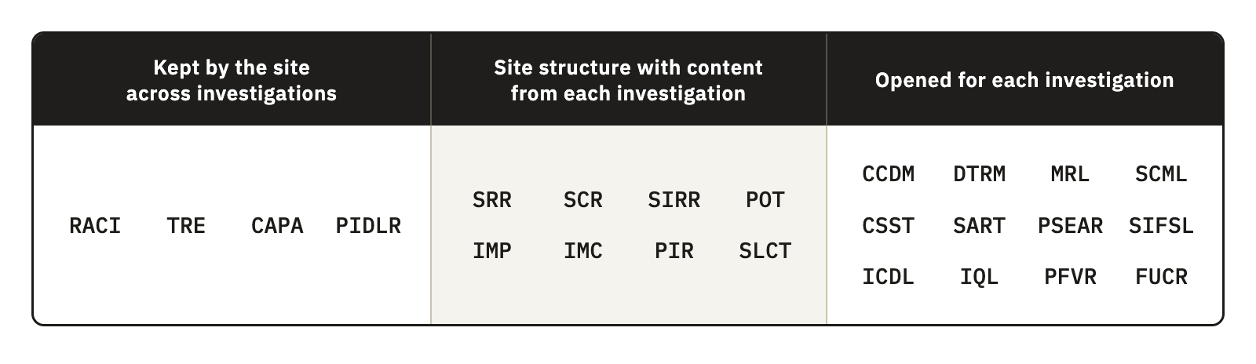
The instruments opened for each investigation are mostly records of participants and procedures, or of visits, so their effort grows with the number of cases. Site compensation is also calculated per procedure and per participant, which means that the work growing with cases is the work the site is paid for. What has no budget line is setting up the structure, and that work sits mainly in the instruments the site keeps or reuses. Fifteen instruments act during start-up, when sponsors measure how quickly a site is activated, but the cost of setting them up falls mostly on the first investigation. A site with a steady portfolio spreads that cost, whereas a site that takes one investigation every few years carries most of it each time.
[Number to compute from the final registry dataset: organizations in the sample with more than one investigation, overall and among nonhospital organizations.]
A site running investigations at the same time needs one role structure and one training history, and also one corrective action log and one oversight meeting for all of them, while the participant records remain separate for each investigation. Safety reporting timeliness and critical data completeness measure site processes shared by all of its investigations, as does the deviation rate by area, so the site can pool their counts to enlarge the small denominators of a single investigation. Surgeon consistency and complication patterns depend on the device and cannot be pooled across different devices, and because each sponsor's data are confidential, pooled counts serve only the site's internal review. Because a surgeon's learning with a device continues across investigations, the learning curve log of a later investigation should start from the earlier cases where the site holds them.

5.4.3 Transfer to other specialties
Neither the MDR nor ISO 14155:2026 distinguishes a shoulder device from a knee or hip device, so the obligations behind the instruments apply across implant surgery and make transfer plausible, although they do not show it. Within the instruments, anatomical content sits in the complication categories and the imaging requirements, together with the complexity levels of the learning curve log, while their structure carries none. Spine surgery shows that specialties also differ in more than content, since one procedure may implant several components, which multiplies the traceability work and the ICDL entries per case. In robot-assisted or navigated arthroplasty part of the execution moves from the surgeon to a system, so the basis of comparison of the SLCT has to separate experience with the procedure from experience with the system. The claim stops at surgical investigations without an implant, where unit traceability does not arise, and at device investigations without surgery, where operator dependence takes another form. Applying the instrument set to the documentation of a completed hip or knee device investigation, and recording which fields had to change, would test the claim at low cost.

5.4.4 Transfer to other jurisdictions and editions
The registry places 155 of the 238 organizations in the United States, including 63 of the 68 nonhospital organizations, while the framework was designed under the MDR and ISO 14155:2026. Most of the nonhospital organizations in the sample therefore operate under another regime. The derivation is unaffected, because the regulatory analysis does not depend on the registry, but the question of how far the framework serves these organizations remains open.
Under 21 CFR Part 812, the investigator reports an unanticipated adverse device effect to the sponsor and to the institutional review board within ten working days of first learning of it _{[12]}. A site in the United States therefore has a regulatory interval for the safety reporting indicator, where a European site takes the interval from the CIP. Since the SART already takes its interval from the CIP, it adapts, and what changes are the terms and the regulatory anchors of each instrument. Neither regime prescribes how a site organizes itself, so the structure should transfer once each anchor is mapped to the corresponding provision, which we have not done.
Within the European Union, the version of ISO 14155 with a presumption of conformity under the MDR is still EN ISO 14155:2020+A11:2024 _{[9]}, while the 2026 edition represents the current state of the art. Some parts of the framework rest on clauses added in the fourth edition, such as the risk stream for clinical procedures beyond routine practice and the clinical events committee. A site working to the harmonized version can use these parts as state of the art, without the presumption of conformity that the harmonized text carries.

5.5 Implications

5.5.1 For the investigational site
For the site, the main gain is an account of its own conduct that survives changes of people. When a coordinator leaves or a monitor is replaced, or when a question settled by an earlier monitor comes back, a site with a documented framework still holds the decisions and the reasons behind them.
That account costs staff time, and the way sites are paid decides whether anyone covers it. Research payments from industry are expected to reflect the fair market value of the work performed [ref: Breault and Knafl 2020], and site budgets are negotiated item by item with the sponsor. In one review of ten industry-sponsored trials, the final budgets exceeded the sponsors' initial proposals by 59% on average, and the costs of preparing the trial were among the items that changed most [ref: Koulizakos et al. 2023]. The preparation of a trial is therefore already a negotiated budget item, and the quality records the framework asks a site to set up for an investigation are work done for that investigation. We found no report of a sponsor paying for such work, so whether it could be negotiated as part of preparation, and on what terms, remains a question for sites and sponsors to examine. Until it is answered, an avoidable error, such as a screen failure caused by an incomplete eligibility record or a missed imaging window, remains a direct loss for the site.
The site pays for the framework in staff time, while the benefits also reach other parties. The sponsor gains easier monitoring and more reliable data, and the manufacturer relies on the operating room records for traceability. The site itself loses less to avoidable errors and keeps instruments it can carry to the next investigation, and it may also gain a record that counts in future site selection, although we could not test this. A site deciding where to begin should start with the instruments that protect data that cannot be recovered, meaning the five records made at the clinical moment and the risk register, because the same records protect its revenue. A site that records a weakness also creates a record that a monitor can read, and a finding the site raised against itself is still a finding. How monitors treat such findings is not known, and it will decide whether sites are willing to keep these records.

5.5.2 For sponsors, contract research organizations, and monitors
The framework is meant to complement the sponsor's quality system. It does not duplicate sponsor monitoring, which would consume resources the target center does not have, and it is not absorbed into the sponsor's system, which would remove the site layer it exists to create. The two systems work at different levels, since the sponsor oversees a trial across many sites and the site controls its own processes. The structure of the framework belongs to the site and serves every investigation it conducts, whatever the sponsor, while its content adapts to each investigation, from the CtQ factors and reporting intervals of the CIP to the templates and systems the sponsor requires.
At qualification, Clause 6.8 asks the sponsor to judge the qualifications of the PI and the adequacy of the site, and a site that arrives with its own risk register and oversight records gives documentary evidence on both. At a monitoring visit the same site can hand over its delegation records and corrective action log, with its indicator results, so the monitor reviews a site that has already described its own risks. Risk-based monitoring is adequate only when certain prerequisites at the site are met _{[43]}, and the framework builds some of them. We found no study measuring how much monitoring time this saves.
The two systems can also be aligned more closely than they are today. If the sponsor gave each site, at initiation, a summary of the critical factors and main risks it identified, the site register and the sponsor's monitoring would address the same targets. Where the CIP allows it, the ICDL can be named as the source of implant identifiers and intraoperative events, so source data verification compares the CRF with a structured record made during the procedure. The site's indicators read at one center the processes that the sponsor's key risk indicators read across the trial, and they could feed central monitoring as long as each datum keeps its source. The clinical events committee that ISO 14155:2026 allows the sponsor to establish addresses the same events as the site's complication review, at a different level, and a local action already taken is information the committee can use.
Only one of 247 randomized surgical trials analyzed learning effects _{[72]}, partly because the case sequence of each surgeon is rarely collected. The SLCT holds that sequence with complexity and duration, so a CIP that planned for it could use the log to examine learning in the main analysis, provided the surgeon's data are protected as Section 5.5.4 describes.
Contract research organizations, to which sponsors often delegate operational conduct, bring systems and timelines designed to work across many sites. These systems govern the data that reach the case report form but cannot establish whether an image was acquired as the charter required, and the monitors they assign change during long investigations. The framework governs the production of data at their origin and keeps the site's history across those changes.
A sponsor could go further and supply templates and help set up the framework across its sites, as it already supplies the protocol and training. This would move part of the cost of construction to the sponsor, but a site working with three sponsors would then receive three frameworks and run three quality systems at once. The more stable division keeps a structure owned by the site, into which each investigation brings its content and, where the sponsor wishes, its templates, while the operation of the framework and the ownership of its records stay with the site.

5.5.3 For standards and regulators
Reading ISO 14155:2026 from the position of the site reveals points that a future revision could consider. Clause 6.2 requires the sponsor to manage risk in three streams: the use of the device, the clinical procedures required by the CIP beyond routine practice, and the conduct of the investigation. All three belong to the sponsor, and no text describes how a site handles the part of those risks that its own execution creates. Clause 9.2.4.5 p) asks monitors to verify that equipment relevant to assessment is maintained and calibrated, yet no clause describes the record through which the site shows this work, and Clause 6.12 introduces the clinical events committee without a local counterpart. These observations come from one position in a standard with a wider purpose, so a revision might reasonably leave them open.
A clause asking a site to keep a risk register would ask for one document and one review cycle, while a requirement for a site-level quality system would ask for much more. Annex XV of the MDR governs the conduct of clinical investigations and says nothing about how a site organizes itself to conduct them, and the harmonization of the fourth edition would be a natural moment to examine that question. ISO 15189:2022 offers a precedent, since it gives the medical laboratory a quality system that can be accredited, so its results are trusted by parties who never see the laboratory. A standard of this kind for investigational sites would also solve the fragmentation that sponsor-supplied frameworks create, because a site working for several sponsors would run one structure recognized by all of them. Whether sites should one day be accredited in this way is beyond what this thesis can answer. A future revision of ICH E6 or ISO 14155 could, more modestly, give the site an explicit proactive role in quality without moving final responsibility, and the framework shows one form that role could take.
No clause in the present texts requires the records this framework produces, so an inspection under the MDR would not treat their absence as a non-compliance. A site with the framework and a site without it therefore present the same regulatory surface and differ in what they can show, since only the first can show how it controlled its conduct without reconstructing it from primary documents.

5.5.4 Ethical implications
The SLCT and the consistency indicator hold performance by surgeon and can lead to a restriction of the cases a surgeon takes, so in substance they assess professional performance. A signal recorded in these instruments, or in the complication review, could follow a surgeon beyond the investigation and harm a career if it were read out of context. The framework therefore has to keep every action that results from these records, from closer observation to a restriction, within the scope of the investigation. The design codes the surgeon and keeps the key with the PI, and it fixes before the first case the outcomes that a review can reach, with the reasoning behind any restriction documented. Who may access these records, and for what purpose, also has to be defined before the first case. They are personal data of the professional and have to be handled under the data protection law that applies, which we did not analyze in detail. The indicator does not rank surgeons, since a fair comparison would need an adjustment for case mix and for clustering _{[67, 68]} that a single site rarely allows.
In a surgeon-owned practice, the site belongs to the surgeon it observes, and the PI who decides on a restriction may be the surgeon under review or a close colleague who shares the commercial consequence. The same structure affects internal verification, where the reviewer may be the employee of the person reviewed. Every function already has a named substitute in the role structure. When the PI is the surgeon under review, the framework can therefore pass the decision to that substitute or to a party outside the site, such as the sponsor's medical monitor or the ethics committee, on a route fixed before the first case.

5.6 Evaluation, limitations, and further research

5.6.1 The evaluation this thesis performed
The Design Science Research Methodology has six activities, and this thesis reports the first three, which run from problem identification to design and development, together with the last, communication _{[49]}. Demonstration and evaluation are not reported, although the thesis did perform one kind of evaluation. The design-science literature distinguishes evaluation before an artifact is used, which tests whether the design decisions are grounded, from evaluation after its use, which tests whether the artifact works [ref: Sonnenberg and vom Brocke 2012]. It also separates formative evaluation, which improves a design while it is still being shaped, from summative evaluation, which judges a finished artifact. A further distinction separates artificial evaluation, carried out away from real use, from naturalistic evaluation in the setting where the artifact will run [ref: Venable et al. 2016]. Our traceability from each component to a requirement, and from each requirement back to its origin in Chapter 3, is an evaluation before use, formative and artificial. It is the expected first step for a design at this stage, because it checks that every part rests on a stated reason before anyone spends resources on implementation. It cannot show that the framework works in a site, because only a naturalistic evaluation can do that, and since we derived the requirements and assigned the components ourselves, the mapping is not independent evidence either. The framework should therefore move next to a naturalistic formative evaluation, in which a site uses the instruments and the design is corrected, and only then to a summative one that judges its effect.

5.6.2 Limitations
The absence of any implementation weakens every claim about effect in this chapter. The propositions of Table 5.3 remain expectations, as do the economic argument and the estimate of effort, and nobody knows how much time the instruments take in a small team. A feasibility study in one site can reduce this limitation, and the design already limits its consequence by keeping the regulatory analysis and the derivation independent of any expected effect.
Because the literature review was narrative, any statement that a body of work is absent from the field is weak, and Section 5.2 describes only the works we found and read, a position that a systematic search can test. We reduced the risk by searching the bodies of work most likely to contain a site-level framework and by reporting the closest works we found.
Our evidence on the state of site practice comes from published studies and regulatory guidance, with some expert commentary. We had no access to the internal documents of any site, from its procedures to its audit data, which weakens the claim that the failures the framework addresses are the ones that occur most often. Field research in sites of each organizational category can test that claim and calibrate the framework against observed failures.
We did not consult experts formally during the design. The framework was discussed informally with professionals working in clinical operations, and some of their criticism changed it, but these conversations were neither planned nor recorded, so they cannot count as evidence. The claim that the instruments can be completed as intended therefore rests on the design alone, until a structured content review tests it.
In the registry analysis, one researcher classified each organization from its public self-description, with a second internal pass and no independent assessor. This weakens the assignment of organizations to environments and the reproducibility of the counts in Table 3.3, which a second coder can test. The registry is also weighted toward the United States, while the framework was designed under the MDR. Since the regulatory analysis does not depend on the registry, the inference that weakens is the one from the organizational profile of the sample to European sites, and a registry analysis based on European data, which Eudamed did not provide, would test it.
Some choices of this thesis are delimitations, made on purpose: the focus on the shoulder and on the European regulatory framework, and the choice of the nonhospital organization as the design case. They set the scope of the claims, and Section 5.4 discusses how far the claims can travel beyond them.

5.6.3 Further research
The framework has completed the development phase of a complex intervention, and the phases that follow, from feasibility to implementation, do not have to come in strict order [ref: Skivington et al. 2021]. The shortest next step is the demonstration activity of the DSRM, which needs no participants. Running the full set through a simulated or retrospective case series, from feasibility to the lessons record, shows whether the instruments connect as the design intends and whether any record lacks a reader.
A content review by sites and monitors, with surgeons included, and a usability test of the templates should come next, because an instrument that nobody can complete correctly cannot be evaluated for anything else. A feasibility study in one nonhospital organization and one hospital can then run the minimum set through a complete investigation. It should measure staff time per instrument, separating the work done once from the work that grows with cases, and compare the completeness of the records with a defined checklist. The share of deviations that the site detected before the monitor did shows most directly whether the framework does what it claims.
Before-and-after comparisons at one site are likely to report an improvement whatever the framework does. In surgical oncology, 86 of 97 non-randomized studies of quality improvement reported a positive effect, against 2 of 12 randomized trials _{[40]}, so the evaluation of effect needs a concurrent comparison. A sponsor could introduce the framework in its sites in a staggered order within one investigation, letting the sites that have not yet started serve as comparators. Where that is not possible, a site could follow its indicators over a long series before and after adoption, as the IDEAL recommendations propose when randomized designs are not feasible. A sponsor-led design of this kind also tests whether a sponsor can supply templates while the site keeps the operation and ownership of its records.
Indicator validation needs another design, because an investigation spread across several centers leaves each center with few cases over several years. It can instead draw on existing records, since a retrospective study can pair historical values of the indicators with the events that followed them, and pooling the records of several centers of one sponsor provides the volume that one site cannot. Query backlog and reporting timeliness can be recovered from most trial databases, while operative time by complexity level is available only where the site recorded the level.
Mapping each instrument to 21 CFR Part 812 would test the transfer to the regime under which most of the nonhospital organizations in the registry operate, again without a new investigation.

