Universidade de Lisboa
Faculdade de Farmácia / Instituto Superior Técnico

Translating ICH E6(R3) into Practice: A Site-Centered Operational Quality Management Framework for Shoulder Medical Device Clinical Investigations
Felipe Gregorio Lima
Dissertation Report supervised by Professor Gracinda Maria Martins Sanches Fernandes and co-supervised by Dr. Nuno Jorge da Silva Moura
Master’s of Pharmaceutical Engineering
2025/2026
Código de Conduta e de Boas Práticas da Universidade de Lisboa:
Declaro ter desenvolvido e elaborado o presente trabalho em consonância com o Código de Conduta e de Boas Práticas da Universidade de Lisboa. Mais concretamente, afirmo não ter incorrido em qualquer das variedades de fraude académica, que aqui declaro conhecer, e que atendi à exigida referenciação de frases, extratos, imagens e outras formas de trabalho intelectual, assumindo na íntegra as responsabilidades da autoria.
________________________________________________

Resumo
A diretriz E6(R3) do International Council for Harmonisation (ICH), baseada na ICH E8(R1), incorpora a qualidade na conceção e na condução do ensaio, proporcionalmente ao risco, e a norma ISO 14155:2026 e o Regulamento (UE) 2017/745 aplicam princípios semelhantes às investigações clínicas de dispositivos médicos. Estes textos atribuem ao centro de investigação uma parte maior da responsabilidade pela qualidade, mas a maioria dos instrumentos analisados foi construída para o promotor. Esta tese deriva um framework de qualidade ao nível do centro para investigações clínicas de dispositivos médicos do ombro, complementar ao sistema do promotor, que permita ao centro agir sobre os riscos que o promotor não consegue ver a tempo e demonstrar como controlou a sua própria condução.
Aplicámos a Design Science Research Methodology, combinando uma revisão narrativa, uma comparação cláusula a cláusula da ICH E6(R3), da ISO 14155:2026 e do Anexo XV do Regulamento, e uma análise de registos de 46 investigações e 235 organizações. Identificaram-se 5 lacunas regulamentares e 12 domínios críticos para a qualidade, que originaram 12 requisitos de conceção.
O framework assenta em quatro pilares: governação, gestão do risco, controlos operacionais e supervisão do desempenho. Vinte e quatro instrumentos compatíveis com papel apoiam a supervisão do investigador, a gestão do risco no centro, a monitorização interna, a vigilância de complicações e a rastreabilidade do dispositivo. Um deles acompanha a curva de aprendizagem cirúrgica durante a condução, função que os instrumentos comparados não atribuem ao centro. Um ciclo de vida de sete fases e três níveis de implementação adaptam o framework à capacidade do centro e ao risco da investigação, dirigido a centros privados com investigação recorrente.
Cada componente é rastreável até um requisito de conceção. Como o framework ainda não foi implementado nem avaliado, a sua viabilidade e os seus efeitos requerem avaliação prospetiva.
Palavras-chave: investigação clínica; dispositivos médicos; gestão da qualidade baseada no risco; ICH E6(R3); cirurgia ortopédica

Abstract
International Council for Harmonisation (ICH) E6(R3), grounded in ICH E8(R1), builds quality into trial design and conduct in proportion to risk, and International Organization for Standardization (ISO) 14155:2026 and Regulation (EU) 2017/745 apply related principles to medical device investigations. These texts give the investigational site a larger share of the responsibility for quality, but most of the instruments reviewed here were built for the sponsor. This thesis aimed to derive a site-level quality framework for shoulder medical device clinical investigations that complements the sponsor’s system, so that a site can act on the risks the sponsor cannot see in time and can show how it controlled its own conduct.
We used a problem-centered Design Science Research Methodology. The study combined a narrative literature review, a clause-level comparison of ICH E6(R3), ISO 14155:2026, and Annex XV of Regulation (EU) 2017/745, and a registry analysis of 46 investigations involving 235 organizations. The analysis identified 5 regulatory gaps and 12 Critical-to-Quality domains, from which 12 design requirements were derived.
The resulting framework has four pillars: Governance, Risk Management, Operational Controls, and Performance Oversight. Twenty-four paper-compatible instruments support investigator oversight and delegation, site risk assessment, internal monitoring, complication surveillance, and device traceability. One of them follows the surgical learning curve during conduct, a function for which the instruments compared assign the site no obligation. A seven-phase lifecycle and three implementation depths adapt the framework to site capacity and investigation risk, with private centers that run investigations recurrently alongside surgical care as the target.
Every component traces back to a design requirement and its regulatory or operational origin. The framework has not been implemented or evaluated at a site, so its feasibility and effects require prospective evaluation.
Keywords: clinical investigation; medical devices; risk-based quality management; ICH E6(R3); orthopedic surgery

Acknowledgments

List of Abbreviations
- ADE — Adverse Device Effect
- AE — Adverse Event
- API — Application Programming Interface
- CAPA — Corrective and Preventive Action
- CCDM — Criticality-Coded Delegation Matrix
- CEC — Clinical Events Committee
- CER — Clinical Evaluation Report
- CFR — Code of Federal Regulations
- CIP — Clinical Investigation Plan
- CRF — Case Report Form
- CRO — Contract Research Organization
- CSST — Complication Signal Surveillance Template
- CTIS — Clinical Trials Information System
- CtQ — Critical-to-Quality
- CTTI — Clinical Trials Transformation Initiative
- DD — Device Deficiency
- DR — Design Requirement
- DSRM — Design Science Research Methodology
- DTRM — Device and Study Training Requirements Matrix
- EMA — European Medicines Agency
- EN — European Standard (European Norm)
- EU — European Union
- FDA — Food and Drug Administration
- FUCR — Follow-up Compliance Review
- GCP — Good Clinical Practice
- ICDL — Intraoperative Checklist and Device Log
- ICH — International Council for Harmonisation of Technical Requirements for Pharmaceuticals for Human Use
- IFU — Instructions for Use
- IMC — Internal Monitoring Checklist
- IMP — Internal Monitoring Plan
- IQL — Imaging Quality Log
- ISO — International Organization for Standardization
- ISO/TR — ISO Technical Report
- MDIC — Medical Device Innovation Consortium
- MDR — Regulation (EU) 2017/745 on medical devices
- MRL — Milestone Review Log
- PD — Protocol Deviation
- PFVR — Participant Follow-up Visit Record
- PI — Principal Investigator
- PIDLR — Post-Investigation Debrief and Lessons Record
- PIR — Performance Indicator Record
- POT — PI Oversight Template
- PRISMA — Preferred Reporting Items for Systematic Reviews and Meta-Analyses
- PROM — Patient-Reported Outcome Measure
- PSEAR — Participant Screening and Eligibility Assessment Record
- QA — Quality Assurance
- QbD — Quality by Design
- QC — Quality Control
- RACI — Responsibility Assignment Matrix (Responsible, Accountable, Consulted, Informed)
- RBM — Risk-Based Monitoring
- RBQM — Risk-Based Quality Management
- ROM — Range of Motion
- ROMIO — Randomised Oesophagectomy: Minimally Invasive or Open
- SADE — Serious Adverse Device Effect
- SAE — Serious Adverse Event
- SART — Safety and Adverse Effect Reporting Template
- SCML — Site Complication Monitoring Log
- SCR — Surgical Credentialing Record
- SIFSL — Subject Identification and Failure Screening Log
- SIRR — Site Imaging Readiness Record
- SLCT — Surgeon Learning Curve Tracking Log
- SQA — Surgical Quality Assurance
- SRR — Site Risk Register
- TRE — Training Record Evaluation and Release
- UDI — Unique Device Identification

List of Tables
Table 3.1 Site-level regulatory gaps
Table 3.2 Site-level CtQ domains
Table 3.3 Organizational environment
Table 3.4 Design requirements (origin)
Table 4.1 Design requirements and framework components
Table 4.2 The scalability model
Table 4.3 The twenty-four instruments

List of Figures
Figure 4.1 The quality lifecycle
Figure 4.2 The twenty-four instruments grouped by pillar
Figure 4.3 Instrument granularity and the information chain
Figure 4.4 Instruments mapped against CtQ domains
Figure 4.5 Instruments mapped against design requirements

1. Introduction

1.1 Historical Overview and Recent Updates
Quality management in clinical research has changed over the past decade [1, 2]. The older model was mainly reactive, because sites and sponsors found problems during monitoring visits and audits and corrected them case by case. These activities ran throughout the trial, but their purpose was detection and verification, and quality was not designed into the trial from the start.
Current guidance holds that quality should be considered before a study begins, built into operational decisions during conduct, and managed across the study lifecycle [3, 4]. The change can be followed through the guidelines of the International Council for Harmonisation (ICH). ICH E6, adopted in 1996, defined the responsibilities of sponsors, investigators, and ethics committees through detailed procedural requirements. ICH E6(R2), adopted in 2016, added an explicit quality-management section and risk-based monitoring (RBM), in recognition that the same level of oversight cannot usefully be applied to every activity [3].
ICH E8(R1), adopted in 2021, moved the central question from how a study should be monitored to how it should be designed, so that the factors needed for reliable results are protected from the start. The guideline brought Quality by Design (QbD) into the guidance for clinical research. QbD holds that quality has to be planned from the beginning, because checking a study after it has happened cannot guarantee it. Planning means identifying the factors that matter most to participant protection and to the reliability of the study, and allocating resources in proportion to the risks that threaten them. ICH E8(R1) turned this idea into something usable through Critical-to-Quality (CtQ) factors [5].
ICH E6(R3) reached Step 4 on 6 January 2025 and pushed further in the same direction, giving greater weight to QbD, CtQ factors, and risk-proportionate oversight across the trial lifecycle [6]. It also asks investigators to have an adequate number of qualified staff and adequate facilities for the conduct of the trial [6].
Commentators have read this development as a move from a prescriptive model toward a governance model [7]. In a prescriptive model, a site shows quality mainly by documenting that it followed the required procedures. In a governance model, the responsible parties have to design, run, and improve a system that is proportionate to the risks of the investigation, so a site also has to show that its processes find and control risks and that it learns from them.
The ICH guidelines are written broadly, but their principal Good Clinical Practice (GCP) scope is interventional trials of investigational products, and their vocabulary reflects that origin [6]. Other study types therefore need instruments written for their own conditions. Clinical investigations of medical devices are governed by International Organization for Standardization (ISO) 14155, the GCP standard for that field [8].
ISO 14155 has followed a parallel path. It was first published in 1996 and revised in 2011, 2020, and 2026 [8]. The fourth edition was published on 23 March 2026, after the research for this thesis had started. Among other changes, it strengthens the treatment of procedure-related risks and the requirements on safety reporting and data integrity. It also separates more clearly the residual risks of the investigational device, which keep the logic of ISO 14971, from the risks arising from clinical procedures or investigation processes outside routine clinical practice. However, the edition carrying a presumption of conformity in the European Union (EU) remains European Standard (EN) ISO 14155:2020+A11:2024, as listed in Commission Implementing Decision (EU) 2026/193 [9]. ISO 14155:2026 is therefore used here as the current international standard, while the harmonized European edition remains the 2020 text.
Regional regulation is what gives these standards their legal force. In the EU, Regulation (EU) 2017/745 on medical devices (MDR) governs clinical investigations and sets requirements for their authorization, conduct, documentation, and reporting [10]. The United States uses a separate statutory and regulatory framework under the Federal Food, Drug, and Cosmetic Act [11] and Title 21 of the Code of Federal Regulations [12]. The two regional frameworks are mentioned here as distinct legal contexts, and this thesis does not treat them as equivalent.
Adoption in practice is still uneven. A global survey of risk-based quality management (RBQM) maturity found that identifying CtQ factors was one of the least adopted components overall, with nonadoption concentrated in the Late Majority and Resisters cohorts, which together made up nearly half of the surveyed organizations [13]. Sites were not the object of that survey, so it does not show how sites apply CtQ principles. It does show that the first step of the QbD approach is still difficult at sponsor level, where the concept was developed and where resources are usually concentrated.
Together these instruments raise the standard that an investigational site is expected to meet, without saying how a site should organize itself to manage the risks of its own work in daily practice. The rest of this chapter examines why that question is hard in surgical device investigations and what the field has offered so far.

1.2 Quality Responsibility at the Investigational Site
Risk-proportionate oversight starts from the observation that the activities in a clinical study do not all carry the same risk, so monitoring, documentation, and oversight should match the importance of each activity and the consequences of its failure. In practice this asks a study team to do four things:
- Identify and validate the CtQ factors.
- Assess risk at study level and at site level.
- Define controls that prevent, detect, and respond.
- Set measurable indicators that trigger proportionate action when a signal appears.
Tools such as key risk indicators and Failure Modes and Effects Analysis give this work a traceable basis.
Sponsors keep primary responsibility for trial-level quality management and oversight [6, 8, 10]. Investigators, in turn, are responsible for the conduct and oversight of the activities delegated at their site, including having qualified staff and adequate resources [6, 8]. The investigator and the site team are therefore directly accountable for the quality of the investigation they conduct, while the quality-management responsibility of the sponsor remains intact.
This allocation reflects operational reality. A large part of a clinical investigation happens at the site, through decisions and processes that the protocol only partly specifies. Routine site work can strengthen or damage quality, from the identification of eligible participants and the consent process to the recording of adverse events (AEs) and the upkeep of source documentation. The site therefore contributes actively to the quality of the investigation.
Accountability of this kind only means something if it is operational. If a site is expected to act as an active agent of quality, the role has to be defined and structured, and it has to be verifiable. Regulatory texts set out principles and responsibilities without saying how each site should turn them into daily practice, and that translation is the subject of this thesis.

1.3 Surgical Device Investigations as a Distinct Methodological Context
Clinical research methodology and its regulatory infrastructure were developed largely around pharmacological interventions, whereas implantable devices raise additional problems of design and evaluation [14, 15]. In the pharmacological model, the intervention is a chemical compound given at a defined dose, on a defined schedule, and by a defined route. Surgical investigations of medical devices work under different conditions, and five of them change what quality management has to do at the operational level.
The first condition is termed irreversibility in this thesis. A prosthesis fixed to bone cannot simply be stopped or withdrawn in the way a medicinal product can, and errors during implantation may have lasting consequences. The cited literature documents the evidential and methodological consequences of implantable devices, although it does not itself use “irreversibility” as a formal category [14, 16, 17].
Operator dependence, the second condition, means that outcomes may depend substantially on the surgeon, with variation between surgeons and also within the practice of one surgeon as experience grows along the learning curve [18, 19, 20, 21, 22].
The third condition is unit-level traceability. Under the MDR, documentation and record-retention duties support the traceability of each individual investigational device [10], and ISO 14155 likewise addresses the accountability and traceability of investigational devices [8]. This condition does not rely on MDR Article 27, because that article excludes investigational devices from its Unique Device Identification (UDI) assignment requirement. In surgical investigations, the framework extends the operational record to the surgical decisions that produced the device configuration in a given patient.
Follow-up burden is the fourth condition. Range of motion (ROM) assessments, patient-reported outcome measures (PROMs), and radiographic evaluations often require repeated attendance over several years and consistent assessment procedures. Orthopedic studies also show that loss to follow-up is common enough to threaten interpretation when it is not defined and managed consistently [23, 24].
The fifth condition, measurement reliability, follows from the limited interobserver reliability of the radiological and clinical classifications on which eligibility and outcome assessment may depend, so measurement variability is present before any site-level variability is added [25, 26, 27].
The work was narrowed to orthopedic investigations and, within them, to the shoulder, for two reasons. The first is the availability of data. A ClinicalTrials.gov Application Programming Interface (API) search performed on 20 September 2026 for interventional studies with the condition string “shoulder arthroplasty OR rotator cuff OR shoulder prosthesis” returned 996 records. This retrieval count indicates a substantial registry base and is not the final analytic sample described in Section 2.4. The second reason is methodological. A framework is usable only if it reaches operational detail, and that level of detail cannot be achieved across several surgical disciplines at once, so the framework is developed for one discipline. Its structural logic may transfer to other implant-based surgical specialties with comparable conditions, but this thesis does not demonstrate that transfer.
The registry characterization developed for this thesis found that nonhospital organizations made up more than a quarter of the organizations taking part in industry-sponsored shoulder device investigations, and that for more than half of them no permanent research structure was publicly identifiable (Section 3.4.4). The framework was therefore designed for private centers that run investigations recurrently alongside surgical care without a system dedicated to investigation quality. The registry did not test whether such centers share staff, rooms, or workflows with routine care, and Section 3.4.5 treats these features as design assumptions.

1.4 What Has Been Built for Sites, and for Whom
Clinical research has built a growing body of operational quality infrastructure over the past two decades, including methods for central monitoring [28] and frameworks for assessing site readiness [29]. Much of the material reviewed for this thesis is defined at trial or network level, and the site appears in it mainly as the object of assessment, although a readiness framework of this kind can also be used by an experienced site to assess itself [29]. The Clinical Trial Assessment of Infrastructure Matrix and the implementation of ISO 9001 in trial centers are other exceptions [30, 31]. The narrower conclusion supported by the reviewed corpus is that relatively few instruments are designed for a site to operate on its own processes.

1.4.1 Instruments written for the sponsor and the trial
TransCelerate BioPharma developed a clinical quality management system and a set of RBM frameworks [32]. The Clinical Trials Transformation Initiative (CTTI) issued QbD recommendations, together with the methodological tools that support them [33]. Device-specific guidance is available in the Medical Device Innovation Consortium (MDIC) supplement to the CtQ framework, which recognizes that device investigations can involve learning curves in product use [34]. These initiatives are detailed and technically mature, and they are written for the sponsor. They explain how a sponsor works out its CtQ factors and then puts monitoring resources where the risk is highest, and they also cover how oversight is coordinated across several sites. In this model, the site receives controls designed elsewhere.
A separate body of work addresses the quality of the surgical intervention itself. A systematic review of oncology trials sorted the reported challenges to surgical quality assurance (SQA) under credentialing and standardization, with monitoring as a third group, and concluded that the implementation and reporting of effective measures were inadequate [35]. The Randomised Oesophagectomy: Minimally Invasive or Open (ROMIO) study then developed concrete methods, including entry criteria for surgeons based on the assessment of operative videos and a standardized operative technique monitored during the trial [36]. International expert consensus followed. A Delphi process with 71 stakeholders produced 59 strategies to overcome the challenges to SQA in oncology trials, of which 14 gained consensus within an active randomized trial [37], and a parallel Delphi process with 40 experts from 15 countries produced a 13-item checklist for gastrointestinal surgery [38].
The evidence that these measures work is limited. A systematic review of randomized trials of arteriovenous grafts applied the same domains outside oncology and found that quality assurance (QA) was highly variable and poorly described, and that it had not improved over three decades. No trial in that review had a defined pretrial monitoring program, and none assessed technical performance [39]. A systematic review of 109 quality improvement studies in surgical oncology found that only 2 of 12 randomized trials demonstrated an effect on the primary outcome, compared with 86 of 97 nonrandomized studies, and 74 of the included studies were uncontrolled before-and-after designs assessed as low quality [40]. The field has therefore validated little of what it has proposed. For this thesis, a second limitation weighs more. Each framework in this line that was reviewed is designed at trial level by the trial team and applied to the site, which is the object of the measures and does not operate them. In multicenter trials this centralization is a deliberate choice, because the aim is a common standard across sites, but it leaves the site without an instrument of its own for the same questions.

1.4.2 Instruments that assess the site from outside
Recent work has pointed out that standardized methods for assessing the performance of clinical trial sites remain underdeveloped, and it has begun to develop validated measures [41]. The Clinical Trial Site Performance Measure reduced 126 candidate indicators to 18, organized into four validated domains: participant retention and consent, data completeness and timeliness, AE reporting, and protocol compliance [41].
Instruments of this kind serve benchmarking and resource allocation across a network, so they assess a site on behalf of another party. A performance score can help a sponsor decide which sites need attention, but it is not built to help a site notice that one of its own processes is drifting while there is still time to act. The second purpose needs a different instrument, and it has received much less attention.
The empirical literature describes what happens at sites in the meantime. In a small Australian survey, the management of data quality at sites was often reactive and ad hoc [42], and other work links the way monitoring and quality management are organized with persistent problems of data quality [43, 44]. Sites differ widely in their rates of deviation reporting and AE reporting, and standardized approaches are still uncommon. In one mature research network, only about half of the participating sites used a standardized method for identifying AEs [45]. Sites value RBM, but they often experience it as an external requirement that reaches them through the sponsor and the contract research organization (CRO) and over which they have little control [46, 47].
The literature therefore suggests an asymmetry between the main parties to an investigation. Sponsors ordinarily operate a documented quality framework, and CROs carry out monitoring and oversight on the sponsor’s behalf, while many of the site workflows described in the reviewed work were not part of an integrated local quality-management structure. This conclusion comes from the reviewed corpus and is not a prevalence estimate. It agrees with the gaps found in the regulatory texts, which Chapter 3 reports.
The closest prior work on implantable devices evaluated an RBM approach run by the sponsor in trials of implantable cardiac devices and found that it improved data quality [48]. It is a precedent for risk-based quality management in implantable-device investigations, although at sponsor level. Orthopedic investigations add the operator-dependent and learning-curve considerations documented in the surgical-methodology literature [18, 19]. The comparison identifies different operational conditions and makes no claim that one specialty is more operator dependent than another.

1.5 Aim, Objectives, and Scope
ICH E6(R3) and ISO 14155:2026 give the investigational site a larger share of the responsibility for quality, but most of the instruments reviewed here were built for the sponsor. This thesis derives a site-level quality framework that complements the sponsor’s system, so that a site can act on the risks the sponsor cannot see in time and can show how it controlled its own conduct. The framework turns the QbD and risk-proportionate oversight principles of ICH E8(R1) and ICH E6(R3) into practices that a site can actually run across the study lifecycle, and it is meant to sit alongside the obligations set by the MDR and the requirements of ISO 14155:2026.
The work builds on the literature described in Section 1.4. SQA frameworks define what a trial should require of a site, and site performance measures define how another party should assess it, so this thesis addresses what a site should operate for itself. The work has four objectives:
- To compare ICH E6(R3), ISO 14155:2026, and MDR Annex XV clause by clause, identifying where the instruments agree, where they differ, and where none creates a structured obligation for the investigational site.
- To identify the CtQ domains that apply at site level, as distinct from the trial-level CtQ factors defined by the sponsor.
- To derive an explicit and traceable set of requirements for a site-level quality framework from the regulatory analysis, from the operational gaps reported in the literature, and from the operational conditions of surgical device investigations.
- To build that framework and show how each component answers a stated requirement and how it relates to prior work that addresses the same subject at a different level.
The work stays at site level and complements the quality system of the sponsor. It deals with the processes of the site, supports sponsor-led quality activities, and claims no authority over the protocol. Its focus on shoulder device investigations follows from the reasons given in Section 1.3, although the discussion considers whether its structural logic could transfer to other surgical disciplines with comparable characteristics. Finally, this is a design study, whose principal result is an artifact built from documented evidence and reasoned requirements, and Section 2.6 states what that does and does not establish.

2. Methodology

2.1 Design research

2.1.1 Design science research methodology
The objective of this thesis is to build a site-level quality framework that puts the principles of the governing guidelines into practice. The work followed the Design Science Research Methodology (DSRM) set out by Peffers et al. [49]. Design science research creates and evaluates artifacts that solve identified organizational problems, and DSRM organizes that work into six activities: problem identification and motivation, definition of the objectives for a solution, design and development, demonstration, evaluation, and communication.
This thesis reports four of the six activities. Chapter 1 and Sections 3.2 to 3.4 carry the problem identification and motivation, and Section 3.5 states the objectives for a solution as design requirements DR1 to DR12. Chapter 4 reports the design and development, and the thesis itself is the communication. Demonstration and evaluation were not carried out, and Section 2.6 states what follows from that.
Peffers et al. also state that the trigger of the research decides where in the sequence the work starts. The problem here was identified by reading the governing guidelines and finding gaps in what they assign to the investigational site, so the work starts at the first activity. The same paper recognizes four kinds of artifact, which are constructs, models, methods, and instantiations. Because the problem is that the instruments examined give the site no structured quality framework for surgical device investigations, the artifact is a model, together with the methods that put it to work.
DSRM also asks that the link between problem and solution stays visible. We kept it visible by tracing each component of the artifact to a design requirement and each requirement to its origin in Chapter 3. Table 4.1 reports the first link, and Table 3.4 reports the second.

2.1.2 Overview of the research process
The problem identification drew on three sources of evidence, starting with the analysis of the normative instruments, which produced the grid of domains on which the design rests. A narrative review of the literature added what the field has observed and proposed, and a characterization of sites in a public registry described where these investigations are conducted. A requirement supported by more than one of these sources therefore rests on more than one kind of evidence.

2.2 Analysis of the normative instruments

2.2.1 Instruments and their status
We used ICH E8(R1) and ICH E6(R3) as conceptual and design references, because they define QbD and CtQ factors and set out the principle of risk-proportionate quality. Their main scope is still medicinal products, so we took the device-specific obligations from two other instruments. ISO 14155:2026 is the GCP standard for device investigations and our main source of investigator-level requirements. The MDR supplies the European legal framework, including the traceability and safety reporting requirements specific to devices.
We also consulted ISO 13485, ISO 14971 with its guidance document ISO/TR 24971, and ISO 15189. None of them creates an obligation for the investigational site, and we used them as models of a documented quality system held by other organizations in the same regulatory and supply chain. ISO 15189 served as a structural analogy, because a medical laboratory and an investigational site both produce data on which an external party bases a decision.

2.2.2 Derivation of the site-level CtQ domains
We read the instruments from the most general to the most specific, starting with ICH E8(R1), then ICH E6(R3), and then the device-specific texts. The CtQ concept is developed in the ICH guidelines [5, 6]. A documentary search performed on 20 September 2026 found no occurrence of the exact phrases “CtQ” or “QbD” in ISO 14155:2026 or in the MDR, a result limited to the texts and search terms examined, which does not show that the related concepts are absent. Reading in this order gave us an explicit definition and its criteria before we reached the device texts, so the same frame could be applied to all of them.
ICH E8(R1) describes CtQ factors as “attributes of a study whose integrity is fundamental to the protection of study participants” and to reliable, interpretable results and decisions [5]. The guideline also names areas to consider when identifying CtQ factors, and we recorded the following 18 from that discussion:
- Stakeholder engagement
- Appropriate eligibility criteria
- Adequacy of prior studies
- Necessary data collection
- Scientific study objectives
- Well-defined endpoints
- Meaningful control group
- Bias minimization
- Participant protection
- Prespecified statistical analysis
- Clear participant information
- Critical data integrity
- Staff competencies and training
- Risk-proportionate monitoring
- Study feasibility
- Data monitoring committee
- Adequate sample size, duration, and visit frequency
- Transparent and timely reporting
These considerations guide the identification of CtQ factors from the position of the sponsor, as the party that designs the study. Our object was the site, so we used them where they applied and added four criteria that we drew from our reading of the guideline. The labels are ours, and the guideline does not group them in this way.
Proportionality holds that procedures should match the risks involved and the importance of the information collected. The criterion comes from ICH E8(R1), which does not ask for procedural perfection [5, 6].
Parsimony asks that the set of critical factors stay focused, and that data and activities serving neither participant protection nor the primary objectives be avoided [5].
Assigned responsibility allocates the identification and protection of critical factors to named parties, with qualified staff and adequate resources to support that allocation [5, 6].
Reliance on existing knowledge means that what is already known about the product, the condition, and the population should shape both the factors selected and the controls applied [5]. At trial level, the sponsor’s quality management should draw on relevant prior knowledge, while the site has to ensure that its personnel are qualified and trained for their assigned activities [6].
When we traced these criteria into ICH E6(R3), proportionality reappeared in Annex 1 through risk evaluation and control. The sponsor is expected to define prespecified acceptable ranges for risks that may affect participant safety or the reliability of trial results, and quality tolerance limits are one trial-level example of such ranges [6]. This is a sponsor duty at trial level, and the guideline does not turn quality tolerance limits into an instrument the site must hold.
While reading ICH E6(R3) we recorded every attribute that introduced a CtQ concept, together with the supporting clause and excerpt, so that each candidate carried its source. We recorded separately the mechanisms that ICH E6(R3) prescribes for putting CtQ factors into practice, and Chapter 4 draws on them in the design of the instruments.
We applied the same procedure, unchanged, to ISO 14155 and to MDR Annex XV, so that the three readings could be compared. We then merged the three sets into a single matrix and compared and clustered the attributes, to see how each instrument presents an attribute and how consistently the instruments treat it as critical.

2.2.3 The clause-level comparison
We compared the attributes clause by clause. For each attribute we recorded the obligation each instrument creates and the party it binds, together with the clause it comes from, and we then sorted the attributes into three categories. An attribute is strongly harmonized when all three instruments create an equivalent obligation on the same party. It is partly harmonized when the instruments agree on the principle but bind a different party or use different terms. It is unaddressed at site level when none of the instruments gives the site an obligation that matches the attribute, either because the obligation falls on the sponsor or because no instrument assigns it to any party in operational form. We call an attribute in this third category a gap.
Convergence shows that an attribute matters, but it does not show that the attribute belongs in a site-level framework. We therefore filtered the matrix against three criteria. The locus of responsibility excluded attributes that the sponsor controls and the site does not, and it kept an attribute when the responsibility is formally the sponsor’s but site execution decides whether it is met. The scope of the thesis excluded attributes that would push the work past its declared boundary or add complexity out of proportion to what they contribute. Material relevance to the surgical device context was the last criterion.
We did not use convergence alone as the selection rule, because several attributes appear in ISO 14155 and the MDR but not in ICH E6(R3), which is expected from a guideline written for medicinal products.
We grouped the remaining attributes by the operational area of a surgical investigation they relate to, and each group became a candidate domain. For example, ICH E6(R3) yields an attribute on investigational product management, which covers storage, dispensing to an eligible participant, accountability, and expiry. ISO 14155 and the MDR yield further attributes on unit-level traceability that have no counterpart in ICH E6(R3). All of them belong to the same operational area, so they were grouped into one domain, device management and traceability.
We then tested each group against the four criteria drawn from ICH E8(R1), to decide whether it qualified as a CtQ area. The test produced twelve domains, which Section 3.3 reports and on which Section 3.5 builds the design requirements.

2.3 Literature review

2.3.1 Scope and approach
The review was narrative and did not follow the Preferred Reporting Items for Systematic Reviews and Meta-Analyses (PRISMA) statement, so it is not an exhaustive account of the field. Its purpose was to inform a design process, and a narrative review suits the mapping of a problem space and the location of gaps in it. It gives up exhaustiveness, but it keeps the reading focused, which mattered here because the relevant material sits in five fields: quality management in clinical research, SQA in trials, the methodology of surgical trials, the clinical literature on the shoulder, and the performance and readiness of investigational sites.
We searched Scopus, PubMed, OpenAlex, and Google Scholar and followed citations from the articles retrieved. We gave priority to recent work, because the regulatory texts changed in the last few years, with ICH E6(R3) in 2025 and ISO 14155:2026 in 2026. Two kinds of source were exempt from that priority: methodological work whose content does not date, such as the surgical trials literature on learning and clustering effects, and normative instruments and guidance documents, which we used in the version in force at the time of writing.

2.3.2 How the material was analyzed
We organized the reading around one question derived from the QbD and risk-proportionate quality principles of ICH E8(R1) and ICH E6(R3). The question was what a site would need to put those principles into its own operational processes. We took notes throughout on what is established, where sources disagree, and where evidence is absent, and we then grouped the recurring themes. Section 3.2 cites this literature where it supports or qualifies a regulatory gap.
Because the search was not systematic, any absence of published work reported here is an outcome of this review and does not prove that no such work exists. We also extended the material beyond peer-reviewed publications to regulatory, standards, and industry guidance. The main interpretive sources were the CTTI QbD recommendations with the QbD Documentation Tool, and the 2016 MDIC device-specific supplement on CtQ factors [33, 34].

2.3.3 Analysis of existing frameworks
The review also had to establish what the field has already built, so that the framework would add something new or improve on what exists. For every framework, consensus statement, and measurement instrument we identified, we recorded the level at which it is defined, the party that operates it, the party it is applied to, and the clinical field it was developed in. Recording these four components showed a pattern that a summary of content would have hidden, because instruments that look similar in subject matter differ in who holds them.
We then compared the instruments closest to the framework with the framework itself, component by component, and recorded whether each component has a direct counterpart, a partial counterpart operating at a different level, or no counterpart. Section 5.2 reports that comparison and states what the framework adds.

2.4 Registry analysis of investigational site characteristics
The relevance of the framework depends on the conditions of the sites that would use it, so the work needed a description of where these investigations are conducted and what research structure those sites have. We found no published source describing that distribution for shoulder device investigations, so we produced the characterization from registry data, and Section 3.4.4 reports the results.

2.4.1 Data source and search
We retrieved study records through the public ClinicalTrials.gov API v2 (documentation and records accessed 20 September 2026). We chose this source because it provides structured, publicly accessible study records, including the facility fields that sponsors enter for participating locations. Those fields are useful but not always complete or consistent, as earlier assessments of ClinicalTrials.gov data quality have shown [50, 51]. The Clinical Trials Information System (CTIS) is the European registry, but this study did not compare CTIS and ClinicalTrials.gov field by field and makes no claim about their equivalence.
We searched for interventional studies of shoulder conditions with a device intervention and an industry lead sponsor, with start dates between 2000 and 2026, and then kept the investigations of implantable shoulder devices. The industry restriction defined the population of interest as investigations that generate pre-market or post-market evidence for these devices. Investigator-initiated studies were excluded, because they follow a different sponsorship pathway and could change the institutional composition of the sample.
After eligibility screening, the final sample comprised 46 investigations. Their location data produced 335 organization-study links, and after facility names were normalized and duplicate or related entries resolved, these links represented 235 distinct organizations in 18 countries. Each organization was counted once, whatever the number of investigations it took part in. The registry data and the institutional sources used for classification were publicly available, and the analysis used no participant-level personal data.

2.4.2 Classification of sites
ClinicalTrials.gov records each study location under the facility name entered by the sponsor. Facility names alone are an unreliable basis for classification, because naming conventions vary across countries and organizations, so we normalized spelling variants, former names, and multiple entries referring to the same organization. Where an entry named a research foundation, an administrative entity, or the sponsor, we resolved it to the clinical organization where the procedure was performed whenever public evidence allowed it.
The organization was the unit of analysis, and each organization was classified once, whatever the number of investigations, registered locations, or name variants associated with it. The registered facility name was used to locate the organization and was not treated as classification evidence by itself.
We classified each organization from public sources, giving priority to the official website of the organization, followed by public licensing records, recognized institutional directories, and academic publications. The classification considered inpatient capacity and ownership, together with any declared university or teaching affiliation.
We assigned each organization to one of four mutually exclusive categories. The academic environment included university or teaching hospitals, university departments, and ambulatory facilities owned by these institutions. The nonacademic hospital environment included hospitals with inpatient capacity and no declared university affiliation, together with ambulatory facilities belonging to a nonacademic hospital system. The nonhospital environment included independent orthopedic practices and ambulatory centers outside hospital or university ownership. Exclusively orthopedic inpatient facilities owned by the surgeons who operate in them were also assigned to the nonhospital environment, under an exception defined before classification. The unresolved category covered incomplete or ambiguous facility names, nonclinical entities, and organizations that could not be verified from public sources.
Of the 235 organizations, 227 were assigned to an environment, of which 86 were academic, 76 nonacademic hospital, and 65 nonhospital organizations. The remaining eight entries could not be linked to an identifiable clinical organization and stayed unresolved. Section 3.4.4 and Table 3.3 present the resulting distribution.

2.4.3 Limitations of the classification analysis
One researcher performed the classification and the evidence review. No second independent assessor was available, so interrater agreement could not be measured, and the same limitation applies to the other qualitative classifications in this work.
The classifications relied on publicly available institutional information. Official websites were supplemented with licensing records, institutional directories, and academic publications when necessary, and these sources allow each decision to be checked. They may not show daily operational arrangements, informal affiliations, or recent organizational changes, so the analysis describes the documented institutional structure at the time of verification.
The sample was concentrated in the United States, which accounted for 149 of the 235 organizations (63.4%), and the concentration was stronger in the nonhospital group, where 60 of the 65 organizations were in the United States. The distribution in the full sample therefore does not represent European investigation sites or all the regions that contribute to medical device research.
Each normalized organization contributed one observation. This prevented organizations that appear in several investigations from receiving extra weight, but it also gave equal weight to organizations with different numbers of studies, locations, and enrolled participants. The results describe the distribution and characteristics of the participating organizations and do not measure their share of enrollment or investigation activity.

2.5 Construction of the framework
The analysis described so far belongs to the first DSRM activity, the identification of the problem. The second activity defines the objectives for a solution, which here take the form of design requirements. A design requirement states what the framework must be able to do once the CtQ domains are known, and each component of the framework can later be checked against it.
A finding became a design requirement when it met two conditions. It had to name something the site must be able to do that the three instruments compared do not turn into a site-level procedure, whether because the obligation falls on the sponsor, because the site holds the obligation without an operational means to meet it, or because no instrument assigns it at all. It also had to be actionable at site level, meaning that a site could meet it with resources it controls. A finding that failed the first condition was already covered in operational form, and a finding that failed the second belongs to the sponsor. Most requirements therefore organize duties the site already holds, or duties that depend on site execution, into something the site can run. One requirement, DR3 on the surgical learning curve, answers a gap for which we found no counterpart obligation in the instruments examined. Section 3.5 states the resulting requirements, DR1 to DR12, and each one names its origin.

2.5.1 Derivation of the pillars
We used standards that govern other organizations in the device conformity chain as structural references. ISO 13485 organizes the quality system of a manufacturer from management responsibility to measurement and improvement [52], and ISO 14971 sets a documented risk-management cycle from planning to post-production activity [53]. ISO 14155:2026 places clinical quality management on the sponsor in Clause 9.1 [8]. These standards do not state a common four-part taxonomy. We synthesized four functions from the clauses they share and from the requirements derived in this study, and these became the four pillars of the framework: Governance, Risk Management, Operational Controls, and Performance Oversight. Section 4.1 gives the clause mapping behind each pillar. ISO 15189 remained a structural analogy, and we did not map its clauses.
We then mapped each design requirement onto the pillar whose function it belongs to. Table 4.1 reports the mapping and lists each requirement against the components that answer it, so the correspondence can be checked in both directions. All twelve requirements fell inside one of the four pillars. Because the pillars were synthesized partly from the requirements themselves, this fit follows from the construction and does not show that the four pillars are the only possible structure.

2.5.2 Development of the operational instruments
Each pillar needed instruments that a site can operate, and we derived them from three inputs in a fixed order. We started from the mechanisms the ICH guidelines use to put CtQ factors into practice. Both guidelines evaluate a risk by its likelihood and its impact and by how easily it can be detected, and ICH E6(R3) also asks for prespecified acceptable ranges, including trial-level quality tolerance limits where appropriate [5, 6]. We turned that logic into records held by the site, which the guidelines do not prescribe, and the CTTI QbD Documentation Tool and the 2016 MDIC device material informed the adaptation. We then considered the operational conditions reported in Section 3.4 and what each one demands of a document. Finally, we adapted familiar clinical-research formats, such as risk registers and delegation logs, and changed their content and ownership to fit the site-level purpose.
Each instrument carries the requirement it answers. Section 4.8 reports the instrument set, and Appendices A to X present the templates.

2.6 Methodological limitations and validation status
Section 2.4.3 states the limitations specific to the registry analysis, and three others apply to the work as a whole. The literature review was narrative, so it supports a map of the problem space and cannot show that a body of work is absent from the field. The qualitative steps of the analysis, from the clause comparison to the derivation of the requirements, were carried out by one researcher without a second assessor, so we do not know how far an independent reading would agree with them.
The framework has not been implemented at a site or tested empirically. Its components are traceable to documented evidence and to stated requirements, but traceability does not make them validated. Where this thesis describes what the framework is designed to enable, it describes a design intention, and any operational benefit remains an expectation until an implementation study measures it. Section 5.7 sets out what such a study would need to establish.

3. Identified Gaps and Framework Design Requirements

3.1 Scope and analytical basis of this chapter
This chapter reports the analysis that precedes the framework and fixes the limits within which the framework had to be designed. It starts with a clause-level comparison of the three normative instruments that govern shoulder device investigations, ICH E6(R3), ISO 14155:2026, and MDR Annex XV. The comparison works at the level of the individual quality attribute and shows where the instruments agree, where they diverge, and where none of them places a structured obligation on the investigational site.
The attributes are then filtered, grouped, and tested to produce the site-level CtQ domains, which are the operational areas of a surgical center where a local failure would most directly threaten participant safety or data reliability. The operational conditions under which a site-level framework would have to work come next, because they decide what form the framework can realistically take. Section 3.5 brings these analyses together into an explicit set of design requirements. We keep the analysis and the framework in separate chapters so that the derivation stays visible, and the framework can be read as the answer to a problem whose terms were fixed in advance.

3.2 The regulatory and operational gap
We compared ICH E6(R3), ISO 14155:2026, and MDR Annex XV clause by clause. The unit of comparison is the individual quality attribute, because that is the level at which a clause creates an obligation. For each attribute we recorded the obligation each instrument creates and the party it binds, together with the clause it comes from, following the procedure in Section 2.2. The comparison sorted the attributes into three categories: strongly harmonized, partly harmonized, and unaddressed at site level.
At system level the instruments agree. The three instruments compared, and ICH E8(R1) as well, place the main quality-management function on the sponsor. ICH E6(R3) assigns the quality system to the sponsor, ICH E8(R1) assigns the identification of CtQ factors to the sponsor and the other parties designing the study, ISO 14155:2026 assigns clinical quality management to the sponsor, and the MDR assigns monitoring to the sponsor [5, 6, 8, 10]. At attribute level, three areas are strongly harmonized: investigator qualification and protocol compliance, source documentation and data integrity, and protocol deviation (PD) documentation. The three instruments treat them in broadly equivalent terms, both in principle and in the obligation they create.
Safety reporting is the only attribute that is partly harmonized. The instruments agree on the principle of prompt reporting, but they differ in who sets the timeline and whom it binds. ISO 14155 sets no fixed reporting deadline for the investigator. It requires reporting to the sponsor without unjustified delay and leaves the operative timeline to the Clinical Investigation Plan (CIP). ICH E6(R3) asks the investigator to report serious adverse events (SAEs) to the sponsor immediately, without a numeric deadline. MDR Annex XV requires the CIP to set the reporting timelines, and Article 80 governs the reporting of the sponsor to the competent authorities [6, 8, 10]. Throughout this comparison, a duty assigned to the investigator is reported as an investigator duty. Even the site-qualification clause makes the principal investigator (PI) responsible for demonstrating that the site has enough eligible participants and a qualified team [8].
The instruments also classify events differently. ISO 14155:2026 separates events related to the investigational device from events related to procedures required by the CIP that fall outside routine clinical practice, and the two are assessed separately [8]. It also establishes central review and classification methods for safety or effectiveness endpoints, including serious adverse device effects (SADEs) and device deficiencies (DDs), when a Clinical Events Committee (CEC) is used [8]. The note to Clause 6.2.3 recognizes that national regulations do not necessarily require the categorization of AEs related to these procedures. ICH E6(R3) has no equivalent category, because it was written for medicinal products and does not treat procedure-related events as a separate class. In the EU, the EN ISO edition of the standard relates its content to the MDR through Annex ZA, and the MDR definitions apply where the standard is used to support conformity. These divergences shape how a site-level instrument has to be built, and Section 4.5.4 constructs the safety indicator accordingly. The result is limited to ICH E6(R3), ICH E8(R1), ISO 14155:2026, and the consolidated MDR text examined in this thesis.
Our narrative search found no peer-reviewed comparison of ICH E6(R3) with ISO 14155:2026. Both texts are recent, so a site that has to draw on both finds little published guidance on how to reconcile them and has to do it informally.
The remaining attributes depend heavily on day-to-day operation at the site, yet the comparison placed them in the third category, where no instrument gives the site a matching obligation. They group into the five gaps in Table 3.1.
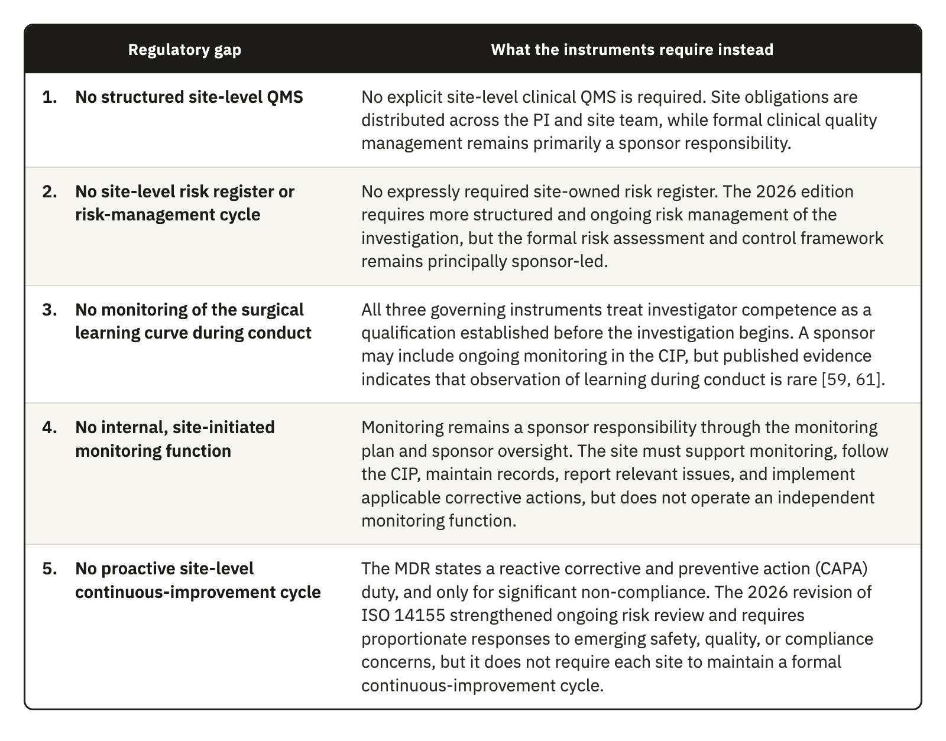
Table 3.1. The five site-level regulatory gaps identified in the clause-level comparison of ICH E6(R3), ISO 14155:2026, and MDR Annex XV.
The five gaps are not defects in the regulatory texts. They follow from the division of responsibility that the instruments were written to express. ICH E6(R3) and ICH E8(R1) set out the quality system mainly from the point of view of the sponsor. ISO 14155 gives the investigator a set of substantive obligations and writes them as outcomes to be achieved, without describing a system to operate them. MDR Annex XV supplies the enforcement context and the device-specific traceability obligations. None of the three instruments asks the site to build an operational layer that carries these obligations in daily practice.

3.2.1 The site’s position in the conformity assessment chain
The missing layer becomes clearer once the investigational site is placed in the chain through which a shoulder implant reaches the market. Under the MDR, every device subject to conformity assessment requires a clinical evaluation, whatever its class, although the level of clinical evidence must suit the device and its intended purpose [10]. Article 61 and Annex XIV set out how that evaluation is planned, how data are identified and appraised, and how conclusions are drawn. The results are documented in a clinical evaluation report (CER), which supports the assessment of conformity and forms part of the technical documentation. Shoulder joint replacements are class III devices under Annex VIII, Rule 8, and for implantable and class III devices Article 61(4) generally requires clinical investigations. Article 62(1), Articles 63 to 80, and Annex XV govern how those investigations are planned, approved, conducted, and reported.
Conduct at the site is therefore not a peripheral activity, because the data produced in the operating room and in follow-up become clinical evidence. The clinical evidence becomes the CER, and the report becomes part of the file the notified body decides on. Every link in that chain is therefore only as reliable as the one before it.
ISO 14155:2026 does not create a site-level quality-management system. It places clinical quality management in Clause 9, Responsibilities of the sponsor, which opens with Clause 9.1, Clinical quality management, and requires the sponsor to maintain written clinical quality procedures and compliance records [8]. Clause 10, Responsibilities of the PI, has no equivalent quality-management subclause. It covers the general responsibility of the investigator, the qualification of the investigator and the investigation site, communication with the ethics committee, informed consent, compliance with the CIP, medical care, and safety reporting [8]. Clause 10.3 places on the PI the duty to demonstrate that the proposed site has enough eligible participants and a qualified team, and Clause 10.6 asks the PI to keep an adequate team throughout the investigation. These are qualification and staffing duties, and they do not describe a local quality-management system.
The fourth edition widened that asymmetry. It added a provision on the CEC, strengthened the Data Monitoring Committee requirement, and added the risks arising from the processes of the clinical investigation [8]. Each of these mechanisms is led by the sponsor and works centrally, and none has a counterpart in Clause 10. The sponsor side of the system therefore expanded without an equivalent local structure being assigned to the PI. None of the standards examined here describes a quality system for the investigational site in the way that ISO 13485 does for a manufacturer and ISO 15189 does for a medical laboratory.
Reading across ISO 13485:2016, ISO 14971:2019, and ISO 14155:2026 allowed us to group the mapped requirements into four functions [8, 52, 53]. They are a defined structure of authority and competence, a documented risk cycle, controls over execution and records, and a loop that measures performance and corrects it through corrective and preventive action (CAPA). The standards do not state these four functions as a shared taxonomy. They are the synthesis adopted in this thesis, and Chapter 4 uses them as the four pillars of the framework.
A documentary search of the three governing instruments also showed one boundary. The terms “proficiency,” “operator performance,” “credential,” “proctor,” and “surgical skill” did not occur in ISO 14155:2026, ICH E6(R3), or the MDR. “Learning curve” occurred once, in ISO 14155:2026 Annex A, where it appears as a CIP item on roll-in procedures, and the term “training” occurred 29 times in ISO 14155:2026. Within this corpus, the learning curve is therefore a design consideration for the CIP, and no instrument assigns the site the case-by-case observation of each operator’s proficiency during conduct.

3.3 Site-level Critical-to-Quality domains
The comparison left us with a classified set of attributes, which three further steps turned into domains: a filter, a grouping by operational area, and a test against the four criteria drawn from ICH E8(R1) in Section 2.2.2. Neither ICH E8(R1) nor ICH E6(R3) performs this translation, which identifies the CtQ factors that matter at site level, as distinct from the trial-level factors a sponsor defines.
A trial-level analysis asks which design features of the study are critical to the interpretability of its results. A site-level analysis asks which operational features of a particular center would compromise participant safety or data reliability in the cases that center contributes. Device-specific guidance on CtQ factors exists and is useful, but it is written from the trial-level perspective [34, 54].
The process produced the twelve domains in Table 3.2, each described by what it covers and by the principal threat that arises when control is inadequate. Figure 4.4 later shows which instruments of the framework control each domain.
Several of these domains take a different operational form in device investigations. Device management and traceability require accountability from receipt through use in a named participant to eventual return or explantation [8, 10]. Procedural delivery and learning-curve control deal with surgeon-dependent variability, which the methodological literature has treated as a design problem and which these domains treat as a site-level control problem. Imaging control recognizes that imaging can determine eligibility, provide an endpoint, and supply safety data. The supporting literature is general or based on knee trials, so it supports these functions of imaging without establishing how often they occur in shoulder investigations [55, 56]. Variability in how images are acquired can therefore produce systematic error that cannot be told apart from genuine clinical variance.
The domains govern the framework in two ways. Every component is introduced to control the risks of one or more domains, and every performance indicator is anchored in at least one domain.

3.4 Operational conditions constraining the design
The gaps establish what is missing and the domains establish what has to be controlled, but the form a site-level framework can take depends on the conditions under which it would have to work. Six conditions apply. Five are structural and common to surgical device investigations, and Section 3.4.1 sets out the consequence of each. Two of the five, operator dependence and unit-level traceability, constrain the design strongly enough to receive their own sections. The sixth is the institutional setting where these investigations take place, which the registry analysis described and which Sections 3.4.4 and 3.4.5 report.
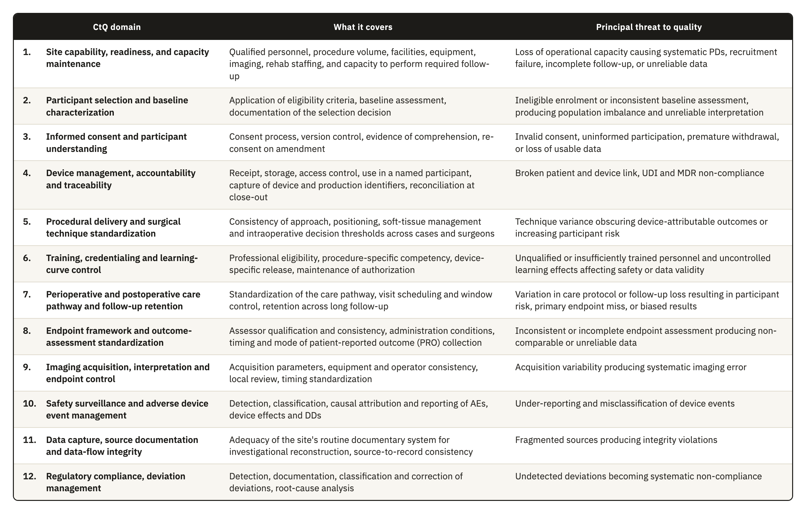
Table 3.2. The twelve site-level CtQ domains derived in Section 2.2.2, with the scope of each domain and the principal threat to quality that follows from inadequate control.

3.4.1 Design consequences of the five structural conditions
Section 1.3 introduced five conditions that separate surgical device investigations from the pharmacological model, and each one has a direct consequence for how quality can be managed at the site.
1. Irreversibility. A drug can be stopped, reduced, or replaced if it fails or causes harm, while a prosthesis fixed to bone has produced a permanent change in the anatomy of the participant. This raises the cost of every quality failure that happens at surgery. An incorrect implant size, an undocumented technical deviation, or a missing traceability record cannot be put right afterward in the way a transcription error can. The European Medicines Agency (EMA) has described poor risk identification and mitigation as leading to a reactive approach based mainly on corrective action [1]. ICH E8(R1) therefore calls for resources to identify and prevent or control the errors that matter (Section 3.3.2), and the CTTI CtQ principles also place attention on prevention before conduct [54]. A site-level framework therefore has to identify in advance which steps of the surgical pathway are irreversible and put preventive controls on them.
2. Operator dependence. Results depend on the device and also on the person who implants it and the technique used [19, 57]. Requirements for surgeon qualification and for training with the specific device already exist. Other sources of variation also need control, including learning-curve effects, differences among surgeons in positioning and soft-tissue management, and intraoperative judgment. Blencowe et al. [58] provide a direct precedent, since they showed that standards for the delivery of a surgical intervention can be agreed before a trial and monitored during conduct through forms that capture deviations. Quality management has to characterize this variation, because removing it would mean removing surgical judgment itself. The framework therefore needs the operator as a unit of analysis, alongside the participant and the case.
3. Unit-level traceability. Pharmaceutical and device trials both require records linking batch or serial numbers to participants [6, 8]. The difference lies in duration. A medicinal product is used or returned, whereas an implanted device may remain in the participant for years, and its records must also cover return or explantation, including traceability after the investigation ends [8, 10]. In surgery, traceability also extends to reconstructing the surgical decisions that produced a given configuration in a given participant, which adds a documentary burden of a different order.
4. Follow-up burden. Long follow-up is not unique to surgical trials, but the measurements involved are. ROM and radiographic assessment of implant position require the participant to attend in person, and PROMs require consistent collection at the specified time points. Consistent assessment procedures and independent central review, where appropriate, are methodological responses to interobserver variability, but none of the three instruments compared requires the same assessor at every visit [25, 59]. Imaging standardization also requires compatible acquisition procedures and quality control (QC) [55, 60]. These requirements raise the cost of every visit and increase the risk of attrition over the years between surgery and the late assessments. Orthopedic studies with at least three years of follow-up reported 14.8% loss to follow-up, compared with 9.8% in studies with shorter follow-up [23], and one shoulder arthroplasty cohort reported 34.3% loss by the seventh year [24].
5. Measurement reliability. Shoulder investigations rely on radiological and clinical classifications that often show only fair to moderate interobserver reliability [61]. Widely used classifications of proximal humeral fractures have been reported with interobserver kappa coefficients in the fair range, even when three-dimensional models reconstructed from computed tomography data are used [62]. Two assessors looking at the same patient can therefore reach different conclusions about eligibility or about an outcome, and the database cannot separate that variance from genuine clinical variance. Outcome measurement adds to the problem, because shoulder arthroplasty trials vary widely in their outcome domains, instruments, and assessment time points, enough to motivate core outcome sets for shoulder disorders [63, 64, 65].

3.4.2 Operator-dependent variability as a design constraint
When one surgeon operates on several participants, those participants share the technique, the intraoperative decision thresholds, and the perioperative management of that surgeon, so they are not independent of one another. This effect is known as clustering [66]. A problem in the execution of one surgeon therefore affects every case that surgeon contributes. Clustering also affects trial design and analysis. Ignoring nonnegligible clustering produced type I error rates above 20% in simulations [67], while only 21.5% of eligible orthopedic randomized trials involving several centers or treatment providers used an analysis that accounted for it [68].
The methodology literature on surgical trials recognizes clustering as one of their central challenges, together with the learning curve that interacts with it [66, 69]. Practice remains uneven. A survey of 44 Clinical Trials Units in the United Kingdom found that clustering was managed mainly by stratification at design, which balances the cases of each surgeon across the arms of the trial, and by adjustment at analysis. Eighty-nine percent of the units managed learning by setting a minimum level of expertise for the treatment provider, and only one unit reported analyzing learning effects as part of the main analysis [70].
Operator learning is therefore controlled mainly at entry and is rarely analyzed or reported during conduct. In a review of 247 published surgical trials, 39% addressed expertise through predefined surgeon credentials, while only one trial analyzed learning during conduct [71]. The documentary search in Section 3.2.1 reached the same boundary, since the governing instruments address qualification and training and do not assign the site any ongoing observation of operator learning. A protocol can define a procedure in general terms, but it cannot standardize the many small decisions through which a particular surgeon implants a particular device in a particular anatomy. The interval between entry qualification and performance during conduct is where a site-level instrument can work, and Table 3.1 records it as gap 3.

3.4.3 Traceability as a point-of-care obligation
Unit-level traceability is detailed in content and demanding in its circumstances, because it is carried out in the operating room, under time pressure, by staff whose attention is on the surgical procedure. ISO 14155:2026 requires records of receipt, identification, quantity, dates of use, participant identification, and return or explantation, together with written procedures for the whole accountability process [8]. The sponsor keeps the record of physical location up to delivery to the site, and the records of the investigator continue the link through use in the participant and any return or explantation. The MDR also requires access control, return procedures, and follow-up in the CIP, the immediate identification and recall of devices in an emergency, and traceability after the investigation [10]. Because dates of use and participant identification have to be recorded, capture at the point of care is the most reliable operational response in surgery. A break in the chain can compromise regulatory compliance and the attribution of an AE to a specific device or lot, although the cited clauses do not state that such a break invalidates the affected case.
Traceability is the clearest example of a pattern that runs through the domains in Table 3.2. A class of critical data is generated at the point of care, where external oversight cannot see it as it happens, and it cannot be recovered once lost. The intraoperative decision to substitute a component belongs to this class, and so does the technical deviation prompted by unexpected anatomy. The immediate postoperative image that may or may not be adequate is another example, together with the early complication whose relationship to the device is still undetermined. A framework that deals with this class of data therefore has to work at the moment the data are generated.

3.4.4 Where these investigations are conducted
The registry search described in Section 2.4 produced 46 eligible industry-sponsored investigations of implantable shoulder devices. Repeated facility listings were cleaned and resolved at organization level, which gave 235 organization-level entries. Each organization counted once in the distribution, and every associated ClinicalTrials.gov identifier stayed linked to its record. Eight entries could not be resolved to a verifiable clinical organization. Section 2.4.2 describes the normalization, the evidence sources, and the case-by-case review behind these decisions.
Table 3.3 reports the organizational environment in four mutually exclusive categories. We chose this variable because academic status and institutional ownership could be identified consistently from public institutional descriptions. We also recorded, for each environment, how many organizations publicly presented a permanent clinical trial infrastructure, as a more direct indication of established research support. Neither variable measures trial quality or research performance.
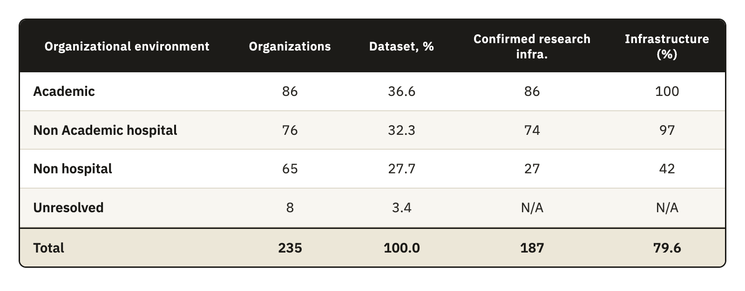
Table 3.3. The organizational environment of the 235 organizations in the registry dataset, with the number and share holding publicly identifiable permanent clinical trial infrastructure by environment type.
Note. Dataset percentages use all 235 organization-level entries, while percentages with infrastructure use the total within each environment and are rounded to the nearest whole percent. The total percentage includes the eight unresolved entries in its denominator. An infrastructure classification of no means that the public sources consulted did not establish a permanent structure. Research activity may still take place through temporary staff or sponsor-provided support.
Academic organizations and nonacademic hospitals accounted for 162 of the 235 entries (68.9%), and permanent clinical trial infrastructure was publicly identifiable in 187 organizations (79.6%). Most organizations in this sample therefore worked within hospital settings or publicly presented an established research structure.
The nonhospital environment contained 65 organizations, 27.7% of the dataset. A permanent clinical trial infrastructure was publicly identifiable in 27 of them and not in the other 38, which represent 58.5% of the nonhospital group and 16.2% of the full dataset. They form a relevant part of the sample for which permanent research support could not be established from public information.
The sample was concentrated in the United States, which accounted for 149 organizations against 86 elsewhere, and 60 of the 65 nonhospital organizations (92.3%) were in the United States. The registry findings describe the selected sample and cannot establish how common comparable organizations are in Europe or across all shoulder device investigation sites. The framework itself was designed under the European regulatory context, the MDR and ISO 14155, because the thesis was developed in the EU and the supervising team has its regulatory experience there. The registry sample is dominated by the United States because ClinicalTrials.gov offered more data and better tools for this analysis than the European sources available to us, and the study is not focused on the United States. We therefore use the registry only to describe the organizational profile of the sites, while the obligations the framework answers come from the European instruments and the ICH guidelines.

3.4.5 The operating conditions of the target center
The target center of the framework is a private organization that takes part in device investigations on a recurrent basis and has staff who carry research tasks, but whose main activity is surgical care. Research is a regular but secondary activity in such a center, and the center has no system dedicated to the quality of its investigations. Section 4.7.1 calls this context Type B. Smaller centers that take part in investigations only occasionally face the same conditions with even fewer people, and Section 4.7.1 calls them Type C.
The registry supports this choice in part. Nonhospital organizations formed more than a quarter of the sample, and for 38 of them the public sources did not identify a permanent clinical trial structure (Section 3.4.4). The framework therefore could not assume that a participating organization has a dedicated clinical trial office or a research quality function, even when it takes part in industry-sponsored investigations. The registry did not measure how often an organization takes part in investigations, how many staff it assigns to research, or what priority research receives, so the features that define the target center are design assumptions that require assessment during implementation. A missing public record of permanent structure also does not show an absence of research activity or poorer trial conduct, because internal arrangements may not appear on public pages and temporary or sponsor-provided support may be available.
The first feature of the target center that shaped the design is that research is a secondary activity, run by people whose main responsibilities are clinical. The instruments therefore had to fit within existing roles and existing records, without depending on new infrastructure or a dedicated quality department. The team is also small, and knowledge of how quality is kept tends to sit with a few named people, so key quality decisions had to remain in records held by the organization when individual responsibilities change, and each critical function needed a named substitute. Finally, the center has no dedicated system for investigation quality, so the instruments had to work on paper or within an electronic system the center already uses.
These conditions define the full implementation that Section 4.7 describes for Type B, and the essential core for Type C follows from the same conditions with fewer people. Organizations with established research departments, Type A, can place the same functions within their existing systems and use deeper controls. The registry findings support an adaptable design for a relevant part of the sample, but they do not show that the framework can equalize performance across environments, which would need empirical evaluation.

3.5 Design requirements
The CtQ domains define what matters, but they do not say what the site must have in place for a domain to be under control. The design requirements fill that space. Each one turns an area of criticality into a statement of what an acceptable solution has to deliver, written so that a component of the framework can later be checked against it, and together they complete the second DSRM activity, the definition of the objectives for a solution.
The three analyses in this chapter produced twelve requirements, which Table 3.4 states and traces to their origin. Requirements DR1 to DR5 follow from the regulatory gaps, DR6 to DR9 from the CtQ analysis and the structural conditions of surgical investigation, and DR10 to DR12 from the operating conditions of the target center. Requirements and domains are not in one-to-one correspondence. All twelve domains feed DR2, because the site risk register has to cover each of them, and several domains also feed more specific requirements where they leave an obligation without an operational means, as Table 3.4 shows.
Meeting one requirement can make another harder to meet, a property that Table 3.4 does not show. DR11 limits how DR1 to DR9 can be met. A site could satisfy every functional requirement by building a dedicated information system for the investigation, a solution that would pass the regulatory analysis and fail the operational one. When two requirements point to different solutions, we treat the operational constraint as the binding one, because a control that the site does not execute gives no protection.
The requirements are traceable to the analysis in this chapter, and each component of the framework answers at least one of them. This trace shows that the framework is coherent with the evidence it was built from. It does not show that a site needs the framework, a question Section 5.1 takes up.
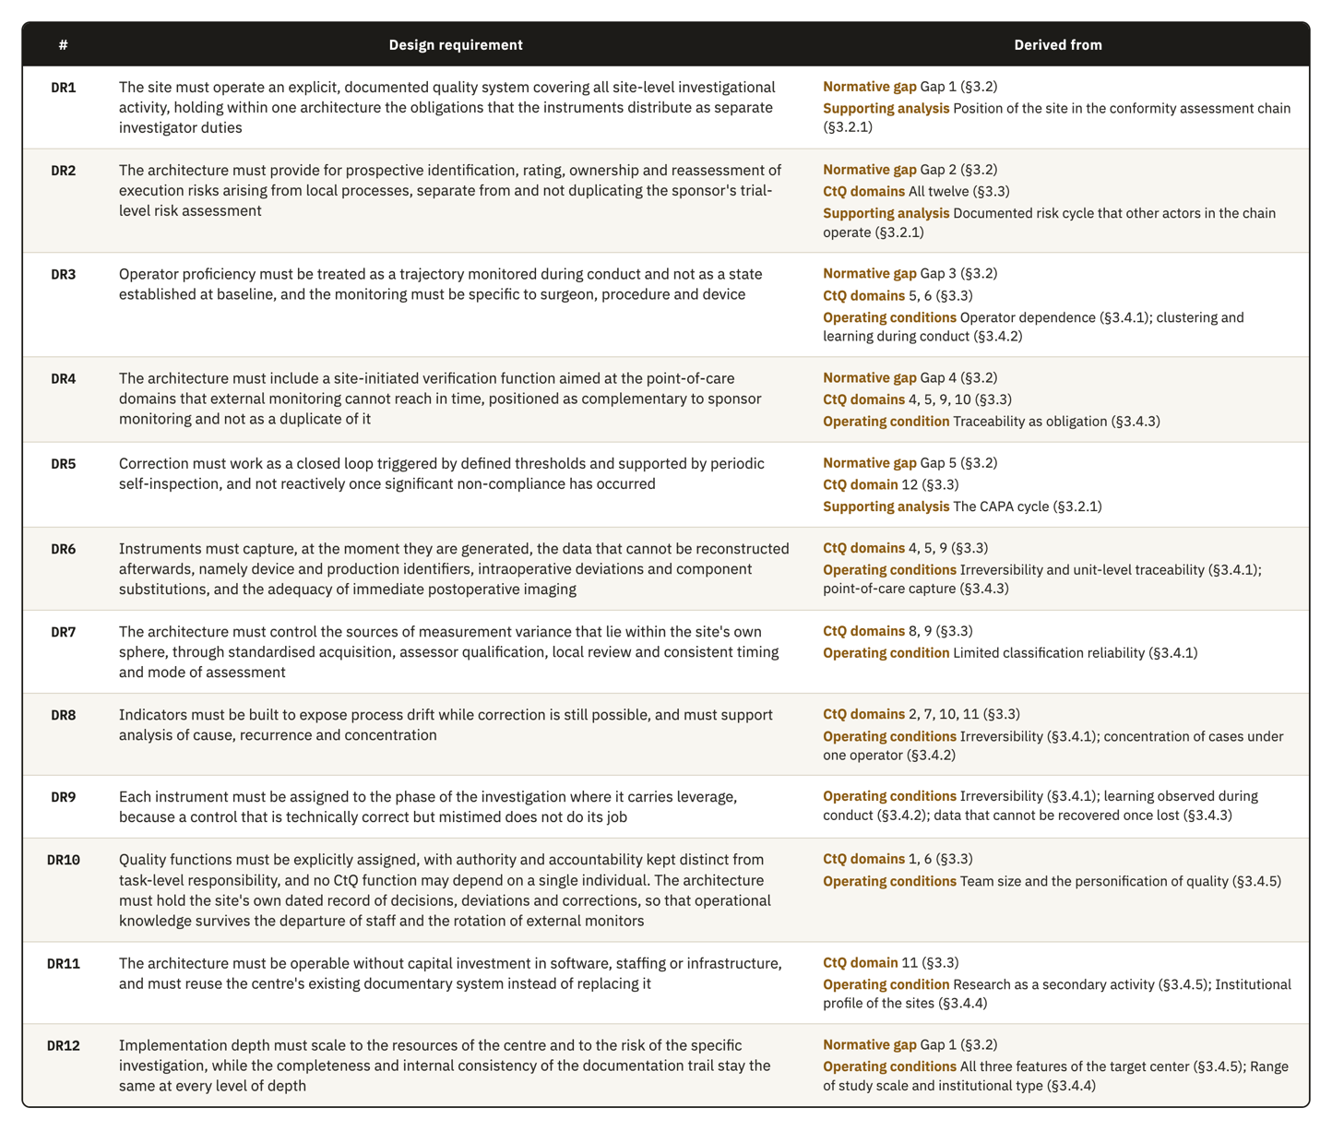
Table 3.4. The twelve design requirements for the site-level quality framework, with the regulatory gap, CtQ domain, or operating condition from Chapter 3 that each one is derived from.

4. Results: The Quality Framework

4.1 Overview and design rationale
Chapter 3 closed the second DSRM activity with the design requirements DR1 to DR12. This chapter reports the third activity, design and development, and describes each component of the framework in enough detail for a site to operate it.
The model is called the Site-Centered Operational Quality Management Framework. It has four pillars, and each pillar holds a set of instruments. A lifecycle decides when each instrument is used and a role structure decides who operates it, while a scalability model decides how deeply it is implemented given the structure and capacity of the site.
The four pillars are Governance, Risk Management, Operational Controls, and Performance Oversight. They are a synthesis made for this framework, and no single standard states them as a taxonomy. They map recurring functions across ISO 13485:2016, ISO 14971:2019, ISO 14155:2026, and the ICH guidance. Governance appears in ISO 13485 Clause 5, ISO 14971 Clause 4, and ISO 14155 Clause 9.1. Risk management appears in ISO 13485 Clause 7.1, ISO 14971 Clauses 5 to 7, and ISO 14155 Clauses 6.2.1 to 6.2.4. Operational controls appear in ISO 13485 Clauses 7 and 7.5 and in ISO 14155 Clause 7, while performance oversight appears in ISO 13485 Clauses 8, 8.2.4, 8.4, and 8.5, ISO 14971 Clauses 9 and 10, and ISO 14155 Clause 9.1. Because these functions are already familiar from the device quality system, the framework is easier to interpret for people who work with those standards.
Table 4.1 maps the twelve design requirements to the components that answer them, and each section of this chapter returns to that mapping. The framework was designed for the target center described in Section 3.4.5, a private center that runs investigations recurrently alongside surgical care, and that setting explains the form the instruments take. The components are nonetheless described as functions, so that a center with a different staffing structure can map its own posts onto them.
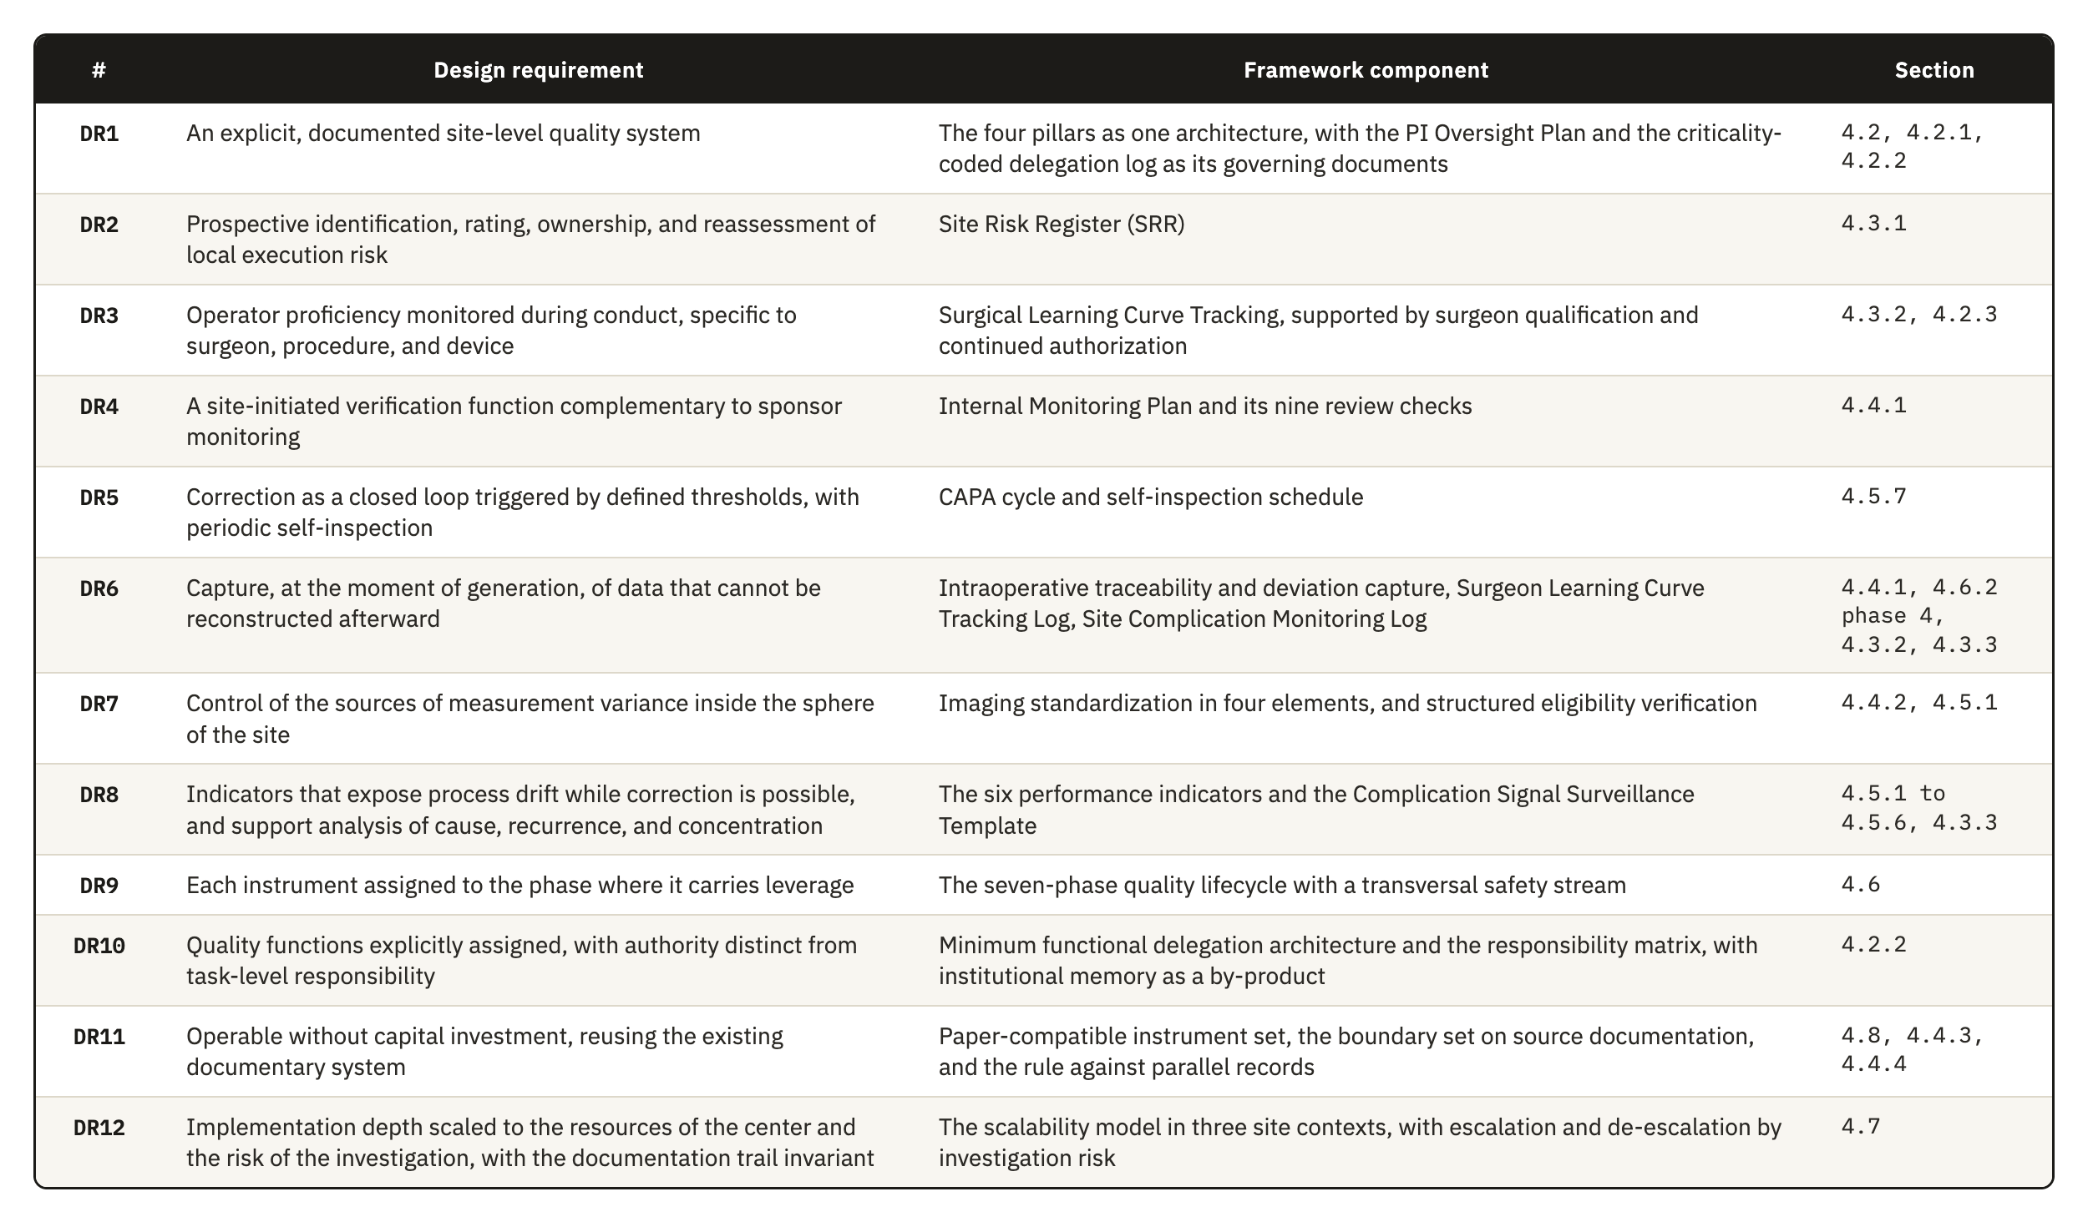
Table 4.1. The twelve design requirements from Section 3.5, the framework component that answers each one, and the section of Chapter 4 where that component is developed.

4.2 Pillar 1: Governance
Governance defines the local authority structure through which regulatory accountability is exercised at the site. The quality of a surgical device investigation depends on technical execution by the surgeon and on decisions taken during the procedure, so the pillar controls clinical authority and delegated execution in a documented and risk-proportionate way, together with the procedural competence and device training of the people involved.
The regulatory basis sits in two places. ICH E6(R3) expects investigator oversight to be proportionate to the nature of the delegated activities, the importance of the data collected, and the risks to participant safety and data reliability. ISO 14155:2026 keeps responsibility for the investigation with the PI under Clause 10.1, even when activities are delegated, and requires the qualification of the investigator under Clause 10.2 and of the site under Clause 10.3.
The pillar has four components: the oversight model, the delegation structure with its roles, surgical qualification, and device training documentation. The oversight model defines how authority is exercised, and the other three define who may act under it. The qualification decision belongs to this pillar, while the observation of how a qualified surgeon performs afterward belongs to Risk Management (Section 4.3.2). Seven instruments carry the pillar, and the sections below name each one where it is described.

4.2.1 The oversight model
During the design we developed three analytic alternatives for allocating oversight at site level. They are not an empirically established taxonomy. They represent recurrent ways in which site functions may be distributed under different constraints of staffing, capacity, and existing organization. Published descriptions of trial-site operations confirm that these functions must be covered, but they do not divide them into the same three models. We therefore present the alternatives as design choices and explain why the framework adopts the third.
In a strongly investigator-centered model, the PI intervenes directly in most critical activities and personally reviews most documentary and operational workflows. It gives an impression of intensive supervision, but it becomes difficult to sustain as activity expands. Site PIs already carry scientific, regulatory, and administrative duties, and their contribution is often under-recognized [72]. Administrative review then consumes the attention needed where clinical judgment cannot be replaced, such as confirming surgical appropriateness, interpreting intraoperative deviations, or assessing whether a complication is related to the investigational device. The model also scales poorly across the operating room, radiology, functional follow-up, and implant accountability.
In a coordinator-led model, daily management is delegated to the study coordinator while the investigator keeps final authority. The model is operationally plausible, because the clinical research coordinator is a core site function [73], and ICH E6(R3) permits delegation while the investigator keeps ultimate responsibility and proportionate oversight [6]. Food and Drug Administration (FDA) guidance on supervisory responsibilities also emphasizes appropriate delegation, staff qualification, and investigator oversight [74]. The weakness of this model lies in nominal oversight, which appears when no defined review structure, periodicity, or escalation pathway states what requires direct investigator involvement. In surgical investigations, those points include borderline eligibility decisions, unplanned intraoperative changes, and component substitutions.
The framework adopts a third arrangement, a tiered and risk-adjusted model of PI oversight recorded in the PI Oversight Template (POT). Investigator involvement is graded by task criticality and calibrated to the risk each task poses to participant safety and data reliability. Oversight is concentrated on the processes, decisions, and data flows that can affect participant protection and study validity, which applies the CtQ logic of ICH E8(R1) to the allocation of the investigator’s own attention. Five mechanisms put this principle into practice.
The first mechanism is a schedule, set in advance for each type of activity, of what requires the investigator’s own judgment and what can be reviewed after the fact without loss. The line moves with the device, the procedure, and the experience of the team. If it is set too low, the investigator returns to the first model, and if it is set too high, oversight becomes a formality that produces no real review.
The second mechanism grades delegated activity by its stakes. Criticality is not a fixed property of a task. Coordinating a routine visit is administrative until a scheduling choice places a follow-up outside the protocol window, and recording an intraoperative note is clerical until the note is what later reconstructs a disputed complication. The grading has to anticipate which routine activities carry this kind of latent significance, so a scheme copied from another site will miss the ones specific to this investigation and this team.
The third mechanism places formal review points, recorded in the Milestone Review Log (MRL). Reviewing too early misses problems that only appear once a procedure or a follow-up window has occurred, and reviewing too late lets a correctable pattern continue through several more cases. The framework places the points at procedural implementation, the immediate postoperative period, the approach to endpoint assessment, and close-out, which reflects the risk profile of a shoulder implant investigation and would not transfer unchanged to a different device or procedure.
The fourth mechanism is an event-triggered escalation pathway, which requires investigator notification regardless of the routine review cadence. Some events threaten participant safety or causal interpretability immediately and have to reach the investigator before the next scheduled review.
The fifth mechanism places this review in the recurring rhythm of the site through scheduled oversight meetings, so it does not depend on ad hoc contact. It transposes to the site the structured, consensus-based review that ISO 14155:2026 uses at sponsor level under Clause 6.12, together with the multidisciplinary review of risk that the EMA reflection paper describes [1]. No study has yet shown that site-level forums of this kind improve oversight. They are also harder to sustain in a Type B center, where the people who attend the meeting are the same people who do the clinical and administrative work the meeting reviews.
These five mechanisms answer DR1 at the level of authority. They also carry part of DR10, because an oversight model that is written down, scheduled, and evidenced leaves a record that survives the departure of the people who operated it.

4.2.2 Delegation, roles, and functions
The delegation structure makes the oversight model operable, and the relationship runs in both directions. Without designated functions and training-linked release, a well-designed oversight model has no clear holders, and a strong delegation structure in turn makes escalation thresholds meaningful and lets the investigator concentrate attention where clinical judgment is needed.
ICH E6(R3) allows the investigator to delegate trial-related activities while keeping ultimate responsibility, and it requires oversight of delegated persons in proportion to the nature of the activity, the importance of the data, and the risks involved. Delegated personnel must be qualified and adequately informed about the protocol and the investigational product. ISO 14155:2026 governs the other members of the investigation site team under Clause 7.6, which requires documented training before assignments begin, together with a record of names, initials, signatures, functions, and designated authorizations.
The conventional delegation log is mainly a record of who performs which trial-related activity. ICH E6(R3) Section 2.3.3 requires documentation proportionate to the significance of the activity, but it does not require a criticality code or evidence of competence in the same record. Delegation records are nevertheless subject to direct inspection, and the investigator remains accountable for delegated work [74, 75]. The framework therefore replaces the plain log with the Criticality-Coded Delegation Matrix (CCDM), which is task-based and competency-gated, kept under version control, and linked to the review intensity defined in the POT. The task-based property matters most, because a research nurse may be entirely appropriate for coordinating visits and maintaining screening logs and still not be the right person to resolve a clinically meaningful discrepancy in operative documentation.
The framework defines a minimum set of six functions that reflects how orthopedic implant investigations are run.
The PI is accountable for conduct at the site and for the appropriateness of every delegated activity. Delegation transfers execution, and responsibility stays with the investigator.
The study coordinator, or the research nurse where the site uses that title, is the principal operational integrator. The function coordinates consent logistics and study visits and carries the flow of documents and the escalation of issues across the site. Its limit is clinical, so a coordinator does not decide eligibility, interpret safety information, or classify a PD.
Operating room staff prepare the investigational device for use and apply the chain-of-custody controls. They record the intraoperative procedural data and complete the procedural source records, and they hold no authority over clinical decisions.
The radiology liaison supports adherence to the imaging protocol and its windows and keeps image acquisition and transfer technically consistent. Control stops at technical quality, and where central reading applies, endpoint adjudication is not a site-level function.
The functional assessor, in many sites a physiotherapist, conducts ROM measurement and the PROM workflows wherever those activities are critical to endpoint quality. The function administers assessments by a defined method and does not interpret what an endpoint means.
The data QA function manages query flow and monitors the completeness of critical data. It identifies discrepancies, and a discrepancy that is clinically meaningful goes to the PI for resolution.
A site does not need a separate post for each function, and in a Type B center one person often holds several of them. The framework therefore requires each function to be assigned to a named individual and to have a named substitute, whatever the number of people involved, so that no CtQ function depends on one person alone. The Responsibility Assignment Matrix (RACI) records, for each activity, who is responsible, accountable, consulted, and informed, together with the backup and the limit of authority of each holder.

4.2.3 Surgeon qualification and continued authorization
The sponsor and the site share the control of which surgeons may perform study procedures throughout the investigation. The sponsor normally defines the minimum entry criteria through the CIP, the training requirements, and the study risk assessment, and during site qualification it reviews the available evidence and confirms whether the site meets those criteria. The site applies the criteria to its surgical team and demonstrates that each delegated surgeon meets them.
ISO 14155:2026 sets out this division of responsibility. Clause 6.8 requires the sponsor to define site selection criteria and to verify the qualifications of the PI and the adequacy of the site, and Clause 9.2.1 requires the sponsor to ensure that relevant training, experience, and knowledge are verified and documented. Clauses 10.1 and 10.3 require the PI to ensure the qualification, training, and oversight of the team and to demonstrate that its members have suitable education, training, and experience for their assigned responsibilities. Clause 10.6 further requires the PI to maintain and document an adequate investigation site team throughout the investigation. These are duties to qualify and staff the team, and none of them asks the site to observe, case by case, how the proficiency of each surgeon develops during conduct, which Section 4.3.2 addresses.
The framework reflects this allocation through the Surgical Credentialing Record (SCR). Sponsor requirements set the threshold, and the site turns that threshold into a documented decision for each surgeon and links the decision to the CCDM, so that assigned surgical tasks stay consistent with current authorization. The SCR separates general standing as a surgeon from competence in the procedure, and both from readiness on this particular device, because each can be adequate while another is not. Standing can be adequate for a comparable procedure and still uncertain for the technique of this device, and the site has to decide how much of that uncertainty the entry criteria of the sponsor already resolve and how much its own judgment has to close before the first case.
The site may also apply temporary controls when the risk assessment or the expected learning curve supports additional supervision, such as proctoring or an initial assignment to less complex cases. Their use remains proportionate to the procedure, the device, and the experience of the surgeon.
Qualification remains a current status throughout the investigation. The framework requires re-evaluation annually and whenever a defined trigger occurs, for example a complication cluster or evidence of performance drift, and the site can then confirm, restrict, suspend, or restore surgical authorization according to the evidence. Deciding what counts as evidence of drift early enough to act is the difficult part, because the performance of a surgeon is the most direct signal available and also the hardest to read without a longer run of cases. This maintenance function is a site-level contribution of the framework, because it connects observed performance with continued authorization to operate.

4.2.4 Device training documentation
Device training documentation is the controlled body of records showing that site personnel received the training their activities require, covering the protocol, the instructions for use (IFU), and the responsibilities of each person. It shows that critical activities were performed by personnel who were both delegated and prepared for the specific investigational context, so its function is operational as well as evidentiary.
The requirement rests on both bodies of guidance. ICH E6(R3) requires individuals involved in the trial to be qualified by education, training, and experience, and those assisting to receive training that corresponds to their delegated activities. ICH E8(R1) requires study personnel to be trained in proportion to their role before becoming involved, with retraining as needed during conduct. ISO 14155:2026 requires documented training before assignments begin under Clause 7.6. The fourth edition also strengthened the upstream side of this obligation, since Annex B now asks the sponsor to include information on device use training in the Investigator’s Brochure under item B.2(h). The sponsor therefore documents what training exists, and none of the clauses examined requires the site to verify that the resulting competence is maintained. The training component of the framework covers that verification.
In orthopedic device investigations, training has to cover the proper use of the investigational device and its instrumentation, the operative workflow, device accountability, and the safety-reporting interfaces. MDR Annex XV, Chapter I, Section 2.7 requires the sponsor to verify, arrange where necessary, and document training in proper device use, the CIP, and GCP, and Annex XV, Chapter II, Section 3.2 links investigator suitability to device and procedural training and experience. Clause 7.9 of ISO 14155:2026 requires device-accountability procedures. Medicinal-product GCP also requires qualified personnel and investigator familiarity with the investigational product [6], so the framework does not claim that the device burden is wider in kind. It specifies the additional device-linked functions that must be controlled.
Two instruments carry this component. The Device and Study Training Requirements Matrix (DTRM) links each role and activity to the training it requires, with the prerequisite, the assessment method, and the renewal interval. Training Record Evaluation and Release (TRE) compares the evidence held for each person with what the DTRM requires and records who was trained, on what, when, by whom, and under which version of the controlled document. The DTRM distinguishes five training domains in a shoulder investigation:
- Protocol and procedural training covers the study objectives, key eligibility restrictions, endpoint-relevant visit windows, PDs, and study-specific decision points.
- Device-specific training covers the investigational system, its instrumentation and implant components, preparation and handling, and any workflow constraint the study introduces.
- Operative and perioperative documentation training covers intraoperative records, component reconciliation, the capture of device and production identifiers, the documentation of substitutions and deviations, and chain-of-custody expectations.
- Assessment training covers radiographic acquisition standards, imaging timing, ROM measurement methods, and the administration of PROMs where these are endpoint-relevant.
- Safety and reporting training covers the recognition and documentation of AEs and DDs, together with the escalation pathway for clinically important findings.
Completing a training session is not the same as being ready to perform a task independently. For activities with higher risk or variability, particularly those involving the device, the imaging, or the outcome assessment, the site records an explicit release decision in the TRE once training is complete. This release decision connects training documentation to the CCDM and, for surgeons, to the SCR.
Training documentation is kept current throughout the investigation. Retraining is triggered by protocol amendments, revised IFU, new device iterations, or workflow changes, and also by safety signals and repeated documentation errors. ICH E8(R1) requires retraining when issues related to CtQ factors arise during a study and when protocol modifications are implemented. The site should therefore be able to show that staff were trained at start-up and that their training stayed current as the investigation developed.

4.3 Pillar 2: Risk Management
Risk Management identifies where site conduct is most likely to fail and decides how those failures are controlled before they reach participants or the data. The pillar concentrates on the risks that threaten CtQ factors and leaves aside the exhaustive listing of everything that could go wrong.
ICH E8(R1) frames quality around CtQ factors and a proportionate response to the threats against them [5]. ICH E6(R3) asks for an approach to the risks that may meaningfully affect participant rights, safety, and well-being or the reliability of results, running from their identification to their periodic review [6]. The EMA reflection paper on RBQM describes a similar operational cycle and names Failure Modes and Effects Analysis among the tools that can be useful for risk assessment [1]. The EMA paper is nonbinding methodological guidance, and the normative duties the framework draws on come from ICH E8(R1) and ICH E6(R3).
ISO 14155:2026 gives this pillar an anchor that the third edition did not provide. The fourth edition restructured Clause 6.2 into three risk streams. Clause 6.2.2 covers risks arising from use of the investigational device, which remain inside the ISO 14971 framework and its Annex H. Clause 6.2.3 covers risks from clinical procedures that the CIP requires outside routine clinical practice, which are assessed descriptively, and Clause 6.2.4 covers risks arising from the conduct of the investigation itself. The second and third streams fall outside ISO 14971, and the standard assigns none of the three streams to the investigational site, so the risks of Clauses 6.2.3 and 6.2.4 have no named local owner.
Three risk-management functions therefore sit side by side in the conformity chain. ISO 14971 governs the risk the device itself carries, and that risk stays with the manufacturer whatever site runs the investigation. ICH E6(R3) and the EMA reflection paper govern risk at trial level, through a cycle that the sponsor operates across every participating center. Between them sits the risk that the execution of a specific site creates. The cycle of the sponsor has to generalize, because the same protocol runs at centers that differ in staffing, workflow, equipment, and experience, and a control built for the weaknesses of one center would not suit the next. The site is the party present when its own data are generated and it knows where its process is strong and where it is weak, so it is well placed to name these risks and control them, although central monitoring by the sponsor can detect some of them later. Risk management at site level follows the same quality logic as the system of the sponsor, anchored in CtQ factors and in controls that prevent, detect, and respond.
Orthopedic device investigations contain sources of variability that general trial controls do not reach, such as surgical learning curves, intraoperative decisions, imaging-dependent assessment, and early device-related complications. A generic register copied from sponsor-level practice would not capture them, so the pillar is built around the risks the center can detect and mitigate through its own processes. It holds a prospective register of process risk and a log of the stabilization of each operator, together with the surveillance of clinical signals, and Sections 4.3.1 to 4.3.3 describe them.

4.3.1 The Site Risk Register
The Site Risk Register (SRR) is the record through which the site identifies, prioritizes, and periodically reassesses the risks that arise from its own execution of the investigation. It is separate from the trial-level risk assessment of the sponsor and from the device risk file of the manufacturer. The assessment of the sponsor supports trial-wide quality management and monitoring strategy across every site, so it is broad by design and does not capture risks shaped by local staffing and workflows. Examples are inconsistent radiographic acquisition, incomplete capture of implant identifiers, delay in documenting intraoperative deviations, and weakness in escalating safety-relevant findings. A trial-level assessment is not built to see these risks as they arise, although some may later appear in central monitoring or central imaging review, and all of them are within the control of the site.
A 2023 study of Portuguese clinical trial sites is consistent with this gap. More than half of the sites reported using some form of systematic risk management, yet only 19.6% described a standard tool or document that systematically captured site-level risk analysis. The authors concluded that sites remain underdeveloped in the autonomous control of risk in their own processes and would benefit from a risk tool built for site operational needs [76]. The study supports DR2 more directly than the other evidence used in this work, although it was conducted in one country and across therapeutic areas.
The SRR can fail in two ways. It can grow into an exhaustive catalogue that no one revisits, or it can stay symbolic because no one holds the authority to act on it. The register therefore rates each risk and assigns it an owner, a residual risk level, and a review trigger, so that the risks that matter to participant safety or data reliability stay separate from the longer list of things that could conceivably happen. The record has to stay current enough that a real change in the conditions of the site appears in it before the change causes a failure.

4.3.2 Operator-dependent risk and the learning curve
Surgeon-dependent variation is a risk in a device investigation for a reason that does not apply to a medicinal product, because the procedure is part of the intervention. Variability in surgical execution reaches protocol adherence, implant traceability, and endpoint consistency, and it reaches clinical outcomes as well. Section 3.4.2 showed why this matters and why none of the instruments examined in this thesis assigns the site a role in observing it once the investigation is under way.
The literature associates procedural experience with changes in operative time, complications, and reoperations, but it is heterogeneous in how it defines and measures proficiency. Avendano et al. reported an average of about 25 cases for reverse total shoulder arthroplasty across eight studies, while a multicenter analysis found plateaus between 12 and 86 cases across surgeons and procedures [20, 77]. These values are descriptive and do not define a universal proficiency threshold, so the framework does not adopt a fixed case count.
The Surgeon Learning Curve Tracking Log (SLCT) answers DR3. It asks whether surgeon-dependent variation is becoming a material source of risk to CtQ factors at this site, in this investigation, with this device, which follows the requirement of ICH E8(R1) to review periodically whether risks to critical factors remain controlled during conduct. SQA frameworks address the learning curve mainly at selection, and the validated Clinical Trial Site Performance Measure contains no counterpart for surgeon procedural consistency once a trial is under way [37, 39, 41]. The SLCT occupies that interval and is operated by the site.
The log records, for each surgeon, the sequence of cases with their complexity and the technical metrics, deviations, and complications of each one, and it reads that sequence against case complexity, with no fixed count. The main difficulty is separating genuine instability from ordinary variation between cases. A longer operative time or an unplanned substitution can mean very different things depending on the complexity of the case and on how far the surgeon has progressed with the device. A reading that ignores this context will flag normal variation as drift, or it will miss real drift inside a case dismissed as complex. Review is therefore triggered by criteria the site defines before the first case, and its output is a decision on whether supervision, retraining, restriction, or continued release is warranted.
Because the SLCT is kept at the point of care as cases occur, it is designed to show procedural drift before the drift becomes an AE, a PD, or an anomalous data point in the study database. Whether it does so in practice is an expected benefit that implementation has to test.

4.3.3 Device-specific complication monitoring
Device-specific complication monitoring is the process the site uses to identify, classify, review, and escalate complications, AEs, adverse device effects (ADEs), and DDs that may relate to the investigational device, to the procedure, or to their interaction in clinical use. Three instruments carry it. The Safety and Adverse Effect Reporting Template (SART) tracks each safety occurrence from the moment it opens until it closes. The Site Complication Monitoring Log (SCML) gives the site a single index of every complication, referencing the SART case and the procedure record without repeating them, and the Complication Signal Surveillance Template (CSST) reads the SCML to decide whether a pattern of complications requires a response.
The scope of complication monitoring is narrower than that of the SRR. The register is a quality-management instrument for the prospective control of execution risk, and a register entry may state that the implant identifier may not be captured before the operating room workflow closes. Complication monitoring is a surveillance mechanism for clinical and technical signals, and its entry records that a specific participant experienced a specific event on a specific date and asks what the event means. The register anticipates a process vulnerability, and complication monitoring evaluates something that has already happened.
The regulatory basis is the MDR and the safety reporting framework for device investigations. Under Article 80, the sponsor must report without delay any SAE with a causal relationship to the investigational device, the comparator, or the procedure, or where such a relationship is reasonably possible. The same obligation covers DDs that might have led to an SAE, together with new findings relating to those events. ISO 14155:2026 sharpened one point that bears on this component, since Annex F now states that an AE associated with a DD triggers both the AE pathway and the DD pathway.
This component adds timing to an obligation that the MDR and ISO 14155 already impose. Both require individual event reports within defined deadlines, but a deadline measured from sponsor notification is different from detection at the point of care. Left to the reporting cycle alone, a pattern of complications becomes visible to the site only when the next periodic summary is compiled for the sponsor, and by then several more cases may share the same cause. The difficulty is aggregation, because a single complication rarely appears as part of a pattern, and several events that are each explicable on their own may still share a cause. The CSST therefore reviews the events together on a cadence the site sets for itself, independent of the reporting calendar of the sponsor, so that a cluster linked to one implant component, one technique, or one surgeon can be recognized while the investigation can still act on it.
ISO 14155:2026 introduced the CEC under Clause 6.12 and requires the sponsor to consider establishing one for unbiased, confidential, and consensus-based event review. The committee works at trial level with aggregated information across participating centers. The framework gives the site a local counterpart that uses its own exposure denominator and predefined local triggers. The available sources do not establish that either level will detect a signal first. A local response is justified when the trigger of the site is met, while the CEC supports consistent assessment across the investigation. ISO 14155 and the MDR require the management of individual events, and neither requires pattern surveillance at site level.

4.4 Pillar 3: Operational Controls
Operational Controls are the practical mechanisms through which the site keeps execution consistent and traceable over time. Governance defines who is responsible, and Operational Controls define how critical activities are carried out and checked in routine operation. The pillar holds nine instruments. Internal verification uses the Internal Monitoring Plan (IMP) and the Internal Monitoring Checklist (IMC), and the Intraoperative Checklist and Device Log (ICDL) records the procedure and the device. Imaging uses the Site Imaging Readiness Record (SIRR) and the Imaging Quality Log (IQL), and screening uses the Participant Screening and Eligibility Assessment Record (PSEAR) and the Subject Identification and Failure Screening Log (SIFSL). Follow-up uses the Participant Follow-up Visit Record (PFVR) and the Follow-up Compliance Review (FUCR).
The difficulty of the pillar lies in the distance between a procedure as the protocol describes it and the same procedure as it happens in an operating room on a given day. Two places where that distance matters are hard for an outside party to observe in time, because local conduct drifts between sponsor visits, and imaging varies in ways that only become clear once images from different time points are compared. Both depend on records that must reconstruct the investigation without competing with the records that already exist, so every control the pillar adds could become one more place where the same fact is written differently.

4.4.1 Internal verification of site conduct
Internal verification is a site-operated function for the periodic review of trial conduct, documentation, and critical site processes, aimed at detecting local process failure and supporting timely correction within the sphere of responsibility of the site. It is narrower than formal monitoring and replaces none of it.
The terminology needs care, because formal monitoring under GCP is a sponsor responsibility. ISO 14155:2026 assigns the monitoring plan to the sponsor under Clause 6.7, site monitoring under Clause 7.3, and the monitoring function under Clause 9.2.4. ICH E6(R3) places formal monitoring inside the QC system of the sponsor. The FDA guidance on a risk-based approach to monitoring recognizes that monitoring is used in several senses but addresses sponsor oversight of trial conduct and data reporting. Its legal basis is Title 21 of the Code of Federal Regulations (21 CFR) 812.40 for device investigations and 21 CFR 312.50 for drug investigations [78]. None of the instruments examined requires the site to review its own conduct in this way, and DR4 answers that gap.
The value of internal review depends on where it looks. The recurring, operationally verifiable problems in implant-based orthopedic investigations sit where operating room practice meets implant logistics, documentation, and imaging, so review concentrates there, following the RBM principle that the intensity of review should reflect the risk to participants and to data integrity. The IMP sets the frequency, sample, criteria, and escalation route for each domain, and the IMC records the execution of each review, with the finding, the action, its owner and deadline, and the verification that the correction worked. The same review, turned periodically on the conduct of the site as a whole and independent of any sponsor visit, is the self-inspection of the site. Nine checks define its scope:
- Sterile release-to-use verification confirms package integrity, expiry, storage, and release status before use, and reconciles any breach of sterile handling or intraoperative substitution.
- Implant traceability and component reconciliation checks that the lot number, serial number, or UDI where the device carries one was captured consistently across the operative note, the accountability records, the implant labels, and the case report form (CRF), and that the implanted configuration matches what was planned.
- Instrumentation and operating room readiness confirms that the correct implant system and instrument set were available and documents any incompatibility or malfunction, as a procedural issue or as a DD where that applies.
- Operative documentation adequacy checks that operative notes record the final configuration and the intraoperative decisions, substitutions, deviations, and complications in enough detail for later interpretation, since this detail cannot be added afterward.
- Imaging usability and timing compliance verifies that required imaging was obtained within the window, with the correct views and technical quality, and whether repeat acquisition followed when it was not.
- Follow-up execution quality checks that each visit produced the outputs that surveillance and endpoint assessment require, since attendance alone does not show a complete visit.
- Timeliness, backlog, and closure discipline tracks whether notes, data entry, queries, and corrective actions close within acceptable timelines. The EMA reflection paper lists delayed data entry and delayed SAE reporting among its examples of trigger metrics [1], but no source examined establishes that backlog predicts a broader site failure, so the framework treats the relationship as a monitoring hypothesis.
- External context review checks literature, registry findings, safety alerts, and field notices for the same implant class or procedure.
- Early complication pattern review examines the complication categories of the investigation, such as instability or loosening, by timing, severity, and possible association with implant configuration or procedure, and links this check to the surveillance in Section 4.3.3.
The ICDL feeds several of these checks. It preserves the record of the procedure and the device at the point of care, including the components used, any substitution, and the final configuration as the case proceeds.

4.4.2 Imaging standardization
Imaging standardization reduces avoidable variability in the information derived from images wherever imaging contributes to eligibility assessment, procedural documentation, safety evaluation, or endpoint interpretation, and it answers DR7. Preoperative imaging may confirm anatomical suitability or fracture configuration, intraoperative and immediate postoperative imaging document implant placement, and follow-up imaging assesses component position, loosening, or periprosthetic fracture. Poorly standardized imaging can change how a case is classified and reduce comparability across participants and follow-up windows. Section 3.4.1 described the underlying problem, which is that the classifications applied to these images already have only fair to moderate reliability, so acquisition variability adds error that the database cannot separate from genuine clinical difference.
The methodological basis exists, although formal trial-imaging guidance has developed mainly outside orthopedics. Core-imaging and central-reading literature shows that acquisition procedures, site qualification, equipment compatibility, QC, and the distinction between local and central interpretation have to be specified in advance [55, 60, 79]. Shoulder-specific evidence is more directly relevant, since radiographic positioning and projection materially affect the measurements used in shoulder assessment, and standardized views improve reproducibility [80, 81, 82, 83, 84].
ISO 14155:2026 added support for one part of this. Clause 9.2.4.5(p) requires routine monitoring visits to verify that the maintenance and calibration of equipment relevant to assessment are performed and documented, and Annex A.6.4 adds calibration to the content of the CIP. The duty to verify falls on the monitor, and the work of keeping the equipment in that condition falls on the site, which is where this component operates.
The SIRR is a site self-assessment, made before imaging arrangements are submitted for review by the sponsor or the CRO, of whether local acquisition, equipment, and radiology resources can meet the imaging charter or manual of the sponsor. It records in advance what acquisition requires, from the modalities and time points to the mandatory views and, in an orthopedic investigation, patient positioning, laterality confirmation, and the acquisition window at each visit. The requirement has to be concrete enough to remove ambiguity at the point of acquisition while staying within what the imaging manual of the sponsor already sets, so that the site does not maintain a second, competing standard.
Site qualification and personnel training decide whether radiology staff, research staff, and assessors can produce technically acceptable and protocol-compliant images. In shoulder radiography, views only 5 degrees from true anteversion can alter the critical shoulder angle by more than 2 degrees [80], and measurements deviate materially beyond about 9 degrees of malrotation [81]. In routine practice, only 22% of images in one study met the standard anteroposterior projection [82]. Projection also produced ranges of 14 to 17 degrees in arthroplasty inclination measures [84], while standardized outlet views achieved interobserver reliability up to an intraclass correlation coefficient of 0.91 for acromiohumeral distance [83]. These findings justify explicit qualification, training, and calibration of acquisition and assessment procedures.
Local review is recorded in the IQL, which checks each required image against the window, technical acceptability, completeness, and traceability. Centralized image review requires trial-level coordination across sites and lies outside the control of any one site, so only the consistency of its own review is within reach of the site. That narrower target still has to state who reviews, against what criteria, when a second reviewer or clinical escalation is required, and how a nonconforming image is handled and documented. If these points stay open, they are answered case by case and possibly inconsistently.
Timing also affects comparability. Baseline images acquired too early or too late and follow-up radiographs taken outside the protocol window reduce comparability. Shoulder studies show that positioning determines the resulting measurement and that inadequate positioning is common [81, 82]. They do not establish that pain, dressings, or sling use are frequent causes of inadequate immediate postoperative films, so the link between timing and a reproducible position is an operational inference that the cited studies do not test. For some time points the framework therefore allows an acceptable window around the nominal date, so that the image is taken when a reproducible acquisition is realistic.

4.4.3 Source documentation and the boundary of the framework
General source documentation belongs to the documentation system of the investigational site, and ISO 14155:2026 governs it under Clauses 7.5.3 and 7.8. The framework does not attempt to rebuild it.
The study-level requirement is narrower. The existing documentary system of the site has to be adapted so that it captures and links the records relevant to CtQ factors, which in an orthopedic device investigation concern implant traceability, operative conduct, imaging, follow-up, and revision events. Routine site documentation then remains sufficient for reconstructing the investigation and for regulatory review, and the framework creates no separate documentation system for the study. This restraint is a design decision that follows from DR11, because a parallel documentation system would impose a cost the target center cannot absorb and would create the duplication problem discussed next.

4.4.4 Avoiding parallel records
Any site-level framework has to deal with the risk that its instruments become a second, divergent record of information that already exists elsewhere. ICH E6(R3) Section 2.12.2 requires the investigator to define the source records before the trial begins and states that unnecessary transcription between the source record and the data-acquisition tool should be avoided, and Section 4.2.2(a)(2) requires changes to be traceable. Practical site guidance on E6(R3) makes the same point, since an up-front source definition prevents uncertainty over which record is authoritative [85]. Each instrument of the framework must therefore have a defined purpose and a defined relationship to the source. Where the same event is documented inconsistently in two places, the discrepancy is itself a finding.
The objection applies to this framework with some force, because it introduces a risk register, a learning curve log, a complication log, a surveillance template, and several review records. These are additional records, and a design rule about what each one is for keeps them from diverging from the source.
The instruments fall into two categories. The first, made up of the SLCT, the CSST, the SRR, and the CAPA Log, holds the judgments of the site about data recorded elsewhere. They do not duplicate the medical record or the electronic CRF, because what they add is the classification, aggregation, and decision of the site, and they point to the source for the underlying facts. The second category records how the site works, which covers the CCDM, the training records, the POT, and the findings of internal monitoring. These process records belong in the investigator site file, and the framework gives them structure without creating a second copy.
The design rule applies throughout the framework. No instrument may become a parallel record of a datum that already has a defined source, and where an instrument needs participant-level information, it references the source and does not copy it. The SLCT records that a component substitution occurred and points to the operative note, and the SCML records the classification and the reporting action without becoming a second clinical narrative. For this reason the instruments are built around identifiers, classifications, and decisions.

4.5 Pillar 4: Performance Oversight
Performance Oversight turns study conduct into measurable signals and shows whether the site keeps control of the processes that weigh most on participant safety and data reliability. The pillar uses a small set of indicators, recorded in the Performance Indicator Record (PIR), which reconciles the sources, denominators, and numerators of each indicator for the period under review and states whether the indicator shows control, a trend, or a need for action.
The indicators answer DR8, which asks for signals that show loss of control while correction is still possible. We selected six on this criterion, because failure in these six areas reaches participant protection or the validity of the investigation directly. Some of them, such as follow-up compliance, also describe what has already happened, and Section 5.4 discusses which ones give an early signal.
DR8 comes from CtQ domains 2, 7, 10, and 11 (Section 3.5). Enrollment quality answers domain 2, follow-up compliance answers domain 7, safety reporting timeliness answers domain 10, and critical data completeness answers domain 11, which covers data capture, source documentation, and the integrity of data flow. The PD rate and surgeon procedural consistency answer domains 12, 5, and 6.

4.5.1 Enrollment quality
Enrollment quality assesses whether the inclusion of each participant was correct, documented, and supported by evidence available before enrollment or surgery, and recruitment volume is assessed separately. The distinction matters in surgical device investigations, where eligibility may depend on anatomical suitability, imaging interpretation, previous surgery, and device compatibility. Errors at inclusion can affect participant safety and outcome interpretation, and they may become irreversible after surgery.
The PSEAR records the eligibility decision for each candidate with its supporting sources, and the SIFSL keeps the reconciliation of every candidate screened, whatever the outcome, so that the pattern of screening failures stays visible. Review covers the proportion of participants with every critical criterion documented before the decision and the frequency of post-enrollment eligibility clarification or error, together with important eligibility-related deviations and repeated ambiguity in a criterion. The site applies structured confirmation, such as a checklist or second-person confirmation, to criteria that require imaging interpretation or information from several sources. A monthly sample review verifies that the supporting evidence was available and correctly interpreted before inclusion, and review is more frequent during the first cases of the site and after major protocol amendments. Recurrent uncertainty, or its concentration in one criterion, assessor, or surgeon, leads to clarification, training, revised documentation, or sponsor escalation.

4.5.2 Protocol deviation rate
The PD rate is read as a profile of where deviations occur, how much they matter, and whether they recur, because an aggregate percentage can hide a small number of events that affect consent, eligibility, surgery, or safety reporting. Materiality reflects the potential effect on participant rights, safety, and well-being and on the reliability of critical data. Recurrence indicates that a process may be failing, and concentration shows whether events cluster around one surgeon, assessor, visit type, or study phase.
Each domain uses an activity-specific denominator, so procedural deviations are counted per procedure, visit-window deviations per expected visit, and eligibility deviations per enrolled participant. Important deviations receive prompt case review according to their urgency, and minor deviations are trended at the monthly governance review. Repetition of an important deviation, or a cluster within one domain or pathway, triggers investigation of the underlying process through the CAPA Log, and the site then decides whether correction requires workflow redesign, retraining, additional oversight, or sponsor escalation.

4.5.3 Follow-up compliance
Follow-up compliance combines attendance, timing, and the completeness of content. A completed visit is methodologically usable when the CtQ assessments required for that time point are performed, documented, and obtained within the protocol window. Depending on the investigation, these assessments may include imaging, ROM, PROMs, complication review, and revision or readmission status. The PFVR records each visit against what the protocol requires at that time point, and the FUCR aggregates visits across a cohort and a period, following those completed within the window, those containing every required component, and the participants whose follow-up cannot be obtained despite documented efforts.
The site assigns each failure to its main cause, such as participant availability, scheduling, staffing, or assessment execution. This attribution links the signal to a corrective response and keeps participant retention problems separate from site execution failures. Early trend review can support reminders, scheduling changes, or staff training before later assessments are lost. Periodic spot checks also examine whether imaging, functional measurements, and PROMs follow the specified method. Continuous second-person verification would add excessive burden for the target center, so intensified review is reserved for recurrent omissions or inconsistent assessment patterns.

4.5.4 Safety reporting timeliness
Safety reporting timeliness measures the pathway from site awareness to initial notification of the sponsor and on to case completion, for the reportable SAEs, SADEs, and DDs defined for the investigation. The applicable site deadline is the interval stated in the CIP under ISO 14155:2026, Clause 10.8. The timelines in MDR Annex XV, Chapter II, Section 3.14 and Article 80(2) apply to the reporting of the sponsor to competent authorities, and they do not set the notification window of the site to the sponsor. The indicator must also reflect any reduced reporting requirements permitted under ISO 14155:2026, Clause 7.4.2.
Four measures separate timeliness from completeness: the proportion of cases notified within the applicable window, the time from awareness to initial notification, the completeness of the first report, and the time to completion of follow-up information. Review also records unresolved cases, and delays are attributed to recognition, internal escalation, investigator assessment, access to documentation, or transmission. Each event receives operational review as it occurs, and a monthly or quarterly trend review examines repeated delays, incomplete first reports, and prolonged open cases.

4.5.5 Surgeon procedural consistency
Surgeon procedural consistency is a context-sensitive panel of signals derived from the SLCT and the complication-monitoring process. It evaluates whether delivery of the investigational procedure becomes stable and remains aligned with the protocol, and it uses information the framework already collects. Its signals include unplanned component substitution, technical or protocol-relevant procedural deviations, operative duration by procedure and case complexity, additional senior assistance or proctoring, the adequacy of documentation of implant configuration and position, and early technical complication patterns.
Each signal has a limited interpretation. Component substitution may reflect planning, implant availability, case complexity, or execution, and operative duration becomes informative only within comparable procedures and case types. Additional assistance may be expected during early participation, and early complications require clinical and technical review before they can be linked to procedural delivery. The panel therefore treats no individual signal as proof of poor performance.
Interpretation centers on stability within each surgeon over time. Comparing a surgeon with the same surgeon’s earlier performance reduces the case-mix problem between surgeons, but it does not remove confounding from changes in case complexity over time. Participants treated by the same surgeon are also clustered, so comparisons across surgeons require both case-mix adjustment and recognition of the clustered structure of the data [66, 67, 68]. Candidate adjustment factors include prior shoulder surgery, glenoid retroversion, age, rheumatoid arthritis, and component characteristics [86]. Review is intensified during early cases and after the introduction of a new device, technique, or indication. Persistent instability or technical drift may lead to governance review, retraining, renewed proctoring, or restriction to less complex cases, and the sponsor is informed of any restriction, because it changes the case mix of the investigation.

4.5.6 Critical data completeness
Critical data completeness measures whether the data that support the endpoints and the safety analysis are present, current, and consistent with their source at defined checkpoints during conduct. CtQ domain 11 covers the adequacy of the documentary system of the site for reconstructing the investigation and the consistency between source and record. The EMA reflection paper already uses delay as a risk trigger [1], and central statistical monitoring has been associated with improvement in site quality metrics, including improvement at 83% of flagged sites in one analysis [44]. These sources do not show that backlog predicts a later data-integrity finding, so the framework treats backlog as an early-warning hypothesis and a reason for review while correction remains possible.
ISO 14155:2026 governs source documents under Clause 7.5.3 and document and data control under Clause 7.8, which covers the traceability and recording of data and electronic clinical data systems. Those clauses state the condition the record has to meet, and none of them requires the site to measure how far its own record has drifted from it. The indicator does that through four measures:
- The proportion of endpoint-critical fields completed within the interval the site defines for each visit type.
- The count of open queries, with their median age.
- The proportion of operative notes finalized within the interval defined by the site.
- The proportion of sampled records in which source and CRF agree on the endpoint-critical fields checked during internal review.
The first three measures are read from records the site already keeps, and the fourth comes from the internal monitoring in Section 4.4.1, so the indicator adds one review and reuses existing records, as DR11 requires. The three backlog measures are reviewed monthly, and source agreement is reviewed at each internal monitoring cycle. Review is intensified when two or more measures worsen across two consecutive months. This rule is a provisional trigger proposed by the framework, with no published or normative threshold behind it, and it will need empirical calibration. Its structure follows the principle of periodic risk review and proportionate control in ICH E6(R3) Section 3.10.1.3 and the EMA examples of trigger metrics [1].

4.5.7 Closing the loop through corrective and preventive action
The pillar closes with a defined correction cycle that answers DR5, because measurement that leads to no correction changes nothing at the site. A threshold breach in any indicator, a confirmed complication signal, a recurrent important deviation, or an SLCT review concluding that action is required opens an entry in the CAPA Log, which records the extent of the problem, its root cause, the corrective and preventive action, and the owner and deadline. ISO 13485:2016 Clauses 8.5.2 and 8.5.3 define corrective and preventive action and require review of the effectiveness of the action taken.
Three features make the cycle proactive. Thresholds are defined in advance, so a signal opens the entry before any external finding does. Periodic self-inspection reviews the conduct of the site against the checks listed in Section 4.4.1 on a defined schedule, independently of any announced visit. Where the center already runs morbidity and mortality review, the two reviews are linked, so that clinical review of complications and quality review of processes inform each other. These features separate the cycle from the reactive correction the instruments describe, such as the root cause analysis and CAPA that ICH E6(R3) asks of the sponsor when significant noncompliance is found [6].
The output of the cycle returns to the SRR. A corrective action that reveals a process vulnerability adds a risk to the register, the risk defines a review trigger, the trigger is expressed as an indicator, and the indicator can open the next corrective action. ICH E6(R3) describes this cycle at sponsor level, and the framework operates it at the level of the site.

4.6 The quality lifecycle
The four pillars define what site-level quality management consists of, and the lifecycle defines when each element carries weight. The lifecycle answers DR9, which rests on the observation that a quality activity performed at the wrong moment does not do its job, however correct it is. A risk register created after the first participant is enrolled loses the preventive value of one created before enrollment, because the risks it was meant to anticipate have already been taken. An SLCT started after the surgeon has passed the steep part of the curve records the plateau and misses the interval that mattered, and corrective action applied at close-out arrives after the problem has produced quality events throughout follow-up.
The lifecycle organizes the work of the site into seven phases with one transversal safety stream. Every action within it belongs to a pillar and controls one or more of the CtQ domains identified in Section 3.3.

4.6.1 Structure and phases of the lifecycle
Two design decisions shape the structure. Safety surveillance is not a phase, because it runs continuously from the first enrolled participant to the last follow-up assessment. Treating it as a sequential stage would misrepresent how it operates and would encourage a site to think of it as something that happens at one point, so we modeled it as a transversal stream that crosses the conduct phases, with its own actions and review cadence.
Continuous improvement is the closing phase, because its main activity is retrospective. It asks what the investigation taught the site about how it runs investigations, a question that can be answered only once conduct is complete. Correction itself does not wait until the end, since corrective action operates throughout (Section 4.5.7), and the closing phase turns the accumulated corrections into changes in the standing procedures of the site. The Post-Investigation Debrief and Lessons Record (PIDLR) carries this phase.
Figure 4.1 gives each phase its predominant quality objective, together with the actions to carry out and the checks to confirm, which work as the exit condition of the phase. Phase 1 includes two actions that are often omitted and surface too late when skipped, namely the gap analysis between the current imaging protocols of the site and those the study requires, and the verification of long-term follow-up logistics. The SRR also opens in Phase 1. Phase 2 produces almost no participant data, but what is decided in it determines whether the participant data that follow will be usable, and the SLCT is prepared in this phase. Phase 4 is the phase where every action produces a record that cannot be created later, as DR6 requires. In the safety stream, causality assessment follows the three risk streams of ISO 14155:2026 Clause 6.2, and patient factors remain relevant to that assessment without forming a fourth stream of the standard. The circular layout shows that the cycle closes and that the next investigation starts from the position Phase 7 leaves.
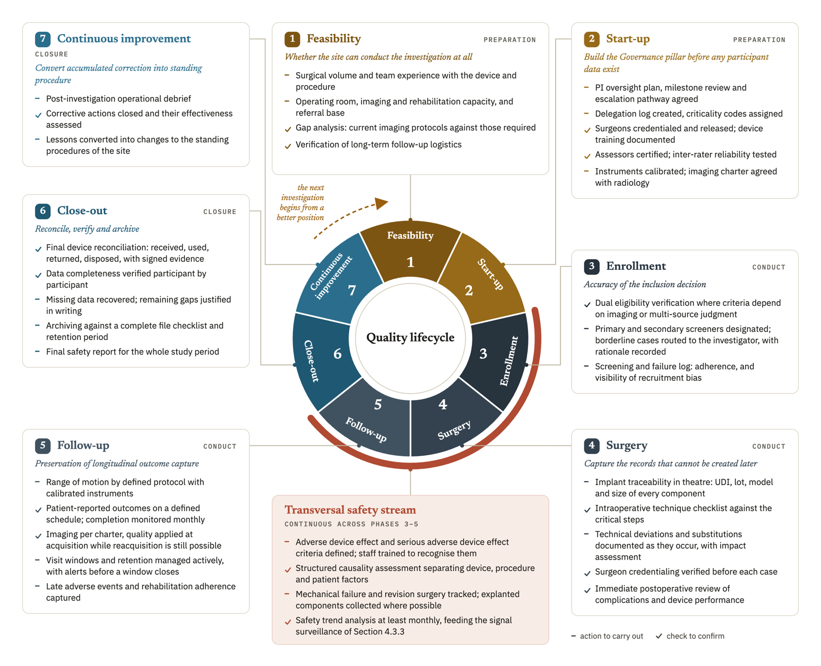
Figure 4.1. The seven-phase quality lifecycle and the transversal safety stream, with the objective, the actions, and the checks of each phase, arranged to show that the cycle closes and feeds the next investigation.
The quality burden at close-out should decrease when controls in Phases 3 to 5 work, although Section 5.4 presents this as an expected benefit that no measurement has yet confirmed. ICH E8(R1) Section 3.3.2 supports simplifying nonessential activity and directing resources to critical areas, and that principle is the basis of the expectation.

4.6.2 Why the sequence matters
The order of the phases has consequences of its own. Phase 1 comes first because a capability gap discovered later cannot be closed by better process, so a site without adequate imaging capacity does not solve that problem with a better imaging procedure. Phase 2 precedes Phase 3 because delegation, credentialing, and training determine who may make the decisions that Phase 3 consists of. A site that begins enrolling while credentialing is incomplete has allowed uncontrolled decisions into its dataset, and it cannot identify afterward which decisions were affected.
The SLCT has to cover the first case, so it is prepared in Phase 2, two phases before the first surgery in Phase 4, and used from that case onward. Its value lies in the early cases, and a log started once a problem has been noticed has already missed what it was built to detect. In post-market investigations a surgeon may already have used the device outside the study, and the SLCT then records that documented experience at start, while still recording each study case from the first.
Safety runs transversally because events do not respect phase boundaries. A complication detected in follow-up may originate in a surgical decision made months earlier, and the framework can connect the two only if both were recorded when they occurred.
Some quality failures concentrate in identifiable phases and take recurrent forms. Surgical complications may cluster during the early ascending phase of the learning curve of a surgeon [22], while loss to follow-up accumulates over later years [24]. These findings support phase-sensitive control, but they do not prove that a lifecycle model is better than an even distribution of effort, so the framework treats phase organization as a design hypothesis. The hypothesis is consistent with ICH E8(R1) Section 3.3.2 and ICH E6(R3) Section 3.10.1.3, which direct quality resources toward critical activities and risks.
A simplified interactive model of the lifecycle was produced to illustrate the phase structure and the relationship between actions and CtQ factors. It was generated with the assistance of an artificial intelligence tool for illustrative purposes and is not a validated instrument. Screenshots and the access link are provided in Appendix Y.

4.7 The scalability model
Academic organizations and nonacademic hospitals made up most of the registry sample (Section 3.4.4), so a framework usable only in small centers would leave out most of the organizations that take part in these investigations. The scalability model answers DR12. Its principle is that the obligations are the same for every site while the depth of implementation varies, so any site that adopts the framework can use all of its functions, with more or less structure behind each one.

4.7.1 Three site contexts
The three site types are design categories defined by how research sits within the organization. The registry did not measure size or staffing, so the types are not derived from it.
Type A covers large academic hospitals and established research institutions with dedicated research infrastructure. The category does not imply uniform quality maturity. Stakeholders from higher-level hospitals performed better on average in one survey, but substantial room for improvement remained [87]. Experience from academic centers also shows that infrastructure has to be built and measured, and international clinical trial units vary in the services they provide [88, 89]. Repeated institutional self-assessment is associated with improved research-conduct capability, although that relationship is correlational [30]. Variation also persists within a center, because surgeons with comparable specialist training may stabilize at different case volumes [22]. The framework is not offered as a replacement for an institutional quality system in Type A. Its CtQ domains and surgical-context instruments address the named surgeon, device, and investigation, so a research unit inside a large institution can describe its own conduct at that level.
Type B covers private clinics and specialized orthopedic centers or hospitals that take part in investigations recurrently and have staff for research tasks, but whose main focus is surgical care, so they have no system dedicated to the quality of their investigations. This is the target center described in Section 3.4.5. Implementation here is full, with every instrument in use and every function assigned, operated by a small team in which one person holds several functions and each function has a named substitute.
Type C covers smaller centers and ambulatory surgical units that take part in investigations only occasionally. They face the same problems as Type B with even fewer people, so implementation is reduced in depth to an essential core. That core comprises the delegation and training records (CCDM and TRE), an SRR limited to the highest-risk domains, the device record in the ICDL, the SART for safety events, and a record of deviations. Some of these elements put into practice requirements that ISO 14155:2026 or the MDR already establish. The instruments keep the same purpose in Type C, while the review cadence is lower, compatible records may be combined, and one person may hold more than one function. Enhanced review or proctoring is activated when the risk of the investigation or limited local experience requires it (Table 4.2).
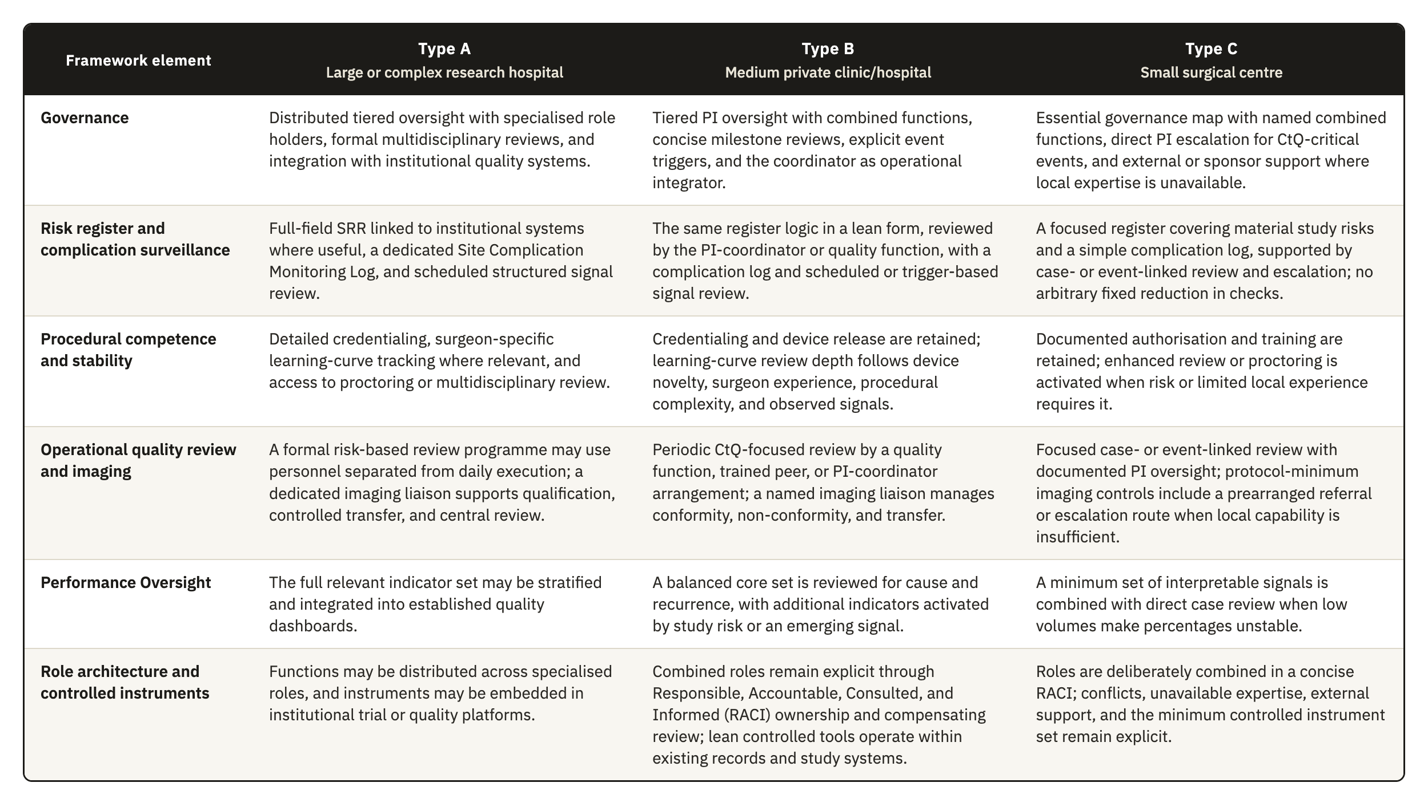
Table 4.2. The scalability model, with the implementation depth of six framework elements across Type A (large or complex research hospital), Type B (medium private clinic or hospital, the target center), and Type C (small surgical center) site contexts.

4.7.2 What does not scale
Reduced depth raises an objection, because a smaller center that implements less may be more exposed at inspection. MDR Article 72(5) permits inspection at an appropriate level, and ISO 14155:2026 Clause 9.1(b) requires the sponsor to keep records showing that the investigation complies with the CIP, the standard, and applicable requirements. A smaller center is protected only to the extent that the minimum clause-linked controls and records remain complete, current, and retrievable. Scaling may reduce organizational depth, and it cannot remove the evidence required to show compliant conduct.
The invariant is the clause-linked evidence needed to report, interpret, and verify the investigation, which every site keeps whatever its type. The minimum record set includes:
- informed-consent evidence under MDR Annex XV, Chapter II, Section 3.13 and ISO 14155 Clause 10.5;
- delegation and training records under ICH E6(R3) Sections 2.3.2 and 2.3.3, ISO 14155 Clauses 10.2 and 10.3, and MDR Annex XV, Chapter I, Section 2.7;
- device-accountability records under ISO 14155 Clause 7.9 and MDR Annex XV, Chapter II, Section 3.11;
- deviation records under MDR Annex XV, Chapter II, Section 3.10 and ICH E6(R3) Section 2.5.3;
- adverse-event records under ISO 14155 Clauses 7.4 and 8.3(a)(4) and MDR Annex XV, Chapter II, Section 3.14;
- calibration evidence under ISO 14155 Clause 9.2.4.5(p) and Annex A.6.4;
- essential records under ISO 14155 Clause 8.6 and Annex E and ICH E6(R3) Appendix C;
- the source definition required by ICH E6(R3) Section 2.12.2.
MDR Article 72(3) requires investigation information to be recorded, processed, handled, and stored so that it can be accurately reported, interpreted, and verified. The framework therefore expects documentary discipline to be achievable at any site type, while the optional organizational layers scale.

4.7.3 Escalation and de-escalation
Depth follows the risk of the investigation as well as the type of the site. Implementation depth is raised for any site type where the investigation involves a first-in-human device, a procedure of unusual complexity, or endpoints with high observer variability. It may be reduced where an established device is used in a routine procedure with objective endpoints and an experienced surgical team. Calibration therefore follows the risk of the specific investigation, which the category of the center only approximates, and this keeps the model consistent with the risk-proportionate principle. A Type C center running a first-in-human device implements more deeply than a Type B center running a well-established one.

4.8 The operational instrument set
The framework is operated through a defined set of instruments, listed here in one place because a site can use the framework only if it sees what it has to produce, and because several instruments appear at more than one point in the preceding sections. Every instrument can be kept on paper. None requires software, a license, or a system integration, as DR11 requires, and a site with digital tools may use them without the framework depending on them.
Table 4.3 lists the twenty-four instruments with their purpose, the inputs each one consumes, how it processes them, and what it produces, grouped by pillar.
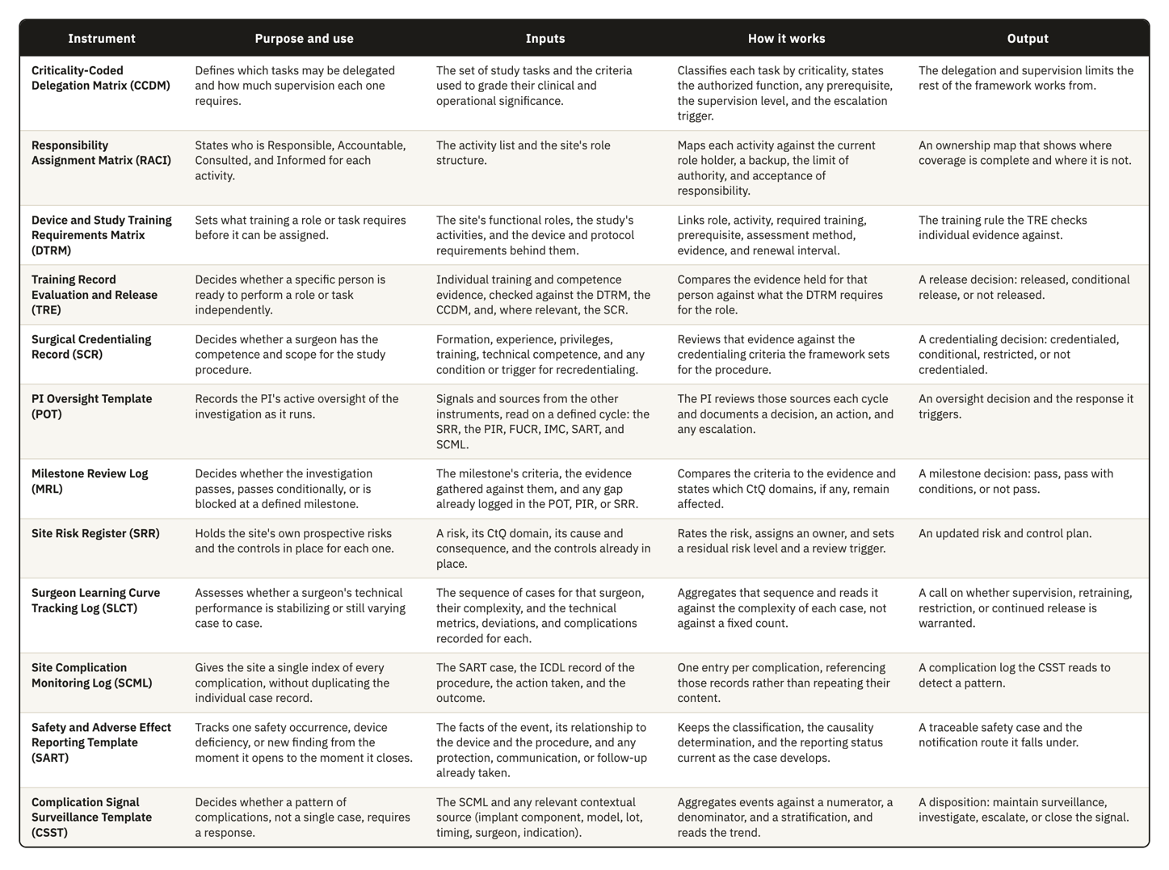
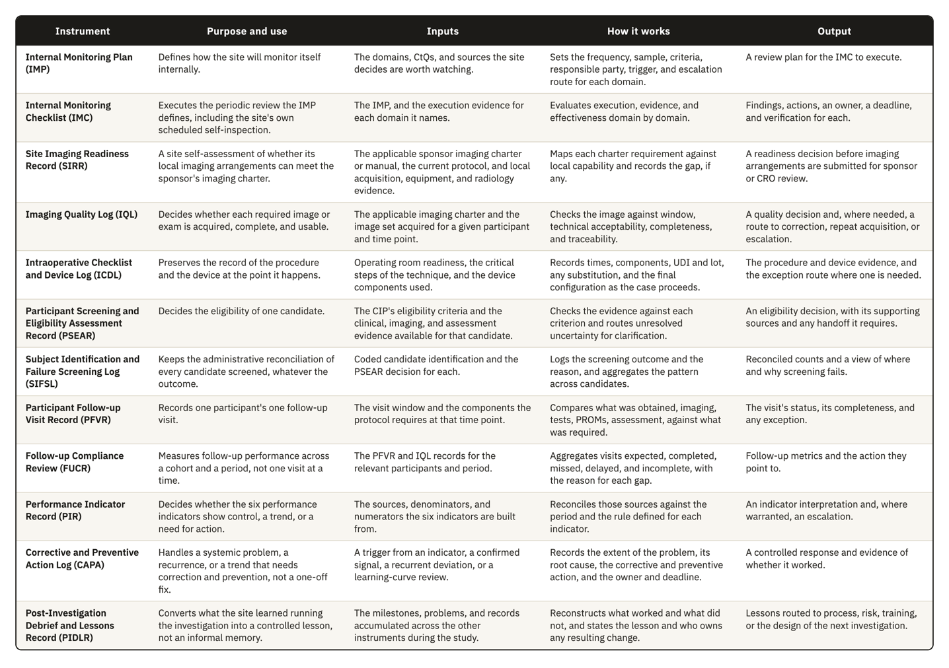
Table 4.3. The twenty-four instruments, with their purpose, the inputs each one consumes, how it processes them, and what it produces.
Figure 4.2 groups the instruments by the pillar that owns each one, with seven in Governance, five in Risk Management, nine in Operational Controls, and three in Performance Oversight.
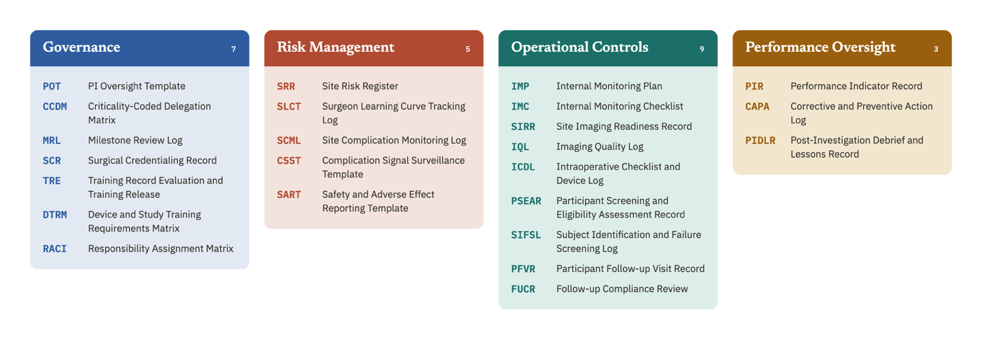
Figure 4.2. The twenty-four instruments grouped by the pillar that owns each one: seven in Governance, five in Risk Management, nine in Operational Controls, and three in Performance Oversight, each shown by acronym with its full name.
Figure 4.3 places the same instruments on the axis that decides how they connect. A fine record is produced by one person, event, or image, a synthesis aggregates several of those records, and a site-level decision rests on the synthesis. The arrows mark the information chain the framework depends on, in which evidence rises from a fine record to a synthesis and then to a decision, and the decision returns to the fine layer as a requirement to verify.
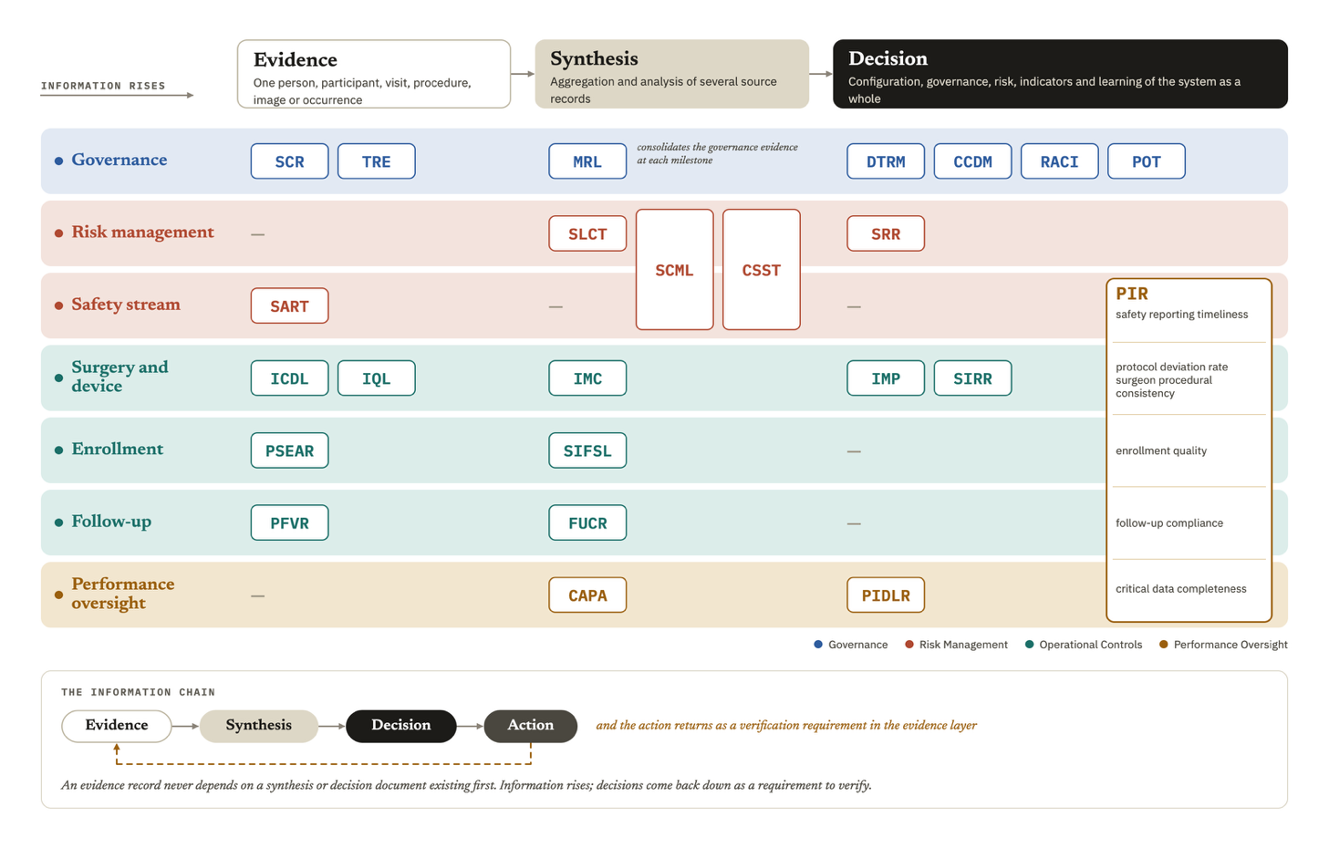
Figure 4.3. The granularity of each instrument, from individual evidence to the site-level decision it supports, with the arrows marking the chain through which information rises and a verification requirement returns to the evidence layer. Rows group instruments by operational area, so the safety stream row holds the SART, which belongs to Risk Management, and Operational Controls appears in three groups: surgery and device, enrollment, and follow-up.
Figure 4.4 maps the instruments against the twelve CtQ domains from Section 3.3, marking where an instrument carries the primary control for a domain and where it only supports, limits, or scopes the control another instrument carries.
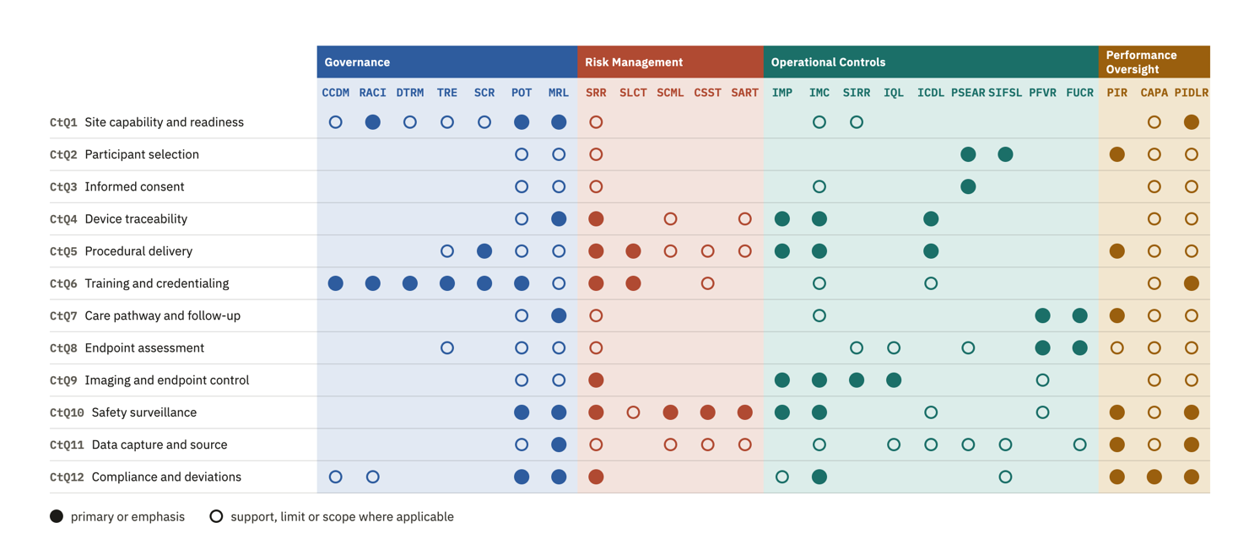
Figure 4.4. The twenty-four instruments mapped against the twelve CtQ domains, with a filled marker for a primary or emphasis relationship and an open marker where the instrument only supports, limits, or scopes another instrument’s control.
Figure 4.5 maps the instruments against the twelve design requirements from Section 3.5. It distinguishes a direct answer to a requirement from a relationship inherited through a combined or earlier instrument, an extension added to the original set, and a supporting contribution that does not carry the requirement alone.
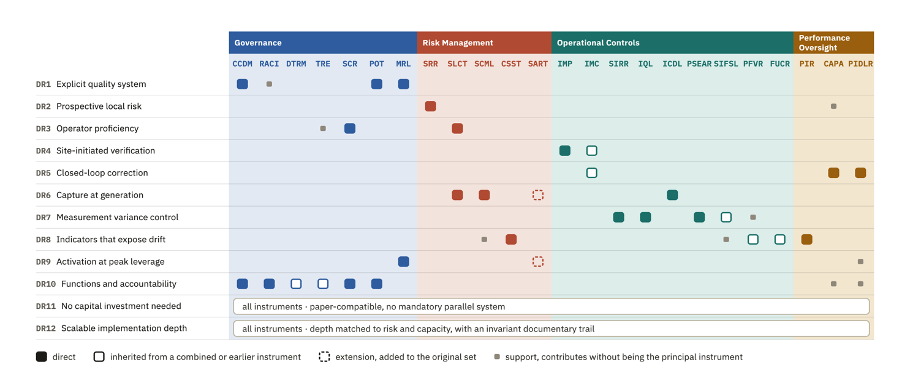
Figure 4.5. The twenty-four instruments mapped against the twelve design requirements, with a filled marker for a direct answer, an open marker for a relationship inherited from a combined or earlier instrument, a dashed marker for an extension added to the original set, and a small marker for a supporting contribution. DR11 and DR12 apply to all instruments as a set and are marked once for the whole set.
The templates were developed for shoulder device investigations, and their content reflects that context, particularly in the complication categories, the imaging requirements, and the complexity classification used in the SLCT. We nonetheless designed them to be as generic as the context allowed, so the field structures, review triggers, and escalation logic carry no shoulder-specific assumption. Adapting an instrument to another surgical specialty would in most cases mean changing the content of the classification lists while leaving the structure intact. Draft templates for all twenty-four instruments are provided in Appendices A to X.

5. Discussion

5.1 The principal contribution and the regulatory gap
A site can conduct an investigation well and still be unable to show that it operates a system, because the two depend on different things. Section 1.1 described the move from a prescriptive model of quality toward a governance model, and a governance review looks for the second.
Under the older arrangement the site supplied the conduct and the sponsor supplied the evidence that the conduct had been controlled, so a site needed no account of its own processes. ICH E6(R3) makes the investigator responsible for the conduct of the trial at the site, with qualified staff and adequate resources, and it states this as a principle without saying what the investigator produces to show it. Our reading is that a party that shares responsibility for quality has to be able to show how it carries that responsibility, and that a list of completed procedures does not show it. We use this reading to present the framework as one defensible way of evidencing site-level processes. No instrument makes it the required way, and a site could answer the same principle through another arrangement.
The target center described in Section 3.4.5 can conduct an investigation properly and still be unable to show the control a governance review looks for, because it holds no account of its own processes to produce. Section 3.2 showed that none of the three instruments we analyzed requires it to hold one. The difficulty is evidentiary before it is operational, so a site that already works carefully meets it first, when it has to show how it controlled its own conduct.
Before we settled on a framework operated by the site, we examined three other routes to the same objective. The first places more of the load on the sponsor, which already carries clinical quality management under Clause 9.1 of ISO 14155:2026 and which ICH E6(R3) addresses directly. The second works through the CRO, which many sponsors already contract for monitoring and verification. The third is commercial software, since electronic systems can carry an investigator site file, document control, and structured records. We did not evaluate the availability or practical effect of those products in the target setting. Software can carry a quality framework, but buying it does not decide which local processes are controlled or give the site a system of its own, so we treat it as a medium for implementation.
Among the parties examined in Section 3.2.1, the site is the one for which none of the standards describes the quality system it operates. Chapter 3 did not compare resources or workload across the parties, so limited site resources are a condition of the target setting, and Chapter 3 does not show that the site holds fewer resources than every other party. Adding obligations to a party that already operates a described system leaves the site without a structure of its own, and it does not keep that structure proportionate to the setting. Deadlines for data entry, system-level edit checks, and upload windows allow a sponsor to tighten a site from outside, and those controls reach the timeliness and completeness of a record. They do not reach the content of an intraoperative decision that nobody recorded when it was made.
Removing these three routes does not show that a site-owned framework is the only workable answer. Hybrid arrangements, regional site networks, and shared services remain open, and we examined none of them. Our claim is narrower. Among the routes we examined, none keeps the record in the hands of the site while also capturing information at the point of care and running on the infrastructure the target center has.
None of the instruments we analyzed tells a site to operate a quality system, so the framework cannot be justified by naming an obligation it satisfies. Its justification runs backward. Each component answers a design requirement, and each requirement derives from a regulatory gap, a CtQ domain, or an operating condition reported in Chapter 3, so a reader can check any component against the analysis that produced it, in either direction. The correspondence shows internal coherence. We derived the requirements and we assigned the components, so the mapping is not independent evidence, and it does not show that the components are necessary, that the set is complete, or that another set would perform worse.
Table 3.1 reports five site-level functions that none of the three instruments requires, and the framework proposes an operational response to each. Four of the responses follow one pattern, in which a principle the instruments state at sponsor level, or a duty they assign to the investigator as an outcome, becomes an instrument the site can run.
The four pillars answer the first gap as a whole, the absence of a structured quality-management system at site level. ICH E6(R3) describes what such a system contains and requires it to be proportionate to the nature and complexity of the trial, and the obligation falls on the sponsor. ISO 14155:2026 gives the PI substantive duties under Clause 10 and writes them as outcomes to be achieved. Many of these duties run for the whole investigation and have to be met repeatedly, so the clause describes a process without calling it one, and giving that process an explicit structure adds organization to obligations the site already carries.
Pillar 2 answers the second gap, the absence of a risk register owned by the site. ICH E6(R3) and ICH E8(R1) require a risk-management cycle oriented to CtQ factors, and both address the sponsor, while many of the execution risks at a surgical center arise from local processes. Sponsor monitoring and CRO oversight do reach the site, but both operate from outside on a schedule the site does not set, and neither leaves the site with an account of its own risks when the assigned monitor changes. A 2023 study of Portuguese clinical trial sites found that 19.6% described a standard tool that systematically captured site-level risk analysis [76]. One national sample does not establish general practice, but the figure indicates that the gap appears in practice as well as in the texts.
The IMP answers the fourth gap, the absence of a verification function started by the site, and the CAPA Log with periodic self-inspection answers the fifth, the absence of a proactive improvement cycle. Both rest on principles ICH E6(R3) already states, shared responsibility for quality and continuous improvement, and both are meant to sit alongside obligations that already exist. These four responses therefore organize duties the site already holds, or duties whose fulfillment depends on its execution, into something it can run.
The third gap is different. None of the three instruments assigns the site the case-by-case observation of each operator’s proficiency during conduct. They require the investigator to be qualified at entry, and ISO 14155:2026 Clause 10.6 asks the PI to keep an adequate team throughout the investigation, which is a staffing duty. Within the corpus we analyzed, this is the one gap for which we found no counterpart obligation. The methodological literature reviewed in Section 3.4.2 does not support treating proficiency as a state fixed at baseline, since early cases differ systematically from cases performed after stabilization, and a difference of that origin can be attributed to the device when it belongs to the operator. The SLCT therefore rests on a weaker derivation than the other four responses, because it applies CtQ logic directly to an intervention delivered by a person whose execution changes over time. Baseline qualification does not control a threat of that shape, because it measures a state at one moment while the threat develops across cases. The SLCT is the element the framework adds where the instruments have no counterpart.

5.2 Position in the literature
Section 1.4 described four bodies of work that bear on this problem: the general quality infrastructure written for sponsors, SQA in surgical trials, the measurement of site performance, and empirical studies of how sites manage quality. The first three produced instruments and the fourth produced evidence, but none of the works we reviewed places an integrated instrument in the hands of the site for its own use. Our narrative review did find two partial precedents operated by sites, the Clinical Trial Assessment of Infrastructure Matrix and the implementation of ISO 9001 in Italian clinical trial centers [30, 31]. Neither covers the surgical and device-specific functions proposed here.
Following Section 2.3.3, we compared the framework component by component with the instruments closest to it. The SQA frameworks have a direct counterpart for the SCR, since entry criteria for surgeons are their principal control over the operator [35, 36, 37, 38]. That counterpart works at trial level, set by the trial team, and the SCR applies it at the site and keeps it current during conduct. None of these frameworks tracks the trajectory of an individual operator across cases while the trial runs, so the SLCT has no counterpart among them. The Portuguese study of site risk management found no standard site risk tool at most sites and recommended one [76], so the SRR answers a need already identified at site level, without a published instrument to compare it with. Section 1.4.1 also showed that SQA measures have rarely been validated [39, 40], and the same observation applies to the present work, which proposes and does not validate.
The Clinical Trial Site Performance Measure allows an item-by-item comparison with the indicators in Section 4.5 [41]. Its four validated domains are participant retention and consent, data completeness and timeliness, AE reporting, and protocol compliance. Data completeness and timeliness has a direct counterpart in critical data completeness, AE reporting in safety reporting timeliness, and protocol compliance in the PD rate. Participant retention has a counterpart in follow-up compliance, but consent has none among our indicators, because the framework controls consent through the minimum record set and internal review and does not measure it as an indicator. Enrollment quality has only a partial counterpart, inside protocol compliance. Surgeon procedural consistency has no counterpart in the validated set, since it addresses the delivery of the intervention, which a measure built for trial sites in general has no reason to contain.
The comparison runs against this work in one respect that matters more than the counterparts. The four validated domains survived a reduction from 126 candidates and a validation study, while our six indicators rest on the domain analysis in Section 3.3 and on argument, so a reader who asks which set is better evidenced should prefer the validated one. The two sets also differ in orientation. A validated performance measure is applied from outside to assess a site for another party and identifies the sites that are performing, while an indicator operated by the site asks whether one of its own processes has begun to drift.
The study of RBM in trials of implantable cardiac devices is the nearest prior work on implantable devices [48]. It evaluated an approach run by the sponsor, so it supports the plausibility of risk-based quality management in device investigations without saying anything about a framework operated by the site, and its results do not transfer causally to shoulder surgery.

5.3 Design implications of the surgical and site context
Section 3.4.1 set out five conditions that separate surgical device investigations from the pharmacological model, and each placed a demand on the design.
Operator dependence required a unit of analysis that clinical research does not normally use. Trials are organized around the participant and the case, and the surgeon is recorded as a delegated person. In a surgical investigation the surgeon is a source of correlated variance across every case that surgeon contributes, and Section 3.4.2 showed that trials control it mainly at entry. The framework therefore adds the operator as a third unit of analysis, carried by the SLCT and the surgeon procedural consistency indicator, together with the SCR and the release records in the TRE. A protocol defines a procedure in general terms and cannot standardize the many small decisions through which one surgeon implants one device in one anatomy, so the site governs this part through credentialing at entry, the SLCT during stabilization, and periodic procedural review afterward. Surgical judgment is part of the intervention, so the framework does not try to remove surgeon-dependent variation. It records the variation and makes it reviewable where it threatens participant safety or endpoint interpretability.
Irreversibility and unit-level traceability produced a demand about timing. Investigational devices are excluded from the MDR UDI system under Article 27(1), so device and production identifiers in UDI form are not mandatory during the investigation, but traceability still has to be produced. ISO 14155:2026 requires the site to record the receipt date, identification, quantity, batch, serial number or unique code of each investigational device, together with the participant and any explantation date, and the MDR requires traceability after the investigation. These records are created in the operating room under time pressure and cannot be reconstructed reliably if nobody captures them at implantation. The intraoperative decision to substitute a component behaves in the same way, and so do the technical deviation prompted by unexpected anatomy and the immediate postoperative image that may prove inadequate. DR6 states what these data points share, and the ICDL answers it, together with the immediate capture of deviations and substitutions.
Measurement reliability is a source of quality risk in this field before any site adds variance of its own (Section 3.4.1). A site-level framework cannot improve the reliability of a classification, because that problem belongs to the field. It can require the site to control the sources of measurement variance within its own reach, and the imaging instruments (SIRR and IQL) do that work together with assessor qualification and timing rules. DR7 states the boundary, and Section 4.4.2 records where the framework stops.
Follow-up burden places follow-up in the same category as the operating room. ROM and radiographic assessment require the participant to attend in person under consistent acquisition conditions, and PROMs, which can be collected remotely, still depend on the specified time points. An assessment window that closes unmet closes permanently. The PFVR and the FUCR answer that demand, and the follow-up compliance indicator reports on both.
Each of these demands concerns information generated at the site, at a moment external oversight cannot observe directly or reliably reconstruct afterward. A sponsor can require that such information be captured at the time, through protocol requirements and system controls with reporting deadlines attached, and remote systems can receive the resulting data almost in real time. The capture itself, however, is done by the site, which is the party present when the data are generated, so the instrument that captures them has to be operated there. Operating an instrument does not by itself require owning its record. The framework gives the record to the site for two further reasons, because the record survives changes of staff and of monitor (Section 5.4), and because it lets the site show how it controlled its own conduct when a question arises.
The resources of the target center set a second group of constraints, and Section 3.5 treats the operational constraint as binding whenever two requirements point to different solutions. Investigation is a secondary activity in the target center, run alongside a surgical practice (Section 3.4.5), so the organization has little reason to build infrastructure for it even where that infrastructure would be useful. We found no source showing that sponsors fund internal quality systems at sites, and we did not examine how these investigations are paid. Whether a control that prevents an avoidable error returns more than it costs is therefore a hypothesis we did not test, and testing it requires staff time per instrument on one side and the cost of the avoided events on the other.
The registry showed that a dedicated research structure cannot be assumed even among organizations that take part in industry-sponsored investigations (Section 3.4.4). The variable records publicly documented structure and does not record budget, staffing, quality maturity, or access to software, so it supports a statement about how these organizations present themselves and no statement about what they are technically able to run. An instrument that presumes a document management system, a validated electronic record, or a dedicated quality function would nevertheless fit poorly in many of them, so adoptability in a setting of limited technical complexity is a requirement separate from low cost. Most nonhospital organizations in the sample were in the United States, while the framework follows the European regulatory context, and Section 3.4.4 explains that the registry describes only the organizational profile of the sites.
Paper is the minimum medium the design assumes, and a site with an electronic investigator site file or a clinical trial management system can carry the same structures. Each instrument is a structure of fields, review triggers, classifications, and escalation rules, and none of these depends on the medium carrying it. We specified the paper form so that the center with the least infrastructure can operate the framework, and the transfer to electronic systems remains a property of the design that awaits testing.
Paper compatibility is a property of format and does not establish low operational burden. The POT and the MRL create reviews and evidence that overlap at several points, as do the SRR, the IMC, and the PFVR. Completing the instruments may lengthen some activities, and the framework expects the benefit to outweigh that time, an expectation that has not been measured.
Reduced implementation depth at a smaller center raises an objection about regulatory exposure, and the scalability model answers it conditionally. Reduced depth creates no additional exposure provided that the minimum record set in Section 4.7.2 is complete and the documentation trail is unbroken. The reasoning is that inspection assesses compliance through the completeness and internal consistency of the documentary record, and that the sophistication of the system producing it is secondary. We could not source that premise, because we found no published study comparing inspection outcomes across systems of different sophistication, and a reader who rejects it should reject the scalability argument with it.
The losses at a Type C center are real. It reviews less often than a Type B center, which lengthens the interval before a signal is noticed, and it combines records that a Type B center keeps separate, which reduces the independence between the instrument that raises a signal and the instrument that assesses it. It also assigns several functions to one person, weakening the separation between execution and oversight that DR10 requires. The escalation rules in Section 4.7.3 are meant to keep these losses proportionate to the risk of the specific investigation.

5.4 Expected mechanisms and operational interfaces
A lagging indicator measures an outcome after it has occurred, as a count of PDs or a revision rate does. A leading indicator measures a process before the outcome it predicts has materialized, as a trend in operative time within cases of comparable complexity does. The first establishes what happened, and the second shows whether something is beginning to happen while there is still room to act.
The six indicators combine the two classes, and DR8 states the preference for the second without making it a property of every measure. Three of them read a process while it runs, since enrollment quality operates partly before each inclusion, critical data completeness reads the current state of the record, and surgeon procedural consistency reads operative time and intraoperative adaptations as cases accumulate. The PD rate and follow-up compliance count events that have already occurred, and so does safety reporting timeliness. Each of these three can still give an early signal of a deterioration ahead, so their timing has to be defined against the outcome predicted in each case, and calling the whole set leading would misdescribe half of it.
The most characteristic instruments of the framework read process states, since the SLCT, the CSST, and the internal monitoring findings measure how work is being performed. This follows the QbD premise that quality is managed by controlling the processes that produce outcomes. A process signal becomes useful only when a rule turns it into an action, and the rule has to exist before the pattern appears, so the site applies a threshold it chose in advance.
The lifecycle carries the same logic in time. It rests on a premise this work does not test, that quality failures concentrate in predictable phases and take predictable forms, and if the premise holds, activating each instrument where it has most effect concentrates effort where the risk sits. We expect a site that defers this work to carry a larger backlog into close-out. That relationship is a mechanism we propose and did not measure, and measuring it requires unresolved queries at database lock and staff hours spent on close-out, compared between sites that operated the framework during conduct and sites that did not.
None of the six indicators has been validated. We found no evidence that a growing query backlog predicts a data integrity failure, or that operative time failing to fall within comparable cases predicts a complication. A claim about prediction without a validation study is an assumption, and a wrong assumption has a concrete cost, since a site that acts on a signal with no predictive value spends scarce effort on a process that was working. The defense of the set at the design stage rests on what each indicator measures and on when it moves. Each indicator measures an attribute with a documented route to a CtQ domain identified in Section 3.3, and each moves at a point where the site can still act. On those two grounds the set is defensible as a design, and its predictive value remains unestablished.
Calling the framework complementary to the sponsor means little until the points where the two quality systems meet are named. At a monitoring visit, the first of these points, a site operating the framework presents a maintained SRR, a current CCDM, and the CAPA Log, together with indicator data for the period. A monitor who receives those records spends less time reconstructing the conduct of the site from primary documents and reviews a site that has already characterized its own risks and documented its own corrections. Adams and colleagues describe the adoption of RBM and the part central monitoring plays in it [90]. That work does not test a site-owned risk register, so the added value of these records is a hypothesis, and measuring it means comparing monitoring time spent on reconstruction with and without the site records.
This first interface carries a disincentive, because a site that documents a weakness has created a record a monitor can read. A finding the site raised against itself is still a finding, while a site that keeps no such record has nothing to hand over. The framework asks a center to accept that exposure. The alternative leaves the same weakness in place and unrecorded, where it reaches a participant or an endpoint before anyone names it. We have no evidence on how monitors treat findings declared by the site itself.
At the second interface, a site with a functioning CAPA process answers a monitoring finding through a mechanism that already exists. It can show that it corrected the specific instance and also addressed the cause, while a site without such a process improvises an answer that leaves no record for the next monitor. The third interface is site qualification, where the sponsor verifies the qualifications of the PI and the adequacy of the site under Clause 6.8 of ISO 14155:2026. A site that arrives with its own SRR and POT gives the sponsor documentary evidence on two of the points Clause 6.8 asks it to judge, since those records show that the site has identified the risks of its own execution and defined how it will supervise them.
The sponsor works across several sites at trial level, and the site works on its own processes. Complementarity therefore excludes duplication of sponsor monitoring, which would consume resources the target center does not have, and Section 4.4.1 concentrates internal monitoring on the point-of-care domains that sponsor monitoring does not see as they happen. It also excludes the absorption of the site’s quality system into the system of the sponsor, which would remove the layer this work proposes. The CEC that Clause 6.12 allows the sponsor to establish and the CSST address the same problem from two levels. A cluster confined to one center may reach the threshold for a local response before it shows as a trial-level signal, but Section 4.3.3 notes that the sources do not establish which level detects first, so this remains an expectation to test.
The objection that bears on every claim in this section is whether documenting a practice improves it, since a site can record its conduct well and conduct itself badly. No evidence in this thesis settles the question, so what follows is an argument about mechanism, with its limits. Tighter controls and documentation written for the specific activity leave fewer gaps open, so less passes unnoticed. The claim concerns the probability that a failure goes undetected and says nothing about the quality of the conduct itself.
Failures in clinical investigation have several origins, such as lapses, competing demands on the same person, inadequate study design, systems that do not fit the work, and ambiguity in the applicable requirements, and we have no observational basis for ranking them. Deliberate noncompliance and fraud form a separate category this framework does not address, since a person who intends to misrepresent conduct will misrepresent the record as readily as the act. The framework addresses the failures nobody noticed in time, whatever produced them, because a failure has to be seen before anyone can respond to it, and an instrument that brings it into view gives a person something to act on.
If the framework changed nothing in conduct and its only effect were a complete and traceable record of what the site did, that outcome would still improve reconstruction and auditability. Whether the record protects a participant depends on someone reviewing it and responding in time, so documentary visibility and effective protection are separate achievements. The framework produces the first directly and the second only through the review rules attached to each instrument.
A second mechanism concerns the people who perform the work, and we treat it as an expectation with no established effect behind it. Staff who know that their work is reviewed in detail may attend differently to what they do, and the review also teaches the standard, since a person who sees which elements are checked learns which elements matter. The expectation cuts both ways, because observation can change behavior toward the record while leaving the conduct as it was. Two features of the design reduce that risk without removing it. The instruments record decisions, identifiers, and dates with classifications attached, and they avoid narratives in which a person assesses their own performance, so a device identifier is either captured or missing. Most instruments are also read by someone other than the person who completed them.
A cost sits on the other side of this argument, and it falls on the resource Section 5.3 identifies as scarce. Every hour a coordinator spends on a record is an hour unavailable for a visit, a query, or a follow-up call, so if documentation produces no improvement in conduct, the framework has consumed what the target center can least spare. Each instrument therefore had to answer at least one design requirement, although Section 5.3 notes that some of them overlap and their total time has not been measured.
The value of the record shows most clearly when continuity breaks, for example when a coordinator leaves, a monitor changes, a PI is replaced, or a question a previous monitor had settled is reopened. A site that holds the records of the framework carries its own history through each of these events, while a site without them has no controlled record to carry across a handover. Section 3.4.5 describes this fragility in the target center.

5.5 Practical, ethical, and regulatory implications
A site that decides to adopt the framework faces twenty-four instruments and has to begin somewhere, and the dependencies between them set the order. The SRR comes first, because it opens during feasibility (Phase 1) and keeps its preventive value only if it exists before enrollment (Section 4.6). The seven Governance instruments follow in Phase 2, since all of them can be completed before the first participant exists, and the SLCT is prepared in the same phase and used from the first case. The IMP and internal monitoring start once cases have begun. Five of the six indicators come last, because each needs accumulated observations before a trend means anything, and enrollment quality is the exception. We propose this order as a sequence to test, and a center that adopts all twenty-four at once is unlikely to operate any of them well.
At site qualification a sponsor can ask whether the site holds its own risk register, an oversight plan, and a corrective action process, and each of those records speaks to a point Clause 6.8 asks the sponsor to judge. During conduct, the sponsor can also take the signals the site produces into account when it adjusts monitoring intensity, since RBM lets a sponsor adjust monitoring to the available evidence. Whether either change requires an amendment to the CIP depends on how the CIP and the monitoring plan are written for the specific investigation and on the sponsor-site agreement. Clause 6.7 places the monitoring strategy in the monitoring plan, which allows the adjustment without an amendment in many arrangements, although we do not claim that this holds generally.
A notified body and a competent authority meet the investigation through different objects. The notified body assesses device conformity and the clinical evaluation, while the competent authority may inspect investigation sites. The CER carries the clinical evidence, and the local framework that produced it stays at the site unless it is requested during an inspection. Within the present texts, no clause expressly requires a site to produce its own risk register, internal monitoring findings, or CAPA Log, so these records add nothing to what an authority can demand. Their value lies in the governance review of the site and in its ability to show, when a question arises, how it controlled its own conduct.
ISO 14155:2026 was published on 23 March 2026, and the gaps reported here are seen from the position of the site. The standard has a wider purpose, and several of the gaps follow from reading it from that one position, so a future revision might reasonably decline to close them. Section 4.3 described how Clause 6.2 assigns the three risk streams to the sponsor without describing the local process through which a site handles the part of those risks that its own execution creates. Section 4.4.2 described the equipment calibration that Clause 9.2.4.5(p) asks the monitor to verify, which is continuing work at the site with no clause describing the record that shows it. Clause 6.12 introduces the CEC and creates no local counterpart.
These observations differ in size. A clause requiring a site to maintain a risk register would ask for one document and one review cycle, while a clause requiring a structured quality-management system at site level would ask for much more. The framework is designed so that a Type B center can build and run that system with its own resources, starting from the order of adoption above. A sponsor could also support a site, for instance by supplying templates and training alongside the protocol and the Investigator’s Brochure, as long as the site operates the instruments and keeps the records they produce.
The version of the standard that carries a presumption of conformity is the harmonized EN ISO 14155:2020+A11:2024, listed under the MDR in OJ L 2026/193. The 2026 edition represents the current state of the art while the 2020 edition remains the harmonized one, so a site in the EU works to one text while the field moves to another. The harmonization of the fourth edition would be a suitable moment to examine what the MDR requires as a minimum structure at site level, since Annex XV governs the conduct of clinical investigations and does not address how a site organizes itself to conduct them. We offer these as observations from one position and do not present them as a program for a standards body.
Clinical investigations are conducted on people who consent to accept risk for the sake of knowledge, and the quality of conduct at the site decides how well that consent is respected. A delayed safety report in an investigation of an implantable device postpones the identification of a device-related signal, and the delay affects participants at every enrolled center, including those the reporting center never saw. An incomplete traceability record can make it impossible to attribute a complication to the lot that produced it, and an eligibility error exposes a participant to a procedure the protocol meant to exclude them from, an error that Section 3.4.1 explains cannot be undone. The participant carries the risk of these failures without seeing the quality system. Fitness to conduct the investigation is judged by the sponsor at qualification, by the ethics committee at approval, and by the site itself in every case it conducts. The framework addresses the third judgment, for which the instruments examined describe no structure.
The SLCT raises a second ethical question, about the people the instruments observe. It holds performance by named surgeon and can lead to a restriction on the cases a surgeon takes, so in substance it assesses professional performance. It is therefore a quality instrument with possible professional consequences, and its use has to be governed as such. The design constrains that use by coding the surgeon identifier and leaving the key with the PI, by defining the outcomes available to a review before the first case, and by requiring the reasoning behind any restriction to be documented.
The residual risk concentrates where the site owns the practice of the surgeon it observes. In a hospital, the authority to restrict a surgeon to less complex cases sits outside the ownership of the institution, while in a surgeon-owned practice the person deciding and the person restricted may be the same person or close colleagues, and so may the person carrying the commercial consequence. When the PI is the surgeon under review, the framework therefore moves the decision on a restriction to a party outside the site, such as the medical monitor of the sponsor or the ethics committee, named before the first case. The documented reasoning and the predefined outcomes apply to that external decision as well.

5.6 Transferability and boundary conditions
The framework was developed for shoulder device investigations, and Section 1.3 gives the reason for narrowing to one discipline. Whether it transfers to other implant-based surgical specialties is a separate question, and the instruments supply most of the answer.
The instruments separate into a transferable structure and the content held inside it. The field structures, review triggers, and escalation logic carry no anatomical content, and neither does the decision not to set a shoulder-only range-of-motion value or a universal minimum number of cases. The complication categories and the imaging requirements do carry anatomical content and would need replacing for another specialty. The complexity classification used in the SLCT may give a useful starting point for another arthroplasty setting, but its transfer has not been validated and its content needs specialty-specific review. Section 4.8 should be read with that distinction, since its statement that the templates reflect the shoulder context refers mainly to the content of those lists.
Neither the MDR nor ISO 14155:2026 distinguishes a shoulder device from a knee device or a hand prosthesis, and both refer generally to the investigational device and to the clinical procedures the CIP requires. The obligations behind these instruments are therefore common to implant surgery. This makes structural adaptability plausible without establishing it, since an instrument can meet a general obligation through a form that suits one specialty alone.
The claim holds for implant-based surgical investigations, where the operator delivers the intervention, the device is traceable at unit level, and outcome assessment depends on imaging and functional measurement. It does not hold for nonsurgical device investigations, where operator dependence takes a different form, or for surgical investigations without an implant, where unit-level traceability does not arise.
Applying the instrument set to a hip or knee device investigation and recording which fields required alteration would show how much of the structure survives the move, and that test is direct and inexpensive. If only classification entries change, the claim holds. If review triggers, escalation rules, or field structures have to be rebuilt, the framework is a shoulder instrument that we described too broadly. Nobody has performed that test, so structural adaptability remains a property we designed for and did not demonstrate.

5.7 Limitations and validation priorities
This is a design-oriented thesis, and its result is an artifact justified by argument and by traceability to regulatory obligations and to the methodological literature. It is not a hypothesis tested against data. Section 2.1.1 reports four of the six DSRM activities, and the two it does not report are demonstration and evaluation.
Three questions therefore remain open: whether the SLCT detects procedural drift earlier, whether the complication monitoring design improves the completeness of AE ascertainment, and whether the indicator set detects loss of control while correction remains possible. Answering any of them requires field implementation and measurement. The absence of an implementation weakens the claims in Section 5.4 about earlier detection and about conduct, and none of them is a finding, while the regulatory analysis in Chapter 3 and the design derivation in Chapter 4 do not depend on them.
The framework asks a center to operate twenty-four instruments, and no site has operated even one of them under the framework. This limitation concerns volume and is separate from the question of effect. Whether a team of one investigator and one coordinator, with operating room staff, can sustain the full set through a complete investigation is unknown, and no evidence shows that the scalability model in Section 4.7 answers that risk.
The literature review was narrative (Section 2.3.1), so it supports a map of the problem space and cannot show that a body of work is absent from the field, and the position claimed in Section 5.2 describes the works we read. The evidence for the problem rests on the regulatory texts, the published literature, and professional guidance. We did not assess site standard operating procedures, investigation files, or audit data, because this work had no access to them, so the operational side of the gap rests on what the literature reports about practice. Field research across the three site types would calibrate the framework against observed failure modes, which the present version infers.
The framework was designed for the European regulatory context, under the MDR with ISO 14155 as the operative GCP standard, because the thesis was developed in the EU and the supervising team has its regulatory experience there. The United States has a different structure of investigator obligations, device accountability, and AE reporting. The registry placed 60 of the 65 nonhospital organizations in the United States, because ClinicalTrials.gov offered more data and better tools for this analysis than the European sources available to us. The registry therefore informs the organizational profile of the target center, and a transfer of the framework to investigations under 21 CFR 812 would need its own regulatory analysis.
Section 2.4.3 records the limitations specific to the registry analysis, and each one bounds a different inference. The classification rests on publicly documented institutional identity, which bounds the environment assignment, since an organization presenting itself as a specialized institute may operate as a general hospital department. The sample is weighted toward the United States, where registration on ClinicalTrials.gov is mandatory for a large share of studies, while it is voluntary elsewhere, and together these facts bound any statement about the global distribution of these investigations. Normalizing facility records to organizations required judgments about ownership and naming based on public sources, and no independent second assessor reviewed them, which bounds the environment assignment and every other qualitative judgment in this thesis. Eight of the 235 organizations remain unresolved, and the percentages reported here keep them in the denominator.
Among these limitations, the absence of an implementation matters most, because removing it would turn the central expectations of this discussion into findings, and removing any of the others would not. An implementation study is therefore the first piece of work this thesis leaves open. It would place the framework in a small number of Type B centers and run it through at least one full investigation, measuring indicator values against the outcomes they are meant to anticipate and the effort per instrument in staff time. It would also measure record completeness against a defined checklist and the proportion of deviations the site detected before the monitor found them, which tests most directly whether the framework does what it claims.
The design of that study meets a volume constraint. The 46 investigations in the registry sample had a mean of about seven registered locations each (335 organization-study links), and their target enrollment was not analyzed. An investigation spread across several centers leaves each center with a small number of cases over several years, which supports a feasibility study of whether the instruments can be operated and does not support validating six indicators. Feasibility and validation therefore need separate designs, and only the first is available to a single-center study. Such a study would also settle two questions this discussion could only raise, namely whether a monitor treats a finding declared by the site differently from one discovered during a visit, and whether documentation changes conduct, which requires measuring conduct as well as records.
Content review and usability testing come first in the validation sequence, because an instrument nobody can complete correctly cannot be evaluated for anything else. Feasibility and fidelity of operation come second, with workload measured in both, then signal validity, and outcome effects come last, since each stage depends on the one before it.
Indicator validation can proceed separately and needs no full deployment. A retrospective study could pair historical indicator values from existing site records with the events that followed them, and pooling records across several centers of one sponsor would supply the volume a single site cannot. Query backlog and reporting timeliness are recoverable from most trial databases, while operative time by case complexity is recoverable only where the site recorded the complexity.
The transferability test in Section 5.6 requires no new investigation, since applying the instrument set to the documentation of a completed hip or knee device investigation would show which fields required alteration. A sponsor that supplies templates and training to several of its sites, as Section 5.5 mentions, could also pilot the framework across those sites in one investigation, which would test whether the instruments carry into an electronic system without structural change.
Two smaller pieces of work would strengthen the evidence base of this thesis directly. A second coder applied to the registry classification would address the single-assessor limitation recorded above. A versioned master index of the instrument set, giving each instrument a code, a version, a pillar, a lifecycle phase, an owner, and the records it links to, would let a reader audit the claim that the framework contains twenty-four instruments.

6. Conclusion
ICH E6(R3) and ISO 14155:2026 give the investigational site a larger share of the responsibility for quality, but most of the instruments reviewed in this thesis were built for the sponsor. The thesis set out to work out what structure a site can use to carry that responsibility in shoulder device investigations. Chapter 3 showed that none of the three instruments compared asks the site for a quality system of its own, while ISO 13485 describes one for the manufacturer and ISO 14155:2026 Clause 9 places clinical quality management on the sponsor. Chapter 4 then derived a site-level framework with four pillars, Governance, Risk Management, Operational Controls, and Performance Oversight, operated through twenty-four instruments that can be kept on paper across a seven-phase lifecycle.
Every component of the framework traces back to a design requirement, and every requirement to a regulatory gap, a site-level CtQ domain, or an operating condition of the target center. Most components organize duties the site already holds into something it can run. The SLCT is the exception, because none of the instruments examined assigns the site the observation of each operator’s proficiency during conduct, and Section 5.1 treats it as both the most exposed claim of the framework and its clearest addition. The trace shows that the framework is coherent with the evidence it was built from, but it does not show that the framework is necessary or complete.
The registry analysis is the one part of this work that produced an empirical finding of its own. Among the 235 organizations taking part in industry-sponsored shoulder device investigations, about one in six were nonhospital organizations with no publicly documented permanent research structure. The finding does not measure conduct or resources, and Section 2.4.3 states its limits, but it shows that the framework cannot assume a dedicated research office at every site. The framework was designed for the Type B center, a private center that runs investigations recurrently alongside surgical care without a system dedicated to their quality, and Type C extends it to smaller centers that face the same problems with fewer people.
The design keeps the record of quality at the site. Section 5.1 examined routes that would supply the same structure from outside the site, and none of them keeps the record in the hands of the site while also capturing information at the point of care. A site that holds its own records can act on the risks of its own execution while they arise, and it can show, when a question comes, how it controlled its conduct.
This thesis carried out four of the six DSRM activities, and Section 5.7 names the two it did not report, demonstration and evaluation, as the limitation that weighs most on every claim in Chapter 5. No site has operated any instrument in this set. The expectations built into the design, such as reduced effort at close-out and earlier detection of procedural drift, remain expectations until an implementation study measures them in a center that runs the framework through a complete investigation.
The framework was built for one surgical specialty, and Section 5.6 states what would have to hold for it to transfer. The field structures, review triggers, and escalation logic carry no assumption specific to the shoulder, while the classification lists and imaging requirements do. Whether the first part survives a move to another implant-based specialty while the second is replaced is a claim this thesis makes and does not test.
Section 1.1 described a shift from a model in which the sponsor supplies the account of what happened at the site to one in which the site is expected to hold that account itself. The framework is one proposal for what that account should contain, derived from the same texts that gave the site its larger share of responsibility. Whether it serves the centers it was built for, at the right depth, is the question an implementation study now has to answer.

References
- European Medicines Agency. Reflection paper on risk based quality management in clinical trials. London: European Medicines Agency; 2013 Nov. Report No.: EMA/269011/2013.
- Bhatt A. Quality of Clinical Trials: A Moving Target. Perspectives in Clinical Research. 2011;2(4):124–8. doi:10.4103/2229-3485.86880 PubMed PMID: 22145122.
- International Council for Harmonisation of Technical Requirements for Pharmaceuticals for Human Use. ICH harmonised guideline: Integrated addendum to ICH E6(R1): Guideline for Good Clinical Practice E6(R2). Geneva: ICH; 2016.
- Bharati V, Rajaram S, Prakash A, Medhi B. International Council for Harmonisation E6 (R3): The Good Clinical Practice, Recent Developments, and Global Perspective. Indian Journal of Pharmacology. 2025;57(1):1–3. doi:10.4103/ijp.ijp_152_25 PubMed PMID: 40324824.
- International Council for Harmonisation of Technical Requirements for Pharmaceuticals for Human Use. ICH harmonised guideline: General considerations for clinical studies E8(R1). Final version, Step 4, adopted 6 October 2021. Geneva: ICH; 2021.
- International Council for Harmonisation of Technical Requirements for Pharmaceuticals for Human Use. ICH harmonised guideline: Guideline for Good Clinical Practice E6(R3). Final version, Step 4, adopted 6 January 2025. Geneva: ICH; 2025.
- Muet F. Rethinking good clinical practice: A shift from guidelines to governance in ICH GCP E6(R3). Regulatory Affairs Watch. 2025 Sep;(10):4–10. doi:10.54920/SCTO.2025.RAWatch.10.4
- International Organization for Standardization. ISO 14155:2026. Clinical investigation of medical devices for human subjects—Good clinical practice. 4th ed. Geneva: ISO; 2026.
- European Commission. Commission Implementing Decision (EU) 2026/193 of 28 January 2026 amending Implementing Decision (EU) 2021/1182 as regards harmonised standards for medical devices. Official Journal of the European Union. 2026 Jan 30;L 2026/193.
- European Parliament, Council of the European Union. Regulation (EU) 2017/745 of 5 April 2017 on medical devices. Official Journal of the European Union. 2017 May 5;L117:1–175.
- United States Congress. Federal Food, Drug, and Cosmetic Act, 21 USC ch. 9 (1938, as amended).
- Electronic Code of Federal Regulations. Title 21, Chapter I: Food and Drug Administration; Parts 312 and 812 [Internet]. Washington (DC): U.S. Government Publishing Office [cited 2026 Sep 20]. Available from: https://www.ecfr.gov/current/title-21/chapter-I
- Florez M, Dirks A, Sullivan L, Young S, Getz K. Adoption Maturity Model for Risk-Based Quality Management (RBQM) in Clinical Trials. Therapeutic Innovation & Regulatory Science. 2025;59(3):549–57. doi:10.1007/s43441-025-00746-6 PubMed PMID: 39953206.
- Fuson RL, Sherman M, Van Vleet J, Wendt T. The Conduct of Orthopaedic Clinical Trials. The Journal of Bone and Joint Surgery American Volume. 1997;79(7):1089–98. doi:10.2106/00004623-199707000-00019 PubMed PMID: 9234889.
- Jalbert JJ, Ritchey ME, Mi X, Chen CY, Hammill BG, Curtis LH, et al. Methodological Considerations in Observational Comparative Effectiveness Research for Implantable Medical Devices: An Epidemiologic Perspective. American Journal of Epidemiology. 2014;180(9):949–58. doi:10.1093/aje/kwu206 PubMed PMID: 25255810.
- Buccheri S, James S, Mafham M, Landray M, Melvin T, Oldgren J, et al. Large Simple Randomized Controlled Trials—from Drugs to Medical Devices: Lessons from Recent Experience. Trials. 2025;26(1):24. doi:10.1186/s13063-025-08724-x
- Fraser AG, Buccheri S, Byrne RA, Kjaersgaard-Andersen P, James S, Jüni P, et al. Recommended Methodologies for Clinical Investigations of High-Risk Medical Devices—Conclusions from the European Union CORE–MD Project. The Lancet Regional Health – Europe. 2025;58:101460. doi:10.1016/j.lanepe.2025.101460
- McCulloch P, Altman DG, Campbell WB, Flum DR, Glasziou P, Marshall JC, et al. No Surgical Innovation without Evaluation: The IDEAL Recommendations. The Lancet. 2009;374(9695):1105–12. doi:10.1016/S0140-6736(09)61116-8 PubMed PMID: 19782876.
- Sedrakyan A, Marinac-Dabic D, Normand SLT, Mushlin A, Gross T. A Framework for Evidence Evaluation and Methodological Issues in Implantable Device Studies. Medical Care. 2010;48(6 Suppl):S121–8. doi:10.1097/MLR.0b013e3181d991c4 PubMed PMID: 20421824.
- Avendano JP, Sudah SY, Gencarelli P, Imam N, Manzi JE, Ghajar M, et al. The Learning Curve for Anatomic and Reverse Total Shoulder Arthroplasty: A Systematic Review. JSES Reviews, Reports, and Techniques. 2023;3:150–9. doi:10.1016/j.xrrt.2022.12.001
- Daher M, Ilyas MH, Gonzalez-Morgado D, Steinmann SP, Abboud JA, Kassam HF. Defining Surgeon Experience Thresholds for the Reduction in Complications and Revisions after Shoulder Arthroplasty: A Meta-Analysis of 332,542 Patients. Journal of Shoulder and Elbow Arthroplasty. 2026;10(1–2):100020. doi:10.1016/j.jsea.2026.100020 PubMed PMID: 42182085.
- Taniguchi S, Hirakawa Y, Manaka T, Nakazawa K, Ito Y, Terai H. Assistant Experience Enhances the Learning Curve in Reverse Total Shoulder Arthroplasty: A Comparative Cumulative Sum Analysis of 3 Surgeons. Journal of Shoulder and Elbow Surgery. 2026;35(11):2763–70. doi:10.1016/j.jse.2026.06.020 PubMed PMID: 42398667.
- Somerson JS, Bartush KC, Shroff JB, Bhandari M, Zelle BA. Loss to Follow-up in Orthopaedic Clinical Trials: A Systematic Review. International Orthopaedics. 2016;40(11):2213–9. doi:10.1007/s00264-016-3212-5 PubMed PMID: 27142421.
- Torrens C, Martínez R, Santana F. Patients Lost to Follow-up in Shoulder Arthroplasty: Descriptive Characteristics and Reasons for Loss to Follow-up. Clinics in Orthopedic Surgery. 2022;14(1):112–8. doi:10.4055/cios21034 PubMed PMID: 35251548.
- Sidor ML, Zuckerman JD, Lyon T, Koval K, Cuomo F, Schoenberg N. The Neer Classification System for Proximal Humeral Fractures: An Assessment of Interobserver Reliability and Intraobserver Reproducibility. The Journal of Bone and Joint Surgery American Volume. 1993;75(12):1745–50. doi:10.2106/00004623-199312000-00002 PubMed PMID: 8258543.
- Shukla DR, McLaughlin RJ, Lee J, Cofield RH, Sperling JW, Sánchez-Sotelo J. Intraobserver and Interobserver Reliability of the Modified Walch Classification Using Radiographs and Computed Tomography. Journal of Shoulder and Elbow Surgery. 2019;28(4):625–30. doi:10.1016/j.jse.2018.09.021 PubMed PMID: 30528438.
- Chelli M, Gasbarro G, Lavoué V, Gauci MO, Raynier JL, Trojani C, et al. The Reliability of the Neer Classification for Proximal Humeral Fractures: A Survey of Orthopedic Shoulder Surgeons. JSES International. 2022;6(3):331–7. doi:10.1016/j.jseint.2022.02.006 PubMed PMID: 35572425.
- Bakobaki JM, Rauchenberger M, Joffe N, McCormack S, Stenning S, Meredith S. The Potential for Central Monitoring Techniques to Replace On-site Monitoring: Findings from an International Multi-centre Clinical Trial. Clinical Trials. 2012;9(2):257–64. doi:10.1177/1740774511427325 PubMed PMID: 22064687.
- Buse JB, Austin CP, Johnston SC, Lewis-Hall F, March AN, Shore CK, et al. A Framework for Assessing Clinical Trial Site Readiness. Journal of Clinical and Translational Science. 2023;7(1):e151. doi:10.1017/cts.2023.541 PubMed PMID: 37456265; PubMed Central PMCID: PMC10346039.
- Dimond EP, Zon RT, Weiner BJ, St. Germain D, Denicoff AM, Dempsey K, et al. Clinical Trial Assessment of Infrastructure Matrix Tool to Improve the Quality of Research Conduct in the Community. Journal of Oncology Practice. 2016;12(1):63–4, e23–35. doi:10.1200/JOP.2015.005181 PubMed PMID: 26627979.
- Franchina V, Stabile S, Cenna R, Mannozzi F, Federici I, Testoni S, et al. ISO 9001:2015 Standard Implementation in Clinical Trial Centers: An Exploratory Analysis. Contemporary Clinical Trials Communications. 2023;33:101104. doi:10.1016/j.conctc.2023.101104 PubMed PMID: 37397430.
- Meeker-O’Connell A, Sam LM, Bergamo N, Little JA. TransCelerate’s Clinical Quality Management System: From a Vision to a Conceptual Framework. Therapeutic Innovation & Regulatory Science. 2016;50(4):397–413. doi:10.1177/2168479016651300 PubMed PMID: 30227025.
- Meeker-O’Connell A, Glessner C, Behm M, Mulinde J, Roach N, Sweeney F, et al. Enhancing Clinical Evidence by Proactively Building Quality into Clinical Trials. Clinical Trials. 2016;13(4):439–44. doi:10.1177/1740774516643491 PubMed PMID: 27098014; PubMed Central PMCID: PMC4952025.
- Medical Device Innovation Consortium. Medical device supplement to the CTTI quality by design project: Critical to quality (CTQ) factors principles document. Medical Device Innovation Consortium; 2016.
- Butterworth JW, Boshier PR, Mavroveli S, van Lanschot JBB, Sasako M, Reynolds JV, et al. Challenges to Quality Assurance of Surgical Interventions in Clinical Oncology Trials: A Systematic Review. European Journal of Surgical Oncology. 2021;47(4):748–56. doi:10.1016/j.ejso.2020.10.002 PubMed PMID: 33059943.
- Blencowe NS, Skilton A, Gaunt D, Brierley R, Hollowood A, Dwerryhouse S, et al. Protocol for Developing Quality Assurance Measures to Use in Surgical Trials: An Example from the ROMIO Study. BMJ Open. 2019;9(3):e026209. doi:10.1136/bmjopen-2018-026209 PubMed PMID: 30826769; PubMed Central PMCID: PMC6429900.
- Butterworth JW, Boshier PR, Mavroveli S, Reynolds JV, Kim YW, Hanna GB. A Proposed Framework of Strategies to Overcome Challenges to Surgical Quality Assurance in Oncology Trials (SQA-Onc.). European Journal of Surgical Oncology. 2025;51(5):109593. doi:10.1016/j.ejso.2025.109593 PubMed PMID: 39826446.
- van der Aa DC, Henckens SPG, Bonjer HJ, Tuynman JB, Besselink MG, Blencowe NS, et al. A Framework for Surgical Quality Assurance (SQA) in Randomized Controlled Trials in Gastrointestinal Surgery: An International Delphi Consensus Study. eClinicalMedicine. 2025;90:103634. doi:10.1016/j.eclinm.2025.103634 PubMed PMID: 41324018; PubMed Central PMCID: PMC12661345.
- Kingsmore DB, Edgar B, Aitken E, Calder F, Franchin M, Geddes C, et al. Quality Assurance in Surgical Trials of Arteriovenous Grafts for Haemodialysis: A Systematic Review, a Narrative Exploration and Expert Recommendations. The Journal of Vascular Access. 2024;26(2):389–99. doi:10.1177/11297298241236521 PubMed PMID: 38501338.
- Rashid A, Sukumar S, Dodkins J, Zachou G, Fearnhead NS, Walker K, et al. Quality Improvement Interventions in Surgical Oncology: Systematic Review of International Studies. BJS Open. 2026;10(3):zrag053. doi:10.1093/bjsopen/zrag053 PubMed PMID: 42159325.
- Bozzetti M, Lo Cascio A, Napolitano D, Orgiana N, Mora V, Fiorini S, et al. Measuring What Matters in Trial Operations: Development and Validation of the Clinical Trial Site Performance Measure. Journal of Clinical Medicine. 2025;14(19):6839. doi:10.3390/jcm14196839 PubMed PMID: 41095920; PubMed Central PMCID: PMC12524836.
- Houston L, Probst Y, Yu P, Martin A. Exploring Data Quality Management within Clinical Trials. Applied Clinical Informatics. 2018;9(1):72–81. doi:10.1055/s-0037-1621702 PubMed PMID: 29388180; PubMed Central PMCID: PMC5801732.
- Ansmann EB, Hecht A, Henn DK, Leptien S, Stelzer HG. The Future of Monitoring in Clinical Research—A Holistic Approach: Linking Risk-Based Monitoring with Quality Management Principles. GMS German Medical Science. 2013;11:Doc04. doi:10.3205/000172 PubMed PMID: 23382708; PubMed Central PMCID: PMC3563312.
- de Viron S, Trotta L, Steijn W, Young S, Buyse M. Does Central Statistical Monitoring Improve Data Quality? An Analysis of 1,111 Sites in 159 Clinical Trials. Therapeutic Innovation & Regulatory Science. 2024;58(3):483–94. doi:10.1007/s43441-024-00613-w PubMed PMID: 38334868; PubMed Central PMCID: PMC11043176.
- Miller TP, Marx MZ, Henchen C, DeGroote NP, Jones S, Weiland J, et al. Challenges and Barriers to Adverse Event Reporting in Clinical Trials: A Children’s Oncology Group Report. Journal of Patient Safety. 2022;18(3):e672–9. doi:10.1097/PTS.0000000000000911 PubMed PMID: 34570002; PubMed Central PMCID: PMC8940729.
- Kumar PP, Dalal J, Jadhav MP. Risk Based Monitoring (RBM): A Global Study Focusing on Perception and Merits among Clinical Investigational Sites. Contemporary Clinical Trials Communications. 2016;4:155–60. doi:10.1016/j.conctc.2016.09.002 PubMed PMID: 29736479; PubMed Central PMCID: PMC5935899.
- Jaguste VS. Risk-Based Monitoring: Review of the Current Perceptions and Toward Effective Implementation. Perspectives in Clinical Research. 2019;10(2):57–61. doi:10.4103/picr.PICR_18_18 PubMed PMID: 31008070; PubMed Central PMCID: PMC6463506.
- Diani CA, Rock A, Moll P. An Evaluation of the Effectiveness of a Risk-Based Monitoring Approach Implemented with Clinical Trials Involving Implantable Cardiac Medical Devices. Clinical Trials. 2017;14(6):575–83. doi:10.1177/1740774517723589 PubMed PMID: 28819983.
- Peffers K, Tuunanen T, Rothenberger MA, Chatterjee S. A Design Science Research Methodology for Information Systems Research. Journal of Management Information Systems. 2007;24(3):45–77. doi:10.2753/MIS0742-1222240302
- Stergiopoulos S, Getz KA, Blazynski C. Evaluating the Completeness of ClinicalTrials.gov. Therapeutic Innovation & Regulatory Science. 2019;53(3):307–17. doi:10.1177/2168479018782885 PubMed PMID: 30048602.
- Chaturvedi N, Mehrotra B, Kumari S, Gupta S, Subramanya HS, Saberwal G. Some Data Quality Issues at ClinicalTrials.gov. Trials. 2019;20(1):378. doi:10.1186/s13063-019-3408-2 PubMed PMID: 31234923.
- International Organization for Standardization. ISO 13485:2016. Medical devices—Quality management systems—Requirements for regulatory purposes. 3rd ed. Geneva: ISO; 2016.
- International Organization for Standardization. ISO 14971:2019. Medical devices—Application of risk management to medical devices. 3rd ed. Geneva: ISO; 2019.
- Clinical Trials Transformation Initiative. CTTI quality by design project: Critical to quality (CTQ) factors principles document. Clinical Trials Transformation Initiative; 2015.
- Seibyl J, Marek K, Zubal IG. The Role of the Core Imaging Laboratory in Multicenter Trials. Seminars in Nuclear Medicine. 2010;40(5):338–46. doi:10.1053/j.semnuclmed.2010.03.002 PubMed PMID: 20674593.
- Roemer FW, Collins JE, Hochberg MC, Kompel AJ, Diaz LE, Hayashi D, et al. The Role of Radiography and MRI as Screening Tools and Outcome Measures in Clinical Trials of Knee Osteoarthritis: A Perspective on the Current Status and Outlook. Therapeutic Advances in Musculoskeletal Disease. 2026;18:1759720X251411062. doi:10.1177/1759720X251411062 PubMed PMID: 41488611.
- Ergina PL, Cook JA, Blazeby JM, Boutron I, Clavien PA, Reeves BC, et al. Challenges in Evaluating Surgical Innovation. The Lancet. 2009;374(9695):1097–104. doi:10.1016/S0140-6736(09)61086-2 PubMed PMID: 19782875.
- Blencowe NS, Mills N, Cook JA, Donovan JL, Rogers CA, Whiting P, et al. Standardizing and Monitoring the Delivery of Surgical Interventions in Randomized Clinical Trials. British Journal of Surgery. 2016;103(10):1377–84. doi:10.1002/bjs.10254 PubMed PMID: 27462835.
- Patra DP, Syal A, Rahme RJ, Abi-Aad KR, Singh R, Turcotte EL, et al. A Comparison of Treating Physician versus Independent Core Lab Assessments of Post-Aneurysm Treatment Imaging Outcomes: An Analysis of Prospectively Collected Data from a Randomized Trial. Journal of Neurosurgery. 2023;139(1):85–93. doi:10.3171/2022.10.JNS22841 PubMed PMID: 36681980.
- Biscombe K, Porta N, Conaghan PG, Doran SJ, Ribeiro A, Mallett S, et al. PROspectiVe Imaging Research DEsign and coNducT (PROVIDENT): Considerations for Clinical Trials and Studies Using Imaging (Part II). Radiography. 2026;32(3):103329. doi:10.1016/j.radi.2026.103329
- Lippe J, Spang JT, Leger RR, Arciero RA, Mazzocca AD, Shea KP. Inter-rater agreement of the Goutallier, Patte, and Warner classification scores using preoperative magnetic resonance imaging in patients with rotator cuff tears. Arthroscopy: The Journal of Arthroscopic & Related Surgery. 2012;28(2):154–9. doi:10.1016/j.arthro.2011.07.016 PubMed PMID: 22019235.
- Majed A, MacLeod I, Bull AMJ, Zyto K, Resch H, Hertel R, et al. Proximal humeral fracture classification systems revisited. Journal of Shoulder and Elbow Surgery. 2011;20(7):1125–32. doi:10.1016/j.jse.2011.01.020 PubMed PMID: 21481611.
- Sims MT, Detweiler BN, Scott JT, Howard BM, Detten GR, Vassar M. Inconsistent selection of outcomes and measurement devices found in shoulder arthroplasty research: An analysis of studies on ClinicalTrials.gov. PLOS ONE. 2017;12(11):e0187865. doi:10.1371/journal.pone.0187865 PubMed PMID: 29125866.
- Gagnier JJ, Page MJ, Huang H, Verhagen AP, Buchbinder R. Creation of a core outcome set for clinical trials of people with shoulder pain: a study protocol. Trials. 2017;18(1):336. doi:10.1186/s13063-017-2054-9 PubMed PMID: 28728574.
- Ramiro S, Page MJ, Whittle SL, Huang H, Verhagen AP, Beaton DE, et al. The OMERACT Core Domain Set for Clinical Trials of Shoulder Disorders. The Journal of Rheumatology. 2019;46(8):969–75. doi:10.3899/jrheum.181070 PubMed PMID: 30709947.
- Cook JA, Bruckner T, MacLennan GS, Seiler CM. Clustering in Surgical Trials—Database of Intracluster Correlations. Trials. 2012;13:2. doi:10.1186/1745-6215-13-2 PubMed PMID: 22217216.
- Kahan BC, Morris TP. Assessing Potential Sources of Clustering in Individually Randomised Trials. BMC Medical Research Methodology. 2013;13:58. doi:10.1186/1471-2288-13-58 PubMed PMID: 23590245.
- Oltean H, Gagnier JJ. Use of Clustering Analysis in Randomized Controlled Trials in Orthopaedic Surgery. BMC Medical Research Methodology. 2015;15:17. doi:10.1186/s12874-015-0006-1 PubMed PMID: 25887529.
- Conroy EJ, Blazeby JM, Burnside G, Cook JA, Gamble C. Managing Clustering Effects and Learning Effects in the Design and Analysis of Randomised Surgical Trials: A Review of Existing Guidance. Trials. 2022;23(1):869. doi:10.1186/s13063-022-06743-6 PubMed PMID: 36221107.
- Conroy EJ, Blazeby JM, Burnside G, Cook JA, Gamble C. Managing clustering effects and learning effects in the design and analysis of multicentre randomised trials: a survey to establish current practice. Trials. 2020;21(1):433. doi:10.1186/s13063-020-04318-x
- Conroy EJ, Rosala-Hallas A, Blazeby JM, Burnside G, Cook JA, Gamble C. Randomized Trials Involving Surgery Did Not Routinely Report Considerations of Learning and Clustering Effects. Journal of Clinical Epidemiology. 2019;107:27–35. doi:10.1016/j.jclinepi.2018.11.004 PubMed PMID: 30439544.
- Mentz RJ, Peterson ED. Site Principal Investigators in Multicenter Clinical Trials: Appropriately Recognizing Key Contributors. Circulation. 2017;135(13):1185–7. doi:10.1161/CIRCULATIONAHA.116.026650
- Sramek JJ, Carrillo MS, Cutler NR. Establishing a Clinical Trial Site: A Primer for Aspiring Principal Investigators. Contemporary Clinical Trials Communications. 2025;48:101561. doi:10.1016/j.conctc.2025.101561
- Anderson C, Young PA, Berenbaum A. Food and Drug Administration Guidance: Supervisory Responsibilities of Investigators. Journal of Diabetes Science and Technology. 2011;5(2):433–8. doi:10.1177/193229681100500234
- Feehan AK, Garcia-Diaz J. Investigator Responsibilities in Clinical Research. Ochsner Journal. 2020;20(1):44–9. doi:10.31486/toj.19.0085
- Vale M, Leite F, Madeira C. Risk Management in Clinical Trials: Assessment of Current Practices at Portuguese Clinical Trial Sites. Risk Management and Healthcare Policy. 2023;16:2187–96. doi:10.2147/RMHP.S426411 PubMed PMID: 37881165; PubMed Central PMCID: PMC10595157.
- Testa EJ, Lowe JT, Namdari S, Gillespie RJ, Sears BW, Johnston PS, et al. Operative Duration-Based Learning Period Analysis for Reverse and Total Shoulder Arthroplasty: A Multicenter Study. Shoulder & Elbow. 2018;12(1 Suppl):23–30. doi:10.1177/1758573218811635
- U.S. Food and Drug Administration. Oversight of clinical investigations: A risk-based approach to monitoring. Guidance for industry. Silver Spring (MD): U.S. Food and Drug Administration; 2013 Aug. Docket No.: FDA-2011-D-0597.
- Gottlieb K, Daperno M, Usiskin K, Sands BE, Ahmad H, Howden CW, et al. Endoscopy and Central Reading in Inflammatory Bowel Disease Clinical Trials: Achievements, Challenges and Future Developments. Gut. 2020;70(2):418–26. doi:10.1136/gutjnl-2020-320690
- Suter T, Gerber Popp A, Zhang Y, Zhang C, Tashjian RZ, Henninger HB. The Influence of Radiographic Viewing Perspective and Demographics on the Critical Shoulder Angle. Journal of Shoulder and Elbow Surgery. 2015;24(6):e149–58. doi:10.1016/j.jse.2014.10.021
- Bouaicha S, Hoch A, Jentzsch T, Moor BK. Impact of Vertical and Horizontal Malrotation on Measurements of Anteroposterior Radiographs of the Scapula: Need for Standardized Images in Modern Omometry. Journal of Shoulder and Elbow Surgery. 2018;27(4):659–66. doi:10.1016/j.jse.2017.10.006
- Shibayama Y, Imamura R, Hirose T, Sugi A, Mizushima E, Watanabe Y, et al. Reliability and Accuracy of the Critical Shoulder Angle Measured by Anteroposterior Radiographs: Using Digitally Reconstructed Radiograph from Three-Dimensional Computed Tomography Images. Journal of Shoulder and Elbow Surgery. 2023;32(2):286–91. doi:10.1016/j.jse.2022.07.017
- Deger GU, Davulcu CD, Karaismailoglu B, Palamar D, Guven MF. Are Acromiohumeral Distance Measurements on Conventional Radiographs Reliable? A Prospective Study of Inter-Method Agreement with Ultrasonography, and Assessment of Observer Variability. Joint Diseases and Related Surgery. 2024;35(1):62–71. doi:10.52312/jdrs.2023.1288
- Sheth M, Khoo K, Telfer S, Schiffman C, Matsen F, Hsu J. How Much Does Radiographic Projection Affect the Measurement of Glenoid Inclination? International Orthopaedics. 2026;50(3):619–24. doi:10.1007/s00264-026-06758-7
- Vulcano D. A pragmatic guide for migrating investigator sites to ICH E6(R3). Association of Clinical Research Professionals and Society for Clinical Research Sites; 2026.
- Aibinder W, Schoch B, Parsons M, Watling J, Ko JK, Gobbato B, et al. Risk Factors for Complications and Revision Surgery after Anatomic and Reverse Total Shoulder Arthroplasty. Journal of Shoulder and Elbow Surgery. 2021;30(11):e689–701. doi:10.1016/j.jse.2021.04.029
- Li W, Ailimu K, Jia N, Chu H, Zhao Y, Tao L, et al. Stakeholder Perception of Quality Management of Investigator-Initiated Clinical Trials. BMC Medical Ethics. 2025;27(1):10. doi:10.1186/s12910-025-01354-7
- Mullen CG, Houlihan JY, Stroo M, Deeter CE, Freel SA, Padget AM, et al. Leveraging Retooled Clinical Research Infrastructure for Clinical Research Management System Implementation at a Large Academic Medical Center. Journal of Clinical and Translational Science. 2023;7(1):e127. doi:10.1017/cts.2023.550
- Hoffmann JM, Bluemle A, Grossmann R, Yau H, Lang B, Bradbury C. Toward a Global Harmonization of Service Infrastructure in Academic Clinical Trial Units: An International Survey. Frontiers in Medicine. 2023;10:1252352. doi:10.3389/fmed.2023.1252352
- Adams A, Adelfio A, Barnes B, Berlien R, Branco D, Coogan A, et al. Risk-Based Monitoring in Clinical Trials: 2021 Update. Therapeutic Innovation & Regulatory Science. 2023;57(3):529–37. doi:10.1007/s43441-022-00496-9

Appendices
Each of the first twenty-four appendices holds the draft template for one instrument of the operational framework developed in Chapter 4. The order follows Table 4.4. The seven Governance instruments and the five Risk Management instruments come first, the nine Operational Controls instruments follow, and the three Performance Oversight instruments close the set. Every template was developed for shoulder device investigations. Section 4.8 already states which parts of that content are specific to the procedure and which structures carry no such assumption, so a template can be adapted to another surgical specialty without a change to its underlying logic. Appendix Y holds the screenshots and the access link of the interactive lifecycle model described in Section 4.6.2.

Appendix A
Appendix A. Criticality-Coded Delegation Matrix (CCDM). Defines which tasks may be delegated and how much supervision each one requires.
[Template pending]

Appendix B
Appendix B. Responsibility Assignment Matrix (RACI). States who is Responsible, Accountable, Consulted, and Informed for each activity.
[Template pending]

Appendix C
Appendix C. Device and Study Training Requirements Matrix (DTRM). Sets what training a role or task requires before it can be assigned.
[Template pending]

Appendix D
Appendix D. Training Record Evaluation and Release (TRE). Decides whether a specific person is ready to perform a role or task independently.
[Template pending]

Appendix E
Appendix E. Surgical Credentialing Record (SCR). Decides whether a surgeon has the competence and scope for the study procedure.
[Template pending]

Appendix F
Appendix F. PI Oversight Template (POT). Records the PI’s active oversight of the investigation as it runs.
[Template pending]

Appendix G
Appendix G. Milestone Review Log (MRL). Decides whether the investigation passes, passes conditionally, or is blocked at a defined milestone.
[Template pending]

Appendix H
Appendix H. Site Risk Register (SRR). Holds the site’s own prospective risks and the controls in place for each one.
[Template pending]

Appendix I
Appendix I. Surgeon Learning Curve Tracking Log (SLCT). Assesses whether a surgeon’s technical performance is stabilizing or still varying case to case.
[Template pending]

Appendix J
Appendix J. Site Complication Monitoring Log (SCML). Gives the site a single index of every complication, without duplicating the individual case record.
[Template pending]

Appendix K
Appendix K. Safety and Adverse Effect Reporting Template (SART). Tracks one safety occurrence, device deficiency, or new finding from the moment it opens to the moment it closes.
[Template pending]

Appendix L
Appendix L. Complication Signal Surveillance Template (CSST). Decides whether a pattern of complications, not a single case, requires a response.
[Template pending]

Appendix M
Appendix M. Internal Monitoring Plan (IMP). Defines how the site will monitor itself internally.
[Template pending]

Appendix N
Appendix N. Internal Monitoring Checklist (IMC). Executes the periodic review the IMP defines, including the site’s own scheduled self-inspection.
[Template pending]

Appendix O
Appendix O. Site Imaging Readiness Record (SIRR). A site self-assessment of whether its local imaging arrangements can meet the sponsor’s imaging charter.
[Template pending]

Appendix P
Appendix P. Imaging Quality Log (IQL). Decides whether each required image or exam is acquired, complete, and usable.
[Template pending]

Appendix Q
Appendix Q. Intraoperative Checklist and Device Log (ICDL). Preserves the record of the procedure and the device at the point it happens.
[Template pending]

Appendix R
Appendix R. Participant Screening and Eligibility Assessment Record (PSEAR). Decides the eligibility of one candidate.
[Template pending]

Appendix S
Appendix S. Subject Identification and Failure Screening Log (SIFSL). Keeps the administrative reconciliation of every candidate screened, whatever the outcome.
[Template pending]

Appendix T
Appendix T. Participant Follow-up Visit Record (PFVR). Records one participant’s one follow-up visit.
[Template pending]

Appendix U
Appendix U. Follow-up Compliance Review (FUCR). Measures follow-up performance across a cohort and a period, not one visit at a time.
[Template pending]

Appendix V
Appendix V. Performance Indicator Record (PIR). Decides whether the six performance indicators show control, a trend, or a need for action.
[Template pending]

Appendix W
Appendix W. Corrective and Preventive Action Log (CAPA). Handles a systemic problem, a recurrence, or a trend that needs correction and prevention, not a one-off fix.
[Template pending]

Appendix X
Appendix X. Post-Investigation Debrief and Lessons Record (PIDLR). Converts what the site learned running the investigation into a controlled lesson, not an informal memory.
[Template pending]

Appendix Y
Appendix Y. Interactive model of the quality lifecycle. Screenshots and access link of the simplified interactive model that illustrates the phase structure and the relationship between actions and CtQ factors, generated with the assistance of an artificial intelligence tool for illustrative purposes and not itself a validated instrument.
[Content pending]

