Universidade de Lisboa
Faculdade de Farmácia / Instituto Superior Técnico



Translating ICH E6(R3) into Practice: A Site-Centered Operational Quality Management Framework for Shoulder Medical Device Clinical Investigations

Felipe Gregorio Lima

Dissertation Report supervised by Professor Gracinda Maria Martins Sanches Fernandes and co-supervised by Dr. Nuno Jorge da Silva Moura

Master’s of Pharmaceutical Engineering
2025/2026

Código de Conduta e de Boas Práticas da Universidade de Lisboa:

Declaro ter desenvolvido e elaborado o presente trabalho em consonância com o Código de Conduta e de Boas Práticas da Universidade de Lisboa. Mais concretamente, afirmo não ter incorrido em qualquer das variedades de fraude académica, que aqui declaro conhecer, e que atendi à exigida referenciação de frases, extratos, imagens e outras formas de trabalho intelectual, assumindo na íntegra as responsabilidades da autoria.

________________________________________________

Resumo
A conceção orientada para a qualidade e a gestão da qualidade proporcional ao risco são princípios centrais das Boas Práticas Clínicas. A diretriz do International Council for Harmonisation (ICH) E6(R3), baseada na ICH E8(R1), incorpora a qualidade na conceção e na condução do ensaio. A norma da International Organization for Standardization (ISO) 14155:2026 e o Regulamento (UE) 2017/745 aplicam esses princípios às investigações de dispositivos médicos. Contudo, a sua tradução para as atividades operadas pelos centros permanece insuficientemente definida. Esta tese teve como objetivo desenvolver um framework de gestão da qualidade operacional para centros que conduzem investigações clínicas de dispositivos médicos.

Aplicámos a Design Science Research Methodology (DSRM), com uma revisão narrativa, a análise cruzada dos quatro instrumentos oficiais e a análise de 347 registos de centros de 45 investigações e 238 organizações. Foram identificadas 5 lacunas regulamentares, 12 domínios críticos para a qualidade e 12 requisitos de conceção.

O framework resultante assenta em quatro pilares: governação, gestão do risco, controlos operacionais e supervisão do desempenho. Um conjunto integrado de 24 instrumentos compatíveis com suporte em papel apoia a supervisão do investigador, a identificação de riscos, a atribuição de responsabilidades, a monitorização interna, a vigilância da curva de aprendizagem cirúrgica, a deteção de complicações, a rastreabilidade do dispositivo e a avaliação do desempenho. Um ciclo de vida de sete fases e três níveis de implementação adaptam esses componentes à capacidade do centro e ao risco da investigação.

O framework fornece um método rastreável para converter princípios regulamentares e lacunas locais em controlos operacionais. Foi concebido para complementar o sistema de qualidade do promotor, preservando a responsabilidade do centro pelos seus processos e registos. Como ainda não foi implementado ou avaliado, a sua viabilidade e os seus efeitos requerem avaliação prospetiva.

Palavras-chave: investigação clínica; dispositivos médicos; gestão da qualidade baseada no risco; ICH E6(R3); cirurgia ortopédica

Abstract
Quality by Design (QbD) and risk-proportionate quality management are central principles of Good Clinical Practice (GCP). International Council for Harmonisation (ICH) E6(R3), grounded in ICH E8(R1), treats quality as a property built into trial design and conduct. International Organization for Standardization (ISO) 14155:2026 and Regulation (EU) 2017/745 apply related principles to medical device investigations. However, their practical translation into the day to day operations at the investigational site remains insufficiently defined. This thesis aimed to develop a site-centered operational quality management framework for shoulder medical device clinical investigations.

We used problem-centered Design Science Research Methodology (DSRM). The study combined a narrative review, a cross-framework analysis of four regulatory and guidance instruments, and a registry analysis of 347 site records from 45 investigations and 238 organizations. The analysis identified 5 regulatory gaps and 12 critical-to-quality (CtQ) domains, from which 12 design requirements were derived.

The resulting framework comprises four pillars: governance, risk management, operational controls, and performance oversight. An integrated set of 24 paper-compatible instruments supports investigator oversight, risk identification, responsibility allocation, internal monitoring, surgical learning-curve surveillance, complication signal detection, device traceability, deviation control, and performance review. A seven-phase lifecycle and three implementation levels adapt these components to site capacity and investigation risk.

The framework provides a traceable method for converting regulatory principles and identified site-level gaps into operational controls across the clinical investigation lifecycle. It is designed to complement the sponsor's quality system while preserving site ownership of local quality processes and records. The framework has not been implemented or evaluated at a site. Its feasibility and effects on conduct, early signal detection, record completeness, and staff workload therefore require prospective evaluation.
Keywords: clinical investigation; medical devices; risk-based quality management; ICH E6(R3); orthopedic surgery

Acknowledgments

List of Abbreviations
- ADE — Adverse Device Effect
- AE — Adverse Event
- API — Application Programming Interface
- CAPA — Corrective and Preventive Action
- CCDM — Criticality-Coded Delegation Matrix
- CEC — Clinical Events Committee
- CER — Clinical Evaluation Report
- CFR — Code of Federal Regulations
- CIP — Clinical Investigation Plan
- CRF — Case Report Form
- CRO — Contract Research Organization
- CSST — Complication Signal Surveillance Template
- CT — Computed Tomography
- CTIS — Clinical Trials Information System
- CtQ — Critical-to-Quality
- CTTI — Clinical Trials Transformation Initiative
- DD — Device Deficiency
- DR — Design Requirement
- DSR — Design Science Research
- DSRM — Design Science Research Methodology
- DTRM — Device and Study Training Requirements Matrix
- EMA — European Medicines Agency
- EN — European Standard (European Norm)
- EU — European Union
- FDA — Food and Drug Administration
- FUCR — Follow-up Compliance Review
- GCP — Good Clinical Practice
- ICC — Intraclass Correlation Coefficient
- ICDL — Intraoperative Checklist and Device Log
- ICH — International Council for Harmonisation of Technical Requirements for Pharmaceuticals for Human Use
- IFU — Instructions for Use
- IMC — Internal Monitoring Checklist
- IMP — Internal Monitoring Plan
- IQL — Imaging Quality Log
- ISO — International Organization for Standardization
- ISO/TR — ISO Technical Report
- IVDR — In Vitro Diagnostic Medical Devices Regulation
- MDCG — Medical Device Coordination Group
- MDIC — Medical Device Innovation Consortium
- MDR — Medical Device Regulation — Regulation (EU) 2017/745
- MRL — Milestone Review Log
- PD — Protocol Deviation
- PFVR — Participant Follow-up Visit Record
- PI — Principal Investigator
- PIDLR — Post-Investigation Debrief and Lessons Record
- PIR — Performance Indicator Record
- POT — PI Oversight Template
- PRISMA — Preferred Reporting Items for Systematic Reviews and Meta-Analyses
- PRO — Patient-Reported Outcome
- PSEAR — Participant Screening and Eligibility Assessment Record
- QA — Quality Assurance
- QbD — Quality by Design
- QC — Quality Control
- QMS — Quality Management System
- RACI — Responsible, Accountable, Consulted, Informed
- RBM — Risk-Based Monitoring
- RBQM — Risk-Based Quality Management
- ROM — Range of Motion
- ROMIO — Randomised Oesophagectomy: Minimally Invasive or Open
- SADE — Serious Adverse Device Effect
- SAE — Serious Adverse Event
- SART — Safety and Adverse Effect Reporting Template
- SCML — Site Complication Monitoring Log
- SCR — Surgical Credentialing Record
- SIFSL — Subject Identification and Failure Screening Log
- SIRR — Site Imaging Readiness Record
- SLCT — Surgeon Learning Curve Tracking Log
- SQA — Surgical Quality Assurance
- SRR — Site Risk Register
- TRE — Training Record Evaluation and Release
- UDI — Unique Device Identification
- UDI-DI — Device Identifier
- UDI-PI — Production Identifier

List of Tables

List of Figures
Figure 4.1. The quality lifecycle 1
Figure 4.2. Use of the twenty-four instruments across the lifecycle phases 1
Figure 4.3. Levels at which the instruments work 1
Figure 4.4. Coverage of the CtQ domains and design requirements 1
Figure 5.1. Proposed interface between sponsor oversight and the site-centered quality framework 1

Index:
Resumo 3
Abstract 4
Acknowledgments 5
List of Abbreviations 6
List of Tables 8
List of Figures 8
Index: 8
1. Introduction 12
1.1 Historical Overview and Recent Updates 12
1.2 Surgical Device Investigations as a Distinct Methodological Context 15
1.3 Quality Responsibility at the Investigational Site 16
1.4 What Has Been Built for Sites, and for Whom 17
1.4.1 Instruments written for the sponsor and the trial 17
1.4.2 Instruments that assess the site from outside 19
1.5 Aim, Objectives, and Scope 20
2. Methodology 21
2.1 Design research 21
2.1.1 Design science research methodology 21
2.1.2 Overview of the research process 22
2.2 Problem identification 22
2.2.1 Normative instruments 22
2.2.2 Reading and comparison of the normative instruments 23
2.2.3 Literature review 24
2.2.4 Analysis of existing frameworks 24
2.3 Registry analysis of investigational site characteristics 25
2.3.1 Data source and search 25
2.3.2 Classification of sites 25
2.4 Definition of the objectives of a solution 26
2.4.1 Selection criteria for site-level CtQ domains 26
2.4.2 Derivation of the site-level CtQ domains 27
2.4.3 Formulation of the design requirements 28
2.5 Design and development 29
2.5.1 Derivation of the pillars 29
2.5.2 Development of the operational instruments 29
3. Identified Gaps and Framework Design Requirements 30
3.1 Scope and analytical basis of this chapter 30
3.2 The regulatory and operational gap 30
3.2.1 Site conduct and the clinical evidence of the device 33
3.3 Site-level Critical-to-Quality domains 34
3.4 Operational conditions constraining the design 37
3.4.1 Design consequences of the five structural conditions 37
3.4.2 Operator-dependent variability as a design constraint 39
3.4.3 Traceability as a point-of-care obligation 40
3.4.4 Where these investigations are conducted 40
3.4.5 The operating conditions of the target center 43
3.5 Design requirements 44
4. Results: The Quality Framework 46
4.1 Overview and design rationale 46
4.2 Pillar 1: Governance 47
4.2.1 The oversight model 47
4.2.2 Delegation, roles, and functions 49
4.2.3 Device training documentation 51
4.2.4 Surgeon qualification and continued authorization 53
4.3 Pillar 2: Risk Management 54
4.3.1 The site risk register 55
4.3.2 Operator-dependent risk and the learning curve 56
4.3.3 Device-specific complication monitoring 57
4.4 Pillar 3: Operational Controls 59
4.4.1 Internal verification of site conduct 59
4.4.2 Imaging standardization 61
4.4.3 Eligibility and follow-up records 62
4.4.4 Source documentation and parallel records 63
4.5 Pillar 4: Performance Oversight 64
4.5.1 Enrollment quality 65
4.5.2 Protocol deviation rate 66
4.5.3 Follow-up compliance 66
4.5.4 Safety reporting timeliness 67
4.5.5 Surgeon procedural consistency 68
4.5.6 Critical data completeness 69
4.5.7 Closing the loop through corrective and preventive action 70
4.6 The quality lifecycle 71
4.6.1 Phases, gates, and the safety stream 71
4.6.2 Where each instrument acts 73
4.7 The scalability model 75
4.8 The operational instrument set 78
5. Discussion 82
5.1 What the thesis set out to do and what it delivered 82
5.2 Position in the literature 84
5.3 Putting the framework to work 87
5.3.1 A route through the lifecycle 87
5.3.2 The review cycle 89
5.3.3 Where implementation is likely to fail 90
5.3.4 What the framework is expected to change 91
5.3.5 Does documentation improve conduct? 91
5.4 Scaling and transfer 92
5.4.1 The minimum level and its trade-offs 93
5.4.2 Instruments that outlive the investigation 93
5.4.3 Transfer to other specialties 94
5.4.4 Transfer to other jurisdictions and editions 95
5.5 Implications 96
5.5.1 For the investigational site 96
5.5.2 For sponsors, contract research organizations, and monitors 96
5.5.3 For standards and regulators 99
5.5.4 Ethical implications 100
5.6 Evaluation, limitations, and further research 101
5.6.1 The evaluation this thesis performed 101
5.6.2 Limitations 101
5.6.3 Further research 103
6. Conclusion 104
References 106
Appendices 114
Appendix A 114
Appendix B 114
Appendix C 114
Appendix D 115
Appendix E 115
Appendix F 115
Appendix G 115
Appendix H 115
Appendix I 115
Appendix J 115
Appendix K 116
Appendix L 116
Appendix M 116
Appendix N 116
Appendix O 116
Appendix P 116
Appendix Q 116
Appendix R 117
Appendix S 117
Appendix T 117
Appendix U 117
Appendix V 117
Appendix W 117
Appendix X 117

1. Introduction

1.1 Historical Overview and Recent Updates
Over the past decade, quality management in clinical research has changed^{1,2}. The older model was mainly reactive. This means that sites and sponsors would find problems during monitoring visits and audits, and then correct them case by case. These activities ran throughout the trial, but their purpose was detection and verification, and quality was not designed into the trial from the start.
Current guidance states that quality should be considered before a study begins, built into operational decisions during conduct, and managed across the study lifecycle^{3,4}. This change can be followed through the guidelines of the International Council for Harmonisation (ICH). ICH E6, adopted in 1996, defined the responsibilities of sponsors, investigators, and ethics committees through detailed procedural requirements. ICH E6(R2), adopted in 2016, added an explicit quality-management section and risk-based monitoring (RBM), recognizing that the same level of oversight cannot usefully be applied to every activity.
ICH E8(R1), adopted in 2021, moved the central question from how a study should be monitored to how it should be designed, so that the factors needed for reliable results are protected from the start. The guideline brought Quality by Design (QbD) into the guidance for clinical research. QbD holds that quality cannot be guaranteed by checking a study after it has happened; it has to be planned from the beginning. Planning means identifying the factors that matter most to participant protection and the reliability of the study and allocating resources in proportion to the risks that threaten them. ICH E8(R1) gave this idea an operational form through Critical-to-Quality (CtQ) factors⁵.
ICH E6(R3), the latest update, was released on 6 January 2025 and reinforced the direction established by ICH E8(R1). It gave greater weight to QbD, CtQ factors, risk-proportionate oversight, and quality management across the trial lifecycle⁶. It also states that the investigator should have the staff and facilities the trial needs and should oversee delegated activities in proportion to the importance of the data and the risks involved⁶.
Several of these ideas were already present in ICH E6(R2). The 2016 addendum asked the sponsor to identify critical processes and data and to evaluate the risks to them, with predefined quality tolerance limits (Section 5.0), and it made the investigator responsible for supervising any person or party to whom trial activities were delegated (Section 4.2.5)³. ICH E6(R3) moved these ideas out of the sponsor’s quality-management section and placed quality by design and proportionality among the principles that govern both the design and the conduct of a trial (Principles 6 and 7). The investigator section also became more specific, because the level of oversight of delegated activities now depends on the importance of the data collected and on the risks to participant safety and data reliability (Section 2.3.1)⁶. The guideline added a section on data governance addressed to investigators and sponsors (Section 4), while trial-level quality management stays with the sponsor (Section 3.10)⁶. Most of the conduct that these principles now reach takes place at the site, so ICH E6(R3) is a more useful starting point for a site-level framework than ICH E6(R2) was.
This development and reinforcement of concepts was considered a landmark, marking a shift from a prescriptive model toward a governance model⁷. In a prescriptive model, a site shows quality mainly by documenting that it followed the required procedures. In a governance model, the responsible parties have to design, run, and improve a system that is proportionate to the risks of the investigation, so a site is also expected to show that its processes find and control risks and that it learns from them.
Although the ICH guidelines are written broadly, their principal Good Clinical Practice (GCP) scope is interventional trials of investigational products, and their vocabulary reflects that origin. Other study types therefore require instruments written for their own conditions. Clinical investigations of medical devices are governed by International Organization for Standardization (ISO) 14155, the GCP standard for that field⁸.
ISO 14155 has followed a parallel path. It was first published in 1996 and revised in 2011, 2020, and 2026⁸. The fourth edition was published on 23 March 2026, after the research for this thesis had started. It strengthens residual-risk assessment, procedure-related risks, oversight, safety reporting, missing data, estimands, clinical performance, and data integrity. It also distinguishes more clearly between residual risks of the investigational device, which retain the logic of ISO 14971, and risks arising from clinical procedures or investigation processes outside routine clinical practice. However, the edition referenced in the European Union (EU) is still the European Standard EN ISO 14155:2020+A11:2024, as listed in Commission Implementing Decision (EU) 2026/193⁹.
Regional regulations supply legal force. In the EU, Regulation (EU) 2017/745 on medical devices (MDR) governs clinical investigations and establishes requirements for authorization, conduct, documentation, and reporting¹⁰. The United States uses a separate statutory and regulatory framework under the Federal Food, Drug, and Cosmetic Act¹¹ and Title 21 of the Code of Federal Regulations¹².
Despite the clear direction set by the guidelines, adoption in practice remains uneven. In a global online survey run by the Tufts Center for the Study of Drug Development in late 2022 and early 2023, Florez et al.¹³ collected responses from 119 pharmaceutical and biotechnology sponsors on 32 risk-based quality management (RBQM) practices, and identifying CtQ factors was among the five practices with the lowest rates of use. The Late Majority and Resisters cohorts together made up 60 of the 119 sponsors, and 39% of the Late Majority and 68% of the Resisters did not use this practice in any trial. The survey does not show how sites apply CtQ principles, because sites were not its object. It does show that the first step of the QbD approach is still difficult at sponsor level, where the concept was developed and where resources are usually concentrated.
Together, these instruments raise the standard that a trial is expected to meet.

1.2 Surgical Device Investigations as a Distinct Methodological Context
Clinical research methodology and its regulatory infrastructure were developed largely around pharmacological investigations, whereas implantable devices raise additional design and evaluation problems^{14,15}. In the pharmacological model, the intervention is a chemical compound given at a defined dose, on a defined schedule, and by a defined route. Surgical clinical investigations of medical devices work under different conditions. Five of these conditions change what quality management has to do at the operational level.
The first condition is irreversibility. A prosthesis fixed to bone cannot simply be stopped or withdrawn in the way a medicinal product can, and errors during implantation may have lasting consequences. The cited literature documents the distinctive evidential and methodological consequences of implantable devices, although it does not itself use “irreversibility” as a formal category^{14,16,17}.
Operator dependence, the second condition, means that outcomes may depend substantially on the surgeon, with variation occurring both between surgeons and within the practice of a single surgeon as experience grows along the learning curve^{18–22}.
The third condition is traceability. Under the MDR, documentation and record-retention duties support traceability of the individual investigational device. ISO 14155:2026 likewise addresses investigational-device accountability and traceability¹⁰. In a surgical investigation, the record has to show which components and sizes were implanted in each participant, and, for quality purposes, it should also allow the surgical decision behind that choice to be reconstructed.
Follow-up, the fourth condition, carries substantial operational weight. Range-of-motion (ROM) assessments, patient-reported outcome measures (PROMs), and radiographic evaluations often require repeated attendance over several years and consistent assessment procedures. Orthopedic studies also show that loss to follow-up is common enough to threaten interpretation when it is not defined and managed consistently^{23,24}.
The fifth condition, measurement reliability, arises because many of the assessments behind eligibility and outcomes depend on who performs or answers them. Radiological and clinical classifications show limited interobserver reliability^{25–27}, and clinical tests and ROM vary with the clinician or physiotherapist who performs them, while PROM scores also depend on how participants interpret each item. Measurement variability is therefore present before any site-level variability is added.

1.3 Quality Responsibility at the Investigational Site
Each of these conditions plays out at the investigational site, because the implant is placed in its operating room and the follow-up assessments that produce the endpoints are carried out by its staff. The standard described in Section 1.1 therefore has to be met at the site as well. Its central principle, risk-proportionate oversight, starts from the observation that the activities in a clinical study do not all carry the same risk, so monitoring, documentation, and oversight should match the importance of each activity and the consequences of its failure. In practice, this asks a study team to do four things:
- Identify and validate the CtQ factors.
- Assess risk at study level and at site level.
- Define controls that prevent, detect, and respond.
- Set measurable indicators that trigger proportionate action when a signal appears.
Sponsors retain primary responsibility for trial-level quality management and oversight^{6,8,10}. Investigators, in turn, are responsible for the conduct and oversight of activities delegated at the site, including ensuring qualified staff and adequate resources^{6,8}. The site is therefore directly accountable for the quality of its own conduct, while the sponsor’s quality-management responsibility remains intact.
A large part of a clinical investigation happens at site level, through decisions and processes that the protocol only partly specifies. Quality can be strengthened or damaged by the routine work of the site in activities such as how it identifies potentially eligible participants, obtains consent, confirms eligibility, delivers the intervention, collects outcome data, records adverse events (AEs), and maintains source documentation. The site is therefore more than the place where sponsor-designed processes are carried out. It contributes actively to the quality of the investigation.
Accountability of this kind has to be operational to be real. If a site is expected to act as an active agent of quality, then the role must be defined, structured, and made verifiable. Regulatory texts set out principles and responsibilities without saying how each site should turn them into daily practice, and that translation is the subject of this thesis.

1.4 What Has Been Built for Sites, and for Whom
The quality instruments that clinical research has built over the past two decades can be sorted by who uses them and on whom. The first group is written for the sponsor and the trial team, who use it to design and monitor a trial and to set the standards every site must follow, including standards for the surgical intervention. Central monitoring methods belong to this group, and Section 1.4.1 reviews it²⁸. The second group measures the readiness or the performance of a site, so that a sponsor or a research network can compare sites and decide where to act, and Section 1.4.2 reviews it²⁹. In both groups the site is the party being assessed or controlled. Instruments that a site applies to its own processes are rare in the material reviewed. Two examples are the Clinical Trial Assessment of Infrastructure Matrix, a self-assessment tool for community research sites, and the implementation of ISO 9001 in clinical trial centers^{30,31}.

1.4.1 Instruments written for the sponsor and the trial
Several organizations were created in the last two decades with the explicit aim of improving how clinical trials are run. TransCelerate BioPharma is a nonprofit organization founded in 2012 by a group of biopharmaceutical companies to develop shared solutions to problems common to their research and development, and it produced a conceptual framework for a clinical quality management system, together with a set of RBM frameworks³². The Clinical Trials Transformation Initiative (CTTI) is a public-private partnership founded in 2007 by the United States Food and Drug Administration and Duke University to identify and promote practices that increase the quality and efficiency of clinical trials, and it issued QbD recommendations with the methodological tools that support them³³. The Medical Device Innovation Consortium (MDIC), founded in 2012 as a public-private partnership for regulatory science in the medical device sector, extended the CTTI approach to devices in a supplement on CtQ factors, which recognizes that device investigations can involve learning curves in product use³⁴.
Despite their different origins, the three initiatives write for the same reader, the sponsor. Their documents answer the questions a sponsor faces when it plans a trial, such as which factors are critical to the quality of a given protocol and where monitoring effort should go, and they also cover how oversight is coordinated across several sites. The site appears in them mainly as the place where these decisions are carried out and checked, for example through on-site and central monitoring. The documents are detailed and technically mature, but they say little about how a site should organize the quality of its own work, so the site receives controls that were designed elsewhere.
A separate body of work addresses the quality of the surgical intervention itself. A systematic review of oncology trials classified the reported challenges to surgical quality assurance (SQA) into three domains: credentialing, standardization, and monitoring. It concluded that the implementation and reporting of effective measures were inadequate³⁵. The Randomised Oesophagectomy: Minimally Invasive or Open (ROMIO) study then developed concrete methods, including entry criteria for surgeons through the assessment of operative videos, standardization of operative technique, and structured monitoring³⁶. A Delphi process with 71 stakeholders produced 59 strategies to overcome the challenges to SQA in oncology trials, of which 14 gained consensus within an active randomized trial³⁷. A parallel Delphi with 40 experts from 15 countries produced a 13-item checklist for gastrointestinal surgery³⁸.
These proposals have not yet translated into consistent practice. In 2024, a multinational panel reviewed randomized trials of arteriovenous grafts for hemodialysis, a surgically implanted device, and assessed their quality assurance (QA) in the domains of the oncology review, credentialing, standardization, and monitoring, together with a generic domain. QA was highly variable and often poorly described, and it had not improved across the three decades of trials examined. Few trials defined the experience a surgeon needed before taking part, and none had a monitoring program defined before the trial or assessed the technical performance of its surgeons³⁹. The oncology review that first organized these domains had reached a similar conclusion, finding that effective SQA measures were inadequately implemented and reported³⁵. The field has therefore proposed many quality measures for surgical trials, and the trials examined rarely carried them through to conduct. A systematic review of quality improvement studies in surgical oncology found that 2 of 12 randomized trials demonstrated an effect on the primary outcome⁴⁰.
The SQA frameworks act at the level of trial design, where the trial team defines what it expects of surgeons and sites, while the step that most often failed came afterward, during conduct, when none of the arteriovenous graft trials assessed the technical performance of its surgeons³⁹. That step takes place at the site, which runs the investigation every day, while the frameworks are held by the trial team and applied to the site from outside. In multicenter trials this centralization is a deliberate choice, because the aim is a common standard across sites, but it leaves the site without an instrument of its own to observe and correct its conduct while the trial runs.

1.4.2 Instruments that assess the site from outside
Instruments that measure the site itself are more recent. In 2025, a multicenter study in six Italian academic hospitals noted that methods for assessing the performance of clinical trial sites remain underdeveloped and developed the Clinical Trial Site Performance Measure to fill that space⁴¹. Starting from 126 candidate indicators drawn from a systematic review and expert consultation, the authors used statistical validation to retain 18, organized into four domains: participant retention and consent, data completeness and timeliness, AE reporting, and protocol compliance. They present the measure as a tool for benchmarking and resource allocation across a network, including the identification of underperforming sites⁴¹.
A performance score of this kind helps a sponsor or a network decide which sites need attention, because it compares sites against each other once their results are known. A site that wants to notice that one of its own processes is drifting, while there is still time to act, needs a different kind of instrument, one that it operates itself and reads during conduct. In the literature reviewed, this second purpose has received much less attention than the first.
Several studies describe site-level quality management as reactive and ad hoc, and they connect this to persistent problems with data quality^{42–44}. Sites differ widely in their rates of deviation reporting and AE reporting, and standardized approaches are still uncommon. In one mature research network, only about half of the participating sites used a standardized method for identifying AEs⁴⁵. Sites value RBM, but they often experience it as an external requirement. It reaches them through the sponsor and the contract research organization (CRO), and they have little control over it^{46,47}.
A device trial shows how this external RBM works in practice. In 2017, BIOTRONIK, a manufacturer of cardiac rhythm devices, reported on the RBM strategy it applied as sponsor to its trials of implantable cardiac devices, which covered 133 investigator sites and 3,442 participants⁴⁸. The company scored each site on weighted risk factors, including follow-up compliance and missing critical data, together with protocol noncompliance, and used the ranking to decide where to send on-site monitoring visits. After one year, the worst-performing sites showed statistically significant improvement in most of these factors, although participant attrition did not improve significantly. The evaluation followed trends over time, with no comparison group reported, so the improvement cannot be attributed to RBM alone. It does show that a sponsor can improve the data that reach it by ranking sites and targeting its visits, while the site takes part only as the object being ranked and visited.
The literature therefore suggests an asymmetry between the three main parties to an investigation. Sponsors ordinarily operate a documented quality framework, and CROs carry out monitoring and oversight on the sponsor’s behalf, while many of the site workflows described in the reviewed studies were handled case by case and were not part of an integrated local quality-management structure. This conclusion comes from the reviewed corpus and is not a prevalence estimate. It is consistent with the gaps found in the regulatory texts, which Chapter 3 reports.

1.5 Aim, Objectives, and Scope
ICH E6(R3) and ISO 14155:2026 expect more of the investigator in the day-to-day quality of conduct, through proportionate oversight of delegated work and through duties that run for the whole investigation, while formal quality management of the trial remains with the sponsor. Most of the instruments reviewed here, however, were built for the sponsor. This thesis derives a site-level quality framework that complements the sponsor’s system, so that a site can act on the risks the sponsor cannot see in time and can show how it controlled its own conduct. The framework turns the QbD and risk-proportionate oversight principles of ICH E8(R1) and ICH E6(R3) into practices that a site can actually run across the study lifecycle, and it is meant to sit alongside the obligations set by the MDR and the requirements of ISO 14155:2026. The question it addresses is what structure a site can use to carry its part of the responsibility for quality during conduct.
The work builds on the literature described in Section 1.4. SQA frameworks define what a trial should require of a site, and site performance measures define how another party should assess it, so this thesis addresses what a site should operate for itself. The work has four objectives:
- To compare ICH E6(R3), ISO 14155:2026, and MDR Annex XV clause by clause, identifying where the instruments agree, where they differ, and where none creates a structured obligation for the investigational site.
- To identify the CtQ domains that apply at site level, as distinct from the trial-level CtQ factors defined by the sponsor.
- To derive an explicit and traceable set of requirements for a site-level quality framework from the regulatory analysis, from the operational gaps reported in the literature, and from the operational conditions of surgical device investigations.
- To build that framework and show how each component answers a stated requirement and how it relates to prior work that addresses the same subject at a different level.
The work was narrowed to orthopedic investigations, because the MDR classifies joint replacements as class III devices and generally requires clinical investigations for them, so a new joint replacement normally reaches the market only after investigations conducted at surgical sites. Within orthopedics, the work focuses on the shoulder, because a framework is usable only if it reaches operational detail, which cannot be achieved across several surgical disciplines at once, and because the shoulder is a widely studied area^{20,21,26,27} with a large base of registered trials.
The registry analysis developed for this thesis found that nonhospital organizations, such as independent orthopedic practices and ambulatory centers, hosted 108 of the 347 site records (31.1%) in industry-sponsored investigations of implantable shoulder devices. The framework was therefore designed to work in such an organization, which runs investigations alongside surgical care, with no hospital system or university behind it and with clinical staff who also carry the research work.
Finally, this is a design study. Its principal result is an artifact built from documented evidence and reasoned requirements, which has not yet been demonstrated or evaluated in practice, and Section 5.6 sets out its limitations.

2. Methodology

2.1 Design research

2.1.1 Design science research methodology
As already stated, the objective of this thesis is to build a framework of quality that supports the principles required by the guidelines. To achieve this, our work used an adapted Design Science Research Methodology (DSRM), based on Peffers et al.⁴⁹. Design science research (DSR) creates and evaluates artifacts that solve identified organizational problems. DSRM organizes that work into six activities: problem identification and motivation, definition of the objectives for a solution, design and development, demonstration, evaluation, and communication.
Four of those activities are reported here. Chapter 1 and Sections 3.2 and 3.4 carry the problem identification and motivation. Sections 3.3 and 3.5 state the objectives for a solution, as site-level CtQ domains and as design requirements DR1 to DR12. Chapter 4 reports the design and development, and this thesis is the communication. The remaining two activities, demonstration and evaluation, were not undertaken.
Peffers et al. also note that a DSRM study can enter the sequence at different activities, depending on what triggers the research, and that a study triggered by a problem, which they call problem-centered initiation, starts at the first activity. This thesis is problem-centered. The difficulty of managing quality at the site is already recognized in the literature, which describes data-quality management at sites as often reactive and standardized site practices as uncommon^{42,45}, together with measures for surgical trials that are rarely carried through conduct³⁹. As Sections 1.1 and 1.3 describe, the recent guidelines ask more of the investigator and the site team in the day-to-day quality of conduct, but they do not describe how a site should organize itself to do so. Since the problem is the absence of a structured, site-level quality management framework for surgical device investigations, the artifact is a framework together with the methods that put it to work.
DSRM also asks that the link between problem and solution stay visible. We kept it visible by tracing each major component of the framework to the design requirement it answers, and each requirement to the regulatory gap, CtQ domain, or operating condition that motivated it. Section 3.5 states the requirements and Table 3.4 traces each one to its origin, while Figure 4.4 maps the requirements onto the instruments that answer them.

2.1.2 Overview of the research process
To support the problem identification and motivation step we used three sources of evidence to feed the design. The first is an analysis of the normative instruments that govern device investigations. The second is a review of the literature. The third is a characterization of the setting where these investigations are conducted.
The regulatory analysis came first and provided the basis on which the design was going to be built. The instruments showed what is required, the literature showed what the field has observed and proposed, and the registry analysis showed in which organizational environments the work is done.
For the definition of the objectives, we derived the site-level CtQ domains from the requirements recorded in the first activity and then formulated the design requirements that the framework must meet. For design and development, we built the pillars and the operational instruments of the framework. Section 5.6 sets out the limitations of each step and the validation status of the framework.

2.2 Problem identification

2.2.1 Normative instruments
We used ICH E8(R1) and ICH E6(R3) as conceptual and design references since they are the main source for the definition of QbD, CtQ, and risk-proportionate quality principles. Both were written for medicinal products, so we took the device-specific obligations from two other instruments. ISO 14155:2026 is the GCP standard for these investigations and our main source of investigator-level requirements. The MDR supplies the European legal framework, including the traceability and safety reporting requirements specific to devices.
We consulted the latest version of three further standards: ISO 13485:2016, ISO 14971:2019 with its guidance document ISO/TR 24971:2020, and ISO 15189:2022. None of them creates an obligation for the investigational site. We use them as models of a documented quality system elsewhere in the same regulatory and supply chain.

2.2.2 Reading and comparison of the normative instruments
We read ICH E8(R1), ICH E6(R3), ISO 14155:2026, and the MDR to identify the responsibilities that the instruments declare for the site or the sponsor, and the quality factors that the site’s own work is known to influence. The matrix was built from ICH E6(R3), ISO 14155:2026, and the MDR. ICH E8(R1) did not enter the matrix, and we used it as a reference to check the entries and the questions raised during the comparison. In each of the three texts we recorded every requirement that concerns participant protection, reliability of the results or procedural consistency. Each entry was associated with the clause, section or chapter it comes from, with the explicit text of that clause. We also recorded the obligation that the clause creates and the party responsible for it.
Some entries describe what has to be protected, such as informed consent or the accountability of the device, and others describe how quality is controlled, such as risk review or monitoring. Both kinds entered the matrix.
We merged the three sets of entries into a single matrix and compared the requirements across the instruments. Each one was sorted into one of three categories. A requirement is strongly harmonized when all three instruments create an equivalent obligation on the same party. A requirement is partially harmonized when the instruments agree on the principle but bind different parties or use different terms. It is unaddressed at site level when none of the instruments gives the site an obligation that matches the requirement, either because the obligation falls on the sponsor or because no instrument assigns it to any party in operational form.
Requirements found in only some of the instruments were classified case by case. A requirement that is absent from ICH E6(R3) only because it is specific to medical devices, and that both device instruments address, was classified as strongly harmonized. A requirement found in only one of the device instruments was classified by the party it binds, as partially harmonized when that instrument binds the site and as unaddressed at site level when it binds only the sponsor.

2.2.3 Literature review
The literature relevant to this work is spread across five fields: quality management in clinical research, SQA in trials, the methodology of surgical trials, the clinical literature on the shoulder, and the organization and performance of investigational sites. We reviewed it narratively so that the review would not drift toward other questions. The review mapped the problem already described in these fields, showed gaps reported by other authors that our reading of the instruments had missed, and allowed us to test our first findings against published work.
We used literature search engines such as Scopus, PubMed, OpenAlex and Google Scholar to find papers related to those fields and tracked citations from the articles we retrieved. We gave priority to recent work, because the regulatory environment has changed substantially in the last few years, although we kept methodological work whose content does not date, which for example applies to the surgical trials literature on learning and clustering effects. We extended the material beyond peer-reviewed publications to regulatory and industry guidance and to standards. The main interpretive sources were the CTTI QbD recommendations with the QbD Documentation Tool, and the 2016 MDIC device-specific supplement on CtQ factors^{33,34}.
The search was not confined to an initial phase. It continued throughout the work, because each stage raised questions that the first reading had not covered. When the comparison of the instruments, the derivation of the domains or the design of the instruments depended on a point that the material already gathered did not settle, we ran targeted searches with the same engines and criteria, either to support the point, to understand it better, or to establish its relevance. One of these searches concerned the conditions of clinical research outside academic centers, and its findings led to the registry analysis described in Section 2.3.

2.2.4 Analysis of existing frameworks
The review had a second function beyond mapping the problem. It had to establish what the field has already built, so that the framework could generate something new or improve what already exists.
For every framework, consensus statement, and measurement instrument we identified, we recorded four components. These are the level at which it is defined, the party that operates it, the party it is applied to, and the clinical field it was developed in.
We then compared each instrument with the framework under construction, component by component. For each pairing we recorded one of three outcomes: a component with a direct counterpart, a component with a partial counterpart operating at a different level, and a component with no counterpart.

2.3 Registry analysis of investigational site characteristics
The framework’s relevance depends on the conditions under which sites work. Studies identified during the literature review report recurring staffing and infrastructure constraints in clinical research outside academic centers (Section 3.4.4), but we found no published source describing in which organizational environments implantable shoulder device investigations are conducted. We therefore produced this characterization ourselves from public registry data.

2.3.1 Data source and search
We first searched the European database on medical devices (Eudamed), set up under the MDR. Applications for clinical investigations are submitted through its electronic system on clinical investigations (Articles 33 and 73). In the application, the sponsor must identify each investigational site and the principal investigator at each one (Annex XV, Chapter II, Section 3.1.3)¹⁰. Eudamed returned few of these investigations and little site-level data, so we retrieved study records from ClinicalTrials.gov through its public application programming interface (API) v2, with records accessed on 2 May 2026. ClinicalTrials.gov provides structured, publicly accessible records, including the facility fields that sponsors enter for participating locations. Those fields are not always complete or consistent, as earlier assessments of ClinicalTrials.gov data quality have shown^{50,51}.
We searched for interventional studies involving shoulder conditions, device interventions, and an industry lead sponsor, with study start dates between 2000 and 2026. We then retained investigations involving implantable shoulder devices. The site record was the unit of analysis, so an organization was counted once for each investigation in which it took part, and the distribution reflects how often each environment hosts investigational activity. The registry data and the institutional sources used for classification were publicly available, and the analysis used no participant-level personal data.

2.3.2 Classification of sites
ClinicalTrials.gov records each study location under the facility name entered by the sponsor. Facility names alone provide an unreliable basis for classification because naming conventions vary across countries and organizations. We therefore normalized spelling variants, former names, and multiple entries referring to the same organization.
We classified each organization from public sources, giving priority to its official website and then to public licensing records and recognized institutional directories, with academic publications as the last source. The classification considered inpatient capacity and ownership, together with any declared university or teaching affiliation, and assigned each organization to one of three categories:
- Academic. University or teaching hospitals and university departments, together with the ambulatory facilities these institutions own.
- Nonacademic hospital. Hospitals with inpatient capacity and no declared university affiliation, together with ambulatory facilities belonging to a nonacademic hospital system.
- Nonhospital. Independent orthopedic practices and ambulatory centers outside hospital or university ownership. Exclusively orthopedic inpatient facilities owned by the surgeons who operate in them were also assigned here.
Entries that could not be resolved to a clinical organization, such as sponsor addresses, unnamed facilities, and research foundations, were excluded.

2.4 Definition of the objectives of a solution

2.4.1 Selection criteria for site-level CtQ domains
ICH E8(R1), in Section 3.2, describes CtQ factors as “attributes of a study whose integrity is fundamental to the protection of study participants, the reliability and interpretability of the study results, and the decisions made based on the study results”⁵. A factor therefore belongs to one study. It depends on the design and endpoints of that study and on the product it tests, and ICH E6(R3) places its identification within the quality management of the sponsor (Section 3.10)⁶. No list written before an investigation exists can state its factors, so this thesis does not define CtQ factors. It defines site-level CtQ domains, the areas of site operation where the factors of an investigation fall and where the work of the site decides whether they are protected. When an investigation starts, the site identifies within each domain the factors that its own conduct can affect, using the protocol and what the sponsor communicates about critical factors and risks (Section 4.3.1).
The test that selected the domains came from ICH E8(R1) and ICH E6(R3), the only instruments examined that define CtQ factors and describe how to identify them. ICH E8(R1) Section 7 lists 18 considerations for identifying them, written from the position of the sponsor as the party that designs the study. Because our object was the site, we used four criteria that apply to any requirement, independent of the party responsible for it. Each of them is a principle already stated in the ICH guidelines, and ICH E6(R3) states three of them among its principles (Principles 4, 7, and 10). We selected them as a joint test for site-level domains and gave them short labels for reference.
1. Proportionality. Study procedures and controls are scaled to the risks of the study and to the importance of the data they produce (ICH E8(R1), Section 3.2; ICH E6(R3), Principle 7).
2. Parsimony. The set of critical factors stays focused. Data and activities that serve neither participant protection nor the primary objectives are left out (ICH E8(R1), Sections 3.2 and 3.3.2).
3. Assigned responsibility. The identification and protection of critical factors are allocated to defined parties, with qualified staff and sufficient resources. At the site, the investigator confirms that each person given a delegated activity is qualified for it (ICH E6(R3), Principle 10 and Sections 2.3.2 and 3.2 to 3.4).
4. Reliance on existing knowledge. What is known about the product and the condition, and about the population for which the product is intended, determines which factors are treated as critical and which controls apply, and both are revised as knowledge grows during the study (ICH E8(R1), Section 3.2; ICH E6(R3), Principle 4 and Section 3.10.1.5).

2.4.2 Derivation of the site-level CtQ domains
We built the domains from the matrix of Section 2.2.2 in three steps. The first step removed the requirements that a site-level framework does not need to cover, using three filters:
- Responsibility. We removed requirements that only the sponsor controls. We kept a requirement when the duty formally belongs to the sponsor but the work done at the site decides whether it is met.
- Scope. We removed requirements that fall outside the limits of this thesis, and requirements that would add more complexity than value.
- Relevance. We removed requirements that do not apply to a surgical device investigation.
Each requirement that passed the filters was then labeled by what it describes. A requirement states something the site has to protect, such as consent or the record of an implanted device, while a control states how quality is kept, such as risk review or internal verification. Requirements went on to form the domains, and the controls that no instrument assigns to the site became the gaps reported in Section 3.2.
In the second step, we grouped the requirements by the area of the site where the work takes place and by the phase of the investigation in which it happens, and each group became a candidate domain. A requirement could feed more than one group. Requirements on the storage and handling of the investigational device, for example, were grouped with requirements on unit-level accountability, because both concern the device and both are met inside the site.
In the third step, we tested each candidate domain against the four criteria of Section 2.4.1, applied together as a single judgment expressed in three questions. Proportionality and parsimony entered the first, assigned responsibility the second, and reliance on existing knowledge the third. For each domain we assessed whether a failure would affect participant protection or the reliability of the results to a meaningful degree, weighing its likelihood against its consequences. We also assessed whether control of the domain demands an assigned responsibility, and to which party it should be assigned. Finally, we checked whether the issue had already been identified, in the literature, together with the risks and difficulties associated with it and any response or solution already available.

2.4.3 Formulation of the design requirements
We formulated the design requirements from the three outputs of the previous steps: the gaps of the clause comparison, the site-level CtQ domains, and the operating conditions identified in the literature and the registry analysis. For each gap we stated what the framework must provide where no instrument assigns the site an obligation. For each domain we stated what the site must have in place for the domain to be under control, and for each operating condition we stated the constraint it places on how the framework can work. We kept regulatory obligations apart from design requirements throughout. An obligation defines what is expected of trial conduct, while a design requirement specifies what the framework should provide to help the site meet that expectation. Each requirement was written as a statement that a component can later be checked against, independent of any particular solution, and Table 3.4 traces each one to its origin.

2.5 Design and development

2.5.1 Derivation of the pillars
We derived the pillars from the clause structure of three standards that govern other organizations in the device conformity chain: ISO 13485:2016⁵², ISO 14971:2019⁵³, and ISO 15189:2022, which sets requirements for medical laboratories⁵⁴. None of them applies to the investigational site. We read the main clauses of each standard, grouped them by the function they serve in the organization, and synthesized four pillars from these groups and from the design requirements in Section 3.5: Governance, Risk Management, Operational Controls, and Performance Oversight. ISO 13485 applies risk management across its other processes (Clauses 4.1.2 and 7.1), whereas ISO 14971 sets it out as a documented cycle of its own, so we made risk management a separate pillar. We then assigned each design requirement to the pillar whose function it serves. Section 4.1 gives the clauses behind each pillar, and Figure 4.4 maps each requirement to the instruments that answer it.

2.5.2 Development of the operational instruments
Each pillar needed instruments that a site can actually operate, so we derived them from three inputs in a fixed order.
We started from the mechanisms used by the ICH guidelines to operationalize CtQ factors. ICH E8(R1) frames risk in terms of probability, detectability, and impact, while ICH E6(R3) uses likelihood, detectability, and impact for risk evaluation and requires pre-specified acceptable ranges, including trial-level quality tolerance limits where appropriate. We operationalized that logic into site-owned records; the guidelines do not prescribe the named site instruments developed here. The adaptation was informed by the CTTI QbD Documentation Tool and MDIC’s 2016 device case material. We then considered the operational conditions reported in Section 3.4 and what each demanded of a document. Finally, we adapted familiar clinical-research formats, including risk registers, delegation logs, monitoring plans, and corrective-action logs, changing their content and ownership to fit the site-level purpose.
Each instrument carries the requirement it answers. Section 4.8 reports the instrument set, and Appendices A through X present the templates. The working files of the design, including the clause comparison matrix, the derivation of the domains and design requirements, and editable versions of the instrument templates, are available in an open repository where each step can be checked [repository link to be added].

3. Identified Gaps and Framework Design Requirements

3.1 Scope and analytical basis of this chapter
This chapter reports the results of the first two DSRM activities. Section 3.2 presents the comparison of the normative instruments and the gaps it identified. Section 3.3 presents the site-level CtQ domains, the operational areas of a surgical center where a local failure would most directly affect participant protection or the reliability of the results. Section 3.4 describes the conditions under which sites conduct these investigations, which determine both what the framework must control and the form it can take. Section 3.5 states the design requirements that follow, and Table 3.4 traces each one to its origin.

3.2 The regulatory and operational gap
We compared ICH E6(R3), ISO 14155:2026, and MDR Annex XV clause by clause. The unit of comparison is the individual requirement, because that is the level at which a clause creates an obligation. For each requirement we recorded the obligation each instrument creates, the party it binds, and the clause it derives from. Section 2.2 describes the procedure. The comparison sorted the requirements into three categories: strongly harmonized, partially harmonized, and unaddressed at site level.
The comparison recorded 251 entries, 100 from ICH E6(R3), 90 from ISO 14155:2026, and 61 from the MDR, which we grouped into 43 themes. ICH E6(R3) gives the investigator or the site a duty in 55% of its entries and ISO 14155:2026 in 59%, while only 25% of the MDR entries reach the site. Of the 43 themes, 8 are strongly harmonized, 21 are partially harmonized, and 14 carry no obligation for the site.
The first result is agreement. At requirement level, a requirement is strongly harmonized when the three instruments in the clause comparison create an equivalent obligation on the same party. Eight themes fall here: informed consent, participant information, participant rights, investigator qualification, protocol compliance, medical care, source records, and confidentiality. In each of them the three instruments treat the requirement in broadly equivalent terms, both in principle and in the obligation they create.
The second result is partial agreement. A requirement is partially harmonized when the instruments agree on the principle but bind a different party or use different terms. Twenty-one themes fall here, among them protocol deviation (PD) documentation, device accountability, follow-up, and safety reporting. Safety reporting shows how far apart the instruments can be while they agree on the principle. They agree on expedited reporting, but they differ in two ways that matter in practice. ISO 14155 sets no fixed reporting deadline for the investigator. It requires reporting to the sponsor without unjustified delay and leaves the operative timeline to the Clinical Investigation Plan (CIP). ICH E6(R3) and MDR Annex XV specify timelines, and those timelines bind different parties.
The instruments also differ in how they classify an event. Since the 2026 update, ISO 14155:2026 separates events related to the investigational device from events related to procedures required by the CIP that fall outside routine clinical practice, and the two are assessed separately⁸. It also establishes central review and classification methods for safety or effectiveness endpoints, including serious adverse device effects (SADEs) and device deficiencies (DDs), when a Clinical Events Committee (CEC) is used⁸. The note to Clause 6.2.3 expressly recognizes that national regulations do not necessarily require categorization of AEs related to these procedures. ICH E6(R3) has no equivalent category because it was written for medicinal products, where the intervention and the procedure are one thing. These divergences affect how a site-level instrument has to be built, and Section 4.5.4 constructs the safety indicator accordingly.
The third category holds the 14 themes that carry no obligation for the site. Six of them concern the design of the investigation or functions the sponsor holds centrally, such as statistics, insurance, and oversight committees, and the responsibility filter removed them. Three are requirements that no instrument assigns to the site, which are surgical technique, endpoint assessment, and the learning curve, and Section 3.3 returns to them. The other five are control functions. They give four of the five gaps listed in Table 3.1, since self-inspection belongs to the improvement cycle of Gap 5, and the learning curve gives the fifth. Most of these functions are required at trial level, with responsibility assigned to the sponsor. The site participates by supporting monitoring, following the CIP, reporting observations, and implementing corrective actions assigned to it^{6,8,10}. For these functions, the gap concerns the absence of an explicit requirement for arrangements that the site owns and operates.
Under the rule in Section 2.4.2, sponsor-assigned requirements were retained when site activities determined whether they were fulfilled. Events relevant to these functions arise in the operating room, during follow-up visits, and in site records. The site therefore contributes directly to detecting and controlling these events, while the instruments generally assign the overarching systems to the sponsor.
Table 3.1. Site-level regulatory gaps identified in the clause-by-clause comparison of ICH E6(R3), ISO 14155:2026, and MDR Annex XV. MDR, Medical Device Regulation; PI, principal investigator; QMS, quality management system.
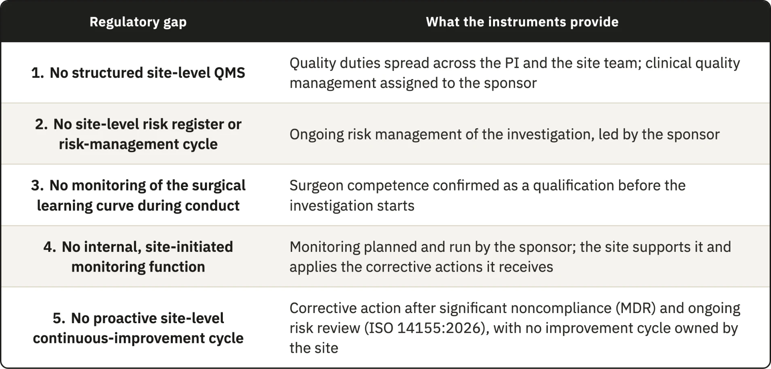

ICH E6(R3) and ISO 14155:2026 already give the investigator several quality duties, such as supervising delegated activities and making sure that staff are qualified and resources adequate. ICH E6(R3) also asks the investigator, together with the sponsor, to implement proportionate processes for the data of the trial (Section 4). These duties appear in separate clauses, and meeting them consistently depends on a system that organizes them, but no clause in the three instruments requires that system. Gap 1 is therefore the absence of a structured site-level QMS, which the manufacturer and the medical laboratory in the same chain hold under ISO 13485:2016 and ISO 15189:2022 (Section 3.2.1).
The instruments require the risks of an investigation to be assessed and reviewed throughout its conduct, and they assign this cycle to the sponsor^{6,8}. Many of these risks come from the way the site executes the protocol, and the site sees them first (Section 3.4.3). For the cycle to work at that level, the site needs a register of its own risks (Gap 2), fed by an internal observation of what it actually does (Gap 4). Those observations then have to lead to correction and prevention through an improvement loop (Gap 5). The duty formally belongs to the sponsor, but the work done at the site decides whether the cycle works. The instruments, however, only ask the site to support sponsor monitoring and to apply the corrective actions it receives.
On surgical competence the three instruments agree, and sites can meet them, because all three treat competence as a qualification confirmed before the investigation starts. The surgical trials literature goes further and recommends that the surgeon’s performance also be followed during conduct, since it changes along the learning curve, and it reports that trials rarely do so^{35–37,39}. The comparison found no site obligation for the learning curve, and this literature shows why the absence matters. Gap 3 is the distance between the practice it recommends and what the instruments require.
The sponsor’s quality system cannot fill this space on its own, because it is built for the trial and not for any one site. In a multicenter investigation, the sponsor’s controls are designed to apply one standard across every participating site, which is a deliberate choice when the aim is comparability (Section 1.4.1). The same choice leaves out what is specific to each site, such as its daily workflow, its staffing, and the technical limits that follow from its size and structure. The literature describes the consequence from the site’s side. Site-level quality management is often reactive and handled case by case^{42–44}, standardized approaches remain uncommon⁴⁵, and sites experience risk-based monitoring as an external requirement over which they have little control^{46,47}. Part of the data that matter most is also generated at the point of care, where external oversight cannot see it in time (Section 3.4.3).

3.2.1 Site conduct and the clinical evidence of the device
Under the MDR, every device subject to conformity assessment needs a clinical evaluation, with clinical evidence appropriate to the device and its intended purpose. Article 61 and Annex XIV set out how the evaluation is planned and the data appraised, and the results go into a clinical evaluation report (CER) within the technical documentation. Where the available data do not show conformity with the general safety and performance requirements, the manufacturer has to generate them through clinical investigations, governed by Article 62(1), Articles 63 to 80, and Annex XV. The data produced at the site, in the operating room and in follow-up, therefore become the evidence behind the CER that the notified body assesses, and each link in that chain is only as reliable as the one before it.
The manufacturer works under a documented quality system, set out in ISO 13485:2016 with corrective and preventive action, and ISO 14971:2019 adds a documented cycle for managing device risk^{52,53}. A medical laboratory sits outside this chain but also produces results on which others base decisions, and ISO 15189:2022 gives it an equivalent system⁵⁴. ISO 14155:2026 gives the investigational site nothing similar, since its Clause 9.1 places clinical quality management on the sponsor and Clause 10, on the responsibilities of the principal investigator (PI), sets entry qualifications without asking for an ongoing local system. The fourth edition enlarged the sponsor’s side further, with risks arising from investigation processes and a provision on the CEC⁸. Of the two organizations that produce the evidence behind the CER, only the site works without a quality system of its own.
These five gaps do not necessarily indicate defects in the regulatory framework. Addressing them may support compliance with existing duties, even where the instruments do not explicitly require the proposed site-level arrangements. They mark where the site can act on the quality of the investigation and on the safety of its own conduct. Chapter 4 develops an operational layer to support the implementation of ICH E6(R3) principles in daily site practice.

3.3 Site-level Critical-to-Quality domains
ICH E8(R1) and ICH E6(R3) ask the sponsor to identify the CtQ factors of each study when it designs the protocol⁵. These factors depend on the design and endpoints of the study, so they change from one investigation to the next. A center, however, runs every investigation through the same processes, from consent and surgery to imaging and follow-up, and a failure in any of them can affect the factors of whatever study is running. A site-level analysis should therefore ask in which areas of its own operation a center can compromise those factors in the cases it contributes. We therefore decided to derive domains, areas of operation that require special attention, and left the factors to be identified by the site for each investigation, within each domain, from the protocol and from what the sponsor communicates as critical and risky.
The derivation started from the 43 themes of the comparison. The responsibility filter initially removed nine that the sponsor alone decides or holds, such as statistics and the Investigator’s Brochure. The scope filter defined for this framework removed another six that fall outside the framework, such as record retention, or whose content another theme already covers. Randomization and blinding are one such case because the sponsor sets the allocation sequence and the masking scheme, and a failure to follow them at the site is a protocol deviation, which is already covered. Of the 28 remaining themes, 22 are requirements, stating what the site has to protect, and 6 are controls, stating how quality is kept. Only the requirements were grouped, since a control applies across every area of the site and would have produced overlapping domains. The learning curve is the only theme that serves twice, as a requirement within domain 6 and as the basis of Gap 3.
Grouping the 22 requirements by the area of the site where the work happens and by the phase of the investigation produced 12 candidate domains. Each of them met the four criteria of Section 2.4.1, which gave the twelve domains in Table 3.2. Eight of the twelve domains rest entirely on requirements that at least one instrument already assigns to the investigator, and for these the framework only organizes and facilitates duties the site already holds. Domains 6 and 9 rest partly, and domains 5 and 8 wholly, on requirements that no instrument assigns to the site. Surgical technique is described by the sponsor in the CIP, endpoints are defined by the sponsor and may be read centrally, and the learning curve appears only in ISO 14155:2026, as a roll-in that the sponsor plans¹⁰. These requirements entered because the work they describe takes place at the site and because the literature reviewed shows that it influences the results^{34,55}.
Device management takes a form specific to device investigations, with accountability from receipt through implantation in a named participant to return or explantation, and ISO 14155:2026 adds, where appropriate, an implant card that the investigator gives the participant after implantation¹⁰. Procedural consistency and learning-curve control turn surgeon-dependent variability, which the methodological literature treats as a design problem, into something the site controls and monitors. Imaging can decide eligibility and provide an endpoint, and it also supplies safety data, so variability in how images are acquired produces systematic error that cannot be told apart from clinical variance. The imaging literature is general or based on knee trials, so we used it with caution^{56,57}.
The device supplement of the MDIC to the CTTI principles offers an external check on four of the domains. Among the considerations it adds for device trials are site feasibility, including the referral base and the equipment for imaging, together with device accountability, product training with proctoring, and the learning curve³⁴. These correspond to domains 1, 4, 6, and 9.
These twelve domains govern the framework in two ways. Every component is introduced to control the risks associated with one or more domains, and every performance indicator is anchored in at least one domain.
Table 3.2. Site-level Critical-to-Quality (CtQ) domains, with the scope of each domain and the principal threat to quality when it is not controlled. AE, adverse event; DD, device deficiency; PD, protocol deviation; PRO, patient-reported outcome; UDI, unique device identification.
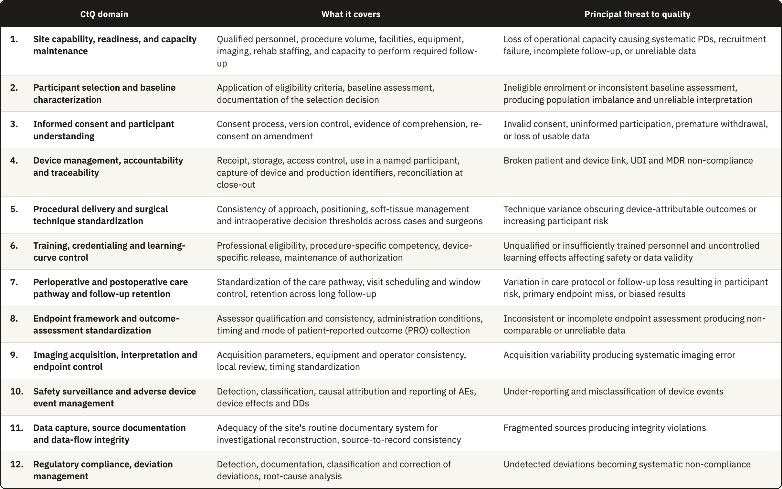

3.4 Operational conditions constraining the design
The gaps establish what is missing, and the domains establish what has to be controlled. Neither yet establishes what form a site-level framework can take. That is settled by the operational conditions under which the framework would have to work, and these conditions constrain the design as tightly as the regulatory analysis does.
As already explained in Section 1.2, surgical device investigations are conducted under conditions that a site-level framework has to take into consideration. Six main conditions apply in total. Five are structural and common to surgical trials, and two of those, operator dependence and traceability, are restrictive enough that Sections 3.4.2 and 3.4.3 treat them separately. The sixth, the organizational setting of the sites, is not structural but heavily influences the design, and Sections 3.4.4 and 3.4.5 present it as one of the findings of this thesis.

3.4.1 Design consequences of the five structural conditions
1. Irreversibility. A drug can be stopped, reduced, or replaced if it fails or causes harm. But once a prosthesis is fixed to bone, the procedure has produced a permanent change in the patient's anatomy. This raises the operational cost of every quality failure that happens at surgery, because an incorrect implant size, an undocumented technical deviation, or a missing traceability record cannot be corrected as a transcription error can. The European Medicines Agency (EMA) has described poor risk identification and mitigation as producing a reactive approach based mainly on corrective action¹. ICH E8(R1) warns that resources are needed to identify and prevent or control errors that matter, and the CTTI CtQ principles also place attention on prevention before conduct. A site-level framework must therefore identify in advance which steps of the surgical pathway are irreversible, and therefore critical, and place controls on them so that errors are prevented and information is not lost.

2. Operator dependence. In device investigations, results depend on the device and just as much on the person and technique used to implant it^{19,58}. Requirements for surgeon qualification and adequate training with the specific device are already established by the instruments, but other sources of variation also require control, including learning-curve effects, differences among surgeons in positioning and soft-tissue management, and intraoperative judgment. The study by Blencowe et al.⁵⁹ provides us one method to evaluate this effect by setting standards for surgical intervention delivery before the trial and monitor it during conduct through forms that capture deviations. Quality management therefore has to characterize this variation without trying to remove it, because removing it would mean removing surgical judgment itself. The consequence for the design is that the framework needs the operator as a unit of analysis, alongside the participant and the device.

3. Device traceability. Pharmaceutical and device trials both require records linking batch or serial numbers to participants, but the requirements differ in how long the link must be kept^{6,8}. A medicinal product is used or returned so once the trial ends there is nothing left in the participant to trace. Its accountability record is kept with the essential records, but no one has to maintain an active link between the product and the participant. An implanted device remains in the participant for years, so the MDR requires post-investigation follow-up that covers traceability, and the records must also cover any return or explantation. Traceability here also extends to reconstructing the surgical decisions that produced that configuration in that participant, which creates a documentary burden of a different order. The framework therefore needs a record of each implanted unit that the site keeps current for as long as the participant is followed.

4. The operational weight of follow-up. Long follow-up is not unique to surgical trials, but the measurements involved like ROM and radiographic assessment of implant position require the participant to be physically present, while PROs require consistent collection at the specified time points. Assessments vary less when the same procedure is used at every visit and, where the protocol provides for it, when an independent reviewer reads the results centrally^{25,60}. None of the three instruments asks for the same assessor at every visit, so keeping assessment consistent over the years of follow-up falls to the site, and images need the same acquisition procedure and quality control at every time point for the same reason^{56,61}. This raises the cost of every visit and increases the risk of attrition over the years between surgery and the late assessments. Orthopedic studies with at least three years of follow-up reported 14.8% loss to follow-up, compared with 9.8% in studies with shorter follow-up²³, and one shoulder arthroplasty cohort reported 34.3% loss by the seventh year²⁴.

5. Limited classification reliability. Shoulder investigations rely on radiological and clinical classifications that in many cases show only fair-to-moderate inter-observer reliability⁶². Widely used classifications for proximal humeral fractures have been reported with inter-observer kappa coefficients in the fair range, even when three-dimensional models reconstructed from computed tomography (CT) data are used⁶³. Two assessors looking at the same patient can therefore reach different conclusions about eligibility or about an outcome, and the database cannot distinguish that variance from genuine clinical variance. Outcome measurement makes this worse. Shoulder arthroplasty trials vary widely in outcome domains, instruments, and assessment time points. That inconsistency was substantial enough to motivate core outcome sets for shoulder disorders^{64–66}. The framework therefore has to control the sources of this variance that lie at the site, such as assessor qualification and the acquisition procedure.

3.4.2 Operator-dependent variability as a design constraint
Operator dependence produces clustering⁶⁷. Participants operated on by the same surgeon share that surgeon’s technique and intraoperative decision thresholds, as well as the perioperative management that follows, so for the purposes of quality they are not independent of one another, and a problem in the surgeon’s execution reaches every case that surgeon contributes. Clustering also matters for the design and analysis of a trial. In simulations, ignoring non-negligible clustering produced type I error rates above 20%⁶⁸, yet only 21.5% of eligible orthopedic randomized trials with several centers or treatment providers used an analysis that accounted for it⁶⁹.
The methodological literature on surgical trials counts clustering among the central challenges of randomized trials involving surgery, together with the learning curve that interacts with it^{67,70}, and practice still varies. In a survey of 44 United Kingdom Clinical Trials Units, clustering was handled mostly at design, through stratification that balances each surgeon’s cases across the arms of the trial, and at analysis, through adjustment. Learning was managed mainly through a minimum level of expertise for the treatment provider, set by 89% of units, while only one unit reported analyzing learning effects as part of the main analysis⁷¹.
Operator learning is therefore controlled mainly at entry but is rarely observed during conduct. In a review of 247 published surgical trials, 39% addressed expertise through predefined surgeon credentials, while, again, only one trial analyzed learning during conduct; a related analysis of funder guidance identified the same general concern⁷². The clause comparison in Section 3.2 reaches the same boundary, since the governing instruments address qualification and training and do not assign ongoing observation of operator learning to the site. The interval between entry qualification and performance during conduct is exactly what a site-level instrument could cover, and it is the interval that Gap 3 in Table 3.1 identifies. A protocol can define a procedure in general terms, but it cannot standardize the many small decisions through which a particular surgeon implants a particular device in a particular anatomy. The site therefore needs an instrument that operates during conduct.

3.4.3 Traceability as a point-of-care obligation
Unit-level traceability is distinctive in how detailed it is, and it is distinctive again in the circumstances under which it has to be met. It is executed in the operating room, under time pressure, by staff whose attention is on the surgical procedure. ISO 14155:2026 requires records of receipt, identification, quantity, dates of use, participant identification, and return or explantation, together with written procedures for the full accountability process. The sponsor maintains the record of physical location through delivery to the site, and the investigator's records continue the link through use in the participant and any return or explantation. The MDR also requires access control, return procedures, and follow-up in the CIP, immediate identification and recall of devices in an emergency, and post-investigation traceability. In surgery, the required dates of use and participant identification make capture at the point of care the most reliable operational response. A break in this chain can compromise regulatory compliance and the attribution of an AE to a specific device or lot. The cited clauses do not state that such a break automatically invalidates the affected case.
Traceability is the clearest example of a broader pattern that runs through the domains in Table 3.2. A class of critical data is generated at the point of care, external oversight cannot see it while it is happening, and it cannot be recovered once it is lost. Four examples share these properties: the intraoperative decision to substitute a component, the technical deviation prompted by unexpected anatomy, the immediate postoperative image that may or may not be adequate, and the early complication whose relationship to the device is still undetermined. A framework that deals with this class of data has to operate when the data are generated, because sponsor verification takes place afterward.

3.4.4 Where these investigations are conducted
During the literature review, we found evidence that clinical research is concentrated in the United States and that, within the country, much of it is done away from academic centers. Between 2006 and 2012, the United States ran 540 trial site-years per million inhabitants, more than twice the rate of the other high-income OECD countries⁷³, and North America held 62.6% of the sites of industry-sponsored device trials registered between 2005 and 2009⁷⁴. Open Payments data show that a large majority of US investigators in commercially sponsored trials conduct them in their private practice⁷⁵. In FDA records from 2008 to 2015, one third of principal investigators each year were filing for the first time, and 40% of those active in a given year did not file again the following year⁷⁶. Among the principal investigators of FDA-regulated drug trials, 63.8% found it burdensome to fit the trial around their other work⁷⁷.
The burden does not rest on investigators alone. Studies of the organizations that host trials report shortages of research staff and infrastructure, and they report them in hospitals as well as in community settings. In a national survey of 58 community cancer centers, 52% named limited staffing as a challenge to conducting research⁷⁸. Stakeholders in Ontario described community hospitals as willing to join trials but mostly without research infrastructure⁷⁹, and authors from a Swiss private hospital network report early difficulties with infrastructure, regulatory compliance and quality assurance in setting up a trial unit⁸⁰. Device research strains even academic centers. Leaders of children’s hospitals linked to the FDA pediatric device consortia described device trial infrastructure in academic medical centers as suboptimal, and found that drug trial infrastructure, though often well developed, did not necessarily carry over to device trials⁸¹.
The constraints weigh more where organizational capacity is lower. Inadequate staffing bandwidth was the most frequent reason sites gave for declining to join a lung cancer screening trial, cited by 33% of those that declined and by 45% of the community-based programs among them⁸². Among community cancer centers running therapeutic trials, 2 of 8 rural practices offered phase 1 trials against 22 of 33 urban ones, and the centers running none cited limited infrastructure, funding and staffing⁷⁸. Respondents with experience of nontraditional research sites named deficient operational infrastructure as their main challenge and quality oversight as a main support need⁸³.
All of these studies concern drug trials, and investigations of implantable shoulder devices add the structural conditions described in Sections 3.4.1 to 3.4.3, which place further demands on the site. This raised the question of where shoulder device investigations mostly take place: in hospital settings, which report these constraints but have some organizational support behind the site, or to a large extent in organizations with less capacity to absorb them. We looked for published data on how these investigations are distributed across organizational environments and found none, so we built that distribution ourselves from public registry records.
The registry search produced 46 eligible industry-sponsored investigations of implantable shoulder devices with 355 site records. Eight records could not be resolved to a clinical organization and were excluded (Section 2.3.2). One investigation lost its only listed site with this exclusion, which left 347 site records from 45 investigations and 238 organizations. We grouped the organizations into the three categories of Table 3.3, because academic status and ownership could be identified consistently from public institutional descriptions.
Table 3.3. Organizational environment of the 347 site records and 238 organizations in the registry dataset, including the organizations located in the United States.
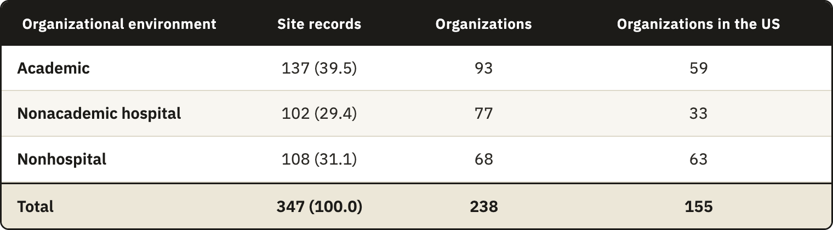
Each organization was counted once for every investigation it hosted. Of the 238 organizations, 178 took part in one investigation and 60 in more than one, up to nine at the Rothman Orthopaedic Institute. A count by organization would give an organization with nine investigations the same weight as one with a single investigation, and it would understate the environments where investigational activity concentrates. Repetition was most frequent in the nonhospital group, whose 68 organizations hosted 1.59 investigations on average, against 1.47 in academic organizations and 1.32 in nonacademic hospitals, and a count by organization would lower its share from 31.1% to 28.6%. Entries for the same organization within one investigation had already been merged during normalization (Section 2.3.2), so each site record stands for one occasion on which an organization conducted an investigation.
Hospitals hosted most of the investigational activity in the sample, with 239 of the 347 site records (68.9%). The remaining 108 site records (31.1%) came from 68 nonhospital organizations, the independent orthopedic practices, ambulatory centers and surgeon-owned orthopedic facilities that operate outside hospital systems and universities (Table 3.3). Most of the activity therefore takes place where some organizational support stands behind the site, even though these settings report the constraints described above. Close to a third takes place in organizations that resemble the community and private-practice settings in which those constraints weighed most.
These categories describe what kind of organization a site is, and they say little about how it is prepared for research. A nonacademic hospital may have a research unit with dedicated staff, or it may run investigations alongside routine care with no such support, and private practices can vary in the same way. The registry holds no information that would separate these cases, so Table 3.3 shows only where investigations take place, but the readiness of each site to conduct them remains unknown.
The sample is weighted toward the United States, with 155 of the 238 organizations (65.1%) and 243 of the 347 site records (70.0%). The weight is greatest in the nonhospital group, and 63 of its 68 organizations (92.6%) were there. Part of this concentration comes from the registry itself, because registration on ClinicalTrials.gov is required for many studies conducted in the United States. We also searched Eudamed, its European counterpart, but it returned few of these investigations and little site-level data compared with ClinicalTrials.gov. The findings therefore describe this sample and should not be read as the distribution of shoulder device investigation sites in Europe or worldwide. The purpose of the analysis was to judge the relevance of the framework and to identify the site conditions its requirements must take into account.

3.4.5 The operating conditions of the target center
The distribution in Table 3.3 guided the selection of the target center, which we defined as a nonhospital organization. This group held 108 of the 347 site records (31.1%), too large a share to treat as an exception. It is also the environment for which the framework can assume the least, because no hospital system or university stands behind the site.
The evidence reviewed in Section 3.4.4 comes from drug trials, and part of it concerns drug administration. Most of what it reports, however, concerns staff, clinician time, infrastructure and oversight, which a site needs whatever the product under investigation, and the conditions of an implantable device investigation add to these demands (Sections 3.4.1 to 3.4.3). The few studies on device and orthopedic research point the same way. In a pilot within a UK hip preservation registry, centers given additional administrative support achieved 79% follow-up compliance at 30 days against 55% in centers without it, and 69.4% against 47% at 90 days⁸⁴. Experts on pediatric device trials rated a device training plan among the most important infrastructure components for implanting and using the device⁸⁵. A nonhospital site conducting a shoulder device investigation is therefore unlikely to face lighter constraints than those reported for drug trials, although the present work did not test this inference.
The registry did not record staffing, budgets or the priority each organization gives to research, so these conditions entered the design as assumptions. The framework does not assume a dedicated research office or quality function, and it allows research duties to be shared among clinical staff. The framework had to fit within existing site roles without depending on a new physical infrastructure or dedicated quality department. Its instruments had to work on paper or within an electronic system already available at the site. Key quality decisions also had to remain in records held by the organization when individual responsibilities changed.
These conditions define the minimum implementation level used in the scalability model presented in Section 4.7. Organizations with established research departments can place the same functions within their existing systems and use deeper controls.

3.5 Design requirements
A CtQ domain defines where the site has to protect the critical factors of an investigation, but it does not say what the site must have in place for that domain to be under control. The design requirements state this. They complete the second DSRM activity, the definition of the objectives of a solution, because they turn the findings of this chapter into statements of what an acceptable framework has to deliver, written so that each of its components can later be checked against them.
Table 3.4 lists the twelve requirements and traces each one back to its origin. DR1 to DR5 come mainly from the regulatory gaps in Section 3.2, and DR6 to DR9 from the CtQ domains and the structural conditions of surgical investigation (Sections 3.4.1 to 3.4.3). DR10 to DR12 come from the operating conditions of the target center (Sections 3.4.4 and 3.4.5).
Requirements and domains do not correspond one to one. DR2 covers all twelve domains, because each of them needs its execution risks identified at the site. The four domains that rest wholly or partly on requirements no instrument assigns to the site (domains 5, 6, 8 and 9) feed the requirements on operator proficiency, point-of-care capture and measurement variance (DR3, DR6 and DR7). The other domains enter the set through how the site organizes their control, for example through indicators (DR8) and correction (DR5). Informed consent (domain 3) is the only domain with no requirement beyond DR2, since the instruments regulate consent in detail.
Meeting one requirement can also make another harder to meet. DR11 rules out capital investment and asks the site to reuse its existing documentary system, so it limits how DR1 to DR9 can be met. A site could satisfy every functional requirement with an information system built for the investigation, and that solution would pass the regulatory analysis while failing the operational one. When two requirements point to different solutions, we treat the operational constraint as binding, because a control the site cannot afford to run will not be run.
No instrument examined here requires a site to operate a quality system (Gap 1, Section 3.2), so the framework cannot be justified by pointing to a rule that demands it. Its justification comes from tracing each part back to its origin. Each component answers a requirement, and each requirement comes from a regulatory gap, a CtQ domain or an operating condition (Table 3.4). The gaps and domains trace back to the clause comparison in Section 2.2, with Gap 3 checked against the surgical trials literature, and the operating conditions to the literature and registry evidence in Section 3.4. Where the framework adds a control that no instrument requires, that control answers a gap the comparison documented. Everywhere else, the framework organizes duties the instruments already assign, so that a site can carry them out under the conditions in which it works.
Table 3.4. Design requirements (DR1 to DR12) for a site-level operational quality framework and their origin in the regulatory gaps, the CtQ domains, or the structural and operating conditions of surgical investigation and of the target center. CAPA, corrective and preventive action; CtQ, critical to quality.
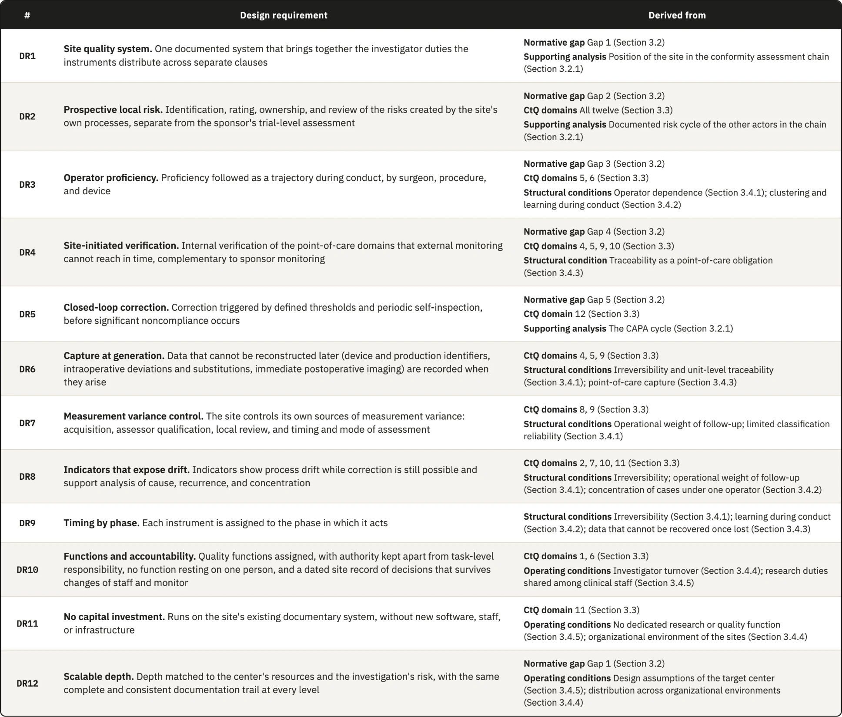

4. Results: The Quality Framework

4.1 Overview and design rationale
This chapter reports the third DSRM activity, the design and development of the framework to meet DR1 to DR12. It describes each component in enough detail for a site to implement and operate it.
The Site-Centered Operational Quality Management Framework consists of four pillars, each with a set of instruments. A lifecycle assigns the instruments to the phases in which they are prepared and used (DR9, Section 4.6), while a scalability model determines which instruments a site runs according to its organizational resources and the risk of the investigation (DR12, Section 4.7). The role structure within Governance assigns each quality function to a defined person and separates authority from responsibility for individual tasks (DR10, Section 4.2.2).
Governance, Risk Management, Operational Controls, and Performance Oversight together answer DR1 to DR8 (Sections 4.2 to 4.5). Of the two organizations producing the evidence behind the clinical evaluation report, only the site works without a quality system of its own (Section 3.2.1), so the pillars bring to the site the functions of the systems that ISO 13485:2016 and ISO 14971:2019 give the manufacturer and ISO 15189:2022 gives the medical laboratory^{52–54}. None of the three standards uses this exact division.
Governance draws on the management clauses of the three standards (ISO 13485 Clause 5, ISO 14971 Clause 4, and ISO 15189 Clause 5). Risk Management draws on ISO 13485 Clauses 4.1.2 and 7.1, ISO 14971 Clauses 5 to 7, and ISO 15189 Clauses 5.6 and 8.5. Operational Controls draws on ISO 13485 Clause 7, including Clause 7.5, and ISO 15189 Clause 7. ISO 14971 does not contribute to this pillar because it does not address the control of routine processes. Performance Oversight draws on the measurement and review clauses of all three standards (ISO 13485 Clauses 8.2.4, 8.4, and 8.5, ISO 14971 Clauses 9 and 10, and ISO 15189 Clauses 8.7 to 8.9).
The instruments form one set that can work on paper or within an electronic system the site already uses (DR11). This operational constraint takes precedence wherever it conflicts with another requirement (Section 3.5), so no component depends on new software or new staff. We designed the instruments after defining the functions of all four pillars. Each instrument therefore belongs to one pillar but can use records produced under another.
The conditions of the target center, a nonhospital organization (Section 3.4.5), shaped the instruments and set the minimum implementation level. Because the components are described as functions, centers with different staffing structures can assign their own posts to those functions.
Each instrument describes a control function, so a site that already keeps a record performing that function uses it without opening a new one. The instruments are not regulatory requirements and do not replace sponsor procedures or the controls defined in the CIP. Records already required by the regulations remain in place. A new record is justified only where a critical process would otherwise lack a control or a record of its execution.

4.2 Pillar 1: Governance
None of the regulatory instruments examined requires a structure that brings together the quality duties they assign to the investigator (Gap 1). Governance provides that structure for DR1 and DR10, in CtQ domains 1 and 6, while leaving each duty with the party that already holds it. The oversight model defines how the PI exercises authority for quality, the delegation structure identifies who may perform each task, and device training documentation sets the preparation each task requires, with a separate qualification and authorization decision for surgeons. Once a surgeon starts operating, Risk Management tracks the learning curve and provides evidence for later authorization decisions (Section 4.3.2).

4.2.1 The oversight model
During design, we compared three ways of allocating oversight under different conditions of staffing and capacity. The descriptions of trial-site operations we reviewed confirm that these functions need to be covered^{86,87}, but they do not classify them into these arrangements. We therefore use the three arrangements as design options.
In the first arrangement, the PI intervenes directly in most critical activities and personally reviews most documentary and operational workflows. This becomes difficult to sustain as activity grows. Site PIs already carry scientific and regulatory duties alongside recruitment, supervision, and administration, and their contribution is often under-recognized⁸⁶. Routine review then takes time from the decisions that need the PI's clinical judgment, and the arrangement scales poorly because the PI would have to follow every area of the investigation.
In the second arrangement, the study coordinator manages daily work while the PI retains final authority. This is a workable allocation: the clinical research coordinator is a core site function⁸⁷, and ICH E6(R3) permits delegation while the investigator retains ultimate responsibility and proportionate oversight⁶. FDA guidance on investigator supervision takes the same position⁸⁸. Oversight becomes nominal, however, if the site leaves undefined the decisions that require the PI, such as borderline eligibility, an unplanned component substitution, or the interpretation of a revision, and sets neither a review schedule nor a route for escalation.
We adopted a third arrangement, a tiered model of PI oversight adjusted to risk. It retains delegation and adds the review structure, schedule, and escalation route missing from the second arrangement, so the PI can concentrate on decisions requiring clinical judgment. The PI's involvement in each task follows the risk it poses to the CtQ factors identified when the investigation starts (Section 4.3.1), which applies the CtQ logic of ICH E8(R1) to the allocation of the investigator's attention⁵. The site therefore sets thresholds and a review schedule before enrolling the first participant and assigns someone to keep the meetings running.
Five mechanisms make this oversight a documented and scheduled practice, as DR1 requires. The criticality grade assigned to each delegated task provides the basis for the other mechanisms.
- Risk-tiered involvement. For each type of activity, the site states in advance which decisions require the PI's own judgment and which activities the PI can review afterward. This distinction depends on the device and procedure and may change as the team gains experience, so the site revisits it at each oversight cycle. Requiring direct involvement too often recreates the workload of the first arrangement, while requiring it too rarely can leave the PI without meaningful oversight. The Criticality-Coded Delegation Matrix (CCDM) records the supervision level for each task (Appendix A).
- Criticality grading of delegated activity. Each task receives a grade that determines its level of supervision and its escalation trigger. Even routine work can be critical, since a scheduling decision can place a follow-up outside the protocol window. The grades therefore come from the CtQ factors of the investigation itself, because a scheme copied from another site may overlook risks specific to its procedures or team. The CCDM records these grades.
- Milestone review. The PI formally reviews the investigation at four points where the most consequential threats concentrate: procedural implementation, the immediate postoperative period, the approach to endpoint assessment, and close-out. A review must take place after the events whose problems it needs to identify, but early enough to correct a pattern before it affects further cases. These points reflect the risk profile of a shoulder implant investigation and would need revision for another device or procedure. The Milestone Review Log (MRL) records each decision (Appendix B).
- Event-triggered escalation. Events that immediately threaten participant safety or causal interpretation require prompt notification to the PI, whatever the scheduled review date. The CCDM defines the trigger for each task, and the PI Oversight Template (POT) records the PI's decision and the resulting action (Appendix C).
- Oversight meetings. The site team meets regularly to conduct the review, giving oversight a structure beyond ad hoc contact. We adapted the consensus-based review of events that ISO 14155:2026 assigns to a sponsor's clinical events committee (CEC)⁸ and the periodic risk review described in the EMA reflection paper¹ to this site-level meeting. We found no study showing that such forums improve oversight at site level. Maintaining them is particularly difficult in the nonhospital organizations targeted here, because the people attending are also responsible for the work being reviewed. Each meeting closes one cycle of the POT.

4.2.2 Delegation, roles, and functions
The PI can adjust supervision to a task's criticality only if the site knows who performs it, whether that person is authorized and trained, and who must act when an escalation trigger is met. DR10 asks for a defined holder of each quality function, so that no CtQ function stops when one person is unavailable.
A conventional delegation log records who performs each trial-related activity. ICH E6(R3) asks for this record in proportion to the significance of the activity and accepts that work performed as part of clinical practice may need no delegation record (Section 2.3.3). ISO 14155:2026 requires the names, signatures, functions, and authorizations of new team members to be documented. Neither requires a criticality grade or evidence of competence in the same record. The framework needs both to connect the supervision assigned to each task with the training or qualification that permits a person to perform it. Delegation records are examined directly at inspection, and the investigator remains accountable for delegated work⁸⁹. The record therefore has three properties.
- Task-based and graded. Each entry identifies a specific task and its criticality grade, which sets how closely the PI reviews it. Authorization for one task does not imply authorization for another. A research nurse may be well placed to coordinate visits and keep screening logs but may not be qualified to resolve a clinically meaningful discrepancy in operative documentation.
- Competency-gated. An entry becomes active only after the person has been released for the task following training or, for a surgeon, qualified and authorized for the procedure (Sections 4.2.3 and 4.2.4).
- Version-controlled. Each change of person, task, or grade is dated. The record can therefore show who was authorized at any point in the investigation, including after the people named in it have left, as DR10 requires.
The role structure comprises six functions covering the work of an orthopedic implant investigation, each with a defined limit of authority (Table 4.1). Under ISO 14155:2026, delegation transfers execution while the PI retains responsibility. The limits of authority distinguish responsibility for individual tasks from the authority to make decisions. Clinical judgments remain with the PI or surgeon, and endpoint adjudication belongs to the central reader where one is used.
Table 4.1. The six functions of the role structure, with their main responsibilities and limits of authority.
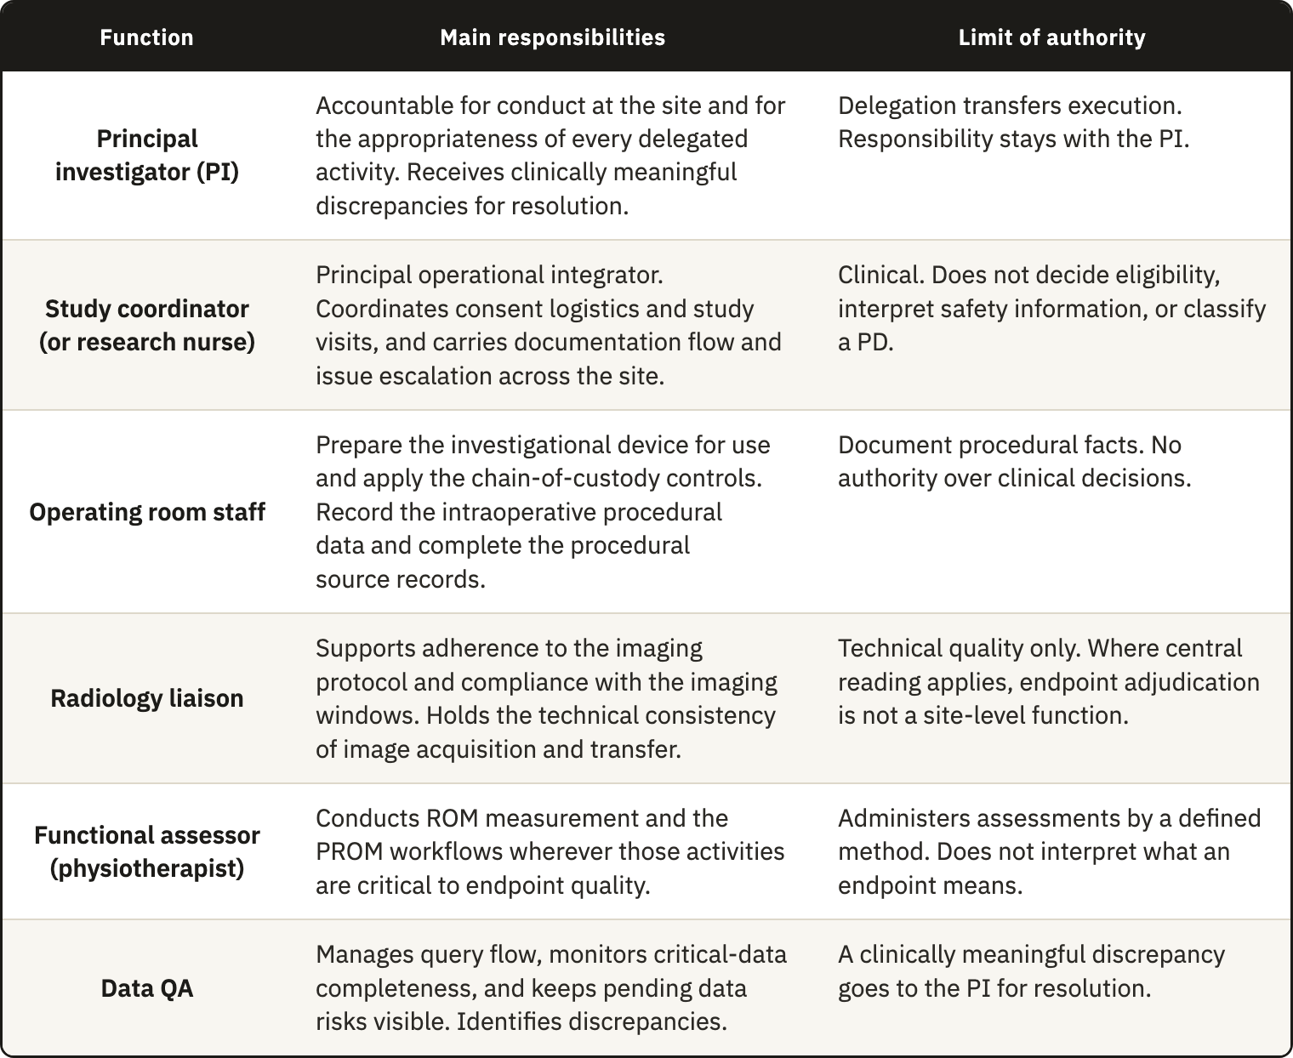
A site assigns its own posts to the six functions. In a nonhospital organization, where clinical staff also perform research work, one person may hold several functions. Each function must still have a named holder and backup so that no CtQ function depends on one individual. Services outside the study team, such as radiology or physiotherapy, fall under the same proportionate oversight of delegated activities in ICH E6(R3). Where the sponsor selects or supplies the provider, the site coordinates that oversight with the sponsor. The CCDM records each task's grade and prerequisite, together with the required supervision and escalation trigger. The Responsibility Assignment Matrix (RACI) identifies the current holder and backup for each activity and the limit of the holder's authority (Appendix D).

4.2.3 Device training documentation
Before assigning a task, the site uses the training records to check that the person has received the preparation it requires. Monitors and inspectors use the same records as evidence that critical activities were performed by staff who were both delegated and prepared for the investigation.
Under the MDR and ISO 14155:2026, the sponsor defines the training content through the CIP and the IB and verifies that training is documented, while the PI trains the site team before each member starts an assignment¹⁰. ICH E6(R3) limits trial-related training to what delegated activities require beyond a person's usual training, and ICH E8(R1) asks that training match each role. None of these texts specifies the training needed for each site role and task, how readiness for independent work is decided, or when training needs updating, and this component organizes the site's existing duty around those decisions.
Medicinal-product GCP also requires personnel familiar with the investigational product. A device investigation adds the functions linked to the device and its use, which the framework groups into five training areas, each protecting one or more CtQ domains.
- Protocol and procedural training: the study objectives, the key eligibility restrictions, the visit windows that matter for endpoints, PDs, and the decision points specific to the study.
- Device training: the investigational system, its instrumentation and implant components, preparation and handling, and any constraint the study places on the workflow.
- Operative and perioperative documentation: intraoperative records, component reconciliation, capture of implant lot and UDI, documentation of substitutions and deviations, and chain of custody.
- Assessment training: radiographic acquisition standards and imaging timing, ROM measurement, and PROM administration where these bear on an endpoint.
- Safety reporting: recognition and documentation of AEs and DDs, and the escalation pathway for clinically important findings.
Each training record identifies the person and training area, the date and trainer, and the version of the controlled document used. After a revised IFU or amended CIP, the site can therefore identify everyone trained on the earlier version.
The site records completion of training separately from release to perform a task. Attendance at a session shows that training took place, but does not establish that the person can perform the task independently. For tasks graded as critical in the delegation record, particularly those involving the device, imaging, or outcome assessment, the site records an explicit release once training is complete. This release activates the competency gate in the delegation record and, for surgeons, provides one input to the authorization decision. A person performing only routine clinical care receives no device-specific training unless the CIP requires it.
The site retrains staff when the work changes through a protocol amendment, revised IFU, new device iteration, or altered workflow. Deviation records and monitoring findings may also indicate a need for retraining, for example after a safety signal or repeated documentation errors. Responding to these findings follows ICH E8(R1), which recommends retraining when issues related to CtQ factors arise during the study. These records support DR10 by linking each function to a defined training requirement and a recorded release. The Device and Study Training Requirements Matrix (DTRM) specifies what each role or task requires, and the Training Record Evaluation and Release (TRE) records each person's training and release (Appendices E and F).

4.2.4 Surgeon qualification and continued authorization
Under the MDR and ISO 14155:2026, the sponsor sets the selection criteria and verifies qualification before the investigation starts, while the PI documents the team's qualifications, keeps the team adequate throughout, and ensures that only authorized users handle the device. The sponsor therefore sets the entry threshold through the CIP and its training requirements, and the site documents that each surgeon assigned a study procedure meets it.
A specialty credential establishes a surgeon's general professional standing, while competence in the specific procedure and readiness to use the investigational device require separate consideration. ISO 14155:2026 already distinguishes experience in the field of application from training in the investigational device for the PI (Clause 10.2(b)). A surgeon experienced in a comparable procedure may still be unfamiliar with the technique required for this device. Before the first case, the site therefore assesses how far the sponsor's entry criteria and the surgeon's release on device training establish readiness, and whether anything remains open. The resulting decision places the surgeon in one of four categories: credentialed, conditional, restricted, or not credentialed. Its link to the delegation record ensures that assigned surgical tasks match the current authorization.
Where the risk assessment or expected learning curve calls for closer supervision, the site may add temporary controls proportionate to the surgeon's experience with the procedure and device. These may include proctoring, co-surgery, or an initial assignment to less complex cases, within the requirements of the investigation. The surgeon holds a conditional authorization until the conditions recorded in the decision have been met.
The site reviews qualification at least once a year while the surgeon operates on study participants, and after a protocol amendment, safety signal, cluster of complications, or evidence of drift in performance. Learning curve tracking and complication monitoring under Risk Management supply the evidence from the surgeon's own cases. Each reassessment uses the same four categories, so authorization can be restricted or withdrawn and later restored. Linking observed performance to continued authorization gives the monitoring required by DR3 a route to action (Gap 3). The Surgical Credentialing Record (SCR) records each decision and its evidence, and the RACI carries the resulting authorization into the delegation record (Appendix G).

4.3 Pillar 2: Risk Management
The site needs to identify where its own conduct may fail and control those risks before they affect participants or the data. Risk Management provides the site risk record missing in Gap 2 and the monitoring of operator learning called for by Gap 3. It answers DR2 and DR3, together with parts of DR6 and DR8. Because execution can affect any of the twelve CtQ domains, the pillar covers all of them, but includes only risks that threaten a CtQ factor.
The texts examined address risk at device and trial levels. The manufacturer manages device risk under ISO 14971, and ICH E8(R1) and ICH E6(R3) ask the sponsor to manage risks to critical factors through a cycle from identification to review. ISO 14155:2026 adds two sources beyond the use of the device, the clinical procedures required by the CIP beyond routine practice and the conduct of the investigation itself, and assigns both to the sponsor.
The third level concerns the risks created by the way an individual site carries out the protocol, and none of these texts assigns an owner to a separate risk cycle at this level. The sponsor's cycle has to work across centers with different staff and working practices, so it cannot be built around the weaknesses of one center. Most of the structural conditions described in Chapter 3 act at the site, and the first signs of device-related complications also appear there, which puts the site in a position to identify and control these local risks.

4.3.1 The site risk register
A 2023 survey of 46 Portuguese clinical trial sites found that only nine (19.6%) described a standard tool or document that captured risk analysis at site level⁹⁰. Although limited to one national survey, this was the closest measurement of Gap 2 that we found.
The register records risks arising from the site's own execution of the investigation. Around surgery, these may include incomplete capture of implant identifiers or late documentation of an intraoperative deviation. Later, they may arise from inconsistent image acquisition or follow-up visits outside their windows. The site opens the register before enrolling the first participant so that controls can be put in place before these failures occur. It uses the protocol and the sponsor's information on critical factors and risks to identify, within each CtQ domain, the factors that its own conduct can affect. Each local risk is then linked to the factor it threatens, with its cause and consequence recorded.
The site rates each risk by its impact on the CtQ factor and by how likely it is to occur and remain undetected, following the risk logic of ICH E8(R1). The rating helps keep the register focused enough for the PI to review at each oversight cycle. Each entry also names an owner from the role structure and records the control in place, the residual risk, and the trigger for reassessment. The named owner is responsible for acting on the entry, and the trigger lets a change in local conditions prompt a review before a failure occurs. A risk with possible effects beyond the site goes to the sponsor. The Site Risk Register (SRR) documents this process from identification to reassessment, as DR2 requires, and holds each risk with its CtQ factor and control plan (Appendix H).

4.3.2 Operator-dependent risk and the learning curve
In a surgical device investigation, the procedure forms part of the intervention, so the surgeon's technique and decision thresholds can affect protocol adherence, implant traceability, and endpoints across all the cases that surgeon performs. Because the instruments compared in this thesis control operator learning only at entry (Gap 3), the framework monitors it during conduct, specific to the surgeon, procedure, and device, as DR3 requires.
Experience is associated with shorter operative times, fewer complications, and better PROM scores, although studies define proficiency differently, and reported learning periods range from about 12 to 86 cases depending on the procedure and the surgeon^{20,91}. The framework therefore sets no fixed case count.
The site tracks each surgeon's cases to assess whether variation is becoming a material risk to its CtQ factors. This follows ICH E8(R1), which calls for periodic review of CtQ factors as new issues arise during a study and risk controls may need adjustment. The learning curve is one such issue at a surgical site. Existing SQA frameworks deal with it mainly at selection^{37,39}, while the Clinical Trial Site Performance Measure has no indicator for a surgeon's procedural consistency during a trial⁴¹.
Before the first case, the site defines the levels of case complexity relevant to the investigation, the operative duration expected for comparable cases, and the support a surgeon should receive early on, such as proctoring, and these definitions form the basis for comparison. The record of each case then includes its complexity and duration, with any unplanned event such as a component substitution or a need for senior support. A slow operation has a different meaning in a complex case and in a routine one, and its interpretation also depends on the surgeon's experience with the device. Each case is therefore compared with the same surgeon's earlier cases at the same level of complexity. This avoids most of the case-mix problem of comparisons between surgeons, although changes in complexity over time still need to be considered.
The site reviews the sequence after the first cases and at set points afterward. A pattern such as repeated substitutions or a cluster of early technical complications prompts an earlier assessment. Signals from complication monitoring are also checked against the case sequence before they are attributed to the device or the operator, so that normal variation is not taken for procedural drift.
The review may confirm stable execution or lead to closer observation, renewed device training, or temporary proctoring. A material or recurrent pattern requires formal escalation, and a material pattern also enters the risk register or corrective and preventive action. If the response would restrict the surgeon's scope, it returns to the credentialing decision under Governance because it changes the authorization to operate. Recording cases as they occur can reveal drift before it appears as an AE or a PD and preserves point-of-care data that cannot be reconstructed later, and so answers part of DR6. The Surgeon Learning Curve Tracking Log (SLCT) holds the case sequence, its basis of comparison, and each review with the resulting decision (Appendix I).

4.3.3 Device-specific complication monitoring
The site reviews clinical events for possible relationships with the investigational device, the procedure, or their interaction in use. Monitoring covers AEs and DDs, with particular attention to complications arising from the procedure or device. An early complication whose relationship to the device remains unclear is one example of the point-of-care data that cannot be recovered once lost (Section 3.4.3). This component answers DR8 and part of DR6 within CtQ domain 10, safety surveillance and adverse device event management.
Each event already has a reporting route that begins at the site. ISO 14155:2026 asks the PI to record and categorize every AE and observed DD and to report the serious ones to the sponsor without unjustified delay, and an AE associated with a DD follows both pathways. Under the MDR, the sponsor then reports serious events with a possible causal relationship to the device or the investigation procedure, together with device deficiencies that might have led to one. These requirements deal with each event on its own, and none of the three instruments asks the site to review its events together for a pattern.
Several events with plausible individual explanations may share a cause, such as one implant component or one surgeon. Reviewing them together can reveal that relationship while the site can still act on it. The framework therefore requires the site to review its own events on a schedule it sets at start-up, independent of the sponsor's, and also whenever a serious event or a cluster of events calls for it. This review starts from events that have occurred, while the risk register works on weaknesses that may cause a future failure, such as an implant identifier that may not be captured before the operating room workflow ends.
The site logs each event when it occurs, whether it is first observed in the operating room or at a later clinical contact. The entry refers to the source records and reporting route, allowing the log to index events without repeating their clinical narrative. It also records a preliminary assessment of what the event may relate to, which the investigator's final classification later confirms or replaces.
At each review, the site counts events by category and examines their distribution by component and surgeon. Each count is read against the number of procedures performed. A rate above a threshold set in advance, or a sharp rise since the previous period, constitutes a signal. The review also flags new event categories and events concentrated in one surgeon. The site assesses each signal for its likely cause and directs it to the relevant process. A signal tied to a surgeon goes to the learning curve review, while one that points to the device goes to the sponsor through the deficiency route. A pattern in a local process enters the risk register or corrective and preventive action.
Under ISO 14155:2026, the sponsor considers establishing a CEC to review and classify events from all participating centers by consensus. The local review uses the site's own denominator and triggers. We found no evidence that either level detects a signal first, so the design gives the site a defined point for action without assuming that it detects signals sooner. When a local trigger is met, the site acts, and signals that may matter beyond the site go to the sponsor to inform the CEC's assessment. The Site Complication Monitoring Log (SCML) indexes events and their routes (Appendix J), while the Safety and Adverse Effect Reporting Template (SART) follows each safety case from opening to closure (Appendix K). The counts and signals from each periodic review are recorded in the Complication Signal Surveillance Template (CSST) (Appendix L).

4.4 Pillar 3: Operational Controls
Critical activities need consistent methods and records that allow the site to reconstruct what happened. Operational Controls define how these activities are carried out and checked, and the pillar answers DR4 and DR7, together with parts of DR6 and DR11. The MDR requires investigation information to be recorded and stored so that it can be accurately reported, interpreted, and verified, and ISO 14155:2026 specifies the requirements for source documents, data, and device accountability at the site.
Some differences between the protocol and its execution are difficult for an outside party to identify in time, because local conduct can drift between sponsor visits and variation in imaging may appear only when images from different time points are compared. The site therefore needs to check its own work during conduct and to control the records used for those checks.

4.4.1 Internal verification of site conduct
The site reviews its conduct and documentation at set intervals to identify and correct failures within its own responsibilities, as DR4 requires. The MDR, ISO 14155:2026, ICH E6(R3), and FDA guidance on risk-based monitoring⁹² place monitoring with the sponsor, and none requires the site to check its own conduct between visits (Gap 4). Internal verification covers this interval alongside the sponsor's monitoring, which remains independent of the site.
The review focuses on the points where operating room practice meets implant logistics and documentation, and on later imaging and follow-up. Its effort follows the risk to participants and data, applying at the site the principle that risk-based monitoring uses for sponsor oversight, and ten checks define its scope.
- Sterile release to use. Package integrity, expiry, and storage are confirmed before use, and any breach of sterile handling or intraoperative substitution is reconciled.
- Implant traceability and component reconciliation. Lot number, serial number, or UDI agree across the operative note, accountability record, implant labels, and CRF, and the implanted configuration matches the plan.
- Instrumentation and operating room readiness. The correct implant system and instrument set were available, and any incompatibility or malfunction is documented as a procedural issue or, where applicable, a DD.
- Operative documentation. The operative note contains enough detail to interpret the final configuration and intraoperative decisions, including substitutions, deviations, and complications. The record needs to preserve these details because missing information cannot be reliably reconstructed later.
- Imaging usability and timing. Required imaging was obtained within its window, with the correct views and technical quality, and was repeated when it did not meet those requirements.
- Follow-up execution. Each visit produced the outputs required for surveillance and endpoint assessment.
- Endpoint data agreement. For endpoint-critical fields first recorded outside the CRF, a sample of CRF entries agrees with the source, and discrepancies are corrected and explained.
- Timeliness and closure. Notes, data entry, queries, and corrective actions are completed within the set times. The EMA reflection paper identifies delays in data entry and SAE reporting as possible triggers for targeted monitoring. It does not establish that a backlog predicts broader failure, so the framework treats delay as a signal to investigate.
- External context. The site reviews the safety alerts and field safety notices it receives for the same implant class or procedure and routes those that affect the investigation to the risk register.
- Complication monitoring. Complication reviews took place at the planned intervals, and their signals were followed up. The analysis of the pattern itself remains part of complication monitoring.
Before enrollment begins, the site defines the frequency and sample for each check and assigns a reviewer, together with the trigger for an earlier review. The reviewer should be someone other than the person who performed the work. Where staffing permits, a person separate from daily execution undertakes the review. A small team can share this work with a trained peer or conduct it under documented PI oversight. Each review covers a defined period or responds to a trigger and can include all ten checks or a selected subset.
For each check, the reviewer records whether the planned control was carried out and whether the record confirms it, then assesses whether the control worked. A negative or uncertain finding leads to an action or a linked record, followed by a check of the correction's effectiveness. Because this review follows the site's own schedule, it also provides the periodic self-inspection required by DR5. Findings that need correction enter the corrective and preventive action process under Performance Oversight. The Internal Monitoring Plan (IMP) defines the scope and schedule (Appendix M), and the Internal Monitoring Checklist (IMC) records each review with its findings and actions (Appendix N).

4.4.2 Imaging standardization
Images support decisions throughout a shoulder investigation, from confirming anatomical suitability before surgery to assessing component position at follow-up. The classifications applied to them already have limited reliability, so variation in acquisition adds error that the database cannot distinguish from a real clinical difference. This component controls the variation introduced by the site and answers DR7 for CtQ domain 9, imaging acquisition, interpretation and endpoint control.
Trial-imaging guidance has developed mainly outside orthopedics, where core-imaging and central-reading work specifies acquisition methods, equipment, and site qualification in advance, along with the division between local and central reading^{56,61,93}. Shoulder studies show how sensitive measurements can be to acquisition. In images reconstructed from cadaver scapulae, views only 5 degrees from true anteversion changed the critical shoulder angle by more than 2 degrees⁹⁴. Another cadaveric study found stable measurements only within about 9 degrees of malrotation⁹⁵, while only 22% of anteroposterior films in routine practice met the standard projection⁹⁶. Simulated changes in scapular position produced ranges of 14 and 17 degrees in arthroplasty inclination measures⁹⁷. With standardized outlet views, the interobserver intraclass correlation coefficient (ICC) for acromiohumeral distance reached 0.91⁹⁸.
The site applies the sponsor's imaging charter through four elements, beginning with a readiness assessment before activation. It maps the charter's requirements, including views and acquisition windows, onto a workflow its radiology service can follow. Any gaps are recorded, and the assessment is submitted to the sponsor, which retains the activation decision.
The people who acquire and assess images must be qualified and trained for those requirements, with release documented through the training records under Governance. Where a measurement depends on the assessor, agreement between assessors is tested before the first participant. ISO 14155:2026 also makes the PI responsible for maintenance and calibration of equipment used in the investigation, and its fourth edition added calibration to the content of the CIP.
Before the first image is acquired, the site defines who reviews images locally, the criteria used, and how nonconforming images are handled, including when a second reviewer or clinical escalation is needed. Each required image set is logged at acquisition with its timing, technical quality, and retrieval reference. A set that falls short leads to repeat acquisition or a second review while these can still resolve the problem. Central review, when used by the sponsor, requires coordination across sites and remains outside the site's control. The site can therefore claim consistency only for its own review.
The site also schedules imaging within the CIP window at a time when a reproducible position can be obtained, which pain, dressings, or a sling may prevent soon after surgery, although we found no study measuring how often this happens. If a scheduled time proves unsuitable, the site documents the problem and raises it with the sponsor, which can define an acceptable window. The Site Imaging Readiness Record (SIRR) documents the mapping of the charter and the readiness assessment (Appendix O), and the Imaging Quality Log (IQL) records each image set (Appendix P).

4.4.3 Eligibility and follow-up records
The decision to enroll and each follow-up visit depend on records made for an individual participant, which protect CtQ domains 2 and 7. The eligibility record also answers the part of DR7 that calls for structured verification of eligibility. In a shoulder investigation, this decision often depends on anatomy interpreted from images and on the planned procedure, and an error at inclusion can become irreversible once the implant is in place.
The site documents each eligibility decision criterion by criterion against the current CIP, identifying the source of the evidence and the date it became available. Consent precedes any assessment that requires it, and the decision is recorded before enrollment so that the record shows what evidence was available at the time. Criteria that depend on imaging interpretation or information from several sources receive a second, independent review. Any unresolved disagreement goes to the PI, and enrollment waits until it is resolved. The investigator then signs the decision, leaving a record that can be reconstructed without relying on undocumented knowledge.
Every person considered for the investigation also enters a screening log under a code, with the screening outcome and the reason for any non-inclusion or withdrawal. The key linking the code to the person's identity is kept separately. ISO 14155:2026 requires each site to log all enrolled subjects under a code linked to their identity and permits the log to include everyone prescreened. At each review, the site reconciles this log with the eligibility records to account for every candidate. The recorded reasons for non-inclusion feed the enrollment quality indicator under Performance Oversight.
The record of each follow-up visit states whether it occurred within its window and which components required by the CIP were completed. It records the result of each component, any exception, and the action taken. A visit counts as usable only when the CtQ assessments for that time point were completed by the specified method and within the window, since attendance alone does not show that these requirements were met. If a visit is late or incomplete, the site records the reason and the effect on the data. Unexpected findings and concerns raised by the participant go to clinical review and, where applicable, the safety route. Performance Oversight then reviews follow-up across participants and review periods.
The Participant Screening and Eligibility Assessment Record (PSEAR) documents each eligibility decision (Appendix Q), while the Subject Identification and Failure Screening Log (SIFSL) records everyone screened (Appendix R). Each follow-up visit is documented in the Participant Follow-up Visit Record (PFVR) (Appendix S).

4.4.4 Source documentation and parallel records
The framework uses the site's existing documentary system for source records. ISO 14155:2026 requires traceable source documents with their type and location documented, and ICH E6(R3) asks the investigator to define before the trial what counts as a source record and where it is kept, since agreeing on the source in advance prevents uncertainty about which record is authoritative⁹⁹. The site therefore defines the source of each critical datum, whether a clinical record or, where the CIP allows it, the CRF itself, and the instruments refer to these sources, supporting CtQ domain 11 without a separate documentation system.
The operating room is the one setting in which the framework adds a source record, because the data generated there cannot be reliably reconstructed afterward. During each procedure, the site completes an intraoperative checklist and device log. It captures the identifiers of implanted components and the checks of critical steps as they occur, together with deviations or substitutions and the immediate review after surgery. The log is the source for data it captures first. For other information, it refers to the operative note and device accountability record, supporting both without replacing them. The log answers the part of DR6 concerned with intraoperative traceability and deviation capture.
Some instruments assemble information that is not brought together elsewhere, such as a surgeon's case sequence or the analysis of a complication signal, and others document how the site works. Information that already has a defined source remains authoritative there. An instrument that needs participant-level information refers to that source and cites it whenever a value is used for a count or comparison, and if the two records differ, the source takes precedence.
For example, the learning curve log records that a component substitution occurred and refers to the operative note. The complication log records the classification and reporting action without creating a second clinical narrative. If an event is documented differently in two places, the discrepancy becomes a finding for internal verification.
Working within the existing records follows DR11, because a parallel documentation system would add work that the target center could have difficulty sustaining. The Intraoperative Checklist and Device Log (ICDL) holds the record of each procedure (Appendix T).

4.5 Pillar 4: Performance Oversight
Performance Oversight uses a small set of indicators to identify a loss of control during the investigation and guide the site's response. The indicators answer DR8, and the corrective and preventive action cycle responds to the absence of a proactive improvement cycle at site level, identified in Gap 5 and expressed in DR5. We based this pillar on the measurement and improvement clauses of the quality management standards used to develop the framework.
We included an indicator when it could help the site recognize a problem while correction was still possible. The six selected indicators monitor processes whose failure can affect participant protection or the validity of the investigation. Enrollment quality, follow-up compliance, safety reporting timeliness, and critical data completeness cover domains 2, 7, 10, and 11, from which Table 3.4 derives DR8. The PD rate covers domain 12 and identifies recurring deviations for the correction cycle of DR5. Surgeon procedural consistency covers domains 5 and 6 by summarizing, for each review period, the learning curve that DR3 asks the site to follow.
The site defines these indicators for its own processes and escalates a trend when it may affect a critical factor of the trial. Their scope differs from that of the quality tolerance limits the sponsor sets for the trial as a whole. Before the first participant is enrolled, the site fixes each indicator's rule and the values that distinguish a process under control from one requiring closer review or action. A rule cannot be changed once its result is known. We found no published site-level threshold for most of these indicators, so the proposed values remain provisional and the site calibrates them as it gains experience across investigations. Because a single site has few cases, each result is reported as a count with its denominator. A percentage is added only when the denominator is large enough to keep it stable.
All six indicators use records already kept within the framework, from eligibility and visit records to safety and learning curve records, so the pillar requires no additional data collection. When an indicator or a finding from internal verification calls for correction, the site investigates the cause and checks whether the corrective action worked. At close-out, the experience from these actions informs changes to the site's standing procedures. The Performance Indicator Record (PIR) records each indicator's rule and result, together with the decision made in each review period (Appendix U).

4.5.1 Enrollment quality
Enrollment quality measures whether each inclusion was correct and supported by evidence available before the decision, which places the indicator in CtQ domain 2. It uses the eligibility records kept under Operational Controls, while recruitment volume is counted separately in the screening log.
The denominator includes every inclusion decision made during the review period because, with few participants enrolled at a single site, sampling would leave most decisions unreviewed. The site counts inclusions for which every critical criterion was evidenced before the decision, along with eligibility errors or clarifications found after enrollment and important eligibility deviations. The review also flags criteria that were ambiguous across several decisions and is conducted more frequently during the first cases and after a major protocol amendment.
The process is under control when every critical criterion was evidenced before every decision. Evidence completed after the decision but before surgery requires closer review. Any eligibility error found after enrollment or any important eligibility deviation requires action. When uncertainty recurs or concentrates in one criterion or assessor, the site responds with clarification and training, involving the sponsor if the criterion itself is unclear.

4.5.2 Protocol deviation rate
The PD rate addresses CtQ domain 12 by showing where deviations occur, their importance, and whether they recur or concentrate in a particular area. A single percentage could conceal a few events in consent or safety reporting that matter more than many minor deviations, so the site reports the indicator by area, each with its own denominator. The PI applies the sponsor's criteria for classifying deviations as important, which ICH E6(R3) describes as deviations that may significantly affect the reliability of trial data or a participant's rights, safety, or well-being.
The indicator uses the deviation record kept under the CIP's policy, whether the site or the sponsor holds it. Each deviation is entered when it is found, including during surgery. Procedural deviations are counted per procedure and visit-window deviations per expected visit, with a corresponding denominator for each other area. Recurrence can indicate a failing process, while concentration helps locate it in the work of a particular surgeon or assessor, a type of visit, or a phase of the investigation.
Important deviations receive prompt case review according to their urgency, and the site reviews trends in minor deviations at its oversight meetings. The process is under control when no important deviation has occurred and minor deviations remain below the number set in advance for each area. Several minor deviations in one area, or a minor type recurring from the previous period, require closer review, and any important deviation requires action. If an important deviation recurs or deviations form a cluster within one area, according to the definition set in advance, the site investigates the underlying process. A correction requiring more than local retraining or closer oversight enters corrective and preventive action or goes to the sponsor.

4.5.3 Follow-up compliance
Follow-up compliance measures whether the schedule produces usable data through visits that take place on time and include the required assessments. It covers CtQ domain 7 and uses the visit records and their definition of a usable visit to assess the site's part in the follow-up that the MDR asks the sponsor to complete.
For each review period, the site reports four counts, each with its own denominator:
Visits completed within their window, out of the visits expected.
Visits containing every component required by the CIP, out of the visits completed.
Visits missing a component needed for an endpoint, out of the visits that required that component.
Participants whose follow-up could not be obtained despite documented efforts, out of the participants due for follow-up.
The reason recorded at each visit allows the reviewer to attribute the failure to its main cause, whether it concerns the participant, the site's process, or the protocol design. This distinction helps the site choose an appropriate response and avoids automatically treating retention problems as failures of site execution. The reviewer also checks how the components were obtained when that check was planned in advance or when omissions recur. Requiring a second person to check every visit would be difficult to sustain at the target center.
The process is under control when the share of visits completed within window remains at or above the value set in advance and no component needed for an endpoint is missing. Closer review is required when this share falls between that value and a second, lower predefined value, or when one visit lacks a component needed for an endpoint. Action is required if the share falls below the lower value, two or more visits lack such a component, or a participant is lost despite documented efforts. Repeated omission of a component that no endpoint depends on also requires closer review.
The site reviews trends early enough for reminders, changes in scheduling or visit preparation, and retraining to help protect later visits. A cause related to protocol design goes to the sponsor. The Follow-up Compliance Review (FUCR) records each period's review and the causes assigned to the failures (Appendix V).

4.5.4 Safety reporting timeliness
Safety reporting timeliness measures whether each reportable event reaches the sponsor within the interval set by the CIP, with a complete first report and subsequent follow-up information. It covers CtQ domain 10 by checking whether the reporting process worked for each event. Complication monitoring examines what the same events show when reviewed together (Section 4.3.3).
The indicator covers SAEs and DDs that could have led to a SADE. The MDR asks the sponsor to have an agreement under which the investigator reports these events in a timely manner, without specifying an interval. ISO 14155:2026 leaves the reporting details to the CIP, which may also reduce AE recording or reporting when the reduction is justified and approved in advance by the ethics committee. The indicator therefore uses the CIP's reporting window and scope. The sponsor's reports to the authorities remain outside its scope.
For each reportable event, the site uses the SART to check whether the initial notification reached the sponsor within the CIP interval, measured from when the site became aware of the event, and whether the first report was complete. It also checks whether follow-up information reached the sponsor on time and records cases still open at the end of the period. Each count uses the reportable events of that period as its denominator. If a report is late or incomplete, the reviewer identifies where the delay arose, from event recognition and internal escalation through the investigator's assessment, access to documentation, and transmission. The site directs the correction at that stage, so repeated delays in recognizing an event, for example, lead to retraining in safety reporting.
The CIP interval determines the threshold for action, so the site does not set a separate value. The process is under control when every initial notification was timely and every first report was complete. A first report requiring correction or late follow-up information requires closer review. Any late initial notification or case remaining open beyond the interval allowed by the CIP requires action and referral to the PI. The site reviews a late initial notification as soon as it is found and enters it in the deviation record, applying the sponsor's criteria to determine whether it is important. Trends are reviewed at the complication review, at the frequency the site has set. Delays recurring at one stage lead to a change in that stage.

4.5.5 Surgeon procedural consistency
For each surgeon and review period, this indicator summarizes whether delivery of the investigational procedure is stable and aligned with the CIP. It covers operator dependence in CtQ domains 5 and 6 and gives Performance Oversight a periodic reading of the learning curve required by DR3, drawn from the learning curve log, the intraoperative records, and the complication review (Section 4.3.2).
Each of these signals has more than one possible cause, so the site considers them together against the surgeon's own earlier cases and treats no single one as proof of poor performance.
The indicator does not rank surgeons, since a comparison would require adjustment for case mix, including previous shoulder surgery, glenoid retroversion, younger age, rheumatoid arthritis, and implant size¹⁰⁰. It would also have to account for clustering among participants treated by the same surgeon^{67–69}, which the small number of cases at a single site seldom allows. These signals therefore prompt a structured clinical review and do not constitute a statistical test.
Reviews are more frequent during a surgeon's first cases and after the introduction of a new device, technique, or indication. The process is under control when support followed the plan and any substitution or deviation was isolated and had a non-technical cause. Closer review is required for a signal with an unclear cause, an operation outside the expected duration for its complexity, or a gap in the documentation of implant position. Action is required if the same signal occurs twice in one period, if the device or technique is a suspected cause of an early complication, or if operative duration falls outside the expected range at two reviews. The site then assesses the surgeon's case sequence in the learning curve log to decide the response. If authorization may need to change, the matter returns to the credentialing decision.

4.5.6 Critical data completeness
Critical data completeness addresses CtQ domain 11 by measuring whether the data needed for the endpoints and safety analysis are available, current, and in agreement with their source. No clause requires the site to measure how far its records have departed from the conditions described in Section 4.4.4, so this indicator provides that assessment.
Three measures are calculated for each review period from existing records: the share of endpoint-critical fields completed within the interval set for each visit type, the number of open queries with their median age, and the share of operative notes finalized on time. A fourth measure is calculated during each cycle of internal verification. Among endpoint-critical fields first recorded outside the CRF, it reports the share of sampled CRF entries that agree with their source.
The process is under control when all three measures remain within their predefined values and every sampled entry agrees with its source. One measure outside its value, such as a late operative note, requires closer review. Action is required for a shortfall beyond a second, lower value, repeated late notes, or an unresolved discrepancy between source and CRF. It is also required if two measures deteriorate from the previous period in each of two consecutive periods.

4.5.7 Closing the loop through corrective and preventive action
An indicator leads to corrective and preventive action when the initial response does not resolve the failure. The same process receives findings from internal verification and from the sponsor's monitoring, audits, or inspections, together with signals from complication monitoring and the learning curve. It answers Gap 5 through DR5 by investigating the causes of the failures detected by the controls and indicators and acting to prevent their recurrence. ISO 14155:2026 already requires the PI to determine the cause of significant non-compliance and put corrective and preventive action in place, with the monitor checking implementation and effectiveness.
The framework extends this work to signals detected before a failure becomes significant or produces an external finding. Thresholds are set before the first participant is enrolled, and oversight meetings and internal verification provide a site-led schedule for reviewing the signals, independent of sponsor visits. Where the center already conducts morbidity and mortality reviews, complications are also discussed there so that the clinical assessment of an event informs the review of the underlying process, and vice versa.
We adapted the corrective action steps in ISO 13485:2016 for use at the site. The site reviews the problem and determines its cause before deciding whether action is needed to prevent recurrence. Where action is needed, the site plans and documents it, checks that it does not compromise CIP compliance or participant safety, and reviews its effectiveness. When an indicator prompted the action, effectiveness is assessed by whether that indicator returns under control in subsequent reviews. An action closes only when the review shows that it was effective or when a documented limitation explains why its effect cannot yet be judged. Preventive action follows the same steps for a failure that has not yet occurred, such as a weakness identified in one process that may also exist in a similar one.
If the investigation of a failure reveals a weakness in a process, the site records the resulting risk in the risk register with a control and a review trigger. An indicator or review then follows that trigger, and a further signal can initiate another corrective action. Findings from correction therefore inform the next cycle of risk management. The Corrective and Preventive Action Log (CAPA) records each action and its cause, with the effectiveness review and closure (Appendix W).

4.6 The quality lifecycle
Current guidance asks that quality be planned before a study begins and managed throughout its lifecycle^{3,4}. We applied this principle to the site's work by assigning each instrument to the phase in which it can have most effect, as DR9 requires. Timing matters most in a surgical investigation, because an error made during surgery cannot be corrected once the implant is fixed, and data generated at the point of care, such as the identifiers of an implanted component, are lost if they are not recorded when they arise (DR6).
The lifecycle sets out when each instrument is prepared and when it is used. It complements the milestone reviews, which identify points for decisions, and the review schedules, which specify how often each control runs. The site's work is organized into seven phases, each covering the CtQ domains relevant to that phase, with a safety stream across the phases of conduct.

4.6.1 Phases, gates, and the safety stream
Preparation includes feasibility and start-up, conduct includes enrollment, surgery, and follow-up, and closure includes close-out and continuous improvement (Figure 4.1). During feasibility, the site assesses whether it can conduct the investigation. This assessment informs the sponsor's selection and covers CtQ domain 1. Start-up establishes the four pillars before participant data are collected, including training and credentialing under domain 6 and arrangements for receiving and storing the device. Enrollment covers participant selection and consent, domains 2 and 3, while surgery covers device management and procedural delivery, domains 4 and 5. Follow-up covers domains 7, 8, and 9, from retention to outcome assessment and imaging. Data capture and deviation management, domains 11 and 12, continue through every phase.
Preparation and closure proceed at site level, with the PI confirming each phase's exit condition at a milestone review before the next phase begins. During conduct, participants progress at different times: one may be in screening while another is already in follow-up. Each conduct phase therefore opens for the site with its first case and closes with its last. At the end of start-up, the site confirms its readiness to enroll and records the implementation level it will use (Section 4.7).
Safety surveillance covers the period from the first enrolled participant to the last follow-up assessment and protects CtQ domain 10. It operates within the applicable external reporting intervals and connects events across phases, since a complication observed during follow-up may arise from a decision made during surgery. The site reviews safety cases at the frequency it sets at start-up, within the reporting intervals of the CIP, and keeps the record of each implanted unit current throughout the participant's follow-up.
At closure, the site can assess what the investigation has taught it about its own conduct. Corrective and preventive action has already been running since the first case, and preventive action can correct a weakness in other ongoing investigations as soon as it is identified. The closing phase brings these findings and the risk register together to revise the site's standing procedures. Recording the changes allows later teams to use the lessons even when the people involved have left, as DR10 requires. The Post-Investigation Debrief and Lessons Record (PIDLR) documents the debrief and its lessons (Appendix X), and the revised procedures provide the starting point for the next investigation.
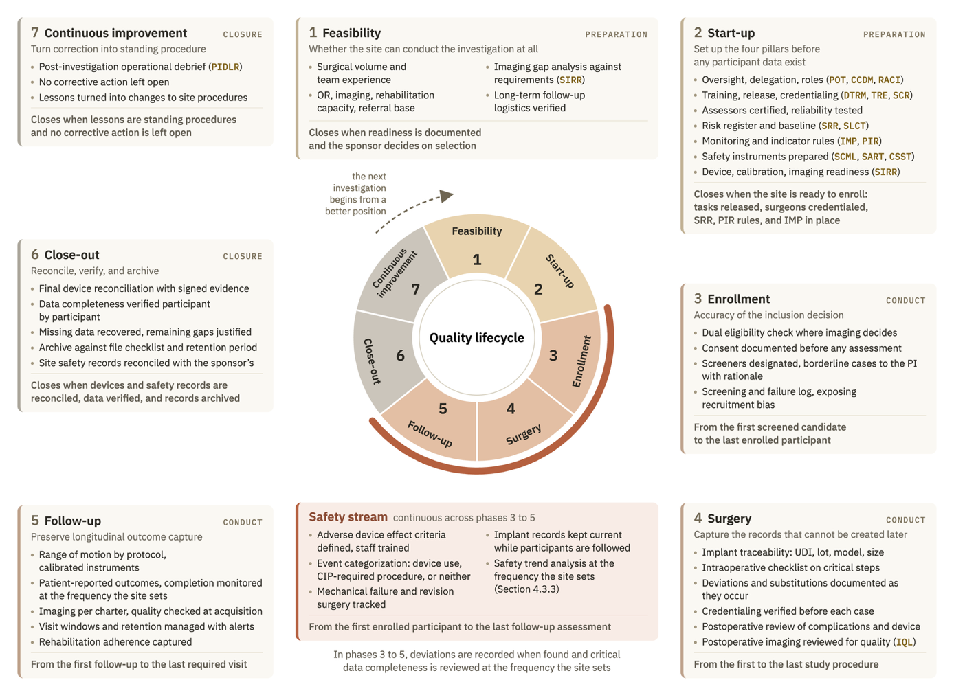
Figure 4.1. The quality lifecycle. Seven phases in three groups, with the safety stream running across the phases of conduct; each phase shows its objective, its main actions and checks, and its exit condition.

4.6.2 Where each instrument acts
Fifteen of the twenty-four instruments act during start-up (Figure 4.2). Although this phase produces almost no participant data, it establishes the conditions under which the subsequent data will be collected. Training and credentialing decisions are completed, the risk register is opened, and imaging readiness is assessed. The site also fixes the rules for most other instruments, including criticality grades and indicator thresholds, before enrolling the first participant. Participant records open in the phase where their data arise, while indicators and complication reviews become more informative as cases accumulate. Milestone reviews extend across every phase, and the debrief is used only in the final phase, continuous improvement.
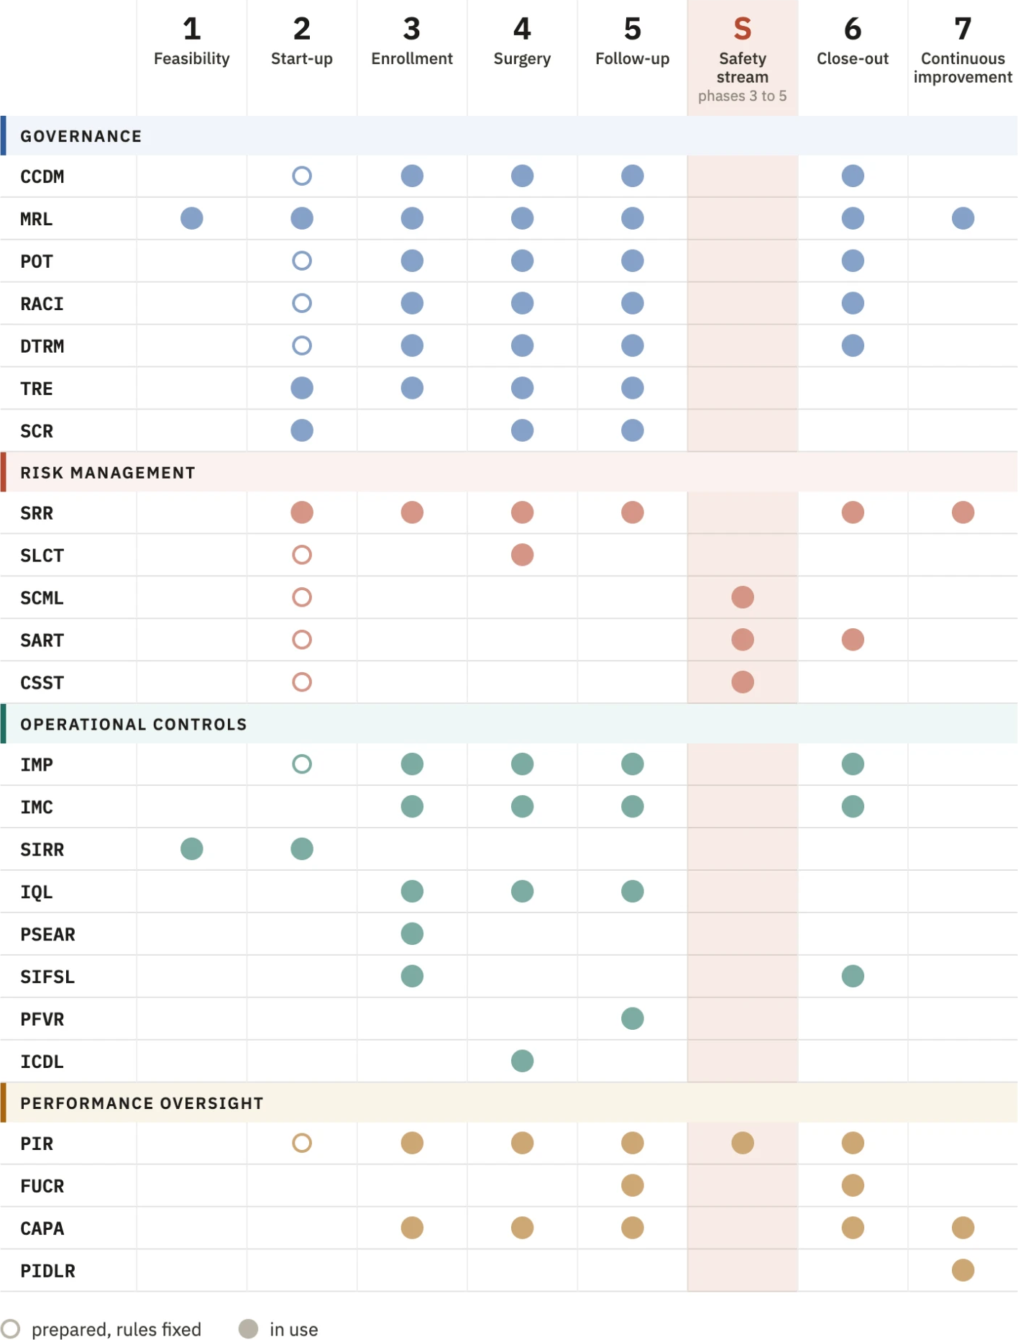
Figure 4.2. Use of the twenty-four instruments across the lifecycle phases. Open marker, instrument prepared and its rules fixed; filled marker, instrument in use.
Within start-up, preparation follows the dependencies between instruments. Training requirements and criticality grades must be defined before anyone is released for a task, and release on device training must precede the credentialing decision that uses it. The site also sets the plan for internal verification before the first review.
The framework specifies four timing requirements that the instruments compared in Chapter 3 do not impose. For Gap 2, the risk register opens before the first participant, while the site can still assess local risks before exposure occurs. For Gap 3, the learning curve log has a defined basis of comparison before the first case and begins with each surgeon's first procedure, including surgeons who join during conduct. Internal verification has its scope and schedule set before conduct, either in its plan or on its checklist, so the site can review its work independently of sponsor visits (Gap 4). Finally, the rule for each indicator in use is fixed before the first participant, allowing a signal to initiate corrective action before an external finding does (Gap 5).
The evidence provides some support for attending to particular phases. Surgical complications may cluster early in a surgeon's learning curve²², and loss to follow-up accumulates over later years²⁴. These findings do not establish that sites using controls organized by phase perform better than sites responding to sponsor monitoring. The phase structure therefore remains a design hypothesis, consistent with the direction in ICH E8(R1) to focus quality resources on critical activities and risks.

4.7 The scalability model
We designed the framework for a nonhospital organization, whose conditions define the minimum implementation level. However, hospitals hosted 239 of the 347 site records in the registry sample (68.9%), so the framework also needs to accommodate the settings in which most of these investigations take place. The scalability model answers DR12 by adapting implementation to the center's resources and the risk of the investigation while maintaining a complete and consistent documentation trail. Proportionality to risk follows ICH E6(R3), while adapting to resources is a choice of this design, acceptable only while the required evidence remains available at every level.
The number of instruments in use varies between levels, while each instrument retains the same form. The three levels follow the organizational environments in Table 3.3 and the support the framework can reasonably assume in each. Where the site does not use a separate instrument, an existing record takes on its control function. Table 4.2 identifies this proxy for each instrument omitted from a minimum set. The recommended minimum is twelve instruments for a nonhospital organization, eighteen for a nonacademic hospital, and all twenty-four for an academic organization. A site with capacity to use more should do so, and investigation-specific risks may require additions to its minimum set.
At the minimum level, the clinical staff also perform the research work, without the support of a hospital system or university. The twelve instruments of this level (Table 4.2) cover the site's existing duties and provide at least one response to each gap.
In these small teams, one person may hold several of the six functions, but each function has a named substitute so that no CtQ function depends on one individual. Where the separation required by DR10 cannot be fully achieved, the operational constraint in Section 3.5 takes precedence. Even so, the person reviewing work must be different from the person who performed it, and reviews must follow the frequency the site fixed at start-up, including the review of safety cases.
A nonacademic hospital provides services such as radiology and controlled storage, with more people available to share review duties. Its recommended minimum rises to eighteen instruments. The six additions support work that requires time for analysis and planning: the learning curve log, the complication log and its separate signal review, the internal monitoring plan, the performance indicator record, and the corrective action log. With these additions, each gap in Table 3.1 has the full response specified by the framework.
In an academic organization, the hospital also has university support and may already have a research unit and an institutional quality system. All twenty-four instruments are recommended at this level. The six additions give larger teams a more formal structure through the graded delegation matrix, milestone review log, training requirements matrix, and records of imaging readiness, screening, and visits. Where the institution already keeps training records or a corrective action system, the instruments refer to it, as DR11 requires. They add the information needed to follow the named surgeon, device, and investigation where the institutional system does not already provide it. The services available from clinical trial units nevertheless vary^{101,102}.
Table 4.2. Scalability model: recommended minimum set of instruments at each implementation level and the proxy that takes on the function of each instrument left out.
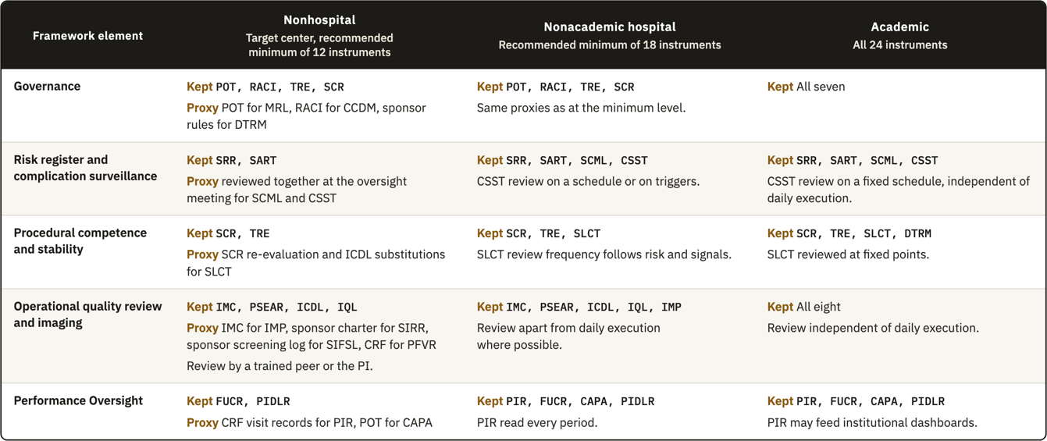
Organizational category alone does not establish research capacity. In one survey, stakeholders from higher-level hospitals performed better on average, but substantial room for improvement remained¹⁰³. Hospitals and academic centers also report shortages of staff and infrastructure (Section 3.4.4). The levels therefore provide an initial assumption about support that the site must check against its actual conditions. A site lacking the support assumed for its category uses the set of the level below, while a nonhospital organization with its own research capacity may use a higher level. The PI records the choice at the review that closes start-up and revisits it when capacity changes, for example after the departure of the coordinator.
Within each level, the site adds instruments for domains rated as high risk in the risk register. Strong operator dependence, such as that associated with a new implant design or technique, calls for the learning curve log. Limited classification reliability calls for the imaging and training controls of the higher levels, while prolonged follow-up calls for closer review of retention. A nonhospital site investigating a new implant design would therefore add the learning curve log to its twelve instruments. If the required controls exceed its capacity, the site must obtain support from the sponsor, such as proctoring, or decline the investigation at feasibility.
Every implementation level must retain the evidence needed to show that the investigation was conducted as required. Because the MDR requires Member States to inspect investigation sites, records must remain complete, consistent, current, and retrievable even at the minimum level. The records required by ISO 14155:2026 and the MDR remain necessary across implementation levels and degrees of risk, including consent and source documents, delegation and training, device accountability, deviations, and adverse events. The framework specifies where these records are kept, and the instruments in use retain their operating rules: the risk register covers all twelve domains, and the intraoperative record is completed during the procedure.

4.8 The operational instrument set
The regulatory texts examined do not require the site to operate a quality system (Gap 1). Section 3.5 therefore established the need to justify each part of the framework through its origin, and Sections 4.2 to 4.5 have done so for the individual instruments (Table 4.3). Adoption also requires a reason to use the instruments together. A site already keeps many records, yet a recurring problem can remain unnoticed within them. For example, an unplanned component substitution may appear in both the operative note and the device accountability record and recur in later cases before anyone reviews the records together. The framework must therefore connect the records to decisions, with a control for each domain and a stated reason for including each instrument.
The instruments work at three levels (Figure 4.3). At the event or person level, the ICDL records one procedure and the TRE records one person's training and release. At the next level, the site reviews several records together, using instruments such as the learning curve log for a surgeon or the follow-up review for a period. These reviews inform decisions about site conduct, documented at the third level in instruments such as the delegation matrix and risk register. A resulting decision then sets a condition against which subsequent work is checked.
The component substitution illustrates how these levels connect in a site using the full set. The event is recorded in the ICDL during surgery, then reviewed alongside the surgeon's other cases in the learning curve log and reported in the procedural consistency indicator for that period. If the review confirms a pattern, the PI records a decision in the POT. That decision may change the surgeon's authorization to require proctoring, which is documented in the credentialing record and checked in the ICDL for subsequent procedures. The sequence begins under Operational Controls, is reviewed under Risk Management and Performance Oversight, and leads to a decision under Governance. We designed the instruments after defining the functions of all four pillars so that these exchanges could be built into the set.
Table 4.3. The twenty-four instruments by pillar, with their purpose, inputs and outputs, and the section and appendix where each is developed.
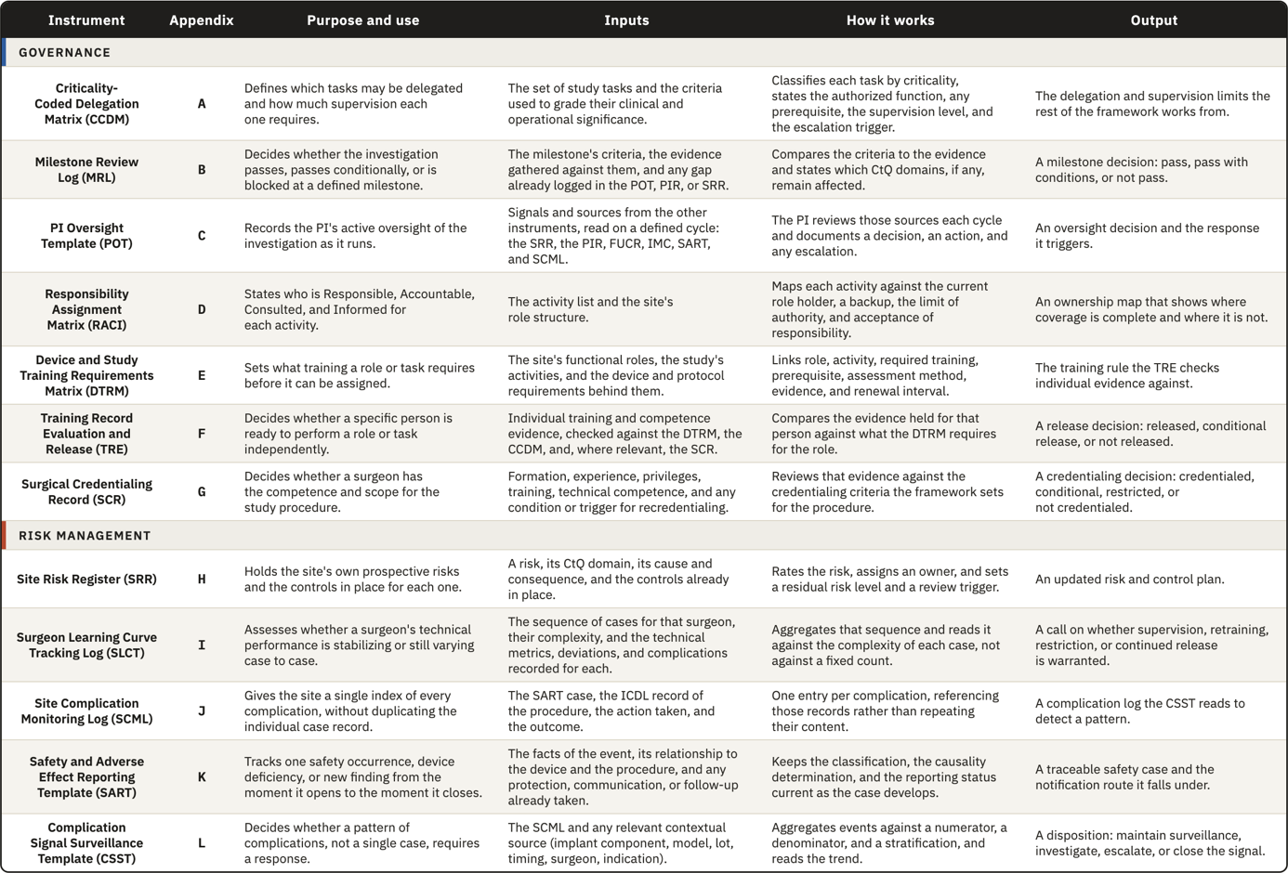
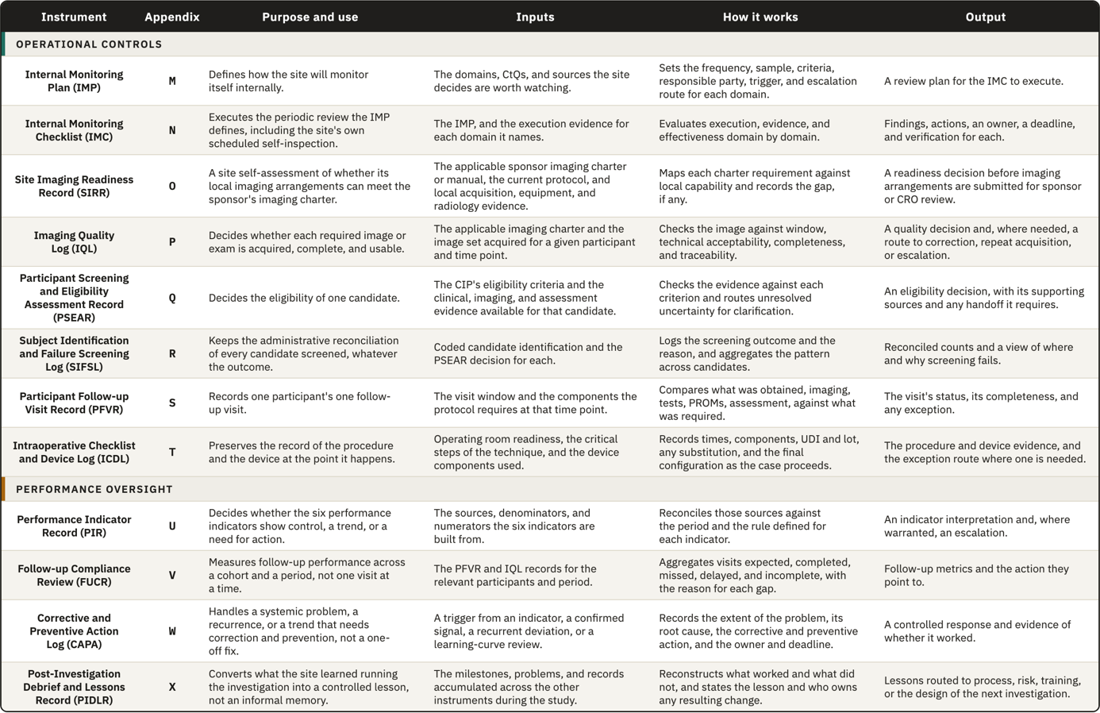
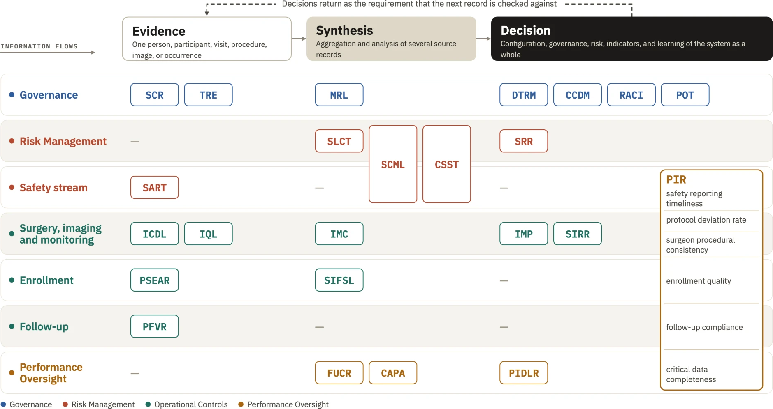
Figure 4.3. Levels at which the instruments work, from the record of one event to decisions about how the site runs. Arrows show information moving from evidence to decision, and decisions returning as the condition against which the next record is checked.

Five instruments require recording at the clinical encounter: the PSEAR, ICDL, IQL, PFVR, and SART. They cover the points where Chapter 3 identified data that cannot be recovered once lost. The other nineteen use existing records, either these five or the site's clinical records, which follows DR11 and the rule on source documentation. Four of the five clinical records remain as instruments at every implementation level, so the underlying evidence remains when the site uses fewer instruments for synthesis (Section 4.7). The time required for the periodic work of the other nineteen instruments has not been measured in a small team.
Coverage has to be checked against both the CtQ domains and the design requirements (Figure 4.4). Every domain has at least one instrument that carries its control. Some of these instruments do not answer a design requirement on their own, but are needed to perform the underlying work, as the training and credentialing records do for domain 6 and the visit record does for follow-up. Checking the set only against the requirements would miss these control records.
The requirements identify a further need to assess whether those controls work. The PIR and FUCR meet DR8 by providing indicators of drift, using information recorded by other instruments. A check based only on domain coverage would miss this measurement function. Across the full set, each requirement that can be met by an individual instrument has a direct response, and each instrument either carries a domain's control or directly answers a requirement. DR9, DR11, and DR12 concern the set as a whole. DR9 is met by assigning instruments to phases (Figure 4.2), while DR11 and DR12 concern use within the site's documentary system and the retention of required records at each implementation level (Table 4.2).
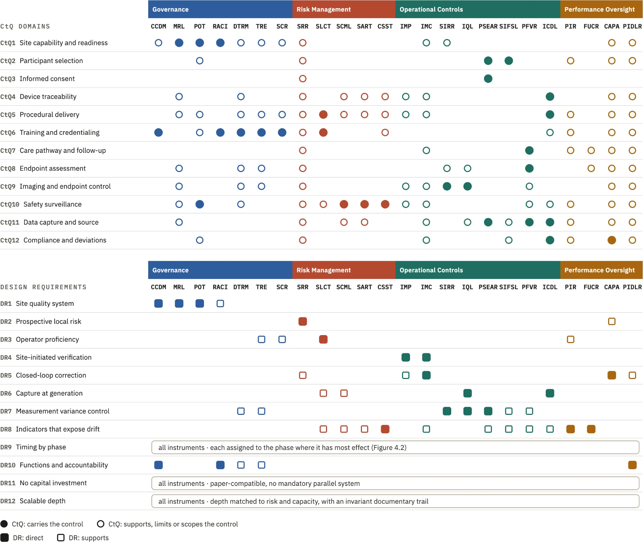
Figure 4.4. Coverage of the twelve CtQ domains and the twelve design requirements by the twenty-four instruments. Filled marker, the instrument carries the control or answers the requirement directly; open marker, it supports a control or answer carried by another instrument. DR9, DR11, and DR12 apply to the set as a whole.
Domains 5, 6, 8, and 9 depend wholly or partly on requirements that the regulatory texts examined do not assign to the site. Their controls are provided through site instruments, including the credentialing record, learning curve log, ICDL, and imaging records. Most of these instruments directly meet requirements derived from the four domains in Section 3.5 and provide controls beyond the duties assigned to the site in those texts. In the other domains, the framework mainly organizes existing duties, such as delegation and adverse event reporting. Additional controls in these domains also follow a requirement derived in Chapter 3, as the review of complication patterns follows DR8.
Within this mapping, consent is covered by the eligibility record because the regulations already specify the consent process and Chapter 3 identified no additional design requirement beyond the risk register. Endpoint assessment has more limited direct coverage. The visit record documents the assessment and is reviewed through the follow-up instrument, while assessor qualification and consistency are covered in the training records. When endpoints depend on readings that vary between observers, the site therefore adds the DTRM according to the risk register, as described in Section 4.7.
The design establishes how records are intended to connect and why each instrument is included. Whether a site reviews those records in time to act depends on the people doing the work and the time available to them, which the mapping cannot establish.
Draft templates for all twenty-four instruments are provided in Appendices A to X. We developed them for shoulder device investigations, with that context reflected mainly in complication categories, imaging requirements, and the case complexity levels used in the learning curve log. We kept their structure, including fields and escalation rules, as general as the context allowed.
The templates are a starting point that each site is expected to edit. What has to be kept is the control function of each instrument and the path by which its records reach a review and a decision, while the fields, layout, thresholds and review intervals can change. Within one site, the instruments can be adjusted from one investigation to the next to follow the CIP and the risks identified for it. A site with its own QMS can rewrite them in the format its procedures require, merge them with documents it already keeps, add fields and data, or calculate its indicators with other statistical methods. The instruments are connected through the information each one passes to the next (Figure 4.3), so a change to the content of one template leaves the set working as long as the information used by the next instrument is still recorded. Editable versions of all templates are available in the repository described in Section 2.5.2.

5. Discussion

5.1 What the thesis set out to do and what it delivered
The main contribution of this thesis is a quality framework that the investigational site runs for itself during conduct, derived from ICH E6(R3), ISO 14155:2026, and MDR Annex XV^{8,10} and fitted to the site with the least support. Conducting an investigation well and showing that the site controlled its conduct are separate achievements. Under the older arrangement the sponsor assured quality through monitoring visits and source data verification, together with audit, and held the evidence that the conduct had been controlled, so the site needed no account of its own processes. ICH E6(R3) now asks the investigator to put processes in place and to make sure that qualified staff and adequate resources support quality at the site⁶, without saying what the site should produce to show it. A party that shares responsibility for quality has to be able to show how it carries its share, and the framework gives the site the means to do so. The thesis delivered this framework as a design, with each component traced to the analysis that produced it, and whether it improves conduct in a real site is a question the thesis prepared and did not answer.
The framework asks the site to act as a quality agent in its own right. The sponsor still designs the investigation and decides what is measured, and the site still executes the protocol. In a multicenter investigation, however, the sponsor cannot assess the specific risks of each site and build controls for each of them. Some of the most consequential risks are local, such as the way a team captures implant identifiers or positions a shoulder for imaging, together with each surgeon's progress through the first cases. The site is the only party that sees these risks as they arise. Every quality activity above it, from the sponsor's planning to central monitoring, rests on the conduct the site performs, and neither planning nor monitoring can recover data that were badly produced at the base. A site without a quality structure depends on what the sponsor asks and corrects its errors after someone else detects them, while a site with one can anticipate part of its failures and prevent them. Responsibility in this sense is a proactive role, in which the site understands the weight of its actions and keeps improving them, while final responsibility for the investigation stays where the regulations place it. We found no published framework that gives the site this role in device investigations, although the successive revisions of ICH guidance point toward sites being asked to show it.
The plan described a comparison of texts and the requirements drawn from it, followed by a framework that answered them, but the design needed more than that. Placing the controls against the course of an investigation showed that the moment of a control matters as much as its content, because an error made while an implant is fixed cannot be corrected afterward, and this led to the lifecycle. The registry analysis then showed that nonhospital organizations hosted almost a third of the site records, so the framework had to work first where it could assume the least support, which produced the scalability model and its minimum level. Finally, a set of records turned out to be insufficient on its own, since a problem can sit unnoticed in several records that nobody reads together. The instruments were therefore built to pass information from the record of one event to a decision about how the site works. None of these elements was among the objectives, and they are what turns a list of instruments into something a site can run.
The observation of the surgeon during conduct delivered less than we hoped, because it is the most original part of the framework and also the part with the weakest derivation, since no clause asks for it. The indicators have rules and thresholds that are provisional, because we found no published values for site-level indicators of this kind. In hindsight, the order of the work also left a mark on the result. We derived the requirements and designed the full set of instruments before the scalability model was settled, and the minimum level was then obtained by removing instruments and naming proxies for them. A design that started from the minimum level and added instruments as capacity grew would probably have produced a smaller and more economical set.
Gregor and Hevner classify a design contribution by how mature its problem and its solution are, and they call the transfer of a known solution to a new problem an exaptation¹⁰⁴. Most of the framework is a contribution of this kind. A documented quality system is an established solution, run by the manufacturer under ISO 13485:2016 and ISO 14971:2019 and by the medical laboratory under ISO 15189:2022^{52–54}. The problem is recent, since the revised guidelines give the site a larger share of the responsibility for quality without a structure to carry it. For four of the five gaps, the framework takes a principle that the texts state for the sponsor, such as the risk management cycle or continuous improvement, and builds the site-level instrument that the texts leave out. A regulator could derive each of these four duties from duties the site already holds, so in these areas the framework adds organization to obligations that already exist.
Observation of the surgeon during conduct, which answers the third gap, is a contribution of another kind. ISO 14155:2026 allows the sponsor to justify a roll-in phase in the CIP, and the surgical trials literature controls the operator at entry, but none of the texts we compared gives the site a role once the investigation has started. In Gregor and Hevner's terms this part is an improvement, a new solution to a problem the field already knows, and its justification rests on an argument. When the CtQ logic required by the texts is applied to an intervention delivered by a person whose execution changes over time, operator learning becomes a threat to data validity. A qualification at entry cannot control it, because it records a state at one moment while learning unfolds as a trajectory.

5.2 Position in the literature
The works we reviewed address four themes that bear on the framework (Table 5.1), and the text below discusses those that shaped the design.
Table 5.1. Prior work on quality in clinical investigations, grouped by theme, with the response of the framework to each theme.
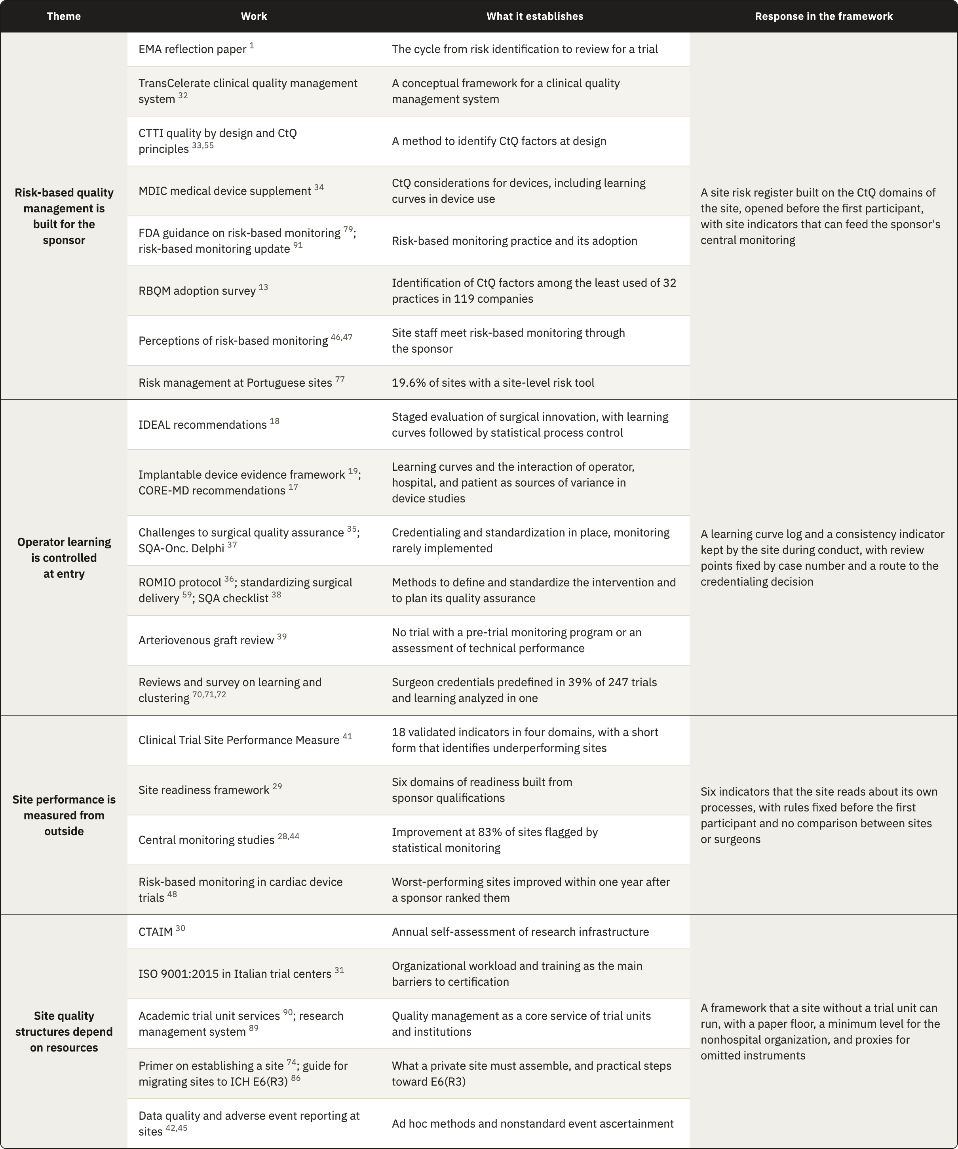
Risk-based quality management was developed for the party that designs and oversees a trial. The EMA reflection paper and the CTTI principles describe how a sponsor identifies critical factors and directs its oversight toward them^{1,55}, and the MDIC supplement carries the same reasoning to devices³⁴. Sites meet this work through the sponsor, as a monitoring plan that arrives with the protocol⁴⁶. Only 19.6% of the Portuguese sites in one survey described a tool that captured risk analysis at site level⁹⁰, and in the RBQM adoption survey identification of CtQ factors was among the least used practices even among sponsors¹³. These findings shaped the SRR, which applies the sponsor's risk cycle to the risks created by the site's own execution and starts from the CIP so that it can be built even where the sponsor never formalized its critical factors. In those investigations the site register may be the first place where anyone applies CtQ reasoning to local processes.
Surgical methodology knows operator learning well and controls it before the trial starts. The challenges reported for surgical quality assurance fall under credentialing and standardization, while monitoring during the trial is rarely implemented³⁵, and the review of arteriovenous graft trials found no trial that assessed technical performance³⁹. Among 247 randomized surgical trials, 39% predefined surgeon credentials and only one analyzed learning⁷². The IDEAL recommendations already proposed statistical process control to follow learning curves¹⁸, but they addressed the evaluation of an innovation by researchers, so the method never reached the site as a quality control. Our response is the SLCT, which keeps each surgeon's case sequence during conduct, compares each case with the same surgeon's earlier cases of the same complexity, and leads to the credentialing decision when a pattern appears. It uses a structured clinical review in place of formal process control, because a single site rarely has enough cases to set control limits.
Site performance is mostly measured by others. The Clinical Trial Site Performance Measure reduced 126 candidate indicators to 18 in six academic hospitals⁴¹, and its four domains match four of our six indicators although the two sets were built independently, which gives modest support to our domain analysis. The validated measure includes consent, which our framework covers only through the eligibility record, so a site whose register rates consent as a high risk should add a measure for it. The validated measure also identifies underperforming sites for another party, while our indicators tell one site that one of its processes has started to drift, without comparing sites or surgeons. Central monitoring shows why a signal at the site is worth having. Data quality improved at 83% of 1,111 sites flagged by statistical monitoring, against 56% in two historical studies without it⁴⁴, and in implantable cardiac device trials the worst-performing sites improved once a sponsor ranked them⁴⁸. In both cases the improvement followed a signal that reached the site from outside, and the framework places the origin of that signal inside the site, earlier in the conduct.
The few quality structures that sites hold today depend on resources. The CTAIM supports an annual self-assessment of a research program's infrastructure³⁰, and Italian trial centers that considered ISO 9001 certification reported organizational workload and insufficient training as the main barriers³¹. Academic institutions add research management systems and trial units whose senior staff rank quality management among their essential services^{101,102}. A nonhospital organization has none of this, and none of these structures carries the CtQ content of a device investigation. The framework therefore sets its minimum level in the nonhospital organization and asks for no software or dedicated staff, so that the instruments carry the quality function that an academic hospital receives from its trial unit.

5.3 Putting the framework to work
A site starts the instruments in an order set by the lifecycle and by the dependencies between them, which differs from the order by pillar that Chapter 4 used to describe them. The route below assumes the full set of instruments and notes where the minimum level differs.

5.3.1 A route through the lifecycle
1. During feasibility the site decides whether it can take the investigation. It reads the CIP together with whatever the sponsor provides on critical factors and risks, and checks each CtQ domain against its own capacity. The check covers whether radiology can produce the required views within each window and whether the surgeons have experience with comparable procedures. It also covers follow-up, which needs a coordinator for several years. The organizational category of the site gives a first estimate of its implementation level, which the site then checks against its actual staff and services. A device or technique that is new to the surgeons will lead the risk register to add the learning curve log. When the investigation requires controls beyond what the site can run, the site asks the sponsor for support, such as proctoring, or declines. Its answer informs the sponsor's judgment of the site under Clause 6.8 of ISO 14155:2026, and the decision is recorded in the MRL at the academic level and in the POT at the other levels.
2. Start-up opens with the RACI, since no task can be assigned until each of the six functions has a holder and a backup, with a limit of authority for each. When the PI also operates in the investigation, the site names at this point the person who will decide on the PI's own authorization.
3. The site then prepares and releases people in a fixed order. It sets the training each role requires, through the DTRM or the sponsor's requirements, and records each person's release in the TRE once that training is complete. Each surgeon then receives a credentialing decision in the SCR, which takes the release on device training as one of its inputs and places the surgeon in one of the four categories. Only after this do the delegation grades of the CCDM, or the limits recorded in the RACI at the lower levels, become active, so nobody is delegated a task before being released for it.
4. The SRR opens before the first participant. For each CtQ domain the site identifies the factors that its own conduct can affect and links each local risk to the factor it threatens, with a rating and a named owner. Each entry also records its control and the trigger for reassessment. In a shoulder investigation the first entries usually concern implant identifiers that may not be captured in the operating room and intraoperative changes documented too late, followed by imaging positions that are hard to reproduce and visit windows spread over a long follow-up. Because the register decides which optional instruments the site adds to its minimum set, the implementation level is confirmed only after this step.
5. Every rule is fixed before any data exist. The site defines the basis of comparison of the learning curve log, with its complexity levels and expected operative durations, and the support a surgeon receives early on. It sets the thresholds of the complication review and the rule and control values of each indicator, and it writes the scope of internal verification by choosing among the ten checks and setting their sample, together with the reviewer. The source of each critical datum is mapped at the same time, including whether the ICDL serves as the source for the intraoperative data the CIP requires. Finally, the site sets the review frequency of each instrument and the triggers that call for an earlier review. Each rule carries a date, and a later change applies only to future periods.
6. At the review that closes start-up, the PI confirms that these steps are complete and records the implementation level, together with the instruments added because of risk. By this point fifteen of the twenty-four instruments have acted, although no participant data exist yet.
7. Participant records are kept as the data arise. Each person considered enters the screening log, and each eligibility decision is documented in the PSEAR before enrollment, with a second review where a criterion depends on imaging. Image sets enter the IQL at acquisition. In the operating room the ICDL is completed during the procedure, and the learning curve log takes its case entry from it. From the operating room onward, any event opens a case in the SART and an entry in the SCML, and each follow-up visit is documented in the PFVR. Only these five records have to be completed at the clinical moment, and every other instrument reads them.
8. Internal verification runs its first review after the first inclusions, earlier than its routine schedule, and the learning curve review follows each surgeon's first cases, while the first safety review takes place soon after the first procedures. Problems of a new workflow are then found while few participants have been exposed to them.
9. An event that meets an escalation trigger in the CCDM goes to the PI without waiting for the next review, and the POT records the PI's decision.
10. At close-out the site reconciles device accountability and safety cases, and it checks the screening log against the eligibility records before a final internal review. Each corrective action closes with an effectiveness review or with a documented limitation. The PIDLR records the lessons and the standing procedures are revised, after which the instruments that outlive the investigation pass to the next one.

5.3.2 The review cycle
The instruments need a review cycle, but a single rhythm for all of them would not match the work they record. A small site that tried to review twenty-four instruments every month would barely finish one round before the next began. The framework therefore fixes a rhythm only where the risk depends on timing, and leaves the rest to the site, which knows its volume of cases and the people available. The learning curve log is reviewed at set points in each surgeon's sequence, for example after the fifth and the tenth case, because learning shows in the early cases whatever the calendar says. Safety cases are followed within the intervals the CIP sets for reporting. For the other instruments the site chooses at start-up whether a review is monthly or quarterly, or only yearly, according to how much each instrument records and how fast its content changes, and records that choice with the other rules. Periodic review also needs a complement, since a serious adverse device effect or a cluster of complications should start a review at once, and so should a protocol amendment or the departure of a key person.
When a review takes place, the oversight meeting connects the instruments, starting with safety. Open cases in the SART come first, and the CSST counts events by category and component, and by surgeon, against the number of procedures. A signal tied to a surgeon goes to the learning curve review and a signal pointing to the device goes to the sponsor through the deficiency route, while patterns in a local process enter the risk register or corrective action. The surgeons are reviewed next, because operative time can only be read once the meeting knows which cases had complications. This review may confirm stable execution or lead to closer observation and retraining, and in some cases to proctoring. A restriction returns to the SCR and passes to the delegation records, where the ICDL checks it at the surgeon's next case. The indicators and the findings of internal verification follow, and the risk register closes the agenda with the new risks and the triggers met since the last review. The PI records each decision in the POT. Corrective action opens when a first response has failed and closes when the indicator that prompted it returns under control. Figure 5.1 shows how this review cycle connects to sponsor oversight and how sponsor feedback informs subsequent site conduct.
The minimum level omits the SLCT and, with it, the instruments that review complication signals and indicators, so the meeting itself does their work. It reads the substitutions recorded in the ICDL and reviews the SART cases together, and it checks follow-up through the FUCR. The minimum level therefore depends on this recurring meeting more than on any single instrument. When meetings are missed, the synthesis that the higher levels spread across several instruments disappears, and no record shows that it is missing.

5.3.3 Where implementation is likely to fail
We applied to the framework the reasoning it asks a site to apply to its own conduct, and looked for the points where a site could operate the instruments and still lose their function. Table 5.2 lists the failures we consider most likely, in the order of the lifecycle, with what each one costs and the guard the design provides. This is our own assessment, made without data from a site, and the list is not complete.
Table 5.2. Most likely failures in operating the framework, by lifecycle phase, with what each failure costs and the guard in the design.
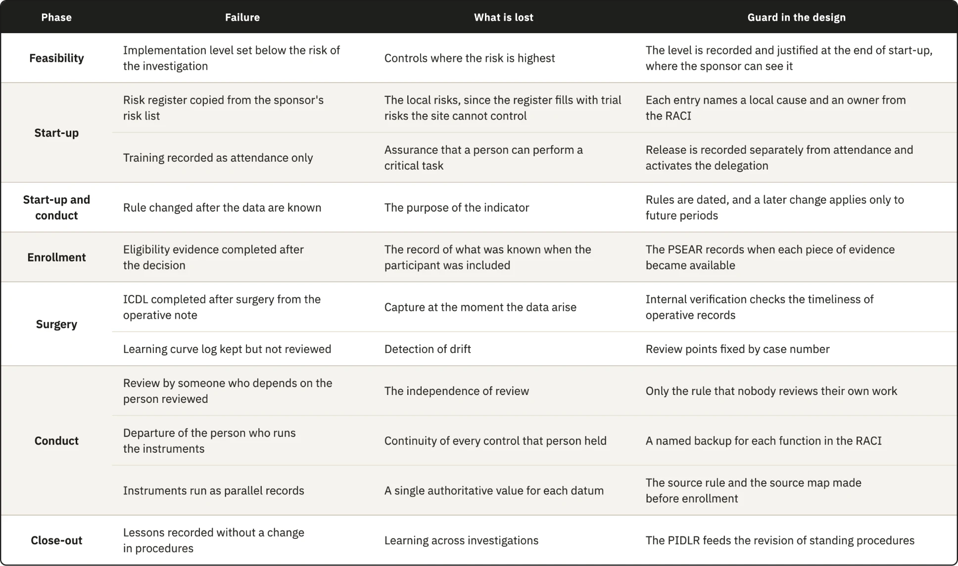
The weakest guard concerns the independence of review in a team of two. The framework only requires that the reviewer is not the person who did the work, and in a surgeon-owned practice the coordinator who reviews the surgeon's operative documentation may be the surgeon's employee. A peer from another site would give that review some distance, as would an arrangement in which two small sites review each other's records, and a sponsor's monitor could examine the internal reviews at each visit. None of these options is part of the current design.

5.3.4 What the framework is expected to change
Each instrument takes part in a chain that starts with a record made at the clinical moment and read together with other records. The synthesis supports a decision, which then becomes the condition against which the next record is checked. The value of the framework depends on that chain closing in time, which depends on the people who run it as much as on the design. Its expected effects are therefore propositions, ordered in Table 5.3 by the phase in which each effect should first appear. The conditions for refuting them are left open on purpose, because a site needs time to learn the instruments before their signals mean much, so each site should decide how many review periods or visits it will observe before judging a proposition.
Table 5.3. Expected effects of the framework stated as testable propositions, ordered by the phase in which each effect should first appear. CIP, Clinical Investigation Plan. CIP, Clinical Investigation Plan.
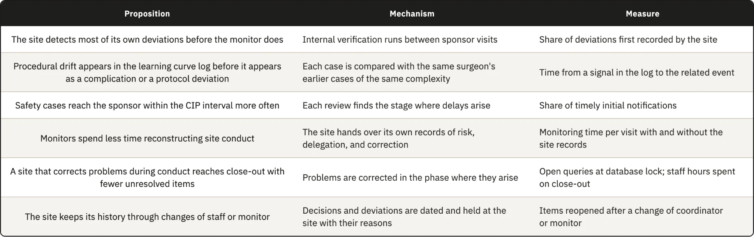
The indicators of enrollment quality and critical data completeness read a process while it runs, and so does surgeon procedural consistency. The other three indicators count events that have already happened, although each can still signal a deterioration before it reaches a participant or an endpoint. With few cases in each review period, one event is often enough to move an indicator from control to closer review or action. In the target center the indicators therefore work mainly as a scheduled review of events against rules fixed in advance, and their value comes from that schedule and those rules more than from any statistical property.

5.3.5 Does documentation improve conduct?
A site can record its conduct impeccably and still conduct itself badly, and nothing in this thesis settles whether documenting a practice improves it. The claim we can defend is narrower, since controls written for a specific activity leave fewer gaps open, so the framework acts on the probability that a failure goes undetected and says nothing directly about the quality of the conduct itself. This rests on a premise we state as such, namely that many failures in clinical investigations come from lapses and competing demands on the same person, or from the lack of a tool that makes an error visible in time. Deliberate misconduct is outside the reach of the framework, since a person who intends to misrepresent conduct can misrepresent the record as well. For the other failures, diligence cannot act on what nobody sees, and an instrument that brings a failure into view turns it into something a person can respond to.
If the framework changed nothing in conduct and its only effect were a complete and traceable record of what the site did, that outcome would still be better than the same conduct leaving no record. The record allows a case to be reconstructed years later and supports the manufacturer whose post-market obligations depend on it, although it protects a participant only when someone reviews it and acts in time.
Observation may also change behavior, since a surgeon or a nurse who knows that the work is reviewed may attend to it more closely and learn from the review which elements matter. The same pressure can lead people to satisfy the fields while the practice stays as it was. The design limits that risk, because its instruments record decisions and identifiers with their dates, so a device identifier is captured or missing whatever attention is paid to the form, and because most records are read by someone other than their author.
Documentation also has a cost, paid in the scarcest resource of the target center. Every hour a coordinator spends on a record is taken from a visit or a follow-up call, so a framework that changed nothing in conduct would have consumed what the site can least spare. For this reason the set has a minimum level, and the effort per instrument is among the first things an implementation study should measure, together with conduct itself, since records alone cannot show that a documented site conducts an investigation better than an undocumented one.

5.4 Scaling and transfer
Many of the organizations the framework was designed for have no structure dedicated to research. A private site is expected to assemble standard operating procedures and trained staff, together with the infrastructure research requires, before it enters the field⁸⁷. We assume, without data from these organizations, that few of them employ people whose only work is clinical trials, so the same people hold several functions. The surgeon is often the PI, and a nurse may also carry out the physical assessments that a physiotherapist would perform in a hospital. Some activities, such as imaging or specialized assessments, may be contracted outside the practice, so the site has to oversee work that it does not perform itself. A framework that assumed a trial unit and dedicated staff would not fit this setting, and ICH E6(R3) itself asks for quality management proportionate to risk, without unnecessary complexity. The scalability model tries to keep the essential controls in place with fewer people and fewer instruments, and to let a site add instruments as its capacity or the risk of its investigation grows.

5.4.1 The minimum level and its trade-offs
At the minimum level a site runs twelve instruments, and these cover the core of the framework. Every gap has at least one response, every record that ISO 14155:2026 and the MDR require is kept, and four of the five records made at the clinical moment remain as instruments, with the CRF serving as the visit record. Each function has a named holder and a backup, and the oversight meeting brings the records together. The level rests on a premise we could not source, namely that inspection assesses compliance through the completeness and consistency of the records, so a site with fewer instruments but a complete record carries no additional regulatory exposure. A reader who rejects the premise should also reject the scalability argument.
In exchange, the meeting at the minimum level reviews less often than dedicated instruments would, so a signal may be noticed later, and one person may hold several functions, which weakens the separation between execution and oversight required by DR10. The proxies carry a less visible cost, since the CRF and the sponsor's screening log sit in systems the sponsor controls and the site's access to them may end after close-out, leaving part of the site's history in records it will not keep. A site at the minimum level should therefore keep a copy of these records under its own control at close-out, or use the PFVR from the start when follow-up lasts several years.
In practice the minimum also depends on the stage of the investigation. The risk register adds the learning curve log for a new implant design or technique, and in a premarket investigation the device is new to every surgeon, so the rule will almost always apply and the effective minimum becomes thirteen instruments. The minimum of twelve applies mainly to investigations of devices already in the surgeon's use, such as post-market clinical follow-up. The PI who records the implementation level also carries part of the work each level adds, so a site has a reason to choose the lowest level its category allows, and only the sponsor can ask for the reasoning behind it.

5.4.2 Instruments that outlive the investigation
Chapter 4 describes the framework for a single investigation, while many sites conduct several, either at once or one after another. Some instruments belong to the site and are kept across investigations, and some keep a site structure that each investigation fills with its own content. The rest are opened again for every investigation (Table 5.4).
Table 5.4. The twenty-four instruments by persistence across investigations.
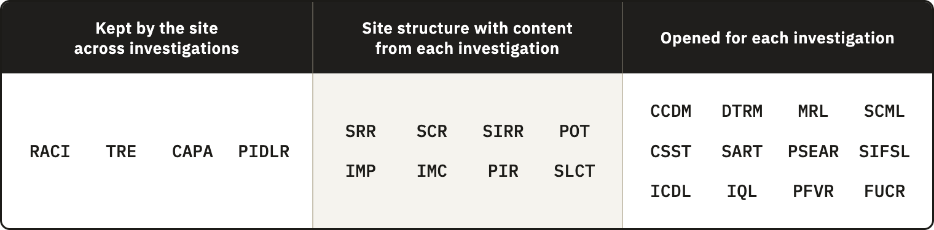
The instruments opened for each investigation are mostly records of participants and procedures, or of visits, so their effort grows with the number of cases. Site compensation is also calculated per procedure and per participant, which means that the work growing with cases is the work the site is paid for. What has no budget line is setting up the structure, and that work sits mainly in the instruments the site keeps or reuses. Fifteen instruments act during start-up, when sponsors measure how quickly a site is activated, but the cost of setting them up falls mostly on the first investigation. A site with a steady portfolio spreads that cost, whereas a site that takes one investigation every few years carries most of it each time.
A site running investigations at the same time needs one role structure and one training history, and also one corrective action log and one oversight meeting for all of them, while the participant records remain separate for each investigation. Safety reporting timeliness and critical data completeness measure site processes shared by all of its investigations, as does the deviation rate by area, so the site can pool their counts to enlarge the small denominators of a single investigation. Surgeon consistency and complication patterns depend on the device and cannot be pooled across different devices, and because each sponsor's data are confidential, pooled counts serve only the site's internal review. Because a surgeon's learning with a device continues across investigations, the learning curve log of a later investigation should start from the earlier cases where the site holds them.

5.4.3 Transfer to other specialties
Neither the MDR nor ISO 14155:2026 distinguishes a shoulder device from a knee or hip device, so the obligations behind the instruments apply across implant surgery and make transfer plausible, although they do not show it. Within the instruments, anatomical content sits in the complication categories and the imaging requirements, together with the complexity levels of the learning curve log, while their structure carries none. Spine surgery shows that specialties also differ in more than content, since one procedure may implant several components, which multiplies the traceability work and the ICDL entries per case. In robot-assisted or navigated arthroplasty part of the execution moves from the surgeon to a system, so the basis of comparison of the SLCT has to separate experience with the procedure from experience with the system. The claim stops at surgical investigations without an implant, where unit traceability does not arise, and at device investigations without surgery, where operator dependence takes another form. Applying the instrument set to the documentation of a completed hip or knee device investigation, and recording which fields had to change, would test the claim at low cost.

5.4.4 Transfer to other jurisdictions and editions
The registry places 155 of the 238 organizations in the United States, including 63 of the 68 nonhospital organizations, while the framework was designed under the MDR and ISO 14155:2026. Most of the nonhospital organizations in the sample therefore operate under another regime. The derivation is unaffected, because the regulatory analysis does not depend on the registry, but the question of how far the framework serves these organizations remains open.
Under 21 CFR Part 812, the investigator reports an unanticipated adverse device effect to the sponsor and to the institutional review board within ten working days of first learning of it¹². A site in the United States therefore has a regulatory interval for the safety reporting indicator, where a European site takes the interval from the CIP. Since the SART already takes its interval from the CIP, it adapts, and what changes are the terms and the regulatory anchors of each instrument. Neither regime prescribes how a site organizes itself, so the structure should transfer once each anchor is mapped to the corresponding provision, which we have not done.
Within the European Union, the version of ISO 14155 with a presumption of conformity under the MDR is still EN ISO 14155:2020+A11:2024⁹, while the 2026 edition represents the current state of the art. Some parts of the framework rest on clauses added in the fourth edition, such as the risk stream for clinical procedures beyond routine practice and the clinical events committee. A site working to the harmonized version can use these parts as state of the art, without the presumption of conformity that the harmonized text carries.

5.5 Implications

5.5.1 For the investigational site
For the site, the main gain is an account of its own conduct that survives changes of people. When a coordinator leaves or a monitor is replaced, or when a question settled by an earlier monitor comes back, a site with a documented framework still holds the decisions and the reasons behind them.
That account costs staff time, and the way sites are paid decides whether anyone covers it. Research payments from industry are expected to reflect the fair market value of the work performed¹⁰⁶, and site budgets are negotiated item by item with the sponsor. In one review of ten industry-sponsored trials, the final budgets exceeded the sponsors' initial proposals by 59% on average, and the costs of preparing the trial were among the items that changed most¹⁰⁷. The preparation of a trial is therefore already a negotiated budget item, and the quality records the framework asks a site to set up for an investigation are work done for that investigation. We found no report of a sponsor paying for such work, so whether it could be negotiated as part of preparation, and on what terms, remains a question for sites and sponsors to examine. Until it is answered, an avoidable error, such as a screen failure caused by an incomplete eligibility record or a missed imaging window, remains a direct loss for the site.
The site pays for the framework in staff time, while the benefits also reach other parties. The sponsor gains easier monitoring and more reliable data, and the manufacturer relies on the operating room records for traceability. The site itself loses less to avoidable errors and keeps instruments it can carry to the next investigation, and it may also gain a record that counts in future site selection, although we could not test this. A site deciding where to begin should start with the instruments that protect data that cannot be recovered, meaning the five records made at the clinical moment and the risk register, because the same records protect its revenue. A site that records a weakness also creates a record that a monitor can read, and a finding the site raised against itself is still a finding. How monitors treat such findings is not known, and it will decide whether sites are willing to keep these records.

5.5.2 For sponsors, contract research organizations, and monitors
The framework complements the sponsor’s quality system by organizing the processes through which the site conducts each investigation. The sponsor oversees quality across the trial, while the site uses the CIP, with what the sponsor communicates about critical factors and risks, to identify risks in its own work and establish proportionate controls (Figure 5.1). The framework’s structure remains with the site across investigations, while its content adapts to each CIP and to the systems the sponsor requires.
Within this interface, the instruments described in Chapter 4 provide the evidence for local assessment. The PI’s decision, recorded in the POT, may revise a risk control or initiate corrective action, and subsequent records allow the site to check whether the response worked. Signals requiring sponsor notification or assessment beyond the site are communicated with the relevant evidence and any local action already taken. The sponsor can then assess the signal across sites and communicate any resulting changes to the site’s conduct. Required reporting proceeds within its applicable timelines while local assessment continues.
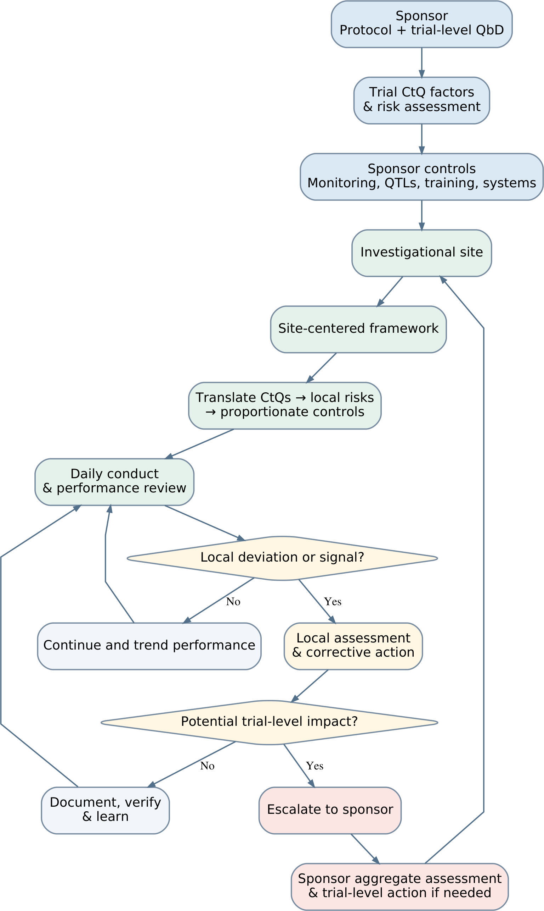
Figure 5.1. Proposed interface between sponsor oversight and the site-centered quality framework. Local review leads to correction and verification, with escalation when a signal may affect the trial. Sponsor feedback informs subsequent site conduct. Required safety reporting and urgent protective action follow their own routes and timelines. QbD, quality by design; CtQ, critical to quality; QTLs, quality tolerance limits.
At qualification, Clause 6.8 asks the sponsor to judge the qualifications of the PI and the adequacy of the site, and a site that arrives with its own risk register and oversight records gives documentary evidence on both. At a monitoring visit the same site can hand over its delegation records and corrective action log, with its indicator results, so the monitor reviews a site that has already described its own risks. Risk-based monitoring is adequate only when certain prerequisites at the site are met⁴³, and the framework builds some of them. We found no study measuring how much monitoring time this saves.
The two systems can also be aligned more closely than they are today. If the sponsor gave each site, at initiation, a summary of the critical factors and main risks it identified, the site register and the sponsor's monitoring would address the same targets. Where the CIP allows it, the ICDL can be named as the source of implant identifiers and intraoperative events, so source data verification compares the CRF with a structured record made during the procedure. The site's indicators read at one center the processes that the sponsor's key risk indicators read across the trial, and they could feed central monitoring as long as each datum keeps its source. The clinical events committee that ISO 14155:2026 allows the sponsor to establish addresses the same events as the site's complication review, at a different level, and a local action already taken is information the committee can use.
Only one of 247 randomized surgical trials analyzed learning effects⁷², partly because the case sequence of each surgeon is rarely collected. The SLCT holds that sequence with complexity and duration, so a CIP that planned for it could use the log to examine learning in the main analysis, provided the surgeon's data are protected as Section 5.5.4 describes.
Contract research organizations, to which sponsors often delegate operational conduct, bring systems and timelines designed to work across many sites. These systems govern the data that reach the case report form but cannot establish whether an image was acquired as the charter required, and the monitors they assign change during long investigations. The framework governs the production of data at their origin and keeps the site's history across those changes.
A sponsor could go further and supply templates and help set up the framework across its sites, as it already supplies the protocol and training. This would move part of the cost of construction to the sponsor, but a site working with three sponsors would then receive three frameworks and run three quality systems at once. The more stable division keeps a structure owned by the site, into which each investigation brings its content and, where the sponsor wishes, its templates, while the operation of the framework and the ownership of its records stay with the site.

5.5.3 For standards and regulators
Reading ISO 14155:2026 from the position of the site reveals points that a future revision could consider. Clause 6.2 requires the sponsor to manage risk in three streams: the use of the device, the clinical procedures required by the CIP beyond routine practice, and the conduct of the investigation. All three belong to the sponsor, and no text describes how a site handles the part of those risks that its own execution creates. Clause 9.2.4.5 p) asks monitors to verify that equipment relevant to assessment is maintained and calibrated, yet no clause describes the record through which the site shows this work, and Clause 6.12 introduces the clinical events committee without a local counterpart. These observations come from one position in a standard with a wider purpose, so a revision might reasonably leave them open.
A clause asking a site to keep a risk register would ask for one document and one review cycle, while a requirement for a site-level quality system would ask for much more. Annex XV of the MDR governs the conduct of clinical investigations and says nothing about how a site organizes itself to conduct them, and the harmonization of the fourth edition would be a natural moment to examine that question. ISO 15189:2022 offers a precedent, since it gives the medical laboratory a quality system that can be accredited, so its results are trusted by parties who never see the laboratory. A standard of this kind for investigational sites would also solve the fragmentation that sponsor-supplied frameworks create, because a site working for several sponsors would run one structure recognized by all of them. Whether sites should one day be accredited in this way is beyond what this thesis can answer. A future revision of ICH E6 or ISO 14155 could, more modestly, give the site an explicit proactive role in quality without moving final responsibility, and the framework shows one form that role could take.
No clause in the present texts requires the records this framework produces, so an inspection under the MDR would not treat their absence as a non-compliance. A site with the framework and a site without it therefore present the same regulatory surface and differ in what they can show, since only the first can show how it controlled its conduct without reconstructing it from primary documents.

5.5.4 Ethical implications
The SLCT and the consistency indicator hold performance by surgeon and can lead to a restriction of the cases a surgeon takes, so in substance they assess professional performance. A signal recorded in these instruments, or in the complication review, could follow a surgeon beyond the investigation and harm a career if it were read out of context. The framework therefore has to keep every action that results from these records, from closer observation to a restriction, within the scope of the investigation. The design codes the surgeon and keeps the key with the PI, and it fixes before the first case the outcomes that a review can reach, with the reasoning behind any restriction documented. Who may access these records, and for what purpose, also has to be defined before the first case. They are personal data of the professional and have to be handled under the data protection law that applies, which we did not analyze in detail. The indicator does not rank surgeons, since a fair comparison would need an adjustment for case mix and for clustering^{67,68} that a single site rarely allows.
In a surgeon-owned practice, the site belongs to the surgeon it observes, and the PI who decides on a restriction may be the surgeon under review or a close colleague who shares the commercial consequence. The same structure affects internal verification, where the reviewer may be the employee of the person reviewed. Every function already has a named substitute in the role structure. When the PI is the surgeon under review, the framework can therefore pass the decision to that substitute or to a party outside the site, such as the sponsor's medical monitor or the ethics committee, on a route fixed before the first case.

5.6 Evaluation, limitations, and further research

5.6.1 The evaluation this thesis performed
The Design Science Research Methodology has six activities, and this thesis reports the first three, which run from problem identification to design and development, together with the last, communication⁴⁹. Demonstration and evaluation are not reported, although the thesis did perform one kind of evaluation. The design-science literature distinguishes evaluation before an artifact is used, which tests whether the design decisions are grounded, from evaluation after its use, which tests whether the artifact works¹⁰⁸. It also separates formative evaluation, which improves a design while it is still being shaped, from summative evaluation, which judges a finished artifact. A further distinction separates artificial evaluation, carried out away from real use, from naturalistic evaluation in the setting where the artifact will run¹⁰⁹. Our traceability from each component to a requirement, and from each requirement back to its origin in Chapter 3, is an evaluation before use, formative and artificial. It is the expected first step for a design at this stage, because it checks that every part rests on a stated reason before anyone spends resources on implementation. It cannot show that the framework works in a site, because only a naturalistic evaluation can do that, and since we derived the requirements and assigned the components ourselves, the mapping is not independent evidence either. The framework should therefore move next to a naturalistic formative evaluation, in which a site uses the instruments and the design is corrected, and only then to a summative one that judges its effect.

5.6.2 Limitations
The absence of any implementation weakens every claim about effect in this chapter. The propositions of Table 5.3 remain expectations, as do the economic argument and the estimate of effort, and nobody knows how much time the instruments take in a small team. A feasibility study in one site can reduce this limitation, and the design already limits its consequence by keeping the regulatory analysis and the derivation independent of any expected effect.
Because the literature review was narrative, any statement that a body of work is absent from the field is weak, and Section 5.2 describes only the works we found and read, a position that a systematic search can test. We reduced the risk by searching the bodies of work most likely to contain a site-level framework and by reporting the closest works we found.
Our evidence on the state of site practice comes from published studies and regulatory guidance, with some expert commentary. We had no access to the internal documents of any site, from its procedures to its audit data, which weakens the claim that the failures the framework addresses are the ones that occur most often. Field research in sites of each organizational category can test that claim and calibrate the framework against observed failures.
We did not consult experts formally during the design. The framework was discussed informally with professionals working in clinical operations, and some of their criticism changed it, but these conversations were neither planned nor recorded, so they cannot count as evidence. The claim that the instruments can be completed as intended therefore rests on the design alone, until a structured content review tests it.
In the registry analysis, one researcher classified each organization from its public self-description, with a second internal pass and no independent assessor. This weakens the assignment of organizations to environments and the reproducibility of the counts in Table 3.3, which a second coder can test. The registry is also weighted toward the United States, while the framework was designed under the MDR. Since the regulatory analysis does not depend on the registry, the inference that weakens is the one from the organizational profile of the sample to European sites, and a registry analysis based on European data, which Eudamed did not provide, would test it.
Some choices of this thesis are delimitations, made on purpose: the focus on the shoulder and on the European regulatory framework, and the choice of the nonhospital organization as the design case. They set the scope of the claims, and Section 5.4 discusses how far the claims can travel beyond them.

5.6.3 Further research
The framework has completed the development phase of a complex intervention, and the phases that follow, from feasibility to implementation, do not have to come in strict order¹¹⁰. The shortest next step is the demonstration activity of the DSRM, which needs no participants. Running the full set through a simulated or retrospective case series, from feasibility to the lessons record, shows whether the instruments connect as the design intends and whether any record lacks a reader.
A content review by sites and monitors, with surgeons included, and a usability test of the templates should come next, because an instrument that nobody can complete correctly cannot be evaluated for anything else. A feasibility study in one nonhospital organization and one hospital can then run the minimum set through a complete investigation. It should measure staff time per instrument, separating the work done once from the work that grows with cases, and compare the completeness of the records with a defined checklist. The share of deviations that the site detected before the monitor did shows most directly whether the framework does what it claims.
Before-and-after comparisons at one site are likely to report an improvement whatever the framework does. In surgical oncology, 86 of 97 non-randomized studies of quality improvement reported a positive effect, against 2 of 12 randomized trials⁴⁰, so the evaluation of effect needs a concurrent comparison. A sponsor could introduce the framework in its sites in a staggered order within one investigation, letting the sites that have not yet started serve as comparators. Where that is not possible, a site could follow its indicators over a long series before and after adoption, as the IDEAL recommendations propose when randomized designs are not feasible. A sponsor-led design of this kind also tests whether a sponsor can supply templates while the site keeps the operation and ownership of its records.
Indicator validation needs another design, because an investigation spread across several centers leaves each center with few cases over several years. It can instead draw on existing records, since a retrospective study can pair historical values of the indicators with the events that followed them, and pooling the records of several centers of one sponsor provides the volume that one site cannot. Query backlog and reporting timeliness can be recovered from most trial databases, while operative time by complexity level is available only where the site recorded the level.
Mapping each instrument to 21 CFR Part 812 would test the transfer to the regime under which most of the nonhospital organizations in the registry operate, again without a new investigation.

6. Conclusion
This thesis advances a site-centered approach to quality management in shoulder medical device clinical investigations. Its central proposition is that the practical application of Quality by Design (QbD) requires an explicit connection between the quality objectives established for an investigation and the processes through which individual sites deliver them. The framework developed here gives that connection an operational structure, enabling the site to identify risks within its own activities, assign responsibility for their control, and use the experience of conduct to inform subsequent decisions.
The analysis identified an asymmetry in the material reviewed: most of the attention has gone to how sponsors design, oversee, and assess investigations, while less operational guidance supports how sites organize and evaluate their own contribution to quality. Sponsor oversight remains essential, but its effectiveness also depends on what happens locally. It cannot continuously observe every clinical decision, anticipate every weakness in a local workflow, or reconstruct information that was never adequately captured. These limits support a more explicit role for the site in applying risk assessment and protecting critical-to-quality (CtQ) factors. The domains proposed in this thesis provide a structure for that assessment, through which each site can consider how its own conduct affects the factors that matter to a particular investigation.
The contribution of the work lies in bringing established quality-management principles into a coherent structure that the site can operate and retain across investigations. The framework connects local observations to review, decisions, and subsequent verification, giving practical form to responsibilities that are otherwise distributed across different requirements and records. In surgical device investigations, this also creates a place for examining operator-dependent risks during conduct, when performance may continue to change despite qualification before the first case. By making these relationships explicit and tracing design choices to their underlying rationale, the thesis provides a concrete proposal that others can examine, adapt, and evaluate.
This approach may anticipate a future in which investigational sites are expected to demonstrate more explicitly how they manage the quality of their own processes. As QbD and risk-proportionate quality management develop, greater attention to the organizational conditions under which sites apply these principles would be a plausible extension. Such a development would require practical support and recognition of the resources involved, especially in centers where clinical care and research depend on the same staff. Whether site-level quality arrangements should eventually become formal requirements requires wider discussion and empirical evidence. The present framework contributes to that discussion by showing how a proactive site role could be structured alongside sponsor oversight.
The contribution remains at the level of a theoretically grounded design. The framework has not been implemented in an investigational site, and its development lacked systematic observation of daily workflows and formal consultation with intended users. These limitations leave important questions about feasibility, workload, and the usefulness of individual controls unresolved. Closer engagement with site teams could reveal demands that were underestimated or simpler ways of performing the proposed functions. Establishing a traceable design nevertheless provides a necessary basis for this work: its assumptions are visible, its intended mechanisms can be examined, and its components can be revised against experience.
Adaptability is therefore central to the proposed instruments. Their open, editable format is intended to accommodate different staffing arrangements, existing records, and investigation-specific risks. Practical evaluation should determine which elements deserve to be retained, simplified, combined, or removed, while preserving the quality functions they serve. Additional detail should be introduced where it improves a decision or addresses a demonstrated need. The framework can consequently develop through successive iterations, with its scope and demands adjusted to what sites can sustain and what participant protection and reliable evidence require.
Further development could also extend its analytical and technological capabilities. Data collected during implementation could support the refinement of indicators, the calibration of review thresholds, and statistical analysis where the number and comparability of observations permit it. Digital implementations could facilitate data capture, link existing records, automate routine calculations, and support the exchange of relevant information with sponsors. These developments should follow an understanding of how the instruments function in practice, so that technology supports workable processes and reduces avoidable effort. The current design offers a basis from which such capabilities can be developed progressively.
Although the framework was developed for shoulder device investigations, its broader ambition is to contribute to clinical research in which sites are supported as active participants in quality management. Its relevance to other specialties and settings remains to be established through adaptation and evaluation. The underlying proposition has wider significance: efforts to improve the quality of clinical investigations should include the capacity of the organizations where participants receive care and evidence is generated. By giving that proposition a theoretical foundation and an explicit operational form, this thesis establishes a starting point for developing site-centered quality systems through practice, with the aim of strengthening participant protection and the reliability of clinical evidence.

References
- European Medicines Agency. Reflection paper on risk based quality management in clinical trials. London: European Medicines Agency; 2013 Nov. Report No.: EMA/269011/2013.
- Bhatt A. Quality of Clinical Trials: A Moving Target. Perspectives in Clinical Research. 2011;2(4):124–8. doi:10.4103/2229-3485.86880 PubMed PMID: 22145122; PubMed Central PMCID: PMC3227329.
- International Council for Harmonisation of Technical Requirements for Pharmaceuticals for Human Use. ICH harmonised guideline: Integrated addendum to ICH E6(R1): Guideline for Good Clinical Practice E6(R2). Geneva: ICH; 2016.
- Bharati V, Rajaram S, Prakash A, Medhi B. International Council for Harmonisation E6 (R3): The Good Clinical Practice, Recent Developments, and Global Perspective. Indian Journal of Pharmacology. 2025;57(1):1–3. doi:10.4103/ijp.ijp_152_25 PubMed PMID: 40324824.
- International Council for Harmonisation of Technical Requirements for Pharmaceuticals for Human Use. ICH harmonised guideline: General considerations for clinical studies E8(R1). Final version, Step 4, adopted 6 October 2021. Geneva: ICH; 2021.
- International Council for Harmonisation of Technical Requirements for Pharmaceuticals for Human Use. ICH harmonised guideline: Guideline for Good Clinical Practice E6(R3). Final version, Step 4, adopted 6 January 2025. Geneva: ICH; 2025.
- Muet F. Rethinking good clinical practice: A shift from guidelines to governance in ICH GCP E6(R3). Regulatory Affairs Watch. 2025;7(10):4–10. doi:10.54920/SCTO.2025.RAWatch.10.4
- International Organization for Standardization. ISO 14155:2026. Clinical investigation of medical devices for human subjects—Good clinical practice. 4th ed. Geneva: ISO; 2026.
- European Commission. Commission Implementing Decision (EU) 2026/193 of 28 January 2026 amending Implementing Decision (EU) 2021/1182 as regards harmonised standards for medical devices. Official Journal of the European Union. 2026 Jan 30;L 2026/193.
- European Parliament, Council of the European Union. Regulation (EU) 2017/745 of 5 April 2017 on medical devices. Official Journal of the European Union. 2017 May 5;L117:1–175.
- United States Congress. Federal Food, Drug, and Cosmetic Act, 21 USC ch. 9 (1938, as amended).
- Electronic Code of Federal Regulations. Title 21, Chapter I: Food and Drug Administration; Parts 312 and 812 [Internet]. Washington (DC): U.S. Government Publishing Office [cited 2026 Sep 20]. Available from: https://www.ecfr.gov/current/title-21/chapter-I
- Florez M, Dirks A, Sullivan L, Young S, Getz K. Adoption Maturity Model for Risk-Based Quality Management (RBQM) in Clinical Trials. Therapeutic Innovation & Regulatory Science. 2025;59(3):549–57. doi:10.1007/s43441-025-00746-6 PubMed PMID: 39953206.
- Fuson RL, Sherman M, Van Vleet J, Wendt T. The Conduct of Orthopaedic Clinical Trials. The Journal of Bone and Joint Surgery American Volume. 1997;79(7):1089–98. doi:10.2106/00004623-199707000-00019 PubMed PMID: 9234889.
- Jalbert JJ, Ritchey ME, Mi X, Chen CY, Hammill BG, Curtis LH, et al. Methodological Considerations in Observational Comparative Effectiveness Research for Implantable Medical Devices: An Epidemiologic Perspective. American Journal of Epidemiology. 2014;180(9):949–58. doi:10.1093/aje/kwu206 PubMed PMID: 25255810.
- Buccheri S, James S, Mafham M, Landray M, Melvin T, Oldgren J, et al. Large Simple Randomized Controlled Trials—from Drugs to Medical Devices: Lessons from Recent Experience. Trials. 2025;26(1):24. doi:10.1186/s13063-025-08724-x PubMed PMID: 39833917.
- Fraser AG, Buccheri S, Byrne RA, Kjaersgaard-Andersen P, James S, Jüni P, et al. Recommended Methodologies for Clinical Investigations of High-Risk Medical Devices—Conclusions from the European Union CORE–MD Project. The Lancet Regional Health – Europe. 2025;58:101460. doi:10.1016/j.lanepe.2025.101460 PubMed PMID: 41262422.
- McCulloch P, Altman DG, Campbell WB, Flum DR, Glasziou P, Marshall JC, et al. No Surgical Innovation without Evaluation: The IDEAL Recommendations. The Lancet. 2009;374(9695):1105–12. doi:10.1016/S0140-6736(09)61116-8 PubMed PMID: 19782876.
- Sedrakyan A, Marinac-Dabic D, Normand SLT, Mushlin A, Gross T. A Framework for Evidence Evaluation and Methodological Issues in Implantable Device Studies. Medical Care. 2010;48(6 Suppl):S121–8. doi:10.1097/MLR.0b013e3181d991c4 PubMed PMID: 20421824.
- Avendano JP, Sudah SY, Gencarelli P, Imam N, Manzi JE, Ghajar M, et al. The Learning Curve for Anatomic and Reverse Total Shoulder Arthroplasty: A Systematic Review. JSES Reviews, Reports, and Techniques. 2023;3(2):150–9. doi:10.1016/j.xrrt.2022.12.001 PubMed PMID: 37588447.
- Daher M, Ilyas MH, Gonzalez-Morgado D, Steinmann SP, Abboud JA, Kassam HF. Defining Surgeon Experience Thresholds for the Reduction in Complications and Revisions after Shoulder Arthroplasty: A Meta-Analysis of 332,542 Patients. Journal of Shoulder and Elbow Arthroplasty. 2026;10(1–2):100020. doi:10.1016/j.jsea.2026.100020 PubMed PMID: 42182085.
- Taniguchi S, Hirakawa Y, Manaka T, Nakazawa K, Ito Y, Terai H. Assistant Experience Enhances the Learning Curve in Reverse Total Shoulder Arthroplasty: A Comparative Cumulative Sum Analysis of 3 Surgeons. Journal of Shoulder and Elbow Surgery. 2026;35(11):2763–70. doi:10.1016/j.jse.2026.06.020 PubMed PMID: 42398667.
- Somerson JS, Bartush KC, Shroff JB, Bhandari M, Zelle BA. Loss to Follow-up in Orthopaedic Clinical Trials: A Systematic Review. International Orthopaedics. 2016;40(11):2213–9. doi:10.1007/s00264-016-3212-5 PubMed PMID: 27142421.
- Torrens C, Martínez R, Santana F. Patients Lost to Follow-up in Shoulder Arthroplasty: Descriptive Characteristics and Reasons for Loss to Follow-up. Clinics in Orthopedic Surgery. 2022;14(1):112–8. doi:10.4055/cios21034 PubMed PMID: 35251548.
- Sidor ML, Zuckerman JD, Lyon T, Koval K, Cuomo F, Schoenberg N. The Neer Classification System for Proximal Humeral Fractures: An Assessment of Interobserver Reliability and Intraobserver Reproducibility. The Journal of Bone and Joint Surgery American Volume. 1993;75(12):1745–50. doi:10.2106/00004623-199312000-00002 PubMed PMID: 8258543.
- Shukla DR, McLaughlin RJ, Lee J, Cofield RH, Sperling JW, Sánchez-Sotelo J. Intraobserver and Interobserver Reliability of the Modified Walch Classification Using Radiographs and Computed Tomography. Journal of Shoulder and Elbow Surgery. 2019;28(4):625–30. doi:10.1016/j.jse.2018.09.021 PubMed PMID: 30528438.
- Chelli M, Gasbarro G, Lavoué V, Gauci MO, Raynier JL, Trojani C, et al. The Reliability of the Neer Classification for Proximal Humerus Fractures: A Survey of Orthopedic Shoulder Surgeons. JSES International. 2022;6(3):331–7. doi:10.1016/j.jseint.2022.02.006 PubMed PMID: 35572425.
- Bakobaki JM, Rauchenberger M, Joffe N, McCormack S, Stenning S, Meredith S. The Potential for Central Monitoring Techniques to Replace On-site Monitoring: Findings from an International Multi-centre Clinical Trial. Clinical Trials. 2012;9(2):257–64. doi:10.1177/1740774511427325 PubMed PMID: 22064687.
- Buse JB, Austin CP, Johnston SC, Lewis-Hall F, March AN, Shore CK, et al. A Framework for Assessing Clinical Trial Site Readiness. Journal of Clinical and Translational Science. 2023;7(1):e151. doi:10.1017/cts.2023.541 PubMed PMID: 37456265; PubMed Central PMCID: PMC10346039.
- Dimond EP, Zon RT, Weiner BJ, St. Germain D, Denicoff AM, Dempsey K, et al. Clinical Trial Assessment of Infrastructure Matrix Tool to Improve the Quality of Research Conduct in the Community. Journal of Oncology Practice. 2016;12(1):63–4, e23–35. doi:10.1200/JOP.2015.005181 PubMed PMID: 26627979.
- Franchina V, Stabile S, Cenna R, Mannozzi F, Federici I, Testoni S, et al. ISO 9001:2015 Standard Implementation in Clinical Trial Centers: An Exploratory Analysis of Benefits and Barriers in Italy. Contemporary Clinical Trials Communications. 2023;33:101104. doi:10.1016/j.conctc.2023.101104 PubMed PMID: 37397430.
- Meeker-O’Connell A, Sam LM, Bergamo N, Little JA. TransCelerate’s Clinical Quality Management System: From a Vision to a Conceptual Framework. Therapeutic Innovation & Regulatory Science. 2016;50(4):397–413. doi:10.1177/2168479016651300 PubMed PMID: 30227025.
- Meeker-O’Connell A, Glessner C, Behm M, Mulinde J, Roach N, Sweeney F, et al. Enhancing Clinical Evidence by Proactively Building Quality into Clinical Trials. Clinical Trials. 2016;13(4):439–44. doi:10.1177/1740774516643491 PubMed PMID: 27098014; PubMed Central PMCID: PMC4952025.
- Medical Device Innovation Consortium. Medical device supplement to the CTTI quality by design project: Critical to quality (CTQ) factors principles document. Medical Device Innovation Consortium; 2016.
- Butterworth JW, Boshier PR, Mavroveli S, van Lanschot JBB, Sasako M, Reynolds JV, et al. Challenges to Quality Assurance of Surgical Interventions in Clinical Oncology Trials: A Systematic Review. European Journal of Surgical Oncology. 2021;47(4):748–56. doi:10.1016/j.ejso.2020.10.002 PubMed PMID: 33059943.
- Blencowe NS, Skilton A, Gaunt D, Brierley R, Hollowood A, Dwerryhouse S, et al. Protocol for Developing Quality Assurance Measures to Use in Surgical Trials: An Example from the ROMIO Study. BMJ Open. 2019;9(3):e026209. doi:10.1136/bmjopen-2018-026209 PubMed PMID: 30826769; PubMed Central PMCID: PMC6429900.
- Butterworth JW, Boshier PR, Mavroveli S, Reynolds JV, Kim YW, Hanna GB. A Proposed Framework of Strategies to Overcome Challenges to Surgical Quality Assurance in Oncology Trials (SQA-Onc.). European Journal of Surgical Oncology. 2025;51(5):109593. doi:10.1016/j.ejso.2025.109593 PubMed PMID: 39826446.
- van der Aa DC, Henckens SPG, Bonjer HJ, Tuynman JB, Besselink MG, Blencowe NS, et al. A Framework for Surgical Quality Assurance (SQA) in Randomized Controlled Trials in Gastrointestinal Surgery: An International Delphi Consensus Study. eClinicalMedicine. 2025;90:103634. doi:10.1016/j.eclinm.2025.103634 PubMed PMID: 41324018; PubMed Central PMCID: PMC12661345.
- Kingsmore DB, Edgar B, Aitken E, Calder F, Franchin M, Geddes C, et al. Quality Assurance in Surgical Trials of Arteriovenous Grafts for Haemodialysis: A Systematic Review, a Narrative Exploration and Expert Recommendations. The Journal of Vascular Access. 2025;26(2):389–99. doi:10.1177/11297298241236521 PubMed PMID: 38501338.
- Rashid A, Sukumar S, Dodkins J, Zachou G, Fearnhead NS, Walker K, et al. Quality Improvement Interventions in Surgical Oncology: Systematic Review of International Studies. BJS Open. 2026;10(3):zrag053. doi:10.1093/bjsopen/zrag053 PubMed PMID: 42159325.
- Bozzetti M, Lo Cascio A, Napolitano D, Orgiana N, Mora V, Fiorini S, et al. Measuring What Matters in Trial Operations: Development and Validation of the Clinical Trial Site Performance Measure. Journal of Clinical Medicine. 2025;14(19):6839. doi:10.3390/jcm14196839 PubMed PMID: 41095920; PubMed Central PMCID: PMC12524836.
- Houston L, Probst Y, Yu P, Martin A. Exploring Data Quality Management within Clinical Trials. Applied Clinical Informatics. 2018;9(1):72–81. doi:10.1055/s-0037-1621702 PubMed PMID: 29388180; PubMed Central PMCID: PMC5801732.
- Ansmann EB, Hecht A, Henn DK, Leptien S, Stelzer HG. The Future of Monitoring in Clinical Research—A Holistic Approach: Linking Risk-Based Monitoring with Quality Management Principles. GMS German Medical Science. 2013;11:Doc04. doi:10.3205/000172 PubMed PMID: 23382708; PubMed Central PMCID: PMC3563312.
- de Viron S, Trotta L, Steijn W, Young S, Buyse M. Does Central Statistical Monitoring Improve Data Quality? An Analysis of 1,111 Sites in 159 Clinical Trials. Therapeutic Innovation & Regulatory Science. 2024;58(3):483–94. doi:10.1007/s43441-024-00613-w PubMed PMID: 38334868; PubMed Central PMCID: PMC11043176.
- Miller TP, Marx MZ, Henchen C, DeGroote NP, Jones S, Weiland J, et al. Challenges and Barriers to Adverse Event Reporting in Clinical Trials: A Children’s Oncology Group Report. Journal of Patient Safety. 2022;18(3):e672–9. doi:10.1097/PTS.0000000000000911 PubMed PMID: 34570002; PubMed Central PMCID: PMC8940729.
- Kumar PP, Dalal J, Jadhav MP. Risk Based Monitoring (RBM): A Global Study Focusing on Perception and Merits among Clinical Investigational Sites. Contemporary Clinical Trials Communications. 2016;4:155–60. doi:10.1016/j.conctc.2016.09.002 PubMed PMID: 29736479; PubMed Central PMCID: PMC5935899.
- Jaguste VS. Risk-Based Monitoring: Review of the Current Perceptions and Toward Effective Implementation. Perspectives in Clinical Research. 2019;10(2):57–61. doi:10.4103/picr.PICR_18_18 PubMed PMID: 31008070; PubMed Central PMCID: PMC6463506.
- Diani CA, Rock A, Moll P. An Evaluation of the Effectiveness of a Risk-Based Monitoring Approach Implemented with Clinical Trials Involving Implantable Cardiac Medical Devices. Clinical Trials. 2017;14(6):575–83. doi:10.1177/1740774517723589 PubMed PMID: 28819983.
- Peffers K, Tuunanen T, Rothenberger MA, Chatterjee S. A Design Science Research Methodology for Information Systems Research. Journal of Management Information Systems. 2007;24(3):45–77. doi:10.2753/MIS0742-1222240302
- Stergiopoulos S, Getz KA, Blazynski C. Evaluating the Completeness of ClinicalTrials.gov. Therapeutic Innovation & Regulatory Science. 2019;53(3):307–17. doi:10.1177/2168479018782885 PubMed PMID: 30048602.
- Chaturvedi N, Mehrotra B, Kumari S, Gupta S, Subramanya HS, Saberwal G. Some Data Quality Issues at ClinicalTrials.gov. Trials. 2019;20(1):378. doi:10.1186/s13063-019-3408-2 PubMed PMID: 31234923.
- International Organization for Standardization. ISO 13485:2016. Medical devices—Quality management systems—Requirements for regulatory purposes. 3rd ed. Geneva: ISO; 2016.
- International Organization for Standardization. ISO 14971:2019. Medical devices—Application of risk management to medical devices. 3rd ed. Geneva: ISO; 2019.
- International Organization for Standardization. ISO 15189:2022. Medical laboratories—Requirements for quality and competence. 4th ed. Geneva: ISO; 2022.
- Clinical Trials Transformation Initiative. CTTI quality by design project: Critical to quality (CTQ) factors principles document. Clinical Trials Transformation Initiative; 2015.
- Seibyl J, Marek K, Zubal IG. The Role of the Core Imaging Laboratory in Multicenter Trials. Seminars in Nuclear Medicine. 2010;40(5):338–46. doi:10.1053/j.semnuclmed.2010.03.002 PubMed PMID: 20674593.
- Roemer FW, Collins JE, Hochberg MC, Kompel AJ, Diaz LE, Hayashi D, et al. The Role of Radiography and MRI as Screening Tools and Outcome Measures in Clinical Trials of Knee Osteoarthritis: A Perspective on the Current Status and Outlook. Therapeutic Advances in Musculoskeletal Disease. 2026;18:1759720X251411062. doi:10.1177/1759720X251411062 PubMed PMID: 41488611.
- Ergina PL, Cook JA, Blazeby JM, Boutron I, Clavien PA, Reeves BC, et al. Challenges in Evaluating Surgical Innovation. The Lancet. 2009;374(9695):1097–104. doi:10.1016/S0140-6736(09)61086-2 PubMed PMID: 19782875.
- Blencowe NS, Mills N, Cook JA, Donovan JL, Rogers CA, Whiting P, et al. Standardizing and Monitoring the Delivery of Surgical Interventions in Randomized Clinical Trials. British Journal of Surgery. 2016;103(10):1377–84. doi:10.1002/bjs.10254 PubMed PMID: 27462835.
- Patra DP, Syal A, Rahme RJ, Abi-Aad KR, Singh R, Turcotte EL, et al. A Comparison of Treating Physician versus Independent Core Lab Assessments of Post-Aneurysm Treatment Imaging Outcomes: An Analysis of Prospectively Collected Data from a Randomized Trial. Journal of Neurosurgery. 2023;139(1):85–93. doi:10.3171/2022.10.JNS22841 PubMed PMID: 36681980.
- Biscombe K, Porta N, Conaghan PG, Doran SJ, Ribeiro A, Mallett S, et al. PROspectiVe Imaging Research DEsign and coNducT (PROVIDENT): Considerations for Clinical Trials and Studies Using Imaging (Part II). Radiography. 2026;32(3):103329. doi:10.1016/j.radi.2026.103329 PubMed PMID: 41570468.
- Lippe J, Spang JT, Leger RR, Arciero RA, Mazzocca AD, Shea KP. Inter-rater agreement of the Goutallier, Patte, and Warner classification scores using preoperative magnetic resonance imaging in patients with rotator cuff tears. Arthroscopy: The Journal of Arthroscopic & Related Surgery. 2012;28(2):154–9. doi:10.1016/j.arthro.2011.07.016 PubMed PMID: 22019235.
- Majed A, MacLeod I, Bull AMJ, Zyto K, Resch H, Hertel R, et al. Proximal humeral fracture classification systems revisited. Journal of Shoulder and Elbow Surgery. 2011;20(7):1125–32. doi:10.1016/j.jse.2011.01.020 PubMed PMID: 21481611.
- Sims MT, Detweiler BN, Scott JT, Howard BM, Detten GR, Vassar M. Inconsistent selection of outcomes and measurement devices found in shoulder arthroplasty research: An analysis of studies on ClinicalTrials.gov. PLOS ONE. 2017;12(11):e0187865. doi:10.1371/journal.pone.0187865 PubMed PMID: 29125866.
- Gagnier JJ, Page MJ, Huang H, Verhagen AP, Buchbinder R. Creation of a core outcome set for clinical trials of people with shoulder pain: a study protocol. Trials. 2017;18(1):336. doi:10.1186/s13063-017-2054-9 PubMed PMID: 28728574.
- Ramiro S, Page MJ, Whittle SL, Huang H, Verhagen AP, Beaton DE, et al. The OMERACT Core Domain Set for Clinical Trials of Shoulder Disorders. The Journal of Rheumatology. 2019;46(8):969–75. doi:10.3899/jrheum.181070 PubMed PMID: 30709947.
- Cook JA, Bruckner T, MacLennan GS, Seiler CM. Clustering in Surgical Trials—Database of Intracluster Correlations. Trials. 2012;13:2. doi:10.1186/1745-6215-13-2 PubMed PMID: 22217216.
- Kahan BC, Morris TP. Assessing Potential Sources of Clustering in Individually Randomised Trials. BMC Medical Research Methodology. 2013;13:58. doi:10.1186/1471-2288-13-58 PubMed PMID: 23590245.
- Oltean H, Gagnier JJ. Use of Clustering Analysis in Randomized Controlled Trials in Orthopaedic Surgery. BMC Medical Research Methodology. 2015;15:17. doi:10.1186/s12874-015-0006-1 PubMed PMID: 25887529.
- Conroy EJ, Blazeby JM, Burnside G, Cook JA, Gamble C. Managing Clustering Effects and Learning Effects in the Design and Analysis of Randomised Surgical Trials: A Review of Existing Guidance. Trials. 2022;23(1):869. doi:10.1186/s13063-022-06743-6 PubMed PMID: 36221107.
- Conroy EJ, Blazeby JM, Burnside G, Cook JA, Gamble C. Managing clustering effects and learning effects in the design and analysis of multicentre randomised trials: a survey to establish current practice. Trials. 2020;21(1):433. doi:10.1186/s13063-020-04318-x PubMed PMID: 32460815.
- Conroy EJ, Rosala-Hallas A, Blazeby JM, Burnside G, Cook JA, Gamble C. Randomized Trials Involving Surgery Did Not Routinely Report Considerations of Learning and Clustering Effects. Journal of Clinical Epidemiology. 2019;107:27–35. doi:10.1016/j.jclinepi.2018.11.004 PubMed PMID: 30439544.
- Drain PK, Parker RA, Robine M, Holmes KK, Bassett IV. Global Migration of Clinical Research during the Era of Trial Registration. PLOS ONE. 2018;13(2):e0192413. doi:10.1371/journal.pone.0192413 PubMed PMID: 29489839; PubMed Central PMCID: PMC5830297.
- Karlberg JPE. Industry Sponsored Medical Device Clinical Trials. Clinical Trial Magnifier. 2009.
- Glass HE. Open Payments and the US Clinical Landscape. Therapeutic Innovation & Regulatory Science. 2020;54(2):390–5. doi:10.1007/s43441-019-00067-5 PubMed PMID: 32072576.
- Getz K, Brown C, Stergiopoulos S, Beltre C. Baseline Assessment of a Global Clinical Investigator Landscape Poised for Structural Change. Therapeutic Innovation & Regulatory Science. 2017;51(5):575–81. doi:10.1177/2168479017701504 PubMed PMID: 30231683.
- Corneli A, Pierre C, Hinkley T, Lin L, Fordyce CB, Hamre G, et al. One and Done: Reasons Principal Investigators Conduct Only One FDA-Regulated Drug Trial. Contemporary Clinical Trials Communications. 2017;6:31–8. doi:10.1016/j.conctc.2017.02.009 PubMed PMID: 29740635.
- Ebrahimi H, Megally S, Plotkin E, Shivakumar L, Salgia NJ, Zengin ZB, et al. Barriers to Clinical Trial Implementation Among Community Care Centers. JAMA Network Open. 2024;7(4):e248739. doi:10.1001/jamanetworkopen.2024.8739 PubMed PMID: 38683608.
- Wang M, Dolovich L, Holbrook A, Jack SM. Factors That Influence Community Hospital Involvement in Clinical Trials: A Qualitative Descriptive Study. Journal of Evaluation in Clinical Practice. 2022;28(1):79–85. doi:10.1111/jep.13583 PubMed PMID: 34008258.
- Rossier L, Snäkä T, Graciotti M, Hernandez M, Matzinger O, Bernier J, et al. Clinical Research in Private Hospitals: A Perspective. Journal of Translational Medicine. 2026;24(1):151. doi:10.1186/s12967-025-07542-8 PubMed PMID: 41507951.
- Espinoza JC, Zapotoczny G, Eskandanian K, Dienstman J, Hunter RB, Levy R, et al. Improving the Infrastructure for Pediatric Medical Device Trials at Children’s Hospitals. Pediatrics. 2025;155(4):e2024066974. doi:10.1542/peds.2024-066974 PubMed PMID: 40031992.
- Ciupek A, Chichester LA, Acharya R, Schofield E, Criswell A, Shelley D, et al. Utilizing a Patient Advocacy-Led Clinical Network to Engage Diverse, Community-Based Sites in Implementation-Effectiveness Research. BMC Health Services Research. 2024;24(1):891. doi:10.1186/s12913-024-11376-3 PubMed PMID: 39103790.
- Bastek A, Zenere A, Manley H, Finkle C, Jaeger C, Matthews J, et al. Frontier Sites in Clinical Trials: Opportunities, Challenges, and Models. Contemporary Clinical Trials Communications. 2025;48:101581. doi:10.1016/j.conctc.2025.101581 PubMed PMID: 41446563.
- Sohatee MA, McBryde C, Andrade T, Gaston P, Hutt J, Khanduja V, et al. Feasibility of Embedding Orthopaedic Clinical Trials into National Registries: A Pilot Quality Improvement Study for the UK Non-Arthroplasty Hip Registry (UK-NAHR). Journal of Hip Preservation Surgery. 2024;11(3):216–22. doi:10.1093/jhps/hnae018 PubMed PMID: 39664203.
- Feudtner C, Hill DL, Nye RT, Borovetz HS, Magnavita A, Sleeper LA, et al. Key Infrastructure Elements for Conducting Pediatric Medical Device Clinical Trials. Pediatrics. 2025;155(6):e2024069842. doi:10.1542/peds.2024-069842 PubMed PMID: 40335061.
- Mentz RJ, Peterson ED. Site Principal Investigators in Multicenter Clinical Trials: Appropriately Recognizing Key Contributors. Circulation. 2017;135(13):1185–7. doi:10.1161/CIRCULATIONAHA.116.026650 PubMed PMID: 28348087.
- Sramek JJ, Carrillo MS, Cutler NR. Establishing a Clinical Trial Site: A Primer for Aspiring Principal Investigators. Contemporary Clinical Trials Communications. 2025;48:101561. doi:10.1016/j.conctc.2025.101561 PubMed PMID: 41142039.
- Anderson C, Young PA, Berenbaum A. Food and Drug Administration Guidance: Supervisory Responsibilities of Investigators. Journal of Diabetes Science and Technology. 2011;5(2):433–8. doi:10.1177/193229681100500234 PubMed PMID: 21527116.
- Feehan AK, Garcia-Diaz J. Investigator Responsibilities in Clinical Research. Ochsner Journal. 2020;20(1):44–9. doi:10.31486/toj.19.0085 PubMed PMID: 32284682.
- Vale M, Leite F, Madeira C. Risk Management in Clinical Trials: Assessment of Current Practices at Portuguese Clinical Trial Sites. Risk Management and Healthcare Policy. 2023;16:2187–96. doi:10.2147/RMHP.S426411 PubMed PMID: 37881165; PubMed Central PMCID: PMC10595157.
- Testa EJ, Lowe JT, Namdari S, Gillespie RJ, Sears BW, Johnston PS, et al. Operative Duration-Based Learning Period Analysis for Reverse and Total Shoulder Arthroplasty: A Multicenter Study. Shoulder & Elbow. 2020;12(1 Suppl):23–30. doi:10.1177/1758573218811635 PubMed PMID: 33343713.
- U.S. Food and Drug Administration. Oversight of clinical investigations: A risk-based approach to monitoring. Guidance for industry. Silver Spring (MD): U.S. Food and Drug Administration; 2013 Aug. Docket No.: FDA-2011-D-0597.
- Gottlieb K, Daperno M, Usiskin K, Sands BE, Ahmad H, Howden CW, et al. Endoscopy and Central Reading in Inflammatory Bowel Disease Clinical Trials: Achievements, Challenges and Future Developments. Gut. 2021;70(2):418–26. doi:10.1136/gutjnl-2020-320690 PubMed PMID: 32699100.
- Suter T, Gerber Popp A, Zhang Y, Zhang C, Tashjian RZ, Henninger HB. The Influence of Radiographic Viewing Perspective and Demographics on the Critical Shoulder Angle. Journal of Shoulder and Elbow Surgery. 2015;24(6):e149–58. doi:10.1016/j.jse.2014.10.021 PubMed PMID: 25591458.
- Bouaicha S, Hoch A, Jentzsch T, Moor BK. Impact of Vertical and Horizontal Malrotation on Measurements of Anteroposterior Radiographs of the Scapula: Need for Standardized Images in Modern Omometry. Journal of Shoulder and Elbow Surgery. 2018;27(4):659–66. doi:10.1016/j.jse.2017.10.006 PubMed PMID: 29329902.
- Shibayama Y, Imamura R, Hirose T, Sugi A, Mizushima E, Watanabe Y, et al. Reliability and Accuracy of the Critical Shoulder Angle Measured by Anteroposterior Radiographs: Using Digitally Reconstructed Radiograph from Three-Dimensional Computed Tomography Images. Journal of Shoulder and Elbow Surgery. 2023;32(2):286–91. doi:10.1016/j.jse.2022.07.017 PubMed PMID: 36067938.
- Sheth M, Khoo K, Telfer S, Schiffman C, Matsen F, Hsu J. How Much Does Radiographic Projection Affect the Measurement of Glenoid Inclination? International Orthopaedics. 2026;50(3):619–24. doi:10.1007/s00264-026-06758-7 PubMed PMID: 41711821.
- Deger GU, Davulcu CD, Karaismailoglu B, Palamar D, Guven MF. Are Acromiohumeral Distance Measurements on Conventional Radiographs Reliable? A Prospective Study of Inter-Method Agreement with Ultrasonography, and Assessment of Observer Variability. Joint Diseases and Related Surgery. 2024;35(1):62–71. doi:10.52312/jdrs.2023.1288 PubMed PMID: 38108167.
- Vulcano D. A pragmatic guide for migrating investigator sites to ICH E6(R3). Association of Clinical Research Professionals and Society for Clinical Research Sites; 2026.
- Aibinder W, Schoch B, Parsons M, Watling J, Ko JK, Gobbato B, et al. Risk Factors for Complications and Revision Surgery after Anatomic and Reverse Total Shoulder Arthroplasty. Journal of Shoulder and Elbow Surgery. 2021;30(11):e689–701. doi:10.1016/j.jse.2021.04.029 PubMed PMID: 33964427.
- Mullen CG, Houlihan JY, Stroo M, Deeter CE, Freel SA, Padget AM, et al. Leveraging Retooled Clinical Research Infrastructure for Clinical Research Management System Implementation at a Large Academic Medical Center. Journal of Clinical and Translational Science. 2023;7(1):e127. doi:10.1017/cts.2023.550 PubMed PMID: 37313387.
- Hoffmann JM, Blümle A, Grossmann R, Yau H, Lang B, Bradbury C. Toward a Global Harmonization of Service Infrastructure in Academic Clinical Trial Units: An International Survey. Frontiers in Medicine. 2023;10:1252352. doi:10.3389/fmed.2023.1252352 PubMed PMID: 37901403.
- Li W, Ailimu K, Jia N, Chu H, Zhao Y, Tao L, et al. Stakeholder Perception of Quality Management of Investigator-Initiated Clinical Trials. BMC Medical Ethics. 2026;27(1):10. doi:10.1186/s12910-025-01354-7 PubMed PMID: 41469650.
- Gregor S, Hevner AR. Positioning and Presenting Design Science Research for Maximum Impact. MIS Quarterly. 2013;37(2):337–55. doi:10.25300/MISQ/2013/37.2.01
- Adams A, Adelfio A, Barnes B, Berlien R, Branco D, Coogan A, et al. Risk-Based Monitoring in Clinical Trials: 2021 Update. Therapeutic Innovation & Regulatory Science. 2023;57(3):529–37. doi:10.1007/s43441-022-00496-9 PubMed PMID: 36622566.
- Breault JL, Knafl E. Pitfalls and Safeguards in Industry-Funded Research. Ochsner Journal. 2020;20(1):104–10. doi:10.31486/toj.19.0093 PubMed PMID: 32284691.
- Koulizakos S, Kjellén T, Mellgren K, Kindblom JM. Paediatric Clinical Trials Need Paediatric Clinical Trial Budgets. Acta Paediatrica. 2023;112(9):1982–5. doi:10.1111/apa.16808 PubMed PMID: 37119385.
- Sonnenberg C, vom Brocke J. Evaluations in the Science of the Artificial: Reconsidering the Build-Evaluate Pattern in Design Science Research. In: Peffers K, Rothenberger M, Kuechler B, editors. Design Science Research in Information Systems. Advances in Theory and Practice. DESRIST 2012. Lecture Notes in Computer Science, vol. 7286. Berlin: Springer; 2012. p. 381–97. doi:10.1007/978-3-642-29863-9_28
- Venable J, Pries-Heje J, Baskerville R. FEDS: A Framework for Evaluation in Design Science Research. European Journal of Information Systems. 2016;25(1):77–89. doi:10.1057/ejis.2014.36
- Skivington K, Matthews L, Simpson SA, Craig P, Baird J, Blazeby JM, et al. A New Framework for Developing and Evaluating Complex Interventions: Update of Medical Research Council Guidance. BMJ. 2021;374:n2061. doi:10.1136/bmj.n2061 PubMed PMID: 34593508.

Appendices
Each of the first twenty-four appendices holds the draft template for one instrument of the operational framework developed in Chapter 4. The order follows the first citation of each instrument in Chapter 4. The seven Governance instruments and the five Risk Management instruments come first, the eight Operational Controls instruments follow, and the four Performance Oversight instruments close the set. Every template was developed for shoulder device investigations. Section 4.8 already states which parts of that content are specific to the procedure and which structures carry no such assumption, so a template can be adapted to another surgical specialty without a change to its underlying logic.

Appendix A
Appendix A. Criticality-Coded Delegation Matrix (CCDM). Defines which tasks may be delegated and how much supervision each one requires.
[Template pending]

Appendix B
Appendix B. Milestone Review Log (MRL). Decides whether the investigation passes, passes conditionally, or is blocked at a defined milestone.
[Template pending]

Appendix C
Appendix C. PI Oversight Template (POT). Records the PI's active oversight of the investigation as it runs.
[Template pending]

Appendix D
Appendix D. Responsibility Assignment Matrix (RACI). States who is Responsible, Accountable, Consulted, and Informed for each activity.
[Template pending]

Appendix E
Appendix E. Device and Study Training Requirements Matrix (DTRM). Sets what training a role or task requires before it can be assigned.
[Template pending]

Appendix F
Appendix F. Training Record Evaluation and Release (TRE). Decides whether a specific person is ready to perform a role or task independently.
[Template pending]

Appendix G
Appendix G. Surgical Credentialing Record (SCR). Decides whether a surgeon has the competence and scope for the study procedure.
[Template pending]

Appendix H
Appendix H. Site Risk Register (SRR). Holds the site's own prospective risks and the controls in place for each one.
[Template pending]

Appendix I
Appendix I. Surgeon Learning Curve Tracking Log (SLCT). Assesses whether a surgeon's technical performance is stabilizing or still varying case to case.
[Template pending]

Appendix J
Appendix J. Site Complication Monitoring Log (SCML). Gives the site a single index of every complication, without duplicating the individual case record.
[Template pending]

Appendix K
Appendix K. Safety and Adverse Effect Reporting Template (SART). Tracks one safety occurrence, device deficiency, or new finding from the moment it opens to the moment it closes.
[Template pending]

Appendix L
Appendix L. Complication Signal Surveillance Template (CSST). Decides whether a pattern of complications, not a single case, requires a response.
[Template pending]

Appendix M
Appendix M. Internal Monitoring Plan (IMP). Defines how the site will monitor itself internally.
[Template pending]

Appendix N
Appendix N. Internal Monitoring Checklist (IMC). Executes the periodic review the IMP defines, including the site's own scheduled self-inspection.
[Template pending]

Appendix O
Appendix O. Site Imaging Readiness Record (SIRR). A site self-assessment of whether its local imaging arrangements can meet the sponsor's imaging charter.
[Template pending]

Appendix P
Appendix P. Imaging Quality Log (IQL). Decides whether each required image or exam is acquired, complete, and usable.
[Template pending]

Appendix Q
Appendix Q. Intraoperative Checklist and Device Log (ICDL). Preserves the record of the procedure and the device at the point it happens.
[Template pending]

Appendix R
Appendix R. Participant Screening and Eligibility Assessment Record (PSEAR). Decides the eligibility of one candidate.
[Template pending]

Appendix S
Appendix S. Subject Identification and Failure Screening Log (SIFSL). Keeps the administrative reconciliation of every candidate screened, whatever the outcome.
[Template pending]

Appendix T
Appendix T. Participant Follow-up Visit Record (PFVR). Records one participant's one follow-up visit.
[Template pending]

Appendix U
Appendix U. Follow-up Compliance Review (FUCR). Measures follow-up performance across a cohort and a period, not one visit at a time.
[Template pending]

Appendix V
Appendix V. Performance Indicator Record (PIR). Decides whether the six performance indicators show control, a trend, or a need for action.
[Template pending]

Appendix W
Appendix W. Corrective and Preventive Action Log (CAPA). Handles a systemic problem, a recurrence, or a trend that needs correction and prevention, not a one-off fix.
[Template pending]

Appendix X
Appendix X. Post-Investigation Debrief and Lessons Record (PIDLR). Converts what the site learned running the investigation into a controlled lesson, not an informal memory.
[Template pending]

