Universidade de Lisboa
Faculdade de Farmácia / Instituto Superior Técnico



Translating ICH E6(R3) into Practice: A Site-Centered Operational Quality Management Framework for Shoulder Medical Device Clinical Investigations

Felipe Gregorio Lima

Dissertation Report supervised by Professor Gracinda Maria Martins Sanches Fernandes and co-supervised by Dr. Nuno Jorge da Silva Moura

Master’s of Pharmaceutical Engineering
2025/2026

Código de Conduta e de Boas Práticas da Universidade de Lisboa:

Declaro ter desenvolvido e elaborado o presente trabalho em consonância com o Código de Conduta e de Boas Práticas da Universidade de Lisboa. Mais concretamente, afirmo não ter incorrido em qualquer das variedades de fraude académica, que aqui declaro conhecer, e que atendi à exigida referenciação de frases, extratos, imagens e outras formas de trabalho intelectual, assumindo na íntegra as responsabilidades da autoria.

________________________________________________

Resumo
A conceção orientada para a qualidade e a gestão da qualidade proporcional ao risco são princípios centrais das Boas Práticas Clínicas. A diretriz do International Council for Harmonisation (ICH) E6(R3), baseada na ICH E8(R1), incorpora a qualidade na conceção e na condução do ensaio. A norma da International Organization for Standardization (ISO) 14155:2026 e o Regulamento (UE) 2017/745 aplicam esses princípios às investigações de dispositivos médicos. Contudo, a sua tradução para as atividades operadas pelos centros permanece insuficientemente definida. Esta tese teve como objetivo desenvolver uma arquitetura de gestão da qualidade operacional para centros que conduzem investigações clínicas de dispositivos médicos.

Aplicámos a Design Science Research Methodology (DSRM) e através de uma revisão narrativa e a análise cruzada dos quatro instrumentos oficiais e análise de registos de 46 investigações e 235 organizações. Foram identificadas 5 lacunas regulamentares, 12 domínios críticos para a qualidade e 12 requisitos de conceção.

A arquitetura resultante assenta em quatro pilares: governação, gestão da qualidade baseada no risco, controlos operacionais e supervisão do desempenho. Um conjunto integrado de 24 instrumentos compatíveis com suporte em papel apoia a supervisão do investigador, a identificação de riscos, a atribuição de responsabilidades, a monitorização interna, a vigilância da curva de aprendizagem cirúrgica, a deteção de complicações, a rastreabilidade do dispositivo e a avaliação do desempenho. Um ciclo de vida de sete fases e três níveis de implementação adaptam esses componentes à capacidade do centro e ao risco da investigação.

A arquitetura fornece um método rastreável para converter princípios regulamentares e lacunas locais em controlos operacionais. Foi concebida para complementar o sistema de qualidade do promotor, preservando a responsabilidade do centro pelos seus processos e registos. Como ainda não foi implementada ou avaliada, a sua viabilidade e os seus efeitos requerem avaliação prospetiva.

Palavras-chave: investigação clínica; dispositivos médicos; gestão da qualidade baseada no risco; ICH E6(R3); cirurgia ortopédica

Abstract
Quality by Design (QbD) and risk-proportionate quality management are central principles of Good Clinical Practice (GCP). International Council for Harmonisation (ICH) E6(R3), grounded in ICH E8(R1), treats quality as a property built into trial design and conduct. International Organization for Standardization (ISO) 14155:2026 and Regulation (EU) 2017/745 apply related principles to medical device investigations. However, their practical translation into the day to day operations at the investigational site remains insufficiently defined. This thesis aimed to develop a site-centered operational quality management architecture for shoulder medical device clinical investigations.

We used problem-centered Design Science Research Methodology (DSRM). The study combined a narrative review, a cross-framework analysis of four regulatory and guidance instruments, and a registry analysis of 46 investigations involving 235 organizations. The analysis identified 5 regulatory gaps, 12 critical-to-quality (CtQ) domains, and directed the creation of 12 design requirements.

The resulting architecture comprises four pillars: governance, risk-based quality management (RBQM), operational controls, and performance oversight. An integrated set of 24 paper-compatible instruments supports investigator oversight, risk identification, responsibility allocation, internal monitoring, surgical learning-curve surveillance, complication signal detection, device traceability, deviation control, and performance review. A seven-phase lifecycle and three implementation depths adapt these components to site capacity and investigation risk.

The architecture provides a traceable method for converting regulatory principles and identified site-level gaps into operational controls across the clinical investigation lifecycle. It is designed to complement the sponsor's quality system while preserving site ownership of local quality processes and records. The framework has not been implemented or evaluated at a site. Its feasibility and effects on conduct, early signal detection, record completeness, and staff workload therefore require prospective evaluation.
Keywords: clinical investigation; medical devices; risk-based quality management; ICH E6(R3); orthopedic surgery

Acknowledgments

List of Abbreviations
- ADE — Adverse Device Effect
- AE — Adverse Event
- API — Application Programming Interface
- CAPA — Corrective and Preventive Action
- CCDM — Criticality-Coded Delegation Matrix
- CEC — Clinical Events Committee
- CER — Clinical Evaluation Report
- CFR — Code of Federal Regulations
- CIP — Clinical Investigation Plan
- CRF — Case Report Form
- CRO — Contract Research Organization
- CSST — Complication Signal Surveillance Template
- CT — Computed Tomography
- CTIS — Clinical Trials Information System
- CtQ — Critical-to-Quality
- CTTI — Clinical Trials Transformation Initiative
- DD — Device Deficiency
- DR — Design Requirement
- DSR — Design Science Research
- DSRM — Design Science Research Methodology
- DTRM — Device and Study Training Requirements Matrix
- EMA — European Medicines Agency
- EN — European Standard (European Norm)
- EU — European Union
- FDA — Food and Drug Administration
- FUCR — Follow-up Compliance Review
- GCP — Good Clinical Practice
- ICC — Intraclass Correlation Coefficient
- ICDL — Intraoperative Checklist and Device Log
- ICH — International Council for Harmonisation of Technical Requirements for Pharmaceuticals for Human Use
- IFU — Instructions for Use
- IMC — Internal Monitoring Checklist
- IMP — Internal Monitoring Plan
- IQL — Imaging Quality Log
- ISO — International Organization for Standardization
- ISO/TR — ISO Technical Report
- IVDR — In Vitro Diagnostic Medical Devices Regulation
- MDCG — Medical Device Coordination Group
- MDIC — Medical Device Innovation Consortium
- MDR — Medical Device Regulation — Regulation (EU) 2017/745
- MRL — Milestone Review Log
- PD — Protocol Deviation
- PFVR — Participant Follow-up Visit Record
- PI — Principal Investigator
- PIDLR — Post-Investigation Debrief and Lessons Record
- PIR — Performance Indicator Record
- POT — PI Oversight Template
- PRISMA — Preferred Reporting Items for Systematic Reviews and Meta-Analyses
- PRO — Patient-Reported Outcome
- PSEAR — Participant Screening and Eligibility Assessment Record
- QA — Quality Assurance
- QbD — Quality by Design
- QC — Quality Control
- QMS — Quality Management System
- RACI — Responsible, Accountable, Consulted, Informed
- RBM — Risk-Based Monitoring
- RBQM — Risk-Based Quality Management
- ROM — Range of Motion
- ROMIO — Randomised Oesophagectomy: Minimally Invasive or Open
- SADE — Serious Adverse Device Effect
- SAE — Serious Adverse Event
- SART — Safety and Adverse Effect Reporting Template
- SCML — Site Complication Monitoring Log
- SCR — Surgical Credentialing Record
- SIFSL — Subject Identification and Failure Screening Log
- SIRR — Site Imaging Readiness Record
- SLCT — Surgeon Learning Curve Tracking Log
- SQA — Surgical Quality Assurance
- SRR — Site Risk Register
- TRE — Training Record Evaluation and Release
- UDI — Unique Device Identification
- UDI-DI — Device Identifier
- UDI-PI — Production Identifier

List of Tables
Table 3.1 Site-level regulatory gaps Erro! Indicador não definido.
Table 3.2 Site-level CtQ domains 35
Table 3.3 Organizational environment 39
Table 3.4 Design requirements (origin) 43
Table 4.1 Design requirements and framework components 45
Table 4.3 The scalability model 73
Table 4.4 The twenty-four instruments 75

List of Figures
Figure 4.1 The quality lifecycle 70
Figure 4.2 The twenty-four instruments grouped by pillar 76
Figure 4.3 Instrument granularity and the information chain 77
Figure 4.4 Instruments mapped against CtQ domains 78
Figure 4.5 Instruments mapped against design requirements 78

Index:
Resumo 3
Abstract 4
Acknowledgments 5
List of Abbreviations 6
List of Tables 8
List of Figures 8
Index: 8
Index Erro! Indicador não definido.
1. Introduction 13
1.1 Historical Overview and Recent Updates 13
1.2 Quality Responsibility at the Investigational Site 14
1.3 Surgical Device Investigations as a Distinct Methodological Context 15
1.4 What Has Been Built for Sites, and for Whom 16
1.4.1 Instruments written for the sponsor and the trial 17
1.4.2 Instruments that assess the site from outside 18
1.5 Aim, Objectives, and Scope 19
2. Methodology 21
2.1 Design research 21
2.1.1 Design science research methodology 21
2.1.2 Overview of the research process 22
2.2 Analysis of the normative instruments 22
2.2.1 Instruments and their status 22
2.2.2 Derivation of the site-level Critical-to-Quality 23
2.2.3 The clause-level comparison 23
2.3 Literature review Erro! Indicador não definido.
2.3.1 Scope and approach Erro! Indicador não definido.
2.3.2 How the material was analyzed Erro! Indicador não definido.
2.3.3 Analysis of existing frameworks Erro! Indicador não definido.
2.4 Registry analysis of investigational site characteristics 24
2.4.1 Data source and search 25
2.4.2 Classification of sites 25
2.4.3 Limitations of the classification analysis Erro! Indicador não definido.
2.5 Construction of the framework Erro! Indicador não definido.
2.5.1 Derivation of the architecture Erro! Indicador não definido.
2.5.2 Development of the operational instruments 28
2.6 Methodological limitations and validation status Erro! Indicador não definido.
3. Identified Gaps and Framework Design Requirements 29
3.1 Scope and analytical basis of this chapter 29
3.2 The regulatory and operational gap 29
3.2.1 The site's position in the conformity assessment chain 32
3.3 Site-level Critical-to-Quality domains 33
3.4 Operational conditions constraining the design 34
3.4.1 Design consequences of the five structural conditions 36
3.4.2 Operator-dependent variability as a design constraint 37
3.4.3 Traceability as a point-of-care obligation 38
3.4.4 Where these investigations are conducted 39
3.4.5 The operating conditions of the target center 40
3.5 Design requirements 41
4. Results: The Quality Framework 44
4.1 Overview and design rationale 44
4.2 Pillar 1: Governance 46
4.2.1 The oversight model 46
4.2.2 Delegation, roles, and functions 48
4.2.3 Surgeon qualification and continued authorization 50
4.2.4 Device training documentation 51
4.3 Pillar 2: Risk Management 53
4.3.1 A risk layer the sponsor's assessment cannot reach 55
4.3.2 Operator-dependent risk and the learning curve 55
4.3.3 Device-specific complication monitoring 56
4.4 Pillar 3: Operational Controls 58
4.4.1 Internal verification of site conduct 58
4.4.2 Imaging standardization 60
4.4.3 Source documentation and the boundary of the framework 62
4.4.4 Avoiding parallel records 62
4.5 Pillar 4: Performance Oversight 63
4.5.1 Enrollment quality 64
4.5.2 Protocol deviation rate 64
4.5.3 Follow-up compliance 65
4.5.4 Safety reporting timeliness 65
4.5.5 Surgeon procedural consistency 66
4.5.6 Critical data completeness 66
4.5.7 Closing the loop through corrective and preventive action 67
4.6 The quality lifecycle 68
4.6.1 Structure and phases of the lifecycle 68
4.6.2 Why the sequence matters 70
4.7 The scalability model 71
4.7.1 Three site contexts 72
4.7.2 What does not scale 74
4.7.3 Escalation and de-escalation 74
4.8 The operational instrument set 75
5. Discussion 79
5.1 The principal contribution and the regulatory gap 79
5.2 Position in the literature 82
5.3 Design implications of the surgical and site context 84
5.4 Expected mechanisms and operational interfaces 88
5.5 Practical, ethical, and regulatory implications 91
5.6 Transferability and boundary conditions 94
5.7 Limitations and validation priorities 95
6. Conclusion 98
References 100
Appendices 108
Appendix A 108
Appendix B 108
Appendix C 108
Appendix D 108
Appendix E 108
Appendix F 109
Appendix G 109
Appendix H 109
Appendix I 109
Appendix J 109
Appendix K 109
Appendix L 109
Appendix M 110
Appendix N 110
Appendix O 110
Appendix P 110
Appendix Q 110
Appendix R 110
Appendix S 110
Appendix T 111
Appendix U 111
Appendix V 111
Appendix W 111
Appendix X 111
Appendix Y 111

1. Introduction

1.1 Historical Overview and Recent Updates
Over the past decade, quality management in clinical research has changed _{[1, 2]}. The older model was mainly reactive. This means that sites and sponsors would find problems during monitoring visits and audits, and then corrected them case by case. These activities ran throughout the trial, but their purpose was detection and verification, and quality was not designed into the trial from the start.
Current guidance states that quality should be considered before a study begins, built into operational decisions during conduct, and managed across the study lifecycle _{[3, 4]}. This change can be followed through the guidelines of the International Council for Harmonisation (ICH). ICH E6, adopted in 1996, defined the responsibilities of sponsors, investigators, and ethics committees through detailed procedural requirements. ICH E6(R2), adopted in 2016, added an explicit quality-management section and risk-based monitoring (RBM), recognizing that the same level of oversight cannot usefully be applied to every activity _{[3]}.
ICH E8(R1), adopted in 2021, moved the central question from how a study should be monitored to how it should be designed, so that the factors needed for reliable results are protected from the start. The guideline brought Quality by Design (QbD) into the guidance for clinical research. QbD holds that quality cannot be guaranteed by checking a study after it has happened; it has to be planned from the beginning. Planning means identifying the factors that matter most to participant protection and the reliability of the study and allocating resources in proportion to the risks that threaten them. ICH E8(R1) gave this idea an operational form through Critical-to-Quality (CtQ) factors _{[5]}.
ICH E6(R3), the latest update, was released on 6 January 2025 and reinforced the direction established by ICH E8(R1). It gave greater weight to QbD, CtQ factors, risk-proportionate oversight, and quality management across the trial lifecycle _{[6]}. It also requires investigators to maintain appropriate site processes and to ensure that qualified staff and adequate resources support trial conduct _{[6]}.
This development and reinforcement of concepts was considered a landmark, marking a shift from a prescriptive model toward a governance model _{[7]}. In a prescriptive model, a site shows quality mainly by documenting that it followed the required procedures. In a governance model, the responsible parties have to design, run, and improve a system that is proportionate to the risks of the investigation, so a site also has to show that its processes find and control risks and that it learns from them.
Although the ICH guidelines are written broadly, their principal Good Clinical Practice (GCP) scope is interventional trials of investigational products, and their vocabulary reflects that origin _{[6]}. Other study types therefore require instruments written for their own conditions. Clinical investigations of medical devices are governed by International Organization for Standardization (ISO) 14155, the GCP standard for that field _{[8]}.
ISO 14155 has followed a parallel path. It was first published in 1996 and revised in 2011, 2020, and 2026 _{[8]}. The fourth edition was published on 23 March 2026, after the research for this thesis had started. It strengthens residual-risk assessment, procedure-related risks, oversight, safety reporting, missing data, estimands, clinical performance, and data integrity. It also distinguishes more clearly between residual risks of the investigational device, which retain the logic of ISO 14971, from risks arising from clinical procedures or investigation processes outside routine clinical practice. However, the edition that it’s still referenced in the European Union (EU) remains European Standard ISO 14155:2020+A11:2024, as listed in Commission Implementing Decision (EU) 2026/193 _{[9]}.
Regional regulations supply legal force. In the EU, Regulation (EU) 2017/745 on medical devices (MDR) governs clinical investigations and establishes requirements for authorization, conduct, documentation, and reporting _{[10]}. The United States uses a separate statutory and regulatory framework under the Federal Food, Drug, and Cosmetic Act _{[11]} and Title 21 of the Code of Federal Regulations _{[12]}.
Despite the clear direction set by the guidelines, adoption in practice remains uneven. In a global online survey run by the Tufts Center for the Study of Drug Development in late 2022 and early 2023, Florez et al. _{[13]} collected responses from 119 pharmaceutical and biotechnology sponsors on 32 RBQM practices and identifying CtQ factors was among the five with the lowest rates of use. The Late Majority and Resisters cohorts together made up 60 of the 119 sponsors, and 39% of the Late Majority and 68% of the Resisters did not use this practice in any trial. The survey does not show how sites apply CtQ principles, because sites were not its object. It does show that the first step of the QbD approach is still difficult at sponsor level, where the concept was developed and where resources are usually concentrated.
Together, these instruments raise the standard that a trial is expected to meet. The rest of this chapter examines why meeting that standard is hard in surgical device investigations and what the field has offered so far.

1.2 Surgical Device Investigations as a Distinct Methodological Context
Clinical research methodology and its regulatory infrastructure were developed largely around pharmacological investigations, whereas implantable devices raise additional design and evaluation problems _{[14, 15]}. In the pharmacological model, the intervention is a chemical compound given at a defined dose, on a defined schedule, and by a defined route. Surgical clinical investigations of medical devices work under different conditions. Five of these conditions change what quality management has to do at the operational level.
The first condition is irreversibility. A prosthesis fixed to bone cannot simply be stopped or withdrawn in the way a medicinal product can, and errors during implantation may have lasting consequences. The cited literature documents the distinctive evidential and methodological consequences of implantable devices, although it does not itself use “irreversibility” as a formal category _{[14, 16, 17]}.
Operator dependence, the second condition, means that outcomes may depend substantially on the surgeon, with variation occurring both between surgeons and within the practice of a single surgeon as experience grows along the learning curve _{[18, 19, 20, 21, 22]}.
The third condition is traceability. Under the MDR, documentation and record-retention duties support traceability of the individual investigational device and ISO 14155 likewise addresses investigational-device accountability and traceability _{[10, 8]}. In a surgical investigation, beyond the record of which components and sizes were implanted in each participant it also requested to explain why and based on which evidence this decision was taken.
Follow-up, the fourth condition, carries substantial operational weight,. Range-of-motion (ROM) assessments, patient-reported outcome measures (PROMs), and radiographic evaluations often require repeated attendance over several years and consistent assessment procedures. Orthopedic studies also show that loss to follow-up is common enough to threaten interpretation when it is not defined and managed consistently _{[23, 24]}.
The fifth condition, measurement reliability, arises because many of the assessments behind eligibility and outcomes depend on who performs or answers them. Radiological and clinical classifications show limited interobserver reliability _{[25, 26, 27]}, and clinical tests and ROM vary with the clinician or physiotherapist who performs them, while PROM scores also depend on how participants interpret each item. Measurement variability is therefore present before any site-level variability is added.

1.3 Quality Responsibility at the Investigational Site
Each of these conditions plays out at the investigational site, because the implant is placed in its operating room and the follow-up assessments that produce the endpoints are carried out by its staff. The standard described in Section 1.1 therefore has to be met at the site as well. Its central principle, risk-proportionate oversight, starts from the observation that the activities in a clinical study do not all carry the same risk, so monitoring, documentation, and oversight should match the importance of each activity and the consequences of its failure. In practice, this asks a study team to do four things:
- Identify and validate the CtQ factors.
- Assess risk at study level and at site level.
- Define controls that prevent, detect, and respond.
- Set measurable indicators that trigger proportionate action when a signal appears.
Sponsors retain primary responsibility for trial-level quality management and oversight _{[6, 8, 10]}. Investigators, in turn, are responsible for the conduct and oversight of activities delegated at the site, including ensuring qualified staff and adequate resources _{[6, 8]}. The site is therefore directly accountable for the quality of the investigation it conducts, while the sponsor’s quality-management responsibility remains intact.
A large part of a clinical investigation happens at site level, through decisions and processes that the protocol only partly specifies. Quality can be strengthened or damaged by the routine work of the site in activities such as how it identifies potentially eligible participants, obtains consent, confirms eligibility, delivers the intervention, collects outcome data, records adverse events (AEs), and maintains source documentation. The site is therefore more than the place where sponsor-designed processes are carried out. It contributes actively to the quality of the investigation.
Accountability of this kind has to be operational to be real. If a site is expected to act as an active agent of quality, then the role must be defined, structured, and made verifiable. Regulatory texts set out principles and responsibilities without saying how each site should turn them into daily practice, and that translation is the subject of this thesis.

1.4 What Has Been Built for Sites, and for Whom
The quality instruments that clinical research has built over the past two decades can be sorted by who uses them and on whom. The first group is written for the sponsor and the trial team, who use it to design and monitor a trial and to set the standards every site must follow, including standards for the surgical intervention. Central monitoring methods belong to this group, and Section 1.4.1 reviews it _{[28]}. The second group measures the readiness or the performance of a site, so that a sponsor or a research network can compare sites and decide where to act, and Section 1.4.2 reviews it _{[29]}. In both groups the site is the party being assessed or controlled. Instruments that a site applies to its own processes are rare in the material reviewed. Two examples are the Clinical Trial Assessment of Infrastructure Matrix, a self-assessment tool for community research sites, and the implementation of ISO 9001 in clinical trial centers _{[30, 31]}.

1.4.1 Instruments written for the sponsor and the trial
Several organizations were created in the last two decades with the explicit aim of improving how clinical trials are run. TransCelerate BioPharma is a nonprofit organization founded in 2012 by a group of biopharmaceutical companies to develop shared solutions to problems common to their research and development, and it produced a conceptual framework for a clinical quality management system, together with a set of RBM frameworks _{[32]}. The Clinical Trials Transformation Initiative (CTTI) is a public-private partnership founded in 2007 by the United States Food and Drug Administration and Duke University to identify and promote practices that increase the quality and efficiency of clinical trials, and it issued QbD recommendations with the methodological tools that support them _{[33]}. The Medical Device Innovation Consortium (MDIC), founded in 2012 as a public-private partnership for regulatory science in the medical device sector, extended the CTTI approach to devices in a supplement on CtQ factors, which recognizes that device investigations can involve learning curves in product use _{[34]}.
Despite their different origins, the three initiatives write for the same reader, the sponsor. Their documents answer the questions a sponsor faces when it plans a trial, such as which factors are critical to the quality of a given protocol and where monitoring effort should go, and they also cover how oversight is coordinated across several sites. The site appears in them mainly as the place where these decisions are carried out and checked, for example through on-site and central monitoring. The documents are detailed and technically mature, but they say little about how a site should organize the quality of its own work, so the site receives controls that were designed elsewhere.
A separate body of work addresses the quality of the surgical intervention itself. A systematic review of oncology trials classified the reported challenges to surgical quality assurance (SQA) into three domains: credentialing, standardization, and monitoring. It concluded that the implementation and reporting of effective measures were inadequate _{[35]}. The Randomised Oesophagectomy: Minimally Invasive or Open (ROMIO) study then developed concrete methods, including entry criteria for surgeons through the assessment of operative videos, standardization of operative technique, and structured monitoring _{[36]}. A Delphi process with 21 stakeholders produced 59 strategies to overcome the challenges to SQA in oncology trials, of which 14 gained consensus within an active randomized trial _{[37]}.
These proposals have not yet translated into consistent practice. In 2024, a multinational panel reviewed randomized trials of arteriovenous grafts for hemodialysis, a surgically implanted device, and assessed their quality assurance (QA) in the domains of the oncology review, credentialing, standardization, and monitoring, together with a generic domain. QA was highly variable and often poorly described, and it had not improved across the three decades of trials examined. Few trials defined the experience a surgeon needed before taking part, and none had a monitoring program defined before the trial or assessed the technical performance of its surgeons _{[39]}. The oncology review that first organized these domains had reached a similar conclusion, finding that effective SQA measures were inadequately implemented and reported _{[35]}. The field has therefore proposed many quality measures for surgical trials, and the trials examined rarely carried them through to conduct.
The SQA frameworks act at the level of trial design, where the trial team defines what it expects of surgeons and sites, while the step that most often failed came afterward, during conduct, when none of the arteriovenous graft trials assessed the technical performance of its surgeons _{[39]}. That step takes place at the site, which runs the investigation every day, while the frameworks are held by the trial team and applied to the site from outside. In multicenter trials this centralization is a deliberate choice, because the aim is a common standard across sites, but it leaves the site without an instrument of its own to observe and correct its conduct while the trial runs.

1.4.2 Instruments that assess the site from outside
Instruments that measure the site itself are more recent. In 2025, a multicenter study in six Italian academic hospitals noted that methods for assessing the performance of clinical trial sites remain underdeveloped and developed the Clinical Trial Site Performance Measure to fill that space _{[41]}. Starting from 126 candidate indicators drawn from a systematic review and expert consultation, the authors used statistical validation to retain 18, organized into four domains: participant retention and consent, data completeness and timeliness, AE reporting, and protocol compliance. They present the measure as a tool for benchmarking and resource allocation across a network, including the identification of underperforming sites _{[41]}.
A performance score of this kind helps a sponsor or a network decide which sites need attention, because it compares sites against each other once their results are known. A site that wants to notice that one of its own processes is drifting, while there is still time to act, needs a different kind of instrument, one that it operates itself and reads during conduct. In the literature reviewed, this second purpose has received much less attention than the first.
Several studies describe site-level quality management as reactive and ad hoc, and they connect this to persistent problems with data quality _{[42, 43, 44]}. Sites differ widely in their rates of deviation reporting and AE reporting, and standardized approaches are still uncommon. In one mature research network, only about half of the participating sites used a standardized method for identifying AEs _{[45]}. Sites value RBM, but they often experience it as an external requirement. It reaches them through the sponsor and the contract research organization (CRO), and they have little control over it _{[46, 47]}.
A device trial shows how this external RBM works in practice. In 2017, BIOTRONIK, a manufacturer of cardiac rhythm devices, reported on the RBM strategy it applied as sponsor to its trials of implantable cardiac devices, which covered 133 investigator sites and 3,442 participants _{[48]}. The company scored each site on weighted risk factors, including follow-up compliance and missing critical data, together with protocol noncompliance, and used the ranking to decide where to send on-site monitoring visits. After one year, the worst-performing sites showed statistically significant improvement in most of these factors, although participant attrition did not improve significantly. The evaluation followed trends over time, with no comparison group reported, so the improvement cannot be attributed to RBM alone. It does show that a sponsor can improve the data that reach it by ranking sites and targeting its visits, while the site takes part only as the object being ranked and visited.
The literature therefore suggests an asymmetry between the three main parties to an investigation. Sponsors ordinarily operate a documented quality framework, and CROs carry out monitoring and oversight on the sponsor’s behalf, while many of the site workflows described in the reviewed studies were handled case by case and were not part of an integrated local quality-management structure. This conclusion comes from the reviewed corpus and is not a prevalence estimate. It is consistent with the gaps found in the regulatory texts, which Chapter 3 reports.

1.5 Aim, Objectives, and Scope
ICH E6(R3) and ISO 14155:2026 give the investigational site a larger share of the responsibility for quality, but most of the instruments reviewed here were built for the sponsor. This thesis derives a site-level quality framework that complements the sponsor’s system, so that a site can act on the risks the sponsor cannot see in time and can show how it controlled its own conduct. The framework turns the QbD and risk-proportionate oversight principles of ICH E8(R1) and ICH E6(R3) into practices that a site can actually run across the study lifecycle, and it is meant to sit alongside the obligations set by the MDR and the requirements of ISO 14155:2026.
The work builds on the literature described in Section 1.4. SQA frameworks define what a trial should require of a site, and site performance measures define how another party should assess it, so this thesis addresses what a site should operate for itself. The work has four objectives:
- To compare ICH E6(R3), ISO 14155:2026, and MDR Annex XV clause by clause, identifying where the instruments agree, where they differ, and where none creates a structured obligation for the investigational site.
- To identify the CtQ domains that apply at site level, as distinct from the trial-level CtQ factors defined by the sponsor.
- To derive an explicit and traceable set of requirements for a site-level quality framework from the regulatory analysis, from the operational gaps reported in the literature, and from the operational conditions of surgical device investigations.
- To build that framework and show how each component answers a stated requirement and how it relates to prior work that addresses the same subject at a different level.
The work was narrowed to orthopedic investigations, because the MDR classifies joint replacements as class III devices and generally requires clinical investigations for them, so a new joint replacement normally reaches the market only after investigations conducted at surgical sites _{[10]}. Within orthopedics, the work focuses on the shoulder, because a framework is usable only if it reaches operational detail, which cannot be achieved across several surgical disciplines at once, and because the shoulder is a widely studied area _{[20, 21, 26, 27]} with a large base of registered trials.
The registry characterization developed for this thesis found that nonhospital organizations made up more than a quarter of the organizations taking part in industry-sponsored shoulder device investigations, and that for more than half of them no permanent research structure was publicly identifiable. The framework was therefore designed for private centers that run investigations recurrently alongside surgical care without a system dedicated to investigation quality.
Finally, this is a design study, whose principal result is an artifact built from documented evidence and reasoned requirements, and their limitations are established during discussion.

2. Methodology

2.1 Design research

2.1.1 Design science research methodology
As already stated, the objective of this thesis is to build a framework of quality that supports the principles required by the guidelines. To achieve this, our work used an adapted Design Science Research Methodology (DSRM), based on Peffers et al. _{[49]}. Design science research (DSR) creates and evaluates artifacts that solve identified organizational problems. DSRM organizes that work into six activities: problem identification and motivation, definition of the objectives for a solution, design and development, demonstration, evaluation, and communication.
Four of those activities are reported here. Chapter 1 and Sections 3.2 and 3.4 carry the problem identification and motivation. Section 3.5 states the objectives for a solution, as design requirements DR1 to DR12. Chapter 4 reports the design and development, and this thesis is the communication. The remaining two activities, demonstration and evaluation, were not undertaken.
Peffers et al. also note that a DSRM study can enter the sequence at different activities, depending on what triggers the research, and that a study triggered by a problem, which they call problem-centered initiation, starts at the first activity. This thesis is problem-centered. The difficulty of managing quality at the site is already recognized in the literature, which describes data-quality management at sites as often reactive and standardized site practices as uncommon _{[42, 45]}, together with measures for surgical trials that are rarely carried through conduct _{[39]}. As Sections 1.1 and 1.3 describe, the recent guidelines place more of the responsibility for quality on the investigator and the site team, but they do not describe how a site should organize itself to carry it. Since the problem is the absence of a structured, site-level quality management framework for surgical device investigations, the artifact is a model together with the methods that put it to work.
DSRM also asks that the link between problem and solution stay visible. We kept it visible by tracing each major component of the framework to the design requirement it answers, and each requirement to the regulatory gap, CtQ domain, or operating condition that motivated it. Section 3.5 states the requirements and Table 3.4 traces each one to its origin, while Table 4.1 maps the requirements onto the components that answer them and Figure 4.5 does the same for the 24 instruments.

2.1.2 Overview of the research process
To support the problem identification and motivation step we used three sources of evidence to feed the design. The first is an analysis of the normative instruments that govern device investigations. The second is a review of the literature. The third is a characterization of the setting where these investigations are conducted.
The regulatory analysis came first and provided the basis on which the design was going to be built. The instruments showed what is required, the literature showed what the field has observed and proposed, and the registry analysis showed where the work is done and under what conditions.
For the definition of the objectives, we derived the site-level CtQ domains from the requirements recorded in the first activity and then formulated the design requirements that the framework must attend. For design and development, we built the pillars and the operational instruments of the framework. Section 5.7 sets out the limitations of each step and the validation status of the framework, and this thesis is the communication of the work.

2.2 Problem identification

2.2.1 Normative instruments
We used ICH E8(R1) and ICH E6(R3) as conceptual and design references since they are the main source for the definition of QbD, CtQ, and risk-proportionate quality principles. Although very important their main focus is still drug investigational products, so we needed to go after the device-specific obligations from two other instruments. ISO 14155:2026 is the GCP standard for these investigations and our main source of investigator-level requirements. The MDR supplies the European legal framework, including the traceability and safety reporting requirements specific to devices.
We consulted the latest version of three further standards: ISO 13485:2016, ISO 14971:2019 with its guidance document ISO/TR 24971:2020, and ISO 15189:2022. None of them creates an obligation for the investigational site. We use them as models of a documented quality system elsewhere in the same regulatory and supply chain.

2.2.2 Reading and comparison of the normative instruments
We read ICH E8 (R1), ICH E6(R3), ISO 14155:2026, and the MDR with the objective to identify the responsibilities that the instruments declare for the site or sponsor, and the quality factors on which the direct action of the site is already known and recognized to influence. The matrix was built from ICH E6(R3), ISO 14155:2026, and the MDR. ICH E8(R1) did not enter the matrix, and we used it as a reference to check the entries and the questions raised during the comparison. In each of the three texts we recorded every requirement that concerns participant protection, reliability of the results or procedural consistency. Each entry was associated with the clause, section or chapter it comes from, with the explicit text of that clause. We also recorded the obligation that the clause creates and the party responsible for it.
Requirements that describe how quality is to be controlled, such as periodic risk review or quality tolerance limits in ICH E6(R3), went into a separate list, which Section 2.5.2 uses in the design of the instruments.
We merged the three sets of entries into a single matrix and compared the requirements at each instrument. Each one was sorted into one of three categories. A requirement is strongly harmonized when all three instruments create an equivalent obligation on the same party. Partially harmonized when the instruments agree on the principle but bind different parties or use different terms. It is unaddressed at site level when none of the instruments gives the site an obligation that matches the requirement, either because the obligation falls on the sponsor or because no instrument assigns it to any party in operational form. We call a requirement in this third category a gap.
Requirements found in only some of the instruments were classified case by case. A requirement that is absent from ICH E6(R3) only because it is specific to medical devices, and that both device instruments address, was classified as strongly harmonized. A requirement that one device instrument requires and the other does not was also classified as a gap, as with an explicit MDR requirement that ISO 14155:2026 does not contain, or a factor that ISO 14155:2026 treats as critical and the MDR does not require.

2.2.3 Literature review
The literature relevant to this work is spread across five fields: quality management in clinical research, SQA in trials, the methodology of surgical trials, the clinical literature on the shoulder, and the performance measurement of investigational sites. We reviewed it narratively so that the review would not drift toward other questions. The review mapped the problem already described in these fields, and it also showed gaps reported by other authors that our reading of the instruments had missed and allowed us to test our first findings against published work.
We used literature search engines such as Scopus, PubMed, OpenAlex and Google Scholar to find papers related to those fields and tracked citations from the articles we retrieved. We gave priority to recent work, because the regulatory environment has changed substantially in the last few years, although we kept methodological work whose content does not date, which for example applies to the surgical trials literature on learning and clustering effects. We extended the material beyond peer-reviewed publications to regulatory and industry guidance and to standards. The main interpretive sources were the CTTI QbD recommendations with the QbD Documentation Tool, and the 2016 MDIC device-specific supplement on CtQ factors _{[33, 34]}.
We organized the reading around a main question: what a site would need to put the QbD and risk-proportionate quality principles of ICH E8(R1) and ICH E6(R3) into its own operational processes. For each source we noted what it establishes, and where sources disagree or evidence is absent, and we then grouped the recurring themes.

2.2.4 Analysis of existing frameworks
The review had a second function beyond mapping the problem. It had to establish what the field has already built, so that the framework could generate something new or improve what already exists.
For every framework, consensus statement, and measurement instrument we identified, we recorded four components. These are the level at which it is defined, the party that operates it, the party it is applied to, and the clinical field it was developed in. Recording these components made visible a pattern that a summary of content would have hidden. Instruments that look similar in subject matter differ in who holds them.
We then compared each instrument with the framework under construction, component by component. For each pairing we recorded one of three outcomes: a component with a direct counterpart, a component with a partial counterpart operating at a different level, and a component with no counterpart.

2.3 Registry analysis of investigational site characteristics
The framework's relevance and functionality depend on the conditions and limitations of the site, so the work needed a description of where and how well prepared the sites were for these investigations. We found no published source establishing that distribution, so we produced the characterization ourselves from registry data available at public sources.

2.3.1 Data source and search
We first searched the European database on medical devices (Eudamed), set up under the MDR, the applications for clinical investigations are submitted through its electronic system on clinical investigations (Articles 33 and 73). In the application, the sponsor must identify each investigational site and the principal investigator at each one (Annex XV, Chapter II, Section 3.1.3) _{[10]}. Eudamed did not return site-level data for the investigations searched, so we retrieved study records from ClinicalTrials.gov through its public application programming interface (API) v2, with records accessed on 2 May 2026. ClinicalTrials.gov provides structured, publicly accessible records, including the facility fields that sponsors enter for participating locations. Those fields are not always complete or consistent, as earlier assessments of ClinicalTrials.gov data quality have shown _{[50, 51]}.
We searched for interventional studies involving shoulder conditions, device interventions, and an industry lead sponsor, with study start dates between 2000 and 2026. We then retained investigations involving implantable shoulder devices. The site record was the unit of analysis, so an organization was counted once for each investigation in which it took part, and the distribution reflects how often each environment hosts investigational activity. The registry data and the institutional sources used for classification were publicly available, and the analysis used no participant-level personal data.

2.3.2 Classification of sites
ClinicalTrials.gov records each study location under the facility name entered by the sponsor. Facility names alone provide an unreliable basis for classification because naming conventions vary across countries and organizations. We therefore normalized spelling variants, former names, and multiple entries referring to the same organization.
We classified each organization from public sources, giving priority to its official website and then to public licensing records and recognized institutional directories, with academic publications as the last source. The classification considered inpatient capacity and ownership, together with any declared university or teaching affiliation, and assigned each organization to one of four categories:
- Academic. University or teaching hospitals and university departments, together with the ambulatory facilities these institutions own.
- Nonacademic hospital. Hospitals with inpatient capacity and no declared university affiliation, together with ambulatory facilities belonging to a nonacademic hospital system.
- Private clinics. Independent orthopedic practices and ambulatory centers outside hospital or university ownership. Exclusively orthopedic inpatient facilities owned by the surgeons who operate in them were also assigned here.
- Unresolved. Entries with incomplete or ambiguous facility names or naming nonclinical entities, together with organizations that could not be verified from public sources.

2.4 Definition of the objectives of a solution

2.4.1 Selection criteria for site-level CtQ factors
We used CtQ factors to decide which of the requirements recorded in Section 2.2.2 a site-level framework has to control. The test came from ICH E8(R1) and ICH E6(R3), the only instruments examined that define CtQ factors and describe how to identify them _{[5, 6]}.
ICH E8(R1), in Section 3.2, describes CtQ factors as “attributes of a study whose integrity is fundamental to the protection of study participants, the reliability and interpretability of the study results, and the decisions made based on the study results” _{[5]}. Its Section 7 lists 18 considerations for identifying them, written from the position of the sponsor as the party that designs the study. But, because our object was the site, we used four criteria that apply to any requirement, independent of the party responsible for it. Each of them is a principle already stated in the ICH guidelines, and ICH E6(R3) states three of them among its principles (Principles 4, 7, and 10) _{[5, 6]}. We selected them as a joint test for site-level domains and gave them short labels for reference.
1. Proportionality. Study procedures and controls are scaled to the risks of the study and to the importance of the data they produce (ICH E8(R1), Section 3.2; ICH E6(R3), Principle 7) _{[5, 6]}.
2. Parsimony. The set of critical factors stays focused. Data and activities that serve neither participant protection nor the primary objectives are left out (ICH E8(R1), Sections 3.2 and 3.3.2) _{[5]}.
3. Assigned responsibility. The identification and protection of critical factors are allocated to defined parties, with qualified staff and sufficient resources. At the site, the investigator confirms that each person given a delegated activity is qualified for it (ICH E6(R3), Principle 10 and Sections 2.3.2 and 3.2 to 3.4) _{[5, 6]}.
4. Reliance on existing knowledge. What is known about the product and the condition, and about the population for which the product is intended, determines which factors are treated as critical and which controls apply, and both are revised as knowledge grows during the study (ICH E8(R1), Section 3.2; ICH E6(R3), Principle 4 and Section 3.10.1.5) _{[5, 6]}.

2.4.2 Derivation of the site-level CtQ domains
We built the domains from the matrix of Section 2.2.2 in three steps. The first step removed the requirements that a site-level framework does not need to cover, using three filters:
- Responsibility. We removed requirements that only the sponsor controls. We kept a requirement when the duty formally belongs to the sponsor but the work done at the site decides whether it is met.
- Scope. We removed requirements that fall outside the limits of this thesis, and requirements that would add more complexity than value.
- Relevance. We removed requirements that do not apply to a surgical device investigation.
In the second step, we grouped the remaining requirements by the operational area of a surgical investigation to which they relate, and each group became a candidate domain. Requirements on the storage and dispensing of the investigational product and accountability, for example, were grouped with requirements on unit-level traceability, because all of them concern the handling of the device.
In the third step, we tested each candidate domain against the four criteria of Section 2.4.1, applied together as a single judgment. For each domain we assessed whether a failure would affect participant protection or the reliability of the results to a meaningful degree, weighing its likelihood against its consequences. We also assessed whether control of the domain demands an assigned responsibility, and to which party it should be assigned. Finally, we checked whether the issue had already been identified, in the literature, together with the risks and difficulties associated with it and any response or solution already available.

2.4.3 Formulation of the design requirements
We formulated the design requirements from a structured analysis of the operational needs of investigational sites. The analysis drew on the regulatory and ethical expectations that apply to these sites and on the literature, including the evidence on how sites manage quality and the difficulties they report. The absence of prescriptive operational guidance in the regulatory documents was not treated as a gap. We used these sources to understand the responsibilities and constraints that shape trial conduct at the site, and how the processes involved depend on each other.

From this analysis we derived candidate requirements wherever we found an operational need, or a recurring difficulty in current practice, that the framework could help the site address. Each candidate was assessed on two grounds: how relevant it is to site activities and how important the underlying need is, and whether the site can act on it, within its own control or in coordination with the sponsor and other parties to the trial. We kept regulatory obligations apart from design requirements throughout. An obligation defines what is expected of trial conduct, while a design requirement specifies what the framework should provide to help the site meet that expectation. Each requirement was written as an actionable statement of what the framework should enable, independent of any particular solution, and linked to the evidence and reasoning that support it.

2.5 Design and development

2.5.1 Derivation of the pillars
We derived the pillars from the clause structure of three standards that govern other organizations in the device conformity chain: ISO 13485:2016 _{[52]}, ISO 14971:2019 _{[53]}, and ISO 15189:2022, which sets requirements for medical laboratories _{[54]}. None of them applies to the investigational site. We read the main clauses of each standard, grouped them by the function they serve in the organization, and synthesized four pillars from these groups and from the design requirements in Section 3.5: Governance, Risk Management, Operational Controls, and Performance Oversight. ISO 13485 applies risk management across its other processes (Clauses 4.1.2 and 7.1), whereas ISO 14971 sets it out as a documented cycle of its own, so we made risk management a separate pillar. We then assigned each design requirement to the pillar whose function it serves. Section 4.1 gives the clauses behind each pillar, and Table 4.1 lists each requirement with the components that answer it.

2.5.2 Development of the operational instruments
Each pillar needed instruments that a site can actually operate, so we derived them from three inputs in a fixed order.
We started from the mechanisms used by the ICH guidelines to operationalize CtQ factors. ICH E8(R1) frames risk in terms of probability, detectability, and impact, while ICH E6(R3) uses likelihood, detectability, and impact for risk evaluation and requires pre-specified acceptable ranges, including trial-level quality tolerance limits where appropriate _{[5, 6]}. We operationalized that logic into site-owned records; the guidelines do not prescribe the named site instruments developed here. The adaptation was informed by the CTTI QbD Documentation Tool and MDIC’s 2016 device case material. We then considered the operational conditions reported in Section 3.4 and what each demanded of a document. Finally, we adapted familiar clinical-research formats, including risk registers, delegation logs, monitoring plans, and corrective-action logs, changing their content and ownership to fit the site-level purpose.
Each instrument carries the requirement it answers. Section 4.8 reports the instrument set, and Appendices A through X present the templates.

3. Identified Gaps and Framework Design Requirements

3.1 Scope and analytical basis of this chapter
This chapter reports the results of the first two DSRM activities. Section 3.2 presents the comparison of the normative instruments and the gaps it identified. Section 3.3 presents the site-level CtQ domains, the operational areas of a surgical center where a local failure would most directly affect participant protection or the reliability of the results. Section 3.4 describes the conditions under which sites conduct these investigations, which determine both what the framework must control and the form it can take. Section 3.5 states the design requirements that follow, and Table 3.4 traces each one to its origin.

3.2 The regulatory and operational gap
We compared ICH E6(R3), ISO 14155:2026, and MDR Annex XV clause by clause. The unit of comparison is the individual requirement, because that is the level at which a clause creates an obligation. For each requirement we recorded the obligation each instrument creates, the party it binds, and the clause it derives from. Section 2.2 describes the procedure. The comparison sorted the requirements into three categories: strongly harmonized, partially harmonized, and unaddressed at site level.
The first result is agreement. At system level, the three instruments place the main quality-management function on the sponsor. ICH E6(R3) assigns the quality system to the sponsor, ISO 14155:2026 assigns clinical quality management to the sponsor, and the MDR assigns monitoring to the sponsor _{[6, 8, 10]}. At requirement level, a requirement is strongly harmonized when the three instruments in the clause comparison create an equivalent obligation on the same party. Three areas fall here. Investigator qualification and protocol compliance, source documentation and data integrity, and protocol deviation (PD) documentation are treated in broadly equivalent terms, both in principle and in the obligation they create.
The second result is partial agreement. A requirement is partially harmonized when the instruments agree on the principle but bind a different party or use different terms, and safety reporting is the only case. The instruments agree on the principle of expedited reporting, but they differ in two ways that matter in practice. ISO 14155 sets no fixed reporting deadline for the investigator. It requires reporting to the sponsor without unjustified delay and leaves the operative timeline to the Clinical Investigation Plan (CIP). ICH E6(R3) and MDR Annex XV specify timelines, and those timelines bind different parties. Throughout this comparison, a duty assigned to the investigator is reported as an investigator duty.
The instruments also differ in how they classify an event. ISO 14155:2026 separates events related to the investigational device from events related to procedures required by the CIP that fall outside routine clinical practice, and the two are assessed separately _{[8]}. It also establishes central review and classification methods for safety or effectiveness endpoints, including serious adverse device effects (SADEs) and device deficiencies (DDs), when a Clinical Events Committee (CEC) is used _{[8]}. The note to Clause 6.2.3 expressly recognizes that national regulations do not necessarily require categorization of AEs related to these procedures. ICH E6(R3) has no equivalent category because it was written for medicinal products, where the intervention and the procedure are one thing. One qualification applies in the EU because Annex ZA of ISO 14155:2026 states that MDR definitions take precedence wherever the standard is used to support conformity. These divergences affect how a site-level instrument has to be built, and Section 4.5.4 constructs the safety indicator accordingly. This result is limited to ICH E6(R3), ISO 14155:2026, and the consolidated MDR text examined in this thesis.
A search of the literature returned no published direct comparison of ICH E6(R3) and ISO 14155. The absence is itself a finding of this chapter. The work of reconciling the pharmaceutical GCP framework with the device-specific standard has not been done in the published literature, so a site that has to draw on both is left to do it informally and without guidance.
A set of requirements, despite being heavily influenced by day-to-day operations, is unaddressed at site level, meaning that a substantive obligation exists but falls on the sponsor, with no matching requirement on the site. These requirements cluster into five gaps as we can see at Table 3.1.

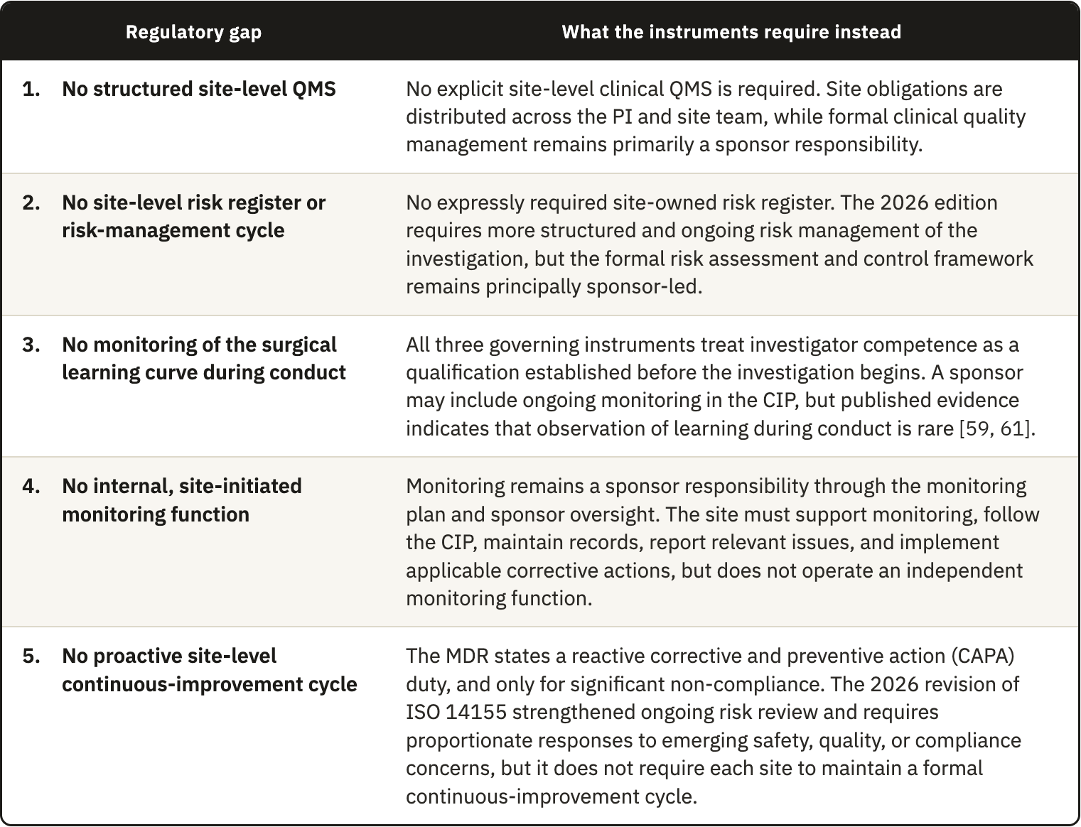
Table 3.1. The five site-level regulatory gaps identified in the clause-level comparison of ICH E6(R3), ISO 14155:2026, and MDR Annex XV.

These five gaps are not defects in the regulatory framework. They follow from the division of responsibility that the instruments were written to express. ICH E6(R3) and ICH E8(R1) set out the quality architecture and they do so mainly from the sponsor's point of view. ISO 14155 gives the investigator a set of substantive obligations, and it writes them as outcomes to be achieved, but it does not write them as a system to be operated. MDR Annex XV supplies the enforcement context and the device-specific traceability obligations. What is missing is not a rule. It is a layer, namely the operational architecture that the instruments would be glad the site has but that none of them requires it to build.

3.2.1 The site's position in the conformity assessment chain
The nature of that missing layer becomes clearer once the investigational site is placed in the chain through which a shoulder implant reaches the market.
Under the MDR, every device subject to conformity assessment requires a clinical evaluation, whatever its classification, although the level of clinical evidence must be appropriate to the device and its intended purpose _{[10]}. Article 61 and Annex XIV set out how that evaluation is planned, how data are identified and appraised, and how conclusions are drawn. The results are documented in a clinical evaluation report (CER), together with the clinical evidence that supports them. That report supports the assessment of the device's conformity and forms part of the technical documentation. Where the available data are not enough to demonstrate conformity with the general safety and performance requirements, the manufacturer generates further clinical data through clinical investigations. Article 62(1), Articles 63 to 80, and Annex XV govern how those investigations are planned, approved, conducted, and reported.
The consequence is that conduct at the site is not a peripheral activity. The data produced in the operating room and in follow-up become clinical evidence. The clinical evidence becomes the CER. The report becomes part of the file the notified body decides on. Every link in that chain is only as reliable as the one before it.
ISO 14155:2026 does not create a site-level quality-management system. It places clinical quality management in Clause 9, Responsibilities of the sponsor, which opens with Clause 9.1, Clinical quality management. That clause requires the sponsor to maintain written clinical quality procedures and compliance records _{[8]}.
Clause 10, Responsibilities of the principal investigator (PI), contains no equivalent quality-management subclause. It covers the investigator's general responsibility, the qualification of the investigator and the investigation site, communication with the ethics committee, informed consent, compliance with the CIP, medical care, and safety reporting _{[8]}. Even Clause 10.3 places the duty on the PI, who must demonstrate that the proposed site has enough eligible participants and a qualified team. Clauses 10.2 and 10.3 therefore establish entry qualifications. They do not describe an ongoing local quality-management system.
The fourth edition widened that asymmetry. It added a new provision on the CEC, strengthened the Data Monitoring Committee requirement, and added risks arising from clinical-investigation processes _{[8]}. Each mechanism is sponsor-led and central, and none has a counterpart in Clause 10. The sponsor side of the architecture therefore expanded without an equivalent local quality-management structure being assigned to the PI. No standard tells an investigational site how to run a quality system in the way that ISO 13485:2016 tells a manufacturer and ISO 15189:2022 tells a laboratory.
This comparison does more than describe the gap. It also indicates what an answer should look like. Reading across ISO 13485:2016, ISO 14971:2019, and ISO 15189:2022 allowed us to group the mapped requirements into four functions: a defined structure of authority and competence, a documented risk cycle, controls over execution and records, and a loop that measures performance and corrects it _{[52, 53, 54]}. The standards do not state these four functions as a shared taxonomy. They are the synthesis adopted in this thesis, and Chapter 4 uses them as the four pillars of the framework.
A documentary search of the three governing instruments also made one boundary visible. The terms “proficiency,” “operator performance,” “credential,” “proctor,” and “surgical skill” did not occur in ISO 14155:2026, ICH E6(R3), or the MDR. “Learning curve” occurred once, in ISO 14155:2026 Annex A, where it appears as a CIP item concerning roll-in procedures. The control term “training” occurred 29 times in ISO 14155:2026. Within this corpus, the learning curve is therefore addressed as a design consideration and is not assigned as a process for the site to observe during conduct.

3.3 Site-level Critical-to-Quality domains
The comparison left us with a classified set of requirements. Three further steps turn them into domains: a filter, a grouping by operational area, and a test against the four criteria described in Section 2.4.1.
ICH E8(R1) assigns the identification of CtQ factors to the sponsor and other parties designing the study _{[5]}. That route is a translational step which neither ICH E8(R1) nor ICH E6(R3) performs. It identifies the CtQ factors that matter at site level, as distinct from the trial-level factors a sponsor defines.
The difference between the two is not only a matter of detail. A trial-level analysis asks which design features of the study are critical to the interpretability of its results. A site-level analysis asks which operational features of this particular center would compromise participant safety or data reliability in the cases that this center contributes. Device-specific guidance on CtQ factors exists and is useful, but it is written from the same trial-level perspective _{[34, 55]}.
This process produced the twelve domains set out in Table 3.2. Each domain is described by what it covers, by the principal threat that arises when control is inadequate, and by the place in the framework where it is addressed.
Several of these domains take a different operational form in device investigations, and they account for the specificity of what follows. Device management and traceability require accountability from receipt through use in a named participant and eventual return or explantation _{[8, 10]}. For implantable devices, ISO 14155:2026 also adds an implant-card requirement _{[8]}. Procedural delivery and learning-curve control deal with surgeon-dependent variability, and they move it from a design problem, which is how the methodological literature has treated it, to a site-level control problem. Imaging control recognizes that imaging can determine eligibility, provide an endpoint, and supply safety data. The supporting literature is general or based on knee trials, so it supports these imaging functions and does not establish their frequency in shoulder investigations _{[56, 57]}. Variability in how images are acquired can therefore produce systematic error that cannot be distinguished from genuine clinical variance.
These twelve domains govern the framework in two ways. Every component is introduced to control the risks associated with one or more domains, and every performance indicator is anchored in at least one domain.

3.4 Operational conditions constraining the design
The gaps establish what is missing, and the domains establish what has to be controlled. Neither yet establishes what form a site-level architecture can take. That is settled by the operational conditions under which the architecture would have to work, and these conditions constrain the design as tightly as the regulatory analysis does.
Surgical device investigations are conducted under conditions that a site-level framework has to take into consideration. Six main conditions apply in total. Five are structural and common to surgical trials, and two of those are restrictive enough that their constraints are tackled separately in this chapter. The sixth, although not structural, heavily influences the design and is one of the findings of this thesis.

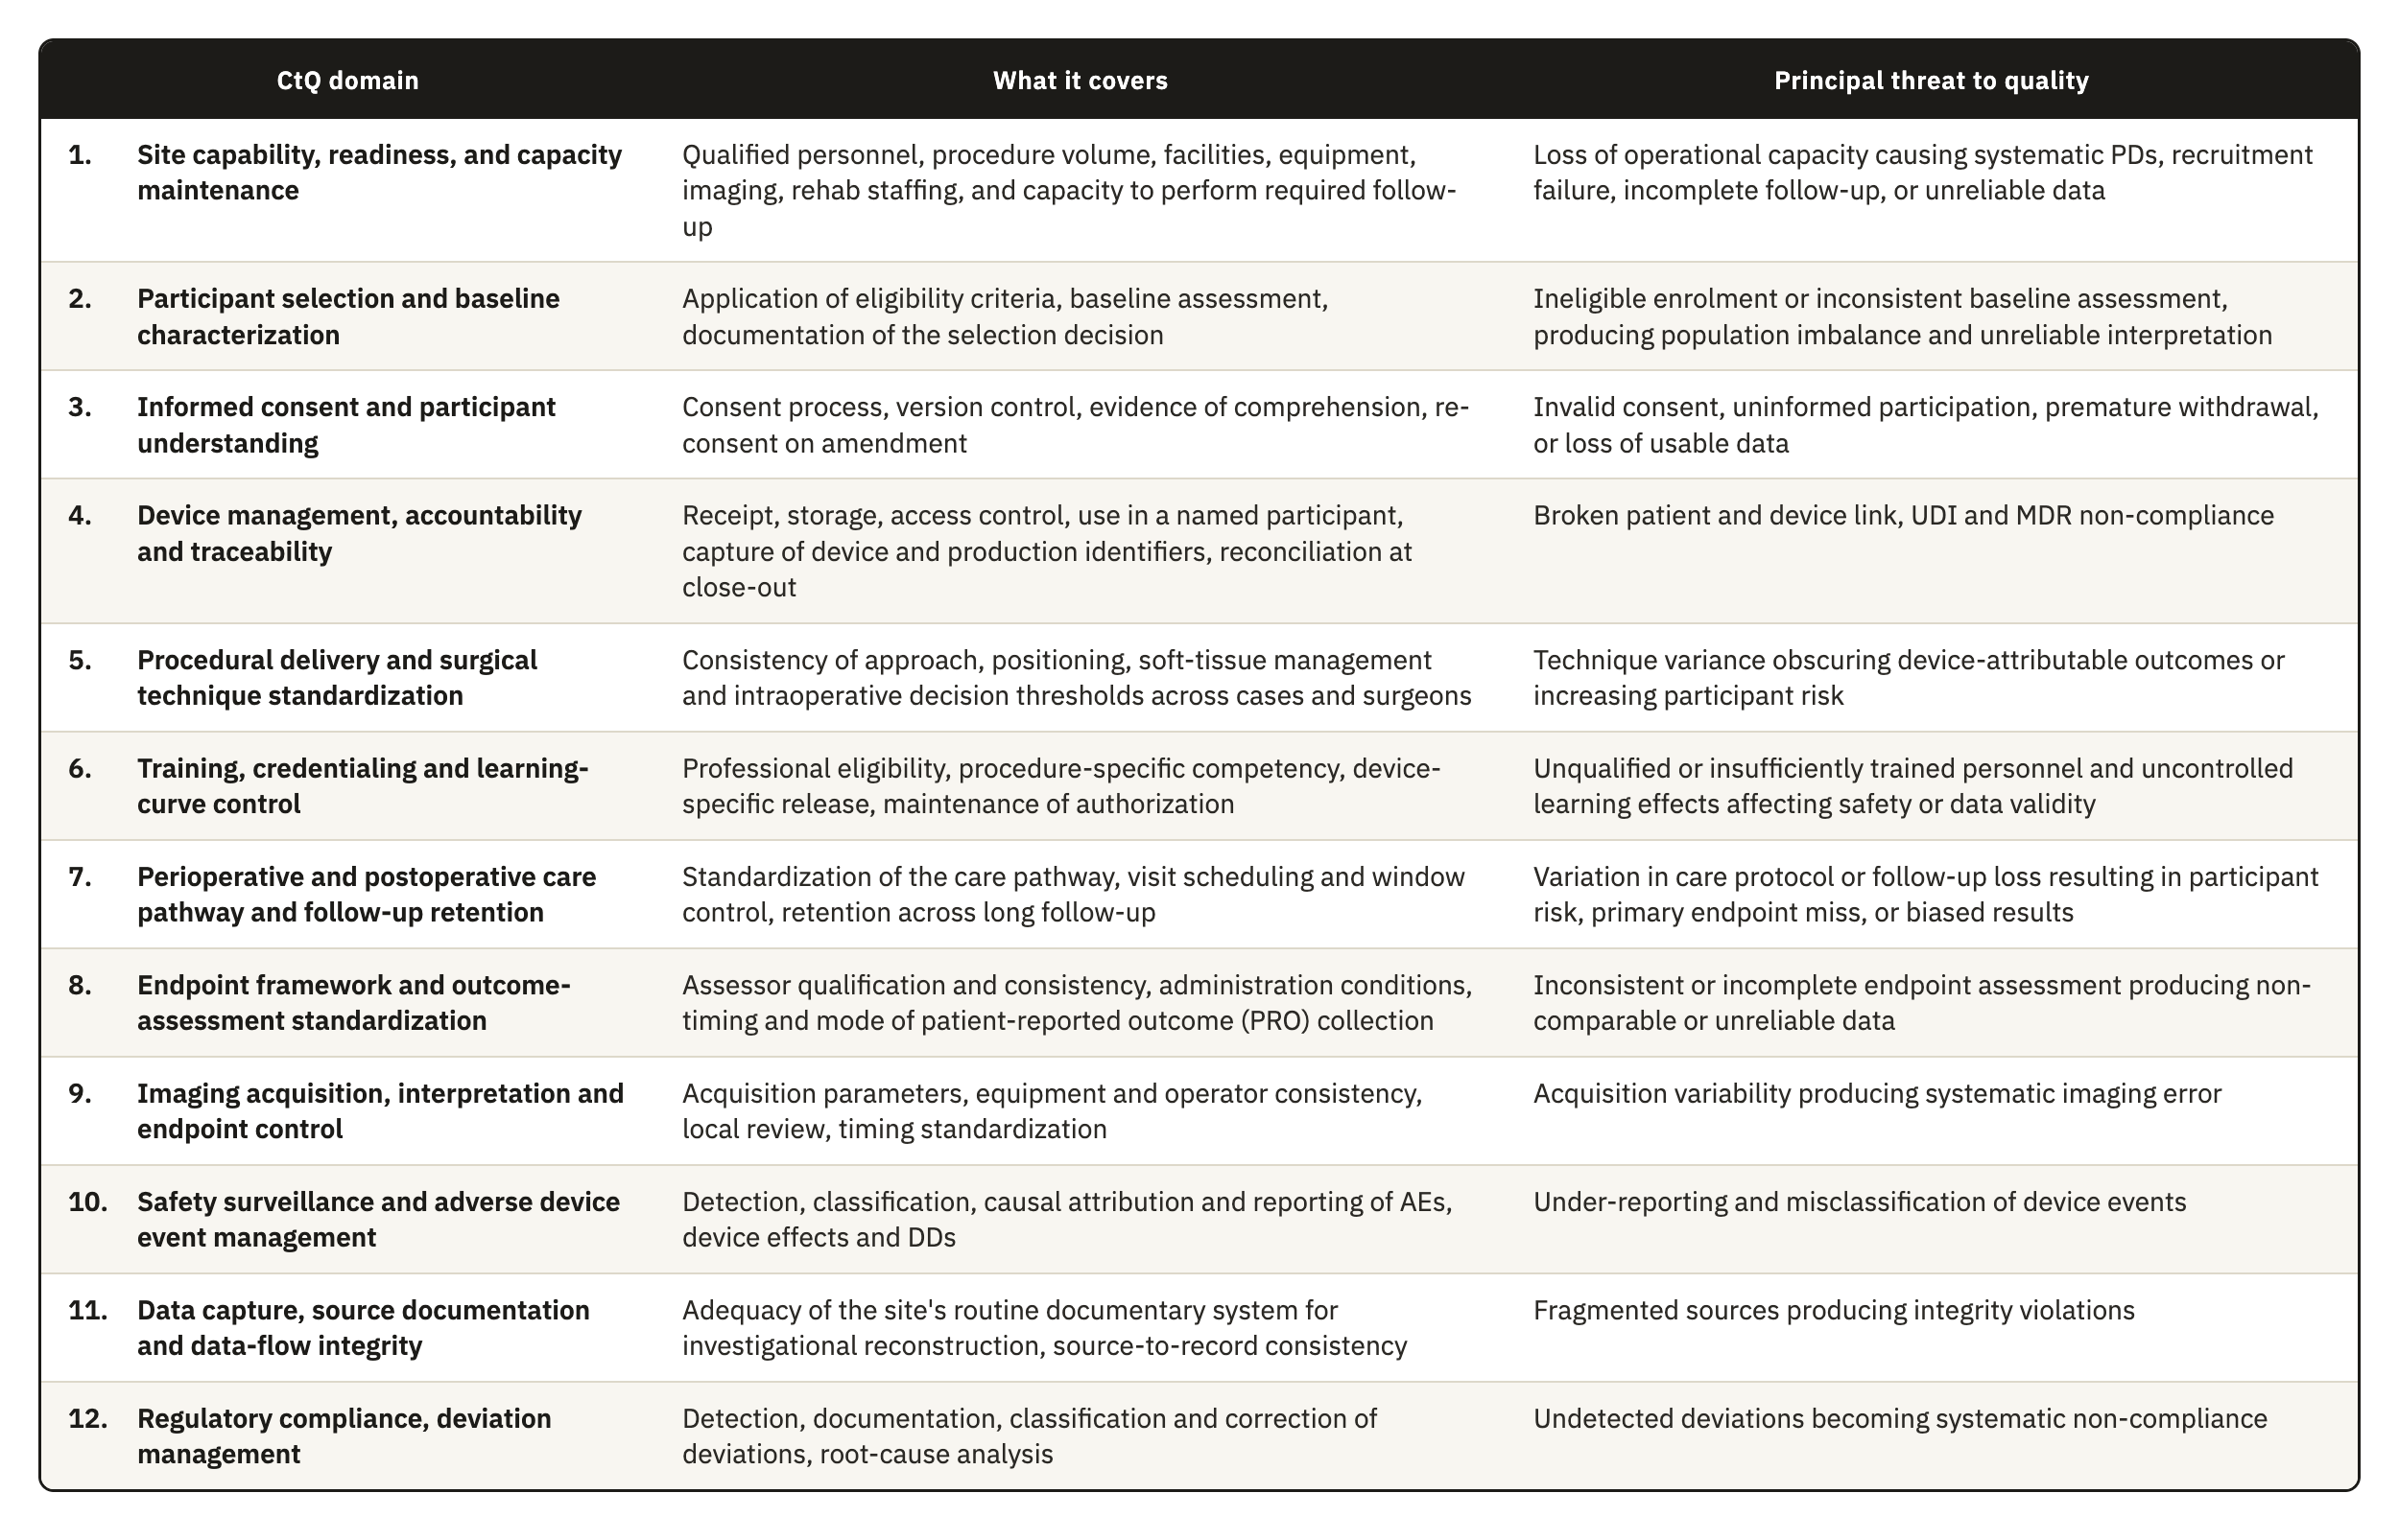
Table 3.2. The twelve site-level CtQ domains derived in Section 2.4.2, with the scope of each domain and the principal threat to quality that follows from inadequate control.

3.4.1 Design consequences of the five structural conditions
Section 1.3 established five conditions that separate surgical device investigations from the pharmacological model. Each one has a direct consequence for how quality can be managed.
1. Irreversibility. A drug can be stopped, reduced, or replaced if it fails or causes harm. A surgical implantation cannot. Once a prosthesis is fixed to bone, the procedure has produced a permanent change in the patient's anatomy. This raises the operational cost of every quality failure that happens at surgery. An incorrect implant size, an undocumented technical deviation, or a missing traceability record cannot be put right afterward in the way a transcription error can. The European Medicines Agency (EMA) has described poor risk identification and mitigation as producing a reactive approach based mainly on corrective action _{[1]}. ICH E8(R1) therefore calls for resources to identify and prevent or control errors that matter (§ 3.3.2), and the CTTI CtQ principles also place attention on prevention before conduct _{[55]}. A site-level architecture therefore must identify in advance which steps of the surgical pathway are irreversible and implement QA actions to prevent errors.
2. Operator dependence. Results depend on the device, and they depend just as much on the person and technique used to implant it _{[19, 58]}. Requirements for surgeon qualification and adequate training with the specific device are already established. Other sources of variation also require control, including learning-curve effects, differences among surgeons in positioning and soft-tissue management, and intraoperative judgment. The study by Blencowe et al. _{[59]} provides a direct precedent: standards for surgical intervention delivery can be agreed before the trial and monitored during conduct through forms that capture deviations. Quality management therefore has to include some way of characterizing this variation, because removing it would mean removing surgical judgment itself. The consequence for the design is that the framework needs the operator as a unit of analysis, alongside the participant and the case.
3. Persistent traceability. Pharmaceutical and device trials both require records linking batch or serial numbers to participants _{[6, 8]}. The distinction lies in duration and persistence. A medicinal product is used or returned, whereas an implanted device may remain in the participant for years and its records must also cover return or explantation. For implantable devices, post-investigation procedures must cover traceability, and ISO 14155:2026 adds an implant card _{[8, 10]}. Traceability here also extends to reconstructing the surgical decisions that produced that configuration in that participant, which creates a documentary burden of a different order.
4. The operational weight of follow-up. Long follow-up is not unique to surgical trials, but the measurements involved are. ROM and radiographic assessment of implant position require the participant to be physically present, while PROs require consistent collection at the specified time points. Consistent assessment procedures and independent central review, where appropriate, are methodological responses to interobserver variability, but none of the three governing instruments requires the same assessor at every visit _{[25, 60]}. Imaging standardization also requires compatible acquisition procedures and quality control (QC) _{[56, 61]}. This raises the cost of every visit and increases the risk of attrition over the years between surgery and the late assessments. Orthopaedic studies with at least three years of follow-up reported 14.8% loss to follow-up, compared with 9.8% in studies with shorter follow-up _{[23]}, and one shoulder arthroplasty cohort reported 34.3% loss by the seventh year _{[24]}.
5. Limited classification reliability. Shoulder investigations rely on radiological and clinical classifications that in many cases show only fair-to-moderate inter-observer reliability _{[62]}. Widely used classifications for proximal humeral fractures have been reported with inter-observer kappa coefficients in the fair range, even when three-dimensional models reconstructed from computed tomography (CT) data are used _{[63]}. Two assessors looking at the same patient can therefore reach different conclusions about eligibility or about an outcome, and the database cannot distinguish that variance from genuine clinical variance. Outcome measurement makes this worse. Shoulder arthroplasty trials vary widely in outcome domains, instruments, and assessment time points. That inconsistency was substantial enough to motivate core outcome sets for shoulder disorders _{[64, 65, 66]}.

3.4.2 Operator-dependent variability as a design constraint
Operator dependence produces an effect known as clustering _{[67]}. When one surgeon operates on several participants, those participants are not independent of one another for the purposes of quality. They share that surgeon's technique, intraoperative decision thresholds, and perioperative management. A problem in that surgeon's execution therefore does not affect one case. It affects every case that surgeon contributes. This also affects trial design and analysis. Failure to account for non-negligible clustering produced type I error rates above 20% in simulations _{[68]}, while only 21.5% of eligible orthopaedic randomized trials involving multiple centers or treatment providers used an analysis that accounted for clustering _{[69]}.
The surgical trials methodology literature recognizes clustering as one of the central challenges of randomized trials involving surgery, alongside the learning curve that interacts with it _{[67, 70]}. How it is handled in practice remains uneven. A survey of 44 United Kingdom Clinical Trials Units found that clustering was managed mainly at two points. The first is stratification at design, which means randomizing in a way that balances each surgeon's cases across the arms of the trial. The second is adjustment at analysis. Eighty-nine percent of units managed learning by setting a minimum expertise level for the treatment provider, and only one unit reported analyzing learning effects as part of the main analysis _{[71]}.
Operator learning is therefore controlled mainly at entry and is rarely observed during conduct. In a review of 247 published surgical trials, 39% addressed expertise through predefined surgeon credentials, while only one trial analyzed learning during conduct; a related analysis of funder guidance identified the same general concern _{[72]}. The documentary search reported in Section 3.2.1 reaches the same boundary: the governing instruments address qualification and training but do not assign ongoing observation of operator learning to the site. The interval between entry qualification and performance during conduct is exactly what a site-level instrument could cover, and it is the same interval that Table 3.1 identifies as covered by no regulatory obligation. A protocol can define a procedure in general terms, but it cannot standardize the many small decisions through which a particular surgeon implants a particular device in a particular anatomy. What the protocol cannot standardize, the site has to govern. Governing it requires an instrument that operates during conduct, and entry criteria alone will not do it.

3.4.3 Traceability as a point-of-care obligation
Unit-level traceability is distinctive in how detailed it is, and it is distinctive again in the circumstances under which it has to be met. It is executed in the operating room, under time pressure, by staff whose attention is on the surgical procedure. ISO 14155:2026 requires records of receipt, identification, quantity, dates of use, participant identification, and return or explantation, together with written procedures for the full accountability process _{[8]}. The sponsor maintains the record of physical location through delivery to the site, and the investigator's records continue the link through use in the participant and any return or explantation. The MDR also requires access control, return procedures, and follow-up in the CIP, immediate identification and recall of devices in an emergency, and post-investigation traceability _{[10]}. In surgery, the required dates of use and participant identification make capture at the point of care the most reliable operational response. A break in this chain can compromise regulatory compliance and the attribution of an AE to a specific device or lot. The cited clauses do not state that such a break automatically invalidates the affected case.
Traceability is the clearest example of a broader pattern that runs through the domains in Table 3.2. A class of critical data is generated at the point of care, external oversight cannot see it while it is happening, and it cannot be recovered once it is lost. Four examples share these three properties. They are the intraoperative decision to substitute a component and the technical deviation prompted by unexpected anatomy. They are also the immediate postoperative image that may or may not be adequate, and the early complication whose relationship to the device is still undetermined. Any architecture that deals with this class of data has to operate at the moment the data are generated. Verification comes too late.

3.4.4 Where these investigations are conducted
The registry search described in Section 2.3.1 produced 46 eligible industry-sponsored investigations of implantable shoulder devices. Repeated facility listings were cleaned and resolved at organization level, giving 235 organization-level entries. Each organization counted once in the distribution, while every associated ClinicalTrials.gov identifier remained linked to its record. Eight entries could not be resolved to a verifiable clinical organization or setting. Section 2.3.2 describes the normalization and evidence sources, together with the case-by-case review used for these decisions.
We reported the organizational environment through the four mutually exclusive categories shown in Table 3.3. This variable was selected because academic status and institutional ownership could be identified consistently from public institutional descriptions. Permanent clinical trial infrastructure was assessed separately under the definition in Section 2.4.2, giving a more direct indication of established research support within each environment. Neither variable measures trial quality or research performance.

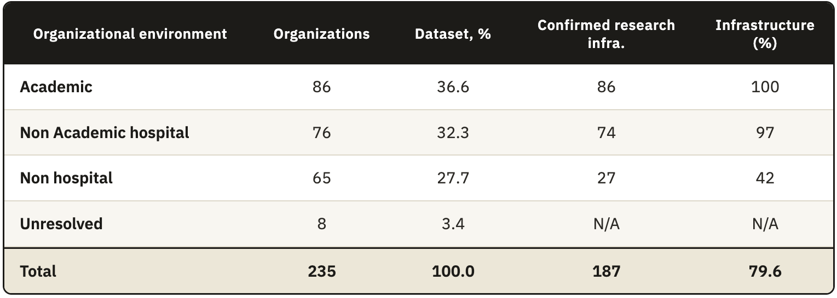
Table 3.3. The organizational environment of the 235 centers in the registry dataset, with the number and share holding publicly identifiable permanent clinical trial infrastructure by environment type.

Note. Dataset percentages use all 235 organization-level entries, while percentages with infrastructure use the total within each environment and are rounded to the nearest whole percent. The total percentage includes the eight unresolved entries in its denominator. An infrastructure classification of no means that the public sources consulted did not establish the defined permanent structure. Research activity may still take place through temporary staff or sponsor-provided support.
Academic organizations and nonacademic hospitals accounted for 162 of the 235 entries, or 68.9% of the dataset. Permanent clinical trial infrastructure was publicly identifiable in 187 organizations, corresponding to 79.6%. Most organizations in this registry sample therefore operated within hospital settings or publicly presented an established research structure.
Within the non hospital environment, 27 organizations met the definition of permanent clinical trial infrastructure and 38 did not. The group contained 65 organizations, equivalent to 27.7% of the dataset. Those 38 organizations represent 58.5% of the nonhospital group and 16.2% of the full dataset. They identify a relevant part of the sample for which permanent research support could not be established from public information.
The geographic distribution was concentrated in the United States, which accounted for 149 organizations compared with 86 elsewhere. Sixty of the 65 nonhospital organizations were in the United States, corresponding to 92.3% of that group. The registry findings describe the selected sample and cannot establish the prevalence of comparable organizations in Europe or across the global population of shoulder device investigation sites.

3.4.5 The operating conditions of the target center
The distribution in Table 3.3 guided the selection of the target center. We defined it as a nonhospital organization with limited or uncertain permanent clinical trial infrastructure. This profile represents a deliberately demanding implementation case within a wider sample that also contains academic organizations and hospitals with established research structures.
The selection rests on the 38 non hospital organizations for which the consulted sources did not establish a permanent clinical trial structure. Under the adopted definition, this finding concerns publicly documented organizational support. It does not establish the absence of research activity or poorer trial conduct. Internal arrangements may not appear on public institutional pages, and temporary or sponsor-provided support may still be available.
The observed distribution still provides a relevant design condition. Publicly identifiable infrastructure was present in almost all academic and nonacademic hospital organizations, while it was present in 27 of the 65 non hospital organizations. The framework therefore could not assume that every participating organization had a dedicated clinical trial office or a permanent research quality function.
Where a permanent structure is not identifiable, research duties may be distributed among staff whose main responsibilities are clinical. Clinical investigations may also receive fewer dedicated organizational resources in these settings. The registry analysis did not measure staffing or budgets. It also gave no information about technology use or the priority assigned to research. We therefore treated these conditions as conservative design assumptions that require assessment during implementation.
The framework had to fit within existing site roles without depending on a new physical infrastructure or dedicated quality department. Its instruments had to work on paper or within an electronic system already available at the site. Key quality decisions also had to remain in records held by the organization when individual responsibilities changed.
These conditions define the minimum implementation level used in the scalability model presented in Section 4.7. Organizations with established research departments can place the same functions within their existing systems and use deeper controls. The registry findings support an adaptable design for a relevant subgroup. They do not establish that the framework can equalize performance across environments, which requires empirical evaluation.

3.5 Design requirements
Now that we have established what is critical and what the challenges are in developing the framework, we can determine the requirements it should be structured around. For example, the CtQs define what is important but do not tell us what the site must have in place for that domain to be under control.
With the creation of those requirements, we complete the second DSRM activity, the definition of the objectives of a solution, by turning each area of criticality into a statement of what an acceptable solution has to deliver, written so that a framework component can later be checked against it.
The three analyses described in this chapter culminated on the development of these twelve requirements. Table 3.4 states them, and each one is traced to its origin. Requirements DR1 to DR5 follow from the regulatory gaps. DR6 to DR9 follow from the CtQ analysis and from the structural conditions of surgical investigation. DR10 to DR12 follow from the operating conditions of the target center.
But the requirements and the domains are therefore not in one-to-one correspondence. Some domains already carry an obligation from one of the instruments. These produce no requirement, because the framework only adds where the instruments are silent. Other domains leave two obligations unmet, and each one produces its own requirement, as Table 3.4 shows.
Two properties of this set do not appear in Table 3.4, and both affect how the framework has to answer it. The first is that meeting one requirement can make another harder to meet. DR11 limits how DR1 to DR9 can be met. A site could satisfy every functional requirement by building a dedicated information system for the investigation. That solution would pass the regulatory analysis and fail the operational one. When two requirements point to different solutions, we treat the operational constraint as the binding one. A control that the site never executes protects no one and adds no value.
The second property asks whether the framework can be justified at all. The twelve requirements say what it must do for quality but no rule or guideline tells a site to run a quality system, which is the gap this work identifies. We therefore cannot justify its existence by pointing to a rule. We justify it by tracing it back. Each component answers a requirement, each requirement comes from a gap, a domain, or an operating condition, and all three came from the clause comparison in Section 2.2. The chain ends in the instruments, so nothing in the framework is invented. It takes duties that already exist and makes them workable at the site.

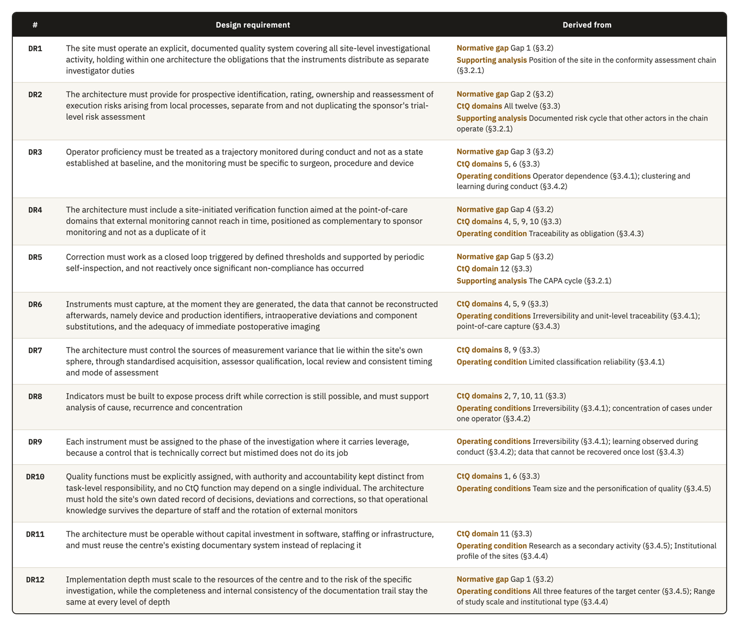
Table 3.4. The twelve design requirements for a site-level operational quality architecture, with the regulatory gap, CtQ domain, or operating condition from Chapter 3 that each one is derived from.

4. Results: The Quality Framework

4.1 Overview and design rationale
Chapter 3 closed the second activity of the DSRM, which is the definition of the objectives for a solution, with the design requirements DR1 to DR12. This chapter reports the third activity, the design and development of the model that meets those requirements. It describes each component in enough detail for a site to operate it.
The model is called the Site-Centered Operational Quality Management Framework. It has four pillars, and each pillar holds a set of instruments. Three further elements govern how those instruments are used. A lifecycle determines when each instrument is activated, a role architecture determines who operates it, and a scalability model determines how deeply it is implemented based on the structure and capacity of the site.
The four pillars are Governance, Risk Management, Operational Controls, and Performance Oversight. They are the framework's synthesis, not a taxonomy reproduced from one standard. They map recurring functions across ISO 13485:2016, ISO 14971:2019, and ISO 15189:2022 _{[52, 53, 54]}. Governance appears in ISO 13485 Clause 5, ISO 14971 Clause 4, and ISO 15189 Clause 5. Risk management appears in ISO 13485 Clause 7.1, ISO 14971 Clauses 5 to 7, and ISO 15189 Clauses 5.6 and 8.5. Operational controls appear in ISO 13485 Clauses 7 and 7.5 and ISO 15189 Clause 7, while performance oversight appears in ISO 13485 Clauses 8, 8.2.4, 8.4, and 8.5, ISO 14971 Clauses 9 and 10, and ISO 15189 Clauses 8.7 to 8.9. Using functions already recognizable in the device quality system makes the architecture easier to interpret and implement.
Table 4.1 maps the twelve design requirements to the components that answer them, and every section of this chapter returns to that mapping.
This framework was designed with its main focus on the vulnerability discussed at Section 3.4.4. That setting shaped the operational constraints reported in Section 3.4.5, and it explains the form the instruments take. The framework is nonetheless written to be transversal. Nothing in its architecture depends on a single form of organization, and the components are described as functions, so that a center with a different staffing structure can map its own posts onto them.

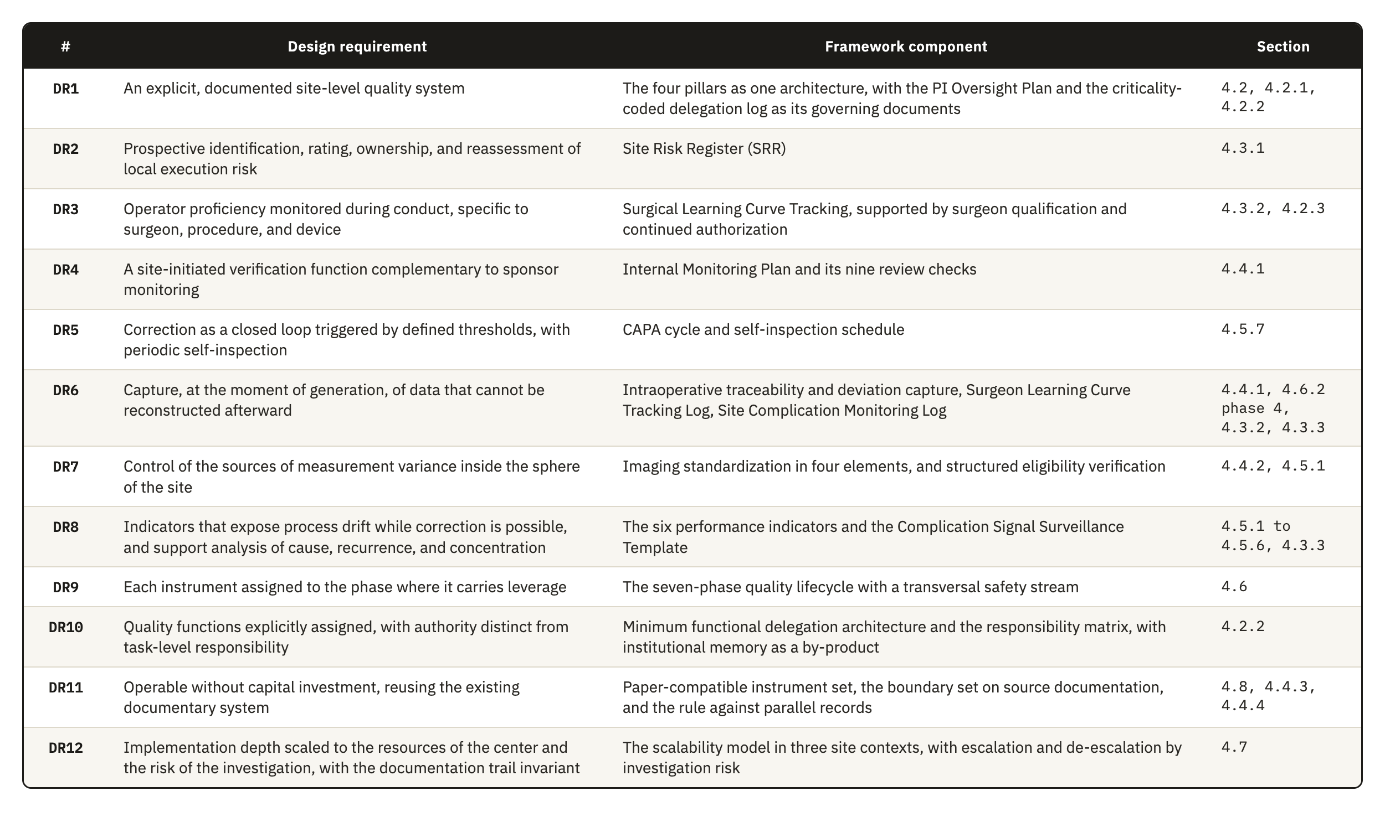
Table 4.1. The twelve design requirements from Section 3.5, the framework component that answers each one, and the section of Chapter 4 where that component is developed.

4.2 Pillar 1: Governance
Governance defines the local authority structure through which regulatory accountability is exercised at site level. The quality of the investigation depends on surgeon-dependent technical execution, on intraoperative decision variability, on device traceability, and on the reproducibility of postoperative assessment. The pillar is therefore designed so that clinical authority, delegated execution, procedural competence, and device-specific training are each controlled in a documented and risk-proportionate way.
The regulatory basis sits in two places. ICH E6(R3) expects investigator oversight to be proportionate to the nature of the delegated activities, to the importance of the data collected, and to the risks to participant safety and data reliability. ISO 14155:2026 keeps responsibility for the investigation with the PI under Clause 10.1, even when activities are delegated. It also requires the qualification of the investigator under Clause 10.2 and of the site under Clause 10.3.
This pillar has four components, which are the oversight model, the delegation structure with its role architecture, surgical qualification, and device training documentation. The oversight model defines how authority is exercised, and the other three define the conditions under which its influence is clear. The pillars that follow observe what the holder does afterward, which is why the surgical learning curve is treated in Section 4.3 while the qualification decision it is treated here.

4.2.1 The oversight model
During the design process, we developed three analytic alternatives for allocating oversight at site level. They are not an empirically established taxonomy. They represent recurrent ways in which site functions may be distributed under different constraints of staffing, capacity, and existing organization. Published descriptions of trial-site operations confirm that these functions must be covered, but do not divide them into the same three models. We therefore present the alternatives as design choices, compare their advantages and limits, and explain why the framework adopts the third.
The first is a strongly investigator-centered model, where the PI intervenes directly in most critical activities and personally reviews most documentary and operational workflows. It looks like the safest option because it conveys an impression of intensive supervision. However, it becomes difficult to sustain as activity expands. Site PIs already carry scientific, regulatory, recruitment, supervisory, and administrative duties, and their contribution is often under-recognized _{[73]}. In this model, administrative review can consume attention needed for the areas where clinical intervention is genuinely irreplaceable, such as confirming surgical appropriateness, interpreting intraoperative deviations, assessing whether a complication is related to the investigational device, or reading early signs of executional drift as a coherent clinical picture. It also scales poorly across the operating room, radiology, postoperative functional follow-up, implant accountability, AE management, and data QC.
The second is a coordinator-led model, where daily management is delegated to the study coordinator while the investigator retains final authority. This is operationally plausible because the clinical research coordinator is a core site function _{[74]}, and ICH E6(R3) expressly permits delegation while retaining ultimate investigator responsibility and proportionate oversight _{[6]}. Food and Drug Administration (FDA) supervisory guidance also emphasizes appropriate delegation, staff qualification, and investigator oversight _{[75]}. Its weakness is not coordinator leadership itself. The risk is nominal oversight when there is no defined review structure, established periodicity, formal escalation pathway, or explicit statement of what requires direct investigator involvement. In surgical investigations, those points include borderline eligibility decisions, unplanned intraoperative changes, component substitutions, revision-related interpretation, and inconsistencies whose significance is not apparent from the documentation alone.
The framework adopts a third arrangement, a tiered and risk-adjusted model of PI oversight. Investigator involvement is stratified by task criticality and calibrated to the risk each task poses to participant safety, procedural integrity, device accountability, and data reliability. The advantage of this model is that it rejects the idea that effective oversight comes from universal visibility or indiscriminate sign-off. Oversight is concentrated on the processes, decisions, and data flows that can affect participant protection and study validity, which applies the CtQ logic of ICH E8(R1) to the allocation of the investigator's own attention. Involvement is intensified where clinical judgment, procedural authority, and regulatory accountability converge, and five mechanisms turn this principle into operable controls.
Turning that principle into a workable schedule is harder than it sounds. A site has to decide, in advance and for each type of activity, what genuinely requires the investigator's own judgment and what can be reviewed after the fact without loss, and that line moves with the device, the procedure, and the experience of the team performing it. Set the threshold too low and the investigator reverts to the first model this section rejected; set it too high and oversight becomes a formality that produces no real review at all.
Grading delegated activity by stakes carries its own difficulty, because criticality is not intrinsic to a task in the abstract. Coordinating a routine visit is administrative until a scheduling choice places a follow-up outside the protocol window, and recording an intraoperative note is clerical until the note is what later reconstructs a disputed complication. A grading scheme has to anticipate which routine activities carry that kind of latent significance, and a scheme copied wholesale from another site's practice will miss the ones specific to this investigation and this team.
Choosing where to place formal review points is itself a judgment call with real consequences. Reviewing too early misses problems that only surface once a procedure or a follow-up window has actually occurred; reviewing too late lets a correctable pattern continue through several more cases before anyone with authority sees it. The points that matter most, procedural implementation, the immediate postoperative period, the approach to endpoint assessment, and close-out, are where the most consequential threats to integrity concentrate, which is itself a claim about the risk profile of this investigation and would not transfer unchanged to a different device or procedure.
An event-triggered escalation pathway requires investigator notification regardless of the routine review cadence, because scheduled review cannot capture every critical governance moment in a high-variability surgical study: some events threaten participant safety or causal interpretability immediately and have to reach investigator authority before the next scheduled point.
An oversight meeting architecture embeds this review in the recurring rhythm of the site, so it does not depend on ad hoc contact. This is a design transposition from ISO 14155:2026's use of structured, consensus-based review at sponsor level under Clause 6.12 and from the EMA reflection paper's recommendation of multidisciplinary review for risk assessment [1], not evidence that site-level forums have independently been shown to improve oversight. Sustaining it is harder at the small or mid-sized centers this framework targets, where the same few people who attend the meeting are also the ones who would otherwise be doing the clinical and administrative work the meeting exists to review.
These five mechanisms together answer DR1 at the level of authority. They also carry part of DR10, because an oversight model that is written down, scheduled and evidenced produces a record that survives the departure of the people who operated it.

4.2.2 Delegation, roles, and functions
The delegation structure makes the oversight model operable. Without designated functions, authorized personnel, training-linked release, and controlled interfaces between roles, even a well-designed oversight model is organizationally underpowered. The relationship runs in both directions, since a strong delegation structure reduces ambiguity, makes escalation thresholds meaningful, and lets the investigator concentrate attention where judgment is clinically necessary.
ICH E6(R3) allows the investigator to delegate trial-related activities while retaining ultimate responsibility. It requires oversight of delegated persons proportionate to the nature of the activity, the importance of the data, and the risks involved. It also requires that delegated personnel be appropriately qualified and adequately informed about the protocol and the investigational product. ISO 14155:2026 governs additional members of the investigation site team under Clause 7.6, which requires documented training before assignments begin, together with a record of names, initials, signatures, functions, and designated authorizations.
The conventional delegation log is principally a record of who performs which trial-related activity. ICH E6(R3) Section 2.3.3 requires documentation proportionate to the significance of the activity, but does not require a criticality code or evidence of competence to be embedded in the same record. Delegation records are nevertheless subject to direct inspection scrutiny, and the investigator remains accountable for delegated work _{[75, 76]}. In this framework, the delegation structure therefore has four additional properties. It is task-based, competency-gated, version-controlled, and linked to the review intensity defined by the oversight model.
The task-based property matters most, because a research nurse may be entirely appropriate for coordinating visits, maintaining screening logs, and managing routine query traffic, and still not be the right person to resolve a clinically meaningful discrepancy in operative documentation.
The framework therefore defines a minimum functional architecture that reflects how orthopedic implant investigations are run, and it names six functions.
The PI is accountable for conduct at the site and for the appropriateness of every delegated activity. Delegation transfers execution, and responsibility stays with the investigator.
The study coordinator, or the research nurse where the site uses that title, is the principal operational integrator. The function coordinates consent logistics and study visits, and it carries documentation flow and issue escalation across the site. Its limit is clinical. A coordinator does not decide eligibility and does not interpret safety information, and classifying a PD sits outside the function as well.
Operating room staff prepare the investigational device for use and apply the chain-of-custody controls. They record the intraoperative procedural data and complete the procedural source records. The function documents procedural facts and holds no authority over clinical decisions.
The radiology liaison supports adherence to the imaging protocol and compliance with the imaging windows, and it holds the technical consistency of image acquisition and transfer. Control stops at technical quality. Where central reading applies, endpoint adjudication is not a site-level function.
The functional assessor, in many sites a physiotherapist, conducts ROM measurement and the PRO workflows wherever those activities are critical to endpoint quality. The function administers assessments by a defined method and does not interpret what an endpoint means.
The data QA function manages query flow and monitors critical-data completeness, and it keeps pending data risks visible. It identifies discrepancies. A discrepancy that is clinically meaningful goes to the PI for resolution.
These are general functions, not required positions. In a small or mid-sized center, one individual may hold more than one of them. The framework therefore requires each function to be assigned to a named individual and formally documented, whatever the number of people involved, so the site can identify who is responsible and has no need to assume that the function is covered.

4.2.3 Surgeon qualification and continued authorization
The sponsor and the site share responsibility for controlling which surgeons may perform study procedures throughout the investigation. The sponsor normally defines the minimum entry criteria through the CIP, training requirements, and the study risk assessment. During site qualification, the sponsor reviews the available evidence and confirms whether the site meets these predefined criteria. The site applies the criteria to its surgical team and demonstrates that each delegated surgeon satisfies the applicable requirements.
ISO 14155:2026 clarifies this division of responsibility across the sponsor, the PI, and the investigation site. Clause 6.8 requires the sponsor to define site selection criteria and verify the PI's qualifications and site adequacy. Clause 9.2.1 also requires the sponsor to ensure verification and documentation of relevant training, experience, and knowledge. Clauses 10.1 and 10.3 require the PI to ensure team qualification, training, documentation, and oversight. The PI must demonstrate that team members have suitable education, training, and experience for their assigned responsibilities. Clause 10.6 further requires the PI to maintain and document an adequate investigation site team throughout the investigation. Together, these provisions establish sponsor verification and site responsibility for demonstrating and maintaining team qualification.
The framework reflects this allocation and defines the site contribution through application, documentation, and continued oversight. Sponsor requirements establish the threshold, and the site converts that threshold into documented decisions for each surgeon. The site also links each decision to the delegation log so assigned surgical tasks remain consistent with current authorization.
Building that evidence is harder than confirming a specialty credential on file. A surgeon's general standing, procedure-specific competency, and readiness on this particular device are three different questions, and a good answer to one does not answer the others. Standing can be adequate for a comparable procedure and still uncertain for this device's specific technique, and the site has to decide how much of that uncertainty sponsor-set entry criteria already resolve and how much is left for its own judgment to close before the first case.
The site may also apply temporary controls when the risk assessment or expected learning curve supports additional supervision. Such controls may include proctoring, co-surgery, or initial assignment to cases with lower procedural complexity. Their use remains proportionate to the procedure, the device, the surgeon's experience, and the requirements established for the investigation.
The framework also treats qualification as a status that remains current throughout the investigation, not a decision made once and left standing. It requires re-evaluation annually and after protocol amendments, safety signals, complication clusters, or evidence of performance drift. The harder question is what counts as evidence of drift early enough to act on, since a surgeon's own performance is the most direct signal available and also the hardest to read without a longer run of cases to compare it against. The site can then confirm, restrict, suspend, or restore surgical authorization according to the available evidence. This maintenance function represents a distinct site-level contribution because it connects observed performance with continued authorization to operate.

4.2.4 Device training documentation
Device training documentation is the controlled body of records showing that site personnel received the training their activities require, covering the protocol, the instructions for use (IFU), and the responsibilities assigned to each person. Its function in this framework is operational as well as evidentiary. Through it the site shows that critical activities were performed by personnel who were delegated and also prepared for the specific investigational context.
The requirement is grounded in both bodies of guidance. ICH E6(R3) requires that individuals involved in the trial be qualified by education, training, and experience, and that those assisting receive trial-related training corresponding to their delegated activities. ICH E8(R1) requires that study personnel be trained commensurately with their role before becoming involved, with retraining as needed during conduct. ISO 14155:2026 requires documented training before assignments begin under Clause 7.6. The fourth edition also strengthened the upstream side of this obligation, since Annex B now requires the sponsor to include information on device use training in the Investigator's Brochure under item B.2 h). The sponsor therefore has to document what training exists, and no clause requires the site to verify that the resulting competence is maintained, which is the space this component occupies.
In orthopedic device investigations, training has to cover device-specific functions. These include proper use of the investigational device and instrumentation, the operative workflow, device accountability, safety-reporting interfaces, and site processes affecting a CtQ factor. MDR Annex XV, Chapter I, Section 2.7 requires the sponsor to verify, arrange where necessary, and document training in proper device use, the CIP, and GCP. Annex XV, Chapter II, Section 3.2 also links investigator suitability to device and procedural training and experience. ISO 14155:2026 Annex B.2 includes training information in the Investigator's Brochure, and Clause 7.9 requires device-accountability procedures. Medicinal-product GCP also requires qualified personnel and investigator familiarity with the investigational product _{[6]}, so the framework does not claim that the device burden is categorically wider. It specifies the additional device-linked functions that must be controlled. Training documentation is therefore role-specific and version-controlled, identifies who was trained, on what, when, by whom, and under which controlled document version, and records when the person was authorized to work independently.
Five training domains are distinguished in a shoulder investigation.
1. Protocol and procedural training covers study objectives, key eligibility restrictions, endpoint-relevant visit windows, PDs, and study-specific decision points.
2. Device-specific training covers the investigational system, the instrumentation, the implant components, preparation steps, handling requirements, and any workflow constraint the study introduces.

3. Operative and perioperative documentation training covers intraoperative records, component reconciliation, implant lot and UDI capture, documentation of substitutions and deviations, and chain-of-custody expectations.

4. Assessment training covers radiographic acquisition standards, imaging timing, ROM measurement methods, and administration of PROMs where these are endpoint-relevant.

5. Safety and reporting training covers recognition and documentation of AEs and DDs, together with the escalation pathway for clinically important findings.

A distinction is drawn between training completion and training release. Attending a session or acknowledging receipt of training material does not by itself demonstrate readiness to perform a task independently. For higher-risk or higher-variability activities, particularly those involving the device, the imaging, or the outcome assessment, the site documents an explicit release decision once training is complete. This is where device training documentation connects to the delegation structure and, for surgeons, to qualification, without collapsing into either.
Training documentation should be maintained as a living control system. Retraining is triggered by protocol amendments, revised IFU, new device iterations, workflow changes, safety signals, repeated documentation errors, and observed deficiencies in processes relevant to CtQ factors. ICH E8(R1) requires retraining when issues related to CtQ factors arise during a study and when protocol modifications are implemented. In practice the site should be able to show two things, which are that staff were trained at start-up and that training stayed current as the investigation developed.

4.3 Pillar 2: Risk Management
Risk Management identifies where site conduct is most likely to fail, establishes why those failures matter, and defines how they are controlled before they reach participants or the data. The pillar concentrates attention on the risks that threaten the parts of execution that are CtQ, and it leaves aside the exhaustive listing of everything that could go wrong.
ICH E8(R1) frames quality around CtQ factors and a risk-proportionate response to threats against them _{[5]}. ICH E6(R3) requires an approach that identifies, evaluates, controls, communicates, and reviews risks that may meaningfully affect participant rights, safety, and well-being or the reliability of results _{[6]}. The EMA Reflection Paper on RBQM in Clinical Trials describes an operational cycle of assessment, control, communication, review, and reporting _{[1]} and recommends multidisciplinary failure mode and effects analysis as one method of risk assessment _{[1]}. The EMA paper is nonbinding methodological guidance. The normative duties used by the framework derive from ICH E8(R1) and ICH E6(R3).
ISO 14155:2026 gives this pillar an anchor that the third edition did not provide. The fourth edition restructured Clause 6.2 into three risk streams. Clause 6.2.2 covers risks arising from use of the investigational device, which remain inside the ISO 14971 framework and its Annex H. Clause 6.2.3 covers risks arising from clinical procedures that the CIP requires outside routine clinical practice, and these are assessed descriptively. Clause 6.2.4 covers risks arising from the conduct of the investigation itself. The second and third categories fall outside ISO 14971, and the standard assigns none of the three to the investigational site, leaving the class of risk that Clauses 6.2.3 and 6.2.4 create with no named local owner.
The pillar matters more here than the general formulation suggests, because orthopedic device investigations contain sources of variability that general trial controls do not reach. Surgical learning curves, intraoperative decision-making, implant traceability, imaging-dependent assessment, and early device-related complication signals generate risks that are clinical and methodological at the same time. A generic register copied from sponsor-level practice would not capture them, so the pillar is built around the risks the center can detect, review, and mitigate through its own processes.
Three risk-management functions therefore sit side by side in the conformity chain. ISO 14971 governs the risk the device itself carries, and that risk stays with the manufacturer whatever site runs the investigation. ICH E6(R3) and the EMA reflection paper govern risk at trial level, through a cycle of assessment, control, communication, and review that the sponsor operates across every participating center. Between them sits a risk that neither function is positioned to see, the risk that a specific site's own execution creates. The sponsor's cycle has to generalize, because the same protocol runs at centers that differ in staffing, workflow, equipment, and experience, and a control built for one center's specific weaknesses would not travel to the next. The site does not carry that constraint, and it holds something the sponsor structurally cannot: a working knowledge of where its own process is strong and where it is not. Risk management at site level is quality-based in the same sense as the sponsor's own system, anchored in CtQ factors and a prevent, detect, and respond logic, but it operates at the one grain only the site can supply.
This pillar puts that grain to work through three functions with distinct objects: a prospective register of process risk, longitudinal tracking of the operator's stabilization, and reactive-then-aggregate surveillance of clinical signals. Each is addressed in turn below.

4.3.1 A risk layer the sponsor's assessment cannot reach
Site-level risk management is the record through which the site identifies, prioritizes, monitors, and periodically reassesses the risks that arise from its own execution of the investigation. It stands apart from the sponsor's trial-level risk assessment and from the manufacturer's device risk file, and that separation gives it its purpose. The sponsor's assessment supports trial-wide quality management, monitoring strategy, and participant protection across every site, so it is broad by design. It does not capture what local processes, local staffing, local workflows, and local technical capability shape on their own: inconsistent radiographic acquisition, incomplete implant identifier capture, delay in documenting intraoperative deviations, variability in postoperative functional assessment, fragility in local follow-up, weakness in escalating safety-relevant findings. A sponsor-level assessment does not see any of these. The site can control all of them.
There is direct evidence that this layer is missing in practice. A 2023 study of Portuguese clinical trial sites found that more than half reported using some form of systematic risk management, yet only 19.6% described a standard tool or document that systematically captured site-level risk analysis. The same study concluded that sites remain underdeveloped in the autonomous control of risk in their own processes, and that they would benefit from a risk tool built for site operational needs [77]. This is the closest measurement available of the gap recorded in Table 3.1, and it supports DR2 more directly than the indirect evidence used elsewhere in this work.
Doing this well is harder than listing what could go wrong. A site with no established discipline for it tends toward one of two failures: an inventory that grows into an exhaustive catalogue no one revisits, or a record that stays symbolic because no one holds the authority to act on what it shows. The harder task is prioritization, separating the risks that matter to participant safety or data reliability from the much longer list of things that could conceivably happen, and keeping the record current enough that a real change in the site's own conditions is reflected in it before the change causes a failure.

4.3.2 Operator-dependent risk and the learning curve
Surgeon-dependent variation is a risk in a device investigation for a reason that does not apply to a medicinal product: the procedure is part of the intervention. Variability in surgical execution reaches protocol adherence, implant traceability, imaging interpretation, and endpoint consistency, and it reaches clinical outcomes as well. Section 3.4.2 established why this matters and why no instrument examined in this thesis assigns the site a role in watching it once the investigation is under way.
The literature associates procedural experience with changes in operative time, complications, reoperations, and PROs, but it is heterogeneous in how proficiency is defined and measured. Avendano et al. reported an average of approximately twenty-five cases for reverse total shoulder arthroplasty across eight studies, while a multicenter analysis found plateaus between twelve and eighty-six cases across surgeons and procedures [20, 78]. These values are descriptive, not universal proficiency thresholds, and the framework does not adopt a fixed case count.
The objective is narrower and more defensible than fixing a threshold. Site-level tracking asks whether surgeon-dependent variation is becoming a material source of risk to CtQ factors at this site, in this investigation, with this device, which follows ICH E8(R1)'s requirement to periodically review whether risks to critical factors remain adequately controlled during conduct.
SQA frameworks address the learning curve mainly at selection, and the validated Clinical Trial Site Performance Measure contains no counterpart for surgeon procedural consistency once a trial is under way [37, 39]. The component this pillar adds occupies that interval, operated by the site itself. The difficulty is separating genuine instability from ordinary case-to-case variation. A slower operative time or an unplanned substitution can mean very different things depending on the complexity of the case and the point a surgeon has reached in their own experience with the device, and an approach that does not account for that context risks flagging normal variation as drift, or missing real drift inside a case dismissed as merely complex.
Because it is kept at the point of care as cases occur, this kind of tracking can surface procedural drift before that drift becomes an AE, a PD, or an anomalous data point in the study database, which is the direct answer to the finding in Section 3.4.2 that operator learning is controlled at entry and almost never observed during conduct.

4.3.3 Device-specific complication monitoring
Device-specific complication monitoring is the site-level process used to identify, classify, review, and escalate complications, AEs, adverse device effects (ADEs), and DDs. Its object is any of these that may relate to the investigational device, to the procedure, or to their interaction in clinical use.
Its scope is narrower than that of the risk register, and the difference is worth stating precisely, because the two are easily confused. The register is a quality-management instrument concerned with prospective control of execution risk. Complication monitoring is a surveillance mechanism concerned with clinical and technical signals emerging during conduct. A register entry reads as a statement that the implant identifier may not be captured before the operating room workflow closes. A complication monitoring entry records that a specific participant experienced a specific event on a specific date, and asks what it means. The first anticipates a process vulnerability, and the second evaluates something that has already happened.
The regulatory basis is the MDR and the safety reporting framework for device investigations. Under Article 80 the sponsor must report without delay any SAE with a causal relationship to the investigational device, to the comparator, or to the procedure. The same applies where such a relationship is reasonably possible. The same obligation covers DDs that might have led to a SAE, together with any new findings relating to those events. ISO 14155:2026 sharpened one point that bears on this component, since Annex F now states that an AE associated with a DD triggers both the AE pathway and the DD pathway.
This component adds timing to an obligation the MDR and ISO 14155 already impose. Both already require the sponsor to receive individual event reports within defined deadlines, but a deadline measured from sponsor notification is not the same as detection at the point of care. Left to the reporting cycle alone, a pattern of complications becomes visible to the site itself only when the next periodic summary, monthly, quarterly, or whatever the CIP sets, is compiled for the sponsor, and by then several more cases may already share the same cause. Closing that interval is harder than tracking events as they occur, because a single complication rarely announces itself as part of a pattern. The real difficulty is aggregation, recognizing that several events, each individually explicable on its own, share a cause, which only becomes visible once they are reviewed together on a cadence the site sets for itself, independent of the sponsor's reporting calendar, so that a cluster tied to one implant component, one technique, or one surgeon can be caught while the investigation can still act on it. This is proactive risk management in the sense Section 2.2.2 already gave the term, prevention and detection built into routine conduct before any report falls due.
ISO 14155:2026 introduced the CEC under Clause 6.12 and requires the sponsor to consider establishing one for unbiased, confidential, and consensus-based event review. The committee operates at trial level with aggregated information across participating centers. The framework gives the site a local counterpart that uses its own exposure denominator and predefined local triggers. The available sources do not establish that either level will detect a signal first. A local response is justified when the site's own trigger is met, while the CEC supports consistent assessment across the investigation. Individual event management is required by ISO 14155 and the MDR. Pattern surveillance at site level is required by neither.

4.4 Pillar 3: Operational Controls
Operational Controls are the practical mechanisms through which the site keeps execution consistent, traceable, and usable over time. Their function is to reduce avoidable variability in how trial procedures are performed, documented, and checked in routine operation. Governance defines who is responsible, and Operational Controls define how critical activities are carried out and kept under control.
The difficulty of this pillar lies in the distance between a procedure as the protocol describes it and the same procedure as it happens in an operating room on a given day. Two of the places where that distance matters most are hard for any outside party to observe in time. Local conduct drifts between sponsor visits, and imaging varies in ways that are easier to see once images from different time points are placed side by side. Both depend on records that have to reconstruct the investigation without competing with the records that already exist, so every control the pillar adds carries the risk of becoming one more place where the same fact is written differently.

4.4.1 Internal verification of site conduct
What the site needs is narrower than formal monitoring and does not replace any of it: a site-operated function for the periodic review of trial conduct, documentation, and critical site processes, aimed at detecting local process failure and supporting timely correction within the site's own sphere of responsibility.
The terminology needs care because formal monitoring under GCP is a sponsor responsibility. ISO 14155:2026 assigns the monitoring plan to the sponsor under Clause 6.7, site monitoring under Clause 7.3, and the monitoring function under Clause 9.2.4. ICH E6(R3) places formal monitoring inside the sponsor's QC system. The FDA Guidance for Industry, Oversight of Clinical Investigations: A Risk-Based Approach to Monitoring, recognizes that monitoring is used in several senses but addresses sponsor oversight of trial conduct and data reporting. Its legal basis is Title 21 of the Code of Federal Regulations (21 CFR) 812.40 for device investigations and 21 CFR 312.50 for drug investigations _{[79]}. No identified instrument requires the site to review its own conduct through a structure of this kind, which is the gap DR4 answers.
Its value lies in where it looks, not in how often it happens. The concrete, recurring, operationally verifiable problems in implant-based orthopedic investigations sit at the interface between operating room practice, implant logistics, documentation, imaging, and postoperative surveillance, and that is where review has to concentrate. This follows the RBM principle that the intensity of review should reflect the risk to participants and to data integrity, not spread evenly across everything the site does.
Executing that review well is harder than scheduling it. Someone has to weigh execution, evidence, and effectiveness against each of the checks below, record what was found, and follow it through to a correction and a verification that the correction worked. Doing this on a cadence independent of any sponsor-announced visit is also where the site's own self-inspection belongs, not as a separate exercise layered on top, but as the same review turned periodically on the site's conduct as a whole. The nine checks below define what it has to cover.
Nine checks define the scope of internal review. Sterile release-to-use verification confirms package integrity, expiry, storage, and release status before use, and reconciles any breach of sterile handling or intraoperative substitution.
Implant traceability and component reconciliation checks that lot number, serial number, or UDI were captured consistently across the operative note, the accountability records, the implant labels, and the CRF, and that the implanted configuration matches what was planned.
Instrumentation and operating room readiness confirms that the correct implant system and instrument set were available and documents any incompatibility or malfunction, as a procedural issue or as a DD where that applies.
Operative documentation adequacy checks that operative notes carry enough detail, the final configuration, intraoperative decisions, substitutions, deviations, complications, to support later interpretation, since this cannot be repaired afterward.
Imaging usability and timing compliance verifies that required imaging was obtained within window, with the correct views and technical quality, and whether repeat acquisition followed when it was not.
Follow-up execution quality checks that a visit produced the outputs surveillance and endpoint assessment require, since attendance alone is not evidence of a complete visit.
Timeliness, backlog, and closure discipline tracks whether notes, data entry, queries, and corrective actions close within acceptable timelines. Delay is a defensible trigger, since the MDIC risk-indicator model weights queries older than sixty days and the EMA reflection paper lists delayed data entry and SAE reporting among its trigger metrics [1], though neither source establishes that backlog predicts a broader site failure, so the framework treats the relationship as a monitoring hypothesis.
External context review means the site periodically checks literature, registry findings, safety alerts, and field notices for the same implant class or procedure.
Early complication pattern review examines instability, fracture, loosening, nerve injury, stiffness, reoperation, and revision by timing, severity, and possible association with implant configuration or procedure, linking this check to the surveillance in Section 4.3.3.

4.4.2 Imaging standardization
Imaging standardization reduces avoidable variability in imaging-derived information wherever imaging contributes to eligibility assessment, procedural documentation, safety evaluation, or endpoint interpretation. DR7 is answered here, and the weight of this pillar comes from the position imaging holds in orthopedic device investigations.
Preoperative imaging may confirm anatomical suitability, deformity pattern, fracture configuration, glenoid or humeral morphology, or revision burden. Intraoperative and immediate postoperative imaging document implant placement and early procedural status. Follow-up imaging assesses component position, radiolucent lines, loosening, migration, periprosthetic fracture, instability, healing, or failure. Poorly standardized imaging in this setting can change how a case is classified, weaken causal interpretation, and reduce comparability across participants or across follow-up windows. Section 3.4.1 established the underlying problem, which is that the classifications applied to these images already carry only fair-to-moderate reliability, so acquisition variability produces error that the database cannot separate from genuine clinical difference.
The methodological basis is established, although formal trial-imaging guidance has developed mainly outside orthopedics. Core-imaging and central-reading literature shows that acquisition procedures, site qualification, equipment compatibility, QC, and the distinction between local and central interpretation have to be specified in advance _{[56, 61, 80]}. Shoulder-specific evidence is more directly relevant to this framework: radiographic positioning and projection materially affect the measurements used in shoulder assessment, and standardized views improve reproducibility _{[81, 82, 83, 84, 85]}. The framework therefore controls acquisition, local review, storage, and interpretation without relying on an unidentified generic imaging guidance.
ISO 14155:2026 added support for one part of this. Clause 9.2.4.5 p) requires routine monitoring visits to verify that maintenance and calibration of the equipment relevant to assessment is performed and documented. Annex A.6.4 adds calibration to the content of the CIP. The obligation to verify falls on the monitor, and the work of keeping the equipment in that condition falls on the site, which is where this component operates.
Meeting that standard starts with deciding, in advance, exactly what acquisition requires: the modalities, the time points, the conditions, the mandatory views, and, in an orthopedic investigation, matters like patient positioning, laterality confirmation, and the acquisition window at each visit. The difficulty is specificity without duplication, since the requirement has to be concrete enough to remove ambiguity at the point of acquisition while staying within what the sponsor's own imaging manual already sets, so the site is not left maintaining a second, competing standard.
Site qualification and personnel training determine whether radiology staff, research staff, and assessors can produce technically acceptable and protocol-compliant images. In shoulder radiography, views only five degrees from true anteversion can alter the critical shoulder angle by more than two degrees _{[81]}, and measurements deviate materially beyond approximately nine degrees of malrotation _{[82]}. In routine practice, only 22% of images in one study met the standard anteroposterior projection _{[83]}. Projection also produced ranges of 14 to 17 degrees in arthroplasty inclination measures _{[85]}, while standardized outlet views achieved interobserver reliability up to an intraclass correlation coefficient (ICC) of 0.91 for acromiohumeral distance _{[84]}. These findings justify explicit qualification, training, and calibration of acquisition and assessment procedures.
A standardized local review process is the third difficulty, and it marks a real limit on what the site can claim for itself. Centralized image review would require trial-level coordination and cross-site governance that lies outside the control of any individual site, so it cannot be an internal operational control; only the consistency of the site's own review is within its reach. That narrower target still has to answer real questions: who reviews, against what criteria, when a second reviewer or clinical escalation is required, and how a non-conforming image is handled and documented. Leaving those questions open does not remove them. It only means they get answered differently, and perhaps inconsistently, case by case.
Timing is the fourth difficulty. Baseline images acquired too early or too late and follow-up radiographs taken outside the protocol window reduce comparability. Shoulder studies show that positioning determines the resulting measurement and that inadequate positioning is common _{[82, 83]}. They do not establish that pain, dressings, or sling use are frequent causes of inadequate immediate postoperative films, so the link between timing and the ability to obtain a reproducible position is an operational inference that no study has demonstrated. The open question is not only when an image should be taken, but whether that moment is realistically suitable for a reproducible acquisition, which sometimes argues for an acceptable window in place of a single nominal one.

4.4.3 Source documentation and the boundary of the framework
General source documentation belongs to the organizational documentation system of the investigational site, and ISO 14155:2026 governs it under Clause 7.5.3 and Clause 7.8. The framework does not attempt to rebuild it.
The study-level requirement is narrower. The existing documentary system of the site has to be adapted so that it captures and links the records relevant to CtQ factors. In an orthopedic device investigation those records concern implant traceability, operative conduct, imaging, follow-up, and revision events. The purpose is to ensure that routine site documentation remains sufficient for investigational reconstruction and regulatory review, and the framework creates no separate documentation system for the study.
This restraint is itself a design decision and it follows from DR11. A framework that specified a parallel documentation system would impose a cost the target centers cannot absorb, and it would create the duplication problem addressed next.

4.4.4 Avoiding parallel records
Any site-level framework has to confront the risk that its instruments become a second, divergent record of information that already exists elsewhere. ICH E6(R3) Section 2.12.2 requires the investigator to define source records before the trial begins and states that unnecessary transcription between the source record and the data-acquisition tool should be avoided. Section 4.2.2(a)(2) also requires changes to be traceable. Practical site guidance on E6(R3) makes the same point: an up-front source definition prevents uncertainty over which record is authoritative _{[86]}. Each framework instrument must therefore have a defined purpose and source relationship. Where the same event is documented inconsistently in two places, the discrepancy is itself a finding.
The objection applies to this framework with some force, since it introduces a risk register, a learning curve log, a complication log, a surveillance template, and several review records. These do constitute a second set of records, and the framework says so. A design rule about what each one is for prevents them from diverging.
The instruments fall into two categories. The first records data that has no other home, which is the case for the learning curve log, the complication signal template, the risk register, and the corrective action log. None of these duplicates the medical record or the electronic CRF, because the information they hold is collected nowhere else. The second category records how the site works, which covers the delegation log, training records, the oversight plan, and internal monitoring findings. These are process records and they have no counterpart in the participant-level systems.
The design rule that follows is applied throughout the framework. No instrument may become a parallel record of a datum that already has a defined source. Where an instrument needs to refer to participant-level information, it references the source and does not copy it. The learning curve log records that a component substitution occurred and points to the operative note. The complication log records the classification and the reporting action and does not become a second clinical narrative. Applied consistently, this rule keeps the framework additive, and it explains why the instruments are designed around identifiers, classifications, and decisions.

4.5 Pillar 4: Performance Oversight
Performance Oversight converts study conduct into measurable signals. It establishes whether the site keeps control of the processes that carry the most weight for participant safety, protocol adherence, follow-up execution, safety responsiveness, procedural consistency, and data completeness. The pillar uses a small set of indicators, and each one was selected for a single purpose.
That purpose answers DR8. An indicator earns its place when it lets the site recognize loss of control while correction is still possible. An indicator that only describes what has already happened produces a report, and oversight needs the earlier signal. We selected six indicators on this criterion, because failure in these six domains reaches participant protection or the validity of the investigation directly.
Section 3.5 derives DR8 from CtQ domains 2, 7, 10, and 11. Enrollment quality answers domain 2, follow-up compliance answers domain 7, and safety reporting timeliness answers domain 10. Domain 11 covers data capture, source documentation, and data-flow integrity, and our earlier set of five indicators left it without a measure. We added critical data completeness for that reason. The two remaining indicators, the PD rate and surgeon procedural consistency, answer domains 12, 5, and 6.

4.5.1 Enrollment quality
Enrollment quality assesses whether each participant's inclusion was correct, documented, and supported by evidence available before enrollment or surgery. Recruitment volume is assessed separately. The distinction is especially important in surgical device investigations, where eligibility may depend on anatomical suitability, imaging interpretation, previous surgery, device compatibility, procedural indication, and the timing of the planned procedure. Errors at inclusion can affect participant safety, baseline comparability, and outcome interpretation. They may also become irreversible after surgery.
Review covers four signals: the proportion of participants with every critical criterion documented before the decision, post-enrollment eligibility clarification or error, important eligibility-related deviations, and repeated ambiguity in a criterion or decision pathway. The site applies structured confirmation to criteria that require imaging interpretation or information from several sources. This control may use a checklist, second-person confirmation, or documented sign-off. A monthly sample review verifies that the supporting evidence was available and correctly interpreted before inclusion. Review is more frequent during the site's first cases and after major protocol amendments. Recurrent uncertainty, or concentration in one criterion, assessor, or surgeon, leads to clarification, training, revised documentation, or sponsor escalation.

4.5.2 Protocol deviation rate
PD rate is interpreted as a profile of where deviations occur, how much they matter, and whether they recur. An aggregate percentage can conceal a small number of events affecting consent, eligibility, surgery, device accountability, imaging, follow-up, endpoint assessment, safety reporting, or critical documentation. The profile therefore combines domain, materiality, recurrence, and concentration. Materiality reflects the potential effect on participant rights, safety, or well-being and on the completeness, accuracy, or reliability of critical data. Recurrence indicates that a process may be failing. Concentration identifies whether events cluster around one surgeon, assessor, visit type, operating-room pathway, or study phase.
Each domain uses an activity-specific denominator. Procedural deviations are calculated per procedure, visit-window deviations per expected visit, and eligibility deviations per enrolled participant. Important deviations receive prompt case review according to their urgency. Minor deviations are trended at the monthly governance review. Repetition of an important deviation, or a cluster within one domain or pathway, triggers investigation of the underlying process. The site then determines whether correction requires workflow redesign, retraining, additional oversight, a corrective and preventive action, or sponsor escalation.

4.5.3 Follow-up compliance
Follow-up compliance combines attendance, timing, and content completeness. A completed visit is methodologically usable when the CtQ assessments required for that timepoint are performed, documented, and obtained within the protocol window. Depending on the investigation, these assessments may include imaging, ROM, PROs, complication review, and revision or readmission status. The indicator follows visits completed within window, visits containing every required component, missing endpoint-relevant elements, and participants whose follow-up cannot be obtained despite documented efforts.
The site assigns each failure to its main cause, including participant availability, scheduling, staffing, imaging, assessment execution, workflow, or protocol design. This attribution links the signal to a corrective response and prevents participant retention problems from being treated as site execution failures. Early trend review can support reminders, scheduling changes, visit preparation, staff training, or sponsor escalation before later assessments are lost. Periodic spot checks also examine whether imaging, functional measurements, and PROs follow the specified method. Continuous second-person verification would add excessive burden for the target centers, so intensified review is reserved for recurrent omissions or inconsistent assessment patterns.

4.5.4 Safety reporting timeliness
Safety reporting timeliness measures the pathway from site awareness to initial sponsor notification and subsequent case completion. It covers the reportable SAEs, SADEs, and DDs defined for the investigation. The applicable site deadline is the interval stated in the CIP under ISO 14155:2026, Clause 10.8. The regulatory timelines in Regulation (EU) 2017/745, Annex XV, Clause 3.8 apply to sponsor reporting to competent authorities. They do not establish the site's notification window to the sponsor. The indicator must also reflect any reduced reporting requirements permitted under ISO 14155:2026, Clause 7.4.2.
Four measures separate timeliness from completeness: the proportion of cases notified within the applicable window, time from awareness to initial notification, completeness of the first report, and time to completion of follow-up information. Review also records unresolved cases. Delays are attributed to recognition, internal escalation, investigator assessment, access to documentation, or transmission. Each event receives operational review as it occurs. Monthly or quarterly trend review examines repeated delays, incomplete first reports, and prolonged open cases. Findings may lead to changes in recognition pathways, escalation responsibilities, investigator availability, documentation access, or transmission procedures.

4.5.5 Surgeon procedural consistency
Surgeon procedural consistency is a context-sensitive signal panel derived from learning-curve tracking and the complication-monitoring process. It evaluates whether delivery of the investigational procedure becomes stable and remains aligned with the protocol. The panel uses information already collected by the framework and therefore adds no separate data-collection process. Its components include unplanned component substitution, technical or protocol-relevant procedural deviations, operative duration by procedure and case complexity, additional senior assistance or proctoring, adequacy of implant-configuration and position documentation, and early technical complication patterns.
Each component has a limited interpretation. Component substitution may reflect planning, implant availability, case complexity, or execution. Operative duration becomes informative only within comparable procedures and case types. Additional assistance may be expected during early participation. Early complications require clinical and technical review before they can be linked to procedural delivery. The panel therefore does not treat any individual signal as proof of poor performance.
Interpretation centers on stability within each surgeon over time. Comparing a surgeon with that surgeon's own prior performance reduces the cross-surgeon case-mix problem, but does not remove confounding from changes in case complexity over time. Participants treated by the same surgeon are also clustered, so across-surgeon comparisons require both case-mix adjustment and recognition of the clustered data structure _{[67, 68, 69]}. Candidate adjustment factors include prior shoulder surgery, glenoid retroversion, age, rheumatoid arthritis, and component characteristics _{[87]}. Review is intensified during early cases and after introduction of a new device, technique, or indication. Persistent instability or technical drift may lead to governance review, revised documentation, retraining, renewed proctoring, restriction to less complex cases, or sponsor escalation.

4.5.6 Critical data completeness
Critical data completeness measures whether the data supporting the endpoints and the safety analysis are present, current, and consistent with their source at defined checkpoints during conduct. CtQ domain 11 covers the adequacy of the site's documentary system for reconstructing the investigation and the consistency between source and record. Delay is already used as a risk trigger in the MDIC indicator model and the EMA reflection paper. Central statistical monitoring has also been associated with improvement in site quality metrics, including improvement at 83% of flagged sites in one analysis _{[44]}. These sources do not prove that backlog predicts a later data-integrity finding. The framework therefore treats backlog as an early-warning hypothesis and a reason for review while correction remains possible, not as a validated predictor.
ISO 14155:2026 governs source documents under Clause 7.5.3 and document and data control under Clause 7.8, which covers traceability of documents and data, recording of data, and electronic clinical data systems. Those clauses state the condition the record has to satisfy. No clause requires the site to measure how far its own record has drifted from that condition, which is the space this indicator occupies. Four measures fill it. The first is the proportion of endpoint-critical fields completed within the interval the site defines for each visit type. The second is the count of open queries together with their median age. The third is the proportion of operative notes finalized within the interval defined for the site, and the fourth is the proportion of sampled records where source and CRF agree on the endpoint-critical fields checked during internal review. The first three measures are read from records the site already maintains, and the fourth is produced by the internal monitoring described in Section 4.4.1, so the indicator adds one review and no new data collection, which is what DR11 requires of every component.
The three backlog measures are reviewed monthly, and source agreement is reviewed at each internal monitoring cycle. The rule that review is intensified when two or more measures worsen across two consecutive months is an explicit provisional trigger proposed by the framework, not a published or normative threshold, and it will require empirical calibration. Its structure follows the principle of periodic risk review and proportionate control in ICH E6(R3) Section 3.10.1.3 and the EMA examples of trigger metrics _{[1]}.

4.5.7 Closing the loop through corrective and preventive action
Measurement without correction produces reporting, so the pillar closes with a defined correction cycle that answers DR5.
Action is triggered by defined events. A threshold breach in any indicator, a confirmed complication signal, a recurrent important deviation, or a learning-curve review concluding that action is required starts a corrective and preventive action (CAPA) cycle and prompts consideration of preventive action alongside it. ISO 13485:2016 Sections 8.5.2 and 8.5.3 define CAPA and require review of the effectiveness of the action taken.
Three features make the cycle proactive, and they are what distinguish it from the obligation that ISO 14155:2026 and the MDR already impose. Thresholds are defined in advance, so a signal opens the entry before any external finding does. Periodic self-inspection reviews the conduct of the site against the domains listed in Section 4.4.1 on a defined schedule, independently of any announced visit. Integration with morbidity and mortality review, where the center already operates one, lets clinical review of complications and quality review of processes inform each other.
The output of the cycle returns to the site's assessment of its own risks, which is where the four pillars close on themselves. A corrective action that reveals a process vulnerability adds a risk to that assessment, the risk defines a review trigger, the trigger is expressed as an indicator, and the indicator raises the next corrective action. ICH E6(R3) describes this cycle at sponsor level, and the framework operates it at the level of the site.

4.6 The quality lifecycle
The four pillars define what site-level quality management consists of, and the lifecycle defines when each element of it carries weight. DR9 is answered by the lifecycle, whose claim is that a quality activity performed at the wrong moment does not perform its function, however correct it is in itself.
Three examples make the claim concrete. A risk register created after the first participant is enrolled provides none of the preventive value of one created before enrollment, because the risks it was meant to anticipate have already been taken. A learning curve log started after the surgeon has passed the steep part of the curve records the plateau and misses the interval that mattered. Corrective action applied at close-out addresses problems that have been generating quality events throughout follow-up. In each case the instrument is correct and the timing makes it useless.
The lifecycle organizes the work of the site into seven phases with one transversal safety stream. It is the temporal expression of the pillars, and every action within it belongs to a pillar and controls one or more of the CtQ domains identified in Section 3.3.

4.6.1 Structure and phases of the lifecycle
Two design decisions shape the structure, and neither of them is obvious from the phase list alone.
The first concerns safety. Safety surveillance is not a phase. It does not begin after follow-up and end before close-out, and it runs continuously from the first enrolled participant to the last follow-up assessment. Treating it as a sequential stage would misrepresent how it operates and would encourage a site to think of it as something that happens at a particular point. We therefore model it as a transversal stream that crosses the conduct phases, with its own actions and its own review cadence.
The second concerns continuous improvement, which we place as the closing phase because its distinctive activity is retrospective. It asks what this investigation taught the site about how it runs investigations, and that question can be answered only once conduct is complete. Correction itself does not wait until the end, since corrective action operates throughout, as described in Section 4.5.7. The closing phase converts accumulated corrections into changes in the standing procedures of the site.
Each phase is defined by an entry condition, an exit condition, a predominant quality objective, and a set of actions. We state the entry and exit conditions explicitly, because a phase with vague boundaries cannot control timing, and controlling timing is the only thing the lifecycle exists to do.
Figure 4.1 sets out the seven phases and the transversal safety stream, with the entry actions, the exit condition, and the predominant quality objective assigned to each. Four of those actions deserve a comment the figure cannot carry. Phase 1 frequently omits the gap analysis between the site's current imaging protocols and those the study requires, and the verification of long-term follow-up logistics, both of which surface too late when they are skipped. Phase 2 produces almost no participant data, and everything decided in it determines whether the participant data that follow will be usable. Phase 4 is the phase where every action produces a record that cannot be created later, which is the operational meaning of DR6. In the safety stream, causality assessment follows the three risk streams of ISO 14155:2026 Section 6.2, and patient factors remain relevant to that assessment without forming a fourth risk stream the standard defines. The circular layout also states what the phase list leaves implicit: the cycle closes, and the next investigation begins from the position Phase 7 leaves it in.

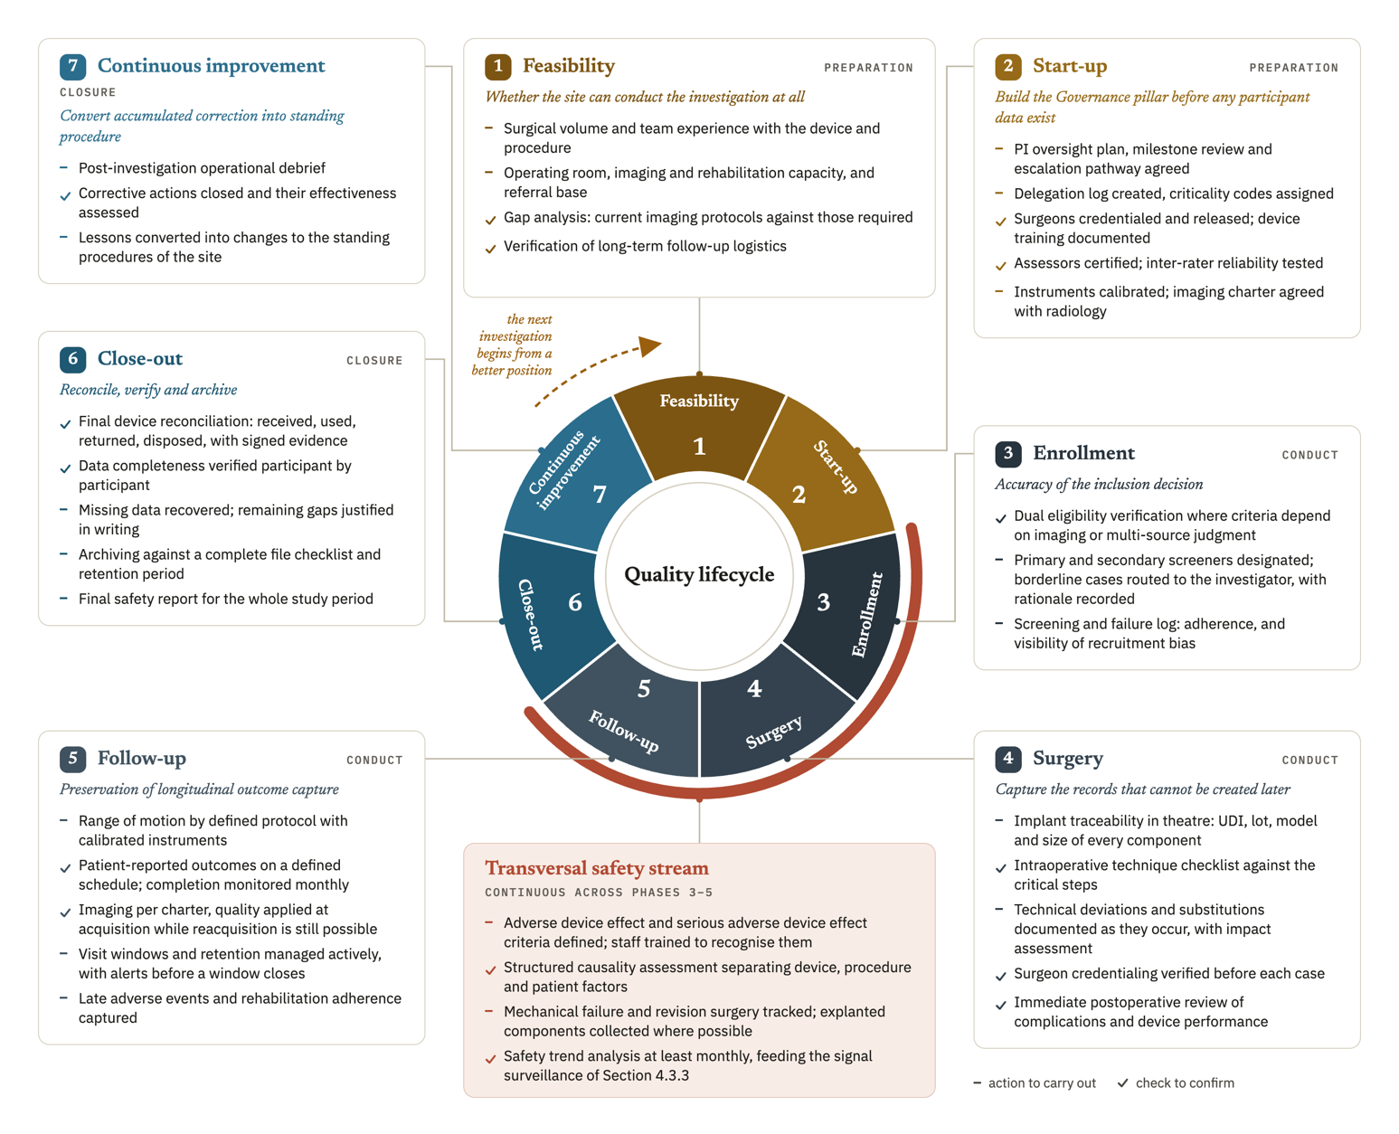
Figure 4.1. The seven-phase quality lifecycle and the transversal safety stream, with the actions, entry conditions, and objective of each phase, arranged to show that the cycle closes and feeds the next investigation.

The quality burden at close-out should decrease when controls in phases 3 to 5 work effectively, though Section 5.4 presents this as an expected benefit that no measurement has yet confirmed as an inverse proportional relationship. ICH E8(R1) Section 3.3.2 supports simplifying nonessential activity and directing resources to critical areas, which is the principle behind that expectation.

4.6.2 Why the sequence matters
The lifecycle is more than a schedule, since the ordering carries consequences of its own, and stating them makes the model useful.
Phase 2 precedes phase 3 because delegation, credentialing, and training determine who is permitted to make the decisions that phase 3 consists of. A site that begins enrolling while credentialing is incomplete has allowed uncontrolled decisions into its dataset, and it cannot identify afterward which decisions were affected.
Phase 1 precedes everything because a capability gap discovered later cannot be closed by better process. A site without adequate imaging capacity does not solve that problem with a better imaging charter.
The learning curve log has to begin at the first case, which is why it is initialized in phase 2, one phase before the first surgery. Its value lies entirely in the early cases, and an instrument that starts once a problem has been noticed has already missed what it was built to detect.
Safety runs transversally because events do not respect phase boundaries. A complication detected in follow-up may originate in a surgical decision made months earlier, and the ability of the framework to connect the two depends on both having been recorded when they occurred.
The general principle is that some quality failures concentrate in identifiable phases and take recurrent forms. Surgical complications may cluster during the early ascending phase of a surgeon's learning curve _{[22]}, while loss to follow-up accumulates over later years _{[24]}. These findings support phase-sensitive control, but do not prove that a lifecycle model is superior to an even distribution of effort. The framework therefore treats phase organization as a design hypothesis. It is consistent with ICH E8(R1) Section 3.3.2 and ICH E6(R3) Section 3.10.1.3, which direct quality resources toward critical activities and risks.
A simplified interactive model of the lifecycle was produced to illustrate the phase structure and the relationship between actions and CtQ factors. It was generated with the assistance of an artificial intelligence tool for illustrative purposes, and it is not itself a validated instrument. Screenshots and the access link are provided in Appendix Y.

4.7 The scalability model
A framework that completely ignored the academic centers or a well-resourced hospital would fail to achieve any significance, since those environments are the most prevalent in shoulder device investigations. The scalability model is therefore a condition of the relevance of the framework, and it answers DR12. Its principle is that the obligations are uniform but the implementation depth is not. We aim that every site that chooses to operate this framework is able to use it to the full extent, and what varies is how much structure each function requires.

4.7.1 Three site contexts
Type A covers large academic hospitals and established research institutions with dedicated research infrastructure. The category does not imply homogeneous quality maturity. Stakeholders from higher-level hospitals performed better on average in one survey, but substantial room for improvement remained _{[88]}. Experience from academic centers also shows that infrastructure has to be built and measured, while international clinical trial units vary in the services they provide _{[89, 90]}. Repeated institutional self-assessment is associated with improved research-conduct capability, although that relationship is correlational and the study could not establish causality _{[30]}. Variation also persists within a center because surgeons with comparable specialist training may stabilize at different case volumes _{[22]}. We do not offer the framework as a replacement for an institutional quality system. Its CtQ domains and surgical-context instruments address the named surgeon, device, and investigation, allowing a research unit inside a large institution to describe its own conduct at that level.
Mid-sized private practices and specialized orthopedic centers or hospitals with a meaningful volume of investigational activity fall under Type B. This is the context the framework was designed for, and it is the setting whose operational constraints are described in Section 3.4.5. Implementation here is full, with every instrument in use and every function assigned, operated by a small team where one person holds several functions.
Smaller centers and ambulatory surgical units participating in a limited number of investigations make up Type C. Implementation is reduced in depth to an essential core. That core comprises a delegation and training record, a risk register limited to the highest-risk domains, a device accountability record, a safety event record, and a PD record. Some of these elements operationalize requirements that ISO 14155:2026 or the MDR already establish. The instruments keep the same purpose in Type C, while the review cadence is lower, compatible records may be combined, and one person may hold more than one function.

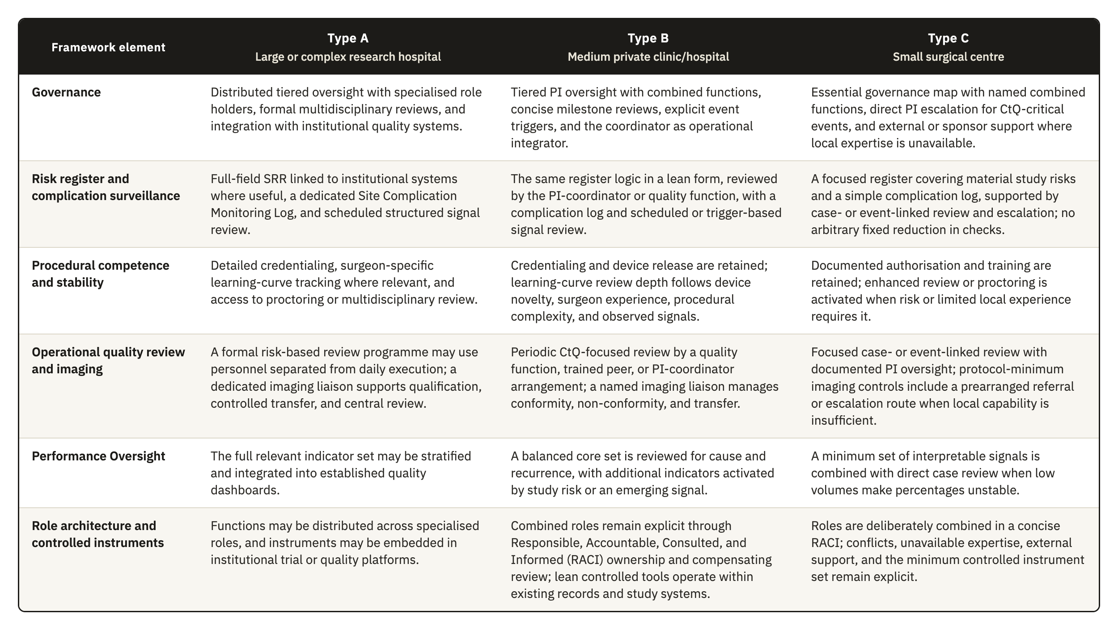
Table 4.3. The scalability model, with the implementation depth of six framework elements across Type A (large or complex research hospital), Type B (medium private clinic or hospital), and Type C (small surgical center) site contexts.

4.7.2 What does not scale
Reduced depth raises an obvious objection: a smaller center implementing less may become more exposed at inspection. This concern cannot be disregarded. MDR Article 72(5) permits inspection at an appropriate level, and ISO 14155:2026 Section 9.1(b) requires the sponsor to maintain records demonstrating that the investigation is conducted in compliance with the CIP, the standard, and applicable requirements. A smaller center is protected only to the extent that the minimum clause-linked controls and records remain complete, consistent, current, and retrievable. Scaling may reduce organizational depth, but it cannot remove evidence required to demonstrate compliant conduct.
The invariant is the clause-linked evidence needed to report, interpret, and verify the investigation, not a ranking of documentary completeness above organizational sophistication. The minimum record set includes informed-consent evidence under MDR Annex XV, Chapter II, Section 3.13 and ISO 14155 Clause 10.5; delegation and training records under ICH E6(R3) Sections 2.3.2 and 2.3.3, ISO 14155 Clauses 10.2 and 10.3, and MDR Annex XV, Chapter I, Section 2.7; device-accountability records under ISO 14155 Clause 7.9 and MDR Annex XV, Chapter II, Section 3.11; deviation records under MDR Annex XV, Chapter II, Section 3.10 and ICH E6(R3) Section 2.5.3; adverse-event records under ISO 14155 Clauses 7.4 and 8.3(a)(4) and MDR Annex XV, Chapter II, Section 3.14; calibration evidence under ISO 14155 Section 9.2.4.5(p) and Annex A.6.4; essential records under ISO 14155 Clause 8.6 and Annex E and ICH E6(R3) Appendix C; and the source definition required by ICH E6(R3) Section 2.12.2. MDR Article 72(3) requires investigation information to be recorded, processed, handled, and stored so that it can be accurately reported, interpreted, and verified. Documentary discipline is therefore achievable at any site type, while optional organizational layers may scale.

4.7.3 Escalation and de-escalation
Depth tracks the risk of the investigation as well as the type of the site. Implementation depth is raised whatever the site type where the investigation involves a first-in-human device, a procedure of unusual complexity, or endpoints with high observer variability. It may be reduced where an established device is used in a routine procedure with objective endpoints and an experienced surgical team. Calibration therefore follows the risk of the specific investigation, which the category of the center only approximates. This is what keeps the model consistent with the risk-proportionate principle. A Type C center running a first-in-human device implements more deeply than a Type B center running a well-established one.

4.8 The operational instrument set
The framework is operated through a defined set of instruments. We list them in one place for two reasons. The framework is usable only if a site can see what it has to produce, and several instruments are referred to at more than one point in the preceding sections. Every instrument is designed to be paper-compatible. None requires software, a license, or a system integration, which is the practical expression of DR11. A site with digital tools available may use them, and nothing in the framework depends on that.
Table 4.4 lists all twenty-four instruments with their purpose, the inputs each one consumes, how it processes them, and what it produces, grouped by the same four pillars.
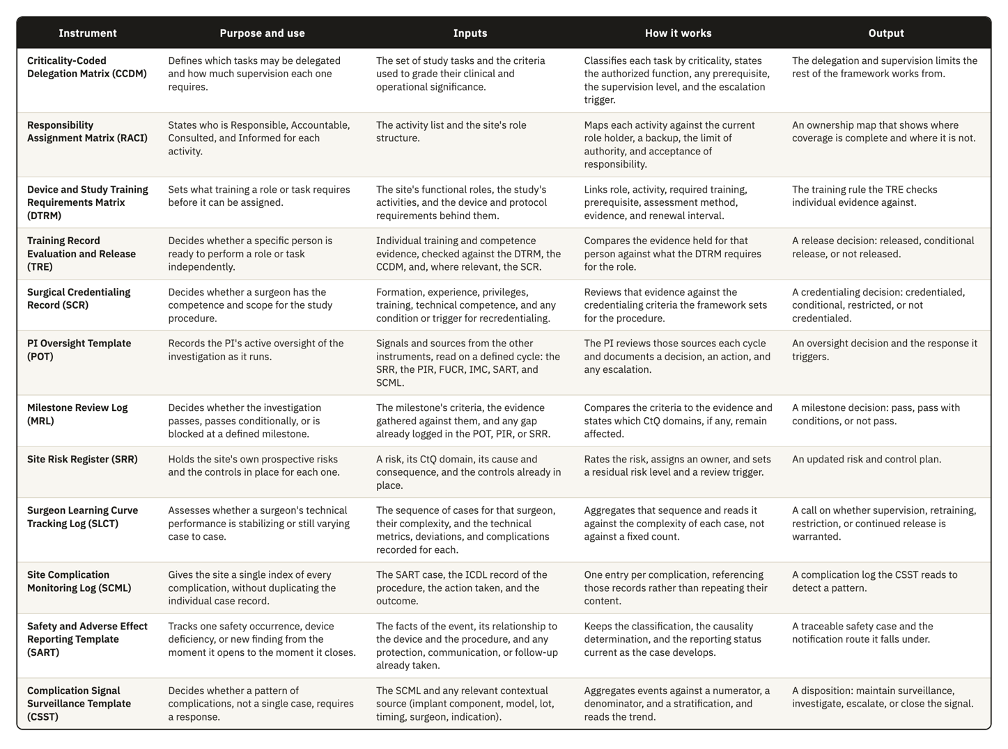
Table 4.4. The twenty-four instruments, with their purpose, the inputs each one consumes, how it processes them, and what it produces.

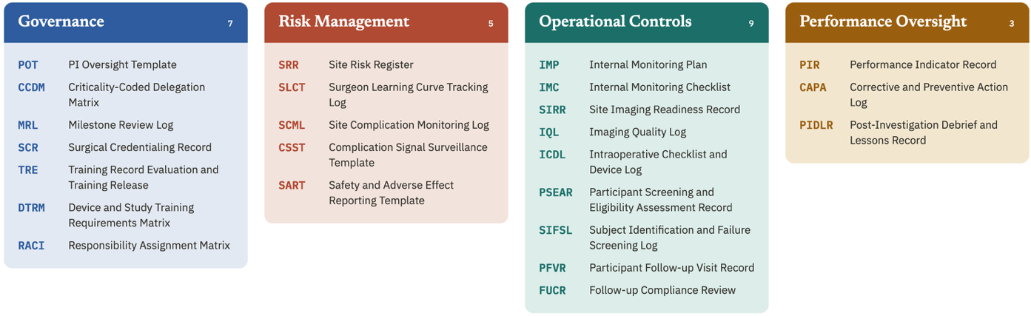
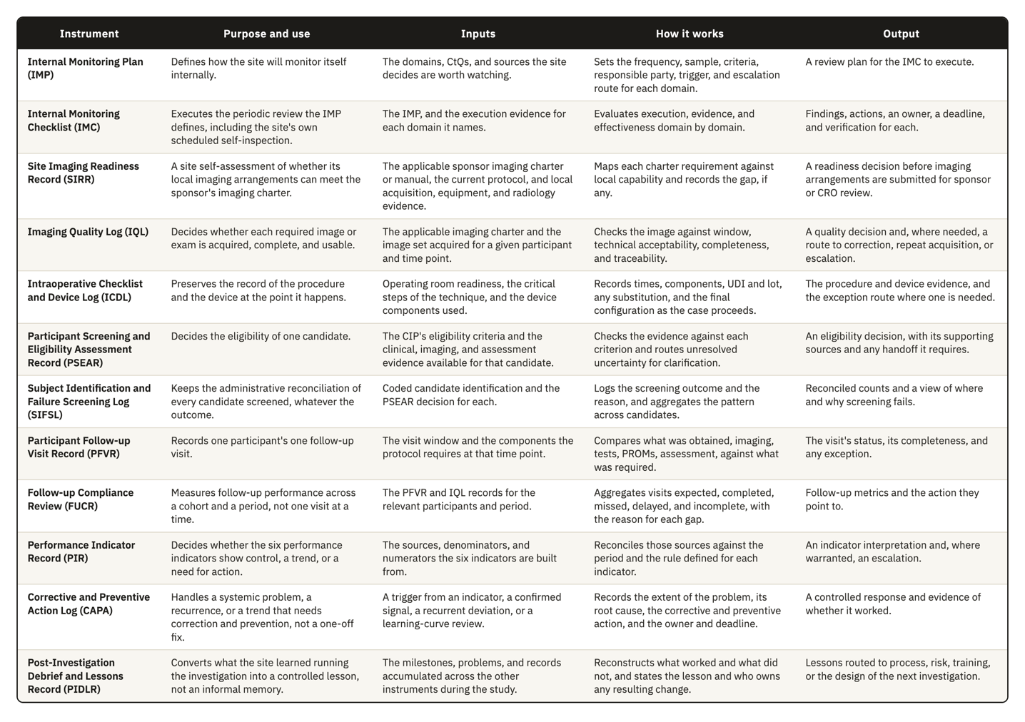
Figure 4.2 groups them by the pillar that owns each one, seven in Governance, five in Risk Management, nine in Operational Controls, and three in Performance Oversight.

Figure 4.2. The twenty-four instruments grouped by the pillar that owns each one: seven in Governance, five in Risk Management, nine in Operational Controls, and three in Performance Oversight, each shown by acronym with its full name.
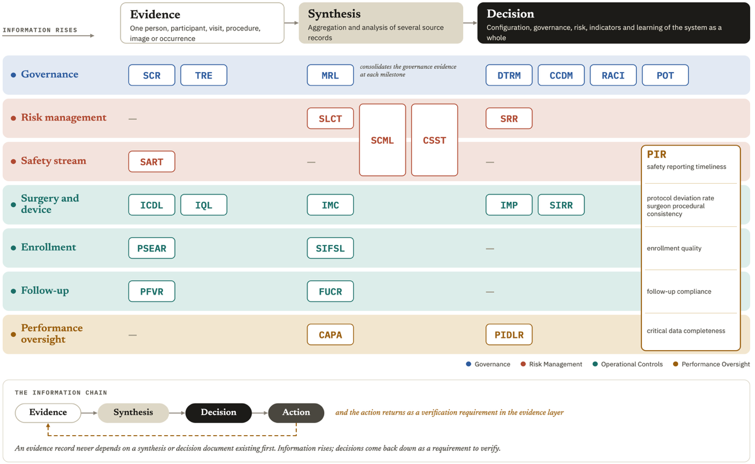
Figure 4.3 places the same twenty-four instruments on the axis that decides how they connect: the fine record one person, one event, or one image produces, the synthesis that aggregates several of those records, and the site-level decision the synthesis supports. The arrows mark the information chain this framework depends on throughout. Evidence rises from a fine record to a synthesis to a decision, and the decision returns to the fine layer as a requirement to verify.

Figure 4.3. The granularity of each instrument, from individual evidence to the site-level decision it supports, with the arrows marking the chain through which information rises and a verification requirement returns to the evidence layer. Rows group instruments by operational area, so Operational Controls appears as four groups, safety, surgery and device, enrollment, and follow-up.
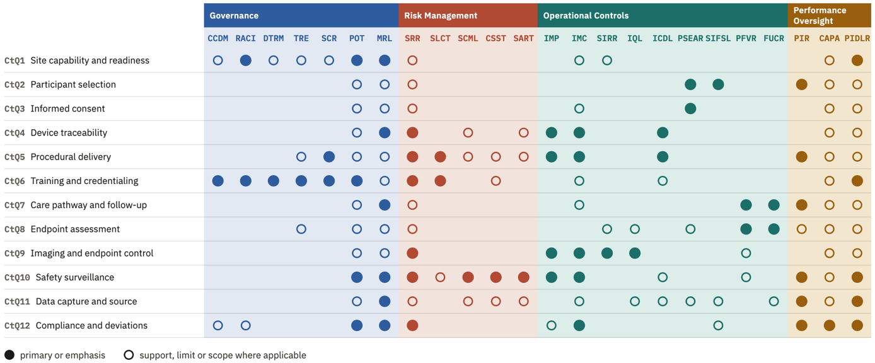
Figure 4.4 maps the same twenty-four instruments against the twelve CtQ domains from Section 2.4.2, marking where an instrument carries the primary control for a domain and where it only supports, limits, or scopes the control another instrument carries.

Figure 4.4. The twenty-four instruments mapped against the twelve CtQ domains, with a filled marker for a primary or emphasis relationship and an open marker where the instrument only supports, limits, or scopes another instrument's control.
Figure 4.5 maps the same instruments against the twelve design requirements from Section 3.5, distinguishing a direct answer to a requirement from one inherited through a combined or earlier instrument, from an extension added to the original set, and from a supporting contribution that does not carry the requirement on its own.
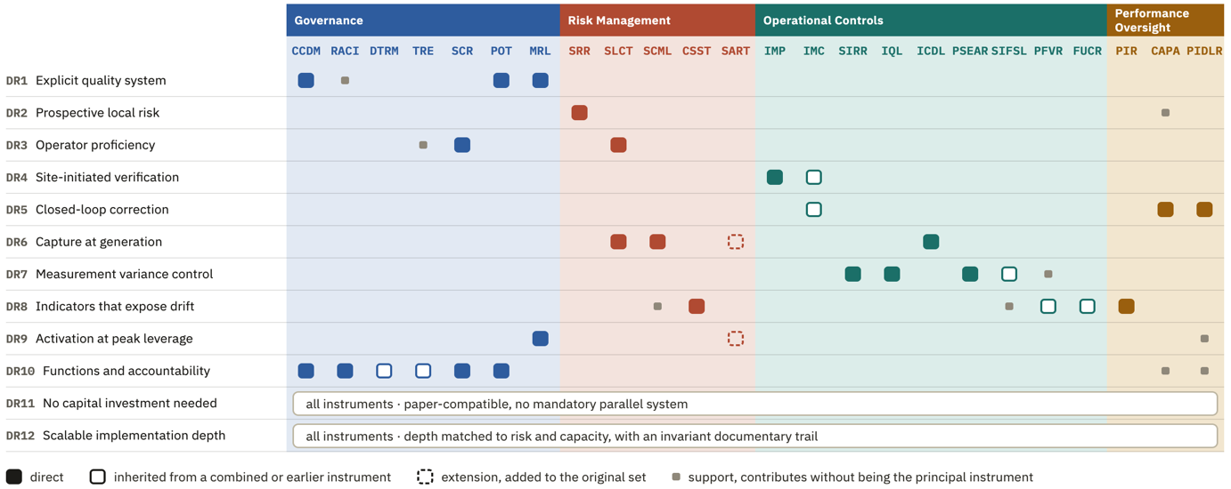

Figure 4.5. The twenty-four instruments mapped against the twelve design requirements, with a filled marker for a direct answer, an open marker for a relationship inherited from a combined or earlier instrument, a dashed marker for an extension added to the original set, and a small marker for a supporting contribution. DR11 and DR12 apply to all instruments as a set and are marked once for the whole set.
The templates were developed for shoulder device investigations, and their content reflects that context, particularly in the complication categories, the imaging requirements, and the complexity stratification used in the learning curve log. We nonetheless designed them to be as generic as the context allowed. The field structures, the review triggers, and the escalation logic carry no shoulder-specific assumption. Adapting an instrument to another surgical specialty would in most cases mean changing the content of the classification lists while leaving the structure intact.
Draft templates for all twenty-four instruments are provided in Appendices A through X.

5. Discussion

5.1 The principal contribution and the regulatory gap
Conducting an investigation well and showing that one operates a system are separate accomplishments, and a site can reach the first without the second. Section 1.1 described the movement from a prescriptive model of quality toward a governance model, and a governance review looks for the second.
Under the older arrangement the site supplied the conduct and the sponsor supplied the evidence that the conduct had been controlled, so a site needed no account of its own processes. ICH E6(R3) requires the investigator to put appropriate processes in place and to make sure that qualified staff and adequate resources support quality at the site. The text states this as a principle and does not say what the investigator produces to show it. Our reading is that a party co-responsible for quality has to be able to show how it carries that responsibility, and that a list of completed procedures does not show it. We use that reading to present the framework as one defensible way of evidencing site-level processes. No instrument makes it the required way, and a site could answer the same principle through another arrangement.
The center described in Section 3.4.4 can conduct an investigation properly and still be unable to show the control a governance review looks for, because it holds no account of its own processes to produce. Section 3.2 established that none of the three instruments we analyzed requires it to hold one. The difficulty is evidentiary before it is operational, so a site that already works carefully feels it first.
The four pillars synthesize functions that ISO 13485:2016, ISO 14971:2019, and ISO 15189:2022 require of the organizations they govern (Section 2.5.1). All twelve design requirements fell inside one of the four.
Before we settled on an architecture operated by the site, we examined three other routes to the same objective. The first places more of the load on the sponsor, who already carries clinical quality management under Clause 9.1 of ISO 14155:2026 and whom ICH E6(R3) addresses directly. The second works through the contract research organization, which many sponsors already contract to conduct monitoring and verification functions. A commercial software product forms the third route, since electronic systems can carry an investigator site file, document control, and structured records. We did not evaluate the availability or practical effect of those products in the target setting. Software can carry a quality architecture, but purchase alone does not determine which local processes are controlled or create a system the site owns. It is therefore an implementation medium, not a substitute for the architecture.
Section 3.2.1 established that the site is the only party in the conformity chain without a standard describing the quality system it operates. Chapter 3 did not measure resources or workload comparatively across the parties, so limited site resources are a condition of the target setting, and Chapter 3 gives no finding that the site holds fewer resources than every other party. Adding obligations to a party that already operates a described system changes neither the absence of a site-level quality architecture nor the need to keep that architecture proportionate to the setting. Deadlines for data entry, system-level edit checks, and required upload windows allow a sponsor to tighten a site from outside, and those controls reach the timeliness and completeness of a record. They do not reach the content of an intraoperative decision that nobody recorded while it was being made.
Removing these three routes does not establish that a site-owned architecture is the only workable answer. Hybrid arrangements and regional site networks remain open, as do shared services and tooling supplied by the sponsor, and we examined none of them. Our claim is narrower. Among the routes we did examine, none keeps the record in the hands of the site while also capturing information at the point of care and running on the infrastructure the target center has.
None of the instruments we analyzed tells a site to operate a quality system. That silence is the gap this work reports, so we cannot justify the framework by naming an obligation it satisfies. The justification runs backward. Each component answers a design requirement, and each requirement derives from a regulatory gap, from a Critical-to-Quality domain, or from an operating condition reported in Chapter 3. A reader can check any component against the analysis that produced it, in either direction. That correspondence shows internal coherence and nothing more. We derived the requirements and we assigned the components, so the mapping is not independent evidence, and it does not show that the components are necessary, that the set is complete, or that another set would perform worse.
Table 3.1 reports five site-level functions that none of the three instruments requires, and the framework proposes an operational response to each of the five. Four of those responses follow one pattern, where we take a principle the instruments state at sponsor level and build the site-level instrument they omit.
The four pillars answer the first gap as a whole, which is the absence of a structured quality management system at site level. ICH E6(R3) describes what such a system contains and requires it to be proportionate to the nature and complexity of the trial, and the obligation falls on the sponsor. ISO 14155:2026 gives the principal investigator substantive duties under Clause 10 and writes them as outcomes to be achieved. Those duties run for the whole investigation and have to be met repeatedly, so what the clause describes is a process without calling it one. Giving that implicit process an explicit structure adds organization to obligations the site already carries.
Pillar 2 answers the second gap, the absence of a risk register owned by the site, on the same reasoning. ICH E6(R3) and ICH E8(R1) require a risk management cycle oriented to Critical-to-Quality factors, and both address the sponsor, while the processes that generate the most consequential execution risks at a surgical center are local. Sponsor monitoring and oversight by a contract research organization do reach the site, although both operate from outside on a schedule the site does not set, and neither leaves the site with an account of its own risks when the assigned monitor changes. A 2023 study of Portuguese clinical trial sites found that 19.6% described a standard tool that systematically captured site-level risk analysis [77]. One national sample does not establish general practice. The figure does indicate that the gap appears in practice as well as in the texts.
The Internal Monitoring Plan answers the fourth gap, the absence of a verification function that the site itself starts, and the corrective and preventive action cycle with periodic self-inspection answers the fifth, the absence of a proactive improvement cycle. Both rest on principles ICH E6(R3) already states, shared quality responsibility and continuous improvement, and both are meant to sit alongside obligations that already exist.
Those four answers share one property that governs how the framework should be read. Each creates a duty a regulator could derive from duties the site already holds, so the framework supplies organization where the obligation already exists. The third gap is where that description stops applying.
None of the three instruments requires surgical proficiency to be observed during conduct, and all three require the investigator to be qualified at baseline and stop there. Within the corpus we analyzed, this is the only one of the five gaps with no counterpart obligation. The methodological literature reviewed in Section 3.4.2 does not support treating proficiency as a baseline state, since early cases differ systematically from cases performed after stabilization, and a difference of that origin can be attributed to the device when it belongs to the operator. Surgical Learning Curve Tracking therefore rests on a weaker derivation than the other four components. Applying Critical-to-Quality logic to an intervention delivered by a person whose execution changes over time produces operator learning as a first-order threat to data validity. Baseline qualification does not control a threat of that shape, because it measures a state at one moment and the threat is a trajectory.

5.2 Position in the literature
The operational quality infrastructure built for clinical research in general is the first of four bodies of work that bear on this problem. Quality assurance of the surgical intervention in trials is the second, the third measures the performance of sites, and the fourth reports empirically on how sites manage quality in practice. The first three produced instruments and the fourth produced evidence. None of the four places an integrated instrument in the hands of the site for its own use. Our narrative review did identify two partial site-operated precedents: the Clinical Trial Assessment of Infrastructure Matrix and ISO 9001 implementation in Italian clinical trial centers [30, 31]. Neither provides the integrated, site-owned architecture proposed here.
TransCelerate BioPharma developed a clinical quality management system together with a set of risk-based monitoring frameworks, and the Clinical Trials Transformation Initiative issued quality by design recommendations with the methodological tools that support them. The Medical Device Innovation Consortium supplement to the Critical-to-Quality framework extends the same approach to devices and recognizes that device trials can involve learning curves in product use. This general infrastructure is technically mature and written for the sponsor. It describes how a sponsor identifies Critical-to-Quality factors and allocates monitoring resources in proportion to risk, and it also covers how oversight is coordinated across several sites. The site receives controls designed elsewhere.
A systematic review of oncology trials sorted the reported challenges to surgical quality assurance under credentialing and standardization, with monitoring as a third group, and concluded that implementation and reporting of effective measures were inadequate [35]. The ROMIO study then developed concrete methods, including entry criteria for surgeons through assessment of operative videos [36], and two consensus exercises followed. A Delphi process with 71 stakeholders produced 59 strategies, of which 14 reached consensus for use within an active randomized trial [37]. A parallel Delphi with 40 experts from 15 countries produced a 13-item checklist for gastrointestinal surgery [38]. These four use expertise criteria at entry as their principal control over the operator, and none of them tracks the trajectory of an individual operator across cases while the trial runs. A review of randomized trials of arteriovenous grafts applied the same domains outside oncology and found quality assurance highly variable and poorly described, with no improvement across three decades. No included trial held a defined pre-trial monitoring program, and none assessed technical performance [39].
A systematic review of 109 quality improvement studies in surgical oncology found that 2 of 12 randomized trials demonstrated an effect on the primary outcome, against 86 of 97 non-randomized studies. Seventy-four of the included studies were uncontrolled before-and-after designs assessed as low quality [40]. The field has proposed a great deal and validated very little. The same observation applies to the present work, which proposes and does not validate.
Recent studies have pointed out that there are no standardized instruments for assessing the performance of clinical trial sites [29]. The Clinical Trial Site Performance Measure reduced 126 candidate indicators to 18, organized into four validated domains [41]. Those domains cover participant retention and consent, data completeness and timeliness, adverse event reporting and protocol compliance. That measure and the indicator set in Section 4.5 can be compared item by item. All four validated domains have a counterpart among our six indicators, since enrollment quality and follow-up compliance cover the first and critical data completeness covers the second. Safety reporting timeliness covers the third and the protocol deviation rate the fourth. The sixth indicator has no counterpart in the validated set, since surgeon procedural consistency addresses the delivery of the intervention and a measure built for trial sites in general has no reason to contain it.
The side of the comparison that runs against this work is the more important of the two. Those four domains survived a reduction from 126 candidates and a validation study, while our six rest on the domain analysis in Section 3.3 and on argument. A reader who asks which set is better evidenced should prefer the validated one. The two sets also differ in orientation. A validated performance measure is applied from outside to assess a site for another party, and it identifies the sites that are performing. An indicator operated by the site answers whether one of its own processes has begun to drift.
Several studies describe site-level quality management as reactive and ad hoc, and they connect that character to persistent data quality problems [42, 43, 44]. In one mature research network, about half of the participating sites used a standardized method for identifying adverse events [45]. Sites value risk-based monitoring and frequently experience it as an external requirement reaching them through the sponsor and the contract research organization [46, 47]. These studies record a site that responds case by case because it holds no local system able to produce a general response.
Diani and colleagues reported that a risk-based monitoring approach improved data quality in trials of implantable cardiac devices [48]. That study is the nearest prior work that combines site-level risk management with implantable devices and investigation quality, and it supports the plausibility of the approach without transferring causally to shoulder surgery. The orthopedic shoulder context differs in the respects that carry most weight here, since outcomes depend far more on operator technique and functional and radiographic assessment introduces standardization problems with no equivalent in the automated data streams of cardiac rhythm devices.
Our search returned no published direct comparison of ICH E6(R3) and ISO 14155, as Section 3.2 reports. The review was narrative and Section 5.7 states the limit that follows. A narrative search supports a claim about what we found, and it supports no claim about what the field contains beyond our search. Within that limit, the absence indicates that the reconciliation of the two frameworks has not reached the indexed literature, and a site drawing on both performs the reconciliation informally.

5.3 Design implications of the surgical and site context
Section 1.3 and Section 3.4.1 set out five conditions that separate surgical device investigations from the pharmacological model. This section reports the demand each condition placed on the design.
Operator dependence required a unit of analysis that clinical research does not normally use. Trials are organized around the participant and the case, and the surgeon is recorded as a delegated person. In a surgical investigation the surgeon is a source of correlated variance across every case that surgeon contributes, which the methodological literature treats as clustering [67]. A survey of 44 United Kingdom Clinical Trials Units found that 89% managed learning by setting a minimum expertise level for the treatment provider, and one unit reported analyzing learning effects as part of the main analysis [71]. Within that survey, control at entry was near universal and observation during conduct was near absent.
The framework adds the operator as a third unit of analysis, carried by the Surgeon Learning Curve Tracking Log and by the surgeon procedural consistency indicator, together with the credentialing and device release records. Operator dependence also fixes a limit on what any protocol can achieve, since a protocol defines a procedure in general terms and cannot standardize the many small decisions through which one surgeon implants one device in one anatomy. The site has to govern what the protocol cannot standardize, through credentialing that gates entry and learning curve tracking that observes stabilization, with periodic procedural review to detect drift afterward. Surgical judgment is part of the intervention, so the framework does not try to remove surgeon-dependent variation. It records that variation and makes it reviewable at the point where it threatens participant safety or endpoint interpretability.
Investigational devices are excluded from the MDR Unique Device Identification system under Article 27(1), so UDI-DI and UDI-PI are not themselves mandatory during the investigation. Traceability still has to be produced. ISO 14155:2026 requires the site to record the receipt date, identification, quantity, batch, serial number or unique code of each investigational device, together with the participant and any explantation date, while the MDR requires traceability for implantable devices and an implant card for the patient. These records are created in the operating room, under time pressure, by staff whose attention is on the procedure, and they cannot be reconstructed reliably if nobody captures them at implantation. The intraoperative decision to substitute a component and the technical deviation prompted by unexpected anatomy behave in the same way, as does the immediate postoperative image that may prove inadequate. Irreversibility and unit-level traceability therefore produced a demand about timing. DR6 states what the four data points share, and the intraoperative checklist and the device log answer it, together with the immediate capture of deviations and substitutions.
Classifications used in shoulder investigations show fair-to-moderate inter-observer reliability. Kappa coefficients for proximal humeral fractures have been reported in the fair range even when three-dimensional models reconstructed from computed tomography are used [62, 63]. Outcome domains and assessment time points also vary across shoulder arthroplasty trials, and that variability motivated core outcome sets for shoulder disorders [64, 65, 66]. Measurement is therefore a source of quality risk in this field before any site contributes variance of its own. A site-level framework cannot improve the reliability of a classification, since that problem belongs to the field and lies outside any one center. It can require the site to control the sources of measurement variance inside its own sphere, and the imaging charter and assessor qualification do that work, as does the standardized local review process with its timing rules. DR7 states the boundary and Section 4.4.2 records where the framework stops.
Range of motion and patient-reported outcomes require the participant to attend in person, with the same assessors and the same acquisition conditions at every time point, as does radiographic assessment. An assessment window that closes unmet closes permanently, which places follow-up in the same category as the operating room. The visit window controls and the retention measures answer that demand, with the follow-up compliance indicator reporting on both.
Each of the four demands concerns information generated inside the site, at a moment external oversight cannot independently generate or reliably reconstruct afterward. One qualification keeps the claim accurate. A sponsor can require that such information be captured at the time, through protocol requirements and system controls, with reporting deadlines attached, and remote systems can receive the resulting data almost in real time. No sponsor can perform the capture itself. The party present when the data are generated is the site, so an instrument that has to operate at that moment has to belong to the site.
The resources available at that site set the second group of constraints, and Section 3.5 treats the operational constraint as binding whenever two requirements point to different solutions. Investigation is not the primary business of the target center. It runs alongside a busy elective surgical practice, and research is neither the main nor the largest source of income, so the organization has little reason to build infrastructure for a complementary activity even where that infrastructure would be useful.
Sponsors negotiate against standardized Fair Market Value schedules, which gives a second reason. A sponsor will not pay a site above the regional rate for an elaborate internal quality system, because no contractual basis exists for it. Payment above Fair Market Value also creates compliance exposure under anti-inducement rules in the United States. We report that as a constraint documented for one jurisdiction, since we did not examine the equivalent rules in the European Union and the framework is designed under Regulation (EU) 2017/745. The claim that survives the jurisdictional limit is narrower. Research compensation in this field is calculated per procedure and per participant who completes the study, and it contains no line that funds internal quality infrastructure, so an avoidable error becomes a direct loss. Whether a control that prevents such an error returns more than it costs is a hypothesis we did not test, and testing it requires staff time per instrument on one side and the cost of the avoided events on the other.
Our registry analysis identified 65 non-hospital organizations among the 235 in the sample, or 27.7%. The group is a minority setting, and we selected it for the vulnerability it shows on the second variable, since 38 of those 65 organizations declare no permanent structure for clinical research, or 58.5% of the group. That variable records a declared organizational function and does not record budget, staffing, quality maturity, or access to software, so it supports a statement about how the group presents itself and no statement about what the group is technically able to run. The figure does establish that a majority of the organizations we designed for do not present a standing research function, and an instrument presuming a document management system, a validated electronic record, or a dedicated quality function would land where no such function is declared. Adoptability in a setting of limited technical complexity is therefore a requirement separate from low cost.
Sixty of those 65 organizations are located in the United States, which is 92.3% of the group, so the framework is designed under the European regulatory environment while the institutional phenotype it targets sits almost entirely in one non-European jurisdiction. Section 3.4.4 states which of the two governs the argument, and Section 5.7 records the limitation this places on every inference drawn from the registry.
Paper is the floor of the design, not its endpoint. Each instrument is a structure of fields, review triggers, classifications, and escalation rules, and no element of that kind depends on the medium carrying it. None of the instruments was designed to live only on paper: a center with an electronic investigator site file or a clinical trial management system can carry the same structures in it. We specified the paper form so that the center with the least infrastructure can operate the framework, and nobody has yet demonstrated that transfer, so it remains a property of the design and awaits testing.
Paper compatibility is a property of format, and it does not establish low operational burden. The two claims need separate evidence. The PI Oversight Template and the Milestone Review Log each create reviews and evidence that overlap at several points, as do the Site Risk Register, the Internal Monitoring Checklist and the Participant Follow-up Visit Record. Nobody has measured the total time they take.
Reduced implementation depth at a smaller center raises an objection about regulatory exposure, and the scalability model answers conditionally. Reduced depth creates no additional exposure provided that the minimum implementation criteria for each function are met and that the documentation trail is unbroken. The reasoning is that inspection assesses compliance through the completeness and internal consistency of the documentary record, and that the sophistication of the system producing the record is secondary. We state that as a premise we could not source, because we found no published study comparing inspection outcomes across systems of different sophistication, and a reader who rejects the premise should reject the scalability argument with it.
A Type C center reviews less often than a Type B center, which lengthens the interval before a signal is noticed. It combines records that a Type B center keeps separate, which reduces the independence between the instrument that raises a signal and the instrument that assesses it. It also assigns several functions to one person, weakening the separation between execution and oversight that DR10 requires. The escalation rules in Section 4.7.3 are meant to keep these losses proportionate to the risk of the specific investigation.

5.4 Expected mechanisms and operational interfaces
A lagging indicator measures an outcome after it has occurred, as a count of protocol deviations or a revision rate does. A leading indicator measures a process before the outcome it predicts has materialized, as a trend in operative time within one complexity stratum does. A lagging indicator establishes what happened, while a leading indicator establishes whether something is beginning to happen while there is still room to act.
Our six indicators combine the two classes, and DR8 states the preference for the second without making it a property of every measure in the set. Three of them read a process while it runs, since enrollment quality operates in part before each inclusion, critical data completeness reads the current state of the record, and surgeon procedural consistency reads operative time and intraoperative adaptations as cases accumulate. The other three count events that have already occurred, since a protocol deviation rate and a follow-up compliance rate each measure something that has happened, as does safety reporting timeliness. Each of those three can still serve as an early signal for a deterioration ahead, so their temporality has to be defined against the outcome predicted in each case. Calling the whole set leading would misdescribe half of it.
The most distinctive instruments of the framework do read process states, since the learning curve log and the signal surveillance template measure how work is being performed, as do the internal monitoring findings. This is a direct expression of the quality by design premise, which holds that quality is managed by controlling the processes that produce outcomes. A process signal becomes operable only when a rule converts it into an action. The rule has to exist before the pattern appears, so the site applies a threshold it chose in advance and does not choose one once it has seen the pattern.
The same logic runs in time through the lifecycle, whose claim is that a quality activity performed at the wrong moment does not perform its function. The model rests on a premise this work does not test, namely that quality failures concentrate in predictable phases and take predictable forms. If the premise holds, activating each instrument where it has leverage concentrates effort where the risk sits. The lifecycle is the site-level analogue of the risk-proportionate principle ICH E6(R3) applies at sponsor level. We expect a site that defers this work to carry a larger backlog into close-out. That relationship is a mechanism we propose and did not measure, and measuring it requires unresolved queries at database lock and staff hours spent on close-out, compared between sites that operated the framework during conduct and sites that did not.
None of the six indicators has been validated. Nobody has demonstrated that a growing query backlog predicts a data integrity failure, or that operative time failing to fall within a stratum predicts a complication. A claim about prediction without a validation study is an assumption, and the cost of a wrong assumption is concrete, since a site that acts on a signal with no predictive value spends scarce effort on a process that was working.
The defense rests on what each indicator measures and on when it moves, and neither ground is psychometric. Each indicator measures an attribute with a documented route to a Critical-to-Quality domain identified in Section 3.3, so the connection between the measure and the thing at risk is argued from the domain analysis. Each also moves at a point where the site retains the ability to act. On those two grounds the set is defensible at the design stage, and its predictive value remains unestablished.
Calling the framework sponsor-complementary means nothing until the points where the two quality systems meet are named, since those points decide whether complementarity is real. Three of them can be specified.
At a monitoring visit a site operating the framework presents a maintained risk register, a current delegation log with criticality coding, and a corrective and preventive action log, together with indicator data for the period. A monitor who receives those records stops reconstructing the conduct of the site from primary documents alone, and reviews a site that has already characterized its own risks and documented its own corrections. Adams and colleagues describe the adoption of risk-based monitoring and the part central monitoring plays within it [91]. That work does not test a site-owned risk register, so the incremental value of these records is a hypothesis, and measuring it means comparing monitoring time spent on reconstruction with and without the site records in hand.
A site that documents a weakness has created a record a monitor can read, so the first interface carries a disincentive. A finding the site raised against itself is still a finding, while a site that keeps no such record has nothing to hand over. The framework asks a center to accept that exposure, and the argument for accepting it is that the alternative leaves the same weakness in place and unrecorded, where it reaches a participant or an endpoint before anyone names it. We have no evidence on how monitors treat self-declared findings in practice.
A site with a functioning corrective and preventive action process answers a monitoring finding through a mechanism that already exists, which forms the second interface. That site can show that it corrected the specific instance and that it addressed the cause, and that difference separates a corrective action from a cosmetic one. A site without such a process improvises an answer that leaves no record for the next monitor to use.
The sponsor verifies the qualifications of the principal investigator and the adequacy of the site under Clause 6.8 of ISO 14155:2026, at the third interface. A site arriving with its own risk register and oversight plan gives the sponsor documentary evidence on two of the points Clause 6.8 asks it to judge. Those records show that the site has identified the risks of its own execution and has defined how it will supervise them. Without those records the same judgment rests on interviews and on the state of the files.
The sponsor works across several sites at the level of the trial, and the site works on its own processes. Complementarity therefore excludes duplication of sponsor monitoring, which would consume resources the target center does not have, and Section 4.4.1 concentrates the internal monitoring function on the point-of-care domains that sponsor monitoring cannot reach in time. It also excludes the opposite arrangement, where a quality system of the site is absorbed into the system of the sponsor, which would remove the layer this work exists to create. Clause 6.12 of the fourth edition allows the sponsor to establish a Clinical Events Committee, which keeps event assessment consistent across participating centers, and that committee and the Complication Signal Surveillance Template address the same problem from two levels. A cluster confined to one center reaches the threshold for a local response long before it reaches a trial-level signal, so the local instrument acts first and the committee acts on a wider base.
Whether documenting a practice improves it is the objection that bears on every claim in this section, since a site can record its conduct impeccably and conduct itself badly. No evidence in this thesis settles the question, so what follows is an argument about mechanism together with its limits. The claim we can defend is narrower than the objection assumes. Tighter controls and documentation written for the specific activity leave fewer gaps open, so less passes unnoticed. The claim concerns the probability that a failure goes undetected, and it says nothing about the quality of the conduct itself.
Failures in clinical investigation have several origins. Lapse and competing demands on the same person are two of them, while inadequate study design, systems that do not fit the work, workload and ambiguity in the applicable requirements are others, and we have no observational basis for ranking them. Deliberate non-compliance and fraud form a separate category this framework does not address, since a person who intends to misrepresent conduct will misrepresent the record as readily as the act. The framework addresses the subset of failures nobody noticed in time, whatever produced them. A failure that nobody sees is not corrected by greater diligence, because diligence cannot act on what it cannot detect, and an instrument that raises the failure into view converts it into something a person can respond to.
Suppose the framework produces no change in conduct at all and its only effect is a complete and traceable record of what the site did. That outcome is still preferable to the alternative, where the same conduct occurs and leaves no record anyone can examine. A complete record improves reconstruction and auditability directly. Whether it protects a participant depends on someone reviewing it and responding in time, so documentary visibility and effective protection are separate achievements. The framework produces the first directly and the second only through the review rules attached to each instrument.
A second mechanism concerns the people who perform the work, and we treat it as an expectation with no established effect behind it. Staff who know that their work is reviewed in detail may attend differently to what they do, and the review also teaches the standard, since a person who sees which elements are checked learns which elements matter. The expectation cuts in two directions, because observation can change behavior toward the record while leaving the conduct as it was. Two features of the design reduce that risk without removing it. The instruments record decisions, identifiers and dates, with classifications attached, and avoid narratives where a person assesses their own performance, so a unique device identifier is captured or missing and no amount of attention to the record improves it beyond capture. Most instruments are also read by someone other than the person who completed them.
A cost sits on the other side of this argument, and it falls on the resource Section 5.3 identifies as scarce. Every hour a coordinator spends on a record is an hour unavailable for a visit, a query, or a follow-up call, so if documentation produces no improvement in conduct the framework has consumed the one thing the target center cannot spare. That risk is why the instrument set was held to the minimum that answers the twelve design requirements.
The value of the record becomes clearest when discontinuity occurs: a coordinator may leave, a monitor may change, a principal investigator may be replaced, or a question a previous monitor had settled may be reopened. A site holding a documented architecture carries its own history through each of these events. A site without one has no controlled record to carry across a handover, which is the fragility Section 3.4.5 reports.

5.5 Practical, ethical, and regulatory implications
A site that decides to adopt the framework faces twenty-four instruments and has to begin somewhere, and the dependencies between them settle the order. The seven Governance instruments come first, because all seven can be completed before the first participant exists and start-up determines whether the participant data that follow will be usable. The Site Risk Register follows, since it has to open during feasibility to hold the preventive value Section 4.6 describes, and the Internal Monitoring Plan and the learning curve log come next, since both depend on cases having started. Five of the six indicators come last, as each needs accumulated observations before a trend means anything, with enrollment quality as the exception. We propose this order as a testable sequence, and a center that adopts all twenty-four at once will operate none of them well.
At site qualification a sponsor can ask whether the site holds a risk register of its own and an oversight plan, together with a corrective action process, and each of those records speaks to a point Clause 6.8 asks a sponsor to judge. During conduct the sponsor can adjust monitoring intensity against the signals the site produces. Risk-based monitoring asks exactly that of a sponsor, and a site without local signals cannot support it. Whether either change requires an amendment to the Clinical Investigation Plan depends on how that plan and the monitoring plan are written in the specific investigation, and on the sponsor-site agreement. Clause 6.7 places the monitoring strategy in the monitoring plan, which makes the adjustment possible without an amendment in many arrangements, and we do not claim that it holds generally.
A notified body and a competent authority encounter the investigation through different objects. The notified body assesses device conformity and clinical evaluation, while the competent authority may inspect investigation sites. The clinical evaluation report carries clinical evidence, while the local architecture that produced it remains at the site unless it is requested during an inspection. Within the present texts, an authority asking a site to produce its own risk register, internal monitoring findings, or corrective action record would be asking for documents no clause expressly requires. A site that operates the framework and a site that operates nothing therefore present the same regulatory surface.
ISO 14155:2026 was published on 23 March 2026, and the gaps reported here are seen through the lens of this thesis, which is centered on the site. The standard has a wider purpose and the fourth edition used the revision to turn existing requirements into something usable. Several of the gaps we describe follow from reading the text from one position, and a future revision might reasonably decline to close them.
No clause requires the investigational site to maintain a register of the risks arising from its own execution, although Clause 6.2 requires the sponsor to manage risk across three streams. Clause 6.2.2 covers risks related to the use of the investigational device, which remain inside the ISO 14971 framework. Clause 6.2.3 covers risks related to clinical procedures required by the Clinical Investigation Plan outside routine clinical practice, and Clause 6.2.4 covers risks related to the clinical investigation process. The second and third fall outside ISO 14971 and are assessed descriptively. The standard assigns all three streams to the sponsor, so each class of risk has a named owner. The text does not describe the local process through which a site handles the part of those risks its own execution generates.
Clause 9.2.4.5 p) requires routine monitoring visits to verify that maintenance and calibration of the equipment relevant to assessment is performed and documented, and Annex A.6.4 adds calibration to the content of the Clinical Investigation Plan. Keeping the equipment in that condition is continuing work performed at the site, and no clause describes the record through which the site demonstrates it. Clause 6.12 introduces the Clinical Events Committee and creates no local counterpart.
These observations differ in size, and the difference matters for what can reasonably be proposed. A clause requiring a site to maintain a risk register would ask for one document and one review cycle. A clause requiring a structured quality management system at site level would ask for something far larger, and expecting a center to build one voluntarily is probably unrealistic for the reasons Section 5.3 sets out. The sponsor already operates a clinical quality management system under Clause 9.1 and already supplies the site with a protocol and an Investigator Brochure, together with training, so a sponsor could supply a quality architecture on the same terms. Construction would then sit with the party that can absorb the cost and operation with the party present when the data are generated. Ownership and derivation separate that proposal from the first two routes Section 5.1 removed, since the site would operate the architecture and own the records it produces.
The version of the standard carrying a presumption of conformity is the harmonized version, EN ISO 14155:2020+A11:2024, listed under Regulation (EU) 2017/745 in OJ L 2026/193. The 2026 edition represents the current state of the art while the 2020 edition remains the harmonized one, so a site in the European Union works to one text while the field moves to another. Harmonization of the fourth edition would be the moment to examine what the MDR imposes regionally as a minimum structure at site level, since Annex XV governs the conduct of clinical investigations and says nothing about how a site organizes itself to conduct them. We offer these as observations from one position and we do not present them as a program for a standards body.
Clinical investigations are conducted on people who consent to accept risk in the service of knowledge, and the quality of conduct at the site measures how seriously that consent is honored. A delayed safety report in an investigation of an implantable device postpones the identification of a device-related signal, and the delay reaches participants at every enrolled center, including those the reporting center never saw. An incomplete traceability record can make it impossible to attribute a complication to the lot that produced it. An eligibility error exposes a participant to a procedure the protocol meant to exclude them from, and Section 3.4.1 explains why a surgical error of that kind cannot be undone. The participant carries the risk of all three failures and sees none of the quality system. Whether a site is fit to conduct the investigation is judged by the sponsor at qualification, by the ethics committee at approval, and by the site itself in the conduct of every case, and none of the three judgments reaches the person whose shoulder is opened. The framework addresses the third, which is the one currently supported by no described architecture.
Section 4.3.2 records surgeon-dependent variation, and a record of that kind is an assessment of professional performance in substance, since it holds performance by named surgeon and can lead to a restriction on the cases a surgeon takes. That raises a second ethical question, this time about the people the instruments observe. Describing the learning curve log as an instrument that does not assess professional performance is therefore inaccurate, and its use has to be governed as a quality instrument with possible professional consequences. The design constrains that use by coding the surgeon identifier and leaving the key with the principal investigator, by defining the outcomes available to a review before the first case, and by requiring the reasoning behind any restriction to be documented.
The residual risk concentrates where the site owns the practice of the surgeon it observes. In a hospital the authority to restrict a surgeon to lower-complexity cases sits outside the ownership of the institution, while in a surgeon-owned practice the person deciding and the person restricted may be the same person or close colleagues, and so may the person carrying the commercial consequence. Safeguards outside this framework remain available, among them independent review, external adjudication and the institutional ethics committee, and none of them lies inside the reach of a site-level design. Within what the framework itself can do, placing the decision with the principal investigator and requiring its reasoning to be documented is the safeguard it provides.

5.6 Transferability and boundary conditions
The framework was developed for shoulder device investigations and Section 1.3 gives the reason for narrowing to one discipline. Whether it transfers to other implant-based surgical specialties is a separate question, and the instruments themselves supply most of the answer.
The instruments separate into a transferable structure and the content held inside it. The field structure, review triggers, and escalation logic carry no anatomical content, and neither does the architecture’s refusal to set a shoulder-only range-of-motion value or a universal minimum number of cases for habituation to a procedure. The complication categories and the imaging charter do carry anatomical content and would need replacement for another specialty. The five complexity strata used in the learning curve log may provide a useful starting structure for another arthroplasty setting, but their transferability has not been validated and their content requires specialty-specific review. The derivation from general implant-surgery obligations makes structural adaptability plausible; it does not establish it. Section 4.8 should be read with that distinction, since its statement that the templates reflect the shoulder context refers primarily to the content of those lists.
Neither the MDR nor ISO 14155:2026 distinguishes a shoulder device from a knee device or a hand prosthesis, and both refer generally to the investigational device and to the clinical procedures the Clinical Investigation Plan requires. The obligations that produced these instruments are therefore transversal across implant surgery. That derivation makes structural adaptability plausible without establishing it, since an instrument can meet a general obligation through a form that suits one specialty alone.
The claim holds for implant-based surgical investigations, where the operator delivers the intervention, the device is traceable at unit level, and outcome assessment depends on imaging and on functional measurement. It does not hold for non-surgical device investigations, where operator dependence takes a different form, and it does not hold for surgical investigations without an implant, where unit-level traceability does not arise.
Applying the instrument set to a hip or knee device investigation and recording which fields required alteration would establish how much of the structure survives the move, and that test is direct and inexpensive. If only classification entries change, the claim holds. If review triggers, escalation rules, or field structures have to be rebuilt, the framework is a shoulder instrument we described too broadly. Nobody has performed that test, so structural adaptability remains a property we designed for and did not demonstrate.

5.7 Limitations and validation priorities
This is a design-oriented thesis and its result is an artifact justified by argument and by traceability to regulatory obligations and to the methodological literature. It is not a hypothesis tested against data. Section 2.1.1 reports four of the six activities of the Design Science Research Methodology, and the two it does not report are demonstration and evaluation.
Whether the learning curve log produces earlier detection of procedural drift is the first of three questions that therefore remain open. Whether the complication monitoring design improves the completeness of adverse event ascertainment is the second, and whether the indicator set detects loss of control while correction remains possible is the third. Answering any of them requires field implementation and measurement. The absence of any implementation weakens the claims in Section 5.3 about protected margin and the claims in Section 5.4 about earlier detection and about conduct. None of them is a finding, and the regulatory analysis in Chapter 3 and the design derivation in Chapter 4 do not depend on them.
The framework asks a center to operate twenty-four instruments, and no site has operated even one of them under the framework. This limitation concerns volume, a separate matter from the question of effect. Whether a team of one investigator and one coordinator, with operating room staff, can sustain the full set through a complete investigation is unknown, and no evidence shows that the scalability model in Section 4.7 answers that risk.
The literature review was narrative and Section 2.2.3 explains the choice. A narrative review supports a map of the problem space. It does not support a claim that a body of work is absent from the field, so the absence of a published direct comparison of ICH E6(R3) and ISO 14155 is a result of our search. The position claimed in Section 5.2 describes the works we read. The evidence base for the problem itself rests on published literature and regulatory guidance, with expert commentary. We did not assess site standard operating procedures, investigation files, or audit data directly, since this work had no access to them, so the gap the framework addresses rests on what the literature reports about the state of practice. Field research across the three site types would calibrate the framework against observed failure modes, which the present version infers.
The framework was designed for the European regulatory environment, under Regulation (EU) 2017/745 with ISO 14155 as the operative Good Clinical Practice standard. The United States context is governed by a different structure of investigator obligations and a different device accountability framework, with different adverse event reporting arrangements. This limitation has grown sharper since the registry analysis, which placed 60 of the 65 non-hospital organizations in the United States. The setting the framework was designed for and the jurisdiction it was designed under are two different places, and Section 3.4.4 has to state which of the two governs the argument.
The registry analysis in Section 2.3 has limitations of its own, and each one bounds a different inference. The classification rests on self-declared institutional identity, which bounds the environment assignment, since an organization presenting itself as a specialized institute may operate as a general hospital department. The sample is weighted toward the United States, with 149 of the 235 organizations located there, and registration on ClinicalTrials.gov is mandatory for a large share of studies conducted there and voluntary elsewhere, which together bound any statement about the global distribution of these investigations. Normalizing facility records to organizations required judgments about ownership and naming that rest on public sources. All classifications were verified case by case and reviewed in a second internal pass, and no independent second assessor reviewed them, which bounds the reproducibility of the environment assignment and of every other judgment in this thesis. Eight of the 235 organizations remain unresolved on the trials structure variable, and the percentages reported here keep them in the denominator.
Among all the limitations recorded here, the absence of an implementation matters most. Removing it would convert the central claims of this discussion from expectations into findings, and removing any of the others would not.
An implementation study is therefore the first piece of work this thesis leaves open. It would place the framework in a small number of Type B centers, run it through at least one full investigation, and measure four classes of variable. The first is indicator values paired with the outcomes they are supposed to anticipate. The second is effort per instrument, measured in staff time, which tests the cost argument in Section 5.3 and the risk named in Section 5.4. The third is record completeness against a defined checklist, and the fourth is the proportion of deviations the site detected before the monitor found them, which measures most directly whether the framework does what it claims.
The design of that study runs into a volume constraint. We have not recalculated the median number of sites or the median target enrollment for the 46 investigations in the current sample, so no figure is given here. An investigation spread across several centers and closed at a modest target enrollment leaves each center with a small number of cases over several years, which supports a feasibility study of whether the instruments can be operated and does not support validating six indicators. Feasibility and validation therefore need separate designs, and only the first is available to a single-center study. Such a study would also settle two questions this discussion could only raise. Whether a monitor treats a self-declared finding differently from one discovered during a visit determines whether the disincentive described in Section 5.4 is real, and whether documentation changes conduct requires measuring conduct as well as records.
Content review and usability testing come first in the validation sequence, because an instrument nobody can complete correctly cannot be evaluated for anything else. Feasibility and fidelity of operation come second, with workload measurement attached to both, and signal validity comes third, with outcome effects last, since each stage depends on the one before it holding.
Indicator validation can proceed separately and needs no full deployment. A retrospective study using existing site records could pair historical indicator values with the events that followed them, and pooling records across several centers of one sponsor would supply the volume a single site cannot. Query backlog and reporting timeliness are recoverable from most trial databases, while operative time by complexity stratum is recoverable only where the site recorded the stratum.
The transferability test described in Section 5.6 requires no new investigation. Applying the instrument set to the documentation of a completed hip or knee device investigation would establish how much of the structure survives the move between specialties, measured as the set of fields that required alteration. Section 5.5 describes a route where a sponsor builds the architecture and the site operates it. One sponsor could pilot that arrangement across several of its sites in a single investigation, which would also test whether the instruments carry into an electronic system without structural change.
Two smaller pieces of work would strengthen the evidence base of this thesis directly. A second coder applied to the registry classification would address the reproducibility limitation recorded above. A versioned master index of the instrument set, giving each instrument a code, a version, a pillar, a lifecycle phase, an owner, and the records it links to, would let a reader audit the claim that the framework contains twenty-four instruments.

6. Conclusion
This thesis set out to answer a question that ICH E6(R3) and ICH E8(R1) raise without resolving: once the investigational site shares responsibility for quality, what structure does it use to discharge that responsibility. Chapter 3 located the reason no existing instrument answers the question already. The site is the only party in the device conformity chain without a documented quality system, while the manufacturer holds ISO 13485, the risk function holds ISO 14971, and the sponsor holds ISO 14155:2026 Clause 9. Chapter 4 built the missing layer: four pillars, Governance, Risk Management, Operational Controls, and Performance Oversight, operated through twenty-four paper-compatible instruments across a seven-phase lifecycle.
Every component in that architecture traces back to a design requirement, and every design requirement traces back to a regulatory gap, a site-level Critical-to-Quality domain, or an operating condition of the target center. Section 3.5 states the twelve requirements, and Table 4.1 maps each one to the component that answers it. Nothing in the framework asserts an obligation the regulatory analysis does not already imply, with one exception. Surgical Learning Curve Tracking answers no clause directly, because no instrument examined here requires operator proficiency to be observed once conduct has started. Section 5.1 treats that exception as the framework's most exposed claim and its clearest addition to what the field already requires.
The registry analysis in Section 2.3 is the one part of this work that produces an empirical finding of its own, and the rest reports a design. It shows that a meaningful share of the organizations running shoulder device investigations, roughly one in four in the sample examined, present no publicly documented permanent research structure. That finding does not measure conduct or resources directly, and Section 5.7 states its limits, but it supports treating the resource-limited, non-hospital center as an empirically grounded part of the target population.
This thesis establishes something narrower than the framework itself, and still worth stating plainly. It derives a site-level quality architecture for surgical device investigations without inventing an obligation, built from instruments a resource-limited center can operate on paper, and organized so that a reader can check any single component against the regulatory clause, the CtQ domain, or the operating condition that produced it. That traceability is the property Section 5.1 argues for over the alternative of asking the sponsor or a commercial vendor to supply the same architecture from outside. A framework built on that alternative would reach the site without making the site the party that holds it.
Chapter 4 therefore delivers a design produced through four of the six Design Science Research activities defined in Chapter 2. Section 5.7 names the two activities it does not report, demonstration and evaluation, as the limitation that weighs most on every claim in Chapter 5. No site has operated any instrument in this set. The expectations built into the design, reduced effort at close-out, earlier detection of procedural drift, protected margin at a resource-limited center, remain expectations until an implementation study measures them against a center that runs the framework through a complete investigation. Section 5.7 states what that study would need to establish.
The architecture was built for one surgical specialty by design, and Section 5.6 states what would have to hold for it to transfer. The field structure, review triggers, and escalation logic carry no assumption specific to the shoulder. The classification lists and the imaging views do, together with the five-stratum learning-curve model built around them. Whether the first survives a move to another implant-based specialty while the second is replaced is a claim this thesis makes and does not test.
Section 1.2 opened this thesis by describing a shift from a model in which the sponsor supplies the account of what happened at the site to one in which the site is expected to hold that account itself. A center that conducts a shoulder device investigation carefully can still fail to produce that account, since holding an account of its own processes was never assigned to it in the first place. The four pillars, the twenty-four instruments, and the seven-phase lifecycle are one answer to what that account should look like. Whether it is the right answer, at the right depth, for the centers it was built for, is the question Section 5.7 leaves to the field to test.
The framework does not close the gap between what the site is asked to demonstrate and what it currently has to demonstrate it with. It gives one traceable structure for closing it, derived clause by clause from the texts that created the gap in the first place.

References
- European Medicines Agency. Reflection paper on risk based quality management in clinical trials. London: European Medicines Agency; 2013 Nov. Report No.: EMA/269011/2013.
- Bhatt A. Quality of Clinical Trials: A Moving Target. Perspectives in Clinical Research. 2011;2(4):124–8. doi:10.4103/2229-3485.86880 PubMed PMID: 22145123.
- International Council for Harmonisation of Technical Requirements for Pharmaceuticals for Human Use. ICH harmonised guideline: Integrated addendum to ICH E6(R1): Guideline for Good Clinical Practice E6(R2). Geneva: ICH; 2016.
- Bharati V, Rajaram S, Prakash A, Medhi B. International Council for Harmonisation E6 (R3): The Good Clinical Practice, Recent Developments, and Global Perspective. Indian Journal of Pharmacology. 2025;57(1):1–3. doi:10.4103/ijp.ijp_152_25 PubMed PMID: 40324824.
- International Council for Harmonisation of Technical Requirements for Pharmaceuticals for Human Use. ICH harmonised guideline: General considerations for clinical studies E8(R1). Final version, Step 4, adopted 6 October 2021. Geneva: ICH; 2021.
- International Council for Harmonisation of Technical Requirements for Pharmaceuticals for Human Use. ICH harmonised guideline: Guideline for Good Clinical Practice E6(R3). Final version, Step 4, adopted 6 January 2025. Geneva: ICH; 2025.
- Muet F. Rethinking good clinical practice: A shift from guidelines to governance in ICH GCP E6(R3). Regulatory Affairs Watch. 2025 Sep;(10):4–10. doi:10.54920/SCTO.2025.RAWatch.10.4
- International Organization for Standardization. ISO 14155:2026. Clinical investigation of medical devices for human subjects—Good clinical practice. 4th ed. Geneva: ISO; 2026.
- European Commission. Commission Implementing Decision (EU) 2026/193 of 28 January 2026 amending Implementing Decision (EU) 2021/1182 as regards harmonised standards for medical devices. Official Journal of the European Union. 2026 Jan 30;L 2026/193.
- European Parliament, Council of the European Union. Regulation (EU) 2017/745 of 5 April 2017 on medical devices. Official Journal of the European Union. 2017 May 5;L117:1–175.
- United States Congress. Federal Food, Drug, and Cosmetic Act, 21 USC ch. 9 (1938, as amended).
- Electronic Code of Federal Regulations. Title 21, Chapter I: Food and Drug Administration; Parts 312 and 812 [Internet]. Washington (DC): U.S. Government Publishing Office [cited 2026 Sep 20]. Available from: https://www.ecfr.gov/current/title-21/chapter-I
- Florez M, Dirks A, Sullivan L, Young S, Getz K. Adoption Maturity Model for Risk-Based Quality Management (RBQM) in Clinical Trials. Therapeutic Innovation & Regulatory Science. 2025;59(3):549–57. doi:10.1007/s43441-025-00746-6 PubMed PMID: 39953206.
- Fuson RL, Sherman M, Van Vleet J, Wendt T. The Conduct of Orthopaedic Clinical Trials. The Journal of Bone and Joint Surgery American Volume. 1997;79(7):1089–98. doi:10.2106/00004623-199707000-00019 PubMed PMID: 9234889.
- Jalbert JJ, Ritchey ME, Mi X, Chen CY, Hammill BG, Curtis LH, et al. Methodological Considerations in Observational Comparative Effectiveness Research for Implantable Medical Devices: An Epidemiologic Perspective. American Journal of Epidemiology. 2014;180(9):949–58. doi:10.1093/aje/kwu206 PubMed PMID: 25255810.
- Buccheri S, James S, Mafham M, Landray M, Melvin T, Oldgren J, et al. Large Simple Randomized Controlled Trials—from Drugs to Medical Devices: Lessons from Recent Experience. Trials. 2025;26(1):24. doi:10.1186/s13063-025-08724-x
- Fraser AG, Buccheri S, Byrne RA, Kjaersgaard-Andersen P, James S, Jüni P, et al. Recommended Methodologies for Clinical Investigations of High-Risk Medical Devices—Conclusions from the European Union CORE–MD Project. The Lancet Regional Health – Europe. 2025;58:101460. doi:10.1016/j.lanepe.2025.101460
- McCulloch P, Altman DG, Campbell WB, Flum DR, Glasziou P, Marshall JC, et al. No Surgical Innovation without Evaluation: The IDEAL Recommendations. The Lancet. 2009;374(9695):1105–12. doi:10.1016/S0140-6736(09)61116-8 PubMed PMID: 19782876.
- Sedrakyan A, Marinac-Dabic D, Normand SLT, Mushlin A, Gross T. A Framework for Evidence Evaluation and Methodological Issues in Implantable Device Studies. Medical Care. 2010;48(6 Suppl):S121–8. doi:10.1097/MLR.0b013e3181d991c4 PubMed PMID: 20421824.
- Avendano JP, Sudah SY, Gencarelli P, Imam N, Manzi JE, Ghajar M, et al. The Learning Curve for Anatomic and Reverse Total Shoulder Arthroplasty: A Systematic Review. JSES Reviews, Reports, and Techniques. 2023;3:150–9. doi:10.1016/j.xrrt.2022.12.001
- Daher M, Ilyas MH, Gonzalez-Morgado D, Steinmann SP, Abboud JA, Kassam HF. Defining Surgeon Experience Thresholds for Outcomes and Complications in Shoulder Arthroplasty. Journal of Shoulder and Elbow Arthroplasty. 2026;10(1–2):100020. doi:10.1016/j.jsea.2026.100020 PubMed PMID: 42182085.
- Taniguchi S, Hirakawa Y, Manaka T, Nakazawa K, Ito Y, Terai H. Assistant Experience Enhances Surgical Efficiency and Postoperative Outcomes in Reverse Shoulder Arthroplasty. Journal of Shoulder and Elbow Surgery. 2026. doi:10.1016/j.jse.2026.06.020 PubMed PMID: 42398667.
- Somerson JS, Bartush KC, Shroff JB, Bhandari M, Zelle BA. Loss to Follow-up in Orthopaedic Clinical Trials: A Systematic Review. International Orthopaedics. 2016;40(11):2213–9. doi:10.1007/s00264-016-3212-5 PubMed PMID: 27142421.
- Torrens C, Martínez R, Santana F. Patients Lost to Follow-up in Shoulder Arthroplasty: Descriptive Characteristics and Reasons for Loss to Follow-up. Clinics in Orthopedic Surgery. 2022;14(1):112–8. doi:10.4055/cios21034 PubMed PMID: 35251548.
- Sidor ML, Zuckerman JD, Lyon T, Koval K, Cuomo F, Schoenberg N. The Neer Classification System for Proximal Humeral Fractures: An Assessment of Interobserver Reliability and Intraobserver Reproducibility. The Journal of Bone and Joint Surgery American Volume. 1993;75(12):1745–50. doi:10.2106/00004623-199312000-00002 PubMed PMID: 8258543.
- Shukla DR, McLaughlin RJ, Lee J, Cofield RH, Sperling JW, Sánchez-Sotelo J. Intraobserver and Interobserver Reliability of the Walch Classification Using Two- and Three-Dimensional Computed Tomography for Primary Glenohumeral Arthritis. Journal of Shoulder and Elbow Surgery. 2019;28(4):625–30. doi:10.1016/j.jse.2018.09.021 PubMed PMID: 30528438.
- Chelli M, Gasbarro G, Lavoué V, Gauci MO, Raynier JL, Trojani C, et al. The Reliability of the Neer Classification for Proximal Humeral Fractures: A Systematic Review. JSES International. 2022;6(3):331–7. doi:10.1016/j.jseint.2022.02.006 PubMed PMID: 35572425.
- Bakobaki JM, Rauchenberger M, Joffe N, McCormack S, Stenning S, Meredith S. The Potential for Central Monitoring Techniques to Replace On-site Monitoring: Findings from an International Multi-centre Clinical Trial. Clinical Trials. 2012;9(2):257–64. doi:10.1177/1740774511427325 PubMed PMID: 22064687.
- Buse JB, Austin CP, Johnston SC, Lewis-Hall F, March AN, Shore CK, et al. A Framework for Assessing Clinical Trial Site Readiness. Journal of Clinical and Translational Science. 2023;7(1):e151. doi:10.1017/cts.2023.541 PubMed PMID: 37456265; PubMed Central PMCID: PMC10346039.
- Dimond EP, Zon RT, Weiner BJ, St. Germain D, Denicoff AM, Dempsey K, et al. Clinical Trial Assessment of Infrastructure Matrix Tool to Improve the Quality of Research Conduct in the Community. Journal of Oncology Practice. 2016;12(1):63–4, e23–35. doi:10.1200/JOP.2015.005181 PubMed PMID: 26627979.
- Franchina V, Stabile S, Cenna R, Mannozzi F, Federici I, Testoni S, et al. ISO 9001:2015 Standard Implementation in Clinical Trial Centers: An Exploratory Analysis. Contemporary Clinical Trials Communications. 2023;33:101104. doi:10.1016/j.conctc.2023.101104 PubMed PMID: 37397430.
- Meeker-O’Connell A, Sam LM, Bergamo N, Little JA. TransCelerate’s Clinical Quality Management System: From a Vision to a Conceptual Framework. Therapeutic Innovation & Regulatory Science. 2016;50(4):397–413. doi:10.1177/2168479016651300 PubMed PMID: 30227025.
- Meeker-O’Connell A, Glessner C, Behm M, Mulinde J, Roach N, Sweeney F, et al. Enhancing Clinical Evidence by Proactively Building Quality into Clinical Trials. Clinical Trials. 2016;13(4):439–44. doi:10.1177/1740774516643491 PubMed PMID: 27108014; PubMed Central PMCID: PMC4952025.
- Medical Device Innovation Consortium. Medical device supplement to the CTTI quality by design project: Critical to quality (CTQ) factors principles document. Medical Device Innovation Consortium; 2016.
- Butterworth JW, Boshier PR, Mavroveli S, van Lanschot JBB, Sasako M, Reynolds JV, et al. Challenges to Quality Assurance of Surgical Interventions in Clinical Oncology Trials: A Systematic Review. European Journal of Surgical Oncology. 2021;47(4):748–56. doi:10.1016/j.ejso.2020.10.002 PubMed PMID: 33059943.
- Blencowe NS, Skilton A, Blazeby J, Avery K, Brierley R, Gaunt D, et al. Protocol for Developing Quality Assurance Measures to Use in Surgical Trials: An Example from the ROMIO Study. BMJ Open. 2019;9(3):e026209. doi:10.1136/bmjopen-2018-026209 PubMed PMID: 30826769; PubMed Central PMCID: PMC6429900.
- Butterworth JW, Boshier PR, Mavroveli S, Reynolds JV, Kim YW, Hanna GB. A Proposed Framework of Strategies to Overcome Challenges to Surgical Quality Assurance in Oncology Trials (SQA-Onc.). European Journal of Surgical Oncology. 2025;51(5):109593. doi:10.1016/j.ejso.2025.109593 PubMed PMID: 39826446.
- van der Aa DC, Henckens SPG, Bonjer HJ, Tuynman JB, Besselink MG, Blencowe NS, et al. A Framework for Surgical Quality Assurance (SQA) in Randomized Controlled Trials in Gastrointestinal Surgery: An International Delphi Consensus Study. eClinicalMedicine. 2025;90:103634. doi:10.1016/j.eclinm.2025.103634 PubMed PMID: 41206560; PubMed Central PMCID: PMC12661345.
- Kingsmore DB, Edgar B, Aitken E, Calder F, Franchin M, Geddes C, et al. Quality Assurance in Surgical Trials of Arteriovenous Grafts for Haemodialysis: A Systematic Review, a Narrative Exploration and Expert Recommendations. The Journal of Vascular Access. 2024;26(2):389–99. doi:10.1177/11297298241236521 PubMed PMID: 38501338.
- Rashid A, Sukumar S, Dodkins J, Zachou G, Fearnhead NS, Walker K, et al. Quality Improvement Interventions in Surgical Oncology: Systematic Review of International Studies. BJS Open. 2026;10(3):zrag053. doi:10.1093/bjsopen/zrag053 PubMed PMID: 42159325.
- Bozzetti M, Lo Cascio A, Napolitano D, Orgiana N, Mora V, Fiorini S, et al. Measuring What Matters in Trial Operations: Development and Validation of the Clinical Trial Site Performance Measure. Journal of Clinical Medicine. 2025;14(19):6839. doi:10.3390/jcm14196839 PubMed PMID: 41095920; PubMed Central PMCID: PMC12524836.
- Houston L, Probst Y, Yu P, Martin A. Exploring Data Quality Management within Clinical Trials. Applied Clinical Informatics. 2018;9(1):72–81. doi:10.1055/s-0037-1621702 PubMed PMID: 29388180; PubMed Central PMCID: PMC5801732.
- Ansmann EB, Hecht A, Henn DK, Leptien S, Stelzer HG. The Future of Monitoring in Clinical Research—A Holistic Approach: Linking Risk-Based Monitoring with Quality Management Principles. GMS German Medical Science. 2013;11:Doc04. doi:10.3205/000172 PubMed PMID: 23382708; PubMed Central PMCID: PMC3563312.
- de Viron S, Trotta L, Steijn W, Young S, Buyse M. Does Central Statistical Monitoring Improve Data Quality? An Analysis of 1,111 Sites in 159 Clinical Trials. Therapeutic Innovation & Regulatory Science. 2024;58(3):483–94. doi:10.1007/s43441-024-00613-w PubMed PMID: 38334868; PubMed Central PMCID: PMC11043176.
- Miller TP, Marx MZ, Henchen C, DeGroote NP, Jones S, Weiland J, et al. Challenges and Barriers to Adverse Event Reporting in Clinical Trials: A Children’s Oncology Group Report. Journal of Patient Safety. 2022;18(3):e672–9. doi:10.1097/PTS.0000000000000911 PubMed PMID: 34570002; PubMed Central PMCID: PMC8940729.
- Kumar PP, Dalal J, Jadhav MP. Risk Based Monitoring (RBM): A Global Study Focusing on Perception and Merits among Clinical Investigational Sites. Contemporary Clinical Trials Communications. 2016;4:155–60. doi:10.1016/j.conctc.2016.09.002 PubMed PMID: 29736479; PubMed Central PMCID: PMC5935899.
- Jaguste VS. Risk-Based Monitoring: Review of the Current Perceptions and Toward Effective Implementation. Perspectives in Clinical Research. 2019;10(2):57–61. doi:10.4103/picr.PICR_18_18 PubMed PMID: 31008070; PubMed Central PMCID: PMC6463506.
- Diani CA, Rock A, Moll P. An Evaluation of the Effectiveness of a Risk-Based Monitoring Approach Implemented with Clinical Trials Involving Implantable Cardiac Medical Devices. Clinical Trials. 2017;14(6):575–83. doi:10.1177/1740774517723589 PubMed PMID: 28819983.
- Peffers K, Tuunanen T, Rothenberger MA, Chatterjee S. A Design Science Research Methodology for Information Systems Research. Journal of Management Information Systems. 2007;24(3):45–77. doi:10.2753/MIS0742-1222240302
- Stergiopoulos S, Getz KA, Blazynski C. Evaluating the Completeness of ClinicalTrials.gov. Therapeutic Innovation & Regulatory Science. 2019;53(3):307–17. doi:10.1177/2168479018782885 PubMed PMID: 30048602.
- Chaturvedi N, Mehrotra B, Kumari S, Gupta S, Subramanya HS, Saberwal G. Some Data Quality Issues at ClinicalTrials.gov. Trials. 2019;20(1):378. doi:10.1186/s13063-019-3408-2 PubMed PMID: 31234923.
- International Organization for Standardization. ISO 13485:2016. Medical devices—Quality management systems—Requirements for regulatory purposes. 3rd ed. Geneva: ISO; 2016.
- International Organization for Standardization. ISO 14971:2019. Medical devices—Application of risk management to medical devices. 3rd ed. Geneva: ISO; 2019.
- International Organization for Standardization. ISO 15189:2022. Medical laboratories—Requirements for quality and competence. 4th ed. Geneva: ISO; 2022.
- Clinical Trials Transformation Initiative. CTTI quality by design project: Critical to quality (CTQ) factors principles document. Clinical Trials Transformation Initiative; 2015.
- Seibyl J, Marek K, Zubal IG. The Role of the Core Imaging Laboratory in Multicenter Trials. Seminars in Nuclear Medicine. 2010;40(5):338–46. doi:10.1053/j.semnuclmed.2010.03.002 PubMed PMID: 20674593.
- Roemer FW, Collins JE, Hochberg MC, Kompel AJ, Diaz LE, Hayashi D, et al. The Role of Radiography and MRI as Screening Tools and Outcome Measures in Clinical Trials of Knee Osteoarthritis: A Perspective on the Current Status and Outlook. Therapeutic Advances in Musculoskeletal Disease. 2026;18:1759720X251411062. doi:10.1177/1759720X251411062 PubMed PMID: 41488611.
- Ergina PL, Cook JA, Blazeby JM, Boutron I, Clavien PA, Reeves BC, et al. Challenges in Evaluating Surgical Innovation. The Lancet. 2009;374(9695):1097–104. doi:10.1016/S0140-6736(09)61086-2 PubMed PMID: 19782875.
- Blencowe NS, Mills N, Cook JA, Donovan JL, Rogers CA, Whiting P, et al. Standardizing and Monitoring the Delivery of Surgical Interventions in Randomized Clinical Trials. British Journal of Surgery. 2016;103(10):1377–84. doi:10.1002/bjs.10254 PubMed PMID: 27462835.
- Patra DP, Syal A, Rahme RJ, Abi-Aad KR, Singh R, Turcotte EL, et al. A Comparison of Treating Physician versus Independent Core Lab Assessments of Post-Aneurysm Treatment Imaging Outcomes: An Analysis of Prospectively Collected Data from a Randomized Trial. Journal of Neurosurgery. 2023;139(1):85–93. doi:10.3171/2022.10.JNS22841 PubMed PMID: 36681980.
- Biscombe K, Porta N, Conaghan PG, Doran SJ, Ribeiro A, Mallett S, et al. PROspectiVe Imaging Research DEsign and coNducT (PROVIDENT): Considerations for Clinical Trials and Studies Using Imaging (Part II). Radiography. 2026;32(3):103329. doi:10.1016/j.radi.2026.103329
- Lippe J, Spang JT, Leger RR, Arciero RA, Mazzocca AD, Shea KP. Inter-rater agreement of the Goutallier, Patte, and Warner classification scores using preoperative magnetic resonance imaging in patients with rotator cuff tears. Arthroscopy: The Journal of Arthroscopic & Related Surgery. 2012;28(2):154–9. doi:10.1016/j.arthro.2011.07.016 PubMed PMID: 22019235.
- Majed A, MacLeod I, Bull AMJ, Zyto K, Resch H, Hertel R, et al. Proximal humeral fracture classification systems revisited. Journal of Shoulder and Elbow Surgery. 2011;20(7):1125–32. doi:10.1016/j.jse.2011.01.020 PubMed PMID: 21481611.
- Sims MT, Detweiler BN, Scott JT, Howard BM, Detten GR, Vassar M. Inconsistent selection of outcomes and measurement devices found in shoulder arthroplasty research: An analysis of studies on ClinicalTrials.gov. PLOS ONE. 2017;12(11):e0187865. doi:10.1371/journal.pone.0187865 PubMed PMID: 29125866.
- Gagnier JJ, Page MJ, Huang H, Verhagen AP, Buchbinder R. Creation of a core outcome set for clinical trials of people with shoulder pain: a study protocol. Trials. 2017;18(1):336. doi:10.1186/s13063-017-2054-9 PubMed PMID: 28728574.
- Ramiro S, Page MJ, Whittle SL, Huang H, Verhagen AP, Beaton DE, et al. The OMERACT Core Domain Set for Clinical Trials of Shoulder Disorders. The Journal of Rheumatology. 2019;46(8):969–75. doi:10.3899/jrheum.181070 PubMed PMID: 30709947.
- Cook JA, Bruckner T, MacLennan GS, Seiler CM. Clustering in Surgical Trials—Database of Intracluster Correlations. Trials. 2012;13:2. doi:10.1186/1745-6215-13-2 PubMed PMID: 22217216.
- Kahan BC, Morris TP. Assessing Potential Sources of Clustering in Individually Randomised Trials. BMC Medical Research Methodology. 2013;13:58. doi:10.1186/1471-2288-13-58 PubMed PMID: 23590245.
- Oltean H, Gagnier JJ. Use of Clustering Analysis in Randomized Controlled Trials in Orthopaedic Surgery. BMC Medical Research Methodology. 2015;15:17. doi:10.1186/s12874-015-0006-1 PubMed PMID: 25887529.
- Conroy EJ, Blazeby JM, Burnside G, Cook JA, Gamble C. Managing Clustering Effects and Learning Effects in the Design and Analysis of Randomised Surgical Trials: A Review of Existing Guidance. Trials. 2022;23(1):869. doi:10.1186/s13063-022-06743-6 PubMed PMID: 36221107.
- Conroy EJ, Blazeby JM, Burnside G, Cook JA, Gamble C. Managing clustering effects and learning effects in the design and analysis of multicentre randomised trials: a survey to establish current practice. Trials. 2020;21(1):433. doi:10.1186/s13063-020-04318-x
- Conroy EJ, Rosala-Hallas A, Blazeby JM, Burnside G, Cook JA, Gamble C. Randomized Trials Involving Surgery Did Not Routinely Report Considerations of Learning and Clustering Effects. Journal of Clinical Epidemiology. 2019;107:27–35. doi:10.1016/j.jclinepi.2018.11.004 PubMed PMID: 30439544.
- Mentz RJ, Peterson ED. Site Principal Investigators in Multicenter Clinical Trials: Appropriately Recognizing Key Contributors. Circulation. 2017;135(13):1185–7. doi:10.1161/CIRCULATIONAHA.116.026650
- Sramek JJ, Carrillo MS, Cutler NR. Establishing a Clinical Trial Site: A Primer for Aspiring Principal Investigators. Contemporary Clinical Trials Communications. 2025;48:101561. doi:10.1016/j.conctc.2025.101561
- Anderson C, Young PA, Berenbaum A. Food and Drug Administration Guidance: Supervisory Responsibilities of Investigators. Journal of Diabetes Science and Technology. 2011;5(2):433–8. doi:10.1177/193229681100500234
- Feehan AK, Garcia-Diaz J. Investigator Responsibilities in Clinical Research. Ochsner Journal. 2020;20(1):44–9. doi:10.31486/toj.19.0085
- Vale M, Leite F, Madeira C. Risk Management in Clinical Trials: Assessment of Current Practices at Portuguese Clinical Trial Sites. Risk Management and Healthcare Policy. 2023;16:2353–65. doi:10.2147/RMHP.S426411 PubMed PMID: 37881165; PubMed Central PMCID: PMC10595157.
- Testa EJ, Lowe JT, Namdari S, Gillespie RJ, Sears BW, Johnston PS, et al. Operative Duration-Based Learning Period Analysis for Reverse and Total Shoulder Arthroplasty: A Multicenter Study. Shoulder & Elbow. 2018;12(1 Suppl):23–30. doi:10.1177/1758573218811635
- U.S. Food and Drug Administration. Oversight of clinical investigations: A risk-based approach to monitoring. Guidance for industry. Silver Spring (MD): U.S. Food and Drug Administration; 2013 Aug. Docket No.: FDA-2011-D-0597.
- Gottlieb K, Daperno M, Usiskin K, Sands BE, Ahmad H, Howden CW, et al. Endoscopy and Central Reading in Inflammatory Bowel Disease Clinical Trials: Achievements, Challenges and Future Developments. Gut. 2020;70(2):418–26. doi:10.1136/gutjnl-2020-320690
- Suter T, Gerber Popp A, Zhang Y, Zhang C, Tashjian RZ, Henninger HB. The Influence of Radiographic Viewing Perspective and Demographics on the Critical Shoulder Angle. Journal of Shoulder and Elbow Surgery. 2015;24(6):e149–58. doi:10.1016/j.jse.2014.10.021
- Bouaicha S, Hoch A, Jentzsch T, Moor BK. Impact of Vertical and Horizontal Malrotation on Measurements of Anteroposterior Radiographs of the Scapula: Need for Standardized Images in Modern Omometry. Journal of Shoulder and Elbow Surgery. 2018;27(4):659–66. doi:10.1016/j.jse.2017.10.006
- Shibayama Y, Imamura R, Hirose T, Sugi A, Mizushima E, Watanabe Y, et al. Reliability and Accuracy of the Critical Shoulder Angle Measured by Anteroposterior Radiographs: Using Digitally Reconstructed Radiograph from Three-Dimensional Computed Tomography Images. Journal of Shoulder and Elbow Surgery. 2023;32(2):286–91. doi:10.1016/j.jse.2022.07.017
- Deger GU, Davulcu CD, Karaismailoglu B, Palamar D, Guven MF. Are Acromiohumeral Distance Measurements on Conventional Radiographs Reliable? A Prospective Study of Inter-Method Agreement with Ultrasonography, and Assessment of Observer Variability. Joint Diseases and Related Surgery. 2024;35(1):62–71. doi:10.52312/jdrs.2023.1288
- Sheth M, Khoo K, Telfer S, Schiffman C, Matsen F, Hsu J. How Much Does Radiographic Projection Affect the Measurement of Glenoid Inclination? International Orthopaedics. 2026;50(3):619–24. doi:10.1007/s00264-026-06758-7
- Vulcano D. A pragmatic guide for migrating investigator sites to ICH E6(R3). Association of Clinical Research Professionals and Society for Clinical Research Sites; 2026.
- Aibinder W, Schoch B, Parsons M, Watling J, Ko JK, Gobbato B, et al. Risk Factors for Complications and Revision Surgery after Anatomic and Reverse Total Shoulder Arthroplasty. Journal of Shoulder and Elbow Surgery. 2021;30(11):e689–701. doi:10.1016/j.jse.2021.04.029
- Li W, Ailimu K, Jia N, Chu H, Zhao Y, Tao L, et al. Stakeholder Perception of Quality Management of Investigator-Initiated Clinical Trials. BMC Medical Ethics. 2025;27(1):10. doi:10.1186/s12910-025-01354-7
- Mullen CG, Houlihan JY, Stroo M, Deeter CE, Freel SA, Padget AM, et al. Leveraging Retooled Clinical Research Infrastructure for Clinical Research Management System Implementation at a Large Academic Medical Center. Journal of Clinical and Translational Science. 2023;7(1):e127. doi:10.1017/cts.2023.550
- Hoffmann JM, Bluemle A, Grossmann R, Yau H, Lang B, Bradbury C. Toward a Global Harmonization of Service Infrastructure in Academic Clinical Trial Units: An International Survey. Frontiers in Medicine. 2023;10:1252352. doi:10.3389/fmed.2023.1252352
- Adams A, Adelfio A, Barnes B, Berlien R, Branco D, Coogan A, et al. Risk-Based Monitoring in Clinical Trials: 2021 Update. Therapeutic Innovation & Regulatory Science. 2023;57(3):529–37. doi:10.1007/s43441-022-00496-9

Appendices
Each of the first twenty-four appendices holds the draft template for one instrument of the operational framework developed in Chapter 4. The order follows Table 4.4. The seven Governance instruments and the five Risk Management instruments come first, the nine Operational Controls instruments follow, and the three Performance Oversight instruments close the set. Every template was developed for shoulder device investigations. Section 4.8 already states which parts of that content are specific to the procedure and which structures carry no such assumption, so a template can be adapted to another surgical specialty without a change to its underlying logic. Appendix Y holds the screenshots and the access link of the interactive lifecycle model described in Section 4.6.2.

Appendix A
Appendix A. Criticality-Coded Delegation Matrix (CCDM). Defines which tasks may be delegated and how much supervision each one requires.
[Template pending]

Appendix B
Appendix B. Responsibility Assignment Matrix (RACI). States who is Responsible, Accountable, Consulted, and Informed for each activity.
[Template pending]

Appendix C
Appendix C. Device and Study Training Requirements Matrix (DTRM). Sets what training a role or task requires before it can be assigned.
[Template pending]

Appendix D
Appendix D. Training Record Evaluation and Release (TRE). Decides whether a specific person is ready to perform a role or task independently.
[Template pending]

Appendix E
Appendix E. Surgical Credentialing Record (SCR). Decides whether a surgeon has the competence and scope for the study procedure.
[Template pending]

Appendix F
Appendix F. PI Oversight Template (POT). Records the PI's active oversight of the investigation as it runs.
[Template pending]

Appendix G
Appendix G. Milestone Review Log (MRL). Decides whether the investigation passes, passes conditionally, or is blocked at a defined milestone.
[Template pending]

Appendix H
Appendix H. Site Risk Register (SRR). Holds the site's own prospective risks and the controls in place for each one.
[Template pending]

Appendix I
Appendix I. Surgeon Learning Curve Tracking Log (SLCT). Assesses whether a surgeon's technical performance is stabilizing or still varying case to case.
[Template pending]

Appendix J
Appendix J. Site Complication Monitoring Log (SCML). Gives the site a single index of every complication, without duplicating the individual case record.
[Template pending]

Appendix K
Appendix K. Safety and Adverse Effect Reporting Template (SART). Tracks one safety occurrence, device deficiency, or new finding from the moment it opens to the moment it closes.
[Template pending]

Appendix L
Appendix L. Complication Signal Surveillance Template (CSST). Decides whether a pattern of complications, not a single case, requires a response.
[Template pending]

Appendix M
Appendix M. Internal Monitoring Plan (IMP). Defines how the site will monitor itself internally.
[Template pending]

Appendix N
Appendix N. Internal Monitoring Checklist (IMC). Executes the periodic review the IMP defines, including the site's own scheduled self-inspection.
[Template pending]

Appendix O
Appendix O. Site Imaging Readiness Record (SIRR). A site self-assessment of whether its local imaging arrangements can meet the sponsor's imaging charter.
[Template pending]

Appendix P
Appendix P. Imaging Quality Log (IQL). Decides whether each required image or exam is acquired, complete, and usable.
[Template pending]

Appendix Q
Appendix Q. Intraoperative Checklist and Device Log (ICDL). Preserves the record of the procedure and the device at the point it happens.
[Template pending]

Appendix R
Appendix R. Participant Screening and Eligibility Assessment Record (PSEAR). Decides the eligibility of one candidate.
[Template pending]

Appendix S
Appendix S. Subject Identification and Failure Screening Log (SIFSL). Keeps the administrative reconciliation of every candidate screened, whatever the outcome.
[Template pending]

Appendix T
Appendix T. Participant Follow-up Visit Record (PFVR). Records one participant's one follow-up visit.
[Template pending]

Appendix U
Appendix U. Follow-up Compliance Review (FUCR). Measures follow-up performance across a cohort and a period, not one visit at a time.
[Template pending]

Appendix V
Appendix V. Performance Indicator Record (PIR). Decides whether the six performance indicators show control, a trend, or a need for action.
[Template pending]

Appendix W
Appendix W. Corrective and Preventive Action Log (CAPA). Handles a systemic problem, a recurrence, or a trend that needs correction and prevention, not a one-off fix.
[Template pending]

Appendix X
Appendix X. Post-Investigation Debrief and Lessons Record (PIDLR). Converts what the site learned running the investigation into a controlled lesson, not an informal memory.
[Template pending]

Appendix Y
Appendix Y. Interactive model of the quality lifecycle. Screenshots and access link of the simplified interactive model that illustrates the phase structure and the relationship between actions and CtQ factors, generated with the assistance of an artificial intelligence tool for illustrative purposes and not itself a validated instrument.
[Content pending]

