3. Identified Gaps and Framework Design Requirements

3.1 Scope and analytical basis of this chapter
This chapter reports the results of the first two DSRM activities. Section 3.2 presents the comparison of the normative instruments and the gaps it identified. Section 3.3 presents the site-level CtQ domains, the operational areas of a surgical center where a local failure would most directly affect participant protection or the reliability of the results. Section 3.4 describes the conditions under which sites conduct these investigations, which determine both what the framework must control and the form it can take. Section 3.5 states the design requirements that follow, and Table 3.4 traces each one to its origin.

3.2 The regulatory and operational gap
We compared ICH E6(R3), ISO 14155:2026, and MDR Annex XV clause by clause. The unit of comparison is the individual requirement, because that is the level at which a clause creates an obligation. For each requirement we recorded the obligation each instrument creates, the party it binds, and the clause it derives from. Section 2.2 describes the procedure. The comparison sorted the requirements into three categories: strongly harmonized, partially harmonized, and unaddressed at site level.
The comparison recorded 251 entries, 100 from ICH E6(R3), 90 from ISO 14155:2026, and 61 from the MDR, which we grouped into 43 themes. ICH E6(R3) gives the investigator or the site a duty in 55% of its entries and ISO 14155:2026 in 59%, while only 25% of the MDR entries reach the site. Of the 43 themes, 8 are strongly harmonized, 21 are partially harmonized, and 14 carry no obligation for the site.
The first result is agreement. At requirement level, a requirement is strongly harmonized when the three instruments in the clause comparison create an equivalent obligation on the same party. Eight themes fall here: informed consent, participant information, participant rights, investigator qualification, protocol compliance, medical care, source records, and confidentiality. In each of them the three instruments treat the requirement in broadly equivalent terms, both in principle and in the obligation they create.
The second result is partial agreement. A requirement is partially harmonized when the instruments agree on the principle but bind a different party or use different terms. Twenty-one themes fall here, among them protocol deviation (PD) documentation, device accountability, follow-up, and safety reporting. Safety reporting shows how far apart the instruments can be while they agree on the principle. They agree on expedited reporting, but they differ in two ways that matter in practice. ISO 14155 sets no fixed reporting deadline for the investigator. It requires reporting to the sponsor without unjustified delay and leaves the operative timeline to the CIP. ICH E6(R3) asks the investigator to report serious adverse events to the sponsor immediately, while the MDR applies its reporting interval to the sponsor, who reports to the Member States, and asks only that investigators report to the sponsor in a timely manner^{3,8}.
The instruments also differ in how they classify an event. Since the 2026 update, ISO 14155:2026 separates events related to the investigational device from events related to procedures required by the CIP that fall outside routine clinical practice, and the two are assessed separately⁶. It also establishes central review and classification methods for safety or effectiveness endpoints, including serious adverse device effects (SADEs) and device deficiencies (DDs), when a Clinical Events Committee (CEC) is used⁶. The note to Clause 6.2.3 expressly recognizes that national regulations do not necessarily require categorization of AEs related to these procedures. ICH E6(R3) has no equivalent category because it was written for medicinal products, where the intervention and the procedure are one thing. These divergences affect how a site-level instrument has to be built, and Section 4.5.4 constructs the safety indicator accordingly.
The third category holds the 14 themes that carry no obligation for the site. Six of them concern the design of the investigation or functions the sponsor holds centrally, such as statistics, insurance, and oversight committees, and the responsibility filter removed them. Three are requirements that no instrument assigns to the site, which are surgical technique, endpoint assessment, and the learning curve, and Section 3.3 returns to them. The other five are control functions. They give four of the five gaps listed in Table 3.1, since self-inspection belongs to the improvement cycle of Gap 5, and the learning curve gives the fifth. Most of these functions are required at trial level, with responsibility assigned to the sponsor. The site participates by supporting monitoring, following the CIP, reporting observations, and implementing corrective actions assigned to it^{3,6,8}. For these functions, the gap concerns the absence of an explicit requirement for arrangements that the site owns and operates.
Under the rule in Section 2.4.2, sponsor-assigned requirements were retained when site activities determined whether they were fulfilled. Events relevant to these functions arise in the operating room, during follow-up visits, and in site records. The site therefore contributes directly to detecting and controlling these events, while the instruments generally assign the overarching systems to the sponsor.
Table 3.1. Site-level regulatory gaps identified in the clause-by-clause comparison of ICH E6(R3), ISO 14155:2026, and MDR Annex XV. MDR, Medical Device Regulation; PI, principal investigator; QMS, quality management system.
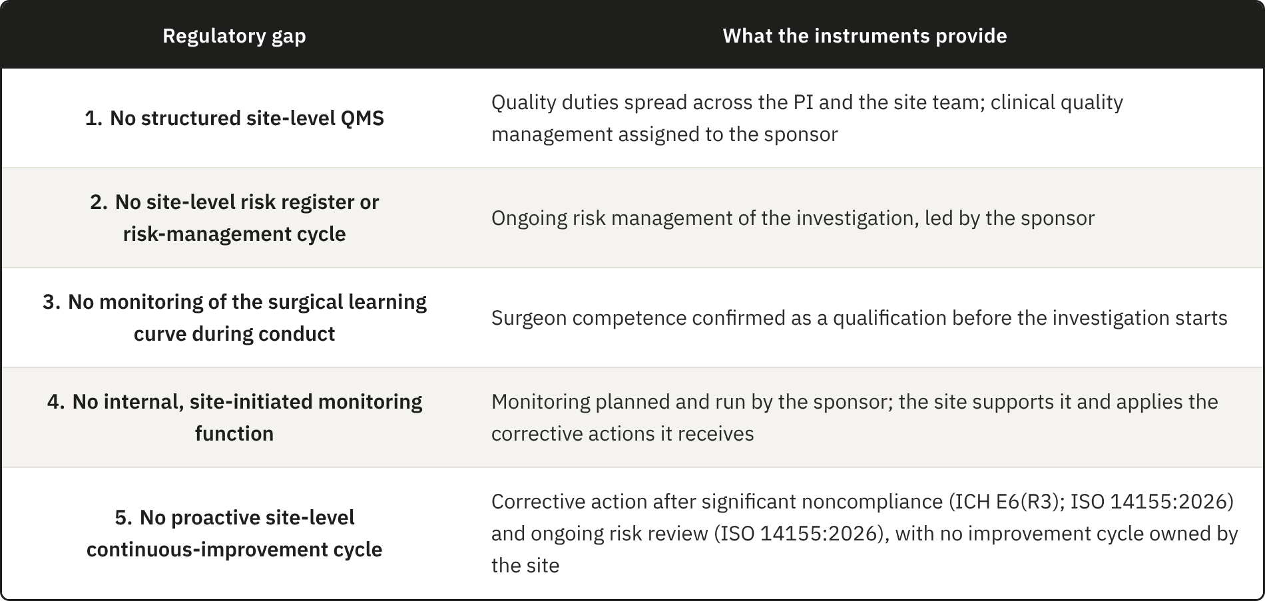

ICH E6(R3) and ISO 14155:2026 already give the investigator several quality duties, such as supervising delegated activities and making sure that staff are qualified and resources adequate. ICH E6(R3) also asks the investigator, together with the sponsor, to implement proportionate processes for the data of the trial (Section 4). These duties appear in separate clauses, and meeting them consistently depends on a system that organizes them, but no clause in the three instruments requires that system. Gap 1 is therefore the absence of a structured site-level quality management system (QMS), which the manufacturer and the medical laboratory in the same chain hold under ISO 13485:2016 and ISO 15189:2022 (Section 3.2.1).
The instruments require the risks of an investigation to be assessed and reviewed throughout its conduct, and they assign this cycle to the sponsor^{3,6}. Many of these risks come from the way the site executes the protocol, and the site sees them first (Section 3.4.3). For the cycle to work at that level, the site needs a register of its own risks (Gap 2), fed by an internal observation of what it actually does (Gap 4). Those observations then have to lead to correction and prevention through an improvement loop (Gap 5). The duty formally belongs to the sponsor, but the work done at the site decides whether the cycle works. The instruments, however, only ask the site to support sponsor monitoring and to apply the corrective actions it receives.
On surgical competence the three instruments agree, and sites can meet them, because all three treat competence as a qualification confirmed before the investigation starts. The surgical trials literature goes further and recommends that the surgeon’s performance also be followed during conduct, since it changes along the learning curve, and it reports that trials rarely do so^{29–31,33}. The comparison found no site obligation for the learning curve, and this literature shows why the absence matters. Gap 3 is the distance between the practice it recommends and what the instruments require.
The sponsor’s quality system cannot fill this space on its own, because it is built for the trial and not for any one site. In a multicenter investigation, the sponsor’s controls are designed to apply one standard across every participating site, which is a deliberate choice when the aim is comparability (Section 1.4.1). The same choice leaves out what is specific to each site, such as its daily workflow, its staffing, and the technical limits that follow from its size and structure. The literature describes the consequence from the site’s side. Site-level quality management is often reactive and handled case by case^{37,45,46}, standardized approaches remain uncommon⁴⁷, and sites experience risk-based monitoring as an external requirement over which they have little control⁴⁹. Part of the data that matter most is also generated at the point of care, where external oversight cannot see it in time (Section 3.4.3).

3.2.1 Site conduct and the clinical evidence of the device
Under the MDR, every device subject to conformity assessment needs a clinical evaluation, with clinical evidence appropriate to the device and its intended purpose. Article 61 and Annex XIV set out how the evaluation is planned and the data appraised, and the results go into a clinical evaluation report (CER) within the technical documentation. Where the available data do not show conformity with the general safety and performance requirements, the manufacturer has to generate them through clinical investigations, governed by Article 62(1), Articles 63 to 80, and Annex XV. The data produced at the site, in the operating room and in follow-up, therefore become the evidence behind the CER that the notified body assesses, and each link in that chain is only as reliable as the one before it.
The manufacturer works under a documented quality system, set out in ISO 13485:2016 with corrective and preventive action, and ISO 14971:2019 adds a documented cycle for managing device risk^{7,56}. A medical laboratory sits outside this chain but also produces results on which others base decisions, and ISO 15189:2022 gives it an equivalent system⁵⁷. ISO 14155:2026 gives the investigational site nothing similar, since its Clause 9.1 places clinical quality management on the sponsor and Clause 10, on the responsibilities of the principal investigator (PI), covers qualification and conduct, including the correction of significant noncompliance, without asking for an ongoing local system. The fourth edition enlarged the sponsor’s side further, with risks arising from investigation processes and a provision on the CEC⁶. Of the two organizations that produce the evidence behind the CER, only the site has no requirement to hold a quality system of its own.
These five gaps do not necessarily indicate defects in the regulatory framework. Addressing them may support compliance with existing duties, even where the instruments do not explicitly require the proposed site-level arrangements. They mark where the site can act on the quality of the investigation and on the safety of its own conduct. Chapter 4 develops an operational layer to support the implementation of ICH E6(R3) principles in daily site practice.

3.3 Site-level Critical-to-Quality domains
ICH E8(R1) and ICH E6(R3) ask the sponsor to identify the CtQ factors of each study when it designs the protocol². These factors depend on the design and endpoints of the study, so they change from one investigation to the next. A center, however, runs every investigation through the same processes, from consent and surgery to imaging and follow-up, and a failure in any of them can affect the factors of whatever study is running. A site-level analysis should therefore ask in which areas of its own operation a center can compromise those factors in the cases it contributes. We therefore decided to derive domains, areas of operation that require special attention, and left the factors to be identified by the site for each investigation, within each domain, from the protocol and from what the sponsor communicates as critical and risky.
The derivation started from the 43 themes of the comparison. The responsibility filter initially removed nine that the sponsor alone decides or holds, such as statistics and the Investigator’s Brochure. The scope filter defined for this framework removed another five that fall outside the framework, such as record retention, or whose content another theme already covers. The relevance filter removed randomization and blinding, because in a surgical device investigation the surgeon knows which device is implanted and the allocation is run centrally, so the site follows a procedure set elsewhere, and a failure to follow it is a protocol deviation, which is already covered. Of the 28 remaining themes, 22 are requirements, stating what the site has to protect, and 6 are controls, stating how quality is kept. Only the requirements were grouped, since a control applies across every area of the site and would have produced overlapping domains. The learning curve is the only theme that serves twice, as a requirement within domain 6 and as the basis of Gap 3.
Grouping the 22 requirements by the area of the site where the work happens and by the phase of the investigation produced 12 candidate domains. Each of them met the four criteria of Section 2.4.1, which gave the twelve domains in Table 3.2. Eight of the twelve domains rest entirely on requirements that at least one instrument already assigns to the investigator, and for these the framework only organizes and facilitates duties the site already holds. Domains 6 and 9 rest partly, and domains 5 and 8 wholly, on requirements that no instrument assigns to the site. Surgical technique is described by the sponsor in the CIP, endpoints are defined by the sponsor and may be read centrally, and the learning curve appears only in ISO 14155:2026, as a roll-in that the sponsor plans⁶. These requirements entered because the work they describe takes place at the site and because the literature reviewed shows that it influences the results^{27,28}.
Device management takes a form specific to device investigations, with accountability from receipt through implantation in a named participant to return or explantation, and ISO 14155:2026 adds, where appropriate, an implant card, prepared by the sponsor as a template, that the investigator gives the participant after implantation⁶. Procedural consistency and learning-curve control turn surgeon-dependent variability, which the methodological literature treats as a design problem, into something the site controls and monitors. Imaging can decide eligibility and provide an endpoint, and it also supplies safety data, so variability in how images are acquired produces systematic error that cannot be told apart from clinical variance. The imaging literature is general or based on knee trials, so we used it with caution^{58,59}.
The device supplement of the MDIC to the CTTI principles offers an external check on four of the domains. Among the considerations it adds for device trials are site feasibility, including the referral base and the equipment for imaging, together with device accountability, product training with proctoring, and the learning curve²⁸. These correspond to domains 1, 4, 6, and 9.
These twelve domains govern the framework in two ways. Every component is introduced to control the risks associated with one or more domains, and every performance indicator is anchored in at least one domain.

Table 3.2. Site-level Critical-to-Quality (CtQ) domains, with the scope of each domain and the principal threat to quality when it is not controlled. AE, adverse event; DD, device deficiency; PD, protocol deviation; PRO, patient-reported outcome; UDI, unique device identification.
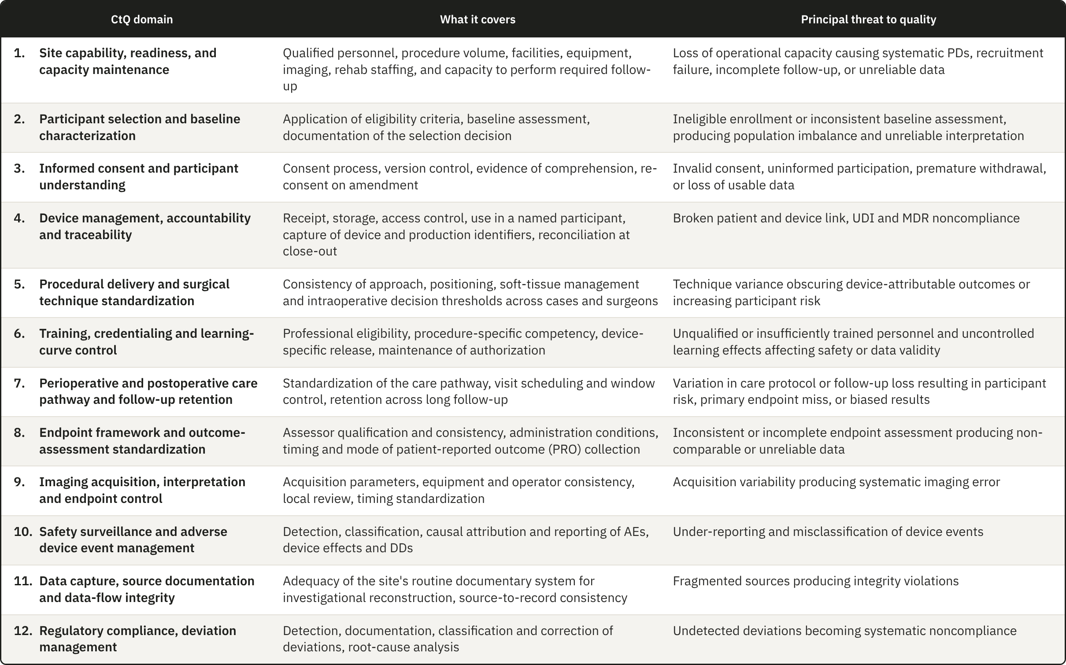

3.4 Operational conditions constraining the design
The gaps establish what is missing, and the domains establish what has to be controlled. Neither yet establishes what form a site-level framework can take. That is settled by the operational conditions under which the framework would have to work, and these conditions constrain the design as tightly as the regulatory analysis does.
As already explained in Section 1.2, surgical device investigations are conducted under conditions that a site-level framework has to take into consideration. Six main conditions apply in total. Five are structural and common to surgical trials, and two of those, operator dependence and traceability, are restrictive enough that Sections 3.4.2 and 3.4.3 treat them separately. The sixth, the organizational setting of the sites, is not structural but heavily influences the design, and Sections 3.4.4 and 3.4.5 present it as one of the findings of this thesis.

3.4.1 Design consequences of the five structural conditions
1. Irreversibility. A drug can be stopped, reduced, or replaced if it fails or causes harm. But once a prosthesis is fixed to bone, the procedure has produced a permanent change in the patient's anatomy. This raises the operational cost of every quality failure that happens at surgery, because an incorrect implant size, an undocumented technical deviation, or a missing traceability record cannot be corrected as a transcription error can. The European Medicines Agency (EMA) has described poor risk identification and mitigation as producing a reactive approach based mainly on corrective action¹. ICH E8(R1) warns that resources are needed to identify and prevent or control errors that matter, and the CTTI CtQ principles also place attention on prevention before conduct. A site-level framework must therefore identify in advance which steps of the surgical pathway are irreversible, and therefore critical, and place controls on them so that errors are prevented and information is not lost.

2. Operator dependence. In device investigations, results depend on the device and just as much on the person and technique used to implant it¹⁷. Requirements for surgeon qualification and adequate training with the specific device are already established by the instruments, but other sources of variation also require control, including learning-curve effects, differences among surgeons in positioning and soft-tissue management, and intraoperative judgment. The study by Blencowe et al.⁶⁰ provides us one method to evaluate this effect by setting standards for surgical intervention delivery before the trial and monitor it during conduct through forms that capture deviations. Quality management therefore has to characterize this variation without trying to remove it, because removing it would mean removing surgical judgment itself. The consequence for the design is that the framework needs the operator as a unit of analysis, alongside the participant and the device.

3. Device traceability. Pharmaceutical and device trials both require records linking batch or serial numbers to participants, but the requirements differ in how long the link must be kept^{3,6}. A medicinal product is used or returned so once the trial ends there is nothing left in the participant to trace. Its accountability record is kept with the essential records, but no one has to maintain an active link between the product and the participant. An implanted device remains in the participant for years, so the MDR requires post-investigation follow-up that covers traceability, and the records must also cover any return or explantation. Traceability here also extends to reconstructing the surgical decisions that produced that configuration in that participant, which creates a documentary burden of a different order. The framework therefore needs a record of each implanted unit that the site keeps current for as long as the participant is followed.

4. The operational weight of follow-up. Long follow-up is not unique to surgical trials, but the measurements involved like ROM and radiographic assessment of implant position require the participant to be physically present, while patient-reported outcomes (PROs) require consistent collection at the specified time points. Assessments vary less when the same procedure is used at every visit and, where the protocol provides for it, when an independent reviewer reads the results centrally⁶¹. None of the three instruments asks for the same assessor at every visit, so keeping assessment consistent over the years of follow-up falls to the site, and images need the same acquisition procedure and quality control at every time point for the same reason^{58,62}. This raises the cost of every visit and increases the risk of attrition over the years between surgery and the late assessments. Orthopedic studies with at least three years of follow-up reported 14.8% loss to follow-up, compared with 9.8% in studies with shorter follow-up²¹, and one shoulder arthroplasty cohort reported 34.3% loss by the seventh year²².

5. Limited classification reliability. Shoulder investigations rely on radiological and clinical classifications that in many cases show only fair-to-moderate interobserver reliability⁶³. Widely used classifications for proximal humeral fractures have been reported with interobserver kappa coefficients in the fair range, even when three-dimensional models reconstructed from computed tomography (CT) data are used⁶⁴. Two assessors looking at the same patient can therefore reach different conclusions about eligibility or about an outcome, and the database cannot distinguish that variance from genuine clinical variance. Outcome measurement makes this worse. Shoulder arthroplasty trials vary widely in outcome domains, instruments, and assessment time points. That inconsistency was substantial enough to motivate core outcome sets for shoulder disorders^{51,52}. The framework therefore has to control the sources of this variance that lie at the site, such as assessor qualification and the acquisition procedure.

3.4.2 Operator-dependent variability as a design constraint
Operator dependence produces clustering⁶⁵. Participants operated on by the same surgeon share that surgeon’s technique and intraoperative decision thresholds, as well as the perioperative management that follows, so for the purposes of quality they are not independent of one another, and a problem in the surgeon’s execution reaches every case that surgeon contributes. Clustering also matters for the design and analysis of a trial. In simulations, ignoring non-negligible clustering produced type I error rates above 20%⁶⁶, yet only 21.5% of eligible orthopedic randomized trials with several centers or treatment providers used an analysis that accounted for it⁶⁷.
The methodological literature on surgical trials counts clustering among the central challenges of randomized trials involving surgery, together with the learning curve that interacts with it^{65,68}, and practice still varies. In a survey of 44 United Kingdom Clinical Trials Units, clustering was handled mostly at design, through stratification that balances each surgeon’s cases across the arms of the trial, and at analysis, through adjustment. Learning was managed mainly through a minimum level of expertise for the treatment provider, set by 89% of units, while only one unit reported analyzing learning effects as part of the main analysis⁶⁹.
Operator learning is therefore controlled mainly at entry but is rarely observed during conduct. In a review of 247 published surgical trials, 39% addressed expertise through predefined surgeon credentials, while, again, only one trial analyzed learning during conduct; a related analysis of funder guidance identified the same general concern⁷⁰. The clause comparison in Section 3.2 reaches the same boundary, since the governing instruments address qualification and training and do not assign ongoing observation of operator learning to the site. The interval between entry qualification and performance during conduct is exactly what a site-level instrument could cover, and it is the interval that Gap 3 in Table 3.1 identifies. A protocol can define a procedure in general terms, but it cannot standardize the many small decisions through which a particular surgeon implants a particular device in a particular anatomy. The site therefore needs an instrument that operates during conduct.

3.4.3 Traceability as a point-of-care obligation
Unit-level traceability is distinctive in how detailed it is, and it is distinctive again in the circumstances under which it has to be met. It is executed in the operating room, under time pressure, by staff whose attention is on the surgical procedure. ISO 14155:2026 requires records of receipt, identification, quantity, dates of use, participant identification, and return or explantation, together with written procedures for the full accountability process. The sponsor maintains the record of physical location through delivery to the site, and the investigator's records continue the link through use in the participant and any return or explantation. The MDR also requires access control, return procedures, and follow-up in the CIP, immediate identification and recall of devices in an emergency, and post-investigation traceability. In surgery, the required dates of use and participant identification make capture at the point of care the most reliable operational response. A break in this chain can compromise regulatory compliance and the attribution of an AE to a specific device or lot. The cited clauses do not state that such a break automatically invalidates the affected case.
Traceability is the clearest example of a broader pattern that runs through the domains in Table 3.2. A class of critical data is generated at the point of care, external oversight cannot see it while it is happening, and it cannot be recovered once it is lost. Four examples share these properties: the intraoperative decision to substitute a component, the technical deviation prompted by unexpected anatomy, the immediate postoperative image that may or may not be adequate, and the early complication whose relationship to the device is still undetermined. A framework that deals with this class of data has to operate when the data are generated, because sponsor verification takes place afterward.

3.4.4 Where these investigations are conducted
During the literature review, we found evidence that clinical research is concentrated in the United States and that, within the country, much of it is done away from academic centers. Between 2006 and 2012, the United States ran 540 trial site-years per million inhabitants, more than twice the rate of the other high-income OECD countries⁷¹. Open Payments data show that a large majority of US investigators in commercially sponsored trials conduct them in their private practice⁷². In FDA records from 2008 to 2015, one third of principal investigators each year were filing for the first time, and 40% of those active in a given year did not file again the following year⁷³. Among the principal investigators of FDA-regulated drug trials, 63.8% found it burdensome to fit the trial around their other work⁷⁴.
The burden does not rest on investigators alone. Studies of the organizations that host trials report shortages of research staff and infrastructure, and they report them in hospitals as well as in community settings. In a national survey of 58 community cancer centers, 52% named limited staffing as a challenge to conducting research⁷⁵. Stakeholders in Ontario described community hospitals as willing to join trials but mostly without research infrastructure⁷⁶, and authors from a Swiss private hospital network report early difficulties with infrastructure, regulatory compliance and quality assurance in setting up a trial unit⁷⁷. Device research strains even academic centers. Leaders of children’s hospitals linked to the FDA pediatric device consortia described device trial infrastructure in academic medical centers as suboptimal, and found that drug trial infrastructure, though often well developed, did not necessarily carry over to device trials⁷⁸.
The constraints weigh more where organizational capacity is lower. Among community cancer centers running therapeutic trials, 2 of 8 rural practices offered phase 1 trials against 22 of 33 urban ones, and the centers running none cited limited infrastructure, funding and staffing⁷⁵. Respondents with experience of nontraditional research sites named deficient operational infrastructure as their main challenge and quality oversight as a main support need⁷⁹.
All of these studies concern drug trials, and investigations of implantable shoulder devices add the structural conditions described in Sections 3.4.1 to 3.4.3, which place further demands on the site. This raised the question of where shoulder device investigations mostly take place: in hospital settings, which report these constraints but have some organizational support behind the site, or to a large extent in organizations with less capacity to absorb them. We looked for published data on how these investigations are distributed across organizational environments and found none, so we built that distribution ourselves from public registry records.
The registry search produced 46 eligible industry-sponsored investigations of implantable shoulder devices with 355 site records. Eight records could not be resolved to a clinical organization and were excluded (Section 2.3.2). One investigation lost its only listed site with this exclusion, which left 347 site records from 45 investigations and 238 organizations. We grouped the organizations into the three categories of Table 3.3, because academic status and ownership could be identified consistently from public institutional descriptions.
Table 3.3. Organizational environment of the 347 site records and 238 organizations in the registry dataset, including the organizations located in the United States.
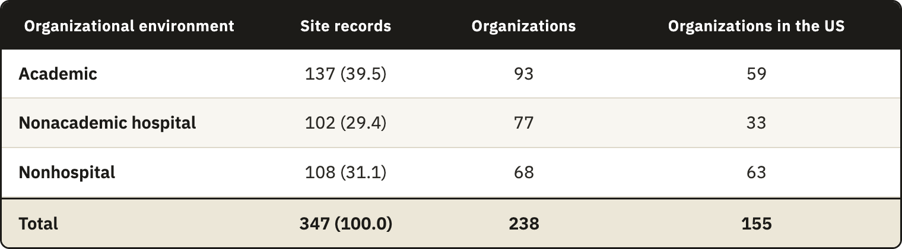

Each organization was counted once for every investigation it hosted. Of the 238 organizations, 178 took part in one investigation and 60 in more than one, up to nine at the Rothman Orthopaedic Institute. A count by organization would give an organization with nine investigations the same weight as one with a single investigation, and it would understate the environments where investigational activity concentrates. Repetition was most frequent in the nonhospital group, whose 68 organizations hosted 1.59 investigations on average, against 1.47 in academic organizations and 1.32 in nonacademic hospitals, and a count by organization would lower its share from 31.1% to 28.6%. Entries for the same organization within one investigation had already been merged during normalization (Section 2.3.2), so each site record stands for one occasion on which an organization conducted an investigation.
Hospitals hosted most of the investigational activity in the sample, with 239 of the 347 site records (68.9%). The remaining 108 site records (31.1%) came from 68 nonhospital organizations, the independent orthopedic practices, ambulatory centers and surgeon-owned orthopedic facilities that operate outside hospital systems and universities (Table 3.3). Most of the activity therefore takes place where some organizational support stands behind the site, even though these settings report the constraints described above. Close to a third takes place in organizations that resemble the community and private-practice settings in which those constraints weighed most.
These categories describe what kind of organization a site is, and they say little about how it is prepared for research. A nonacademic hospital may have a research unit with dedicated staff, or it may run investigations alongside routine care with no such support, and private practices can vary in the same way. The registry holds no information that would separate these cases, so Table 3.3 shows only where investigations take place, but the readiness of each site to conduct them remains unknown.
The sample is weighted toward the United States, with 155 of the 238 organizations (65.1%) and 243 of the 347 site records (70.0%). The weight is greatest in the nonhospital group, and 63 of its 68 organizations (92.6%) were there. Part of this concentration comes from the registry itself, because registration on ClinicalTrials.gov is required for many studies conducted in the United States. We also searched Eudamed, its European counterpart, but it returned few of these investigations and little site-level data compared with ClinicalTrials.gov. The findings therefore describe this sample and should not be read as the distribution of shoulder device investigation sites in Europe or worldwide. The purpose of the analysis was to judge the relevance of the framework and to identify the site conditions its requirements must take into account.

3.4.5 The operating conditions of the target center
In Table 3.3, nonhospital organizations held 108 of the 347 site records (31.1%), too large a share to treat as an exception, although most of them were in the United States. Within this group, the framework was designed for a small independent clinic with few research staff and little research infrastructure, the environment for which it can assume the least, because no hospital system or university stands behind the site. The category is broader than this case, since it also includes surgeon-owned orthopedic facilities with inpatient beds, and the registry records neither staffing nor infrastructure. The registry therefore supports the relevance of designing for sites outside hospital systems, and the choice of the small clinic is a design decision.
The evidence reviewed in Section 3.4.4 comes from drug trials, and part of it concerns drug administration. Most of what it reports, however, concerns staff, clinician time, infrastructure and oversight, which a site needs whatever the product under investigation, and the conditions of an implantable device investigation add to these demands (Sections 3.4.1 to 3.4.3). The few studies on device and orthopedic research point the same way. In a pilot within a UK hip preservation registry, centers given additional administrative support achieved 79% follow-up compliance at 30 days against 55% in centers without it, and 69.4% against 47% at 90 days⁸⁰. Experts on pediatric device trials rated a device training plan among the most important infrastructure components for implanting and using the device⁸¹. A small clinic conducting a shoulder device investigation is therefore unlikely to face lighter constraints than those reported for drug trials, although the present work did not test this inference.
The registry did not record staffing, budgets or the priority each organization gives to research, so these conditions entered the design as assumptions. The framework does not assume a dedicated research office or quality function, and it allows research duties to be shared among clinical staff. The framework had to fit within existing site roles without depending on a new physical infrastructure or dedicated quality department. Its instruments had to work on paper or within an electronic system already available at the site. Key quality decisions also had to remain in records held by the organization when individual responsibilities changed.
These conditions define the minimum implementation level used in the scalability model presented in Section 4.7. Organizations with established research departments can place the same functions within their existing systems and use deeper controls.

3.5 Design requirements
A CtQ domain defines where the site has to protect the critical factors of an investigation, but it does not say what the site must have in place for that domain to be under control. The design requirements state this. They complete the second DSRM activity, the definition of the objectives of a solution, because they turn the findings of this chapter into statements of what an acceptable framework has to deliver, written so that each of its components can later be checked against them.
Table 3.4 lists the twelve requirements and traces each one back to its origin. DR1 to DR5 come mainly from the regulatory gaps in Section 3.2, and DR6 to DR9 from the CtQ domains and the structural conditions of surgical investigation (Sections 3.4.1 to 3.4.3). DR10 to DR12 come from the operating conditions of the target center (Sections 3.4.4 and 3.4.5).
Requirements and domains do not correspond one to one. DR2 covers all twelve domains, because each of them needs its execution risks identified at the site. The four domains that rest wholly or partly on requirements no instrument assigns to the site (domains 5, 6, 8 and 9) feed the requirements on operator proficiency, point-of-care capture and measurement variance (DR3, DR6 and DR7). The other domains enter the set through how the site organizes their control, for example through indicators (DR8) and correction (DR5). Informed consent (domain 3) is the only domain with no requirement beyond DR2, since the instruments regulate consent in detail.
Meeting one requirement can also make another harder to meet. DR11 rules out capital investment and asks the site to reuse its existing documentary system, so it limits how DR1 to DR9 can be met. A site could satisfy every functional requirement with an information system built for the investigation, and that solution would pass the regulatory analysis while failing the operational one. When two requirements point to different solutions, we treat the operational constraint as binding, because a control the site cannot afford to run will not be run.
No instrument examined here requires a site to operate a quality system (Gap 1, Section 3.2), so the framework cannot be justified by pointing to a rule that demands it. Its justification comes from tracing each part back to its origin. Each component answers a requirement, and each requirement comes from a regulatory gap, a CtQ domain or an operating condition (Table 3.4). The gaps and domains trace back to the clause comparison in Section 2.2, with Gap 3 checked against the surgical trials literature, and the operating conditions to the literature and registry evidence in Section 3.4. Where the framework adds a control that no instrument requires, that control answers a gap the comparison documented. Everywhere else, the framework organizes duties the instruments already assign, so that a site can carry them out under the conditions in which it works.
Table 3.4. Design requirements (DR1 to DR12) for a site-level operational quality framework and their origin in the regulatory gaps, the CtQ domains, or the structural and operating conditions of surgical investigation and of the target center. CAPA, corrective and preventive action; CtQ, critical to quality.


