3. Identified Gaps and Framework Design Requirements

3.1 Scope and analytical basis of this chapter
This chapter reports the results of the first two DSRM activities, the identification of the problem and the definition of the objectives of a solution. The clause comparison showed where the three instruments give the site no explicit requirement for certain local controls, and the same comparison, read by area of site work, produced the site-level CtQ domains. The conditions under which surgical device investigations are conducted then limited the form a framework can take. The design requirements bring these results together, and Table 3.4 traces each requirement to its origin.

3.2 Gaps in explicit site-level requirements
We compared ICH E6(R3), ISO 14155:2026 and the provisions of the MDR on clinical investigations, mainly Annex XV, clause by clause. Each normative entry holds one clause-level requirement of one instrument, with its text, the clause it comes from and the party it binds. The comparison recorded 251 entries, 100 from ICH E6(R3), 90 from ISO 14155:2026 and 61 from the MDR. ICH E6(R3) gives the investigator or the site a duty in 55% of its entries and ISO 14155:2026 in 59%, while 25% of the MDR entries reach the site, since most of its provisions bind the sponsor.
The entries were grouped into 43 themes, each covering one subject, such as informed consent or device accountability. Each theme was then classified by the obligations the instruments create for the site. A theme is strongly harmonized when all three instruments address it and give the site equivalent obligations. It is partially harmonized when the instruments agree on the principle and at least one of them gives the site an obligation, while another binds a different party, uses different terms or does not address the theme. It is unaddressed at site level when none of the instruments gives the site an explicit obligation for it, either because the obligation falls on the sponsor or because no party is named. Of the 43 themes, 8 are strongly harmonized, 21 are partially harmonized and 14 are unaddressed at site level.
Eight themes show full agreement: informed consent, participant information, participant rights, investigator qualification, protocol compliance, medical care, source records and confidentiality. In each of them the three instruments treat the subject in broadly equivalent terms, and each gives the investigator or the site an obligation.
Twenty-one themes are partially harmonized, among them protocol deviation (PD) documentation, device accountability, follow-up and safety reporting. Safety reporting shows how far apart the instruments can be while they agree on the principle. All three require serious events to reach the sponsor, but they set the interval and the reporting party differently. ICH E6(R3) asks the investigator to report serious adverse events to the sponsor immediately (ICH E6(R3), Section 2.7.2)³. ISO 14155:2026 asks the principal investigator (PI) to report to the sponsor, without unjustified delay, serious adverse events and device deficiencies (DDs) that could have led to a serious adverse device effect (SADE), and leaves the detailed written reports to the CIP (Clause 10.8)⁶. The MDR requires the sponsor to report these events to the Member States without delay, in a period that takes account of their severity, and asks the sponsor to have an agreement under which investigators report to it in a timely manner (Article 80(2); Annex XV, Chapter III, Section 2)⁸.
The instruments also differ in how they classify an event. ISO 14155:2026 separates events related to the investigational device from events related to clinical procedures that the CIP requires outside routine clinical practice, and it asks the sponsor to manage risk across the device, these procedures and the investigation process (Clause 7.1)⁶. The note to Clause 6.2.3 recognizes that national regulations do not necessarily require the categorization of AEs related to these procedures. The standard also asks the sponsor to consider a clinical events committee (CEC) for the central review of events (Clause 6.12)⁶. ICH E6(R3) has no equivalent category, because it was written for medicinal products, where the intervention and the procedure are one thing. These divergences affect how a site-level safety indicator has to be built.
Fourteen themes are unaddressed at site level. Six concern the design of the investigation or functions the sponsor holds centrally, such as statistics, insurance and oversight committees. Three describe work that takes place at the site, namely the surgical technique, endpoint assessment and the learning curve, and they entered the CtQ domains. The remaining five are control functions: a quality management system, risk management, monitoring, continual improvement, and audit and inspection. For these functions the instruments assign the system to the sponsor, to the Member States in the case of inspection, or to no named party. The site takes part by supporting monitoring, following the CIP, reporting what it observes and carrying out the corrective actions assigned to it^{3,6,8}.
These five control functions, together with the learning curve, give the five gaps in explicit site-level requirements listed in Table 3.1. Self-inspection, the part of audit and inspection that remains for the site, belongs to the improvement cycle of Gap 5. Each gap names a local arrangement that none of the three instruments explicitly requires, next to the duties that the instruments already give the investigator or the sponsor. The gaps describe what the texts require and do not show that sites lack such arrangements. Many sites may already run some of them, and neither the comparison nor the literature reviewed can establish how common they are.
Table 3.1. Gaps in explicit site-level requirements identified in the clause-by-clause comparison of ICH E6(R3), ISO 14155:2026, and the MDR, with the related duties the instruments already assign. CAPA, corrective and preventive action; CIP, clinical investigation plan; MDR, Medical Device Regulation; PI, principal investigator.
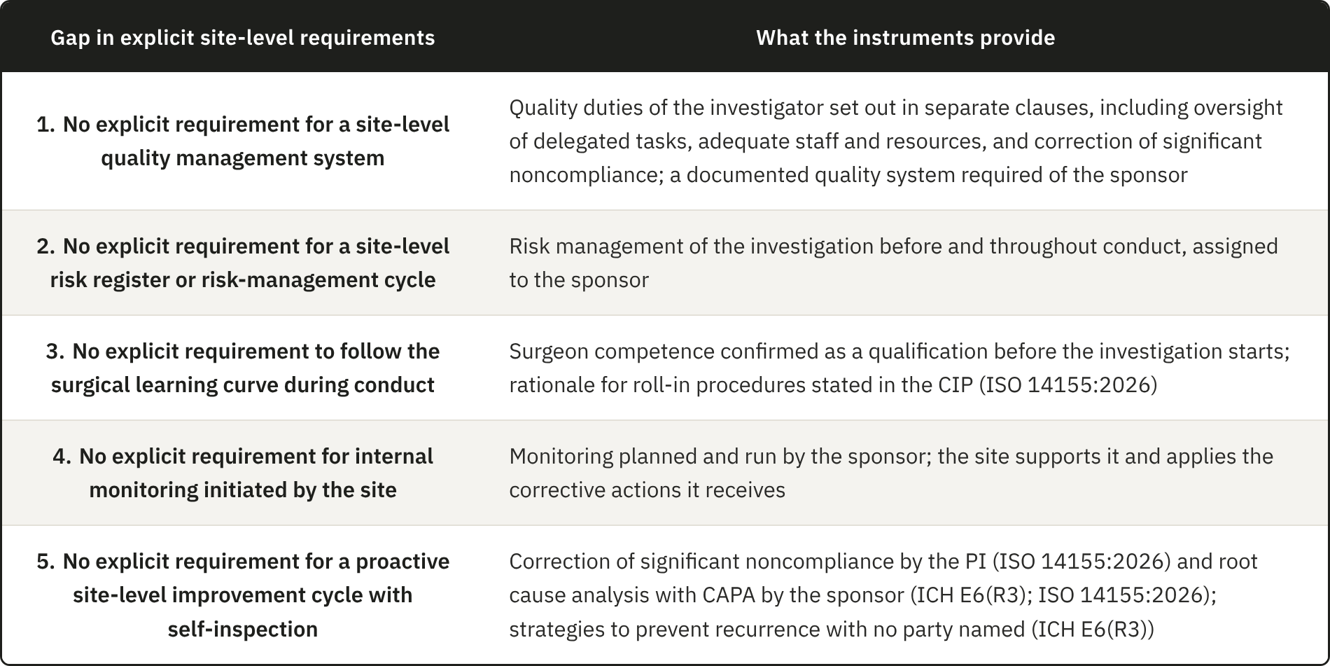

ICH E6(R3) and ISO 14155:2026 already give the investigator several quality duties. The investigator has to oversee delegated activities in proportion to the importance of the data and the risks involved (ICH E6(R3), Section 2.3.1)³, make sure that staff are qualified and resources adequate, and, under ISO 14155:2026, determine the cause of significant noncompliance and put corrective and preventive action in place (Clause 10.6)⁶. ICH E6(R3) also asks investigators and sponsors to run data processes proportionate to the risks (ICH E6(R3), Section 4)³. These duties sit in separate clauses, and the instruments ask only the sponsor for a documented quality system (ICH E6(R3), Section 3.10; ISO 14155:2026, Clause 9.1)^{3,6}. Gap 1 is therefore the absence of an explicit requirement for a site-level quality management system that brings the investigator's duties together. The operational reason for such a structure is that these duties are met consistently, from one investigation to the next, only when someone at the site organizes them.
The instruments require the sponsor to manage risks to the CtQ factors before and throughout the trial (ICH E6(R3), Section 3.10.1; ISO 14155:2026, Clause 7.1)^{3,6}, and they place monitoring with the sponsor. Many of these risks come from the way the site executes the protocol, and the site sees them first, in the operating room and at follow-up visits. None of the three instruments explicitly requires the site to keep a register of the risks its own execution creates (Gap 2) or to check its own conduct between sponsor visits (Gap 4). Corrective action already reaches the site in a reactive form, since the PI has to correct significant noncompliance and the sponsor runs root cause analysis with corrective and preventive action (ICH E6(R3), Section 3.12.2; ISO 14155:2026, Clauses 9.2.3 and 10.6)^{3,6}. ICH E6(R3) also asks for strategies to prevent the recurrence of serious noncompliance, without naming who applies them (ICH E6(R3), Principle 6.3)³. None of the instruments explicitly requires a proactive improvement cycle owned by the site, with periodic self-inspection of its own processes (Gap 5), and only the site can improve the processes it runs.
On surgical competence, the three instruments agree that qualification is confirmed before the investigation starts. ISO 14155:2026 adds that the CIP should justify any roll-in procedures used for the learning curve and say how their data will be analyzed (Annex A)⁶. The surgical trials literature recommends that the surgeon's performance also be followed during conduct, since it changes along the learning curve, and it reports that trials rarely do so^{29–31,33}. None of the instruments explicitly requires the site to follow each surgeon's learning while the investigation runs, and Gap 3 is the distance between that recommended practice and what the instruments require.
The sponsor's quality system covers this space only in part, because it is built for the trial and not for any one site. In a multicenter investigation, the sponsor's controls apply one standard across every participating site, which is a deliberate choice when the aim is comparability. The same choice leaves out what is specific to each site, such as its daily workflow, its staffing and the technical limits that follow from its size and structure. Studies of site practice report quality management at sites as often reactive and handled case by case^{37,45,46}, standardized approaches as uncommon⁴⁷, and risk-based monitoring as an external requirement over which sites have little control⁴⁹. Part of the data that matter most is also generated at the point of care, where external oversight cannot see it in time.

3.2.1 Site conduct and the clinical evidence of the device
Under the MDR, every device subject to conformity assessment needs a clinical evaluation, with clinical evidence appropriate to the device and its intended purpose. Article 61 and Annex XIV set out how the evaluation is planned and the data appraised, and the results go into a clinical evaluation report (CER) within the technical documentation. Where the available data do not show conformity with the general safety and performance requirements, the manufacturer has to generate them through clinical investigations, governed by Article 62(1), Articles 63 to 80 and Annex XV. The data produced at the site, in the operating room and in follow-up, therefore become the evidence behind the CER that the notified body assesses, and each link in that chain is only as reliable as the one before it.
The manufacturer works under a documented quality system, set out in ISO 13485:2016 with corrective and preventive action, and ISO 14971:2019 adds a documented cycle for managing device risk^{7,56}. A medical laboratory sits outside this chain but also produces results on which others base decisions, and ISO 15189:2022 gives it an equivalent system⁵⁷. ISO 14155:2026 gives the investigational site no equivalent explicit requirement. Its Clause 9.1 asks the sponsor for written clinical quality procedures, and Clause 10, on the responsibilities of the PI, covers qualification and conduct, including the correction of significant noncompliance, without asking for a local quality system⁶. Of the two organizations that produce the evidence behind the CER, the site is the only one without an explicit requirement to hold a quality system of its own.
These five gaps do not necessarily indicate defects in the regulatory framework. Closing them may help the site meet duties it already has, even where the instruments do not explicitly require the proposed arrangements, and they mark where the site can act on the quality of the investigation and on the safety of its own conduct.

3.3 Site-level Critical-to-Quality domains
ICH E8(R1) and ICH E6(R3) ask the sponsor to identify the CtQ factors of each study when it designs the protocol^{2,3}. These factors depend on the design and endpoints of the study, so they change from one investigation to the next. A center, however, runs every investigation through the same processes, from consent and surgery to imaging and follow-up, and a failure in any of them can affect the factors of whatever study is running. A site-level analysis should therefore ask in which areas of its own operation a center can compromise those factors in the cases it contributes. We therefore derived domains, the areas of site operation that require special attention, and left the factors to be identified by the site for each investigation, within each domain, from the protocol and from what the sponsor communicates as critical and risky.
The domains were built from the 43 themes of the comparison. A first set of filters removed the themes that a site-level framework does not need to develop. The responsibility filter removed nine themes that the sponsor alone decides or holds, such as statistics and the Investigator's Brochure, while it kept themes assigned to the sponsor when the work done at the site decides whether they are met. Two further filters set the limits of the framework. The scope filter left out five themes: participant rights, whose content the consent, care and safety themes already carry; record retention, direct access and confidentiality, which the institution meets through its general administrative and data protection arrangements; and agreements, since a signed contract does not by itself decide the quality of conduct. The relevance filter left out randomization and blinding, because in a surgical device investigation the surgeon knows which device is implanted and the allocation is usually run centrally, so the site follows a procedure set elsewhere. The duties of the investigator on these six themes remain as the instruments state them, and the framework adds no controls for them.
Each of the remaining 28 themes was then labeled by what it describes. Twenty-two are protection themes, which state something the site has to protect, such as consent or the record of an implanted device. Six are control themes, which state how quality is kept, such as risk review or internal verification. Only the protection themes were grouped into domains, since a control applies across every area of the site and would have produced overlapping domains. The learning curve is the only theme used twice, as a protection theme within domain 6 and as the basis of Gap 3.
Grouping the 22 protection themes by the area of the site where the work happens and by the phase of the investigation produced 12 candidate domains, and one theme could feed more than one domain. Each candidate met the four selection criteria set in the methodology, which gave the twelve domains in Table 3.2. Eight of the twelve rest entirely on themes for which at least one instrument already gives the investigator an obligation, and in these the framework organizes duties the site already holds. Domains 6 and 9 rest partly, and domains 5 and 8 wholly, on themes for which no instrument gives the site an explicit obligation. Surgical technique is described by the sponsor in the CIP, endpoints are defined by the sponsor and may be read centrally, and the learning curve appears only in ISO 14155:2026, as a roll-in that the sponsor plans⁶. These themes entered because the work they describe takes place at the site and because the literature reviewed shows that it influences the results^{27,28}.
Device management takes a form specific to device investigations, with accountability from receipt through implantation in a named participant to return or explantation. ISO 14155:2026 also asks the sponsor to prepare, where appropriate, a template for an implant card that investigators give the participant after implantation (Clause 9.2.2)⁶. Procedural consistency and learning-curve control turn surgeon-dependent variability, which the methodological literature treats as a design problem, into something the site controls and monitors. Imaging can decide eligibility and provide an endpoint, and it also supplies safety data, so variability in how images are acquired produces systematic error that cannot be told apart from clinical variance. The imaging literature is general or based on knee trials, so we used it with caution^{58,59}.
The device supplement of the MDIC to the CTTI principles offers an external check on four of the domains. Among the considerations it adds for device trials are site feasibility, including the referral base and the equipment for imaging, together with device accountability, product training with proctoring, and the learning curve²⁸. These correspond to domains 1, 4, 6 and 9.
The twelve domains govern the framework in two ways. Every component is introduced to control the risks associated with one or more domains, and every performance indicator is anchored in at least one domain.

Table 3.2. Site-level Critical-to-Quality (CtQ) domains, with the scope of each domain and the principal threat to quality when it is not controlled. AE, adverse event; DD, device deficiency; MDR, Medical Device Regulation; PD, protocol deviation; PRO, patient-reported outcome; UDI, Unique Device Identification.
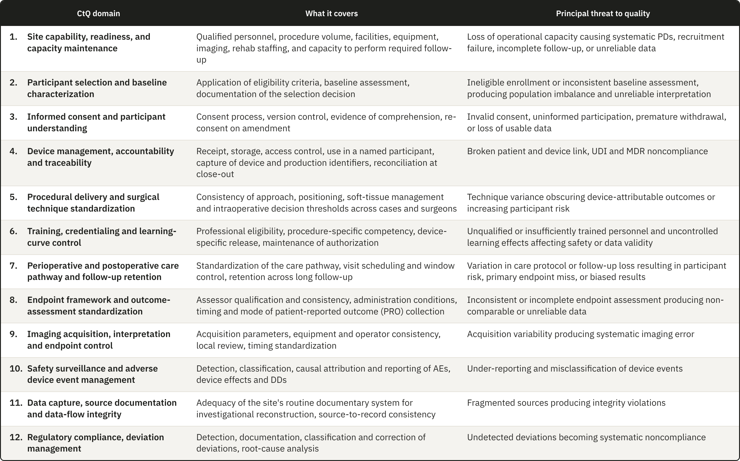

3.4 Operational conditions constraining the design
The gaps show which local arrangements the instruments do not explicitly require, and the domains show what the site has to control. The form a framework can take depends on the conditions under which it has to work, and these conditions constrain the design as tightly as the regulatory analysis does. Six conditions apply. Five are structural and common to surgical device investigations, and two of them, operator dependence and traceability, constrain the design enough to be examined on their own. The sixth, the organizational setting of the sites, varies from one center to another and strongly influences the design.

3.4.1 Design consequences of the five structural conditions
1. Irreversibility. A drug can be stopped, reduced or replaced if it fails or causes harm, but once a prosthesis is fixed to bone, the procedure has produced a permanent change in the patient's anatomy. This raises the operational cost of every quality failure that happens at surgery, because an incorrect implant size or a missing traceability record cannot be corrected the way a transcription error can, and neither can a technical deviation that nobody recorded. The European Medicines Agency (EMA) has described poor risk identification and mitigation as producing a reactive approach based mainly on corrective action¹. ICH E8(R1) warns that resources are needed to identify and prevent or control errors that matter, and the CTTI CtQ principles also place attention on prevention before conduct. A site-level framework must therefore identify in advance which steps of the surgical pathway are irreversible, and therefore critical, and place controls on them so that errors are prevented and information is not lost.

2. Operator dependence. In device investigations, results depend on the device and just as much on the person and technique used to implant it¹⁷. The instruments already require surgeon qualification and adequate training with the specific device, but other sources of variation also require control, including learning-curve effects, differences among surgeons in positioning and soft-tissue management, and intraoperative judgment. Blencowe et al. proposed setting standards for the delivery of the surgical intervention before the trial and monitoring that delivery during conduct with forms that capture deviations⁶⁰. Quality management therefore has to characterize this variation without trying to remove it, because removing it would mean removing surgical judgment itself. The consequence for the design is that the framework needs the operator as a unit of analysis, alongside the participant and the device.

3. Device traceability. Pharmaceutical and device trials both require records linking batch or serial numbers to participants, but the requirements differ in how long the link must be kept^{3,6}. A medicinal product is used or returned, so once the trial ends there is nothing left in the participant to trace. An implanted device remains in the participant for years, and for implantable devices the MDR requires the follow-up procedures in the CIP to cover traceability as a minimum (Annex XV, Chapter II, Section 3.15)⁸. Traceability here also extends to reconstructing the surgical decisions that produced a given configuration in a given participant, which creates a documentary burden of a different order. The framework therefore needs a record of each implanted unit that the site keeps current for as long as the participant is followed.

4. The operational weight of follow-up. Long follow-up is not unique to surgical trials, but measurements such as ROM and the radiographic assessment of implant position require the participant to be physically present, while patient-reported outcomes (PROs) require consistent collection at the specified time points. Assessments vary less when the same procedure is used at every visit and, where the protocol provides for it, when an independent reviewer reads the results centrally⁶¹. None of the three instruments asks for the same assessor at every visit, so keeping assessment consistent over the years of follow-up falls to the site, and images need the same acquisition procedure and quality control at every time point for the same reason^{58,62}. This raises the cost of every visit and increases the risk of attrition over the years between surgery and the late assessments. Orthopedic studies with at least three years of follow-up reported 14.8% loss to follow-up, compared with 9.8% in studies with shorter follow-up²¹, and one shoulder arthroplasty cohort reported 34.3% loss by the seventh year²².

5. Limited classification reliability. Shoulder investigations rely on radiological and clinical classifications that in many cases show only fair-to-moderate interobserver reliability⁶³. Widely used classifications for proximal humeral fractures have been reported with interobserver kappa coefficients in the fair range, even when three-dimensional models reconstructed from computed tomography (CT) data are used⁶⁴. Two assessors looking at the same patient can therefore reach different conclusions about eligibility or about an outcome, and the database cannot distinguish that variance from genuine clinical variance. Outcome measurement adds to the problem, because shoulder arthroplasty trials vary widely in outcome domains, instruments and assessment time points, enough to motivate core outcome sets for shoulder disorders^{51,52}. The framework therefore has to control the sources of this variance that lie at the site, such as assessor qualification and the acquisition procedure.

3.4.2 Operator-dependent variability as a design constraint
Operator dependence produces clustering⁶⁵. Participants operated on by the same surgeon share that surgeon's technique and intraoperative decision thresholds, as well as the perioperative management that follows, so for the purposes of quality they are not independent of one another, and a problem in the surgeon's execution reaches every case that surgeon contributes. Clustering also matters for the design and analysis of a trial. In simulations, ignoring non-negligible clustering produced type I error rates above 20%⁶⁶, yet only 21.5% of eligible orthopedic randomized trials with several centers or treatment providers used an analysis that accounted for it⁶⁷.
The methodological literature on surgical trials counts clustering among the central challenges of randomized trials involving surgery, together with the learning curve that interacts with it^{65,68}, and practice still varies. In a survey of 44 United Kingdom Clinical Trials Units, clustering was handled mostly at design, through stratification that balances each surgeon's cases across the arms of the trial, and at analysis, through adjustment. Learning was managed mainly through a minimum level of expertise for the treatment provider, set by 89% of units, while only one unit reported analyzing learning effects as part of the main analysis⁶⁹.
Operator learning is therefore controlled mainly at entry and rarely observed during conduct. In a review of 247 published surgical trials, 39% addressed expertise through predefined surgeon credentials, while only one trial analyzed learning during conduct, and a related analysis of funder guidance identified the same general concern⁷⁰. The clause comparison reaches the same boundary, since the governing instruments address qualification and training and do not assign ongoing observation of operator learning to the site. The interval between entry qualification and performance during conduct is what a site-level instrument could cover, and it is the interval that Gap 3 identifies (Table 3.1). A protocol can define a procedure in general terms, but it cannot standardize the many small decisions through which a particular surgeon implants a particular device in a particular anatomy. The site therefore needs an instrument that operates during conduct.
The records that support this observation are produced at surgery. The total operative time and, where the site records them, the times of the main steps sit alongside any component substitution, intraoperative adjustment or change to the planned technique. Read in the order of each surgeon's cases and against cases of similar complexity, these records show whether execution is settling or still varying, and they give the site a basis for reviewing the learning or competence of the surgeon. The framework uses them to keep the case sequence, to signal a pattern that needs review and to support the decision that follows. It does not set a statistical model or validated thresholds for this review.

3.4.3 Traceability as a point-of-care obligation
Unit-level traceability is demanding both in its detail and in the circumstances under which it has to be met, since it is carried out in the operating room, under time pressure, by staff whose attention is on the procedure. ISO 14155:2026 asks the PI or an authorized designee to keep records of each device, including its receipt, identification and quantity, the dates of use and the participant who received it, and its return or explantation (Clause 7.9)⁶. The sponsor has to establish an accountability procedure that allows the immediate identification and, where necessary, the recall of the devices (ISO 14155:2026, Clause 9.2.2; MDR, Article 72(6))^{6,8}, and the MDR requires the CIP to describe the control of access to the device, its follow-up and the return of unused, expired or malfunctioning devices (Annex XV, Chapter II, Section 3.11)⁸. In surgery, the required dates of use and participant identification make capture at the point of care the most reliable operational response. A break in this chain can compromise regulatory compliance and the attribution of an AE to a specific device or lot, although the cited clauses do not state that such a break invalidates the affected case.
Traceability is the clearest example of a broader pattern that runs through the domains (Table 3.2). A class of critical data is generated at the point of care, external oversight cannot see it while it is happening, and it cannot be recovered once it is lost. Four examples share these properties: the intraoperative decision to substitute a component, the technical deviation prompted by unexpected anatomy, the immediate postoperative image that may or may not be adequate, and the early complication whose relationship to the device is still undetermined. A framework that deals with this class of data has to operate when the data are generated, because sponsor verification takes place afterward.

3.4.4 Where these investigations are conducted
During the literature review, we found evidence that clinical research is concentrated in the United States and that, within the country, much of it is done away from academic centers. Between 2006 and 2012, the United States ran 540 trial site-years per million inhabitants, more than twice the rate of the other high-income OECD countries⁷¹. Open Payments data show that a large majority of US investigators in commercially sponsored trials conduct them in their private practice⁷². In FDA records from 2008 to 2015, one third of principal investigators each year were filing for the first time, and 40% of those active in a given year did not file again the following year⁷³. Among the principal investigators of FDA-regulated drug trials, 63.8% found it burdensome to fit the trial around their other work⁷⁴.
The burden does not rest on investigators alone. Studies of the organizations that host trials report shortages of research staff and infrastructure, and they report them in hospitals as well as in community settings. In a national survey of 58 community cancer centers, 52% named limited staffing as a challenge to conducting research⁷⁵. Stakeholders in Ontario described community hospitals as willing to join trials but mostly without research infrastructure⁷⁶, and authors from a Swiss private hospital network report early difficulties with infrastructure, regulatory compliance and quality assurance in setting up a trial unit⁷⁷. Device research strains even academic centers. Leaders of children's hospitals linked to the FDA pediatric device consortia described device trial infrastructure in academic medical centers as suboptimal, and found that drug trial infrastructure, though often well developed, did not necessarily carry over to device trials⁷⁸.
The constraints weigh more where organizational capacity is lower. Among community cancer centers running therapeutic trials, 2 of 8 rural practices offered phase 1 trials against 22 of 33 urban ones, and the centers running none cited limited infrastructure, funding and staffing⁷⁵. Respondents with experience of nontraditional research sites named deficient operational infrastructure as their main challenge and quality oversight as a main support need⁷⁹.
All of these studies concern drug trials, and investigations of implantable shoulder devices add the structural conditions described above, which place further demands on the site. This raised the question of the organizational environments in which shoulder device investigations take place, and in particular whether a large part of them runs outside hospital systems and universities. We looked for published data on this distribution and found none, so we built it from public registry records.
The registry search produced 46 eligible industry-sponsored investigations of implantable shoulder devices with 355 site records. Eight records could not be resolved to a clinical organization and were excluded, and one investigation lost its only listed site with this exclusion, which left 347 site records from 45 investigations and 238 organizations. We grouped the organizations into the three categories of Table 3.3, because academic status and ownership could be identified consistently from public institutional descriptions.
Table 3.3. Organizational environment of the 347 site records and 238 organizations in the registry dataset, including the organizations located in the United States.
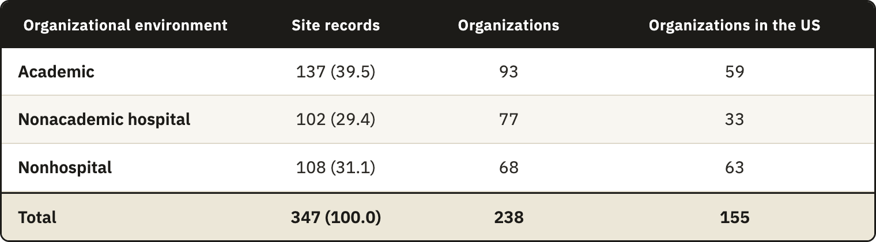

Each organization was counted once for every investigation it hosted. Of the 238 organizations, 178 took part in one investigation and 60 in more than one, up to nine at the Rothman Orthopaedic Institute. A count by organization would give an organization with nine investigations the same weight as one with a single investigation, and it would understate the environments where investigational activity concentrates. Repetition was most frequent in the nonhospital group, whose 68 organizations hosted 1.59 investigations on average, against 1.47 in academic organizations and 1.32 in nonacademic hospitals, and a count by organization would lower its share from 31.1% to 28.6%. Entries for the same organization within one investigation had already been merged during normalization, so each site record stands for one occasion on which an organization conducted an investigation.
Hospitals hosted most of the investigational activity in the sample, with 239 of the 347 site records (68.9%). The remaining 108 site records (31.1%) came from 68 nonhospital organizations, the independent orthopedic practices, ambulatory centers and surgeon-owned orthopedic facilities that operate outside hospital systems and universities (Table 3.3). Organizations of this kind are therefore a regular part of these investigations in the sample, and not an exception.
These categories describe what kind of organization a site is, and they say little about how it is prepared for research. A nonacademic hospital may have a research unit with dedicated staff, or it may run investigations alongside routine care with no such support, and private practices can vary in the same way. The registry holds no information that would separate these cases, so Table 3.3 shows where investigations take place and does not show the resources or the readiness of each site.
The sample is weighted toward the United States, with 155 of the 238 organizations (65.1%) and 243 of the 347 site records (70.0%). The weight is greatest in the nonhospital group, where 63 of the 68 organizations (92.6%) were in the United States, so the nonhospital share describes mostly US practice. Part of this concentration comes from the registry itself, because registration on ClinicalTrials.gov is required for many studies conducted in the United States. We also searched Eudamed, its European counterpart, but it returned few of these investigations and little site-level data compared with ClinicalTrials.gov. The findings therefore describe this sample and should not be read as the distribution of shoulder device investigation sites in Europe or worldwide. The purpose of the analysis was to judge the relevance of the framework and to identify the site conditions its requirements must take into account.

3.4.5 The operating conditions of the target center
The registry showed that investigations of implantable shoulder devices run in several organizational environments and that nonhospital organizations contributed close to a third of the site records in this sample. The choice of the target center is a separate design decision. The framework was designed for a center with limited support, a small independent clinic that runs investigations alongside surgical care, with few research staff and little research infrastructure. A framework that works in such a center can be extended where more support exists, while a framework built for a research hospital would be hard to scale down.
This design scenario is narrower than the nonhospital category of the registry. The category also includes exclusively orthopedic facilities with inpatient beds owned by the surgeons who operate in them, which may hold more infrastructure than a small clinic. The classification was kept as it was made. The registry share supports the relevance of designing for organizations outside hospital systems, but it does not show that these organizations lack resources, since the registry records neither staffing nor infrastructure.
The evidence reviewed above comes from drug trials, and part of it concerns drug administration. Most of what it reports, however, concerns staff, clinician time, infrastructure and oversight, which a site needs whatever the product under investigation, and the conditions of an implantable device investigation add to these demands. The few studies on device and orthopedic research point the same way. In a pilot within a UK hip preservation registry, centers given additional administrative support achieved 79% follow-up compliance at 30 days against 55% in centers without it, and 69.4% against 47% at 90 days⁸⁰. Experts on pediatric device trials rated a device training plan among the most important infrastructure components for implanting and using the device⁸¹. A small clinic conducting a shoulder device investigation is therefore unlikely to face lighter constraints than those reported for drug trials, although the present work did not test this inference.
The registry did not record staffing, budgets or the priority each organization gives to research, so the conditions of the target center entered the design as assumptions. The framework does not assume a dedicated research office or quality function, and it allows research duties to be shared among clinical staff. It had to fit within existing site roles, without new physical infrastructure or a dedicated quality department, and its instruments had to work on paper or within an electronic system already available at the site.
Designing for limited resources shapes how the essential functions are delivered and does not remove them. One person may hold several functions, provided each function has a named substitute who can act when the holder is absent, so that control continues while the investigation runs. A site that cannot sustain even the minimum set of functions needs additional support, for example from the sponsor, before it takes the investigation. Adopting part of the framework may still bring benefits, but partial adoption does not amount to the minimum level. These conditions set the minimum implementation level of the framework, and organizations with established research departments can place the same functions within their existing systems and use deeper controls.
The main purpose of these arrangements is to control quality while the investigation is being conducted. Keeping the records within the organization also preserves decisions when people change and allows the site to reuse its structure in later investigations, and both are additional benefits.
The regulatory base of the design is European, since the clause comparison used ISO 14155 and the MDR, while the registry sample is weighted toward the United States. The framework is intended for international use, including in the United States, but its regulatory references would first need to be mapped to the local requirements, and no regulatory equivalence between the two regimes is claimed.

3.5 Design requirements
A CtQ domain defines where the site has to protect the critical factors of an investigation, but it does not say what the site must have in place for that domain to be under control. The design requirements state this. They complete the second DSRM activity, the definition of the objectives of a solution, by turning the findings of this chapter into statements of what the framework has to provide. They guide the design, and each component of the framework can be traced to at least one of them. They were not written as formal acceptance criteria, and no test of the framework against them was performed.
The requirements were set before the instruments were designed and stayed the same while the instruments were developed. The scalability model came afterward and changed how each requirement is met at each implementation level, without redefining any of them.
Table 3.4 lists the twelve requirements and traces each one back to its origin. DR1 to DR5 come mainly from the gaps in explicit site-level requirements, and DR6 to DR9 from the CtQ domains and the structural conditions of surgical investigation. DR10 to DR12 come from the operating conditions of the target center.
Requirements and domains do not correspond one to one. DR2 covers all twelve domains, because each of them needs its execution risks identified at the site. The four domains that rest wholly or partly on themes with no explicit site-level obligation (domains 5, 6, 8 and 9) feed the requirements on operator proficiency, point-of-care capture and measurement variance (DR3, DR6 and DR7). The other domains enter the set through how the site organizes their control, for example through indicators (DR8) and correction (DR5). Informed consent (domain 3) is the only domain with no requirement beyond DR2, since the instruments regulate consent in detail.
DR10 is mainly a requirement of continuity. Each quality function needs a named holder and a substitute, so that the function continues when the holder is absent, and one person may hold several functions. The requirement also keeps the authority to take a decision apart from the responsibility for carrying out a task, so that, for example, a coordinator can perform a task whose acceptance remains with the PI. The review of critical decisions is a separate matter, since such a decision should not be reviewed only by the person who took it.
Meeting one requirement can also make another harder to meet. DR11 rules out capital investment and asks the site to reuse its existing documentary system, so it limits how DR1 to DR9 can be met. A site could satisfy every functional requirement with an information system built for the investigation, and that solution would pass the regulatory analysis while failing the operational one. When two requirements point to different solutions, the design takes the one the site can run, provided the essential function is still delivered, because a control the site cannot afford to run will not be run.
None of the three instruments explicitly requires a site to operate a quality system (Gap 1), so the framework cannot be justified by pointing to a rule that demands it. Its justification comes from tracing each part back to its origin. Each component answers a requirement, and each requirement comes from a gap, a CtQ domain or an operating condition (Table 3.4). The gaps and domains trace back to the clause comparison, with Gap 3 checked against the surgical trials literature, and the operating conditions trace back to the literature and the registry evidence. Where the framework adds a control that no instrument explicitly requires, that control answers a gap the comparison documented. Everywhere else, the framework organizes duties the instruments already assign, so that a site can carry them out under the conditions in which it works.
Table 3.4. Design requirements (DR1 to DR12) for a site-level operational quality framework and their origin in the gaps in explicit site-level requirements, the CtQ domains, or the structural and operating conditions of surgical investigation and of the target center. CAPA, corrective and preventive action; CtQ, critical to quality.


