5. Discussion

5.1 Contribution of the thesis
The main contribution of this thesis is a quality framework that the investigational site runs for itself during conduct, derived from ICH E6(R3), ISO 14155:2026, and MDR Annex XV^{3,6,8} and fitted to the site with the least support. Conducting an investigation well and showing that the site controlled its conduct are separate achievements. Under the older arrangement the sponsor assured quality through monitoring visits and source data verification, together with audit, and held the evidence that the conduct had been controlled, so the site needed no account of its own processes. ICH E6(R3) now asks the investigator to put processes in place and to make sure that qualified staff and adequate resources support quality at the site³, without saying what the site should produce to show it. The same guideline treats the essential records as the means by which the conduct of the investigator is evaluated, by the sponsor and in inspections (ICH E6(R3), Appendix C, C.1.3)³, so a site that shares responsibility for quality needs records through which it can show how it carries its share. The framework gives the site the means to do so, and the thesis delivered it as a design, with each component traced to the analysis that produced it.
The framework asks the site to act as a quality agent in its own right. The sponsor still designs the investigation and decides what is measured, and the site still executes the protocol. In a multicenter investigation, however, the sponsor cannot assess the specific risks of each site and build controls for each of them. Some of the most consequential risks are local, such as the way a team captures implant identifiers or positions a shoulder for imaging, together with each surgeon's progress through the first cases, and the site is usually the first to see them as they arise. Every quality activity above it, from the sponsor's planning to central monitoring, rests on the conduct the site performs, and neither planning nor monitoring can recover data that were badly produced at the base. A site without a quality structure depends on what the sponsor asks and corrects its errors after someone else detects them, while a site with one can anticipate part of its failures and prevent them. Responsibility in this sense is a proactive role, in which the site understands the weight of its actions and keeps improving them, while final responsibility for the investigation stays where the regulations place it. We found no published framework that gives the site this role in device investigations, although the successive revisions of ICH guidance point toward sites being asked to show it.
The plan described a comparison of texts and the requirements drawn from it, followed by a framework that answered them, but the design needed more than that. Placing the controls against the course of an investigation showed that the moment of a control matters as much as its content, because an error made while an implant is fixed cannot be corrected afterward, and the lifecycle gave form to this need, already stated in DR9. The registry analysis then showed that nonhospital organizations hosted almost a third of the site records, so the framework had to work first where it could assume the least support. The scalability model came after the instruments, by adjusting the set already designed to meet DR12. The third element was not anticipated, because a set of records seemed enough until it became clear that a problem can sit unnoticed in several records that nobody reads together. The instruments were therefore built to pass information from the record of one event to a decision about how the site works.
Gregor and Hevner classify a design contribution by how mature its problem and its solution are, and they call the transfer of a known solution to a new problem an exaptation⁸⁹. Most of the framework is a contribution of this kind. A documented quality system is an established solution, which the manufacturer and the medical laboratory already run under their own standards^{7,56,57}, and the problem is recent, since the revised guidelines give the site a larger share of the responsibility for quality without a structure to carry it. For four of the five gaps, the framework takes a principle that the texts state for the sponsor, such as the risk management cycle or continuous improvement, and builds the site-level instrument that the texts leave out. A regulator could derive each of these four duties from duties the site already holds, so in these areas the framework adds organization to obligations that already exist.
Observation of the surgeon during conduct, which answers the third gap, is also an exaptation, since surgical methodology already follows operator learning, although its derivation is of another kind. ISO 14155:2026 allows the sponsor to justify a roll-in phase in the CIP, and the surgical trials literature controls the operator at entry, but none of the texts we compared gives the site a role once the investigation has started. Since no clause asks for this observation, its justification rests on an argument. When the CtQ logic required by the texts is applied to an intervention delivered by a person whose execution changes over time, operator learning becomes a threat to data validity. A qualification at entry cannot control it, because it records a state at one moment while learning unfolds as a trajectory.

5.2 Position in the literature
Risk-based quality management was developed for the party that designs and oversees a trial, in medicines and in devices^{1,27,28}, and sites meet it through the sponsor, as a monitoring plan that arrives with the protocol⁴⁹. Few of the sites surveyed in Portugal held a risk tool of their own, and the identification of CtQ factors is among the least used practices even among sponsors^{12,48}. The Site Risk Register (SRR) applies the risk cycle of the sponsor to the risks created by the site's own execution, and it starts from the CIP so that it can be built even where the sponsor never formalized its critical factors. In those investigations the SRR may be the first place where anyone applies CtQ reasoning to local processes (Table 5.1).
Table 5.1. Prior work on quality in clinical investigations, grouped by theme, with the response of the framework to each theme.
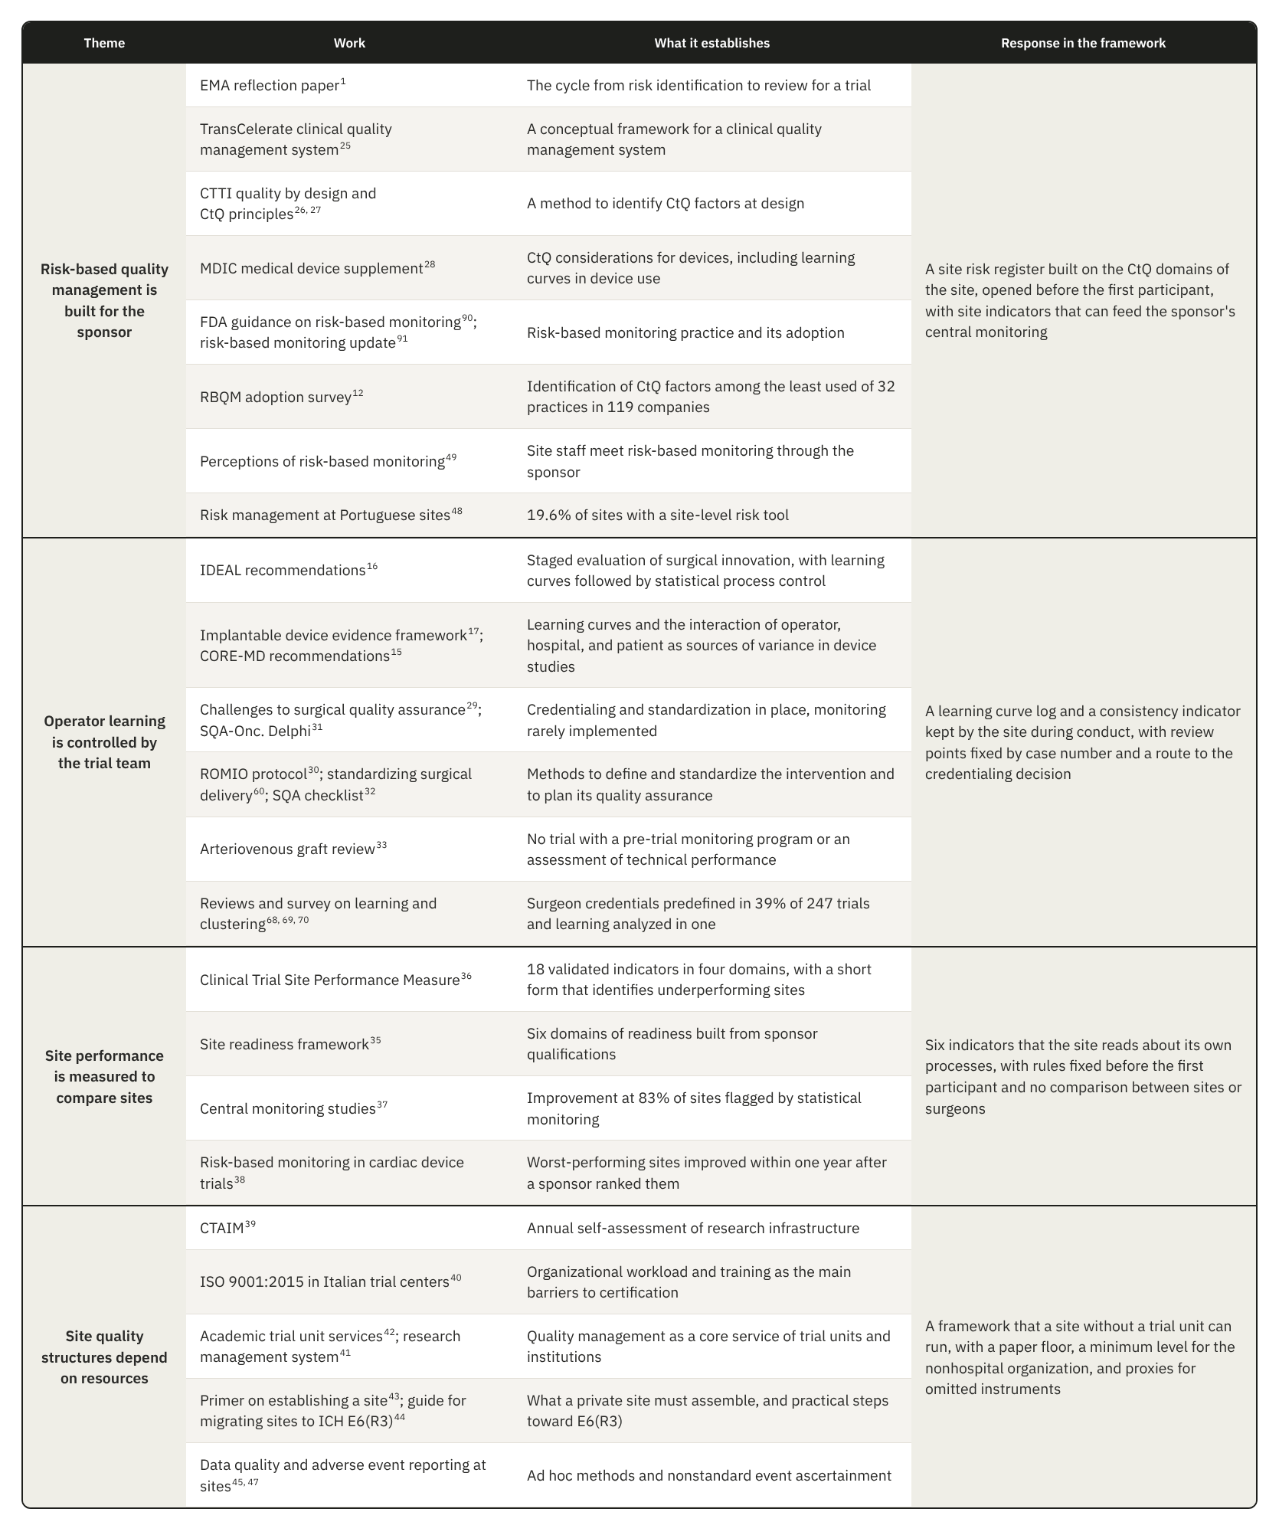
Surgical methodology controls operator learning mainly before the trial starts, through credentialing and standardization, and the more recent consensus frameworks that add monitoring during the trial specify it for the trial team^{29,31,32}. The IDEAL recommendations already proposed statistical process control to follow learning curves¹⁶, but they addressed the evaluation of an innovation by researchers, so the method did not reach the site as a quality control. The Surgeon Learning Curve Tracking Log (SLCT) keeps each surgeon's case sequence during conduct and compares each case with the same surgeon's earlier cases of the same complexity, so that a pattern leads to the credentialing decision. It uses a structured clinical review in place of formal process control, because a single site rarely has enough cases to set control limits.
Measures of site performance are built mainly to compare sites, and the validated Clinical Trial Site Performance Measure serves benchmarking across networks³⁶. It includes consent, which our framework covers only through the eligibility record, so a site whose register rates consent as a high risk should add a measure for it. Our indicators are tied to the CtQ factors of one investigation and tell the site that one of its processes has started to drift, without comparing sites or surgeons. Central monitoring and the ranking of sites by a sponsor improved data quality at many of the sites they flagged^{37,38}, but in both cases the signal reached the site from outside. Whether a signal produced inside the site, earlier in the conduct, has a comparable effect is one of the expected effects of the framework (Table 5.3).
The few quality structures that sites hold today depend on resources, from an annual self-assessment of research infrastructure and ISO 9001 certification to the trial units of academic institutions^{39–42}. A nonhospital organization has no trial unit or research office behind it. Some independent practices receive standard procedures and staff from site management organizations or site networks, but this support is built for trials in general, and none of these structures carries the CtQ content of a device investigation. The framework therefore sets its minimum level in the nonhospital organization and asks for no software or dedicated staff, so that the instruments carry part of the quality function that an academic hospital receives from its trial unit.

5.3 Putting the framework to work

5.3.1 A route through the lifecycle
A site starts the instruments in the order set by the lifecycle and by the dependencies between them, which differs from the order by pillar used to describe them. During feasibility the site reads the CIP with whatever the sponsor provides on critical factors and risks and checks each CtQ domain against its own capacity, taking a first estimate of its implementation level from its organizational category. When the investigation requires controls beyond what it can run, the site asks the sponsor for support, such as proctoring, or declines, and its answer informs the judgment of the sponsor on the site under Clause 6.8 of ISO 14155:2026.
Start-up follows a fixed order, because each step needs the one before it. The role structure comes first, since no task can be assigned until each function has a holder and a substitute, and when the PI also operates, the site names at this point the person who will decide on the PI's own authorization. Training and release come next, followed by the credentialing of each surgeon, and only then do delegations become active, so nobody is delegated a task before being released for it. The SRR opens before the first participant and decides which optional instruments the site adds to its minimum set. Every rule is then fixed before any data exist, from the basis of comparison of the SLCT to the thresholds of the indicators and the scope of internal verification, and a later change applies only to future periods.
Once participants are enrolled, only five records have to be completed at the clinical moment, the PSEAR, IQL, ICDL, SART and PFVR, and every other instrument reads them. The first reviews come earlier than their routine schedule, after the first inclusions and after each surgeon's first cases, so that problems of a new workflow are found while few participants have been exposed to them. At close-out the site reconciles device accountability and safety cases and closes each corrective action with an effectiveness review or a documented limitation, and the PIDLR keeps the lessons that pass to the next investigation.

5.3.2 The review cycle
The instruments need a review cycle, but a single rhythm for all of them would not match the work they record, and a small site that tried to review twenty-four instruments every month would barely finish one round before the next began. The framework therefore fixes a rhythm only where the risk depends on timing and leaves the rest to the site, which knows its volume of cases and the people available. The SLCT is reviewed at set points in each surgeon's sequence, for example after the fifth and the tenth case, because learning shows in the early cases whatever the calendar says, and safety cases are followed within the intervals the CIP sets for reporting. For the other instruments the site chooses at start-up a monthly, quarterly or yearly review, according to how much each instrument records and how fast its content changes. A serious adverse device effect or a cluster of complications starts a review at once, and so does a protocol amendment or the departure of a key person.
The oversight meeting reads the instruments in an order that lets each finding inform the next. Safety comes first, because the operative times of each surgeon can only be read once the meeting knows which cases had complications, and the indicators and internal verification follow, with the SRR closing the agenda. The PI records each decision in the POT, and a decision that restricts a surgeon returns to the credentialing and delegation records, where the ICDL checks it at the surgeon's next case.
The minimum level omits the SLCT and, with it, the instruments that review complication signals and indicators, so the meeting itself does their work. It reads the substitutions recorded in the ICDL and reviews the SART cases together, and it checks follow-up through the FUCR. The minimum level therefore depends on this recurring meeting more than on any single instrument, and when meetings are missed, the synthesis that the higher levels spread across several instruments disappears without any record showing that it is missing.

5.3.3 Where implementation is likely to fail
We applied to the framework the reasoning it asks a site to apply to its own conduct and looked, phase by phase, for the points where a site could operate the instruments and still lose their function. The failures we consider most likely, with what each one costs and the guard the design provides, follow the order of the lifecycle (Table 5.2). The list is our own assessment, made without data from a site, and it is not complete.
Table 5.2. Most likely failures in operating the framework, by lifecycle phase, with what each failure costs and the guard in the design.
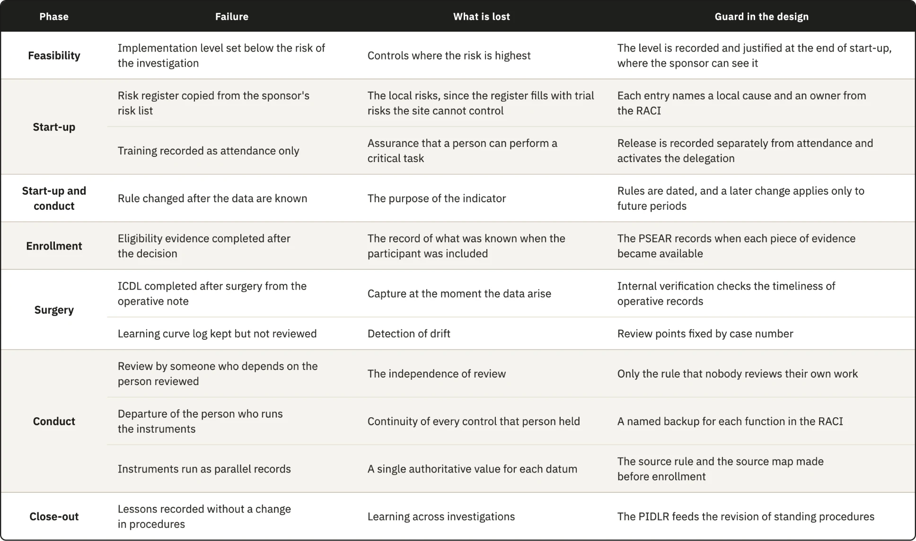
The weakest guard concerns the independence of review in a team of two. The framework only requires that the reviewer is not the person who did the work, and in a surgeon-owned practice the coordinator who reviews the surgeon's operative documentation may be the surgeon's employee. A peer from another site would give that review some distance, as would an arrangement in which two small sites review each other's records, and a sponsor's monitor could examine the internal reviews at each visit. None of these options is part of the current design.

5.3.4 What the framework is expected to change
Each instrument takes part in a chain that starts with a record made at the clinical moment and read together with other records. The synthesis supports a decision, and the decision becomes the rule that the next record is checked against, so the value of the framework depends on that chain closing in time, which depends on the people who run it as much as on the design. Its expected effects follow the phase in which each should first appear (Table 5.3). The framework does not fix the conditions under which an effect counts as absent, because a site needs time to learn the instruments before their signals mean much. Each site sets these conditions at start-up, with its other review rules and before any data exist, including the minimum number of review periods or visits it will observe before judging an effect.
Table 5.3. Expected effects of the framework, ordered by the phase in which each effect should first appear. CIP, clinical investigation plan.
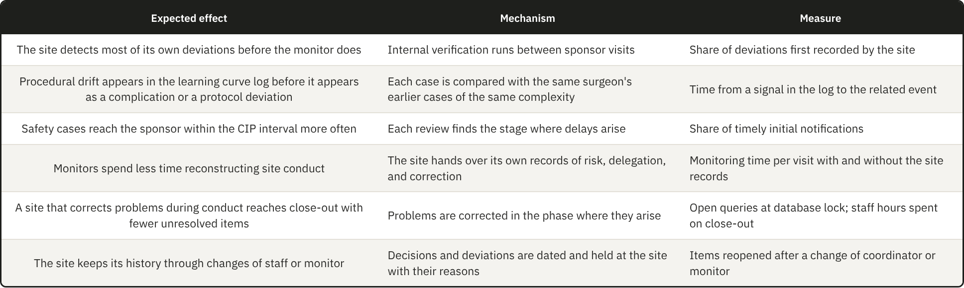
The indicators of enrollment quality and critical data completeness read a process while it runs, and so does surgeon procedural consistency. The other three indicators count events that have already happened, although each can still signal a deterioration before it reaches a participant or an endpoint. With few cases in each review period, one event is often enough to move an indicator from control to closer review or action. In the target center the indicators therefore work mainly as a scheduled review of events against rules fixed in advance, and their value comes from that schedule and those rules more than from any statistical property.

5.3.5 Documentation and conduct
A site can record its conduct impeccably and still conduct itself badly, and nothing in this thesis settles whether documenting a practice improves it. The claim we can defend is narrower, since controls written for a specific activity leave fewer gaps open, so the framework acts on the probability that a failure goes undetected and says nothing directly about the quality of the conduct itself. This rests on a premise we state as such, namely that many failures in clinical investigations come from lapses and competing demands on the same person, or from the lack of a tool that makes an error visible in time. Deliberate misconduct is outside the reach of the framework, since a person who intends to misrepresent conduct can misrepresent the record as well. For the other failures, diligence cannot act on what nobody sees, and an instrument that brings a failure into view turns it into something a person can respond to.
If the framework changed nothing in conduct and its only effect were a complete and traceable record of what the site did, that outcome would still be better than the same conduct leaving no record. The record allows a case to be reconstructed years later and supports the manufacturer whose post-market obligations depend on it, although it protects a participant only when someone reviews it and acts in time.
Observation may also change behavior, since a surgeon or a nurse who knows that the work is reviewed may attend to it more closely and learn from the review which elements matter. The same pressure can lead people to satisfy the fields while the practice stays as it was. The design limits that risk, because its instruments record decisions and identifiers with their dates, so a device identifier is captured or missing whatever attention is paid to the form, and because most records are read by someone other than their author.

5.4 Scaling and transfer
Many of the organizations the framework was designed for have no structure dedicated to research, and a private site is expected to assemble standard operating procedures and trained staff, together with the infrastructure research requires, before it enters the field⁴³. We assume, without data from these organizations, that few of them employ people whose only work is clinical trials, so the same people hold several functions. The surgeon is often the PI, and a nurse may also carry out the physical assessments that a physiotherapist would perform in a hospital. Some activities, such as imaging or specialized assessments, may be contracted outside the practice, so the site has to oversee work that it does not perform itself. A framework that assumed a trial unit and dedicated staff would not fit this setting, and ICH E6(R3) itself asks for quality management proportionate to risk, without unnecessary complexity. The scalability model tries to keep the essential controls in place with fewer people and fewer instruments, and to let a site add instruments as its capacity or the risk of its investigation grows.

5.4.1 The minimum level and its trade-offs
At the minimum level a site runs twelve instruments, and these cover the core of the framework. Every gap has at least one response and every record that ISO 14155:2026 and the MDR require is kept, while four of the five records made at the clinical moment remain as instruments, with the CRF serving as the visit record. Each function has a named holder and a substitute, and the oversight meeting brings the records together. Inspections assess conduct through the essential records (ICH E6(R3), Appendix C, C.1.3)³, and none of the twenty-four instruments is required by ICH E6(R3), ISO 14155:2026 or the MDR, so a site at the minimum level that keeps every required record carries no regulatory exposure beyond that of a site running the full set.
In exchange, the meeting at the minimum level reviews less often than dedicated instruments would, so a signal may be noticed later, and one person may hold several functions, which weakens the separation between execution and oversight required by DR10. The proxies carry a less visible cost, since the CRF and the sponsor's screening log sit in systems the sponsor controls and the site's access to them may end after close-out, leaving part of the site's history in records it will not keep. A site at the minimum level should therefore keep a copy of these records under its own control at close-out, or use the PFVR from the start when follow-up lasts several years.
In practice the minimum also depends on the stage of the investigation. The SRR adds the SLCT for a new implant design or technique, and in a premarket investigation the device is new to every surgeon, so the rule will almost always apply and the effective minimum becomes thirteen instruments. The minimum of twelve applies mainly to investigations of devices already in the surgeon's use, such as post-market clinical follow-up. The PI who records the implementation level also carries part of the work each level adds, so a site has a reason to choose the lowest level its category allows, and the reasoning recorded at start-up is what a sponsor or an inspector would ask to see.

5.4.2 Instruments that outlive the investigation
The framework is described for a single investigation, while many sites conduct several, either at once or one after another. Some instruments belong to the site and are kept across investigations, and some keep a site structure that each investigation fills with its own content. The rest are opened again for every investigation (Table 5.4).
Table 5.4. The twenty-four instruments by persistence across investigations.
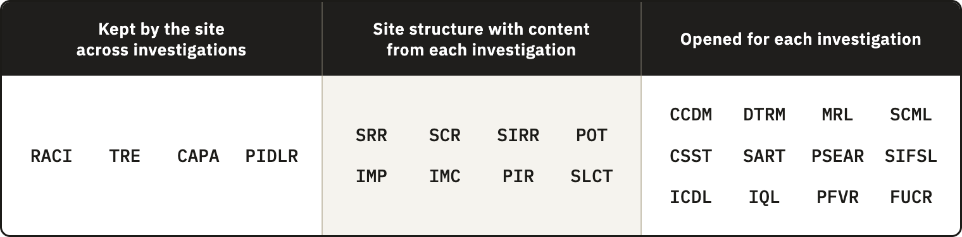
The instruments opened for each investigation are mostly records of participants and procedures, or of visits, so their effort grows with the number of cases, which is the work a site budget prices per participant and per procedure. Setting up the structure is work of another kind, concentrated in the instruments the site keeps or reuses. Fifteen instruments act during start-up, when sponsors measure how quickly a site is activated, and the cost of setting them up falls mostly on the first investigation. A site with a steady portfolio spreads that cost and, as it refines the instruments, spends less on running them in each new investigation, whereas a site that takes one investigation every few years carries most of the cost each time.
A site running investigations at the same time needs one role structure and one training history, and also one corrective action log and one oversight meeting for all of them, while the participant records remain separate for each investigation. Safety reporting timeliness and critical data completeness measure site processes shared by all of its investigations, as does the deviation rate by area, so the site can pool their counts to enlarge the small denominators of a single investigation. Surgeon consistency and complication patterns depend on the device and cannot be pooled across different devices, and because each sponsor's data are confidential, pooled counts serve only the site's internal review. Because a surgeon's learning with a device continues across investigations, the SLCT of a later investigation should start from the earlier cases where the site holds them.

5.4.3 Transfer to other specialties
Neither the MDR nor ISO 14155:2026 distinguishes a shoulder device from a knee or hip device, so the obligations behind the instruments apply across implant surgery and make transfer plausible, although they do not show it. Within the instruments, anatomical content sits in the complication categories and the imaging requirements, together with the complexity levels of the SLCT, while their structure carries none. Spine surgery shows that specialties also differ in more than content, since one procedure may implant several components, which multiplies the traceability work and the ICDL entries per case. In robot-assisted or navigated arthroplasty part of the execution moves from the surgeon to a system, so the basis of comparison of the SLCT has to separate experience with the procedure from experience with the system. The claim does not reach surgical investigations without an implant, where unit traceability does not arise, or device investigations without surgery, where operator dependence takes another form. Applying the instrument set to the documentation of a completed hip or knee device investigation, and recording which fields had to change, would test the claim at low cost.

5.4.4 Transfer to other jurisdictions and editions
The registry places 155 of the 238 organizations in the United States, including 63 of the 68 nonhospital organizations, while the framework was designed under the MDR and ISO 14155:2026, so most of the nonhospital organizations in the sample operate under another regime. The regulatory derivation is unaffected, because it does not depend on the registry, but the question of how far the framework serves these organizations remains open.
Under 21 CFR Part 812, the investigator reports an unanticipated adverse device effect to the sponsor and to the institutional review board within ten working days of first learning of it¹¹. A site in the United States therefore has a regulatory interval for the safety reporting indicator, where a European site takes the interval from the CIP. Since the SART already takes its interval from the CIP, it adapts, and what changes are the terms and the regulatory anchors of each instrument. Neither regime prescribes how a site organizes itself, so the structure should transfer once each anchor is mapped to the corresponding provision.
Within the European Union, the version of ISO 14155 with a presumption of conformity under the MDR is still EN ISO 14155:2020+A11:2024⁹, while the 2026 edition represents the current state of the art. Some parts of the framework rest on clauses added in the fourth edition, such as the risk stream for clinical procedures beyond routine practice and the clinical events committee. A site working to the harmonized version can use these parts as state of the art, without the presumption of conformity that the harmonized text carries.

5.5 Implications

5.5.1 For the investigational site
For the site, the main gain is control of its own conduct while the investigation runs, held in an account that the site can show. That account also has economic and reputational value, and because the organization keeps it, it survives changes of people. When a coordinator leaves or a monitor is replaced, or when a question settled by an earlier monitor comes back, the site still holds the decisions and the reasons behind them.
The work the framework asks of the site can be priced, because research payments from industry are expected to reflect the fair market value of the work performed⁹² and site budgets are negotiated item by item with the sponsor. In one review of ten industry-sponsored trials, the final budgets exceeded the sponsors' initial proposals by 59% on average, and the costs of preparing the trial were among the items that changed most⁹³. The quality work a site performs for an investigation can therefore enter the budget as an item of its own, within the fair market value of the activity, and a function such as a data quality reviewer can be justified as a budget line in the same way. As the site repeats and refines the instruments, the time they take should fall, while the payment for the activity stays at least the same.
The framework may also make the income of the site more stable. Closer control over assessment and enrollment should lose fewer eligible patients to incomplete records or missed assessments, and each inclusion is paid, while fewer errors mean fewer costs of correction, such as a screen failure caused by an incomplete eligibility record or a missed imaging window. A site that can show how it controls its conduct may also gain standing with the sponsors that select it for later investigations, although we could not test this.
The benefits also reach other parties, since the sponsor gains easier monitoring and more reliable data and the manufacturer relies on the operating room records for traceability. A site deciding where to begin should start with the instruments that protect data that cannot be recovered, meaning the five records made at the clinical moment and the SRR, because the same records protect its revenue. A site that records a weakness also creates a record that a monitor can read, and a finding the site raised against itself is still a finding, although it also shows a site that knows its weaknesses and acts on them. How monitors read such findings is not known, and it will decide whether sites are willing to keep these records.

5.5.2 For sponsors and monitors
The framework sits alongside the sponsor's quality system and organizes the processes through which the site conducts each investigation. The sponsor oversees quality across the trial, while the site uses the CIP, with what the sponsor communicates about critical factors and risks, to identify the risks of its own work and set controls in proportion to them (Figure 5.1). The structure of the framework stays with the site across investigations, while its content follows each CIP and the systems the sponsor requires.
Within this interface, the instruments give the evidence for local review. The PI's decision, recorded in the POT, may revise a risk control or open a corrective action, and the records that follow show whether the response worked. A signal that needs the sponsor's assessment goes to the sponsor with its evidence and with any local action already taken, so that the sponsor can read it across sites and return any change to the site's conduct. Required reporting follows its own timelines while the local review continues.
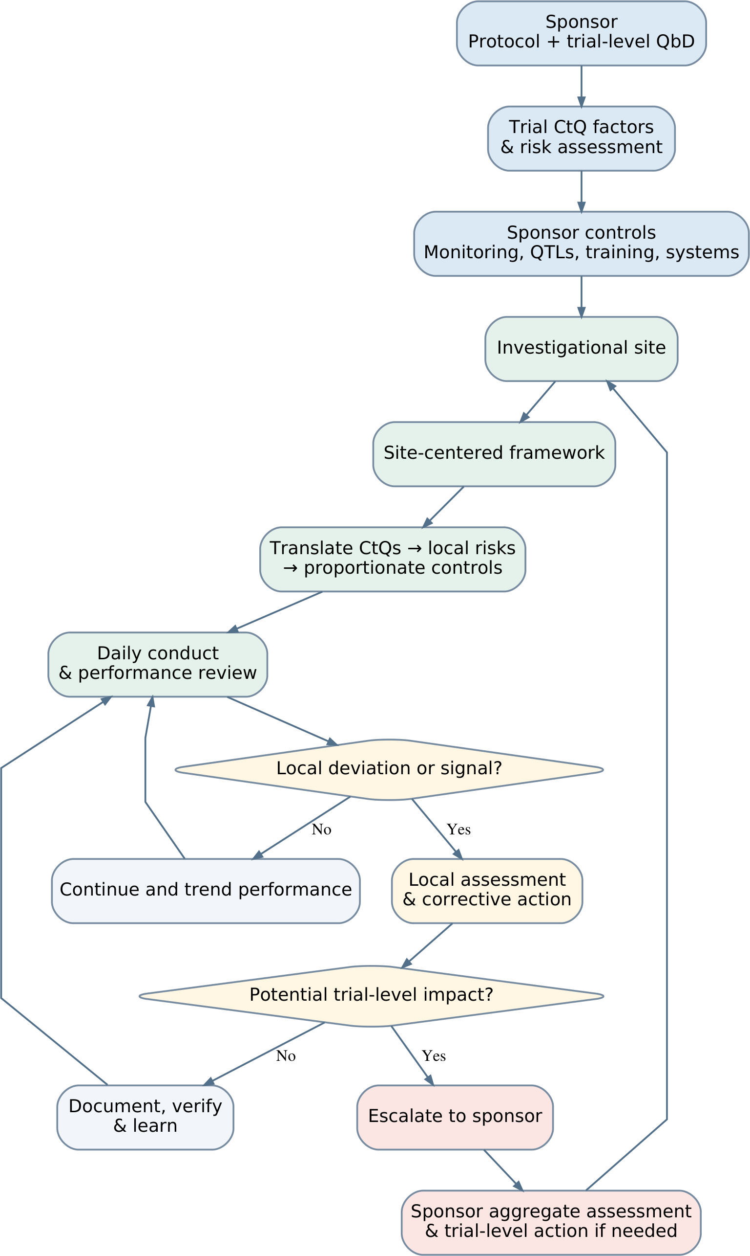
Figure 5.1. Proposed interface between sponsor oversight and the site-centered quality framework. Local review leads to correction and verification, with escalation when a signal may affect the trial. Sponsor feedback informs subsequent site conduct. Required safety reporting and urgent protective action follow their own routes and timelines. QbD, quality by design; CtQ, critical to quality; QTLs, quality tolerance limits.
At qualification, Clause 6.8 asks the sponsor to judge the qualifications of the PI and the adequacy of the site, and a site that arrives with its own risk register and oversight records gives documentary evidence on both. At a monitoring visit the same site can hand over its delegation records and corrective action log, with its indicator results, so the monitor reviews a site that has already described its own risks. Risk-based monitoring is adequate only when certain prerequisites at the site are met⁴⁶, and the framework builds some of them. We found no study measuring how much monitoring time this saves.
The two systems can also be aligned more closely than they are today. If the sponsor gave each site, at initiation, a summary of the critical factors and main risks it identified, the SRR and the sponsor's monitoring would address the same targets. Where the CIP allows it, the ICDL can be named as the source of implant identifiers and intraoperative events, so source data verification compares the CRF with a structured record made during the procedure. The site's indicators read at one center the processes that the sponsor's key risk indicators read across the trial, and they could feed central monitoring as long as each datum keeps its source. The clinical events committee that ISO 14155:2026 allows the sponsor to establish addresses the same events as the site's complication review, at a different level, and a local action already taken is information the committee can use.
Only one of 247 randomized surgical trials analyzed learning effects⁷⁰, partly because the case sequence of each surgeon is rarely collected. The SLCT holds that sequence with complexity and duration, so a CIP that planned for it could use the log to examine learning in the main analysis, provided the surgeon's data are protected.
Central monitoring by the sponsor finds problems in the data that reach the CRF, such as an image that does not meet the imaging requirements or a visit outside its window, but it finds them after the data are entered, often when the window to repeat an examination has already closed. The IQL and the ICDL check the same points when the data are produced, so a site can still repeat an image or complete a record while the participant is available. The framework also keeps the site's history when the monitors assigned to a long investigation change.
A sponsor could go further and supply templates and help set up the framework across its sites, as it already supplies the protocol and training. This would move part of the cost of construction to the sponsor, but a site working with three sponsors would then receive three frameworks and run three quality systems at once. The more stable division keeps a structure owned by the site, into which each investigation brings its content and, where the sponsor wishes, its templates, while the operation of the framework and the ownership of its records stay with the site.

5.5.3 For standards and regulators
Reading ISO 14155:2026 from the position of the site shows points that a future revision could consider. All three risk streams of Clause 6.2 belong to the sponsor, and no text describes how a site handles the part of those risks that its own execution creates. Clause 9.2.4.5 p) asks monitors to verify that equipment relevant to assessment is maintained and calibrated, yet no clause describes the record through which the site shows this work. These observations come from one position in a standard with a wider purpose, so a revision might reasonably leave them open.
A clause asking a site to keep a risk register would ask for one document and one review cycle, while a requirement for a site-level quality system would ask for much more. Annex XV of the MDR governs the conduct of clinical investigations and says nothing about how a site organizes itself to conduct them, and the harmonization of the fourth edition would be a natural moment to examine that question. Recognition schemes for research sites already exist, since the UK Medicines and Healthcare products Regulatory Agency accredits units that run phase I trials against requirements beyond good clinical practice⁹⁴, and the Association for the Accreditation of Human Research Protection Programs accredits the programs through which research organizations protect participants⁹⁵, while ISO 15189:2022 gives the medical laboratory a quality system that can be accredited⁵⁷. None of them addresses the quality of conduct at a site running device investigations, and a framework of the kind proposed here could become the content of a future standard or accreditation for such sites. A standard of this kind could also reduce the fragmentation that frameworks supplied by sponsors create, because a site working for several sponsors would run one structure recognized by all of them. A future revision of ICH E6 or ISO 14155 could, more modestly, give the site an explicit proactive role in quality without moving final responsibility, and the framework shows one form that role could take.
No clause in the present texts requires the records this framework produces, so an inspection under the MDR would not treat their absence as a noncompliance. A site with the framework and a site without it therefore carry the same obligations and differ in what they can show, since only the first can show how it controlled its conduct without reconstructing it from primary documents. If later revisions move to the site part of the quality requirements that now rest on the sponsor, as the direction of ICH E6 suggests, a site with the framework will already hold much of what it is asked for.

5.5.4 Ethical implications
The SLCT and the consistency indicator hold performance by surgeon and can lead to a restriction of the cases a surgeon takes in the investigation, so in substance they assess professional performance. What they record, however, is performance with a device or technique that is new to the surgeon, under the conditions of the investigation, and a result below expectation in that setting says nothing about the surgeon's usual practice. Poor practice is a different matter, which belongs to the clinical governance of the organization. A signal recorded in these instruments, or in the complication review, could still follow a surgeon beyond the investigation and harm a career if it were read out of context, so the framework keeps every action that results from these records, from closer observation to a restriction, within the scope of the investigation.
The design codes the surgeon and keeps the key with the PI, which protects the surgeon when other staff, reviewers or patients see the documents by chance, and it fixes before the first case the outcomes that a review can reach, with the reasoning behind any restriction documented. Who may access these records, and for what purpose, also has to be defined before the first case. They are personal data of the professional and have to be handled under the data protection law that applies, which we did not analyze in detail. The indicator does not rank surgeons, since a fair comparison would need an adjustment for case mix and for clustering^{65,66} that a single site rarely allows.
In a surgeon-owned practice, the site belongs to the surgeon it observes, and the PI who decides on a restriction may be the surgeon under review or a close colleague who shares the commercial consequence. The same structure affects internal verification, where the reviewer may be the employee of the person reviewed. Every function has a named substitute in the role structure, so when the PI is the surgeon under review, the decision passes to that substitute on a route fixed before the first case.

5.6 Evaluation, limitations, and further research

5.6.1 The evaluation this thesis performed
The Design Science Research Methodology has six activities, and this thesis reports the first three, which run from problem identification to design and development, together with the last, communication⁵³. Demonstration and evaluation are not reported, although the thesis did perform one kind of evaluation. The design-science literature distinguishes evaluation before an artifact is used, which tests whether the design decisions are grounded, from evaluation after its use, which tests whether the artifact works⁹⁶. It also separates formative evaluation, which improves a design while it is still being shaped, from summative evaluation, which judges a finished artifact. A further distinction separates artificial evaluation, carried out away from real use, from naturalistic evaluation in the setting where the artifact will run⁹⁷. Our traceability from each component to a requirement, and from each requirement back to its origin, is an evaluation before use, formative and artificial. It is the expected first step for a design at this stage, because it checks that every part rests on a stated reason before anyone spends resources on implementation. It cannot show that the framework works in a site, because only a naturalistic evaluation can do that, and since we derived the requirements and assigned the components ourselves, the mapping is not independent evidence either. The framework should therefore move next to a naturalistic formative evaluation, in which a site uses the instruments and the design is corrected, and only then to a summative one that judges its effect.

5.6.2 Limitations
Some choices of this thesis are delimitations made on purpose, such as the focus on the shoulder and on the European regulatory framework and the choice of a small nonhospital clinic as the design case, and they set the scope of the claims. The limitations that follow each weaken an inference within that scope. The framework has not been implemented, so its expected effects, the economic argument and the estimate of effort remain expectations, and nobody knows yet how much time the instruments take in a small team. The gaps and the design requirements do not depend on any expected effect, so this limitation leaves the derivation intact and bears on the claims about effect, which a feasibility study in one site can begin to test.
The rules and thresholds of the indicators are provisional, because we found no published values for site-level indicators of this kind. The order of the work also shaped the result, since the scalability model was settled after the full set of instruments and the minimum level was obtained by removing instruments and naming proxies for them. A design that started from the minimum level might have produced a smaller set.
Because the literature review was narrative, any statement that a body of work is absent from the field is weak, and the position of this work in the literature rests only on the works we found and read, which a systematic search can test. We reduced the risk by searching the bodies of work most likely to contain a site-level framework and by reporting the closest works we found.
Our evidence on the state of site practice comes from published studies and regulatory guidance, with some expert commentary. We had no access to the internal documents of any site, from its procedures to its audit data, which weakens the claim that the failures the framework addresses are the ones that occur most often. Field research in sites of each organizational category can test that claim and calibrate the framework against observed failures.
We did not consult experts formally during the design. The framework was discussed informally with professionals working in clinical operations, and some of their criticism changed it, but these conversations were neither planned nor recorded, so they cannot count as evidence. The claim that the instruments can be completed as intended therefore rests on the design alone, until a structured content review tests it.
In the registry analysis, one researcher classified each organization from its public self-description, with a second internal pass and no independent assessor. This weakens the assignment of organizations to environments and the reproducibility of the counts in Table 3.3, which a second coder can test. Because the sample is weighted toward the United States, the inference that weakens most is the one from the organizational profile of the sample to European sites, and a registry analysis based on European data, which Eudamed did not provide, would test it.

5.6.3 Further research
The framework has completed the development phase of a complex intervention, and the phases that follow, from feasibility to implementation, do not have to come in strict order⁹⁸. The shortest next step is the demonstration activity of the DSRM, which needs no participants. Running the full set through a simulated or retrospective case series, from feasibility to the lessons record, shows whether the instruments connect as the design intends and whether any record lacks a reader.
A content review by sites and monitors, with surgeons included, and a usability test of the templates should come next, because an instrument that nobody can complete correctly cannot be evaluated for anything else. A feasibility study in one nonhospital organization and one hospital can then run the minimum set through a complete investigation. It should measure staff time per instrument, separating the work done once from the work that grows with cases, and compare the completeness of the records with a defined checklist. The share of deviations that the site detected before the monitor did shows most directly whether the framework does what it claims.
Before-and-after comparisons at one site are likely to report an improvement whatever the framework does. In surgical oncology, 86 of 97 non-randomized studies of quality improvement reported a positive effect, against 2 of 12 randomized trials³⁴, so the evaluation of effect needs a concurrent comparison. A sponsor could introduce the framework in its sites in a staggered order within one investigation, letting the sites that have not yet started serve as comparators. Where that is not possible, a site could follow its indicators over a long series before and after adoption, as the IDEAL recommendations propose when randomized designs are not feasible. A design led by a sponsor of this kind also tests whether a sponsor can supply templates while the site keeps the operation and ownership of its records.
Indicator validation needs another design, because an investigation spread across several centers leaves each center with few cases over several years. It can instead draw on existing records, since a retrospective study can pair historical values of the indicators with the events that followed them, and pooling the records of several centers of one sponsor provides the volume that one site cannot. Query backlog and reporting timeliness can be recovered from most trial databases, while operative time by complexity level is available only where the site recorded the level.
Mapping each instrument to 21 CFR Part 812 would test the transfer to the regime under which most of the nonhospital organizations in the registry operate, again without a new investigation.

