4. Results: The Quality Framework

4.1 Overview and design rationale
In the DSRM, the second activity defines the objectives of a solution, and Chapter 3 ended that activity with the design requirements DR1 to DR12. This chapter reports the third activity, in which we designed and developed the framework that answers those requirements. Each component is described in enough detail for a site to put it into operation.
Its full name is the Site-Centered Operational Quality Management Framework. It has four pillars, each with its own set of instruments, and their use is governed by a lifecycle, which decides when each instrument is activated, and by a role architecture, which decides who operates it. A scalability model then sets how deeply a site implements them, according to its structure and capacity.
The four pillars are Governance, Risk Management, Operational Controls, and Performance Oversight. They are a synthesis made for this framework, and each one groups a function that recurs across ISO 13485:2016, ISO 14971:2019, and ISO 15189:2022 [52, 53, 54]. Governance corresponds to ISO 13485 Clause 5, ISO 14971 Clause 4, and ISO 15189 Clause 5. For risk management, the relevant clauses are ISO 13485 Clause 7.1, ISO 14971 Clauses 5 to 7, and ISO 15189 Clauses 5.6 and 8.5. Operational controls are covered by ISO 13485 Clauses 7 and 7.5 and by ISO 15189 Clause 7. Performance oversight rests on ISO 13485 Clauses 8, 8.2.4, 8.4, and 8.5, together with ISO 14971 Clauses 9 and 10 and ISO 15189 Clauses 8.7 to 8.9. Using functions already recognizable in the device quality system makes the framework easier to interpret and implement.
Table 4.1 maps the 12 design requirements to the components that answer them, and every section of this chapter returns to that mapping.
This framework was designed mainly around the vulnerability discussed in Section 3.4.4. That setting shaped the operational constraints reported in Section 3.4.5, and it explains the form the instruments take. Even so, we wrote it to be transversal. Nothing in its architecture depends on a single form of organization, and the components are described as functions, so that a center with a different staffing structure can map its own posts onto them.
The instruments are not regulatory requirements. They do not replace sponsor procedures or the controls defined in the CIP, and they do not replace records that the regulations already require. Each instrument describes a control function, so a site that already keeps a record performing that function uses it and does not open a new one. A new record is justified only where a critical process would otherwise not be controlled or not be evidenced. The depth at which a site uses each instrument follows the risk of the investigation and the criticality of the process, together with the controls the sponsor already provides.

Table 4.1. The 12 design requirements from Section 3.5, the framework component that answers each one, and the section of Chapter 4 where that component is developed.
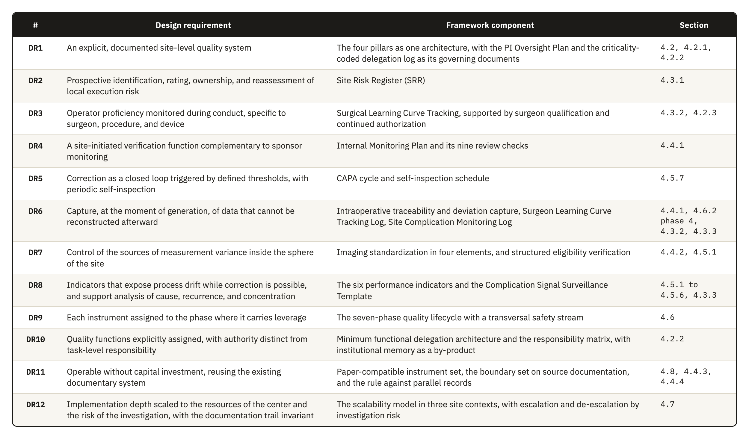

4.2 Pillar 1: Governance
Governance defines the local authority structure through which regulatory accountability is exercised at site level. The quality of the investigation depends on surgeon-dependent technical execution, on intraoperative decision variability, on device traceability, and on the reproducibility of postoperative assessment. The pillar is therefore designed so that clinical authority, delegated execution, procedural competence, and device-specific training are each controlled in a documented and risk-proportionate way.
The regulatory basis sits in two places. ICH E6(R3) expects investigator oversight to be proportionate to the nature of the delegated activities, to the importance of the data collected, and to the risks to participant safety and data reliability. ISO 14155:2026 keeps responsibility for the investigation with the PI under Clause 10.1, even when activities are delegated. It also requires the qualification of the investigator under Clause 10.2 and of the site under Clause 10.3.
This pillar has four components: the oversight model, the delegation structure with its role architecture, surgical qualification, and device training documentation. The oversight model defines how authority is exercised, and the other three set the conditions under which that authority is delegated and exercised. The pillars that follow observe what the authorized person does afterward, so the surgical learning curve is treated in Section 4.3 and the qualification decision is treated here.

4.2.1 The oversight model
During the design process, we developed three analytic alternatives for allocating oversight at site level. They are not an empirically established taxonomy. They represent recurrent ways in which site functions may be distributed under different constraints of staffing, capacity, and existing organization. Published descriptions of trial-site operations confirm that these functions must be covered, but do not divide them into the same three models. We therefore present the alternatives as design choices, compare their advantages and limits, and explain why the framework adopts the third.
The first is a strongly investigator-centered model, where the PI intervenes directly in most critical activities and personally reviews most documentary and operational workflows. The intensive supervision it conveys makes this model look like the safest option. It is hard to sustain, however, once the activity of the site grows. Site PIs already carry scientific, regulatory, recruitment, supervisory, and administrative duties, and their contribution is often under-recognized [73]. Administrative review then takes attention from the areas where the PI's clinical intervention cannot be replaced, such as confirming surgical appropriateness, interpreting intraoperative deviations, judging whether a complication is related to the investigational device, or reading early signs of executional drift as one clinical picture. The model also scales poorly across the operating room, radiology, postoperative functional follow-up, implant accountability, AE management, and data QC.
In the second alternative, a coordinator-led model, the study coordinator manages the daily work and the investigator keeps final authority. This is workable because the clinical research coordinator is a core site function [74] and ICH E6(R3) allows delegation as long as the investigator keeps ultimate responsibility and proportionate oversight [6]. Food and Drug Administration (FDA) supervisory guidance also stresses appropriate delegation and staff qualification, together with investigator oversight [75]. The weak point lies in how oversight is organized. It becomes nominal when the site has no defined review structure, set periodicity, formal escalation pathway, or explicit statement of what needs the investigator directly. In surgical investigations, such points include borderline eligibility decisions, unplanned intraoperative changes, component substitutions, the interpretation of revisions, and inconsistencies that the documentation alone does not make visible.
The framework adopts a third arrangement, in which PI oversight is tiered and adjusted to risk. The investigator's involvement in each task follows its criticality and the risk it poses to participant safety, procedural integrity, device accountability, and data reliability. Effective oversight then no longer depends on seeing everything or signing off every record. Attention goes to the processes and decisions that can affect participant protection and study validity, together with their data flows, so the CtQ logic of ICH E8(R1) is applied to the investigator's own time. Involvement is strongest where clinical judgment meets the PI's procedural authority and regulatory accountability, and five mechanisms turn this principle into controls the site can operate.
The first mechanism is a review schedule. The site decides in advance, for each type of activity, what needs the investigator's own judgment and what can be reviewed afterward without loss. Where that line falls changes with the device and the procedure, and also with the experience of the team that performs it. If the threshold is set too low, the investigator goes back to the first model, and if it is set too high, oversight becomes a formality with no real review behind it.
A second mechanism grades delegated activity by its stakes, and these stakes depend on the context of the task. Coordinating a routine visit is administrative until a scheduling choice places a follow-up outside the protocol window, and an intraoperative note is clerical until it becomes the record that reconstructs a disputed complication. The grading scheme therefore has to anticipate which routine activities carry this hidden significance, and a scheme copied from another site would miss the ones specific to this investigation and this team.
Formal review points are the third mechanism, and their timing decides what they can detect. A review held too early misses problems that only appear once a procedure or a follow-up window has passed, while a late one lets a correctable pattern run through several more cases before anyone with authority sees it. The points that matter most are procedural implementation, the immediate postoperative period, the approach to endpoint assessment, and close-out, because the most serious threats to integrity concentrate there. This placement follows the risk profile of this investigation and would not transfer unchanged to another device or procedure.
The fourth mechanism is an event-triggered escalation pathway, which notifies the investigator outside the routine review cadence. Some events threaten participant safety or causal interpretability at once, and in a high-variability surgical study no schedule can catch all of them before the next review point.
The fifth mechanism is an oversight meeting architecture, which places this review in the recurring rhythm of the site so that it does not depend on ad hoc contact. It is a design transposition of two sponsor-level practices, the structured, consensus-based review that ISO 14155:2026 uses under Clause 6.12 and the multidisciplinary review for risk assessment recommended by the EMA reflection paper [1]. Site-level forums of this kind have not been shown independently to improve oversight. They are also harder to sustain in the small or mid-sized centers this framework targets, because the few people who attend the meeting are the same people who do the clinical and administrative work the meeting reviews.
These five mechanisms together answer DR1 at the level of authority. They also carry part of DR10, because an oversight model that is written down, scheduled and evidenced produces a record that survives the departure of the people who operated it.

4.2.2 Delegation, roles, and functions
The delegation structure makes the oversight model operable. Without designated functions, authorized personnel, training-linked release, and controlled interfaces between roles, even a well-designed oversight model is organizationally underpowered. The relationship runs in both directions, since a strong delegation structure reduces ambiguity, makes escalation thresholds meaningful, and lets the investigator concentrate attention where judgment is clinically necessary.
ICH E6(R3) allows the investigator to delegate trial-related activities while retaining ultimate responsibility, and it expects oversight of delegated persons to be proportionate to the nature of the activity and the importance of the data, together with the risks involved. Delegated personnel should also be qualified and informed about the protocol and the investigational product. For device investigations, ISO 14155:2026 turns these expectations into obligations. It governs additional members of the investigation site team under Clause 7.6, which requires documented training before assignments begin, together with a record of names, initials, signatures, functions, and designated authorizations.
The conventional delegation log is principally a record of who performs which trial-related activity. ICH E6(R3) Section 2.3.3 expects documentation proportionate to the significance of the activity, and it does not ask for a criticality code or for evidence of competence in the same record. Delegation records are nevertheless subject to direct inspection scrutiny, and the investigator remains accountable for delegated work [75, 76]. In this framework, the delegation structure therefore has four additional properties. It is task-based, competency-gated, version-controlled, and linked to the review intensity defined by the oversight model.
The task-based property matters most, because a research nurse may be entirely appropriate for coordinating visits, maintaining screening logs, and managing routine query traffic, and still not be the right person to resolve a clinically meaningful discrepancy in operative documentation.
For this reason, the framework defines a minimum functional architecture of six functions, drawn from the way orthopedic implant investigations are run.
The PI is accountable for conduct at the site and for the appropriateness of every delegated activity. Delegation transfers execution, and responsibility stays with the investigator.
The study coordinator, or the research nurse where the site uses that title, is the main operational integrator. Consent logistics and study visits run through this function, which also carries documentation and the escalation of issues across the site. The limit of the function is clinical judgment, so eligibility decisions and the interpretation of safety information are outside it, as is the classification of a PD.
Operating room staff prepare the investigational device for use and apply the chain-of-custody controls. They record the intraoperative procedural data and complete the procedural source records. Their records cover procedural facts, and clinical decisions are outside their authority.
The radiology liaison helps the site follow the imaging protocol and respect the imaging windows, and is responsible for the technical consistency of how images are acquired and transferred. This control covers technical quality only. When central reading applies, endpoint adjudication happens outside the site.
The functional assessor, who is often a physiotherapist, measures ROM and runs the PROM workflows wherever these activities are critical to the quality of the endpoints. The function administers assessments by a defined method and does not interpret what an endpoint means.
The data QA function handles query flow and follows critical-data completeness, so that pending data risks stay visible. It identifies discrepancies and sends the clinically meaningful ones to the PI for resolution.
The framework describes functions and does not require a position for each. In a small or mid-sized center, one individual may hold more than one of them. The framework therefore requires each function to be assigned to a named individual and formally documented, whatever the number of people involved, so the site can identify who is responsible and has no need to assume that the function is covered. Services outside the study team that the site relies on, such as radiology or physiotherapy, are delegated activities in the sense of ICH E6(R3) Section 2.3.1 and fall under the same proportionate oversight. If the sponsor selects or supplies the provider, the site coordinates this oversight with the sponsor [6].

4.2.3 Surgeon qualification and continued authorization
Control over which surgeons may perform study procedures is shared by the sponsor and the site for the whole investigation. The sponsor normally sets the minimum entry criteria through the CIP and its training requirements and through the study risk assessment, and at site qualification it reviews the evidence and confirms whether the site meets them. Applying the criteria to the surgical team is then the task of the site, which includes showing that each delegated surgeon meets the applicable requirements.
ISO 14155:2026 makes this division of responsibility clearer. Under Clause 6.8, the sponsor defines site selection criteria and verifies the PI's qualifications and the adequacy of the site, and Clause 9.2.1 adds that the sponsor ensures relevant training, experience, and knowledge are verified and documented. Clauses 10.1 and 10.3 require the PI to ensure team qualification, training, documentation, and oversight. The PI must demonstrate that team members have suitable education, training, and experience for their assigned responsibilities. Clause 10.6 further requires the PI to maintain and document an adequate investigation site team throughout the investigation. Together, these provisions establish sponsor verification and site responsibility for demonstrating and maintaining team qualification.
The framework reflects this allocation and defines the site contribution through application, documentation, and continued oversight. Sponsor requirements establish the threshold, and the site converts that threshold into documented decisions for each surgeon. Each decision is also linked to the delegation log, so the surgical tasks assigned to a surgeon match the authorization that surgeon currently holds.
A specialty credential on file is only the starting point for this evidence. General standing as a surgeon and competence in the procedure are separate questions, and readiness on this particular device is a third, so a good answer to one does not settle the others. Standing can be adequate for a comparable procedure and still uncertain for this device's technique. Before the first case, the site decides how much of that uncertainty the sponsor's entry criteria already resolve and how much remains for its own judgment.
Where the risk assessment or the expected learning curve justifies more supervision, the site may add temporary controls such as proctoring, co-surgery, or starting with cases of lower procedural complexity. Their use stays proportionate to the procedure and the device, to the surgeon's experience, and to the requirements of the investigation.
In the framework, qualification is a status that has to stay current for as long as the investigation runs. The site re-evaluates it every year and also after a protocol amendment, a safety signal, a cluster of complications, or any evidence of performance drift. Depending on the evidence, the site then confirms, restricts, suspends, or restores the surgeon's authorization. The difficult part is to recognize drift early enough to act. The surgeon's own performance is the most direct signal available, but it is also the hardest to read without a longer series of cases to compare it with. Because it connects observed performance with the continued authorization to operate, this maintenance function is a distinct contribution of the site.

4.2.4 Device training documentation
Device training documentation is the controlled set of records showing that site personnel were trained for what their activities require, from the protocol and the instructions for use (IFU) to the responsibilities of each person. It has an operational use in the framework, beyond its value as evidence. With it, the site shows that each critical activity was done by someone both delegated and prepared for this investigational context.
The requirement rests on both the ICH guidelines and the device standard. Under ICH E6(R3) Section 2.3.2, individuals involved in the trial should be qualified by education, training, and experience, and their trial-related training should cover what their delegated activities require beyond that usual background [6]. ICH E8(R1) recommends training study personnel before they become involved, in proportion to their role, and retraining them as needed while the study is conducted [5]. For device investigations the obligation comes from ISO 14155:2026, which requires documented training before assignments begin under Clause 7.6. The fourth edition also strengthened the upstream side of this obligation, since Annex B now requires the sponsor to include information on device use training in the Investigator's Brochure under item B.2 h). The sponsor therefore has to document what training exists, and no clause requires the site to verify that the resulting competence is maintained, which is the space this component occupies.
In orthopedic device investigations, training has to cover device-specific functions. These include proper use of the investigational device and instrumentation, the operative workflow, device accountability, safety-reporting interfaces, and site processes affecting a CtQ factor. MDR Annex XV, Chapter I, Section 2.7 requires the sponsor to verify, arrange where necessary, and document training in proper device use, the CIP, and GCP. Annex XV, Chapter II, Section 3.2 also links investigator suitability to device and procedural training and experience. ISO 14155:2026 Annex B.2 includes training information in the Investigator's Brochure, and Clause 7.9 requires device-accountability procedures. Medicinal-product GCP also requires qualified personnel and investigator familiarity with the investigational product [6], so the framework does not claim that the device burden is categorically wider. It specifies the additional device-linked functions that must be controlled. Training documentation is therefore role-specific and version-controlled. Each record says who was trained, on what, when, by whom, and under which version of the controlled document, and also when the person was authorized to work independently.
In a shoulder investigation, the framework distinguishes five training domains.
1. Protocol and procedural training covers the study objectives and key eligibility restrictions, the visit windows relevant to endpoints, PDs, and the decision points specific to the study.
2. Device-specific training covers the investigational system with its instrumentation and implant components, how these are prepared and handled, and any workflow constraint the study introduces.
3. Operative and perioperative documentation training prepares staff for intraoperative records and component reconciliation, implant lot and UDI capture, the documentation of substitutions and deviations, and chain-of-custody expectations.
4. Assessment training deals with radiographic acquisition standards and timing and with ROM measurement methods, and also with the administration of PROMs where these are endpoint-relevant.
5. Safety and reporting training teaches staff to recognize and document AEs and DDs and to escalate clinically important findings.
The framework separates training completion from training release, since attending a session or acknowledging receipt of the material does not show readiness to perform a task alone. Once training is complete, the site records an explicit release decision for higher-risk or higher-variability activities, particularly those involving the device or the imaging, and outcome assessment. Device training documentation meets the delegation structure here and, for surgeons, the qualification process, but stays a separate record from both. Staff who only provide routine clinical care receive device-specific training only when the CIP requires it, so training effort follows the criticality of the delegated activity.
Training documentation is kept up to date for as long as the investigation runs. The site retrains staff after protocol amendments, a revised IFU, or a new device iteration, and also after workflow changes, safety signals, repeated documentation errors, or deficiencies observed in processes relevant to CtQ factors. ICH E8(R1) recommends retraining when issues related to CtQ factors arise during a study and when protocol modifications are implemented [5]. The site should therefore be able to show that staff were trained at start-up and that their training stayed current as the investigation developed.

4.3 Pillar 2: Risk Management
Risk Management shows the site where its conduct is most likely to fail and why each failure matters, so that the failure can be controlled before it reaches participants or the data. The pillar works on the risks to the CtQ parts of execution and does not try to list everything that could go wrong.
ICH E8(R1) frames quality around CtQ factors and a risk-proportionate response to threats against them [5]. ICH E6(R3) asks the sponsor to use an approach that identifies, evaluates, controls, communicates, and reviews risks that may meaningfully affect participant rights, safety, and well-being or the reliability of results [6]. The EMA Reflection Paper on RBQM in Clinical Trials describes an operational cycle of assessment, control, communication, review, and reporting [1] and recommends multidisciplinary failure mode and effects analysis as one method of risk assessment [1]. The EMA paper is nonbinding methodological guidance. The framework takes the logic of its risk cycle from ICH E8(R1) and ICH E6(R3), while the obligations for device investigations come from ISO 14155:2026, as the next paragraph shows.
ISO 14155:2026 gives this pillar an anchor that the third edition did not provide. In the fourth edition, Clause 6.2 is divided into three risk streams. Risks from the use of the investigational device fall under Clause 6.2.2 and stay inside the ISO 14971 framework and its Annex H. Clause 6.2.3 deals with the risks of clinical procedures that the CIP requires beyond routine clinical practice, which are assessed descriptively, and Clause 6.2.4 with the risks created by the conduct of the investigation. Only the first stream is covered by ISO 14971. The standard assigns none of the three streams to the investigational site, so the risks of Clauses 6.2.3 and 6.2.4 have no named owner at local level.
In orthopedic device investigations this pillar carries more weight than its general formulation suggests, since these investigations have sources of variability that general trial controls do not reach. Surgical learning curves, intraoperative decision-making, implant traceability, imaging-dependent assessment, and early signals of device-related complications all generate risks that are clinical and methodological at once. A generic register copied from sponsor practice would miss these risks. The pillar is therefore built around the risks that the center can detect and review, and then mitigate through its own processes.
The conformity chain therefore holds three risk-management functions. ISO 14971 governs the risk carried by the device itself, which stays with the manufacturer whatever site runs the investigation. At trial level, ICH E6(R3) and the EMA reflection paper govern risk through a cycle of assessment, control, communication, and review that the sponsor runs across all participating centers. The third risk lies between these two and comes from the way a specific site executes the investigation, and neither function is placed to see it. The sponsor's cycle has to generalize, because the same protocol runs in centers with different staffing, workflow, equipment, and experience, and a control designed for the weaknesses of one center would not work in the next. The site has no such constraint. It also knows from daily work where its own process is strong and where it is weak, which the sponsor cannot know from outside. Site-level risk management is quality-based in the same sense as the sponsor's system, because it rests on CtQ factors and on the logic of preventing and detecting failures and responding to them, but it works at a level of detail that only the site can provide.
The pillar uses this local knowledge in three functions. A prospective register covers process risk (Section 4.3.1) and longitudinal tracking follows the operator's stabilization (Section 4.3.2), while surveillance of clinical signals reacts to each event and then looks at events in aggregate (Section 4.3.3).

4.3.1 A risk layer the sponsor's assessment cannot reach
Site-level risk management is the record in which the site identifies and prioritizes the risks created by its own execution of the investigation, then monitors them and reassesses them at intervals. Its purpose depends on staying separate from both the sponsor's trial-level risk assessment and the manufacturer's device risk file. The sponsor's assessment supports trial-wide quality management, monitoring strategy, and participant protection across every site, so it is broad by design. It does not capture what local processes, local staffing, local workflows, and local technical capability shape on their own: inconsistent radiographic acquisition, incomplete implant identifier capture, delay in documenting intraoperative deviations, variability in postoperative functional assessment, fragility in local follow-up, weakness in escalating safety-relevant findings. A sponsor-level assessment does not see any of these. The site can control all of them. The register is also where the site turns the domains into the CtQ factors of a given investigation. At start-up the site identifies, within each domain, the factors of the investigation that its own conduct can affect, using the protocol and what the sponsor communicates about critical factors and risks. Each local risk then enters the register linked to the factor it threatens, and a risk whose possible effect reaches beyond the site is escalated to the sponsor.
There is direct evidence that this layer is missing in practice. A 2023 study of Portuguese clinical trial sites found that more than half reported using some form of systematic risk management, yet only 19.6% described a standard tool or document that systematically captured site-level risk analysis. Its authors concluded that sites are still underdeveloped in controlling, on their own, the risk of their own processes, and that a risk tool built for the operational needs of a site would help them [77]. This is the closest measurement available of the gap recorded in Table 3.1, and it supports DR2 more directly than the indirect evidence used elsewhere in this work.
A site with no established practice for this kind of record tends toward one of two failures. The inventory grows into an exhaustive catalog that no one revisits, or the record stays symbolic because no one has the authority to act on what it shows. Most of the work is prioritization, which means separating the risks that matter to participant safety or data reliability from the much longer list of things that could happen. The record also has to stay current, so that a change in the site's own conditions appears in it before the change causes a failure.

4.3.2 Operator-dependent risk and the learning curve
Surgeon-dependent variation is a risk in a device investigation for a reason that does not apply to a medicinal product: the procedure is part of the intervention. Variability in surgical execution reaches protocol adherence, implant traceability, imaging interpretation, and endpoint consistency, and it reaches clinical outcomes as well. Section 3.4.2 established why this matters and why no instrument examined in this thesis assigns the site a role in watching it once the investigation is under way.
The literature associates procedural experience with changes in operative time, complications, reoperations, and PROM scores, but it is heterogeneous in how proficiency is defined and measured. Avendano et al. reported an average of approximately 25 cases for reverse total shoulder arthroplasty across eight studies, while a multicenter analysis found plateaus between 12 and 86 cases across surgeons and procedures [20, 78]. These values describe the studies they come from and are not general proficiency thresholds, so the framework does not adopt a fixed case count.
The objective of site-level tracking is narrower, and for that reason easier to defend. It asks whether surgeon-dependent variation is becoming a material source of risk to CtQ factors at this site and in this investigation, with this device. This follows the recommendation of ICH E8(R1) to review periodically during conduct whether risks to critical factors remain adequately controlled [5].
In SQA frameworks the learning curve is treated mainly at selection, and the validated Clinical Trial Site Performance Measure has nothing that measures the procedural consistency of surgeons after a trial starts [37, 39]. The component added by this pillar covers that period and is operated by the site. The difficulty is separating genuine instability from ordinary case-to-case variation. A slower operative time or an unplanned substitution can mean very different things depending on the complexity of the case and the point a surgeon has reached in their own experience with the device, and an approach that does not account for that context risks flagging normal variation as drift, or missing real drift inside a case dismissed as merely complex.
Because it is kept at the point of care as cases occur, this kind of tracking can surface procedural drift before that drift becomes an AE, a PD, or an anomalous data point in the study database. It answers directly the finding in Section 3.4.2 that operator learning is controlled at entry and almost never observed during conduct.

4.3.3 Device-specific complication monitoring
Device-specific complication monitoring is the site-level process used to identify, classify, review, and escalate complications, AEs, adverse device effects (ADEs), and DDs. Its object is any of these that may relate to the investigational device, to the procedure, or to their interaction in clinical use.
Complication monitoring has a narrower scope than the risk register, and the two are easy to confuse. The register is a quality-management instrument concerned with prospective control of execution risk. Complication monitoring, in turn, is a surveillance mechanism for the clinical and technical signals that appear during conduct. A register entry reads as a statement that the implant identifier may not be captured before the operating room workflow closes. An entry in complication monitoring records the event a given participant had on a given date and asks what that event means. The register therefore anticipates a weakness in a process, while complication monitoring evaluates an event that has already happened.
This component rests on the MDR and on the safety reporting rules for device investigations. Under Article 80 the sponsor must report without delay any SAE with a causal relationship to the investigational device, to the comparator, or to the procedure. The duty also applies when such a relationship is reasonably possible, and it extends to DDs that might have led to an SAE and to any new findings about these events. ISO 14155:2026 made one point sharper for this component, because its Annex F now states that an AE associated with a DD triggers both the AE pathway and the DD pathway.
This component adds timing to an obligation the MDR and ISO 14155 already impose. Both already require the sponsor to receive individual event reports within defined deadlines, but a deadline measured from sponsor notification is not the same as detection at the point of care. If the site relies only on the reporting cycle, it sees a pattern of complications only when the next periodic summary is compiled for the sponsor, at the interval the CIP sets (monthly or quarterly, for example), and by then several more cases may share the same cause. A single complication rarely looks like part of a pattern when it occurs. The pattern appears when events that each have a plausible explanation are reviewed together and turn out to share a cause, so the site reviews them on a cadence of its own, independent of the sponsor's reporting calendar. A cluster linked to one implant component or one technique, or to one surgeon, can then be caught while the investigation can still act on it. This is proactive risk management, with prevention and detection built into routine conduct before any report falls due.
Clause 6.12 of ISO 14155:2026 introduced the CEC and requires the sponsor to consider setting one up for unbiased and confidential event review by consensus. This committee works at trial level with information aggregated across participating centers. The framework's local counterpart uses the site's own exposure denominator and predefined local triggers. We found no source showing that either level detects a signal first. A local response is justified once the site's own trigger is met, and the CEC keeps assessment consistent across the investigation. ISO 14155 and the MDR both require individual event management, but neither requires pattern surveillance at site level.

4.4 Pillar 3: Operational Controls
Operational Controls are the practical means by which the site keeps its execution consistent and traceable, with records usable over time. They reduce avoidable variability in how trial procedures are performed and documented in routine operation, and in how they are checked. Governance defines who is responsible, and Operational Controls define how critical activities are carried out and kept under control.
The difficulty of this pillar lies in the distance between a procedure as the protocol describes it and the same procedure as it happens in an operating room on a given day. Two of the places where that distance matters most are hard for any outside party to observe in time. Local conduct drifts between sponsor visits, and imaging varies in ways that are easier to see once images from different time points are placed side by side. Both depend on records that have to reconstruct the investigation without competing with the records that already exist, so every control the pillar adds carries the risk of becoming one more place where the same fact is written differently.

4.4.1 Internal verification of site conduct
The site needs a function it operates itself to review trial conduct and documentation at regular intervals, together with its critical processes, so that it can detect local process failures and correct them in time within its own sphere of responsibility. This function has a narrower scope than formal monitoring and replaces none of it.
The terminology needs care because formal monitoring under GCP is a sponsor responsibility. ISO 14155:2026 assigns the monitoring plan to the sponsor under Clause 6.7, site monitoring under Clause 7.3, and the monitoring function under Clause 9.2.4. ICH E6(R3) places formal monitoring inside the sponsor's QC system. The FDA Guidance for Industry, Oversight of Clinical Investigations: A Risk-Based Approach to Monitoring, recognizes that monitoring is used in several senses but addresses sponsor oversight of trial conduct and data reporting. Its legal basis is Title 21 of the Code of Federal Regulations (21 CFR) 812.40 for device investigations and 21 CFR 312.50 for drug investigations [79]. None of the instruments we identified requires the site to review its own conduct through a structure of this kind, and DR4 answers that gap.
The value of this review depends mainly on where it looks. In implant-based orthopedic investigations, the concrete and recurring problems that can be verified in operation sit at the interface between operating room practice, implant logistics, documentation, imaging, and postoperative surveillance, so review has to concentrate there. This follows the RBM principle that the intensity of review should reflect the risk to participants and to data integrity, and should therefore vary across the activities of the site.
For each check, someone weighs execution, evidence, and effectiveness and records the finding, which is then followed through to a correction and to a verification that the correction worked. When this review runs on a cadence independent of any visit announced by the sponsor, it also serves as the site's self-inspection, applied periodically to the site's conduct as a whole.
The first of the nine checks that define the scope of internal review is sterile release-to-use verification. It confirms package integrity, expiry, storage, and release status before use, and reconciles any breach of sterile handling or intraoperative substitution.
Implant traceability and component reconciliation checks that lot number, serial number, or UDI were captured consistently across the operative note, the accountability records, the implant labels, and the CRF, and that the implanted configuration matches what was planned.
Instrumentation and operating room readiness confirms that the right implant system and instrument set were in the room. Any incompatibility or malfunction is documented as a procedural issue, or as a DD where it qualifies as one.
Operative documentation adequacy checks whether operative notes record the final configuration and intraoperative decisions, with any substitutions, deviations, and complications, in enough detail for later interpretation. A missing detail cannot be repaired afterward.
Imaging usability and timing compliance verifies that the required images were obtained inside the window, with the correct views and acceptable technical quality. When they were not, the check records whether the acquisition was repeated.
Follow-up execution quality checks what each visit produced, because a participant can attend without the visit yielding the outputs that surveillance and endpoint assessment require.
Timeliness, backlog, and closure discipline tracks whether notes, data entry, queries, and corrective actions close within acceptable timelines. Delay can be defended as a trigger. The MDIC risk-indicator model weights queries older than 60 days, and the EMA reflection paper lists delayed data entry and SAE reporting among its trigger metrics [1]. Neither source shows that backlog predicts a wider site failure, so the framework treats the relationship as a monitoring hypothesis.
In external context review, the site checks at set intervals the literature, registry findings, safety alerts, and field notices on the same implant class or procedure.
Early complication pattern review examines instability, fracture, loosening, nerve injury, stiffness, reoperation, and revision. It looks at their timing and severity and at any association with implant configuration or procedure, and so connects with the surveillance in Section 4.3.3.

4.4.2 Imaging standardization
Imaging standardization reduces the avoidable variability of information derived from images wherever imaging contributes to eligibility assessment, procedural documentation, safety evaluation, or endpoint interpretation. This component answers DR7. Its weight in the pillar comes from the place imaging has in orthopedic device investigations.
Before surgery, imaging may confirm anatomical suitability, the deformity pattern, fracture configuration, glenoid or humeral morphology, or the revision burden. Images taken during the operation and immediately after it document implant placement and the early procedural status. At follow-up, imaging is used to assess component position, radiolucent lines, loosening, migration, periprosthetic fracture, instability, healing, or failure. When imaging is poorly standardized, a case can be classified differently and causal interpretation becomes weaker, and comparability across participants or follow-up windows also drops. As Section 3.4.1 showed, the classifications applied to these images already have only fair-to-moderate reliability. Variability in acquisition therefore adds error that the database cannot separate from a genuine clinical difference.
Formal guidance on trial imaging developed mostly outside orthopedics, but the method is well established. Core-imaging and central-reading literature shows that acquisition procedures, site qualification, equipment compatibility, QC, and the split between local and central interpretation have to be specified in advance [56, 61, 80]. Shoulder-specific evidence is more directly relevant to this framework: radiographic positioning and projection materially affect the measurements used in shoulder assessment, and standardized views improve reproducibility [81, 82, 83, 84, 85]. The framework therefore controls acquisition, local review, storage, and interpretation without relying on an unidentified generic imaging guidance.
ISO 14155:2026 added support for one part of this. Under Clause 9.2.4.5(p), routine monitoring visits verify that the equipment used for assessment is maintained and calibrated and that this is documented, and Annex A.6.4 adds calibration to the content of the CIP. Verification is the monitor's task, but keeping the equipment in that condition is the site's work, and this component operates there.
The first difficulty is to specify acquisition in advance. The site has to define the modalities, time points, conditions, and mandatory views, and in an orthopedic investigation also patient positioning, confirmation of laterality, and the acquisition window at each visit. The specification must be concrete enough to remove ambiguity at the moment of acquisition and still stay within the sponsor's imaging manual, so that the site does not maintain a second standard that competes with the sponsor's.
The second difficulty is site qualification and personnel training, which decide whether the radiology and research staff, and the assessors, can produce technically acceptable, protocol-compliant images. In shoulder radiography, a view only 5 degrees from true anteversion can change the critical shoulder angle by more than 2 degrees [81], and measurements deviate materially beyond about 9 degrees of malrotation [82]. In one study of routine practice, only 22% of images met the standard anteroposterior projection [83]. Projection also produced ranges of 14 to 17 degrees in arthroplasty inclination measures [85], while standardized outlet views reached interobserver reliability of up to an intraclass correlation coefficient (ICC) of 0.91 for acromiohumeral distance [84]. These findings justify explicit qualification and training, with calibrated acquisition and assessment procedures.
The third difficulty is a standardized local review process, and here the site reaches a limit on what it can claim. Centralized image review needs coordination at trial level and governance across sites, which no single site controls, so it cannot be one of the site's internal operational controls. What the site can control is the consistency of its own review. Even this narrower goal needs answers on who reviews and against which criteria, on when a second reviewer or a clinical escalation is required, and on how a non-conforming image is handled and documented. If the site leaves these questions open, they do not disappear. It only means they get answered differently, and perhaps inconsistently, case by case.
Timing is the fourth difficulty. Baseline images acquired too early or too late and follow-up radiographs taken outside the protocol window reduce comparability. Shoulder studies show that positioning determines the resulting measurement and that inadequate positioning is common [82, 83]. They do not establish that pain, dressings, or sling use are frequent causes of inadequate immediate postoperative films, so the link between timing and the ability to obtain a reproducible position is an operational inference that no study has demonstrated. The open question is when an image should be taken and also whether that moment is realistically suitable for a reproducible acquisition, which sometimes argues for an acceptable window in place of a single nominal one.

4.4.3 Source documentation and the boundary of the framework
General source documentation belongs to the organizational documentation system of the investigational site, and ISO 14155:2026 governs it under Clause 7.5.3 and Clause 7.8. The framework does not attempt to rebuild it. It also adds no separate map of critical data sources. Each instrument references the source of the critical data it touches (Section 4.4.4), and the definition of source records that ICH E6(R3) Section 2.12.2 asks the investigator to make before the trial begins covers the remaining data [6].
The study-level requirement is narrower. The existing documentary system of the site has to be adapted so that it captures and links the records relevant to CtQ factors. In an orthopedic device investigation those records concern implant traceability, operative conduct, imaging, follow-up, and revision events. The purpose is to ensure that routine site documentation remains sufficient for investigational reconstruction and regulatory review, and the framework creates no separate documentation system for the study.
This restraint is itself a design decision and it follows from DR11. A framework that specified a parallel documentation system would impose a cost the target centers cannot absorb, and it would create the duplication problem addressed next.

4.4.4 Avoiding parallel records
Any site-level framework has to confront the risk that its instruments become a second, divergent record of information that already exists elsewhere. ICH E6(R3) Section 2.12.2 expects the investigator to define source records before the trial begins and to avoid unnecessary transcription between the source record and the data-acquisition tool, and Section 4.2.2(a)(2) expects changes to be traceable. For device investigations, ISO 14155:2026 sets the corresponding obligations for source documents under Clause 7.5.3 and for document and data control under Clause 7.8. Practical site guidance on E6(R3) makes the same point: an up-front source definition prevents uncertainty over which record is authoritative [86]. Each framework instrument must therefore have a defined purpose and source relationship. Where the same event is documented inconsistently in two places, the discrepancy is itself a finding.
This framework is exposed to the same objection, because it adds a risk register, a learning curve log, a complication log, a surveillance template, and several review records. These instruments do form a second set of records, and a design rule about the purpose of each one keeps them from diverging.
The instruments fall into two categories. The first records data that have no other home, which is the case for the learning curve log, the complication signal template, the risk register, and the corrective action log. None of these duplicates the medical record or the electronic CRF, because the information they hold is collected nowhere else. The second category records how the site works, which covers the delegation log, training records, the oversight plan, and internal monitoring findings. These are process records and they have no counterpart in the participant-level systems.
The design rule applied throughout the framework is that no instrument may become a parallel record of a datum that already has a defined source. An instrument that needs participant-level information points to the source and does not copy it. The learning curve log, for example, notes that a component substitution occurred and refers to the operative note. The complication log keeps the classification and the reporting action without becoming a second clinical narrative. If the rule is applied consistently, the framework stays additive. The same rule explains why the instruments are built around identifiers and classifications, and around decisions.

4.5 Pillar 4: Performance Oversight
Performance Oversight turns study conduct into signals the site can measure, so that it can see whether it keeps control of the processes that weigh most on participant safety, protocol adherence, follow-up execution, safety responsiveness, procedural consistency, and data completeness. For this the pillar uses a small set of indicators, each selected for a single purpose.
The purpose, which answers DR8, is to let the site recognize a loss of control while correction is still possible. An indicator that only describes what has already happened produces a report and gives oversight no earlier signal. We selected six indicators on this criterion, because a failure in the domains they cover reaches participant protection or the validity of the investigation directly. They should not be confused with quality tolerance limits. Quality tolerance limits are set by the sponsor for the trial as a whole (ICH E6(R3) Section 3.10.1.3), while the indicators are local signals that the site defines for its own processes and escalates when a trend may affect a factor of the trial [6].
Section 3.5 derives DR8 from CtQ domains 2, 7, 10, and 11. Enrollment quality answers domain 2, follow-up compliance answers domain 7, and safety reporting timeliness answers domain 10. Critical data completeness answers domain 11, which covers data capture, source documentation, and data-flow integrity. The two remaining indicators, the PD rate and surgeon procedural consistency, answer domains 12, 5, and 6.

4.5.1 Enrollment quality
Enrollment quality assesses whether each participant was correctly included, with documentation and evidence available before enrollment or surgery. Recruitment volume is assessed separately. The difference matters most in surgical device investigations, where eligibility may depend on anatomical suitability, imaging interpretation, previous surgery, device compatibility, procedural indication, and the timing of the planned procedure. An error at inclusion can affect participant safety and baseline comparability as well as outcome interpretation, and after surgery it may be impossible to reverse.
The review follows four signals: the proportion of participants whose critical criteria were all documented before the decision, eligibility clarifications or errors after enrollment, important eligibility-related deviations, and repeated ambiguity in a criterion or decision pathway. Criteria that depend on imaging interpretation or on several sources of information receive structured confirmation, by checklist, second person, or documented sign-off. A monthly sample review checks that the supporting evidence was available and correctly interpreted before inclusion. The site reviews more often during its first cases and after major protocol amendments. Recurrent uncertainty, or its concentration in one criterion or in one assessor or surgeon, leads to clarification, training, revised documentation, or sponsor escalation.

4.5.2 Protocol deviation rate
The PD rate is read as a profile of where deviations occur and how much they matter, and of whether they recur. An aggregate percentage can hide a few events in consent, eligibility, surgery, device accountability, imaging, follow-up, endpoint assessment, safety reporting, or critical documentation. The profile therefore combines domain with materiality, recurrence, and concentration. Materiality is the potential effect on participant rights, safety, or well-being and on the reliability of critical data, including their completeness and accuracy. Recurrence suggests a failing process, and concentration shows whether events cluster around one surgeon, assessor, visit type, operating-room pathway, or study phase.
Each domain has its own activity-specific denominator, with procedural deviations counted per procedure, visit-window deviations per expected visit, and eligibility deviations per enrolled participant. Important deviations get prompt case review according to their urgency, and minor ones are trended at the monthly governance review. A repeated important deviation, or a cluster within one domain or pathway, triggers an investigation of the underlying process. The site then decides whether correction needs workflow redesign, retraining, additional oversight, a corrective and preventive action, or sponsor escalation.

4.5.3 Follow-up compliance
Follow-up compliance combines attendance and timing with the completeness of each visit. A visit is methodologically usable only when the CtQ assessments required at that timepoint were performed and documented within the protocol window. Depending on the investigation, these may include imaging, ROM, PROMs, complication review, and revision or readmission status. The indicator follows visits completed within window and visits with every required component, as well as missing endpoint-relevant elements and participants whose follow-up cannot be obtained despite documented efforts.
Each failure is assigned to its main cause, such as participant availability, scheduling, staffing, imaging, assessment execution, workflow, or protocol design. Knowing the cause links the signal to a corrective response, and retention problems on the participant's side are not counted as site execution failures. Early trend review leaves time for reminders, scheduling changes, visit preparation, staff training, or sponsor escalation before later assessments are lost. Periodic spot checks also examine whether imaging and functional measurements follow the specified method, and PROMs as well. Second-person verification of every assessment would be too heavy for the target centers, so intensified review is kept for recurrent omissions or inconsistent assessment patterns.

4.5.4 Safety reporting timeliness
Safety reporting timeliness measures the path from site awareness to initial sponsor notification and on to case completion. It covers the SAEs, SADEs, and DDs defined as reportable for the investigation. The site deadline is the interval stated in the CIP under ISO 14155:2026, Clause 10.8. The MDR sets the timelines for the sponsor's reports to the competent authorities in Article 80(2), which asks for reporting without delay and lets the period take account of the severity of the event. They do not establish the site's notification window to the sponsor. Annex XV, Chapter III, Section 2 only requires an agreement under which investigators report these events to the sponsor in a timely manner. The indicator must also reflect any reduced reporting requirements permitted under ISO 14155:2026, Clause 7.4.2.
Four measures keep timeliness apart from completeness: the proportion of cases notified within the applicable window, the time from awareness to initial notification, the completeness of the first report, and the time to complete follow-up information. Unresolved cases are recorded as well. Delays are attributed to recognition, internal escalation, investigator assessment, access to documentation, or transmission. Each event is reviewed operationally as it occurs. A monthly or quarterly trend review looks for repeated delays and incomplete first reports, and for cases left open too long, and its findings may change recognition pathways, escalation responsibilities, investigator availability, documentation access, or transmission procedures.

4.5.5 Surgeon procedural consistency
Surgeon procedural consistency is a panel of signals, read in context, drawn from learning-curve tracking and complication monitoring. It evaluates whether delivery of the investigational procedure becomes stable and remains aligned with the protocol. The panel uses information already collected by the framework and therefore adds no separate data-collection process. The panel looks at unplanned component substitutions and at technical or protocol-relevant procedural deviations. It also follows operative duration by procedure and case complexity, additional senior assistance or proctoring, the documentation of implant configuration and position, and early patterns of technical complications.
Each component has a limited interpretation. Component substitution may reflect planning, implant availability, case complexity, or execution. Operative duration becomes informative only within comparable procedures and case types. Additional assistance may be expected during early participation. Early complications require clinical and technical review before they can be linked to procedural delivery. The panel therefore does not treat any individual signal as proof of poor performance.
Interpretation centers on stability within each surgeon over time. Comparing a surgeon with that surgeon's own prior performance reduces the cross-surgeon case-mix problem, but does not remove confounding from changes in case complexity over time. Participants treated by the same surgeon are also clustered, so across-surgeon comparisons require both case-mix adjustment and recognition of the clustered data structure [67, 68, 69]. Prior shoulder surgery, glenoid retroversion, age, rheumatoid arthritis, and component characteristics are candidates for this adjustment [87]. Review is intensified during early cases and after introduction of a new device, technique, or indication. Persistent instability or technical drift may lead to governance review, revised documentation, retraining, renewed proctoring, restriction to less complex cases, or sponsor escalation.

4.5.6 Critical data completeness
Critical data completeness measures whether the data behind the endpoints and the safety analysis are present and current at defined checkpoints during conduct, and whether they agree with their source. The indicator answers CtQ domain 11, which covers how well the site's documentary system can reconstruct the investigation and how consistent source and record are. The MDIC indicator model and the EMA reflection paper [1] already use delay as a risk trigger, and central statistical monitoring has been associated with better site quality metrics, with improvement at 83% of flagged sites in one analysis [44]. None of these sources proves that a backlog predicts a later data-integrity finding. The framework therefore treats backlog as an early-warning hypothesis, a reason to review while correction is still possible, and makes no claim that it is a validated predictor.
ISO 14155:2026 governs source documents under Clause 7.5.3 and document and data control under Clause 7.8, which covers the traceability of documents and data, the recording of data, and electronic clinical data systems. These clauses define the condition the record has to meet, but none of them asks the site to measure how far its own record has moved away from that condition. The indicator covers this with four measures. Two are the proportion of endpoint-critical fields completed within the interval the site sets for each visit type and the number of open queries with their median age. The other two are the proportion of operative notes finalized within the interval defined for the site and the proportion of sampled records in which source and CRF agree on the endpoint-critical fields checked during internal review. The first three measures are read from records the site already maintains, and the fourth is produced by the internal monitoring described in Section 4.4.1, so the indicator adds one review and no new data collection, as DR11 requires of every component.
The three backlog measures are reviewed monthly, and source agreement is reviewed at each internal monitoring cycle. The rule that review is intensified when two or more measures worsen across two consecutive months is a provisional trigger proposed by the framework. It does not come from a published or normative threshold and will require empirical calibration. Its structure follows the principle of periodic risk review and proportionate control in ICH E6(R3) Section 3.10.1.3 and the EMA examples of trigger metrics [1].

4.5.7 Closing the loop through corrective and preventive action
The pillar closes with a defined correction cycle, which answers DR5, because measurement that leads to no correction only produces reports.
A corrective and preventive action (CAPA) cycle starts when one of four defined events occurs: a threshold breach in any indicator, a confirmed complication signal, a recurrent important deviation, or a learning-curve review concluding that action is required. The cycle also prompts consideration of preventive action. ISO 13485:2016 Clauses 8.5.2 and 8.5.3 define CAPA and require review of the effectiveness of the action taken.
The cycle is proactive because of three features, which set it apart from the obligation that ISO 14155:2026 and the MDR already impose. Thresholds are set in advance, so a signal opens a CAPA entry before any external finding does. Periodic self-inspection then reviews the site's conduct against the checks listed in Section 4.4.1 on a defined schedule, independently of any announced visit. Where the center already runs a morbidity and mortality review, the cycle is linked to it, so that clinical review of complications and quality review of processes inform each other.
The output of the cycle feeds the site's assessment of its own risks, where the four pillars close the loop. A corrective action that reveals a weak process adds a new risk to that assessment. The site then sets a review trigger for the risk and expresses it as an indicator, which may raise the next corrective action. ICH E6(R3) describes this cycle at sponsor level, and the framework operates it at the level of the site.

4.6 The quality lifecycle
The four pillars define what site-level quality management consists of, and the lifecycle defines when each element of it carries weight. DR9 is answered by the lifecycle, whose claim is that a quality activity performed at the wrong moment does not perform its function, however correct it is in itself.
A risk register created after the first participant is enrolled, for example, provides none of the preventive value of one created before enrollment, because the risks it was meant to anticipate have already been taken. A learning curve log started after the surgeon has passed the steep part of the curve records the plateau and misses the interval that mattered, and corrective action applied at close-out addresses problems that have been generating quality events throughout follow-up. In all three cases the instrument is correct but comes too late to do its job.
The lifecycle organizes the work of the site into seven phases with one transversal safety stream. It is the temporal expression of the pillars, and every action within it belongs to a pillar and controls one or more of the CtQ domains identified in Section 3.3.

4.6.1 Structure and phases of the lifecycle
Two design decisions shape the structure, and the phase list alone does not show them.
The first is that safety surveillance runs continuously, from the first enrolled participant to the last follow-up assessment, so it has no place as a phase between follow-up and close-out. A sequential stage would misrepresent how surveillance works and could lead a site to treat it as something that happens at one point in time. We therefore model it as a transversal stream that crosses the conduct phases, with its own actions and review cadence.
The second decision places continuous improvement as the closing phase, because its distinctive activity looks back. It asks what this investigation taught the site about the way it runs investigations, a question that can be answered only after conduct is complete. Corrective action runs throughout the investigation, as described in Section 4.5.7, and the closing phase turns the corrections accumulated along the way into changes to the site's standing procedures.
Each phase has an entry condition and an exit condition, a predominant quality objective, and a set of actions. We state the entry and exit conditions explicitly because the lifecycle exists to control timing, and a phase with vague boundaries cannot do that.
Figure 4.1 shows the seven phases and the transversal safety stream, and gives for each the entry actions and the exit condition, together with the predominant quality objective. Four of these actions need a comment that the figure cannot hold. In Phase 1, sites often skip the gap analysis between their current imaging protocols and those the study requires, and the verification of long-term follow-up logistics, and both problems appear too late when that happens. Phase 2 produces almost no participant data, but what is decided in it determines whether the participant data that follow will be usable. In Phase 4, DR6 takes its operational form, since every action produces a record that cannot be created later. In the safety stream, causality assessment follows the three risk streams of ISO 14155:2026 Clause 6.2. Patient factors remain relevant to that assessment, although the standard does not define them as a fourth risk stream. The circular layout of the figure also shows that the cycle closes, a point the phase list leaves implicit, and that the next investigation starts from where Phase 7 leaves the site.
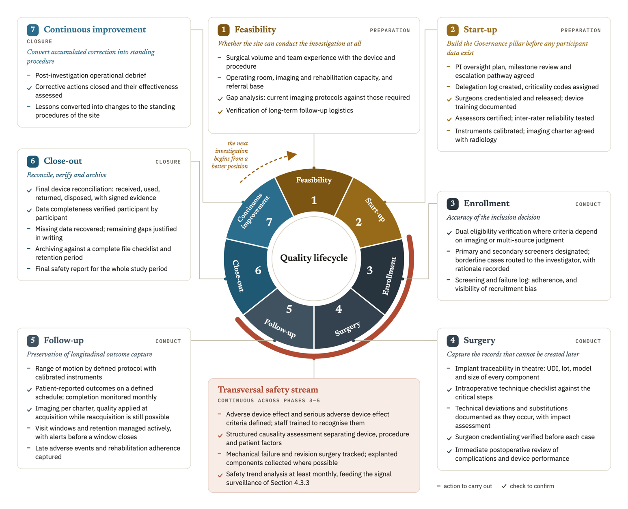
Figure 4.1. The seven-phase quality lifecycle and the transversal safety stream, showing for each phase its entry actions and exit condition, with its predominant quality objective. The circular layout shows that the cycle closes and feeds the next investigation.
When the controls in Phases 3 to 5 work, the quality burden at close-out is expected to fall. Section 5.4 treats this as an expected benefit, since no measurement has yet confirmed an inverse relationship between the two. The expectation rests on ICH E8(R1) Section 3.3.2, which supports simplifying nonessential activity and directing resources to critical areas [5].

4.6.2 Why the sequence matters
The order of the phases has consequences of its own, and the lifecycle is useful to a site only when those consequences are stated.
Phase 2 comes before Phase 3 because delegation and credentialing, together with training, decide who may take the decisions that make up Phase 3. If a site starts enrolling before credentialing is complete, uncontrolled decisions enter its dataset, and afterward the site cannot tell which decisions were affected.
Phase 1 comes first because a capability gap found later cannot be closed by improving a process. A site that lacks adequate imaging capacity, for example, will not solve the problem by writing a better imaging charter.
The learning curve log is opened in Phase 2, one phase before the first surgery, so that it covers the first case. Its value comes from the early cases, and a log started only after a problem has been noticed has already missed what it was built to detect.
Safety runs across the phases because events do not follow phase boundaries. A complication found at follow-up may come from a surgical decision taken months earlier, and the framework can connect the two only if both were recorded when they occurred.
Behind these choices is the observation that some quality failures concentrate in identifiable phases and recur in similar forms. Surgical complications may cluster in the early, ascending part of a surgeon's learning curve [22], while loss to follow-up builds up over the later years [24]. These findings support control that changes with the phase, but they do not show that a lifecycle model works better than spreading the effort evenly, so the framework treats the phase organization as a design hypothesis. The hypothesis is consistent with ICH E8(R1) Section 3.3.2 and ICH E6(R3) Section 3.10.1.3, which direct quality resources toward critical activities and risks [5, 6].
A simplified interactive model of the lifecycle was produced to illustrate the phase structure and the relationship between actions and CtQ domains. It was generated with the assistance of an artificial intelligence tool for illustrative purposes, and it is not itself a validated instrument. Screenshots and the access link are provided in Appendix Y.

4.7 The scalability model
Academic centers and well-resourced hospitals are the most common settings for shoulder device investigations, so a framework that left them out would have little relevance. The scalability model, which answers DR12, is therefore a condition for that relevance. It keeps the obligations the same for every site and lets the depth of implementation vary. Our aim is that any site choosing to operate the framework can use it in full, with only the amount of structure behind each function changing from site to site.

4.7.1 Three site contexts
Type A covers large academic hospitals and established research institutions with dedicated research infrastructure. Quality maturity is not uniform within this category. Stakeholders from higher-level hospitals performed better on average in one survey, but substantial room for improvement remained [88]. Reports from academic centers show that research infrastructure has to be built and measured, and international clinical trial units differ in the services they offer [89, 90]. Repeated institutional self-assessment is associated with improved research-conduct capability, although that relationship is correlational and the study could not establish causality [30]. Variation also exists inside a single center, since surgeons with comparable specialist training may reach stable performance at different case volumes [22]. We do not offer the framework as a replacement for an institutional quality system. Its CtQ domains and surgical-context instruments work at the level of the named surgeon and device in a given investigation, so a research unit inside a large institution can describe its own conduct at that level.
Type B includes mid-sized private practices, as well as specialized orthopedic centers or hospitals with a meaningful volume of investigational activity. The framework was designed for this context, whose operational constraints Section 3.4.5 describes. A Type B site implements the framework in full, using every instrument and assigning every function, and in its small team one person holds several functions.
Type C covers smaller centers and ambulatory surgical units that take part in a limited number of investigations. Here the implementation is reduced to an essential core of five records: a delegation and training record, a risk register limited to the highest-risk domains, a device accountability record, a safety event record, and a PD record. Some of them put into practice requirements that ISO 14155:2026 or the MDR already set. Each instrument keeps the same purpose as in the other types, but reviews are less frequent and compatible records may be combined. One person may also hold more than one function.

Table 4.2. The scalability model, showing how deeply six framework elements are implemented in each site context: Type A (large or complex research hospital), Type B (medium private clinic or hospital), and Type C (small surgical center).
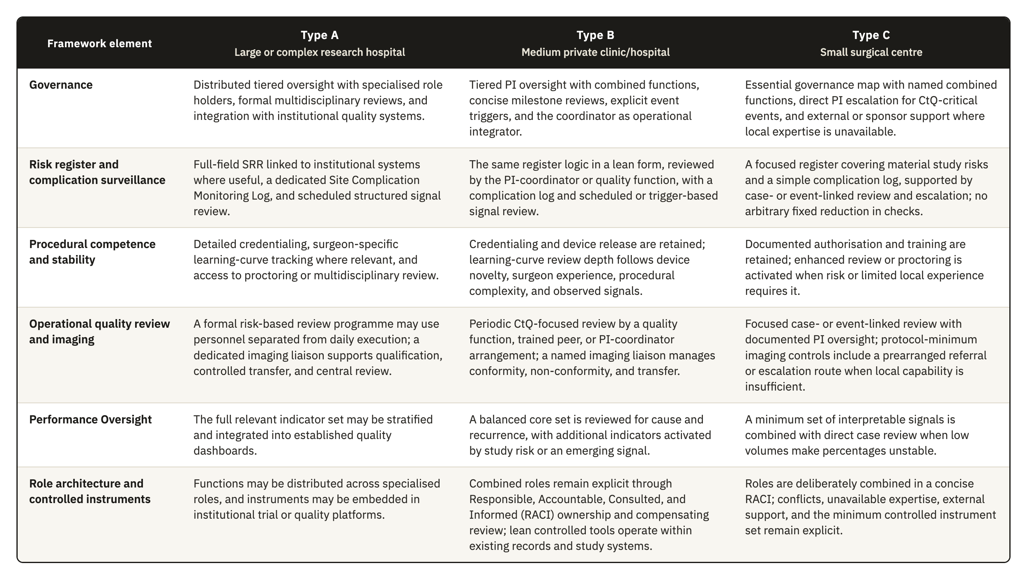

4.7.2 What does not scale
A smaller center that implements less may be more exposed at inspection, and this objection to reduced depth is a serious one. Under MDR Article 72(5), Member States inspect investigation sites at an appropriate level, and ISO 14155:2026 Clause 9.1(b) requires the sponsor to keep records showing that the investigation complies with the CIP, the standard, and the applicable requirements. A smaller center is therefore protected only as long as its minimum clause-linked controls and records stay complete and consistent, and also current and retrievable. Scaling can reduce organizational depth, but it cannot remove the evidence needed to show that the investigation was conducted in compliance.
What does not vary between sites is the clause-linked evidence needed to report, interpret, and verify the investigation. Keeping it fixed does not mean that documentary completeness is valued above organizational sophistication. The minimum record set includes informed-consent evidence under MDR Annex XV, Chapter II, Section 3.13 and ISO 14155 Clause 10.5; delegation and training records under ISO 14155 Clauses 10.2 and 10.3 and MDR Annex XV, Chapter I, Section 2.7; device-accountability records under ISO 14155 Clause 7.9 and MDR Annex XV, Chapter II, Section 3.11; deviation records under MDR Annex XV, Chapter II, Section 3.10; adverse-event records under ISO 14155 Clauses 7.4 and 8.3(a)(4) and MDR Annex XV, Chapter II, Section 3.14; calibration evidence under ISO 14155 Clause 9.2.4.5(p) and Annex A.6.4; essential records under ISO 14155 Clause 8.6 and Annex E; and source documents under ISO 14155 Clause 7.5.3. ICH E6(R3) describes the same records in Sections 2.3.2, 2.3.3, 2.5.3, and 2.12.2 and in Appendix C, and we use it as GCP guidance for their content, while the obligation comes from ISO 14155 and the MDR. MDR Article 72(3) requires investigation information to be recorded, processed, handled, and stored so that it can be accurately reported, interpreted, and verified. Documentary discipline is therefore achievable at any site type, while optional organizational layers may scale.

4.7.3 Escalation and de-escalation
Depth tracks the risk of the investigation as well as the type of the site. Implementation depth is raised whatever the site type where the investigation involves a first-in-human device, a procedure of unusual complexity, or endpoints with high observer variability. It may be reduced where an established device is used in a routine procedure with objective endpoints and an experienced surgical team. Calibration therefore follows the risk of the specific investigation, which the category of the center only approximates, and in this way the model stays consistent with the risk-proportionate principle. A Type C center running a first-in-human device implements more deeply than a Type B center running a well-established one.

4.8 The operational instrument set
The framework is operated through a defined set of instruments, listed here in one place. A site can use the framework only if it sees what it has to produce, and several instruments are referred to at more than one point in the preceding sections. In practice, DR11 is met because every instrument is designed to work on paper and needs no software, license, or system integration. A site that has digital tools may use them, but the framework does not depend on them.
Table 4.3 lists all 24 instruments with their purpose, the inputs each one consumes, how it processes them, and what it produces, grouped by the same four pillars.
Table 4.3. The 24 instruments, with their purpose, the inputs each one consumes, how it processes them, and what it produces.
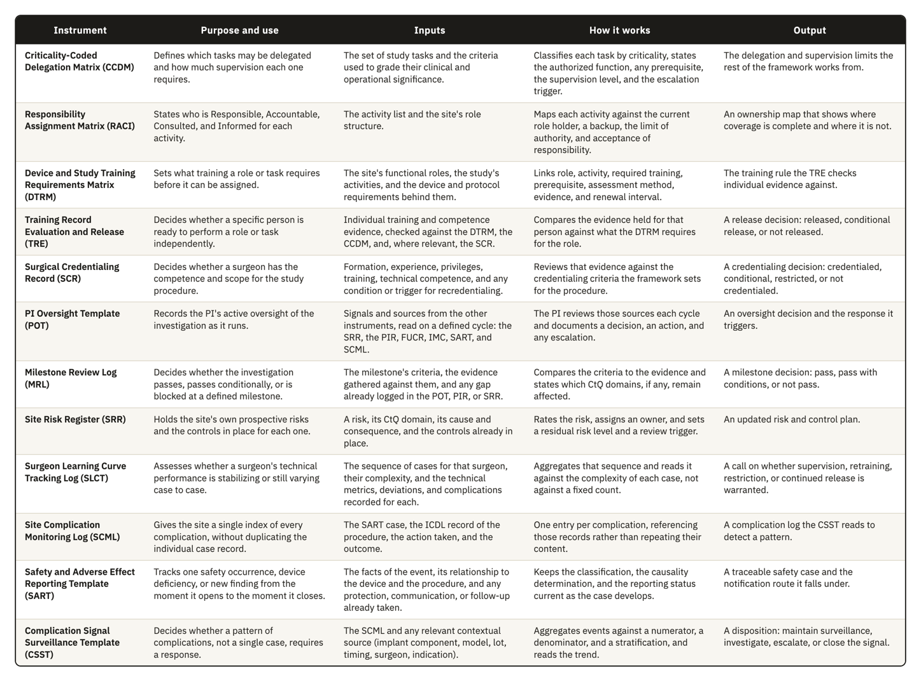
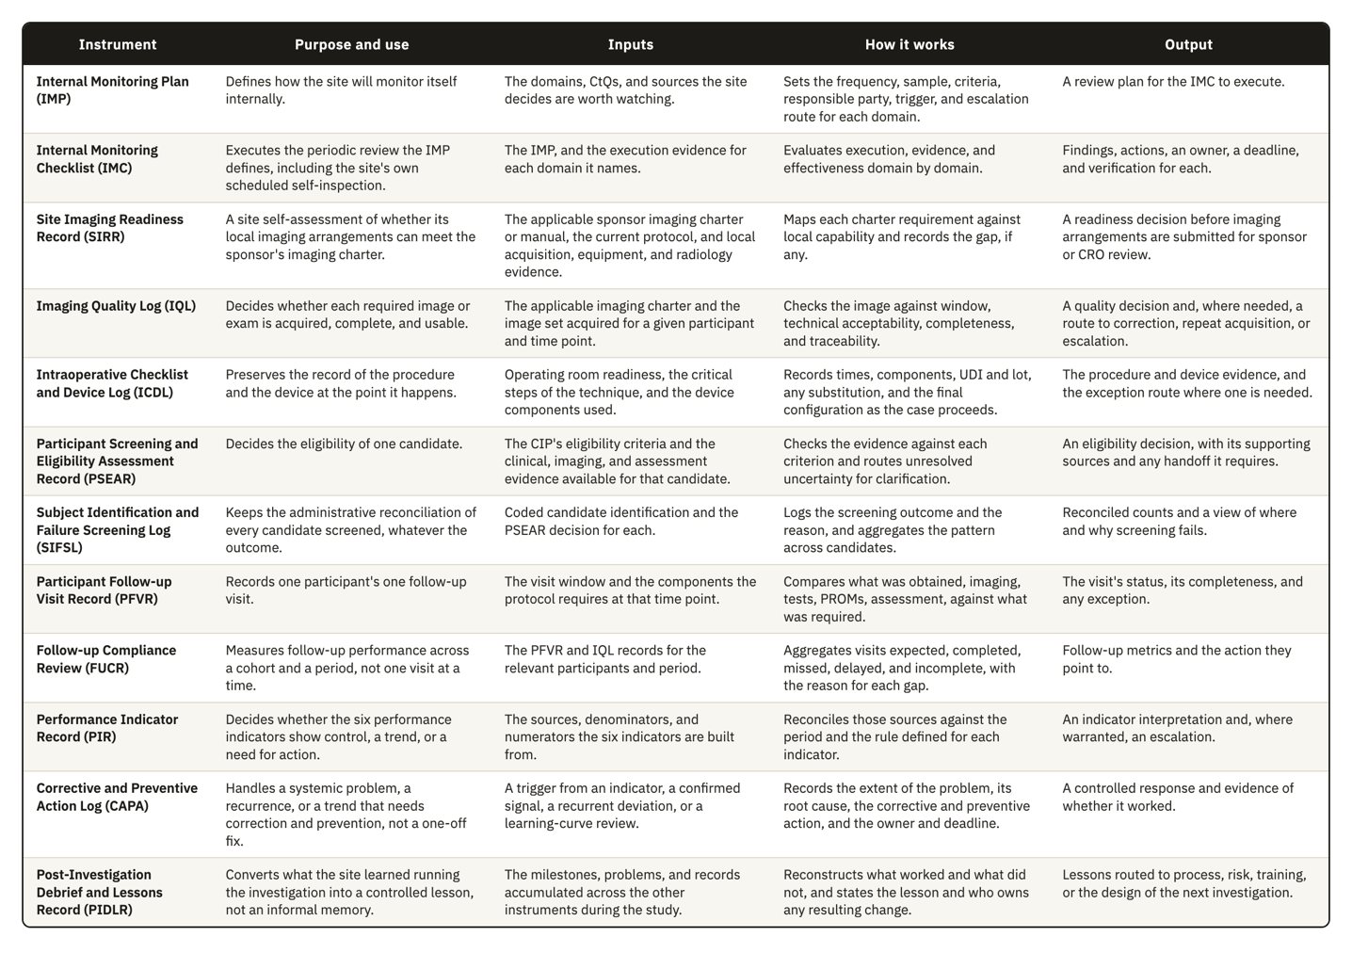
Figure 4.2 groups them by the pillar that owns each one, with 7 in Governance, 5 in Risk Management, 9 in Operational Controls, and 3 in Performance Oversight.
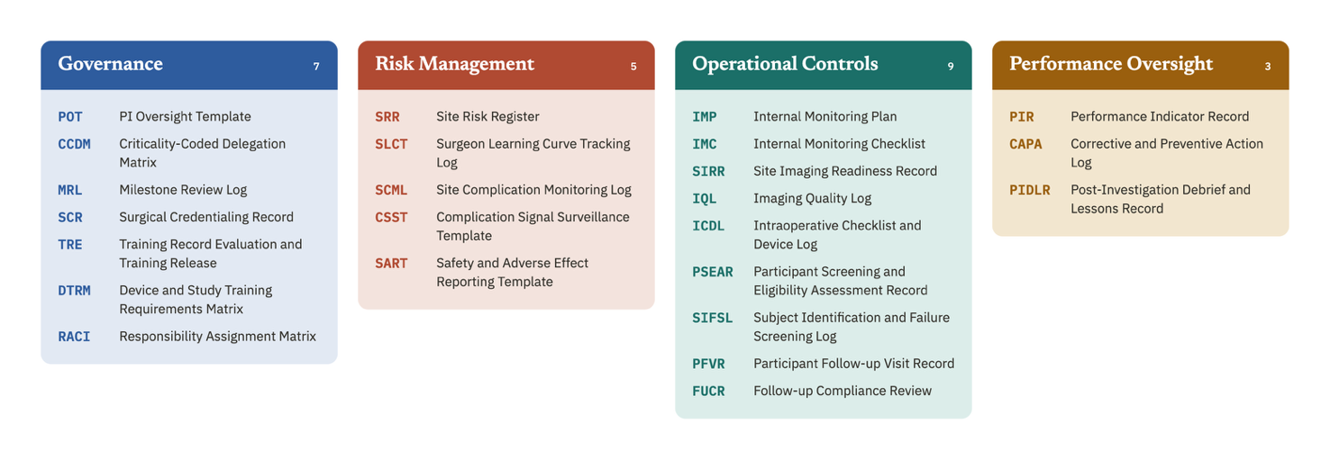
Figure 4.2. The 24 instruments grouped by the pillar that owns each one: 7 in Governance, 5 in Risk Management, 9 in Operational Controls, and 3 in Performance Oversight, each shown by acronym with its full name.
Figure 4.3 places the same 24 instruments on the axis that decides how they connect: the fine record one person, one event, or one image produces, the synthesis that aggregates several of those records, and the site-level decision the synthesis supports. The arrows mark the information chain this framework depends on throughout. Evidence rises from a fine record to a synthesis to a decision, and the decision returns to the fine layer as a requirement to verify.
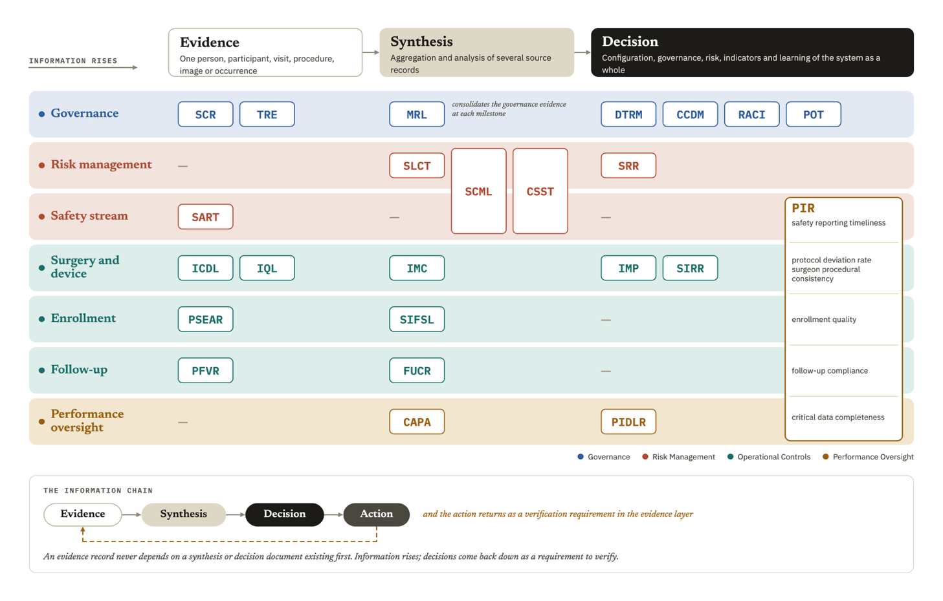
Figure 4.3. The granularity of each instrument, from individual evidence to the site-level decision it supports, with the arrows marking the chain through which information rises and a verification requirement returns to the evidence layer. Rows group instruments by operational area, so Operational Controls appears as four groups: safety, surgery and device, enrollment, and follow-up.
Figure 4.4 maps the same 24 instruments against the 12 CtQ domains from Section 3.3, marking where an instrument carries the primary control for a domain and where it only supports, limits, or scopes the control another instrument carries.
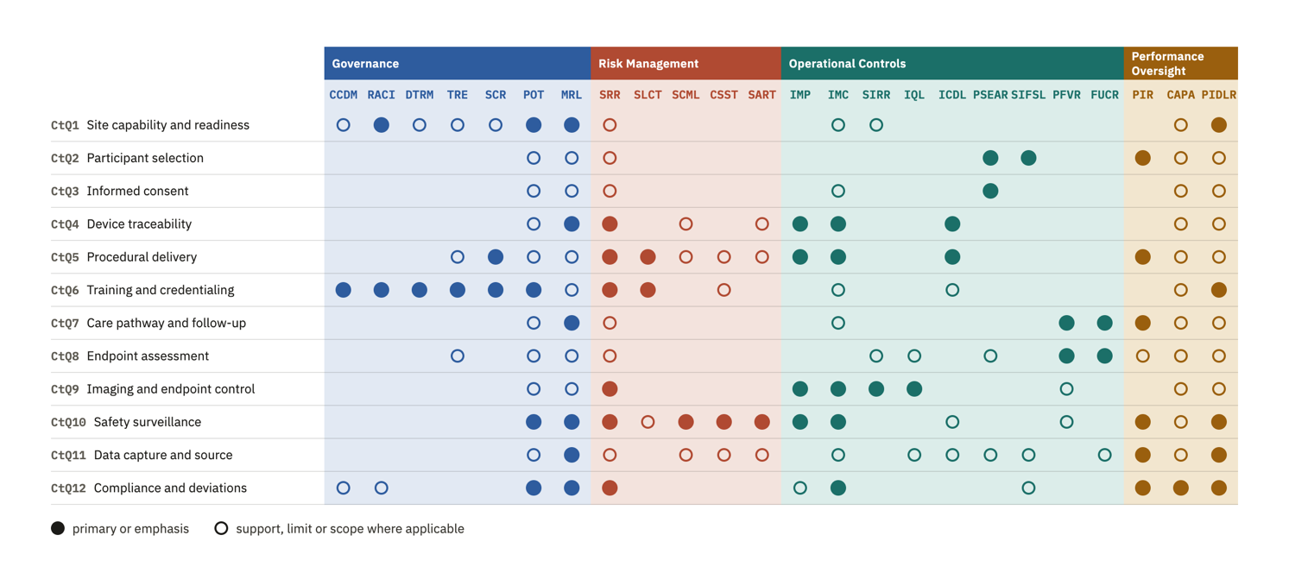
Figure 4.4. The 24 instruments mapped against the 12 CtQ domains, with a filled marker for a primary or emphasis relationship and an open marker where the instrument only supports, limits, or scopes another instrument's control.
Figure 4.5 maps the same instruments against the 12 design requirements from Section 3.5, distinguishing a direct answer to a requirement from one inherited through a combined or earlier instrument, from an extension added to the original set, and from a supporting contribution that does not carry the requirement on its own.
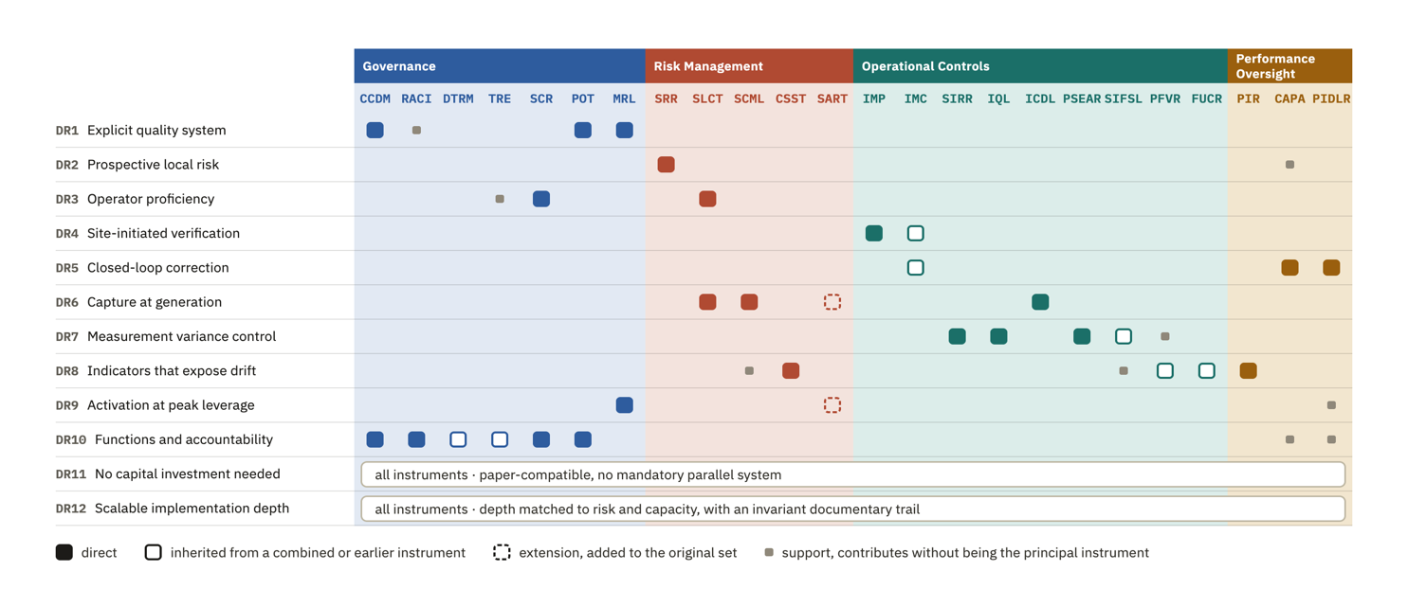
Figure 4.5. The 24 instruments mapped against the 12 design requirements, with a filled marker for a direct answer, an open marker for a relationship inherited from a combined or earlier instrument, a dashed marker for an extension added to the original set, and a small marker for a supporting contribution. DR11 and DR12 apply to all instruments as a set and are marked once for the whole set.
The templates were developed for shoulder device investigations, and their content shows it, above all in the complication categories and the imaging requirements, and in the complexity stratification of the learning curve log. Even so, we made them as generic as that context allowed. The field structures and review triggers carry no shoulder-specific assumption, and neither does the escalation logic. To adapt an instrument to another surgical specialty, a site would in most cases change the content of the classification lists and keep the structure as it is.
Appendices A to X contain draft templates for all 24 instruments.

