# *Web Programming I (420-H10-HR)*

# *Assignment 3 – Finished Website*

Date assigned: Monday, November 7, 2022

Date due: **Tuesday, December 13, 2022**

**Learning Objectives**

Upon successful completion of this assignment, the student will be able to:

* Create a web page containing images
* Create a web page containing a video

NOTE: YOU CANNOT USE ANY EXTERNAL LIBRARIES FOR THIS ASSIGNMENT EXCEPT FOR BOOTSTRAP.

To do:

1. Create a folder named YourUserName_H10A03_Website. Copy all the folders for the web site developed in the last assignment into this folder.
2. On the Home page, add a second paragraph after the one you created in the previous assignment. The content will have relative links to the associated pages listed. This paragraph must reference other pages on your website. Such as (underlines indicate links):

Our highly qualified staff is committed to blah blah the company’s mission of providing quality services for all your blah blah needs. We offer flexible hours and competitive rates and you can read about what some of our satisfied customers have to say. If you have like further information about our services, please fill out our inquiries form. We also have links to other websites of interest to blah blah and a map and directions to our location are available for your convenience.

1. Complete your site, updating any pages as required and completing any remaining pages necessary. At a minimum you must have pages as follows:
2. Home page (MUST BE CALLED index.html)
3. Hours or equivalent – using a table or tables to indicate the hours of operation of all or part of your company.
4. Rates or equivalent – using a table or tables to indicate the rates of various services or products for your company.
5. Contact Us – uses a form to allow visitor to send you a message. Form must contain text fields, radio buttons, check boxes, text area, dropdown list and a submit button.
6. Testimonials – contains a paragraph or more in a different format from a client or clients about your company. Includes the video from Lab 10 about your company complete with a poster.
7. Staff or equivalent – includes photos from Lab 10 of classmates/family members and a brief description of their job, interests, etc.
8. Links page – includes links to related websites. Do not use default list style on your links page. Make sure all links open in a new window.
9. Any other pages or second level pages to make your site complete.
10. Add at least 3 meta tags that can be used to increase the possibility of the web site being found by search engines. Add the tags to the **template**. Your template must be up to date in assignment 3. However, remember that some must be unique to each page. *Week 14.*
11. You must use at least 5 CSS custom properties in your site.
12. You must use at least 3 advanced features of CSS that may not have been covered in lecture but were part of the labs.  
      
    Examples may include but are not limited to:

* Absolutely position images as accents (lab 7)
* Emphasized typography using pseudo-classes/pseudo-elements (lab 7)
* Responsive layouts using flex/grid (week 9/10)
* Neon glowing font (lab 8)
* Angled headers (lab 8)
* Blur, with focus on hover (lab 9)
* Comic book or stained-glass layout/clip-path (lab 11)
* Bootstrap (week 13)

If you have other ideas for advanced CSS features, please check in with me. It is a good idea to comment in your code where you are using your advanced CSS features so I can easily tell when marking.

1. Choose an appropriate domain name for the web site. Check for its availability. When you have found an appropriate domain name that is available, include the domain name in header section of the web page and in any e-mail address on any of your other pages. *Week 14.*
2. In addition to adding the domain name to any email addresses, you can make a phone number be dialed automatically by adding a hyperlink using the tel: code; that is <a href=“tel:123-132-1234”>123-123-1234</a>. Since only mobile devices have telephony, you can only add this to your mobile site. Change any phone numbers that appear on your mobile site to dial the number when the link is selected. Make sure the number is only available as a link on mobile sites. That is, the href is not there when the desktop site is displayed (but the phone number is).
3. Make sure your site works properly on mobile and desktop devices. The mobile site should only include the limited information as detailed in the previous assignment. You must deploy your website to the o drive to do this, test this early!
4. Validate your site for both HTML5 and CSS3. When your site is valid, include the “valid icons” at the bottom of your home page (see the bottom of the CSS validation page when you have successfully validated for the required code).
5. Deploy your web site to the csdev web server (your O drive). Name the folder H10 and, if required, rename the home page to be index.html. The url for your deployed site should be <http://csdev.cegep-heritage.qc.ca/students/yourusername/H10/index.html>. Note, you cannot do this at home, it must be done in the school, so plan for this when submitting your assignment.

**Here are some examples of page content:**

1. Either the hours or the rates page must have TWO separate tables for two different pieces of information. For example, different rates for different types of service or different rates for different kinds of service.
2. On the Staff page, add the following content along with the photographs of the staff that were taken in the multimedia lab, using and appropriate heading for the page, and a flex box (or boxes) for the photographs and the biographies. Ensure that the images have been compressed for a web site.

**Staff**

|  |  |
| --- | --- |
| Brent’s photo | Brent is responsible for booking your pet’s stay at Happy Valley Kennel and for keeping the office running. Brent has been with KVK since 2001 and has become a valued member of the team. Brent is also the proud owner of Grizzly, a Yorkshire Terrier. |
| Charlie’s photo | Charlie has been with Happy Valley Kennel for 10 years, and has worked in all areas of the business. He has always been passionate about animals and treats each pet as if it were his own.  Charlie has a pet cat named Angel. |
| Michelle’s photo | Michelle joined the staff at Happy Valley Kennel in the spring of 2004. She graduated from Algonquin College in 1990 and has many years of experience in boarding kennels. Her compassion and experience is evident as she cares for your pets. |
| Sam’s photo | Sam is in his first year at Heritage College in the Science program, in preparation for university, where he plans to study veterinary medicine. He works at HVK on weekends and after school.  Sam is responsible for taking care of your pets while they are here in boarding, as well as making sure the facility is clean inside and out. |

1. On the Testimonials page, add the following or similar content, using an appropriate for the page, and the formatting as shown below, using a new style in the style sheet:

**Testimonials**

*Analog Nirvana is really THE place to go when you need a dear-old beloved vintage analog electronic musical instrument repaired or serviced. Their service is very reliable!*

*Margaret W., Gatineau, QC*

*They have an out-of-this-world selection of synths, and their staff is awesome! I’ll be coming back again and again, and I would recommend them to any musical enthusiast!*John P., Ottawa, ON

Include following the text, the video that was completed in the multimedia lab, and the format and size of the video (so that visitors to the web site know what to expect). Add an appropriate image as a poster for the video.

1. On the Links page, add links to companies that support your company or perhaps even are competitors to your company. The list-style tag must NOT be the default tag. All links must open in a new window/tab.

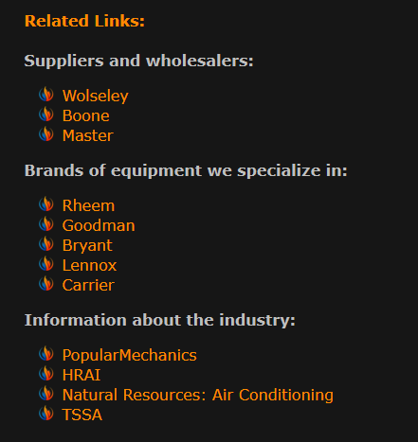

1. On the Inquiries page, add the following content, using a heading and a form with the controls specified below. Use CSS with fieldgroups to format your form. Fieldgroups must, at least, be included around the check boxes, but can be included to group other fields together. Make sure that labels are aligned to the right and that the fields have different lengths depending on how long you think the field would be.

**Inquiries**

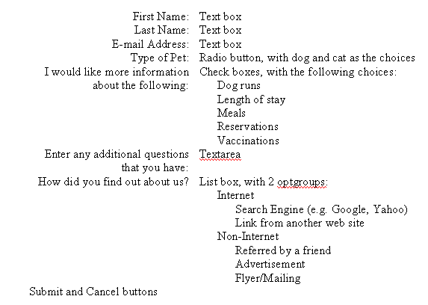

Test your web site (both on screen and on mobile) to ensure the following:

* No Broken Links.  All links are checked and work.
* No Broken Images.  All images work.
* All pages use "jpg" or "gif" or “png” image files, not "bmp," or "psd" files.
* Every page includes a Copyright notice.  For example, © 2020 Happy Valley Kennel. All Rights Reserved.
* Each page contains "text links" to central pages on the website.
* Each page has a common look and feel.
* Each page has "Alt tags" for all central images. You don't really need Alt tags for horizontal bars or tiny bullet gifs. Include sources for all images in the footer of the page it is used on.
* Each page uses either a "1024 by 768" or “1280 x 1024” layout. If you use a "1280 x 1024" layout, you must put a warning on the top of the webpage that it is best viewed in this format.
* Each page has a title and heading that tells the user what its larger goal is.
* Each page uses the basic principles of alignment to layout text, images, and graphics on a page. The material should not be thrown on the page, but laid out according to a larger grid strategy.
* A website should include a set of linked pages that go together based on a larger theme. A website isn't just one web page.

Make sure that you do not have any embedded or inline styles in the page.

**To submit**

When you have completed the assignment, zip the YourUserName_H10A03_Website folder containing the following documents to the H10 and load them to Moodle:

* All the files in the web site.