testing and fault tolerance

Laboratory Session 1: “Fault Injection Concepts”

|  |  |  |
| --- | --- | --- |
| **Student Name** | **Student Surname** | **Student ID** |
|  |  |  |

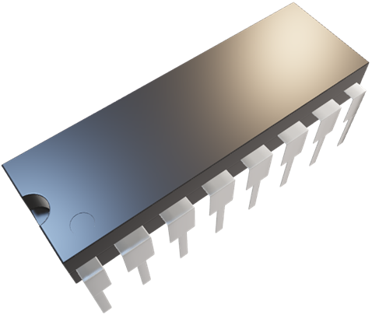

**SAVE THIS FILE IN PDF AND SUBMIT IT ON “EXERCISE”**

# **[A] Circuit Fault Lists**

The combinational circuit ex1 is provided in both *dataflow* and *structural* formats.

* The dataflow format is a unique module which makes use of VHDL primitives (and, or, nand, xor etc.) and wires.
* The structural format instantiates sub-module (so called cells described in the technology library (pdt2002).

A structural version of the circuit can be obtained from a high-level description of the circuit (behavioral, dataflow) by means of logic synthesis.

**[A.1] Tasks:**

1. Draw the gate-level schematic of the ex1 circuit.
2. Compute the size of the full **stuck-at** fault list.

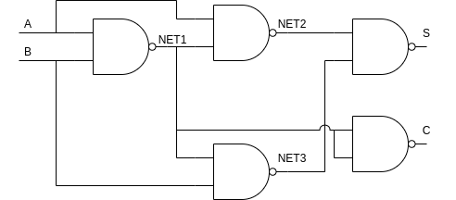

1)

2) There are 2x17 stuck-at faults.

* You can use [draw.io](https://app.diagrams.net/) to draw the circuit.

**Run** the provided TestMAX script and check the results. The provided script is responsible for the following actions:

1. Read the structural circuit files and the technology library.
2. Build the top-level module.
3. Perform the design rule checking (drc).
4. Set the fault list type (full or collapsed).
5. Add all faults.
6. Write the faults to a file.

After the **successful** execution of the script you will find two new text files in the directory lab1/run. By checking the content of the full fault list, you can understand how faults are grouped in **equivalence classes**. An equivalence class can be easily identified in the full fault list, where a fault is (eventually) followed by one or more lines that contain the symbols “- -”. All such faults, including the one without the mark, are equivalent and can be collapsed. The collapsed fault list contains the so-called **prime** faults.

**[A.2] Tasks:**

1. Report the total number of equivalence classes for the circuit.
2. Explain how the prime faults are selected from the full fault list.

1) There are 19 eq. classes

2) First all the faults are grouped in equivalence classes, then for each eq. Class a fault is taken and it’ll be the prime fault of that eq. Class.

# **[B] Testbench (TB)**

A VHDL testbench for the circuit ex1 is provided. It can be used to apply stimuli to the circuit and to monitor the circuit responses to that stimulus. Look inside the source code of the testbench.

**[B.1] Tasks:**

1. Draw the waveform of the clock signal.
2. Annotate on the previously drawn waveform:
   1. The exact times in which stimuli is applied.
   2. The exact times in which the circuit outputs are observed.

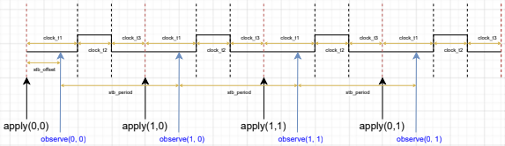

Run the testbench using the provided bash script, which invokes the QuestaSim shell and executes the simulation tcl script. The testbench includes a “monitor” process, which reports, for each pattern, the values applied to the primary inputs (PIs) and the values observed on the primary outputs (POs). After the logic simulation, the monitor produces a new text file in in the directory lab1/run.

The objective of this exercise is to inject faults in the circuit and then to compare the results against the fault-free simulation: in case the values of a primary output changes for at least a pattern, then the fault is detected. The procedure to follow in the fault injection campaign is the following:

1. Run the fault-free simulation and rename the monitor text file (e.g., monitor_gold.txt)
2. Inject a fault and then re-run the simulation, which produces the new monitor.txt
3. Compare monitor_golden.txt and monitor.txt

* For comparing, you can use the [**cmp**](https://man7.org/linux/man-pages/man1/cmp.1.html) or [**diff**](https://man7.org/linux/man-pages/man1/diff.1.html)binaries/commands available in Linux.

Faults can be injected by modifying the simulation tcl script. Inside the tcl script you can find some examples. In order to check the behavior of the internal signals when a fault is injected, you can run the simulation using the QuestaSim GUI. In order to run the GUI, you need to slightly modify the bash script simulation.sh by commenting out the command that invokes the vsim shell and uncommenting the one that invokes the GUI.

* Inside the GUI window, there is also a terminal that can be used to execute commands. For example, you can copy and paste the commands of the tcl script. Furthermore, you can add the waveforms of the internal signals **before** executing the simulation with the run command. Also, you can inspect waveforms produced in previous simulations.

Waveforms are written into wlf files. The name of the output file can be specified by specifying it with the -wlf parameter of the vsim command (like in simulation.sh). You can view a wlf file by executing the following command:

* vsim -view FILENAME.wlf

# **[C] Pin Faults**

QuestaSim can inject faults in the wires (i.e., VHDL signals) that connect the various gates of the circuit, as you have seen in the previous exercise (see [[B] Testbench (TB)](#_[B]_Testbench_(TB))). However, if you look at the fault list produced by TestMAX in the first exercise (see [A] Circuit Fault Lists), you will

notice that such faults are related to input and output pins of the gates. You can observe via logic simulation that, if you force a gate pin to 0 or to 1, then all the other gates that are connected to that pin by a single wire are also forced to the same value (as well as the wire itself). This behavior is fine if the wire interconnects only two gates.

**[C.1] Tasks:**

1. **Identify** and **report** the faults in the fault list produced by TestMAX for the ex1 circuit that cannot be properly injected using the current version of the circuit.

sa0 NC B

sa1 NC B

sa0 NC A

sa1 NC A

sa1 NC U1/I1

sa0 -- U1/I1

sa1 NC U2/I1

sa0 -- U2/I1

sa1 NC U3/I2

sa0 -- U3/I2

sa0 NC U1/O

sa1 NC U1/O

sa1 NC U2/I2

sa0 -- U2/I2

sa1 NC U3/I1

sa0 -- U3/I1

sa1 NC U5/I1

sa0 -- U5/I1

sa1 NC U5/I2

sa0 -- U5/I2

To overcome this problem, pin faults can be emulated by adding additional wires to the circuit, following the example in the figure below.

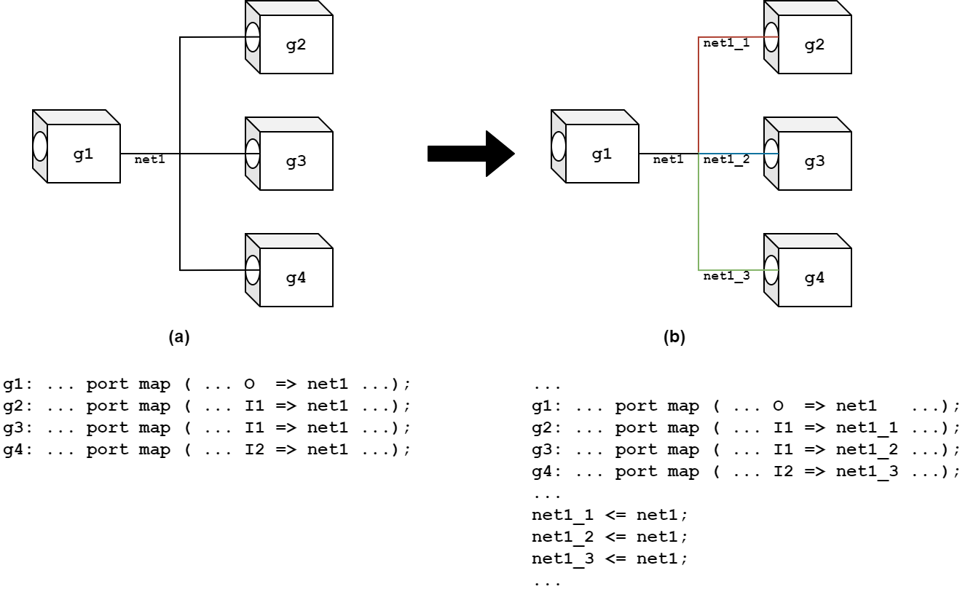In the left circuit (a), when you inject a stuck-at fault in g4/I2, all the other pins connected to net1 are stuck at the same value (wrong implementation of the single stuck-at fault model). In the right circuit (b), g4/I2 is connected to net1_3, which is the only wire in the circuit that would be stuck at the same value of the pin, in case you do a force, while the other 3 nets would keep their functional values (correct implementation).

Apply the proper modifications to the circuit ex1 by modifying the structural VHDL file. Then, perform a fault injection campaign on the circuit using the fault list produced on the first exercise (see [A] Circuit Fault Lists).

* You can use the provided script to convert a line in the fault list file to a force command for the simulation, as in the example below (**the third parameter is the line number**):
* **./convert_faults.sh run/fault_list_stuckat_full.txt 14 > run/inject_fault.tcl**

In the example, the force command is written to a tcl file, which can be included in the simulation script (uncomment the line “source inject_fault.tcl”). In this way, you can simply choose another line in the fault list and re-run the simulation with another fault injected.

**[C.2] Tasks:**

1. Complete the table below.
2. **Report** the faults in the circuit that are untestable.
3. **Report** any redundant test pattern.

|  |  |  |  |
| --- | --- | --- | --- |
| **PIs** | **POs** | **Excited /not observed faults** | **Detected faults** |
| 00 | 00 | sa1 NC U1/I1  sa0 -- U1/I1  sa0 -- U2/I1  sa0 -- U3/I2  sa1 NC U2/I2  sa0 -- U2/I2  sa1 NC U3/I1  sa0 -- U3/I1  **sa1 NC U5/I1**  **sa1 NC U5/I2** | sa1 NC U2/I1  sa1 NC U3/I2  sa0 NC U1/O  sa0 -- U5/I1  sa0 -- U5/I2 |
| 01 | 10 | sa0 -- U1/I1  sa1 NC U2/I1  sa0 -- U2/I1  sa1 NC U3/I2  sa1 NC U2/I2  sa0 -- U2/I2  sa1 NC U3/I1  **sa1 NC U5/I1**  **sa1 NC U5/I2** | sa1 NC U1/I1  sa0 -- U3/I2  sa0 NC U1/O  sa0 -- U3/I1  sa0 -- U5/I1  sa0 -- U5/I2 |
| 10 | 10 | sa1 NC U1/I1  sa0 -- U1/I1  sa1 NC U2/I1  sa1 NC U3/I2  sa0 -- U3/I2  sa1 NC U2/I2  sa1 NC U3/I1  sa0 -- U3/I1  **sa1 NC U5/I1**  **sa1 NC U5/I2** | sa0 -- U2/I1  sa0 NC U1/O  sa0 -- U2/I2  sa0 -- U5/I1  sa0 -- U5/I2 |
| 11 | 01 | sa1 NC U1/I1  sa1 NC U2/I1  sa0 -- U2/I1  sa1 NC U3/I2  sa0 -- U3/I2  sa0 NC U1/O  sa1 NC U1/O  sa0 -- U2/I2  sa0 -- U3/I1  **sa1 NC U5/I1**  sa0 -- U5/I1  **sa1 NC U5/I2**  sa0 -- U5/I2 | sa0 -- U1/I1  sa1 NC U1/O  sa1 NC U2/I2  sa1 NC U3/I1 |

1) In the table above, the faults highlighted are the ones that doesn’t generate any difference in the output despite the input pattern.

2) The redundant faults are highlighted with a ‘--’

# **[D] Synthesized Circuit**

The dataflow version of circuit ex1 can be synthesized with DesignCompiler using the provided script. After the successful execution of the script, you can find the synthesized circuit in both VHDL and Verilog formats. You can use the Verilog file for the TestMAX work (VHDL files need to be adjusted), while the VHDL is fine for the logic simulation. In order to use the synthesized file, modify the path in the simulation.sh script accordingly.

**[D.1] Tasks:**

1. Perform the fault injection campaign on the new, synthesized circuit.
2. Report any redundant fault(s).

## **APPENDIX: Files and Scripts of LAB1**

|  |  |
| --- | --- |
| **Filename** | **Description** |
| ex1_dataflow.vhd | ex1 circuit (dataflow variant) |
| ex1_structural.vhd | ex1 circuit (structural variant) |
| ex1_structural_tmax.vhd | ex1 circuit (structural variant, TestMAX compliant) |
| ex1_testbench.vhd | Testbench for ex1 circuit |
| pdt2002.v | Technology library models (for simulation of structural/synthesized circuits) |
| pdt2002.db | Technology library models (for synthesis) |
| convert_faults.sh | Bash script that converts TestMAX faults to QuestaSim force commands |
| synthesis.sh | Bash script that invokes DesignCompiler |
| synthesis_script.tcl | DesignCompiler script that performs the logic synthesis of ex1 circuit |
| simulation_script.tcl | QuestaSim script with commands for the logic simulation run |
| tmax.sh | Bash script that invokes TestMAX |
| tmax_script.sh | TestMAX script that produces the fault lists of ex1 circuit |

* **All files listed here are included in your remote /home directory under lab1 folder.**